FAST FACTS

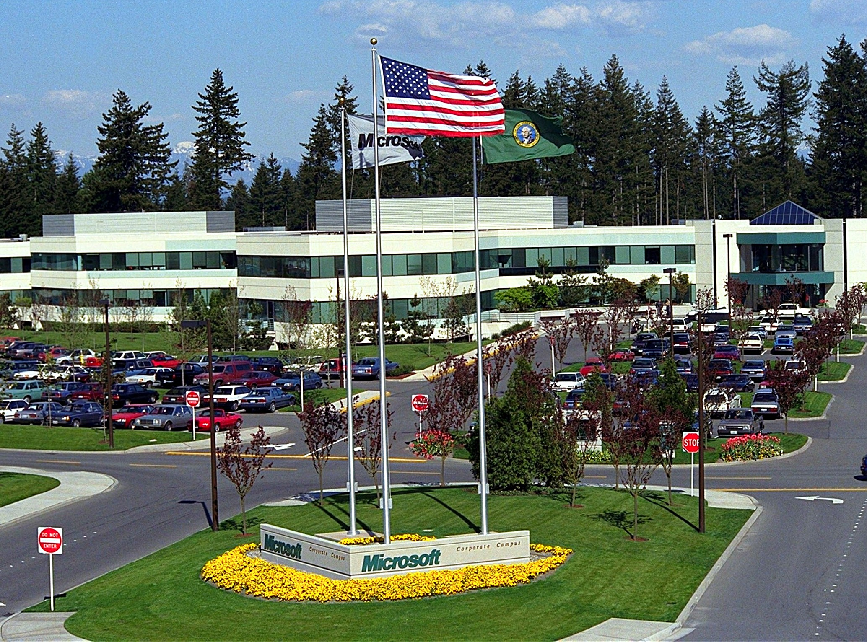
Microsoft Corporate Campus, Redmond. Wash.

Important Dates

1975 Microsoft founded

January 1, 1979 Microsoft moves from Albuquerque, New Mexico to Bellevue, Washington

June 25, 1981 Microsoft incorporates

August 12, 1981 IBM introduces its PC with Microsoft’s 16-bit operating system, MS-DOS 1.0

February 26, 1986 Microsoft moves to corporate campus in Redmond, Washington

March 13, 1986 Microsoft stock goes public

August 1, 1989 Microsoft introduces earliest version of Office suite of productivity applications

May 22, 1990 Microsoft launches Windows 3.0

August 24, 1995 Microsoft launches Windows 95

December 7, 1995 Bill Gates outlines Microsoft’s commitment to supporting and enhancing the Internet

June 25, 1998 Microsoft launches Windows 98

February 17, 2000 Microsoft launches Windows 2000

June 22, 2000 Bill Gates and Steve Ballmer outline Microsoft’s .NET strategy for Web services

May 31, 2001 Microsoft launches Office XP

October 25, 2001 Microsoft launches Windows XP

January 15, 2002 Bill Gates outlines Microsoft’s commitment to Trustworthy Computing

November 7, 2002 Microsoft and partners launch Tablet PC

January 16, 2003 Microsoft declares annual dividend

April 24, 2003 Microsoft launches Windows Server 2003

October 21, 2003 Microsoft launches Microsoft Office System

July 20, 2004 Microsoft announces plans to return up to $75 billion to shareholders in dividends and stock buybacks.

Corporate Offices

Microsoft Corporation
One Microsoft Way
Redmond, WA 98052-6399
USA
425.882.8080
Fax: 425.936.7329
www.microsoft.com

Founded in 1975, Microsoft (Nasdaq “MSFT”) is the worldwide leader in software, services and solutions that help people and businesses realize their full potential.

BOARD OF DIRECTORS
Steven A. Ballmer, Chief Executive Officer, Microsoft Corporation
James I. Cash Jr., Ph.D., Former James E. Robison Professor, Harvard Business School
Dina Dublon, Former Chief Financial Officer, JPMorgan Chase
William H. Gates III, Chairman and Chief Software Architect, Microsoft Corporation
Raymond V. Gilmartin, Former Chairman, President and Chief Executive Officer, Merck & Co., Inc.
Ann McLaughlin Korologos, Chairman, RAND Corporation; Chairman Emeritus, The Aspen Institute; Senior Advisor, Benedetto, Gartland & Co., Inc.
David F. Marquardt, General Partner, August Capital
Charles H. Noski, Former Vice Chairman, AT&T Corporation
Helmut Panke, Chairman of the Board of Management, BMW AG
Jon A. Shirley, Former President & Chief Operating Officer, Microsoft Corporation
As of May 5, 2005

MICROSOFT Businesses
Windows Client - including the Microsoft® Windows® XP desktop operating system, Windows 2000, and Windows Embedded operating system.
Server & Tools - including the Microsoft Windows Server System™ integrated server software, software developer tools, and MSDN®.
Information Worker - including Microsoft Office, Microsoft Publisher, Microsoft Visio®, Microsoft Project, and other stand-alone desktop applications.
Microsoft Business Solutions - encompassing Great Plains and Navision business process applications, and bCentral™ business services.
MSN - including the MSN® network, MSN Internet Access, MSNTV, MSN Hotmail® and other Web-based services.
Mobile and Embedded Devices - featuring mobile devices including the Windows Powered Pocket PC, the Mobile Explorer microbrowser, and the Windows Powered Smartphone software platform.
Home and Entertainment - including Microsoft Xbox®, consumer hardware and software, online games, and our TV platform.

Financial Information
Fiscal year ending June 30, 2004:
Net revenue: $36.84 billion
Net income: $8.17 billion

Revenue & Headcount
Microsoft worldwide revenue and headcount for the past 10 fiscal years:
FY  ENDING | HEAD-  COUNT | NET  REVENUE | %  GROWTH | NET  INCOME | %  GROWTH
6/30/1995 | 17,801 | $6.08B | 29% | $1.45B | 27%
6/30/1996 | 20,561 | $9.05B | 49% | $2.20B | 51%
6/30/1997 | 22,232 | $11.94B | 32% | $3.45B | 57%
6/30/1998 | 27,055 | $15.26B | 28% | $4.49B | 30%
6/30/1999 | 31,575 | $19.75B | 29% | $7.79B | 73%
6/30/2000 | 39,170 | $22.96B | 16% | $9.42B | 21%
6/30/2001 | 48,030 | $25.30B | 10% | $7.35B | -22%
6/30/2002 | 50,621 | $28.37B | 12% | $5.35B* | -28%
6/30/2003 | 54,468 | $32.19B | 13% | $7.53B* | 29%
6/30/2004 | 57,086 | $36.84B | 14% | $8.17B | 8%
As of June 30, 2004
*Fiscal year 2002 & 2003 results have been restated to reflect the retroactive adoption of SFAS 123, Accounting for Stock Based Compensation.

Current employment Headcount

TOTAL EMPLOYEES
Puget Sound (Washington State) |  | 28,900
USA |  | 38,336
Worldwide |  | 59,947

Gender Breakout (USA)
Male | 28,780 | 75%
Female | 9,556 | 25%

Age Breakout (USA)
Under 20 | 2 | 0.0%
20-29 | 7,361 | 19%
30-39 | 19,368 | 51%
40+ | 11,166 | 30%

Average Age (USA)
36 years

Functional Breakout (Worldwide)
Business Group |  | 29,411
Sales & Marketing Support Group |  | 26,245
Operations Group |  | 4,291
As of April 29, 2005

Real Estate Portfolio
OWNED | Total Square Feet | No. of Sites
Puget Sound | 7,821,131 | 73
Other US | 576,090 | 5
International | 578,421 | 5
Subtotal: | 8,975,642 | 83
Leased*
Puget Sound | 2,158,329 | 29
Other US | 2,538,051 | 80
International | 6,389,021 | 272
Subtotal: | 11,085,401 | 381
Total Portfolio
Puget Sound | 9,979,460 | 102
Other US | 3,114,141 | 85
International | 6,967,442 | 277
Grand Total | 20,061,043 | 464
As of April 29, 2005

Manufacturing, Distribution, & Logistics

Licensing, Manufacturing,
Operations and Logistics Dublin, Ireland

Manufacturing Humacao, Puerto Rico, USA

Licensing and Operations Reno, Nevada, USA

Operations and Logistics Singapore

Microsoft Subsidiaries
Microsoft Corporation has subsidiary offices located in the following countries and regions:
Algeria | Honduras | Oman
Argentina | Hong Kong | Pakistan
Australia | Hungary | Panama
Austria | Iceland | Paraguay
Bahrain | India | Peru
Bangladesh | Indonesia | Philippines
Belgium | Iraq | Poland
Bermuda | Ireland | Portugal
Bolivia | Israel | Qatar
Brazil | Italy | Romania
British Virgin Islands | Jamaica | Russia
Bulgaria | Japan | Saudi Arabia
Canada | Jordan | Serbia & Montenegro
Cayman Islands | Kazakhstan | Singapore
Chile | Kenya | Slovakia
China | Korea | Slovenia
Colombia | Kuwait | South Africa
Costa Rica | Latvia | Spain
Côte d'Ivoire | Lebanon | Sri Lanka
Croatia | Lithuania | Sweden
Cyprus | Luxembourg | Switzerland
Czech Republic | Macau | Taiwan
Denmark | Macedonia | Thailand
Dominican Republic | Malaysia | Trinidad & Tobago
Ecuador | Malta | Tunisia
Egypt | Mauritius | Turkey
El Salvador | Mexico | Ukraine
Estonia | Morocco | United Arab Emirates
Finland | Namibia | United Kingdom
France | Netherlands | Uruguay
Germany | New Zealand | Venezuela
Greece | Nigeria | Vietnam
Guatemala | Norway | Zimbabwe
As of April 29, 2005

For More Information
Please contact Microsoft Public Relations at 425.882.8080, or visit our Web sites:
- Microsoft.com—the main gateway to all sites providing information about Microsoft: www.microsoft.com
- PressPass—provides extensive media resources and current news about Microsoft: www.microsoft.com/presspass
- Investor Relations—provides financial information about Microsoft: www.microsoft.com/msft
- Bill Gates—find background information on Microsoft’s Chairman and Chief Software Architect, including essays, speeches and causes: www.microsoft.com/billgates
MS-DOS, Windows, Windows 3.0, Windows 95, Windows 98, Windows 2000, .NET, Office XP, Windows XP and Windows Server are registered trademarks of Microsoft Corporation. Other product and company names mentioned herein may be the trademarks of their respective owners.

