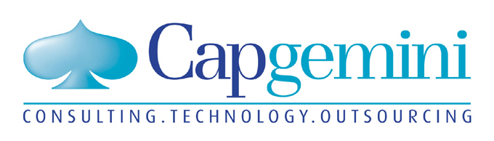 |  | 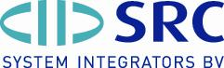
Nina Groothuijzen  Tel: +31 30 689 9190  nina.groothuijzen@cgey.nl | Anne Lomax  +44 207 436 6676  annel@ladermanpr.co.uk | Arjan Sloot,  +31 229 233 154  Arjan.Sloot@src.nl

Capgemini, Microsoft and SRC Launch Best Practice Roadmap and Technology for Global Data Synchronisation

Initiative will help retailers and suppliers improve flow of accurate product data and prepare for implementation of RFID and new traceability requirements

ECR Conference and Marketplace, Brussels, Belgium – 25 May, 2004 - Capgemini, Microsoft and SRC have combined their expertise and knowledge of standards initiatives to produce a best practice strategy to help retailers and manufacturers deal with the pressing need for Global Data Synchronisation (GDS). The collaboration provides a methodology, solution and implementation roadmap.

New Capgemini studies on behalf of the Global Commerce Initiative (GCI), voluntary body for improving the performance of the international supply chain for consumer goods, have shown that the quality of master data held by manufacturers and retailers is poor with more than half of the items in company systems containing incorrect data such as wrong values and duplicate or obsolete entries. The principal reason for this is that currently most product data is handled manually and is, therefore, fraught with the errors of re-keying. It is also estimated that over half of the items in company systems contain incorrect data.

SRC’s Product Data Manager solution, which is based on Microsoft technology, allows manufacturers and retailers to align and manage product data centrally for distribution in whatever format is required for business users to fully exploit. The solution also allows internal synchronisation between different systems, like web catalogues, and external synchronisation with data pools.

The benefits of synchronised data are far reaching, both from an internal and external perspective. Apart from significantly reducing lead times, GDS is an essential enabler in helping businesses prepare the foundation for the introduction of RFID and, particularly important for fast-moving consumer goods companies, to enable them to access accurate mandatory traceability information.

According to Kees Jacobs, Global Data Synchronisation Leader, Capgemini, which has carried out indepth research of 39 retailers and suppliers, by standardising and synchronising data businesses can lower supply chain costs by between one and three percent.

“The sharing of data between trading partners is now one of the most important supply chain processes, as the integrity of the information is critical for the uninterrupted flow of goods,” says Michèl Annink, Managing Director, Retail Industry Solutions Group, Microsoft Europe, Middle East and Africa. “Sharing data efficiently is reliant on everyone using common definitions and ensuring the data is accurate in order to produce a single view. The changes which will need to be made aligning various systems and formats are going to be considerable, but the benefits in terms of smarter store operations, merchandising, accounting and supply chains will be enormous.”

This joint initiative between Capgemini, Microsoft and SRC around GDS is a major step towards enabling the mass adoption of integrated and interoperable solutions that allow retailers and manufacturers to collaborate with each other through standards-based, open, scaleable and adaptable technology.

About Capgemini
Capgemini, one of the world's foremost providers of Consulting, Technology and Outsourcing services, has a unique way of working with its clients, which it calls the Collaborative Business Experience. Through commitment to mutual success and the achievement of tangible value, the company helps businesses implement growth strategies, leverage technology, and thrive through the power of collaboration. Capgemini employs approximately 55,000 people worldwide and reported 2003 global revenues of 5.7 billion euros.

About Microsoft Corporation

Founded in 1975, Microsoft (Nasdaq “MSFT”) is the worldwide leader in software, services and Internet technologies for personal and business computing. The company offers a wide range of products and services designed to empower people through great software – any time, any place and on any device.

Microsoft is a registered trademark of Microsoft Corp. in the United States and/or other countries. Other product and company names herein may be trademarks of their respective owners.

About SRC System Integrators BV

SRC is a service and solution provider for B2B e-Commerce and data synchronization. SRC develops, implements and support state-of-the-art solutions, together with their partners such as Microsoft Corporation Capgemini and Transora. SRC works for more than 400 customers in retail, CPG, automotive, consumer electronics, high tech, consumer electronics, DIY and pharmaceuticals.

