
Advanced Payroll

Microsoft Dynamics™ SL

Benefits
- Expedite data collection
Enter time for complex payrolls, including for both union and non-union employees, in the same payroll. Data is defaulted for labor class, union code, shift differential, pay rate, and other categories, based on your employee definitions.

- Enhance information access
Use an extensive set of payroll reporting tools to provide information to managers, government agencies, and tax boards. Define reports as needed to meet special needs when reporting earnings and deductions to union locals. When a job is defined as a certified project, reporting of
certified payrolls is fully supported.

- Apply flexible calculations
Pay wage premiums for different shifts,
accrue fringe benefits, pay prevailing wages or wages based on skill type, and deduct union and membership dues–all in the same payroll run. You can also define an unlimited number of fringe benefits and union and membership deduction codes.

- Integrate with project management
Share data with project management and accounting modules. Employee time information becomes available to Microsoft Dynamics SL project controller once a payroll batch is released, making it available to update project labor costs.

Take the guesswork out of complex labor and time collection. Microsoft Dynamics SL advanced payroll helps you calculate true labor costs, meet time-sensitive government reporting requirements, provide flexible deductions and benefits, and most importantly, pay your employees accurately and on time.

Enter Time
for complex payrolls, including those for both union and non-union employees, in the same payroll via the Advanced Time Entry screen.

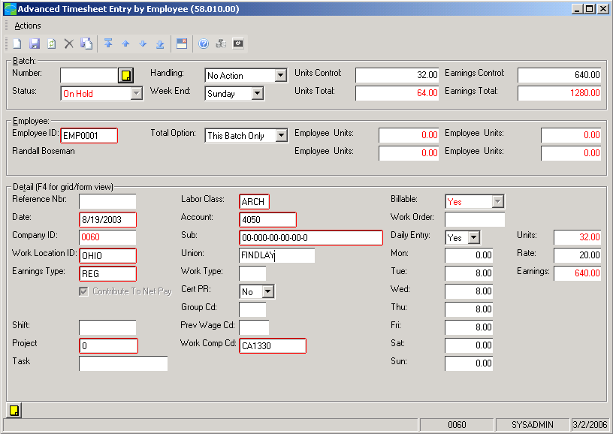

Pay
wage premiums for
different shifts.

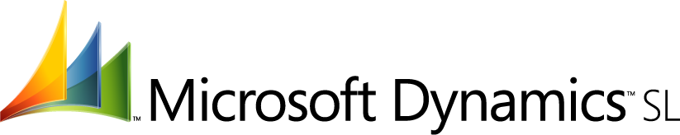

Flexible Setup Options  features  BENEFITS | Ease pay rate determination by setting up defaults to determine  employees’ rates of pay depending on timesheet information.
Default Reversal | Accommodate a large number of labor classes and shift premiums based  on a flat amount or percentage. The highest rate of pay is applied for  determining which rate to default. Easily override the rate to handle  exceptions as needed.
Streamlined Data Entry | Enter time for both salary and union employees once to produce paychecks and update project costs, eliminating double entry. Override default data to make time entry flexible for each employee, especially when multiple jobs are in process at the same time.
Consolidated Data and Processes | Process all employees’ time in a single batch that is stored in a single database.
Nonstandard Hours Calculation | Calculate shift differentials automatically based on an incremental  amount or percentage.
Certified Payroll Reports | Satisfy government contract requirements with the Certified Payroll Report. Set up employees with a certified status or mark time as certified by line item at the point of time entry.
Multi-state Time Entry | Track time each pay period for union employees that work in multiple  states with a single timesheet entry to keep accurate W-2 information.  Each state can be set up as a work location.
Powerful Benefits Tracking | Calculate fringe benefits automatically for each individual employee.  The employee Master File contains the hire date so that effective dates are easily located.
Integrated Systems | Share employee time data with Microsoft Dynamics SL project  management and accounting modules to update labor costs for projects  as soon as payroll batches are released, holding data entry errors to a  minimum.

For more information about Microsoft Dynamics™ SL, visit: http://www.microsoft.com/dynamics/sl

This document is for information purposes only.
MICROSOFT MAKES NO WARRANTIES, EXPRESS, IMPLIED, OR STATUTORY, AS TO THE INFORMATION IN THIS DOCUMENT.

© 2005 Microsoft Corporation. All rights reserved.
Microsoft, The Microsoft Dynamics Logo, are either registered trademarks or trademarks of Microsoft Corporation or Microsoft Business Solutions ApS in the United States and/or other countries. Microsoft Business Solutions ApS is a subsidiary of Microsoft Corporation.

