

Network Diagnostics Technologies in Windows Vista
Identify and Resolve Network-Related Issues Using Integrated Diagnostic and Repair Capabilities

Published: January 2007
For the latest information, please see http://www.microsoft.com/windowsvista.

The information in this document and any document referenced herein is provided for informational purposes only, is provided AS IS AND WITH ALL FAULTS and cannot be understood as substituting for customized service and information that might be developed by Microsoft Corporation for a particular user based upon that user’s particular environment. RELIANCE UPON THIS DOCUMENT AND ANY DOCUMENT REFERENCED HEREIN IS AT THE USER’S OWN RISK.
© 2007 Microsoft Corporation. All rights reserved.
If the user of this work is using the work SOLELY FOR NON-COMMERCIAL PURPOSES INTERNALLY WITHIN A COMPANY OR ORGANIZATION, then this work is licensed under the Creative Commons Attribution-NonCommercial License. To view a copy of this license, visit http://creativecommons.org/licenses/by-nc/2.5 or send a letter to Creative Commons, 543 Howard Street, 5th Floor, San Francisco, California, 94105, USA.
MICROSOFT CORPORATION PROVIDES NO WARRANTIES, EXPRESS, IMPLIED OR STATUTORY, AS TO THE INFORMATION CONTAINED IN THIS DOCUMENT AND ANY DOCUMENT REFERENCED HEREIN. Microsoft Corporation provides no warranty and makes no representation that the information provided in this document or any document referenced herein is suitable or appropriate for any situation, and Microsoft Corporation cannot be held liable for any claim or damage of any kind that users of this document or any document referenced herein may suffer. Your retention of and/or use of this document and/or any document referenced herein constitutes your acceptance of these terms and conditions. If you do not accept these terms and conditions, Microsoft Corporation does not provide you with any right to use any part of this document or any document referenced herein.
Complying with the applicable copyright laws is the responsibility of the user. Without limiting the rights under copyright, no part of this document may be reproduced, stored in or introduced into a retrieval system, or transmitted in any form or by any means (electronic, mechanical, photocopying, recording or otherwise), or for any purpose, without the express written permission of Microsoft Corporation.
Microsoft may have patents, patent applications, trademarks, copyrights or other intellectual property rights covering subject matter within this document. Except as provided in any separate written license agreement from Microsoft, the furnishing of this document does not give you, the user, any license to these patents, trademarks, copyrights or other intellectual property.
Information in this document, including URL and other Internet Web site references, is subject to change without notice. Unless otherwise noted, the example companies, organizations, products, domain names, e-mail addresses, logos, people, places and events depicted herein are fictitious, and no association with any real company, organization, product, domain name, e-mail address, logo, person, place or event is intended or should be inferred.
Microsoft, Internet Explorer, Windows, and Windows Vista are either registered trademarks or trademarks of Microsoft Corporation in the United States and/or other countries.
The names of actual companies and products mentioned herein may be the trademarks of their respective owners.

Contents
Introduction 1
The Network System Icon 1
System Tray States 1
Network Status and Proxy Server Identification 3
Hiding the Network System Icon 4
Disabling NCSI Active Probes 4
The Network Diagnostics Framework 6
Architecture 6
How the NDF Works 7
Session Flow 8
Common Networking Connectivity Scenarios 8
Cable Modem Not Working 8
Wireless Radio Is Turned Off 8
File Sharing Inoperable 9
Wireless Authentication Failure 9
The NDF for Developers 9
NDF Event Logging 10
Additional Resources 11
Appendix A: NDF Event Log Reference 12

Introduction
Previous versions of the Microsoft® Windows® operating system provided basic help for identifying and resolving networking problems. A status tray icon showed whether you were connected; if you encountered an actual problem, you might receive information to help with simple troubleshooting—for example, “network cable unplugged” or “not connected.” Typically, however, you were left to diagnose the problem on your own, a difficult and typically frustrating process.
With Windows Vista™, Microsoft introduces two new tools designed to make diagnosing network problems easier: the Network System Icon and the Network Diagnostics Framework (NDF). With these tools, users can troubleshoot and resolve common network connectivity issues—such as Internet connectivity, file sharing, wireless networking, and the like—themselves, potentially reducing support costs.
The Network System Icon is the entry point for accessing network functions as well as for visually identifying current network status. This section describes the icon states, network access levels, and the ways in which you can use (or hide) this feature.

The Network System Icon
The Network System Icon in the system tray provides quick, clear information about your computer’s network connectivity. However, this icon communicates more than merely the connection status; you can use it to initiate network diagnostics, connect to a network, turn on activity animation, and turn off notification of new networks.

System Tray States
In Windows Vista, a single icon in the system tray represents the aggregate connectivity status of all attached network adapters, thereby reducing clutter in the system tray and communicating the computer’s overall connectivity state. The Network System Icon has four states, as shown in Table 1.
Table 1. Network System Icon States
Icon | Status | Description
 | No Connectivity | No cable is plugged in, and no connection to a wireless access point has been detected (no layer-2 connectivity).
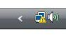 | Limited | A connectivity problem exists.  The system is currently not communicating with any other systems on local or remote subnets and cannot communicate with systems on the Internet.
 | Local Only | The system can communicate with other systems on local and remote subnets but cannot communicate with systems on the Internet. This status may also appear during Internet connectivity state identification.
 | Local and Internet | At least one network adapter is connected to the local network and can reach the Internet. The system can communicate with other systems on local and remote subnets, and the system can communicate with systems on the Internet.

Regardless of the number of network interfaces available on a computer (for example, a portable computer may have a wireless adapter and an Ethernet adapter), only one Network System Icon appears. However, you can view the status of each connected network by moving your pointer over the icon, as shown in Figure 1.
Figure 1. Move your pointer over the Network System Icon to view detailed network connectivity status

Right-click the Network System Icon to access the available network-related functions, as shown in Figure 2.
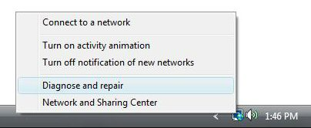
Figure 2. The Network System Icon context menu
From this menu, you can access several functions:
- Connect to a network. Accesses the Connect to a network dialog box, from which you can connect to available wireless networks, dial-up networks, and virtual private networks (VPNs).
- Turn on activity animation. Causes the Network System Icon to blink when the computer sends or receives packets from the network, indicating network activity.
Note This setting is off by default, because the animation is resource intensive. For the animation to accurately reflect network activity, it must actively monitor network activity. On a portable computer, this monitoring may result in a greater drain on battery power.
- Turn off notification of new networks. Windows Vista no longer shows the Select a network location dialog box when you connect to a new network, as shown in Figure 3).
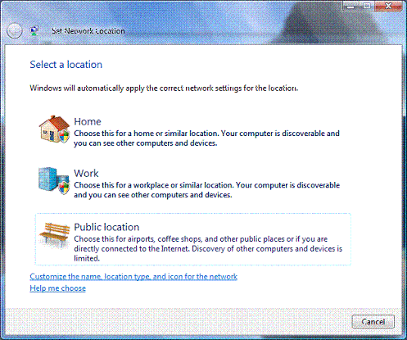
Figure 3. The Select a Network Location dialog box
Note By default, Windows Vista shows the Select a network location dialog box when you connect to a network for the first time. If you disable this dialog box, new networks will always be considered “Public,” and some network services will remain off to maintain security. For more information about network location types, see “Network Location Types in Windows Vista” at http://www.microsoft.com/technet/community/columns/cableguy/cg0906.mspx.
- Diagnose and repair. Runs the NDF to examine the connection for issues and implement or suggest repairs.
- Network and Sharing Center. Launches the Network and Sharing Center applet.

Network Status and Proxy Server Identification
The Network Connectivity Status Indicator (NCSI) is a component that determines the connectivity levels that the Network System Icon reports. In most home environments, the NCSI should report connectivity access levels accurately and quickly by default. However, on larger networks that use proxy servers, NCSI has to perform extra steps to accurately report the connectivity access level of the system. NCSI must detect whether the system is running in an environment that has proxy servers and discover those proxy servers to test connectivity to the Internet. How your Windows clients are configured to discover proxy servers will affect the speed with which NCSI can accurately report connectivity status.
For best results with NCSI in an environment that has proxy servers, it is recommended that you use the Web Proxy Automatic Discovery (WPAD) protocol. For NCSI, WPAD proxy detection typically allows NCSI to accurately and quickly report Internet connectivity. If you are not using WPAD and are manually specifying the name or IP address of proxy servers in the Windows Internet Explorer® Internet Options dialog box or in the Control Panel Internet Options item, it is recommended that you configure WinHTTP proxy settings on each computer to help NCSI be as accurate as possible. This is necessary, because proxy server settings configured using Internet Explorer or Control Panel are per-user settings and cannot be used by any Windows services, including NCSI (and may affect other Windows services as well). The WinHTTP proxy settings are global settings that will affect all WinHTTP clients on the system.
To configure WinHTTP, use the netsh winhttp set proxy proxy-server bypass-list command. Table 2 lists the command-line arguments.

Table 2. Netsh Command-Line Arguments
Argument | Description
proxy-server | The proxy server to be used for the Hypertext Transfer Protocol (HTTP) or HTTP over Secure Sockets Layer (HTTPS) protocol
bypass-list | A list of sites that should be visited directly, bypassing the proxy*
*Use <local> to bypass all short name hosts.
For example, use the command:
netsh winhttp set proxy corpproxy.example.microsoft.com
For more details on configuring your environment for operation behind a proxy server, see the Microsoft TechNet article, “Automatic Discovery for Firewall and Web Proxy Clients,” at http://www.microsoft.com/technet/isa/2004/plan/automaticdiscovery.mspx.
Note Configuring the WinHTTP proxy in this manner will take effect for all components that use WinHTTP. If WinHTTP is unable to identify the proxy in use, components other than NCSI (including non-Microsoft components) may have difficulty accessing the Internet.

Hiding the Network System Icon
You can hide the Network System Icon by using the notification area settings. To access these settings, right-click the Windows taskbar, click Properties, and then click the Notification Area tab, as shown in Figure 4.
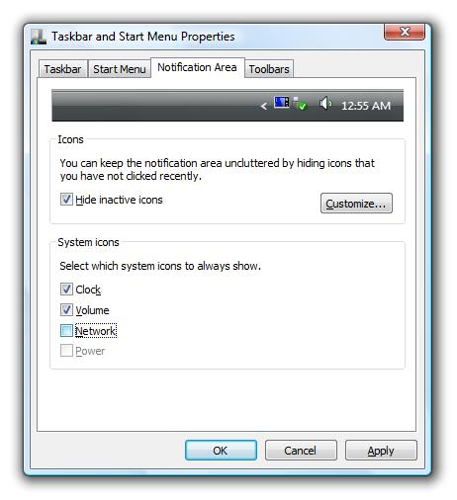
Figure 4. Changing the Network System Icon notification area settings

Disabling NCSI Active Probes
Most of the time, NCSI is able to determine the connectivity status level passively, without generating network traffic. However, when Windows first detects a network, NCSI performs an active probe, which does generate a small amount of network traffic. To prevent this network traffic, you can modify the registry value shown in Table 3. If NCSI active probe is disabled through the registry, applications that check for Internet connectivity might work more slowly. If a computer running Windows Vista is brought into a hot spot that requires sign-in, the computer might not detect the hot spot.

Table 3. Registry Key to Enable/Disable the NCSI
Subkey | HKEY_LOCAL_MACHINE\SYSTEM\CurrentControlSet\Services\NlaSvc\ Parameters\Internet
Value | EnableActiveProbing (DWORD type)
Data | 0
Note By default, this value is set to 1 (enabled).
For details on how the NCSI communicates and how to control NCSI communication, see “Appendix K: Network Connectivity Status Indicator and Resulting Internet Communication in Windows Vista” of the white paper, “Using Windows Vista: Controlling Communication with the Internet,” at http://technet2.microsoft.com/WindowsVista/f/?en/library/3e2d2dc5-c802-411e-9be4-dd29ec86c9351033.mspx.

The Network Diagnostics Framework
Microsoft Windows XP provided a network repair function, but the function was not comprehensive about the problems the user faced and instead took a simple, approach to re-establishing network connectivity. Specifically, this feature would take steps such as disable and re-enable the network adapter, clear the Address Resolution Protocol (ARP) cache, clear and refresh the NetBT cache, and clear the Domain Name System (DNS) cache. These same steps were performed regardless of the actual problem. In Windows Vista, the NDF provides an interface to help in identifying specific root causes of a wide range of network issues and suggest specific solutions based on its findings.
The NDF provides a new set of diagnostics tools that help resolve connectivity issues that, in many cases, do not require users to call their support center. The NDF also provides richer diagnostic information to the Event Viewer to assist support personnel when further troubleshooting is necessary.

Architecture
As part of NDF functionality, Microsoft has developed NDF Helper Classes that diagnose issues as they occur. Each of these Helper Classes contains the logic required to troubleshoot issues in the corresponding network component or application.
Individual NDF Helper Classes perform the primary tasks of the diagnostics session. Each helper class is a unit of code designed to evaluate one health aspect of its respective network component. The helper class also understands what possible repair options are available to restore the health of the component, as well as the cost and risk of any particular repair option. For example, a helper class exists that evaluates the IP configuration (that is, the Dynamic Host Configuration Protocol, or DHCP) of a specific network connection. The helper class identifies missing or invalid configurations and offers options for requesting new configurations from the DHCP server.
Each helper class plugs into the overall network diagnostics framework. As the number of helper classes associated with Microsoft networking components increases, a greater number of issues can be resolved this way.
The Helper Classes developed by Microsoft provide software developers with the primary functionality of NDF. Microsoft provides a small set of application programming interfaces (APIs) to allow application developers to take advantage of this new technology. Figure 5 shows the relationship among the various system components, APIs, and helper classes and how they interact.
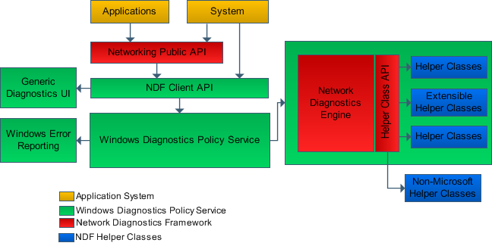
Figure 5. The NDF architecture
Note The NDF is extensible for non-Microsoft software developers.

How the NDF Works
Using the NDF, users can easily initiate the diagnosis and repair of many common networking issues, such as Internet connectivity, file sharing, and wireless networking. In this way, support costs both for consumers and for corporate enterprise (as well as user frustration) may be reduced.
Users can launch the NDF (in the user’s context) from several locations within Windows, including the Network System Icon in the system tray, from Internet Explorer, from the Network and Sharing Center, and so on. The point from which users launch the NDF determines how diagnostics will be performed—for example:
- When launched from within Internet Explorer, the NDF considers the target Uniform Resource Locator (URL).
- When a user initiates the Connect To operation, the NDF uses the media type that the user selected.
- When launched from a failed attempt to access a file share, the NDF considers the target Universal Naming Convention (UNC) path.
- From the Network Connections folder, the NDF uses the specific network interface that the user clicked.
Note When initiated from the Network System Icon, the URL www.microsoft.com URL is used. Otherwise, the URL or UNC path the computer is attempting to reach is used as a target location when diagnostics are performed.
When launched, the NDF can perform any of three basic repair types:
- Automatic. While some repairs may require administrative credentials, the NDF can be programmatically triggered to perform a repair action.
- Manual. Sometimes, the resolution to a network problem results in a manual action—for example, the user must plug in a network cable.
- Help content. When repair requires multiple or complex steps, the NDF displays a more detailed explanation for possible root causes and corresponding recommended repairs.

Session Flow
Diagnostic sessions follow a flow that takes them from the initial triggering of the diagnostic session to confirmation that the issue has been resolved. A typical session looks like this:
- The user or application starts a diagnostic session.
- The NDF diagnoses the problem and displays the root cause along with repair options.
- The NDF attempts to repair the problem by running the repair option that the user selects and may enter related information into the event logs.
- Optionally, the NDF performs a validation operation to confirm that the repair resolved the issue.

Common Networking Connectivity Scenarios
NDF is capable of diagnosing hundreds of different networking issues. These issues include:
- Incorrect IP address or configuration issues.
- Name-resolution issues.
- Network connectivity issues.
- Many wireless networking issues, including configuration and authentication issues.
- Internet Protocol security (IPsec) policy issues.
- Issues with Windows Filtering Platform filters blocking connections.
- Winsock corruption issues.
- Issues with incorrect proxy server settings.
- Some Network Access Protection (NAP) limited access issues.
- Network Driver Interface Specification (NDIS) driver issues.
The sections that follow provide some common networking connectivity scenarios and explain how the NDF works to help resolve them.

Cable Modem Not Working
A cable modem intermittently stops switching network traffic. If the user called the Internet Service Provider (ISP) for support, the ISP representative would instruct the user to power cycle the cable modem to solve the problem. The NDF would first identify the cable modem as the probable cause of the lack of connectivity, and then recommend the same course of action, thereby eliminating the need for a support call, reducing support costs, and getting the user connected more quickly.

Wireless Radio Is Turned Off
A user turns off the wireless radio on a portable computer during a flight and forgets to turn it back on after landing. The NDF diagnoses this problem, telling the user exactly what to do with no outside support required and reducing user frustration.
NDF can diagnose many different wireless issues, but its success in doing so is limited to the type of wireless device driver installed on the system. There are two types of wireless drivers: FAT drivers, which are older drivers, and Native Wi-Fi drivers, which are newer drivers. You will get much better results from NDF if you have installed Native Wi-Fi drivers. To check which of the two types of drivers are installed on a Windows Vista-based computer, open a Command Prompt window, and then run the following netsh command:
netsh wlan show drivers
In the output, look for a line labeled “Type”: The type will be either “Native Wi-Fi Driver” or “FAT Driver.” If you have a FAT driver installed, it is recommended that you contact the wireless device vendor and get a Native Wi-Fi driver for the device (if one is available). In this way, NDF will be able to diagnose many more types of wireless issues with greater accuracy.

File Sharing Inoperable
A user tries to access a remote file share to open or save a file, but the remote server is unavailable. The user launches NDF from the same error message dialog box to diagnose the specific problem. If the problem is the result of a firewall on the remote system blocking the connection attempt, the NDF would not be able to fix the problem automatically; instead, the NDF displays Help topics to assist the user in resolving the issue.
Note While the NDF can easily be extended to other applications, many Microsoft applications already take advantage of the NDF, including the 2007 Microsoft Office system, Windows File Explorer, and even Notepad, as shown in Figure 6.
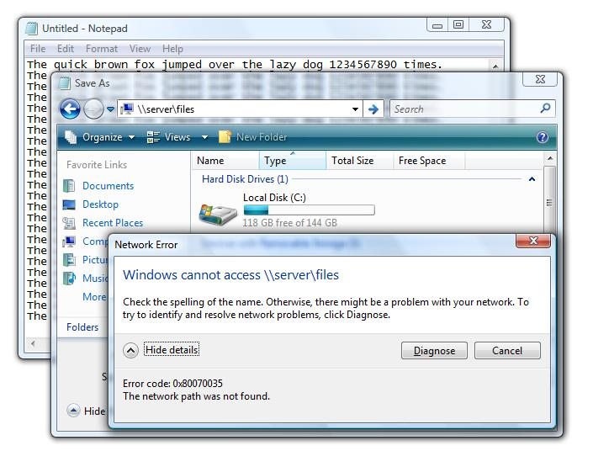
Figure 6. The NDF offers help for a network problem encountered when saving a document from within Notepad

Wireless Authentication Failure
A user tries to connect to a secure network, but the system fails IEEE 802.1X authentication. The NDF diagnoses the problem and helps the user modify the existing profile (or create a new profile) with the correct security settings.
Note While the NDF does its best to present problems in a simple manner, problems such as this still require user education or help from a network administrator.

The NDF for Developers
For vendors and in-house developers, using the NDF in their applications is easy. If the application requires network connectivity, such as access to the Internet, a couple of lines of code can allow the application to take advantage of the NDF.
Note Similar functionality can be integrated into non-Microsoft applications to provide a Diagnose button or links that start the NDF.
Note For more information about using the NDF in application development, see the Network Diagnostics Framework Software Development Kit (SDK) at http://msdn2.microsoft.com/en-us/library/aa369892.aspx.

NDF Event Logging
Microsoft made significant enhancements in the detailed logging that the NDF provides, taking full advantage of the enhanced Windows Vista Event Log to detail attempts and results to paint a clear picture of diagnostic attempts. When the NDF runs, it creates events that may contain detailed information about the network adapter, its driver, the environment, the NDF actions taken, and their results. See “Appendix A: NDF Event Log Reference” for a breakdown of the events that the NDF generates.
Note The specific information recorded is dynamic and may differ from session to session.
You can view the recorded events by using Event Viewer, which can also help you understand your network environment at the time the problem occurred without having to recreate the scenario. Finally, with the detailed logs provided, you need not rely on users to explain the symptoms of the problem. In an enterprise environment, you can take advantage of events by using collection and reporting tools to discover trends and act upon them before support calls roll in. Windows Vista natively uses Event Subscriptions in the updated Event Viewer.
Note For more information about Event Subscriptions, see Event Viewer Overview http://technet2.microsoft.com/WindowsVista/en/library/4229f239-16a6-4ecd-b3cf-aec03dc08cd51033.mspx.
With Windows Vista, the integration of Event Viewer with Task Scheduler enables it to trigger predetermined actions, such as sending an e-mail message, running a command, or displaying a message whenever a specified event occurs, as shown in Figure 7.
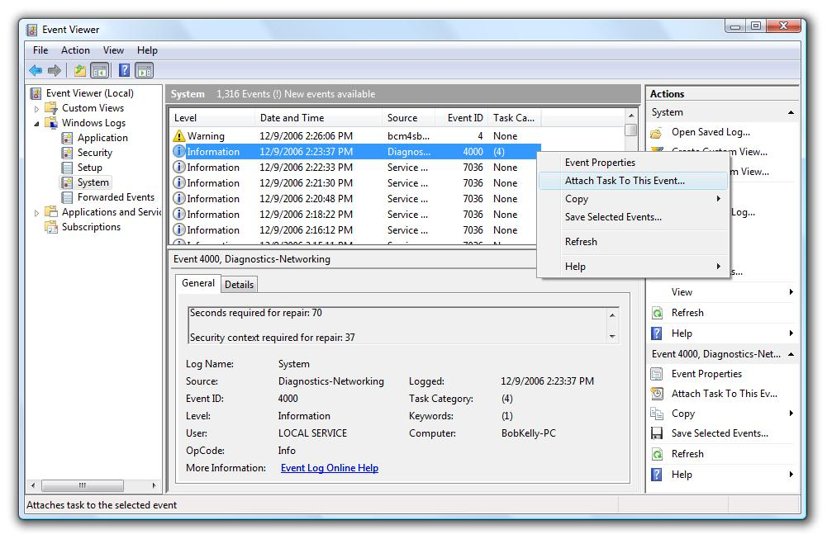
Figure 7. Right-click an event to attach a scheduled task
For more information on how to run a task in response to a given event, see Event Viewer Overview at http://technet2.microsoft.com/WindowsVista/en/library/4229f239-16a6-4ecd-b3cf-aec03dc08cd51033.mspx.
For purposes of offline analysis or recording problem history, NDF event logs can be converted into Extensible Markup Language (XML) or Comma-Separated Values (CSV) format.
To convert the NDF log files into XML or CSV formats
- Open a Command Prompt window as an administrator.
- Change to the directory in which the NDF log files reside--for example, type the cd %windir%\system32\ndf command.
- Stop the Diagnostic Policy Service by typing the command:
net stop dps
- Convert the existing log file to XML or CSV format using the command:
Tracerpt.exe -l eventlog.etl
or
Tracerpt.exe -l eventlog.etl -of csv
- Restart the Diagnostic Policy Service by typing the command:
net start dps

Note Debug events are not typically accessible from Event Viewer but are available when following these conversion steps.

Additional Resources
- Windows Vista Support Webcast: “Troubleshooting Network Issues on Windows Vista - New Network Diagnostics” at http://support.microsoft.com/kb/927551
- The Network Diagnostics Framework SDK at http://msdn2.microsoft.com/en-us/library/aa369892.aspx

Appendix A: NDF Event Log Reference
Table 4 provides a list of event log entries for operations, admin, and debug events.
Table 4. Event Log List
Event ID | Event type | Description
1000 | Operational | The NDF started because the user requested a diagnostics session.
2000 | Operational | The NDF stopped because it completed the user-initiated diagnostics session (result: Success, no problems found).
2100 | Operational | The NDF stopped because it completed the user-initiated diagnostics session (result: Success, problems repaired).
2200 | Operational | The NDF stopped because it completed the user-initiated diagnostics session (result: Failed during diagnosis).
2300 | Operational | The NDF stopped because it completed the user-initiated diagnostics session (result: Failed during repair).
2400 | Operational | The NDF stopped because it completed the user-initiated diagnostics session (result: Cancelled during diagnosis).
2500 | Operational | The NDF stopped because it completed the user-initiated diagnostics session (result: Cancelled during repair).
3000 | Operational | An error occurred. The NDF failed to complete the operation. A Windows Error Report was generated (NDF Failure).
3100 | Operational | An error occurred. The NDF failed to complete the operation. A Windows Error Report was generated (NDF Helper Class Failure).
4000 | Admin | The NDF has completed the diagnosis phase of the operation. The following repair option was offered:  <root cause>  Repair option: [string] LPWSTR pwszDescription;  Repair GUID: GUID guid;  Seconds *required for repair: long cost;  Security context required for repair:
4100 | Admin | The NDF has completed the diagnosis phase of the operation, but no network problem was identified.
4200 | Admin | An error occurred. The NDF failed to complete the diagnosis phase of the operation. A Windows Error Report was generated.
5000 | Admin | The NDF has completed the repair phase of the operation. The following repair option or workaround was executed:  - Helper class: LPWSTR pwszHelperClassName  - Repair option: [string] LPWSTR pwszDescription  - Repair GUID: GUID guid  - Result: The repair option appears to have successfully fixed the diagnosed problem.
5100 | Admin | The NDF has completed the repair phase of the operation. The following repair option or workaround was executed:  - Helper class: LPWSTR pwszHelperClassName  - Repair option: [string] LPWSTR pwszDescription  - Repair GUID: GUID guid  - Result: The repair option appears to have successfully fixed the diagnosed problem, but the NDF has detected the existence of other network problems. Re-run the NDF to diagnose these problems.
5200 | Admin | The NDF has completed the repair phase of the operation. The following repair option or workaround was executed:  - Repair option: [string] LPWSTR pwszDescription  - Repair GUID: GUID guid  - Seconds required for repair: long cost  - Result: The repair option failed to fix the diagnosed problem. A Windows Error Report was generated.
5300 | Admin | An error occurred. The NDF failed to complete the repair phase of the operation. A Windows Error Report was generated.
6000 | Operational | - Helper class: pwszHelperClassName  - Event: pwszEventDescription  - Event verbosity: Verbosity (NDF Helper Class Operational Event)
6100 | Admin | - Helper class: pwszHelperClassName  - Event: pwszEventDescription  - Event verbosity: Verbosity
7000 | Debug | Diagnostics Event (LowHealth and HighUtilization)  - Helper class: pwszHelperClassName  - Function Name:  - Initial state:  - Diagnosis status:  - Return code: <Diagnosis description>
7010 | Debug | Hypotheses Event  - Helper class: pwszHelperClassName  - Function name:  - Initial state:  - Diagnosis status:  - Return code: <Diagnosis description>
7020 | Debug | Repair Event  - Helper class: pwszHelperClassName  - Function Name:  - Initial state:  - Diagnosis status:  - Return code: <Diagnosis description>
7030 | Debug | Validate Event  - Helper class: pwszHelperClassName  - Function name:  - Initial state:  - Diagnosis status:  - Return code: <Diagnosis description>
7040 | Debug | Cache Hit Event  - Helper class: pwszHelperClassName  - Function name:  - Initial state:  - Diagnosis status:  - Return code: <Diagnosis description>
7050 | Debug | Registration Events  - Helper class: pwszHelperClassName  - Function name:  - Initial state:  - Diagnosis status:  - Return code: <Diagnosis description>
7100 | Debug | NDF Helper Class Event  - Helper class: pwszHelperClassName  - Function name:  - Initial state:  - Diagnosis status:  - Return code: <Diagnosis description>

