
Payroll/Direct Deposit

Microsoft Dynamics™ SL

Benefits
- Tailor to your business needs
Define flexible setup options to accommodate individual employee
needs, different pay periods, unlimited pay groups, earnings types, deductions, work locations, benefits, departments,
and tax tables to manage the calculation process.

- Streamline data entry
Help make payroll data entry more efficient with multiple data entry
modes and default settings based on employee definition. Employee data and labor cost transactions integrate with Microsoft Dynamics SL project accounting and field service modules, eliminating the need for duplicate data entry.

- Access critical information
Maintain earnings and deductions on
A monthly, quarterly, and yearly basis. Display payroll data in multiple views
with standard or easily customizable reports that provide the precise information your business needs.

- Work more efficiently
Process timesheets at a pay group level,
use both manual and automated check
printing to pay employees, and print
checks by department to facilitate efficient distribution.

- Apply powerful controls
Rely on controls for payroll calculations,
period posting, and employment status
to ensure accurate payroll information.

- Process payments accurately
Process payroll earnings and expenses
accurately using unlimited earnings types
and deductions. Information is stored by
calendar month, quarter, and year, so
you can prepare precise and timely government reports.

Make payroll and benefits administration a smooth, predictable, and timely process with powerful and flexible capabilities that allow you to operate faster, smarter, and more profitably.

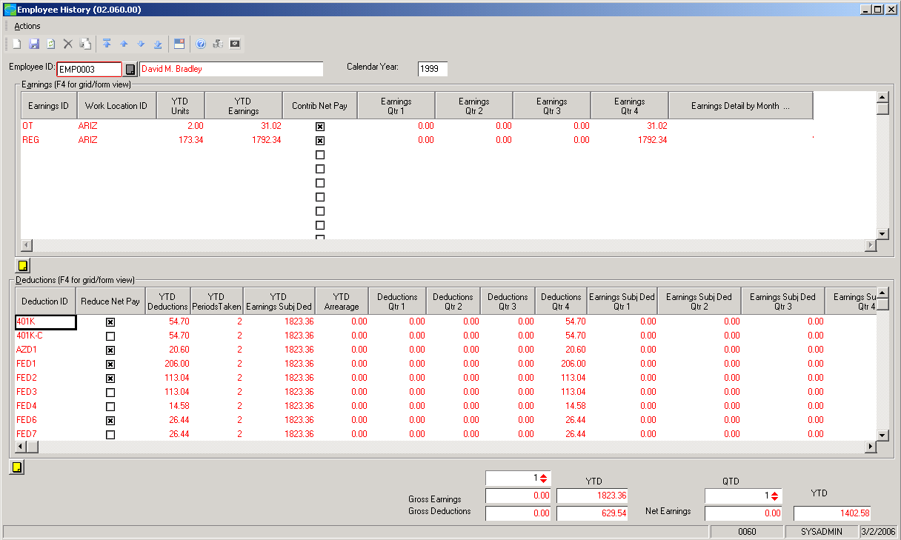
Maintain
earnings and deductions on a monthly, quarterly, and yearly basis for easy lookup of employee status.

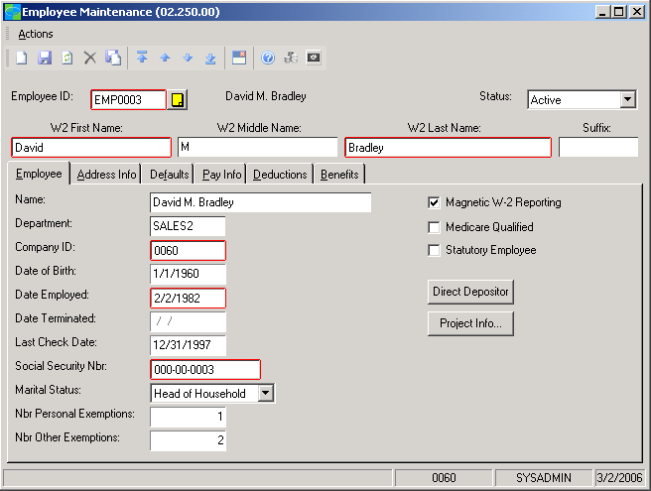

Designate
employees as active, on hold, or inactive, and define employee filing status as single, head of household, married/joint, or married/single.

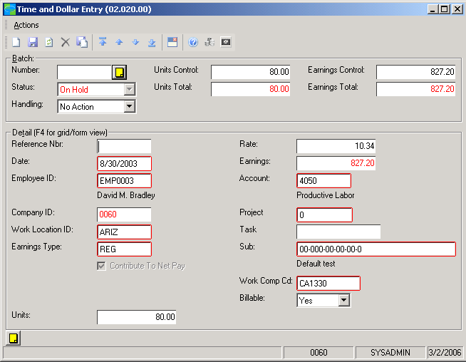

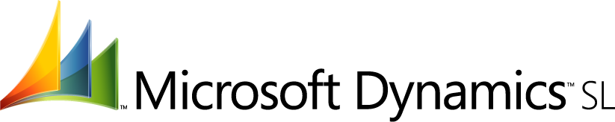
Enter data
in a time-oriented,
time-and-expense
mode.

Powerful Automation  FEATURES  BENEFITS | Instantly update project costs by sharing labor cost data with project accounting  data in Microsoft Dynamics SL. Benefits are calculated automatically based on  employee information.
Flexible Reporting | Work with a variety of standard reports, including: check preview, check  register, earnings and deductions, payroll transactions, benefits history,  check history, 941 quarterly federal tax form, unemployment tax form,  and W-2 forms.
Efficient Payment Tracking | Reconcile checks accurately within Microsoft Dynamics SL Payroll or through  integration with Microsoft Dynamics SL Cash Manager.
Direct Deposit | Deposit net pay directly into as many as five distribution bank accounts  per employee, in addition to a main account.
Tax Table Updates | Prepare accurate reports that meet federal regulations by importing tax  tables to update your database with the latest federal and state changes.
Accurate Refund Handling | Process payroll refunds in the event that payroll deductions are too high.  Make expense reimbursements to deal with situations like reducing a  deduction amount after the calculation has occurred.
Multi-Task Allotment | Charge the wages for employees who work multiple tasks during a pay  period to the correct accounts automatically. Allocate earnings to any  number of expense accounts or sub-accounts based on earnings type or  by employee.
Multi-Company Support | Pay employees of subsidiary companies and charge payroll expenses,  wages and earnings to the company where the work was performed.
Third-Party Payments | Manage deductions requiring payment to a third party. Liability  vouchering allows for deductions such as child support or student loan  repayment to be automatically sent to Accounts Payable for processing  and check creation.
Net Checks | Specify payroll items – such as bonuses or employee advances – as net  checks. Bonus checks can be specified as gross checks and disbursed to  individuals or groups. Tax deductions are automatically calculated to  arrive at a net amount.
401k Loan Repayment | Record the amount of a loan and schedule regular deductions from the  employee’s paycheck until the full amount of the loan is repaid.
Deduction Consolidation | Employ flexible deduction scheduling for items such as monthly parking  fees or union dues, when they are deducted on a different schedule from  other payroll deductions, so that they can be included in regular payroll  processing.
For more information about Microsoft Dynamics™ SL, visit: http://www.microsoft.com/dynamics/sl

This document is for information purposes only.
MICROSOFT MAKES NO WARRANTIES, EXPRESS, IMPLIED, OR STATUTORY, AS TO THE INFORMATION IN THIS DOCUMENT.

© 2005 Microsoft Corporation. All rights reserved.
Microsoft, The Microsoft Dynamics Logo, are either registered trademarks or trademarks of Microsoft Corporation or Microsoft Business Solutions ApS in the United States and/or other countries. Microsoft Business Solutions ApS is a subsidiary of Microsoft Corporation.

