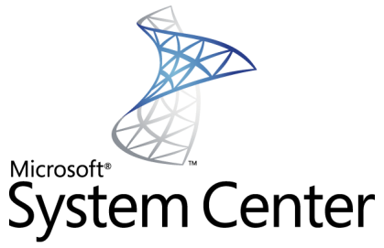

Virtual Application Management with   
Microsoft Application Virtualization 4.5 and System Center Configuration Manager 2007 R2

White Paper Descriptor

This whitepaper describes the virtual application management capabilities provided by the integration of Microsoft System Center Application Virtualization 4.5 and Microsoft System Center Configuration Manager 2007 R2.

Copyright © 2008 MICROSOFT CORPORATION

Introduction 5

Audience 5

Prior Knowledge 5

Configuration Manager and Application Virtualization Infrastructure Overview 6

Overview of Configuration Manager and Application Virtualization Integration 7

Application Virtualization Client-Side Architecture 8

Features Gained or Lost by Integration of Configuration Manager and Application Virtualization 9

New or Improved Features 9

Lost or Reduced Features 9

Configuration Manager and Application Virtualization Software Requirements 10

Required Software Components 10

Configuration Manager, Intel vPro and Application Virtualization 11

Configuration Manager Asset Intelligence and Application Virtualization 11

Configuration Manager Virtual Application Delivery Methods 12

Streaming Delivery 12

Streaming Delivery Process 13

Distribution Point Selection Process 14

Advantages of Streaming Delivery 15

Disadvantages of Streaming Delivery 15

Local Delivery (Download and Execute) 16

Local Delivery Process 16

Advantages of Local Delivery 17

Disadvantages of Local Delivery 17

Weighing the Impact of Streaming Delivery vs. Local Delivery for Virtual Application Deployment 18

Supported Scenarios for Virtual Application Deployment with Configuration Manager and Application Virtualization 18

Scenario 1 18

Scenario 2 19

Scenario 3 19

Roaming Client Scenarios 20

Package Coexistence Scenario 23

Internet-Based Scenarios 24

Planning for Virtual Application Deployment with Configuration Manager 24

Disk Space Considerations for Distribution Point Servers and Clients 24

Recommended Disk Space Allocation for the Configuration Manager and Application Virtualization Client Caches 25

Migration from Application Virtualization Full Infrastructure or Stand-alone MSI to Configuration Manager 26

Virtual Application Delivery to Terminal Servers 27

How to Perform Common Virtual Application Management Tasks with Configuration Manager 27

Deploy the Application Virtualization Client Software to Configuration Manager Client PCs 27

Configure Configuration Manager Distribution Point Servers and Client to Enable Virtual Application Deployment 29

Deploy a Virtual Application to Configuration Manager Clients 33

Verify Virtual Application Delivery to a Specific Client 34

Report Virtual Application Deployment Data 35

Upgrade a Previously Deployed Virtual Application 35

Delete a Virtual Application from All Members of a Collection or a Specific Client 36

Distribute Virtual Application Packages Using a Configuration Manager Task Sequence 36

Track Virtual Application Usage with Configuration Manager Metering 36

Application Virtualization Tools Installed with Configuration Manager R2 37

AppVirtMgmtClient.sms – Package Definition File 37

AppVirtMgmtSequencer.sms – Package Definition File 37

ManageVAppPackage.vbs – Script File 37

SetRetensionRules.vbs – Script File 37

Troubleshooting 38

New Configuration Manager Client Log Files 38

New Configuration Manager Client Status Messages for Virtual Application Registration and Launch 38

Application Virtualization Client Log Files and Event Log Entries 41

Troubleshooting Configuration Manager Virtual Application Package Content Distribution 41

Frequently Asked Questions (FAQ) 43

Package Creation / Update 43

Content Distribution 43

Virtual Application Package Registration (execution of the Configuration Manager advertisement) 44

Application Virtualization Dynamic Suite Composition 44

Application Virtualization Local Interaction 44

Miscellaneous 45

Glossary 47

Conclusion 47

More Information 48

*System Center Configuration Manager 2007 R2 Help File* 48

# Introduction

Microsoft System Center Configuration Manager 2007 R2 is the solution to comprehensively assess, deploy, and update your servers, clients, and devices across physical, virtual, distributed, and mobile environments. Optimized for Windows Vista and Windows Server 2008, it is the best choice for centralizing management from the datacenter to the desktop. The System Center Configuration Manager 2007 R2 release includes key enhancements in application virtualization management, client status reporting, operating system (OS) deployment, SQL reporting services integration, and Forefront Client Security reporting integration.

Microsoft Application Virtualization (Application Virtualization) transforms applications into centrally-managed virtual services that are never installed and do not conflict with other applications. Application Virtualization dramatically accelerates application deployment, upgrades, patching and retirement by eliminating time-consuming processes and simplifying the application management lifecycle.

Application Virtualization 4.5 fully integrates with Microsoft System Center Configuration Manager 2007 R2. Through seamless integration to the Software Distribution capability, customers can easily deploy virtual applications through the Configuration Manager infrastructure and scale their deployments throughout the enterprise, both as fully streamed virtual applications, or as locally delivered packages. This paper discusses the integration of System Center Configuration Manager R2 and Microsoft Application Virtualization 4.5, including supported scenarios, best practices, deployment planning considerations, and how to perform common virtual application management tasks with Configuration Manager R2.

NOTE: Throughout this document, the term “Configuration Manager” is used to refer to Microsoft System Center Configuration Manager 2007 R2, and the term “Application Virtualization” is used to refer to Microsoft Application Virtualization 4.5.

## Audience

This document is intended for IT administrators that are interested in using Configuration Manager to deploy virtualized applications to client PCs. This document provides a technical overview of the integration of Configuration Manager 2007 R2 and Application Virtualization 4.5, and describes how to configure and use a Configuration Manager infrastructure to deploy virtual applications.

## Prior Knowledge

The administrator using this guide should have previous knowledge of the following technologies:

* System Center Configuration Manager 2007
* Microsoft Application Virtualization
* Internet Information Server (IIS)

## Configuration Manager and Application Virtualization Infrastructure Overview

illustrates the minimal Configuration Manager and Application Virtualization components required to manage virtual applications with Configuration Manager.

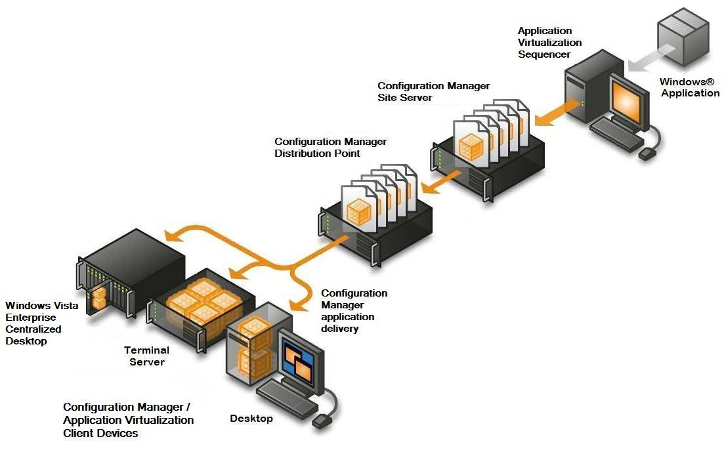

Figure 1 – Configuration Manager and Application Virtualization Infrastructure

A Configuration Manager + Application Virtualization infrastructure is comprised of the following components:

**Microsoft Application Virtualization Sequencer** – The Application Virtualization Sequencer ‘program’ is used to package virtual applications for deployment with Configuration Manager.

**Configuration Manager Site Server** – A part of the Configuration Manager Site hierarchy, the Configuration Manager Site Server manages virtual application distribution through Configuration Manager Distribution Points to target systems, either as a streaming service, or as a locally delivered package.

**Configuration Manager Distribution Point (Distribution Point)** – Configuration ManagerDistribution Point site roles provide management services such as hardware and software inventory, operating system deployment, and software updates, as well as software distribution of both physical and virtual applications, to Configuration Manager target systems (often referred to as ‘clients’).

**Configuration Manager / Application Virtualization Clients** – Client devices include desktop/laptop PCs, terminal servers and Windows Vista Enterprise Centralized Desktop (VECD) clients.Configuration Manager Clients that receive delivery of virtual applications from a Configuration Manager infrastructure require both the Configuration ManagerAdvanced Client and Application Virtualization Client software to be installed and configured. The Configuration Manager and Application Virtualization Client software work together to deliver, interpret and launch virtual application packages. The Configuration Manager Client manages the delivery of virtual application packages to the Application Virtualization Client. The Application Virtualization Client executes the virtual application on the client PC.

# Overview of Configuration Manager and Application Virtualization Integration

This section describes the integration of Configuration Manager R2 and Application Virtualization 4.5.

Configuration Manager includes capabilities to integrate with Application Virtualization out-of-the box. Configuration Manager uses only publicly documented interfaces to interact with the Application Virtualization Client software. All integration is implemented with the following methods:

* Configuration Manager uses the Application Virtualization Client's enhanced SFTMIME command line interface to manage virtual application publishing and delivery to the Application Virtualization Client cache.
* Configuration Manager uses the Application Virtualization Client’s new OverrideURL registry value to direct the Application Virtualization Client to retrieve application packages from a specific Distribution Point server.
* Configuration Manager uses the Application Virtualization Client’s SFTTRAY command line interface to launch virtual applications.
* Configuration Manager uses the Application Virtualization Client's Windows Management Instrumentation (WMI) provider to query and report on the status of virtual applications that reside in the Application Virtualization Client cache. For more information about WMI, see  
  <http://www.microsoft.com/technet/scriptcenter/resources/wmifaq.mspx>
* Standard Configuration Manager metering rules and reports must be manually configured in Configuration Manager to track virtual application usage.

## Application Virtualization Client-Side Architecture

shows a high-level overview of the new Application Virtualization 4.5 client-side architecture and illustrates communication paths between the Configuration Manager Client and the Application Virtualization Client.

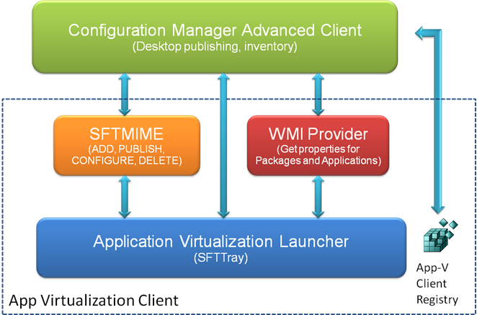

Figure 2 – Application Virtualization Client-Side Architecture

The Application Virtualization 4.5 Desktop and Terminal Services Clients have been enhanced with the following new features to support integration with Configuration Manager and third-party solutions:

* New Application Virtualization Client SFTMIME command line interface options provide greater external control of the operation of the Application Virtualization Client.
* A new OverrideURL Application Virtualization Client registry value has been added to direct it to retrieve application packages from an alternate server location regardless of the source path information contained within virtual application packages or the ASR (Application Source Root) registry setting.
* A new Application Virtualization Client WMI provider has been added to enable any WMI-enabled application to perform WMI queries to retrieve information about the status of virtual applications residing in the Application Virtualization Client cache.
* The Application Virtualization Client now includes support for streaming application packages via HTTP, HTTPS and Server Messages Block (SMB) network protocols.

The Configuration Manager Advanced Client has been enhanced with the addition of new client agents and a new virtual application launcher process to support virtual application management.

The integrated operation of the Configuration Manager Client and Application Virtualization Client is explained in detail later in this document.

## Features Gained or Lost by Integration of Configuration Manager and Application Virtualization

### New or Improved Features

* Scalability - By leveraging Configuration Distribution Points for hosting the virtual application package content, this removes the need to deploy and maintain a large number of standalone Application Virtualization 4.5 streaming servers. The Configuration Manager Distribution Points can be used for both streaming and local delivery scenarios.
* Explicit targeting and scheduling - Configuration Manager provides the ability to target systems or users with a collection of management capabilities, including virtual applications. Depending on the customer’s Active Directory infrastructure, computer targeting of virtual application delivery can be a huge benefit verses user targeting.

### Lost or Reduced Features

* Manage shortcuts & file type associations (FTAs) through an Admin user interface – It is necessary to use the Application Virtualization Sequencer to modify the package and redistribute it through Configuration Manager to change the location of the shortcuts or change the file type associations.
* Active upgrade – With an Application Virtualization full infrastructure, Application Virtualization servers will automatically stream a newer version of a package to the client when the application is restarted. With the integration with Configuration Manager, the Configuration Manager Client must first re-execute the advertisement for the updated package in order to stream the new version of the package. While this may appear to be lost functionality, it enables a Configuration Manager administrator to advertise different versions of a virtual application package to different collections, which is not possible with an Application Virtualization full infrastructure. This ‘re-advertisement’ will occur through traditional client polling intervals set within the Configuration Manager environment.
* When the Application Virtualization Client is managed by Configuration Manager, no simultaneous interoperability with an Application Virtualization server is possible. Any virtual applications not distributed by Configuration Manager are automatically removed from the clients. Management of virtual applications with Configuration Manager is exclusive of other methods of virtual application delivery with Application Virtualization 4.5.

When a Configuration Manager Site is enabled to manage virtual applications, all delivery and management of virtual applications on client PCs that are assigned to that Configuration Manager Site must be performed by Configuration Manager from that point forward.

**NOTE: When Configuration Manager takes control of the virtual application delivery to client PCs, any virtual applications that have been previously delivered to those client PCs using delivery methods other than Configuration Manager will be removed from the client PCs.**

* Reporting of virtual application distribution and usage is limited to the capabilities described in this document. Depending on which Configuration Manager virtual application delivery method is chosen, some options limit reporting further compared to the reporting features that are provided by a full Application Virtualization 4.5 infrastructure. For example: when using local delivery (download and execute), it is not possible to report on how many times an application has been used, only that it has been used and the “last launch date.”

See the section of this document for a description of the Application Virtualization-related tools that are installed with Configuration Manager R2.

# Configuration Manager and Application Virtualization Software Requirements

## Required Software Components

* A healthy Configuration Manager infrastructure – It is critical to ensure that the customer’s Configuration Manager infrastructure is healthy before enabling Configuration Manager’s virtual application management features.
* lists the minimum Configuration Manager infrastructure components required for virtual application management with Configuration Manager.

|  |  |
| --- | --- |
| **Component** | **Description** |
| Primary Site | A Configuration Manager Primary Site with Configuration Manager 2007 SP1 + Configuration Manager 2007 R2 installed |
| Site Server | A Configuration Manager Site Server configured with the following site server roles: Site System, Site Server, Component Server, Distribution Point, Fallback Status Point, Management Point and Reporting Point |
| Distribution Point Servers | One or more standard Distribution Point servers or Branch Distribution Point servers. The use of a Branch Distribution Point requires at least one standard Distribution Point |
| Clients | One or more Configuration Manager Client PCs |

Table 1 – Minimum Required Configuration Manager Components

* lists the minimum Application Virtualization 4.5 infrastructure components required for virtual application management with Configuration Manager R2.

|  |  |  |
| --- | --- | --- |
| **Component** | **Description** | **Version** |
| Application Virtualization Sequencer | Required to sequence applications | 4.5.0.1485 or later |
| Application Virtualization Client for Windows Desktops | Required to run virtual applications on desktop and laptop PCs | 4.5.0.1485 or later |
| Application Virtualization Client for Terminal Services | Required to run virtual applications on Windows Terminal Servers | 4.5.0.1485 or later |

Table 2 – Minimum Required Application Virtualization Components

## Configuration Manager, Intel vPro and Application Virtualization

* Configuration Manager Service Pack 1 (released before R2) provides integration with Intel’s vPro technology, which hardware manufacturers are including in many client PC platforms. The Intel vPro chipset enables a number of core scenarios for Configuration Manager to remotely configure and manage clients. Included in these scenarios is the ability to remotely power-on a provisioned system to deliver a new application or update an existing application. This feature of Configuration Manager requires client PCs that include the Intel vPro chipset hardware.
* For more information on Configuration Manager Integration with Intel vPro enabled PC see <http://download.microsoft.com/download/7/0/D/70DB0231-57E7-4CA1-A835-84840779A1D3/Configuration_Manager_SP1_and_Intel_datasheet.pdf>.

## Configuration Manager Asset Intelligence and Application Virtualization

* The Asset Intelligence features of Configuration Manager 2007 R2 can report application data (i.e., digital PID, MSI product codes, publisher names, etc.) for each virtual application that has been registered on a client computer.

NOTE: Only applications that have at least feature block 1 in the Application Virtualization Client cache can be inventoried. For more information on Asset Intelligence in Configuration Manager see <http://technet.microsoft.com/en-us/library/cc161988.aspx>

NOTE: It is not currently possible to inventory a virtual application with Configuration Manager Asset Intelligence reports when the same version of that application is locally installed on the client PC. The inventory data for the locally installed version of the application will overwrite the inventory data for the virtual version of the application in the inventory.

# Configuration Manager Virtual Application Delivery Methods

Configuration Manager supports two methods for delivery of virtual applications to clients: streaming delivery and local delivery (download and execute). This section describes these delivery methods.

Sequenced application packages contain a fully pre-configured run-time environment for the virtualized application. The application installation process occurs only on the Application Virtualization Sequencer workstation during the packaging process. Any system reboots that would normally occur during the application installation process are intercepted and handled programmatically by the Sequencer program. When a virtual application is delivered to a client PC, the application is ready to run. No application software installation, client PC reboot or post-installation application configuration is required when delivering a virtual application to client PCs. This significantly reduces the time required to deliver a virtual application to a client PCs verses the time that is required to deliver a non-virtualized (i.e., locally installed) application to a client PC. This benefit is independent of the Configuration Manager application delivery method (i.e., streaming or local delivery) that is used to deliver the application to client PCs.

## Streaming Delivery

When managed by Configuration Manager, the Application Virtualization Client supports streaming virtual applications via HTTP or HTTPS from a Configuration Manager standard Distribution Point server or streaming via SMB from a Configuration Manager Branch Distribution Point. When streaming from a standard Distribution Point, HTTP is used when the Configuration Manager site is operating in mixed mode and HTTPS is used when the Configuration Manager site is operating in native mode.

NOTE: Before a Distribution Point can be used to stream virtual applications to clients, the Distribution Point must first be enabled to stream applications. See the section of this document for instructions describing how to enable Distribution Point servers for application streaming.

### Streaming Delivery Process

illustrates the virtual application steaming delivery process from end to end.

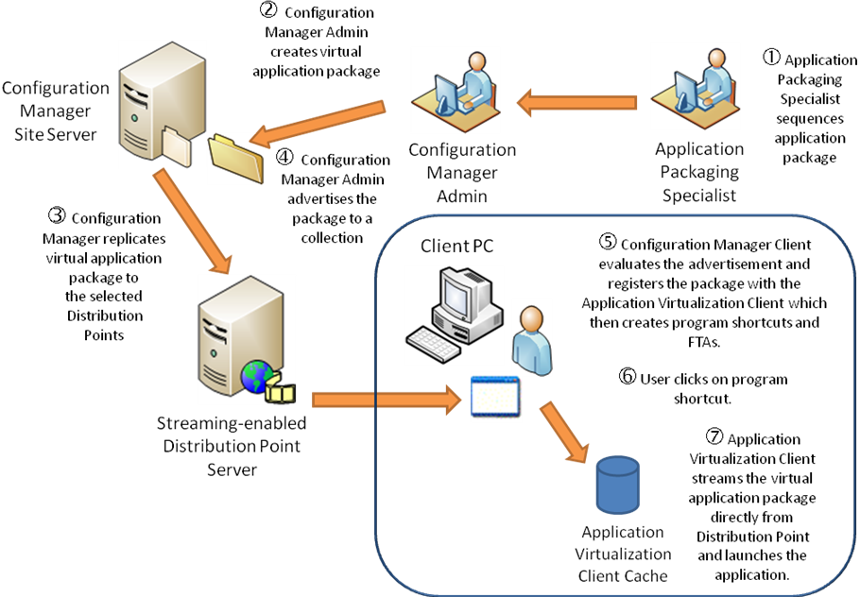

Figure 3 – Streaming Application Delivery Process

1. An application packaging specialist sequences an application and saves the new virtual application package to the Application Virtualization Content Source directory. The Application Virtualization Content Source directory is a network share that contains sequenced application packages.
2. The Configuration Manager administrator creates a virtual application package. To create the new virtual application package, the Configuration Manager administrator runs the Configuration Manager *New Virtual Application Package Wizard*.

The *New Virtual Application Package Wizard* copies the sequenced application package from the   
Application Virtualization content source location to the site server and generates a Configuration Manager application ID for the new package.

1. The Configuration Manager administrator selects the Distribution Point servers (in the *New Virtual Application Package Wizard*) to which he wants to distribute the new virtual application package. The *New Virtual Application Package Wizard* Configuration Manager replicates the virtual application package to the selected Distribution Point servers.

For more information on the *New Virtual Application Package Wizard* see<http://technet.microsoft.com/en-us/library/cc161975.aspx>

1. The Configuration Manager administrator creates an advertisement targeting the new virtual application package to a collection of client PCs or users using streaming delivery.
2. The Configuration Manager Client evaluates the advertisement and registers the new application package with the Application Virtualization Client. The Application Virtualization Client creates program shortcuts and FTAs for each program in included in the package.

NOTE: The Application Virtualization Client will not stream the new application package until the user clicks on one of the program shortcuts associated with the new package.

1. The user clicks on one of the program shortcuts associated with the virtual application package.
2. The Application Virtualization Client streams the blocks of the virtual application package that are required to launch the program (i.e., Feature Block 1) into the Application Virtualization Client cache directly from a Configuration Manager Distribution Point Distribution Pont or Branch Distribution Point. Which Distribution Point server is used for streaming is determined by the current location of the Configuration Manager Client and the policies contained in the advertisement for the virtual application package.

After Feature Block 1 is streamed into the Application Virtualization Client cache, the application is launched and presented to the user. By default, any additional blocks are streamed in the background until the package is fully cached. This ensures that all features of the application are available when the client system is offline.

### Distribution Point Selection Process

illustrates the Distribution Point selection process that occurs whenever a virtual application is launched on a client PC.

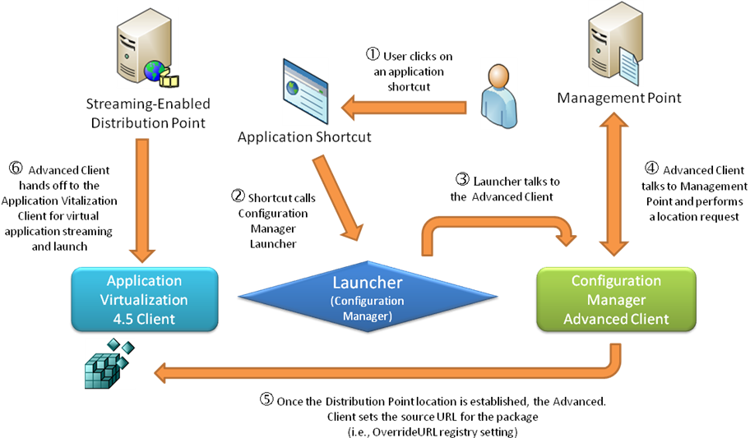

Figure 4 – Streaming Application Delivery to a Client PC

1. The user clicks on one of the program shortcuts associated with a virtual application package.

NOTE: All program shortcuts for virtual application packages are linked to a new “Launcher” program that is included in the Configuration Manager R2 Client.

1. The shortcut runs the Launcher program.
2. The Launcher program sends a request to the Configuration Manager Client to poll the Management Point for the location of the virtual application package.
3. The Configuration Manager Client polls the Management Point to determine which Distribution Point should be used to stream the application package and the location of the SFT on the Distribution Point.
4. The Configuration Manager Client sets the Application Virtualization Client’s OverrideURL registry value with the explicit path to the SFT file for that application package on the selected Distribution Point.
5. The Configuration Manager Client calls the Application Virtualization Client’s Application Virtualization Launcher program (sfttray.exe) to launch the virtual application. At this point, the Configuration Manager Client has effectively handed off the virtual application launch to the Application Virtualization Client and is no longer involved. The Application Virtualization Client then streams and launches the application.

### Advantages of Streaming Delivery

* Uses well-known network protocols to stream package content from Distribution Points.
* Program shortcuts for virtual applications invoke a connection to the server so the virtual application can be delivered on demand.
* Works well for clients with high-bandwidth connections to the Distribution Point servers.
* Virtual Application updates are applied at the server. The client connects to the new version on the server fast and streams the updates seamlessly.
* Access permissions can be defined on the Distribution Point to prevent user from accessing unauthorized applications/packages.

### Disadvantages of Streaming Delivery

* Requires a minimum of two copies of the SFT file on the distribution point.
* Configuration Manager Streaming Delivery (i.e., streaming a virtual application from a Distribution Point to a client PC) requires LAN (Local Area Network) speed network connectivity between the Configuration Manager Distribution Point servers and client PCs. Streaming delivery is not supported for unreliable network connections or offline scenarios. This should not be confused with streaming a virtual application from removable media (i.e., CD) which is also not supported with Configuration Manager virtual application management.
* With streaming delivery, a virtual application is not streamed until the user launches the application for the first time. When using streaming delivery, it is possible for a user to receive program shortcuts for virtual applications and then unplug from the network before launching the virtual applications for the first time. If the user tries to launch the virtual application while the client is offline, the user will receive an error and will not be able to launch the virtualized application because a Configuration Manager Distribution Point server is not available to stream the application. The application will be unavailable until the user reconnects the client to the network and launches the application. This scenario can result in a negative user experience. This issue can be avoided by using the local delivery method for virtual application delivery to clients.

This limitation, along with the lack of support for Configuration Manager application streaming delivery for Internet-facing scenarios, caused the Microsoft IT organization to decide to use Configuration Manager Local Delivery for virtual application delivery throughout Microsoft.

* Not supported for “Internet-facing” scenarios.

## Local Delivery (Download and Execute)

The Configuration Manager Client also supports local delivery of virtual applications. With this delivery method, the Configuration Manager Client first downloads the entire virtual application package into the Configuration Manager Client cache and then directs the Application Virtualization Client to stream the SFT file from the Configuration Manager cache into the Application Virtualization cache.

### Local Delivery Process

illustrates the virtual local delivery (download and execute) process.

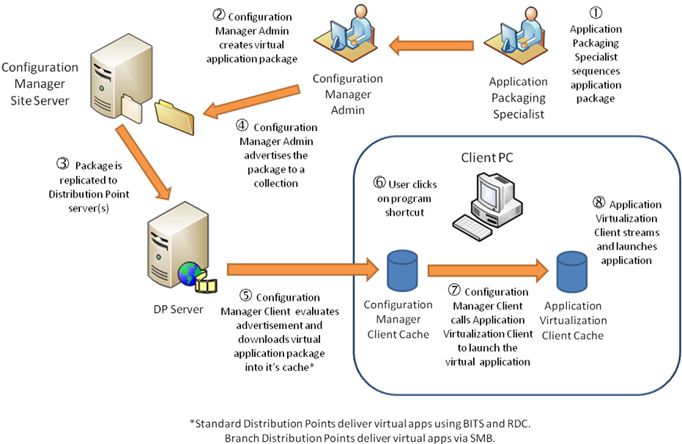

Figure 5 – Download and Execute Delivery from Distribution Point Server

1. An application packaging specialist sequences an application and saves the new virtual application package to the Application Virtualization Content Source directory.
2. The Configuration Manager administrator creates a virtual application package. To create the new virtual application package, the Configuration Manager administrator runs the Configuration Manager *New Virtual Application Package Wizard*.

The *New Virtual Application Package Wizard* copies the sequenced application package from the Application Virtualization content source location to the site server and generates a Configuration Manager application ID for the new package.

1. The Configuration Manager administrator selects the Distribution Point servers (in the *New Virtual Application Package Wizard)* that he wants to distribute the new virtual application package to. The *New Virtual Application Package Wizard* replicates the new package to the selected Distribution Point servers.
2. The Configuration Manager administrator creates an advertisement targeting the new virtual application package to a collection of client PCs (or users) using local delivery.
3. The Configuration Manager Client evaluates the advertisements and registers the new application package with the Application Virtualization Client. The Application Virtualization Client creates program shortcuts and FTAs for each program in included in the package.
4. The user clicks on one of the program shortcuts associated with the virtual application package.
5. The Configuration Manager Client Launcher program runs and calls the Application Virtualization Client to launch the application.
6. The Application Virtualization Client streams the SFT file from the Configuration Manager Client cache into the Application Virtualization cache and launches the application. After a successful launch of the application, the Configuration Manager Launcher deletes any older versions of the package that exist in the Configuration Manager Client cache.

### Advantages of Local Delivery

* Standard distribution point functionality is used to efficiently download the package using Background Intelligent Transfer Service (BITS). The execute function is virtual application aware and is used to instruct the Application Virtualization to publish the application (i.e., create program shortcuts and FTAs).
* Virtual application package contents are delivered locally to the client enabling off-line operation.
* Virtual application program shortcuts refer to a local copy of the virtual application which resides in the Configuration Manager Client cache. No server connection is required.
* Great for unreliable/slow network connections and occasionally connected clients.
* Remote Differential Compression (RDC) is a data transfer method that optimizes data transmission over the network. Configuration Manager uses RDC to send only the portions of files that have changed to clients when virtual application package content is updated. The Configuration Manager Client uses RDC to build a new version of a virtual application package based on the current version of the package and the changes that are sent to the client.
* Application resiliency for mobile/disconnected users. Once the SFT is downloaded, it remains locked in the Configuration Manager Client cache as long as the virtual application remains advertized. The SFT in the Configuration Manager Client cache effectively serves as a local, reliable streaming source for the Application Virtualization Client to pull the SFT into its cache.   
  The Application Virtualization Client GUI’s application maintenance functions (i.e., load, unload, clear, repair, etc.) still work as expected, even when operating offline.
* The Distribution Points do not need to be enabled for streaming in order to use this delivery method.

### Disadvantages of Local Delivery

* Disk space equaling up to three times the size of the virtual application package (SFT file size) is required on the client when the package is fully loaded in cache.
  + One copy of the SFT file resides in the Configuration Manager cache and remains locked in the Configuration Manager Client cache as long as the advertisement that delivered the application to the client exists.
  + Another copy of the SFT file resides in the Application Virtualization Client cache.
  + A third temporary copy is created on the client while RDC calculates differential deltas for an application upgrade or downgrade and the most recent version of the SFT file is created.

## Weighing the Impact of Streaming Delivery vs. Local Delivery for Virtual Application Deployment

When deciding which Configuration Manager virtual application delivery method to use, it is necessary to weigh the increased network bandwidth and increased server disk space on Distribution Point servers that is required for Streaming Delivery verses the increased client disk space for the Configuration Manager and Application Virtualization Client caches that is required for local delivery. The increased client disk space required for local delivery is typically less expensive than the impact to network bandwidth and the increased server disk space required for Streaming Delivery.

# Supported Scenarios for Virtual Application Deployment with Configuration Manager and Application Virtualization

lists the virtual application deployment scenarios that are possible with Configuration Manager and indicates which virtual application delivery methods are supported for each scenario.

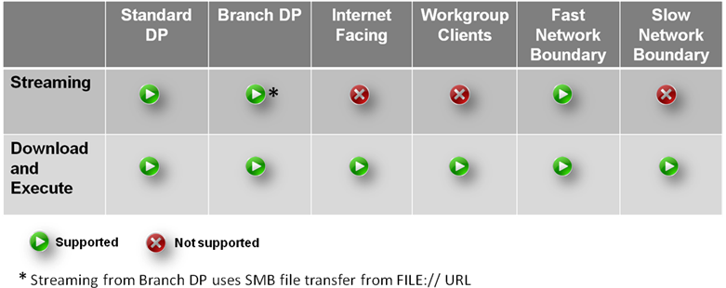

Table 3 – Supported Delivery Methods and Scenarios

Examples of typical scenarios for virtual application deployment that are supported with Configuration Manager and Application Virtualization follow:

## Scenario 1

**Business Scenario**

Customer wants to deploy virtual application to many locations and many users by leveraging the scalability of Configuration Manager. Also, the customer does not want to deploy SQL servers at each location and maintain separate databases for an Application Virtualization full infrastructure.

**Solution Description**

Configuration Manager provides application publishing and delivery to all clients. IIS server software is deployed to Configuration Manager Distribution Point servers, and clients stream virtual application package content from the Configuration Manager Distribution Point servers.

**Virtual Application Package Delivery Method**

* Virtual application package streaming from Configuration Manager standard Distribution Point server(s) running IIS.

**Streaming Protocols Used**

* HTTP is used when Configuration Manager is operating in mixed mode.
* HTTPS is used when Configuration Manager is operating in native mode.

**Components Needed**

* IIS server software on Configuration Manager Distribution Point servers for streaming functionality.
* Configuration Manager for virtual application publication policy delivery to clients and delivery of content to the Distribution Point server(s) running IIS.

## Scenario 2

**Business Scenario**

Customer does not have server-class hardware in branch office locations and wants to deliver virtual applications to client PCs located in the branch offices using Configuration Manager streaming delivery method.

**Solution Description**

A non-server class PC located in each branch office is configured to be a Branch Distribution Point via the Configuration Manager Admin Console. When a PC is designated as a Branch Distribution Point, a file share is automatically created on a designated branch Distribution Point. Configuration Manager pushes virtual application packages to the Branch Distribution Point via BITS. Configuration Manager delivers virtual application package publishing policies to the clients. Configuration Manager automatically sets the OverrideURL registry value on clients to cause them to file stream from the Branch Distribution Point.

**Virtual Application Package Delivery Method**

* Streaming delivery from Configuration Manager Branch Distribution Point servers to clients.

**Streaming Protocols Used**

* Server Message Block (SMB).

**Components Needed**

* File server for streaming functionality.
* Configuration Manager for virtual application publication policy delivery to clients and delivery of content to the file server(s).

## Scenario 3

**Business Scenario**

Customer does not have server-class hardware in branch office locations and wants to deliver virtual applications to client PCs located in the branch offices using Configuration Manager’s local delivery method.

**Solution Description**

On policy activation, the virtual application package content (i.e., SFT, ICO, OSD files, etc.) is downloaded to the client’s local Configuration Manager Client cache using BITS. Once the package has been fully downloaded to the Configuration Manager Client cache, Configuration Manager will publish the application to the desktop. When the application is launched, the Application Virtualization Client streams the SFT file from the local Configuration Manager Client cache to the Application Virtualization Client cache.

**Virtual Application Package Delivery Method**

* Local delivery (virtual application package download and execute)

**Streaming Protocols Used**

* Server Message Block (SMB).

**Components Needed**

* Free disk space on the client PCs to accommodate full copies of the SFT file in the Configuration Manager Client cache and the Application Virtualization Client cache.

## Roaming Client Scenarios

**Business Scenario**

A client PC travels between sites that have different speeds of network connections (i.e., fast verses low speed) between the Distribution Point server and the client. The customer wants to deliver virtual applications to the roaming client PC regardless of its current location.

**Solution Description**

1. Setup Configuration Manager network boundaries to reflect the network connection speed (i.e., fast verses slow) between the client and Distribution Points at each location.

For more information on Planning Configuration Manager Network Boundaries see   
<http://technet.microsoft.com/en-us/library/bb632910.aspx>

1. Configure Configuration Manager software distribution advertisements to use the desired application delivery method (i.e., streaming delivery or download and execute). The following screen shot shows the Distribution Points tab of a virtual application advertisement.  The selected options will cause the package to be streamed to the client whenever the client is located within a Configuration Manager fast network boundary, or download and execute the application whenever the client in located within a slow network boundary.

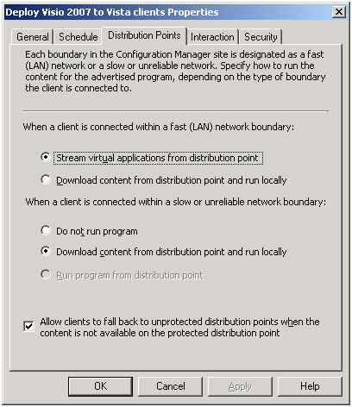

Figure 6 – Configuration Manager Virtual Application Advertisement Properties

To use local delivery (download and execute) for the application regardless of the network connection speed, select the “When a client is connected within a fast (LAN) network boundary 🡪 Download content from a distribution point and run locally” radio button on the Distribution Points tab of the advertisement properties window.

For more information on advertising virtual applications see  
<http://technet.microsoft.com/en-us/library/cc161935.aspx>

For more information on client roaming in Configuration Manager see  
<http://technet.microsoft.com/en-us/library/bb632476.aspx>

**Roaming Scenario Example**

This example assumes the following Configuration Manager setup:

1. Network boundaries have been properly configured to reflect the network connections speeds between client PCs and Distribution Point servers.
2. An advertisement (Advertisement-A) for a virtual application package (Package-A) has been created to deliver the application to client PCs residing within fast network boundaries using streaming delivery, and deliver the application using local delivery to client PCs residing within slow network boundaries. The advertisement targets the application delivery to a collection that includes Client-A.
3. Client-A is a mobile laptop PC.

Operation:

1. When Client-A resides in a location within a fast network boundary, the Configuration Manager Client pulls new policy from the management point (MP) and determines that it is within a fast network boundary.
2. Client-A streams Package-A via HTTP/ HTTPS from a Distribution Point server directly into the Application Virtualization Client cache.
3. The user then removes Client-A from the docking station and connects to the wireless network.
4. The Configuration Manager Client on Client-A pulls new policy from the management point (MP) and determines that it now resides within a slow network boundary.
5. The Configuration Manager Client then receives policy that it should now download and execute the new/updated version of Package A.
6. The Configuration Manager Client downloads the updated version of the SFT for Package-A into the Configuration Manager Client cache.
7. The Configuration Manager Client then changes the Application Virtualization Client’s OverrideURL for package A from an HTTP:// URL path to a Distribution Point server to the File:// local path of the new SFT file in the Configuration Manager Client cache.
8. The Application Virtualization Client does not flush existing package from Application Virtualization Client cache and streams the updated package (delta blocks) from the local file path specified by the OverrideURL registry value.

NOTE: Whenever the client resides within a fast network boundary, streaming delivery will be used to update Package-A whenever Client-A resides within a fast network boundary, and local delivery will be used to update Package-A whenever Client-A resides within a slow network boundary unless Advertisement-A is changed or removed.

lists supported variations to the roaming client scenario described above. Variations not listed in this table are not supported.

|  |  |  |
| --- | --- | --- |
| **Variation** | **Switch from this application source…** | **To this application source using OverrideURL registry value…** |
| 1 | Stream via SMB from file on local client drive. | Stream via SMB from file on a Branch Distribution Point. |
| 2 | Stream via SMB from file on a Branch Distribution Point. | Stream via SMB from file on local client drive. |
| 3 | Stream via HTTP/HTTPS from one Distribution Point. | Stream via HTTP/HTTPS from another Distribution Point.  *NOTE: For this scenario to work, the same package version must be distributed to both Distribution Point servers.* |
| 4 | Stream via SMB from file on local client drive. | Stream via HTTP/HTTPS from a Distribution Point. |
| 5 | Stream via SMB from file on a Branch Distribution Point. | Stream via HTTP/HTTPS from a Distribution Point. |
| 6 | Stream via HTTP/HTTPS from a Distribution Point. | Stream via SMB from file on local client drive. |
| 7 | Stream via HTTP/HTTPS from a Distribution Point. | Stream via SMB from file on a Branch Distribution Point. |

Table 4 – Roaming Client Scenarios

### Package Coexistence Scenario

An Application Virtualization Client can run multiple virtual application packages that are being streamed from Configuration Manager Distribution Point servers via different protocols.  The protocols that are supported for this scenario are HTTP, HTTPS and SMB. For example, the following packages can be run on the same client PC:

* Package-A is streamed via HTTP or HTTPS to the client from a Configuration Manager Distribution Point.
* Package-B is streamed via SMB to the client from a Configuration Manager Branch Distribution Point using the download and execute delivery method.

In both examples noted above, Configuration Manager leverages the Application Virtualization Client’s OverrideURL registry value to direct the Application Virtualization Client to use the appropriate explicit path for each SFT file.

### Internet-Based Scenarios

Configuration Manager can be used to deploy virtual applications to Configuration Manager Internet-based clients. Configuration Manager Internet-Based Client Management (IBCM) only supports the local delivery method (i.e., download and execute) for all application delivery including virtual and non-virtual applications. All standard recommended practices for planning a Configuration Manager infrastructure to support Internet-based clients apply to virtual application deployment to Internet-based clients with Configuration Manager.

NOTE: Streaming virtual applications to Internet-based clients is not supported with Configuration Manager; however, streaming to Internet-based clients is supported with an Application Virtualization full infrastructure.

For more information on application deployment to Internet-based clients with Configuration Manager see <http://technet.microsoft.com/en-us/library/bb693755.aspx>.

# Planning for Virtual Application Deployment with Configuration Manager

## Disk Space Considerations for Distribution Point Servers and Clients

* Disk space requirements for local delivery (download and execute)
  + Disk space required on Distribution Point server to support local delivery of virtual application packages:
    - 1x SFT file size for the application package that is currently advertised for delivery to clients using local delivery.
  + Disk space required on client PCs for local delivery of virtual application packages:
    - Total peak disk space required on a client PC for delivery of a new virtual application package = 3 x SFT file size. This total includes the following:
      * 1x SFT file size to store a copy of the SFT file in the Configuration Manager Client cache.
      * 1x SFT file size to store a copy of the SFT file in the Application Virtualization Client cache.
      * 1x SFT file size to temporarily store a new version of the package on the client when an existing package is being updated. This space is needed while RDC (Remote Differential Compression) calculates the deltas and generates the new version of the SFT file.
* Disk space requirements Streaming Delivery
  + Disk space required on Distribution Point server when the Distribution Point is configured to enable streaming of virtual application packages:
    - Total peak disk space required on a Distribution Point server for distribution of a virtual application =
      * 1x SFT file size for the current version of the package.
      * 1x SFT file size for each version of streaming copy of the package.

Depending on how often the package is updated and how the retention rules are configured for the Distribution Point’s streaming store (the default maximum is two copies), there could be anywhere from one to ten copies of the SFT in the streaming store on the Distribution Point. The streaming store must maintain multiple versions of the package (one copy of the SFT for each version of the package).

* + - * 1x SFT file size for constructing the new version from the deltas.
    - The original package and the streaming copies all reside in the IIS virtual directory on the Distribution Point server.
  + Disk space required on client PCs for application packages using streaming delivery:
    - 1x SFT file size to store the contents of the SFT file in the Application Virtualization Client cache.

## Recommended Disk Space Allocation for the Configuration Manager and Application Virtualization Client Caches

* Disk space for a full copy of the SFT file is required in the Application Virtualization Client cache even if the client only streams Feature Block 1 into cache. This is because the Application Virtualization 4.5 Client pre-allocates space for the entire SFT file before it begins to stream the application. This behavior is intentional and is intended to improve the reliability of the Application Virtualization Client.
* The disk space allocation settings for the Configuration Manager Client cache and Application Virtualization Client cache should be configured as follows to limit the risk of locking out the Configuration Manager Client cache due to a low disk space condition on the client which would affect the ability of Configuration Manager to deploy critical security patches to the client:
  + The disk space allocation for the Configuration Manager Client cache should be set to a maximum size that will provide sufficient space for a full copy of all virtual application packages that will be deployed to the client. The Configuration Manager Client cache size can be set at install time or configured manually as follows:

1. **Open** the Control Panel 🡪 Configuration Manger Applet.
2. **Select** the Advanced tab.
3. **Click** the Configure Settings button.
4. **Adjust** the "Amount of disk space to use (MB)" slider to the desired value.   
   For example: to set the Configuration Manager Client cache size to 4 GB,   
   enter 4192.
5. **Click** OK.
   * The Application Virtualization Client cache free disk space threshold parameter should be set to ensure that the available disk space on the client PC is at least 1 GB larger than the Configuration Manager Client cache size. For example, if the Configuration Manager Client cache size is set to 4 GB, set the Application Virtualization Client cache to ensure that at least 5 GB of free disk space is available before the Application Virtualization Client cache is allowed to grow. The Application Virtualization Client cache MINFREESPACEMB parameter can be set at install time or configured manually as follows:
6. **Select** Start 🡪 Programs 🡪 Administrative Tools 🡪 Application Virtualization Client.
7. The Application Virtualization Client Management Console will appear.
8. **Select** Action 🡪 Properties from the menu bar.
9. **Select** the File System tab.
10. **Select** “Use free disk space threshold”.
11. **Enter** the desired value for "Minimum free space (MB)" parameter.   
    For example: to set the free disk space threshold to 5 GB, enter 5120.
12. **Click** OK.
13. **Close** the Application Virtualization Client Management Console.

NOTE: There is additional impact to overall client PC disk space with cache management as disk space is not recovered, even when a user or administrator removes virtual application data. The space is available to, and reserved for, the Application Virtualization Client, but not recovered for the user. This can be an area of concern regarding user experience as users are typically used to removing unneeded files and programs when they get low on disk space. This doesn’t carry over with virtual applications as removing them has no impact on the available disk space on the client PC.

For a detailed description of the Application Virtualization Client installer command line options see <http://technet.microsoft.com/en-us/library/cc843737.aspx>.

For information about Configuration Manager Client installation properties see   
<http://technet.microsoft.com/en-us/library/cc843737.aspx>.

## Migration from Application Virtualization Full Infrastructure or Stand-alone MSI to Configuration Manager

This section lists the steps required to migrate from an existing Application Virtualization 4.5 full infrastructure or stand-alone Application Virtualization 4.5 MSI deployment to application virtualization management with Configuration Manager.

1. **Import** existing Application Virtualization virtual application packages into Configuration Manager.
2. **Create** Configuration Manager collections and advertisements that will be used to target virtual application delivery to clients.
3. **Enable** Configuration Manager and Application Virtualization 4.5 integration through the Advertised Programs Client Agent.

NOTE: This action causes Configuration Manager to take control of the Application Virtualization Client on the Configuration Manager Client PC. **This will cause the Configuration Manager Advanced clients to remove ALL previously deployed virtual application packages** **(published through an Application Virtualization Full Infrastructure or stand-alone MSI).** This is accomplished by purging the Application Virtualization Client cache and removing any existing Application Virtualization Client references to Application Virtualization Management Servers. If no applications have been published (i.e., advertised) to a specific client, then no virtual applications will be available on that client until virtual applications are advertized to that client.

1. Configuration Manager virtual application advertisements and client policies are evaluated and the advertised virtual applications are re-deployed to clients via Configuration Manager.

NOTE: It is not necessary to re-sequence all existing virtual application packages to deploy them with Configuration Manager; however, if the package was created with an earlier version of the Sequencer (i.e., prior to version 4.5) each virtual application package must be opened with the Application Virtualization 4.5 Sequencer program and saved. This is necessary to create the Application Virtualization 4.5 mainifest.xml file that is required for virtual application deployment with Configuration Manager.

Virtual application packages created with the SoftGrid 4.1 or 4.2 versions of the Sequencer are fully supported with Application Virtualization 4.5. Virtual application packages created with the SoftGrid 3.x or 4.0 versions of the Sequencer are expected to work with 4.5; however, some applications created with pre-4.1 versions of the Sequencer may need to be re-sequenced with the Application Virtualization 4.5 Sequencer.

For more information on how to manage virtual application packages see  
<http://technet.microsoft.com/en-us/library/cc161843.aspx>

# Virtual Application Delivery to Terminal Servers

There is one unavoidable restriction that must be considered when using Configuration Manager to target virtual application delivery to terminal servers. The Configuration Manager Client only allows software distribution to the console session of a terminal server system (i.e., mstsc.exe /console). Therefore, if virtual application delivery is targeted to users with an advertisement and those users are using a remote session on the terminal services system, they will not be able to execute the advertisement. This restriction applies to all types of software distribution with Configuration Manager, not just virtual applications. After the user logs on to the console session and executes the advertisement for a virtual application, the user can then execute the virtual app from any type of session (remote or console).

The recommended practice for application delivery to terminal servers is to target the terminal server system (not users) with mandatory advertisements. In this situation, the advertisement executes even when no one is logged in and the applications will to be available for all users that log into the system remotely.

# How to Perform Common Virtual Application Management Tasks with Configuration Manager

## Deploy the Application Virtualization Client Software to Configuration Manager Client PCs

This section describes how to use the Configuration Manager package definition file (AppVirtMgmtClient.sms) that is provided with Configuration Manager R2 to simplify distribution of the Application Virtualization Client software to client PCs.

* Obtain the Application Virtualization Client software from Microsoft (i.e., download the MDOP 2008 R2 software form the Microsoft Volume Licensing Services web site) and extract the Application Virtualization Client software into a source directory. This directory should include the following Application Virtualization Client assets:
* AppVReadme.htm file
* Setup.exe file
* Setup.msi file
* Support subdirectory containing the Dr Watson 2.0 redistributable (dw20shared.msi)
* Customize the AppVirtMgmtClient.sms package definition file to suit your Application Virtualization Client installation requirements.

Before proceeding to the next step to create the software distribution package, edit the AppVirtMgmtClient.sms package definition file and add/change the command line options   
for the setup.exe program to customize the Application Virtualization Client installation options.

The default command line provided in the AppVirtMgmtClient.sms file follows:

COMMANDLINE=setup.exe /s /v"/quiet /norestart /qn"0\"\"

The above command line performs a silent installation of the Application Virtualization Client software with all of the default values and suppresses the client PC reboot.

NOTE: Because the Application Virtualization Client includes a virtual filesystem driver, it is necessary to reboot the client PC when upgrading the Application Virtualization Client. However, a reboot is not required for installation of the Application Virtualization Client on a client PC that does not already include the Application Virtualization Client software.

An example modification of the AppVirtMgmtClient.sms package definition file to set the   
Application Virtualization Client growth options, is to change the command line in the AppVirtMgmtClient.sms file as follows:

setup.exe /s /v"/quiet /norestart **MINFREESPACEMB=\"5120\"** **/qb**"0\"\"

NOTE: MINFREESPACEMB=”5120” causes the Application Virtualization Client to ensure that at least 5 GB   
(5120 MB) of free disk space is available on the client PC before allowing the size of the cache to increase. It is currently necessary to change the /qn command line switch to /qb to allow the MINFREESPACEMB option to take effect. This causes the installation to run unattended with a basic user interface rather than invisibly with no user interface.

NOTE: The examples provided in this section are based on Microsoft IT organization’s experience with Configuration Manager 2007 R2 and Application Virtualization 4.5. Each customer’s disk space requirements for the Configuration Manager and Application Virtualization Client caches will vary depending on the number and size of virtual application packages that are distributed to client PCs.

For a detailed description of the Application Virtualization Client installer command line options see <http://technet.microsoft.com/en-us/library/cc843737.aspx>.

* Use the AppVirtMgmtClient.sms to create a Configuration Manager software distribution package for the Application Virtualization Client software as follows:
  1. In the Configuration Manager Admin Console, **navigate** to System Center Configuration Manager 🡪 Site Database 🡪 Computer Management 🡪 Software Distribution.
  2. **Right-click** on Packages, **point** to New, and then **click** Package from Definition.
  3. The *Create Package from Definition Wizard will appear.*
  4. For Welcome, **click** Next.
  5. For Package Definition, **click** Browse… and **navigate** to the AppVirtMgmtClient.sms package definition file.

NOTE: The default location of the AppVirtMgmtClient.sms file is C:\Program Files\ Microsoft Configuration Manager\Tools\VirtualApp\AppVirtMgmtClient.sms.

* 1. **Click** on the AppVirtMgmtClient.sms file and **click** Open.
  2. *Application Virtualization Desktop Client* should appear in the list of available package definitions.
  3. **Click** on *Application Virtualization Desktop Client* and **click** Next.
  4. **Select** Always obtain files from a source directory and **click** Next.
  5. **Select** Network path (UNC path) or Local drive on site server.
  6. **Click** Browse…, navigate to the source directory where you extracted the installation files for the Application Virtualization Client software, **click** OK.
  7. **Click** Next and **click** Finish.

For more information about the *Create Package from Definition Wizard*, see <http://technet.microsoft.com/en-us/library/bb633299.aspx>.

* Advertise the Application Virtualization Client package to one or more collections of client PCs.

For details on how to create advertisements, see   
<http://technet.microsoft.com/en-us/library/bb693497.aspx>.

## Configure Configuration Manager Distribution Point Servers and Client to Enable Virtual Application Deployment

1. Enable Standard Distribution Point server(s) to Deliver Virtual Applications to Configuration Manager Clients
2. **Install** the BITS and IIS Server software on all Configuration Manager standard Distribution Point servers that you plan to use for delivery of virtual applications.
3. **Configure** the standard Distribution Point server(s) to enable virtual application delivery as follows:
   1. In the Configuration Manager Admin Console, **open** the properties of a specific standard Distribution Point server.
   2. On the General tab, **select** “Communication Settings 🡪 Allow clients to transfer content from this distribution point using BITS, HTTP, and HTTPS”.

The following screen shot highlights the setting described above:

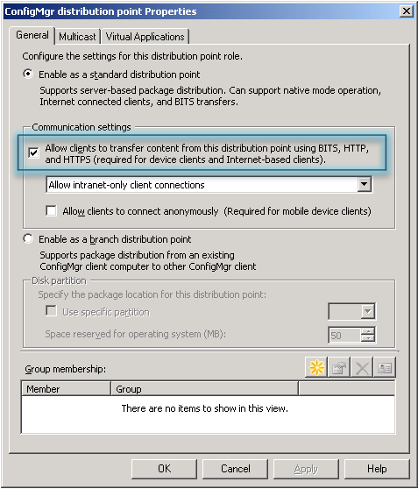

Figure 7 – Configuration Manager Admin Console Distribution Point Properties

* 1. If streaming delivery will be used with this Distribution Point, on the Virtual Applications tab, **select** “Enable virtual application streaming.”

NOTE: If you plan to only use local delivery for virtual applications   
(i.e., no streaming delivery), then do not select this option. If you plan   
to use a combination of local delivery and streaming delivery for virtual applications, then do select this option.

The following screen shot highlights the setting described above:

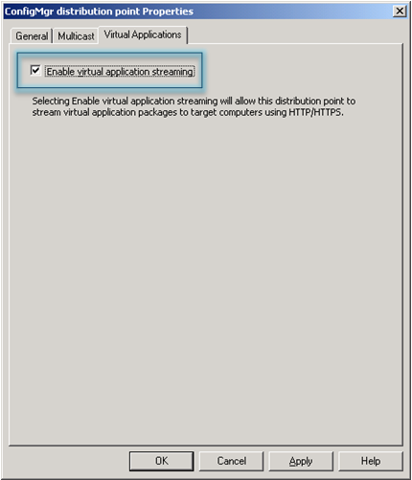

Figure 8 – Configuration Manager Admin Console Distribution Point Properties

1. Enable Branch Distribution Point server(s) to Stream Virtual Applications to Configuration Manager Clients
2. In the Configuration Manager Admin Console, **edit** the properties of a specific Branch Distribution Point.
3. On the Virtual Applications tab, **select** “Enable virtual application streaming.”

NOTE: If you plan to only use local delivery for virtual applications (i.e., no streaming delivery), then do not select this option. If you plan to use a combination of local delivery and streaming delivery for virtual applications, then do select this option.

The following screen shot highlights the setting described above:



Figure 9 – Configuration Manager Admin Console Distribution Point Properties

1. Enable Configuration Manager Clients to Evaluate Advertisements for Virtual Application Delivery

To enable Configuration Manager Clients to evaluate advertisements for virtual application delivery, the Configuration Manager Advertised Programs Client Agent must be configured to allow clients to execute virtual application package advertisements as follows:

1. In the Configuration Manager Admin Console, **open** the properties of the Advertised Programs Client Agent and **select** “Allow virtual application package advertisement.”

The following screen shot highlights the setting described above:

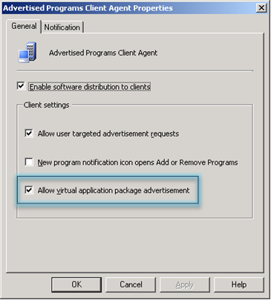

Figure 10 – Configuration Manager Admin Console Advertized Programs Client Agent Properties

IMPORTANT: This action gives Configuration Manager control of the Application Virtualization Client on the Configuration Manager Client PC.   
**This will cause the Configuration Manager Advanced clients to remove ALL previously deployed virtual application packages (published through an Application Virtualization full infrastructure or stand-alone MSI).** This is accomplished by purging the Application Virtualization Client cache and removing any existing Application Virtualization Client references to Application Virtualization Management Servers. If no applications have been published (i.e., advertised) to a specific client, then no virtual applications will be available on that client until virtual applications are advertised to that client.

## Deploy a Virtual Application to Configuration Manager Clients

1. **Sequence** an Application

A sequencing engineer uses the Application Virtualization Sequencer program to sequence an existing application and saves the new virtual application package to a specified content directory.

1. **Import** the Sequenced Application into Configuration Manager

To deploy a virtual application package to Configuration Manager Clients, the Configuration Manager administrator must first import a sequenced application package into Configuration Manager. Before importing a new sequenced application into Configuration Manager, source and destination directories should be created for the virtual application package. Any name can be assigned to the source and destination directories. The source directory should contain the sequenced application content created using the Application Virtualization Sequencer (SFT, OSD, Manifest, Icons, etc.).

1. **Create** a Configuration Manager Virtual Application Package

Use the *New Virtual Application Package Wizard* to specify the sequenced application source directory location and import the sequenced application into the Configuration Manager site.

The *New Virtual Application Package Wizard* is launched as follows:

* + 1. **Open** the Configuration Manager Admin Console
    2. **Expand** Site Database 🡪 Computer Management 🡪 Software Distribution
    3. **Right-click** on Packages and select New 🡪 Virtual Application Package
    4. The New Virtual Application Package Wizard will appear

More information about the *New Application Package Wizard* can be found at:

<http://technet.microsoft.com/en-us/library/cc161975.aspx>

1. **Distribute** Virtual Application Package to Specific Distribution Point/Branch Distribution Point Servers

After a virtual application package has been imported into Configuration Manager, the package must be replicated to the distribution points that will be used to deliver the virtual application package to clients. The Configuration Manager administrator chooses which distribution points the virtual application package will be sent to.

1. **Create** Collection(s) that will be used to target virtual application delivery to clients (or users)

Configuration Manager advertisements are targeted at collections. These can be collections of computers or users. Both user and machine-based targeting fully supported.

1. **Advertise** Virtual Application for Deployment to Configuration Manager Clients

After a virtual application package has been replicated to distribution points, it can be advertised to any Configuration Manager collection. When a virtualized application is advertised to a collection of client PCs, each target computer in a collection will receive the advertisement and all applications contained in the virtual application package. Configuration Manager Clients will use normal Configuration Manager Client polling methods to locate the advertisement.

Virtual application packages can be advertised by using the *New Advertisement* *Wizard* or the *Distribute Software Wizard*. Advertisements created using the *New Advertisement* *Wizard* can be used to deploy virtual application packages using the streaming or local delivery methods. The New Advertisement Wizard can specify things such as:

* The collection of client PCs (or users) to which the package should be delivered.
* The time at which the application should be delivered.
* Should the application delivery be mandatory or should the user(s) have an option to install or reject the package?
* When delivered, should the application be added as a streaming virtual application or a locally available virtual application (“Stream from Distribution Point” or “Download and Run”)
  + Stream from Distribution Point – SFT file is streamed from the distribution point.
  + Download and Run - the SFT file is downloaded to the Configuration Manager cache and then loaded locally into the Application Virtualization Client cache.
* Advertisements created using the *Distribute Software Wizard* can only be used to deploy virtual application packages using the local delivery method.

NOTE: It is not possible to create advertisements for streaming delivery using the Distribute Software Wizard.

For more information on the New Virtual Application Package Wizard see <http://technet.microsoft.com/en-us/library/cc161975.aspx>.

For more information on the Distribute Software Wizard see   
<http://technet.microsoft.com/en-us/library/bb694237.aspx>.

## Verify Virtual Application Delivery to a Specific Client

Delivery of a virtual application to client PCs can be accomplished by running a Configuration Manager report (see the next topic) or by manually testing the virtual application on the client as follows:

1. Logon to a client PC that is a member of a collection that you have targeted for delivery of a virtual application package.
2. Wait for the application advertisement to run on the client.
3. When the client PC evaluates the advertisement, it will create program shortcut(s) for the programs contained in the virtual application package on the Start Menu, Desktop and/or Quick Launch bar. If the virtual application package is advertised for local delivery, the SFT file will also be downloaded to the Configuration Manager and Application Virtualization Client caches.
4. Locate one of the program shortcuts for the virtual application on the client and click on the shortcut to launch the application.
5. Depending on the method used to deliver the application to the client, the application should immediately launch (local delivery), or stream and then launch (streaming delivery).

## Report Virtual Application Deployment Data

* Configuration Manager R2 includes the following built-in reports that can be used to report the status of virtual application distribution throughout the Configuration Manager hierarchy and virtual application delivery to Configuration Manager Clients:
* *All distribution points with virtual application streaming enabled*
* *All virtual application packages in the streaming store of a distribution point*
* *Computers with a specific virtual application*
* *Computers with a specific virtual application package*
* *Count of all instances of virtual application packages*
* *Count of all instances of virtual applications*
* *Streaming store distribution status of a specific virtual application package*
* *Virtual application launch failures for a specific application*
* *Virtual application launch failures for a specific computer*
* *Virtual application launch failures over a number of days*
* To list the available Configuration Manager Virtual Application Reports:

1. **Open** the Configuration Manager Admin Console.
2. **Expand** Site Database 🡪 Computer Management 🡪 Reporting 🡪 Reports.
3. The list of all available Configuration Manager reports will appear in the Reports pane.
4. In the Reports pane, in the Look for box, **type** the word virtual and **click** the Find Now button.
5. The Reports pane will display the list of available virtual application reports.

* To run a virtual application report:

1. **Right-click** on the name of the desired report in the Reports pane and select Run.
2. **Enter** any required report parameters as needed and click Display.
3. The results of the report will be displayed in a pop-up window.

## Upgrade a Previously Deployed Virtual Application

* Virtual application packages that have been deployed with Configuration Manager can easily be upgraded to include service packs, software updates, etc.
* To deploy multiple versions of the same application to different collections, it is necessary to create separate sequenced application packages (one for each version) and import them into Configuration Manager to create separate Configuration Manager virtual application packages with different Configuration Manager package IDs. This can be done using the Save As feature in the Sequencer program.
* When a virtual application package is updated, Configuration Manager evaluates the data source for the package and makes the necessary file updates to the advertised application.
* The updated package must be advertised again to Configuration Manager Clients and/or users in order for the users to use the updated applications in the package. Virtual application packages that have been deployed with Configuration Manager can be updated by using the Virtual Application Package Update Wizard or by editing the package source directory. Users must exit and restart the virtual application for the updated version to be available.

## Delete a Virtual Application from All Members of a Collection or a Specific Client

* Virtual applications do not need to be uninstalled like traditional software; they are simply and instantly removed from the client.
* To remove an application from a given client, all existing advertisements for that virtual application that are targeted at the given client must be deleted by the Configuration Manager administrator.
* Once an application is deleted from a client PC, it is also removed from the Application Virtualization Client cache.

## Distribute Virtual Application Packages Using a Configuration Manager Task Sequence

* Task sequences are used to automate procedures during operating system deployment with Configuration Manager. A Configuration Manager task sequence can be used to deploy virtual application packages.
* When using a Configuration Manager task sequence to deploy a virtual application package, you do not need to specify a program that will be associated with the package. The virtual application package contains a preconfigured virtual run-time environment including one or more applications.
* A virtual application package task sequence must be advertised to a collection of Configuration Manager Clients for the task sequenced to be executed.
* If the task sequence is advertised with a “download on demand” advertisement, a copy of the SFT file is not retained in the Configuration Manager Client cache. In this case, it’s necessary to disable (set to zero) the “RequireAuthorizationIfCached” registry setting on the Application Virtualization Client.

For more information on how to distribute virtual application packages using a task sequence see  
 <http://technet.microsoft.com/en-us/library/cc431389.aspx>

## Track Virtual Application Usage with Configuration Manager Metering

* Configuration Manager can track and report on virtual application usage using Configuration Manager’s built-in software metering features. The same application metering methods are used to track virtual and non-virtual applications with Configuration Manager. Tracking application usage with Configuration Manager requires the Configuration Manager administrator to set up metering rules to track execution of specific application programs contained within the application package.
* For Configuration Manager metering to work correctly, a restart of the client system is necessary after the Application Virtualization 4.5 Client is installed.

# Application Virtualization Tools Installed with Configuration Manager R2

This section describes the tools (scripts, templates, etc.) that are installed with Configuration Manager R2 to simplify management of virtual application packages. The default location of the Application Virtualization tools is the C:\Program Files\ Microsoft Configuration Manager\Tools\VirtualApp directory on a Configuration Manager R2 site server. The following Application Virtualization tools are included with Configuration Manager R2:

### AppVirtMgmtClient.sms – Package Definition File

The AppVirtMgmtClient.sms file is a Configuration Manager package definition file that should be used to create a Configuration Manager software distribution package to distribute the Application Virtualization Client software to client PCs. See the section of this document for details.

### AppVirtMgmtSequencer.sms – Package Definition File

The AppVirtMgmtSequencer.sms file is a Configuration Manager package definition file that can be used to install the Application Virtualization Sequencer into your Configuration Manager environment.

For more information about the *Create Package from Definition Wizard*, see <http://technet.microsoft.com/en-us/library/bb633299.aspx>.

### ManageVAppPackage.vbs – Script File

The ManageVAppPackage.vbs script can be used to automate the process of importing new virtual application packages and updating existing virtual application packages in Configuration Manager.

### SetRetensionRules.vbs – Script File

The SetRetentionRules.vbs script can be used to configure the retention rules for virtual application packages. This script can be used only on a primary Configuration Manager site. The retention rules for a virtual application package affect how long (i.e., how many days) virtual application package content remains on Distribution Point servers, as well as the maximum number of versions of the virtual application package that should be kept on Distribution Point servers.

For more information regarding these tools see the SMSv4AppVToolsReadme.htm file in the VirtualApp directory on a Configuration Manager R2 site server.

# Troubleshooting

### New Configuration Manager Client Log Files

The Configuration Manager R2 Advanced Client includes the following two new log files that are used to record virtual application-related status information:

* VirtualApp.log – Tracks virtual application registration and publishing
* VAppLauncer.log – Tracks virtual application launch by user

Check these log files for error messages when you are experiencing problems with virtual application registration (i.e., virtual application advertisements not working properly) or virtual application launch problems (i.e., clicking on a program shortcut for a virtual application does not launch the application or generates an error).

Details about the new status messages that are written to these log file are provided in the next section.

### New Configuration Manager Client Status Messages for Virtual Application Registration and Launch

The Configuration Manager R2 Advanced Client includes new client status messages to track virtual application registration and launch status. shows a screenshot of the SMS Trace log viewer program, which is displaying the contents of the new VirtualApp.log Configuration Manager Client log file with some of the new virtual application status messages highlighted.

The following screen shot shows the SMS Trace program displaying the contents of the Configuration Manager Client’s VirtualApp.log file with examples of the new status messages highlighted.

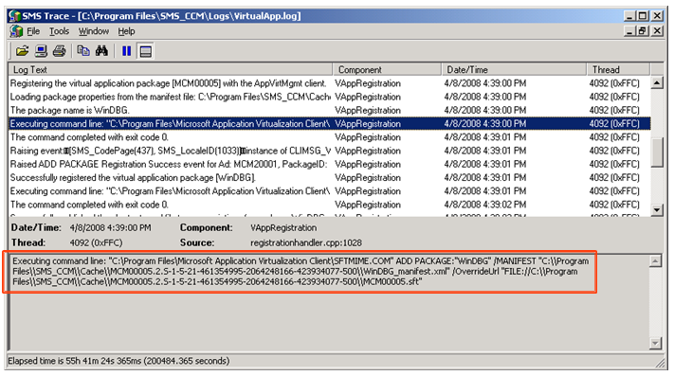

Figure 11 – New Configuration Manager R2 Client Status Messages

Following is the list of the new Configuration Manager R2 Client status messages for virtual application for virtual application registration and launch. In the new Configuration Manager R2 Client status messages, the abbreviations “SCCM” and “App-V” refer to Configuration Manager 2007 R2 and Application Virtualization 4.5 respectively.

***MessageID***12100

***Severity*** Informational

***Facility*** Application

***SymbolicName***CLIMSG_VIRTUALAPP_INFO_PACKAGEADD_SUCCESS

***Message Body***  
The virtual application package <*Package Name*> has been registered on the client successfully for advertisement <*Advertisement Name*>. [SCCM package ID = <Package ID>] [Virtual app package GUID = <*Application Virtualization Package GUID*>]

***Description***  
This client status message occurs when the advertisement for a virtual app package is successfully executed to register the package with the Application Virtualization Client.

***MessageID*** 12101

***Severity*** Error

***Facility*** Application

***SymbolicName*** CLIMSG_VIRTUALAPP_ERROR_PACKAGEADD_FAILURE

***Message***   
The virtual application package <*Package Name*> failed to register on the client for advertisement <*Advertisement Name*>. The error message is: [*<Error Message Text*>] and error code is: [*<Error* *Code>*]. [SCCM package ID = <Package ID>] [Virtual app package GUID = <*Application Virtualization Package GUID*>]

***Description***  
This client status message occurs when the advertisement for a virtual app package is fails to execute successfully.

***MessageID*** 12102

***Severity*** Informational

***Facility*** Application

***SymbolicName*** CLIMSG_VIRTUALAPP_INFO_PACKAGEADD_PENDING

***Message***   
The virtual application package <*Package Name*> is pending registration as the package is currently in use on the client. [Advertisement ID = <*Advertisement ID*>] [SCCM package ID = <Package ID>] [Virtual app package GUID = *<Application Virtualization Package GUID>*]

***Description***  
This client status message occurs when an existing virtual app package is updated and the update cannot be registered due to an application within the package being in use on the client.

***MessageID*** 12103

***Severity*** Informational

***Facility*** Application

**SymbolicName** CLIMSG_VIRTUALAPP_INFO_PACKAGEDELETE_SUCCESS

***Message***  
The virtual application package *<Package Name>* has been deleted from the client successfully. [SCCM package ID = *<Package ID>*] [Virtual app package GUID = *<Application Virtualization Package GUID>*]

***Description***  
This client status message occurs when a virtual app package is successfully deleted from the Application Virtualization Client.

***MessageID*** 12104

***Severity*** Error

***Facility*** Application

***SymbolicName*** CLIMSG_VIRTUALAPP_ERROR_PACKAGEDELETE_FAILURE

***Message***  
The virtual application package *<Package Name>* failed to be deleted from the client. The error message is: [*<Error Message>*] and error code is: [*<Error Code>*]. [SCCM package ID = *<Package ID>*] [Virtual app package GUID = *<Application Virtualization Package GUID>*]

***Description***  
This client status message occurs when a virtual app package fails to delete from the Application Virtualization Client (this does not occur if the application is in use).

***MessageID*** 12105

***Severity*** Informational

***Facility*** Application

***SymbolicName*** CLIMSG_VIRTUALAPP_INFO_PACKAGEDELETE_PENDING

***Message***  
The virtual application package *<Package Name>* is pending deletion, as the package is currently in use on the client. [SCCM package ID = *<Package ID>*] [Virtual app package GUID = *<Application Virtualization Package GUID>*]

***Description***  
This client status message occurs when an existing virtual app package is deleted but an application within the package is in use on the client.

***MessageID*** 12106

***Severity*** Error

***Facility*** Application

***SymbolicName*** CLIMSG_VIRTUALAPP_ERROR_LAUNCH_FAILURE

***Message***  
The virtual application *<Package Name>* failed to launch on the client. The error message is: *<Error Message>*] and error code is: [*<Error Code>*].

***Description***  
This client status message occurs when the Configuration Manager launcher (VappLauncher.exe) is used to start a virtual app and a failure occurs. The error code and error message are retrieved from the Application Virtualization Client.

### Application Virtualization Client Log Files and Event Log Entries

The Application Virtualization Client logs status information to a log file and the Application Event Log.

The default location for the Application Virtualization Client log file is:

**Windows XP** C:\Documents and Settings\All Users\Application Data\Microsoft\Application Virtualization Client

**Windows Vista** C:\ProgramData\Microsoft\Application Virtualization Client

Application Virtualization Client error codes are comprised of 16 digits organized as two groups of 8 digits separated by a hyphen (e.g., 19006D2A-0000274D). The Application Virtualization error codes will be logged to the sftlog.txt log file and the Application event log on the client PC. Depending on how the Application Virtualization Client is configured, the error message and error code may also appear in the Application Virtualization Client status bar located above the Windows System tray area.

When diagnosing an Application Virtualization Client error, try looking up the last 10 digits of the error code, including the hyphen (e.g., 2A-0000274D) in the Application Virtualization support TechNet database at <http://technet.microsoft.com/en-us/appvirtualization/default.aspx>.

Check the TechNet Application Virtualization Community Forum discussion groups to see if anyone has experienced a similar issue and posted a resolution at  
<http://forums.microsoft.com/TechNet/default.aspx?ForumGroupID=497&SiteID=17>

### Troubleshooting Configuration Manager Virtual Application Package Content Distribution

#### **How Configuration Manager Creates the Streaming Store of Virtual Application SFT Files**

When a virtual application is deployed to a Configuration Manager Distribution Point, and that Distribution Point has the "Enable virtual application streaming" setting selected, Configuration Manger will create a streaming copy of an SFT file on that Distribution Point. The streaming copy of the SFT file is saved under x:\SMSPKGx$\VirtualAppStreaming\PackageID\VersionGUID, where x is the drive letter that holds the SMS share. VersionGUID is the version GUID for the virtual application package.

#### **When Configuration Manager Creates the Streaming Store of Virtual Application SFT Files**

When you deploy a virtual application package to a streaming-enabled Distribution Point or when you select "Enable virtual application streaming" setting for a Distribution Point, Configuration Manager walks through all existing virtual applications already deployed to that Distribution Point, and creates streaming copies of SFT files for the virtual applications.

#### **When Configuration Manager Deletes the Streaming Store of Virtual Application SFT Files**

* When you remove a streaming-enabled Distribution Point from a virtual application (i.e., the application package’s list of Distribution Point servers to distribute the package to), Configuration Manager deletes the streaming and non-streaming copies of the SFT file for that application package on that Distribution Point.
* When you delete a virtual application package from Configuration Manager, Configuration Manager deletes the streaming and non-streaming copies of the SFT file for that application package from all assigned Distribution Points.
* When you disable the setting "enable virtual application streaming" for a Distribution Point, Configuration Manager loops all existing virtual applications already deployed to this Distribution Point, and deletes streaming copy of SFT files, but keeps the regular copy of packages on the Distribution Point.

#### **How Configuration Manager Maintains the Streaming Store Using Retention Rules**

For the same virtual application package, each version of that package has a unique Version GUID. The Version GUID can be found in the manifest.xml file of each version of the package. Whenever you re-save the virtual application package in the Application Virtualization Sequencer, the Sequencer program generates a new version GUID for that version of the package.

Configuration Manager has a retention rule that controls the deletion of old versions of SFT files when a newer version SFT file is distributed to a Distribution Point. The Retention Rule includes two parameters: Transition Days and Maximum Versions. By default, Transition Days = 7, and Maximum Versions = 2. The default values cause Configuration Manager to always retain the latest two versions of the SFT files, and also retain all versions added in last seven days. Following are three examples to clarify how the retention rule works:

**Example #1:** Assume there are only two versions of an SFT file on a Distribution Point; one was added 10 days ago and one was added today. In this case, Configuration Manager will retain both SFT files in the streaming store of the Distribution Point.

**Example #2:** Assume there are three versions of an SFT file on a Distribution Point and all were added in last seven days. In this case, Configuration Manager will retain all of them in the streaming store of the Distribution Point.

**Example #3:** Assume there are three versions of an SFT file on a Distribution Point; one is added 10 days ago, one is added eight days ago, and one is added today. In this case, Configuration Manager will retain the last two versions (i.e., the SFT versions added today and added eight days ago) in the streaming store of the Distribution Point.

When you create a virtual application package version 1 and deploy it to a Distribution Point, Configuration Manager will create a folder named VersionGUIDOfV1 in the streaming store of the Distribution Point and copy the SFT file into it. Each time a new version of a package is distributed to   
a Distribution Point, the Configuration Manager creates a new streaming store folder for the new package version (i.e., VersionGUIDOfV2, VersionGUIDOfV3, etc.) on the Distribution Point and copies the new version of the SFT into the streaming store folder.

Each time a new version of the SFT file is distributed to the Distribution Point, Configuration Manager checks the retention rule to determine if it needs to delete an older version: If the default values of the retention rule are in effect (i.e., Transition Days = 7 and Maximum Versions = 2). If version 1 of the SFT file was added earlier than seven days ago when version 3 is distributed to the Distribution Point, Configuration Manager will delete the VersionGUIDOfV1 folder in the streaming store.

To change the default retention rule, you can use the SetRetentionRules.vbs script that is installed on Configuration Manager R2 site servers. For more information about this script, see the section of this document.

#### **How to Troubleshoot Configuration Manager Streaming Store Issues**

On a Standard Distribution Point server, check the distmgr.log file. On a Branch Distribution Point server, check the peerDPAgent.log file. Look for status messages related to *streaming store*.

Additional troubleshooting related information is included in the FAQ section.

# Frequently Asked Questions (FAQ)

### Package Creation / Update

**Q:** Can I create a virtual app package from a regular package source (i.e., Setup.exe or MSI-based setup)?

**A:** No. A virtual app package can only be imported from the source created from the Application Virtualization 4.5 Sequencer. A regular package source (i.e., Setup.exe or MSI-based setup) can be used to install the application package on the Sequencer workstation during the sequencing process.

**Q:** Why can't I see any programs defined under a virtual application package in the Configuration Manager Admin Console?

**A:** A virtual application package doesn't have a program in the traditional sense. The installation "program" for every virtual app package is the same. The application programs contained in a virtual app package can be viewed in the Virtual Applications tab of the package properties.

**Q:** How do I apply a patch to an existing virtual application package?

**A:** First, the Application Virtualization 4.5 Sequencer must be used to upgrade a virtual application package as follows:

1. **Copy** the existing virtual application package to a clean Sequencer workstation.
2. **Launch** the Sequencer program and **open** the virtual application package for upgrade.
3. **Install** the desired application updates.
4. **Save** the new version of thepackage.
5. **Open** the Configuration Manager Admin Console to update the existing package as follows:
6. **Expand** Site Database 🡪 Computer Management 🡪 Software Distribution 🡪 Package
7. **Right-click** on the package that you want to update and **select** "Update Package."
8. The *Virtual Application Package Update Wizard* will appear.
9. **Use** the *Virtual Application Package Update Wizard* to import the updated version of the sequenced application package.

For more information on the *Virtual Application Package Update Wizard* see <http://technet.microsoft.com/en-us/library/cc431457.aspx>.

### Content Distribution

**Q:** What is the purpose of the virtual application streaming store on Configuration Manager Distribution Point servers?

**A:** When a Distribution Point server has been enabled for streaming virtual application packages, the Distribution Manager creates a streaming "store" for any virtual app packages that are hosted on that Distribution Point. The streaming store is used to ensure that the Application Virtualization Clients can access the virtual application package content at all times. Without the streaming store, virtual applications would potentially crash without warning when the package is updated on the Distribution Point server.

### Virtual Application Package Registration (execution of the Configuration Manager advertisement)

**Q:** Why can't I see any shortcuts for the virtual application after running an advertisement for a virtual application package with no visible errors?

**A:** The likely cause is that the virtual application package is not applicable to the OS where the advertisement ran. Examine the OSD file(s) in the sequenced application source location to verify that the targeted client's OS is listed there. For example, client OS is Vista but .OSD does not have   
<OS VALUE="WinVista"/> in the .OSD file. The Application Virtualization Client's sftlog.txt will have the error code rc=07708844-00000007 when this occurs.

### Application Virtualization Dynamic Suite Composition

**Q:** What is Dynamic Suite Composition (DSC) and can I use this with virtual applications in Configuration Manager 2007 R2?

**A:** Dynamic Suite Composition (DSC) is the ability to define one virtual app package as having a dependency on another virtual application package. In order to enable this, the OSD file for an application in the primary package must be modified to reference the package GUID of the dependent package. When the application is launched, the Application Virtualization Client will host both the primary package and the dependent package in the same virtual environment for the application.

In order to use this with Configuration Manager 2007 R2, both packages must be advertised and registered with the Application Virtualization Client. It's recommended that dependent packages be delivered to the client via local delivery (download and execute) advertisement so that the dependant package content is hosted locally on the client system.

For the latest information and recommendations for Dynamic Suite Composition see the following:

Application Virtualization Sequencing Guide document   
<http://technet.microsoft.com/en-us/appvirtualization/cc843994.aspx>.

The Official Application Virtualization Blog  
<http://blogs.technet.com/softgrid/default.aspx>

The Virtual World Blog   
<http://blogs.technet.com/virtualworld/default.aspx>

### Application Virtualization Local Interaction

**Q:** What is Application Virtualization Local Interaction and can I use this with virtual applications in Configuration Manager 2007 R2?

**A:** In some application deployment scenarios, some applications are installed locally on client PCs and other applications are deployed as virtual applications to the same client PC. By default, locally installed applications cannot see or communicate directly with virtualized applications. This is intended behavior of the application isolation that is provided by Application Virtualization. Local Interaction is a feature of the Application Virtualization Client that can be enabled on a per application basis to allow locally installed applications running on a client PC to see and communicate with virtualized applications. Local Interaction is fully supported with Configuration Manager R2 and Application Virtualization 4.5.

For more information about the Application Virtualization Local Interaction feature, see  
<http://blogs.technet.com/softgrid/archive/2007/09/20/a-look-under-the-covers-the-local-interaction-allowed-tag.aspx>

### Miscellaneous

**Q:** Is it a supported scenario to pre-cache applications to a client PC using Configuration Manager R2 and then create a snapshot image of that PC and use that image for OS deployment to other client PCs?

**A:** Yes this is a supported scenario.

The only potential issue that we are currently aware of is related to updating the virtual applications that are included in the client PC image after the image has been deployed to the client PC. If the virtual application packages that are pre-loaded in the client PC image were created on a site different than the site that is later used to update them, binary delta replication would not be used on the client to pull down the updated package. This may be confusing so an example follows:

1. The OneNote 2007 application is sequenced as a virtual application.
2. It is imported to site ABC and distributed via the Local Delivery (download & execute) method to the client that will be used to create the OS image (i.e., the Gold Master PC). The application is executed once on the Gold Master PC to ensure that is loaded into the Application Virtualization Client cache. The Configuration Manager package ID for OneNote is ABC00003.
3. The client image is captured and deployed through the Configuration Manger hierarchy. The OneNote virtual application works fine when launched on client PCs that are built from the image.
4. Later, the OneNote package is updated using the Application Virtualization Sequencer and imported into site XYZ. The Configuration Manager package ID is XYZ0000A (although the Application Virtualization package GUID has not changed).
5. The clients that receive an advertisement for the updated OneNote package (XYZ0000A) will not be able to leverage binary delta replication when downloading the content because the Configuration Manager Client will look for a previous version of the XYZ0000A package which is not in the Configuration Manager Client cache. The problem would occur whether the applications were pre-cached as part of the image or delivered via two different sites. This should not impact the user experience other than taking longer to get the updated package downloaded to the client. It is important to ensure that the client PC that is used to create the gold master image receives the same packages that will later be updated in the production Configuration Manager hierarchy (the actual assigned site doesn't matter).

**Q:** Why is package content in the Configuration Manager cache not reclaimed (i.e., deleted) when it is unpinned from the cache?

**A:** Unpinned content in the Configuration Manager cache must be "tombstoned" for 24 hours before it will be deleted by the Configuration Manager Client to make room for additional package content. If the tombstoned cache is within 24 hours from creation time (default value of CacheTombstoneContentMinDuration), Configuration Manager will not remove it even though there is not enough cache free space.

The list of possible workarounds follows:

1. Increase the default size of Configuration Manager Client cache (default 2GB) to accommodate new content.
2. Reduce the duration of MinTombstoneDuration by modifying the site control file directly.
3. Check the Cache percentage in WMI and DeleteCacheElementEx with true as 2nd parameter (force deletion) if 100% cached in Application Virtualization cache.

**Q:** Is it possible to sequence the Configuration Manager Admin Console?

**A:** Yes. For details on sequencing the Microsoft System Center Configuration Manager Admin Console see <http://blogs.technet.com/softgrid/archive/2008/05/21/sequencing-the-microsoft-system-center-configuration-manager-admin-console.aspx>.

**Q:** Does Configuration Manager R2 provide Desired Configuration Management (DCM) support for virtual applications?

**A:** No. However, DCM can be used to track the configuration compliance for the Application Virtualization Client software.

**Q:** Is it possible to perform a phased migration from an Application Virtualization standalone or Application Virtualization full infrastructure to Configuration Manager virtual application management?

**A:** No. Migration to Configuration Manager virtual application management is an all-or-nothing switch. If a client PC includes the Configuration Manager Client and the Application Virtualization Client when virtual application management is enabled in the Configuration Manager Advertised Programs Client Agent, then Configuration Manager will assume exclusive control of the Application Virtualization Client. All virtual application packages residing in the Application Virtualization Client cache will be automatically removed and only Configuration Manager will be able to deliver virtual applications to the client PC. All other Application Virtualization Client application delivery methods are no longer available. All virtual application packages must be redeployed with Configuration Manager before they can continue to be used. Existing virtual application data and user preference settings are preserved when the migration to Configuration Manager virtual application management occurs.

A recommended practice is to queue up all your virtual application packages and advertisements in Configuration Manager before initiating the migration to Configuration Manager virtual application management, to make the transition quicker for end users.

# Glossary

The following terms are used to describe virtual application packages and the components of virtual application packages.

**Microsoft Application Virtualization Platform**

The name for the Microsoft products used to create, store, distribute, and run sequenced applications.

**Application Virtualization Streaming Enabled Distribution Point**

A Configuration Manager Distribution Point that has been enabled to stream virtual application packages to Configuration Manager Clients.

**Microsoft Application Virtualization Desktop Client**

An application that resides on a Configuration Manager Client computer and communicates and authenticates with the Configuration Manager site to receive the virtual application package and allows a sequenced application to be run locally.

**Microsoft Application Virtualization Terminal Services Client**

An application that resides on a Terminal Server and communicates and authenticates with the Configuration Manager site to receive the virtual application package and allows a sequenced application to be run locally.

**Sequenced Application**

An application that has been created by the Microsoft Application Virtualization Sequencer, streamed to a computer running the Microsoft Application Virtualization Terminal Services Client or the Microsoft Application Virtualization Desktop Client, and that can run inside of its own virtual environment.

**Sequencing**

The process of creating an application package by using the Application Virtualization Sequencer. In this process, an application is monitored, its shortcuts are configured, and a sequenced application package is created containing the **.osd**, **.sft**, **.sprj**, and **.ico** files.

**Streaming**

The process of running a virtual application package from a virtual application streaming-enabled distribution point.

**Configuration Manager Virtual Application Package**

An Application Virtualization-sequenced application that has been imported into Configuration Manager.

# Conclusion

The integration of Microsoft System Center Configuration Manager R2 and Microsoft System Center Application Virtualization 4.5 provides both users and administrators with a seamless experience for deploying, running and managing virtualized applications throughout the enterprise.

## More Information

***The Microsoft Application Virtualization Blog***  
[*http://blogs.technet.com/softgrid/*](http://blogs.technet.com/softgrid/)

***Application Virtualization documentation in the Application Virtualization TechCenter***

<http://technet.microsoft.com/en-us/library/cc843848.aspx>

***Additional Application Virtualization White Papers***[*http://technet.microsoft.com/en-us/appvirtualization/cc843994.aspx*](http://technet.microsoft.com/en-us/appvirtualization/cc843994.aspx)

***System Center Configuration Manager TechCenter***  
[*http://technet.microsoft.com/en-us/configmgr/default.aspx*](http://technet.microsoft.com/en-us/configmgr/default.aspx)

***System Center Website***[*http://www.microsoft.com/systemcenter/configmgr/default.mspx*](http://www.microsoft.com/systemcenter/configmgr/default.mspx)

***Application Virtualization Website***<http://www.microsoft.com/systemcenter/softgrid/default.mspx>

***Management TechCenter***[*http://www.microsoft.com/systemcenter/softgrid/default.mspx*](http://www.microsoft.com/systemcenter/softgrid/default.mspx)

***Windows Vista***[*http://www.microsoft.com/windows/products/windowsvista/default.mspx*](http://www.microsoft.com/windows/products/windowsvista/default.mspx)

***Windows Server Resources***[*http://www.microsoft.com/servers/default.mspx*](http://www.microsoft.com/servers/default.mspx)

***System Center Team Blog***[*http://blogs.technet.com/systemcenter/*](http://blogs.technet.com/systemcenter/)

***Website for Microsoft Desktop Optimization Pack for Software Assurance***[*http://www.windowsvista.com/optimizeddesktop*](http://www.windowsvista.com/optimizeddesktop)

***Microsoft Virtualization 360***[*http://www.microsoft.com/virtualization*](http://www.microsoft.com/virtualization)

***MYITForum***[*http://www.myitforum.com/*](http://www.myitforum.com/)

### *System Center Configuration Manager 2007 R2 Help File*

*The help file that gets installed with Configuration Manager R2 provides detailed information about Configuration Manager R2, including how to perform common virtual application management tasks. The default location for the help file is C:\Windows\Help\SMSv4.chm.*