
ALIGNING YOUR BUSINESS FOR CUSTOMER SATISFACTION AND SALES GROWTH

What are the best practices and strategies for improving sales while building deeper customer relationships? This article examines topics at the intersection of sales force incentives and training, customer relationship management, and company-wide efforts to develop stronger customer relationships.

This article is one in a series from Microsoft that explores issues and perspectives facing global sales executives.

Driving Business Value from Customer Satisfaction

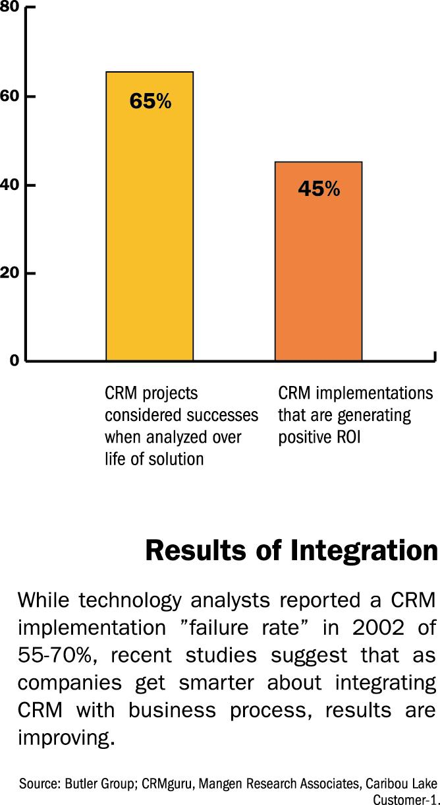
As a long-awaited recovery in the global economy continues to prove elusive, the pressure on sales executives to drive revenue growth is increasing. Many sales organizations have significantly reduced their headcount and are finding new ways to do more with less. Leading global companies increasingly realize that that their success or failure hinges on their ability to retain their best customers and create value around them.
Sales executives should start with an understanding of the cost avoidance and value creation opportunities that flow from customer satisfaction. The high cost of attracting new customers is one factor, but costs imposed by dissatisfied customers are perhaps more important. The dissatisfied customer buys less over time, demands more service than a satis-fied customer, and has the power to dissuade potential customers from doing business with your company. Ultimately these customers could cease being customers altogether. Obviously, the challenges of managing
Source: Butler Group; CRMguru, Mangen Research Associates. Caribou Lake Customer-1 2002
customer satisfaction are greatly inc- increased for companies like HP, Cisco, and BT that must manage the complexities of a distributed global sales force. The need to meet these challenges has helped fuel the explosive growth of the customer relationship management (CRM) category.
“Leading global companies increasingly realize that that their success or failure hinges on their ability to retain their best customers and create value around them.”
CRM tools are important, but are too often seen as an answer in and of themselves, divorced from larger issues of corporate structure and business processes. To ensure that these investments actually drive increased sales and improved customer satisfaction, companies should first examine their organiza-tional framework and develop specific processes tailored to customer needs. Wherever possible, these processes should be automated for maximum efficiency and leverage existing productivity tools.
The sales organization is a crucial leader in these efforts, but driving customer focus throughout the company requires an important shift in the thinking of many sales pro-fessionals. Each employee and functional unit must understand their role in the broader organizational challenges of customer engagement—a competency that can no longer be seen as the exclusive domain of the sales organization. Success at driving sales success and business value from customer satisfaction is the responsibility of many throughout the organization.

U.S. Wireless
Market in Decline?
Not For Service Leaders

- Decrease in average monthly spending on wire-less service 2000-2000:
$5, from $66 to $61

- Decrease in average length of time before a customer switches wire-less providers 1999-2001:
1.7 months less

- Differential in customer retention among wireless providers with higher overall satisfaction scores versus those with lower scores, 2002:
2 months longer

- Differential in per-cust-omer revenue among wireless providers with higher overall satisfaction scores versus those with lower scores, 2002:
$11 more per month

Source: J.D. Power and Associates, 2002

Alignment, Configuration and Sales Success
George Day is a distinguished professor of marketing at The Wharton School at the University of Pennsylvania. He has extensively studied the role of customer focus on the business success of global companies. According to Day, a company’s “configuration” is the most important ingredient in success with customers. Day defines configuration as the optimized combination of “incentives, metrics, accountabilities and structure that align a firm toward building customer relationships.” All of these elements should be designed to reinforce each other. Creating dis-parate, uncoordinated processes cannot provide a solid foundation for true customer satisfaction—or good productivity—across the global enterprise. While local standards and practices around customer engage-ment may vary, the processes that lead to customer alignment and satisfaction appear to be quite consistent globally.

Achieving this deep level of alignment requires a re-thinking of traditional approaches to sales success. Day of a firm whose internal processes combine incentives, metrics and accountability in a way that keeps everyone truly focused on the customer. A full 50 percent of management incentives and 25 percent of sales force compensation is based on customer satisfaction. Significantly, satisfaction is measured and bonuses are paid a year after the signing of a sales contract, to ensure the employees commit to a sustained effort to build relationships rather than merely closing deals.
Paying attention to configuration will also help ensure that a great sales effort is not undermined when the customer has contact with other company employees outside the sales organization or across national boundaries. “Companies with superior configurations are structured to ensure their customers have a seamless interaction with all parts of the business,” writes Day in MIT’s Sloan Management Review. “That prevents a customer from having to deal with different functional groups as separate entities within the same company.”
By reducing redundant interactions, superior configuration can help increase overall productivity both internally and for your customers. Verizon Wireless, for example, recently received the highest ranking among domestic mobile carriers in the respected J.D. Power and Associates study. The Wall Street Journal’s analysis of the study linked Verizon’s industry-leading customer satisfaction ratings to company-wide initiatives like its “Worry Free Guarantee,” that streamlines issue resolution for customers, removing the need to describe problems to both frontline and technical service staff or make repeated calls to resolve issues.

Verizon and its customers share the benefit of immediate productivity gains from this approach. The effort is backed by a $100 million investment in customer service systems and processes that allow service reps to resolve many common issues in a single call. Due largely to its advantages in customer satisfaction, Verizon enjoys some of the lowest “customer churn” rates in the industry, and has been able to resist the aggressive discounting other carriers have resorted to in their efforts to attract new customers.
The directors of the loyalty and retail practices at leading management consultants Bain & Company under-score the importance of building incentives and metrics that reinforce CRM deployments and other efforts to link customer satisfaction to higher sales. In an article in the December 2002 edition of Optimize, a business strategy magazine for technology executives, Darrel Rigby and Fred Richfield point out that “even the best customer strategies aligned with business processes and appropriate technology support will fall short without the right metrics, the ability to track customer retention rates and the return on marketing campaigns.”
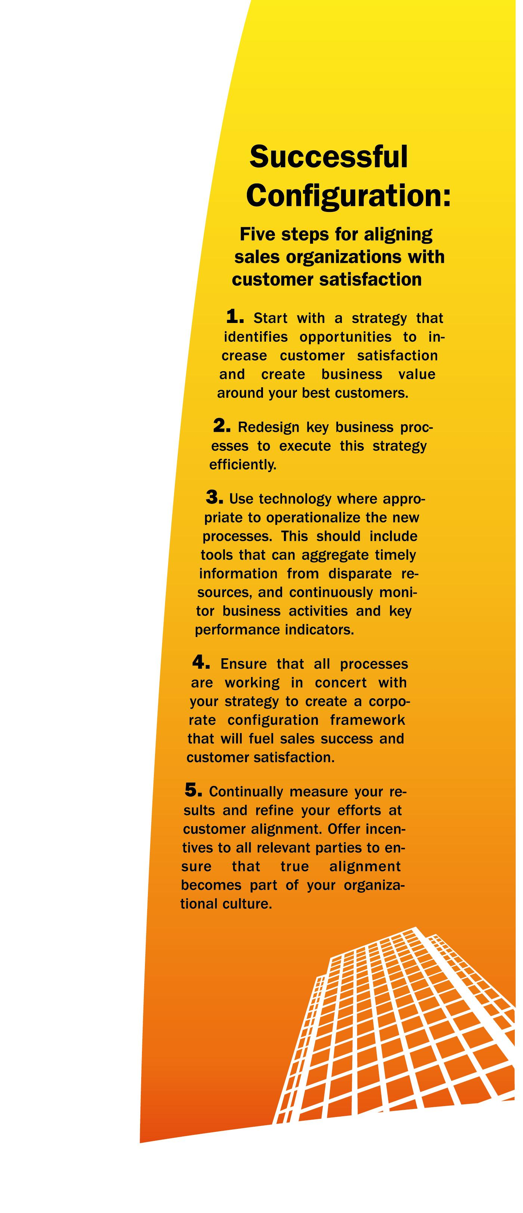
This mix of metrics and incentives is critical to increasing sales productivity and success. But in designing incen-tives based on success against these metrics, companies should not ignore incentives designed to bolster adop-tion of the enhanced tools. Rigby and Richfield cite the experience of a large grocery chain that made a major investment in a CRM system, only to discover a year later that just 5 per-cent of the sales force used the system. By basing all profitability incentives on the data in the system, and decreasing the bonuses of non-users, the company realized a 90 percent utilization rate and a profitability impact of more than $10 million a year. Clearly, this approach required sales leaders willing and able
to drive behavioral change—the last and most important link in deriving value from the investment in an overall customer strategy. This level of behavior and cultural change is required for companies that want to evolve to leveraging customer relationships as true strategic assets.
Finally, new tools for driving customer satisfaction do not relieve sales organizations of the traditional need for training and motivation programs. While CRM and sales force auto-mation (SFA) systems generally embed best-practice approaches, this is not enough to provide global sales teams with a holistic focus on customer satisfaction.
Rosemary Hume, senior consultant with the New Zealand office of leading training firm Rogen, focuses on the motivation and skill development that should accompany infrastructure in-vestments. Noting the high degree of interest in Australasia in CRM tools that help standardize customer inter-action, she underscores the need for sales executives to balance these tools with the training and flexibility that preserves the independence of team members. “To ensure that you empower your team, the individuals need to be able to make decisions on the spot in front of clients to win the business,” Hume notes. “This level of autonomy will be different for each individual."
Employees’ ability to use this auto-nomy to the benefit of the company can be maximized by tools that provide efficient access to customer insights and business analytics. Processes that rightly focus on metrics, best practices, and account-ability should still preserve the unique skills and talents of each employee. Integrating training and metrics to develop and measure each employee in a customized fashion will allow him or her to reach their maximum poten-tial, thereby increasing the overall productivity of the group as whole.
Capital One: Alignment Drives Results

Credit services provider Capital One provides an example of true organ-izational alignment in support of customer satisfaction that drives strong sales results and increased profitability. Capitol One’s “config-uration” starts with a corporate structure and work culture that gives a high degree of autonomy to business unit managers and allows individual employees the flexibility to resolve a wide range of customer issues.
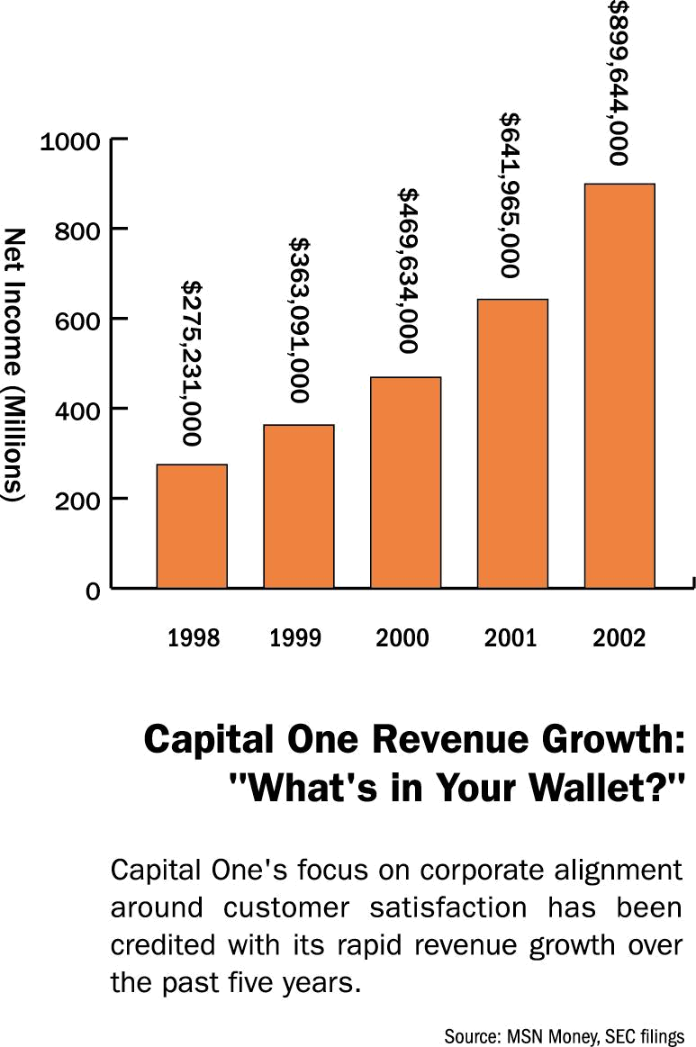
Incentive programs are carefully designed to reinforce these behaviors. Wharton’s George Day notes that “employees at all levels have implicit permission to act as customer advo-cates, and service representatives are measured not only on their perfor-mance but also on how supportive they are to colleagues.” Extensive training reinforces these efforts, and is in fact required by the company’s commitment to an ever-more-expansive CRM environment designed to identify the customers with the highest profit potential and relent-lessly drive increased sales from them. This success has fueled a sales growth rate that nearly doubled the average in the credit services industry in 2002.
Elaborate processes for metrics track- ing and benchmarking are key to Capitol One’s success. It employs around 1,000 statisticians tasked with mining data captured through CRM to better understand its customers and anticipate products and services that can meet their needs. The insights from this effort feed into a massive rapid-prototyping effort that in 2001 involved 45,000 tests of product concepts, customer communications, and process changes. This level of productivity would never be possible without the ability to quickly analyze and act on massive amounts of data—
Source: MSN Money, SEC filings 2003
an ability that is grounded in adaptive business processes that allow for the strategic alignment of IT resources.
Capitol One’s outstanding success at relentless aligning business process with customer needs has helped it sustain market value growth at five times the industry average. The $11 billion company is well on its way to overtaking its larger, longer-established rivals and is meeting with success in its rapid expansion into the UK and other international markets. But it considers alignment to be, by definition, an endless project. While others point to their success, the company’s culture resists self-congratulation.
“Don't try and prove that you're aligned. It's kind of an unprovable thing; it's a never-ending quest.”
John Scanlon, Capitol One’s vice president of Line of Business Technology sums it up this way: “Don't try and prove that you're aligned. It's kind of an unprovable thing; it's a never-ending quest.”
Our Assessment: Sales Leaders as Agents of Alignment
Clearly, creating the kind of customer satisfaction that fuels increased sales productivity hinges on the ability of many processes to operate in concert. These processes require an infra-structure for measurement, analysis, communication, and collaboration that is accessible to—and consistently used by—disparate teams throughout the enterprise.
Sales executives need to understand their role in helping create this

alignment of business goals, organ-izational structure, and the needs of customers. Furthermore, they need to devote time and energy to the challenges of ongoing implementation and management with their peers in IT, finance, operations, and HR. As many experts point out, all of the interdependent organizations should take part in this “customer conversation.”
Once well-designed structures, processes, and infrastructure are in place, investments in technologies like CRM or SFA are much more likely to succeed. Integration of these systems with core communications, collaboration, and analytics systems is essential. This holistic approach to business process and software infrastructure that enables excellent customer focus can also set the stage for advances in a company’s sales productivity and developing customer loyalty by highlighting areas where additional investment can see immediate returns. For example, the confluence of powerful tools that
Additional Resources

Microsoft Office
www.microsoft.com/office

Market Driven Strategy and Market Driven Organizations, by George Day

Massachusetts Institute of Technology Sloan Management Review
smr.mit.edu

Sales and Marketing Management
www.salesandmarketing.com

Northwestern University Kellogg School of Business Kellogg World
www.kellogg.northwestern.edu/kwo

Management Magazine
www.managementmag.com

Optimize
www.optimizemag.com

Schuster-Zingheim and Associates, Inc.
www.schuster-zingheim.com
leverage existing CRM or SFA applications, mobile wireless connect-ivity and computing is creating a new global sales force – one that adds value and drives sales from the front lines. Making good on this promise requires truly integrated and accessible CRM applications that allow collaboration via everyday productivity tools.
“…mobile wireless connectivity and computing is creating a new global sales force – one that adds value and drives sales from the front lines.”
The end result will be an organization that can thrive in good times and bad by truly understanding and caring for customers. This level of customer intimacy is a key driver of the responsiveness and agility required to manage rapid change and remain strong and productive in times of uncertainty.

Microsoft Office System Can Help

Identifying the right business applications to meet your organization’s needs sometimes can be overwhelming. Microsoft is experienced in helping companies address their critical business needs such as cutting costs while simultaneously planning for growth and innovation. Microsoft Office System is a reliable business platform that allows you to manage business insight, adapt processes to address ever-changing customer needs and leverage your organization’s strategic assets while improving productivity, visibility and integrity.

This document is for informational purposes only. MICROSOFT MAKES NO WARRANTIES, EXPRESS OR IMPLIED, IN THIS DOCUMENT.
©2003 Microsoft Corporation. All rights reserved. Microsoft and the Office logo are either registered trademarks or trademarks of Microsoft Corporation in the United States and/or other countries.

