
BEST PRACTICES: RECRUITING AND
RETAINING TALENTED EMPLOYEES

With In today’s challenging business climate, management of your company’s human capital is critical to success. Is your approach to recruiting and retention aligned with your company’s strategic goals? This article explores the key principles and business processes that will help drive long-term business benefits.

This article is one in a series from Microsoft Office System that explores issues and perspectives facing human resources executives.

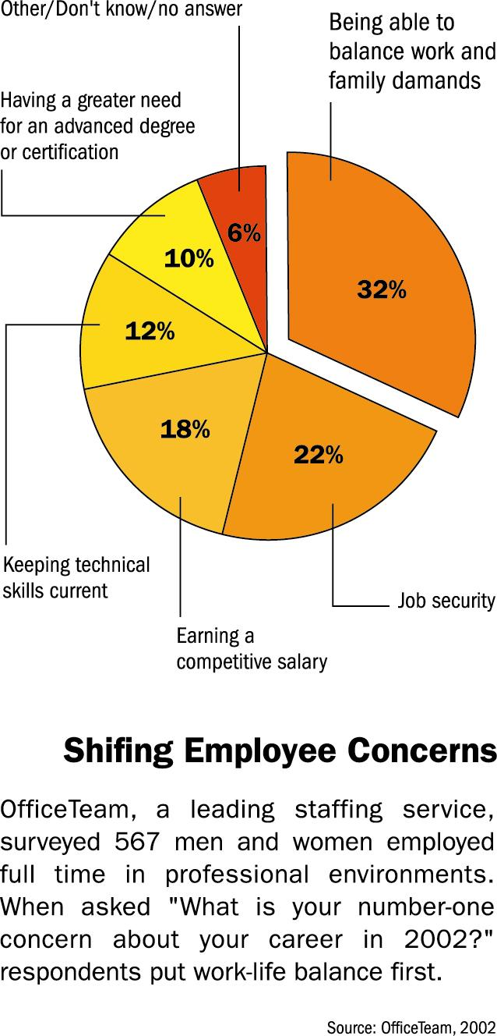
Recruitment and Retention: A Brave New World

Just a few years ago, as job growth in Europe and the United States out-paced the supply of employees, most human resources professionals were grappling with the serious workers to fill available positions. Retaining these workers in an overheated job market was a serious challenge.
While the business landscape has changed dramatically, recruiting and retaining the right people is just as important as before. But the stakes are higher now that the margin between success and failure is razor thin. In today’s climate, HR is expected to deliver business results on a much tighter budget. Lower headcounts mean that each new hire is that much more crucial to the firm’s success, and the departure of a star performer can impact financial results that investors are watching more closely than ever. In this environment, HR leaders need to develop business processes that allow their teams to be more efficient and productive. At the same time, they
will need to build airtight business cases for any proposals to spend money on initiatives related to recruit-ing, training and retention efforts.
Just as the business climate has shifted, employee attitudes toward work have undergone a radical transformation in just a few short years. Widespread layoffs, corporate financial scandals and the dramatic decrease in public perceptions of global security that followed September 11, 2001 have all con-tributed to a re-evaluation of career and life priorities among many employees. Attracting and retaining the best people is no longer simply about compensation. As these trends interact with deeper economic shifts, HR executives face pressure from both management peers and employees to evolve a new, more strategic approach to recruitment and retention. The new holistic approach to workforce management is often referred to as human capital management (HCM).

The Human Capital Revolution

A key business lesson of the “In-formation Age” is that strategic value is shifting from tangibles — factories, inventories, physical infrastructure — to intangibles. As noted in an article in London-based finance publication The Economist, “Economies are increa-singly based on knowledge what is new is that a growing chunk of pro-duction in the modern economy is in the form of intangibles, based on the exploitation of ideas, rather than material things.”
Among companies’ increasingly valuable intangibles — which include intellectual property, brand value, and customer relationships — human cap-ital is perhaps the most vulnerable to erosion. The very definition of human capital is that it walks out the door every evening, and exits permanently with an employee who leaves a company. Nobel Prize winning economist Gary S. Becker, who coined the term “human capital,” explains it
The High Costs of
Turnover
While the actual cost of employee turnover is hard to calculate, there is a general consensus on the importance of personal relationships in reducing employee defect-ions. Studies also point to excellent ROI on programs designed to reduce turnover.
- A survey of 700 companies found tenure was deter-mined primarily by the employee’s relationship with their immediate manager

- The average cost of turnover is $100,000 per employee, including re-cruiting, training and lost productivity. Reducing turnover by 1% with more effective performance management can save $10M annually

Source: Cap Gemini Ernst & Young, Saratoga Institute
2002
“The very definition of human capital is that it walks out the door every evening, and exits permanently with an employee who leaves a company.”
this way in his book of the same name: “You cannot separate a person from his or her knowledge, skills, health, or values the way it is possible to move financial and physical assets while the owner stays put.” Knowledge management efforts, which increasingly involve HR organizations in their implementation, are one approach to mitigating human capital losses, but Becker’s work shows that reducing the number of people who leave voluntarily is critical.
In a recent interview with LiNEZine, an online publication about learning in

the New Economy, Becker restated his famous formulation in a novel way. “I would start out with some obvious things that are still sometimes for-gotten: the basic resource in any company is the people,” said Becker. “The most successful companies and the most successful countries will be those that manage human capital in the most effective and efficient fashion.”
Becker’s statement serves as an excellent checklist for the approaches that leading companies use not only to keep the employees they have, but also to set themselves apart as “em-ployers of choice” that attract the best candidates to start with. Though recruiting and retention are separate issues that each require specific business processes, a strong under-standing of the principles of human capital management — shared throughout the organization — can unite your efforts.
Once the principles of human capital management are established intern-ally, experts offer clear direction on a number of practical steps that will help advance recruitment and re-tention success. Dave Lefkow, an interactive solutions consultant with global HR communications and solutions provider TMP Worldwide, offers several insights in a recent article in specialist online publication Electronic Recruiting Exchange. Examining companies like Nike and Microsoft that he cites as having leading recruitment efforts, he observes several trends, including:
- Centralization of HR efforts. Centralizing the recruiting team not only allows economies of scale, but also brings together expertise formerly distributed throughout the organi-zation to create a center of excellence.

- Specialization. Aided by centralization, developing specialist practices within recruiting allows innovation around key functions like workforce planning, hiring process management, business analysis and others.
- Focused recruiting. As basic HR processes like applicant tracking become ubiquitous, HR staff can spend more time on activities
focused on identifying successful professionals who are most likely to offer your company high value—and the least likely to be in the general pool of job-seekers.
These three efforts are interrelated and each puts a premium on having an infrastructure that allows efficient teaming, process management and collaboration. As process improve-ments to support these efforts are implemented, it is important to measure recruiting success against overall business goals and communicate these metrics within the HR organization and the larger enterprise. For example, is one business unit more successful in closing offers with high-value candidates? Knowledge of this success is a key step in replicating it throughout the organization.
“…if your budget is limited, a retention program that focuses on the highest-profile, highest-value contributors is a logical place to start.”
Similarly, employee retention requires business processes that combine measurement, training and collab-oration. Beyond the top-line strategic value of proper management of human capital, a strong retention program can offer dramatic cost savings and productivity gains. Turn-over is a serious business problem in every industry and requires a stra-tegic, process-based retention pro-gram to stop the losses and enable human capital value creation.
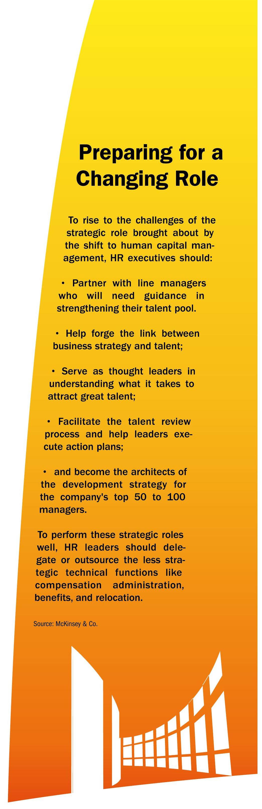
There are numerous approaches to measuring the many factors that impact employee retention. For example, The Gallup Organization, well-known for its polling and market research, also offers diagnostic tools that can assist HR professionals in gauging employee alignment and engagement. Some of Gallup’s “12 Questions” may appear “soft:” “In the last seven days, have you received recognition or praise for doing good work?” “Do you have a best friend at work?” “In the last year, have you had opportunities at work to learn and grow?” However, Gallup reports that in benchmarking their use with over 1.5 million employees in over 87,000 divisions or work units, organizations with “high Q12 scores have also experienced lower turnover, higher sales growth, better productivity, better customer loyalty or other manifestations of superior perform-ance.” Moreover, the quantitative nature of the study helps ground subsequent discussions between employees and managers in data, which helps defuse tension and produce actionable results. Continual tracking of these attitudinal metrics — along with data on business results — helps employees understand that their satisfaction is valued; this in itself can lead to higher retention.
2002

Companies are increasingly tailoring related but separate programs for rank-and-file workers and high performers Analyst Monica Barron with IT consulting firm AMR Research notes that institutional investors, ever more aware of the human capital value of high-performing employees, are beginning to ask companies about retention plans that focus on the employees whose hard work can make or break a company’s short-term earning and long term success. While looking at retention across the board makes good financial sense, if your budget is limited a retention program that focuses on the highest-profile, highest-value contributors is a logical place to start.

Recruiting and Retention for a Global Workforce
The need to increase recruiting and retention effectiveness is not just an issue in the United States and Europe, but is in fact a worldwide issue. The business benefits of these approaches are reaching into the developing world—an encouraging sign that the learnings of human capital management can help raise global workforce standards.
Several Indian companies offer examples of comprehensive retention programs that include employee stock option plans (ESOPs). Business leaders in India are increasingly concerned with the challenges of recruiting and retaining talented employees, despite a population of over one billion. The Workforce Stability Institute, a U.S.-based not-for-profit research and educational organization, reports that the Indian mutual-fund industry has been a leader in creating ESOPs designed to help address the problem. Templeton Asset Management (India) launched one such program. Templeton India CEO Rajiv Vij stated that the program is “designed to retain our best talent by enhancing the feeling of owner-ship… at a time when the industry as a whole is facing an attrition problem.” Vij sums up the logic of human capital management by adding, “People are the key asset for us.”
Recruiting and Staffing Services Trends
As the economic downturn continued, recruiting and staffing services took a hit in 2002. But industry forecasts estimate healthy growth in the next several years, as companies increasingly outsource less strategic parts of the HR process to concentrate on efforts that have the potential to yield strategic advantages.
- The worldwide market for recruiting and staffing services in 2002 decreased by 6.3% from 2001 levels, to $58.9 billion

- Worldwide recruiting and staffing service spending is forecasted to increase to $85.5 billion by 2007, with a compound annual growth rate (CAGR) of 7.7% during the period

Source: Cap Gemini Ernst & Young, Saratoga Institute
2003
Pacific Bridge Consulting, a U.S. -based human resources consultancy focused on Asia, reports that retention is also an increasing focus of both state-owned enterprises and foreign firms operating in China. In an indication that cultural differences play an important role in creating effective retention plans, Pacific Bridge notes that to an even greater degree than in other nations, “one of the most vital elements of employee ‘compensation’ and retention is treating employees well. This means that companies in China must make real efforts to engender employee loyalty, feeling of belonging, and commitment to the firm.” Beyond these “soft” retention efforts, compensation programs that involve personal and team incentives are increasingly important in China. Political and economic issues in China make stock-option programs for Chinese employees challenging, but this has not stopped companies like Lucent and Intel from developing innovative incentive programs that offer similar rewards tied to corporate performance.
“Business leaders in India are increasingly concerned with the challenges of recruiting and retaining talented employees…”
As these global developments make clear, sophisticated employee recruit-ment and retention programs are increasingly seen as integral to business success.
Our Assessment: Opportunity in Value Creation
True competitive advantage increas-ingly will be gained by integrating employee retention programs into a holistic human capital management framework that includes ongoing training and management, based on an infrastructure that maximizes the productivity of individual contributors and HR teams. Leading global con-sulting firm McKinsey & Company sums up the opportunity for HR executives this way. “Attracting, dev-eloping, and retaining talented people can be the stuff of competitive advantage. Therefore, HR leaders will

have a much more strategic role to play in the years ahead, arguably one equal to that of the CFO.” Along with this strategic role comes bottom-line responsibility, and HR executives will need processes to measure their results against overall business goals and share best-practice information within the organization.
“…HR Leaders will have a much more strategic role to play in the years ahead, arguably one equal to that of the CFO.”
Over the past several decades, human resources executives have been steadily increasing their ability to drive business results while positively
Additional Resources

Microsoft Office
www.microsoft.com/office

Workforce Stability Institute
www.employee.org

OfficeTeam
www.officeteam.com

LiNEzine
www.LiNEzine.com

Electronic Recruiting Exchange
www.erexchange.com

Gallup Performance Management Systems
www.gallup.com/management/Q12_system.asp

Pacific Bridge, Inc.
www.pacificbridge.com
influencing the quality of work life among their companies’ employees. Human capital management provides an opportunity for thought leadership about the links between job satis-faction, employee alignment, produc-tivity and value creation. As this understanding spreads around the world, the real challenge will be to drive these insights deeper into integrated processes; competitive advantages will accrue to those companies that maximize the benefits of strategic human capital manage-ment more quickly than the competition can. For companies that stay ahead of the curve, and the human resources executives that fuel that success, the rewards will be significant.

Microsoft Office System Can Help

Identifying the right business applications to meet your organization’s needs sometimes can be overwhelming. Microsoft is experienced in helping companies address their critical business needs such as cutting costs while simultaneously planning for growth and innovation. Microsoft Office System is a reliable business platform that allows you to manage business insight, adapt processes to address ever-changing customer needs and leverage your organization’s strategic assets while improving productivity, visibility and integrity.

This document is for informational purposes only. MICROSOFT MAKES NO WARRANTIES, EXPRESS OR IMPLIED, IN THIS DOCUMENT.
©2003 Microsoft Corporation. All rights reserved. Microsoft and the Office logo are either registered trademarks or trademarks of Microsoft Corporation in the United States and/or other countries.

