
Customization Management
Customization Management

Microsoft Dynamics™ SL

Benefits
- Work the way you want
Add new fields and controls, hide data items, set defaults, change field captions, and much more. Screens are instantly updated so you see the results of your changes immediately across your entire company.

- Seamlessly integrate custom solutions
Attach custom programs and specific
business rules to any object in any screen. Customization Manager includes Microsoft Visual Basic® for Applications, which you can use for sophisticated customization capabilities such as enhanced calculations, table lookups, validations, and references to most Microsoft Dynamics SL fields.

- Tailor your solution
Create screens with Tools for Visual Basic and incorporate them as objects with the Microsoft Dynamics SL Object Model — an innovative programmatic interface. The Object Model lets you automate any Microsoft Dynamics SL screen, whether standard or created by you, helping ensure data integrity by leveraging the screens’ business logic.

- Alter processes and functionality
Adjust field colors, screen fonts, and
the assignment of tool tips with the
Customization Manager property window, consistent with other form-oriented design tools such as Visual Basic or Microsoft Access. Easily see the original, as well as the customized property values for all controls.

- Enhance productivity
Assist newer and more advanced users.
For example, optimize data entry by
rearranging field on the screen to match
your business flow or unique document
layout. You can create custom Tool Tips to
provide additional information, or assign custom keyboard shortcuts for single keystroke operations.
S O L O M O N

Adapt your system to the specific requirements of your organization with Microsoft Dynamics SL Customization Manager. Quickly and easily modify any screen in any Microsoft Dynamics SL module without changing the underlying source code, and update screens as often as necessary to match the pace of your business growth.

Inserting
new objects is a snap with the Insert Object Wizard

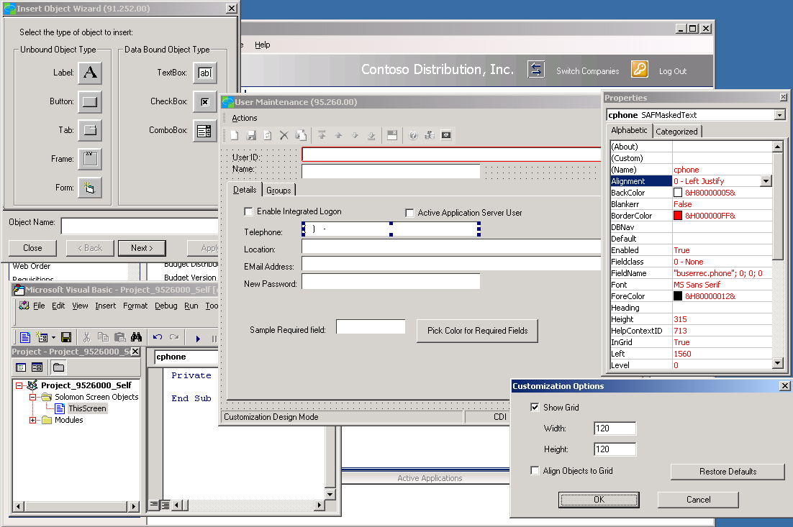



Advanced Customization  FEATURES  BENEFITS  Capabilities | Attach custom processes to specific “events” with Visual Basic for Applications. Validate an entry in a custom table or enforce a specific rule based on your requirements.
Industry-Standard Integration | Take advantage of industry-standard integration technologies such as  Automation and Open Database Connectivity (ODBC) to integrate with off-the-  shelf Microsoft Windows® applications and database sources using Visual Basic  for Applications.
Data Access and Transfer | Access any ODBC-compliant data source within any Microsoft Dynamics SL  screen, including information stored in SQL databases outside the Microsoft  Dynamics SL system. Automate data transfer between products such as Microsoft  Office Excel or Microsoft Office Word.
Powerful Security Features | Set up and control access to Customization Manager.
Rights-Based Functionality | Grant functional-level customization rights, such as the ability to change field  order and visual appearance, or restrict the ability to insert new objects or write  code.
Field-Level Security | Define field-level security — such as making a balance field invisible to some  users — or define a more restrictive range of valid entries.
Customization Control | System administrators can make screen changes that apply to all users, one user, or that apply only to themselves; individuals can customize their own screens.
Flexible Import and Export | Copy customizations from one system to another. Easily manage libraries  of customizations, control deployment within your organization, or merge  new customizations with existing ones.
Customization Packaging and  Distribution | Create packaged customizations for import to other sites. For example, an administrator who wants to repeat a series of customizations at multiple sites  can package and distribute them to those sites.
Industry-Specific Customizations | Create customizations for a specific industry, such as one that refers to  “Vendors” as “Suppliers,” and all “Vendor ID” labels will be changed to  “Supplier ID.” Customizations can be exported as a package for re-sale.
Insert Object Wizard | Capture additional information in certain Microsoft Dynamics SL screens by  adding data fields — without requiring the help of a programmer. The Insert  Object Wizard allows you to quickly and easily insert new objects on a screen.
Security-Enhanced Customizations | All customizations are stored in the Microsoft SQL Server™ database, This helps ensures that customizations are protected, deployed across the entire system instantly, and allows easier migration to future versions.

For more information about Microsoft Dynamics™ SL, visit: http://www.microsoft.com/dynamics/sl

This document is for information purposes only.
MICROSOFT MAKES NO WARRANTIES, EXPRESS, IMPLIED, OR STATUTORY, AS TO THE INFORMATION IN THIS DOCUMENT.

© 2005 Microsoft Corporation. All rights reserved.
Microsoft, The Microsoft Dynamics Logo, are either registered trademarks or trademarks of Microsoft Corporation or Microsoft Business Solutions ApS in the United States and/or other countries. Microsoft Business Solutions ApS is a subsidiary of Microsoft Corporation.

