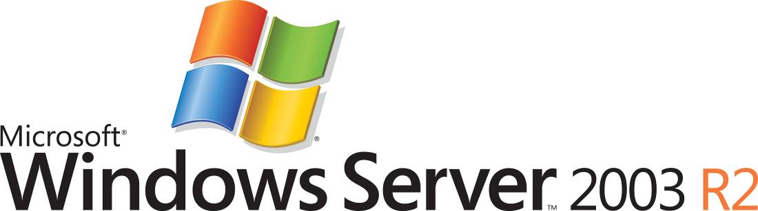

Configuring File Sharing for Branch Offices
Microsoft Corporation
Published: May 2006

Abstract
The file sharing technologies in Microsoft® Windows Server™ 2003 R2 allow you to easily share files between a central office site and branch offices while avoiding many of the traditional challenges of doing so. This article provides specific prescriptive guidance to configure your Windows Server 2003 R2 servers to take advantage of powerful file sharing functionality.

This is a preliminary document and may be changed substantially prior to final commercial release of the software described herein.
The information contained in this document represents the current view of Microsoft Corporation on the issues discussed as of the date of publication. Because Microsoft must respond to changing market conditions, it should not be interpreted to be a commitment on the part of Microsoft, and Microsoft cannot guarantee the accuracy of any information presented after the date of publication.
This White Paper is for informational purposes only. MICROSOFT MAKES NO WARRANTIES, EXPRESS, IMPLIED OR STATUTORY, AS TO THE INFORMATION IN THIS DOCUMENT.
Complying with all applicable copyright laws is the responsibility of the user. Without limiting the rights under copyright, no part of this document may be reproduced, stored in or introduced into a retrieval system, or transmitted in any form or by any means (electronic, mechanical, photocopying, recording, or otherwise), or for any purpose, without the express written permission of Microsoft Corporation.
Microsoft may have patents, patent applications, trademarks, copyrights, or other intellectual property rights covering subject matter in this document. Except as expressly provided in any written license agreement from Microsoft, the furnishing of this document does not give you any license to these patents, trademarks, copyrights, or other intellectual property.
© 2006 Microsoft Corporation. All rights reserved.
Microsoft, Active Directory, Windows, the Windows logo, and Windows Server are either registered trademarks or trademarks of Microsoft Corporation in the United States and/or other countries.
The names of actual companies and products mentioned herein may be the trademarks of their respective owners.

Contents
Configuring File Sharing for Branch Offices 1
Abstract 1
Contents 3
Configuring File Sharing for Branch Offices 5
Terminology 6
Assumptions 7
Skills Needed 7
Infrastructure 7
Before You Begin 8
Good Solution: File Sharing over WAN 9
Better Solution: Local Branch File Server, Distinct from the Central Site 10
Best Solution: Local Branch File Server Synchronized with the Central Site using Distributed File System (DFS) Technology in Windows Server 2003 R2 10
Distributed File System Replication 11
Install the Distributed File System 11
Distributed File System Namespaces 13
Create a DFS Namespace 13
Add a Namespace Server 14
Delegate Management Permissions 15
Add Folders to a Namespace 16
Use DFS Replication to Replicate a Folder in the Namespace 17
Test Failover Functionality in DFS 19
Additional Resources 19

Configuring File Sharing for Branch Offices
Microsoft® Windows Server™ 2003 R2 helps you to effectively and affordably provide file sharing to branch office locations while avoiding the most of the traditional challenges of serving branch office environments: reliable connectivity, bandwidth limitations, and file synchronization.
Windows Server 2003 R2 provides technologies that help to simplify branch office file sharing for these scenarios, enabling you to:
• Publish files from centralized hubs to branch offices.
• Replicate files from branch to hub locations for backup, fault tolerance, or cross-branch publication.
• Manage loose collaboration of documents between branches or between hubs and branches.
Historically, in order to maintain security, file shares were centralized away from the branch office. This strategy often results in either improperly secured remote file storage or the addition of a significant burden to IT resources. With Windows Server 2003 R2, the Distributed File System (DFS) solution supports these scenarios. DFS includes new tools for DFS Namespaces, a new replication engine known as DFS Replication, and improved print management tools which allow for distributed file sharing with enhanced security for branch office file servers.
The DFS solution provides simplified, fault-tolerant access to files and WAN-friendly replication. DFS Namespaces allow you to group shared folders located on different servers more securely and present them to users as a virtual tree of folders known as a namespace. A namespace provides numerous benefits, such as increased availability of data, load sharing, and simplified data migration. Users navigate virtual namespaces without knowledge of the names of the physical servers or shared folders that host the data.
DFS Replication, the successor to File Replication Service (FRS), is a new state-based, multi-master replication engine that supports scheduling and bandwidth throttling, a feature that sets the maximum bandwidth a network connection may use. DFS Replication uses a new compression algorithm known as Remote Differential Compression (RDC), a differential over-the-wire protocol that can update files efficiently over a limited-bandwidth network more securely. DFS requires a Microsoft Active Directory® directory services-enabled domain and reaps the security benefits of operation in a domain configured for high server and network security.
On-demand file replication eliminates the replication of unneeded files and can conserve disk space on a branch office server. This kind of replication performs a full data replication the first time a remote user accesses a file, and then replicates only file header information regularly. For on-demand file replication, branch data acts as a cache for centrally authored data.

Terminology
Here is a brief overview of the terms and acronyms used in this article.
Distributed File System (DFS) Namespace
Allows administrators to group shared folders located on different servers and present them to users as a virtual tree of folders known as a namespace.
Distributed File System (DFS) Replication
The successor to File Replication service (FRS), it is a state-based, multimaster replication engine that supports scheduling, delta compression, and bandwidth throttling.
Local-Area Network (LAN)
A communications network connecting a group of computers, printers, and other devices located within a relatively limited area (for example, a building). A LAN enables any connected device to interact with others on the network.
Remote Differential Compression (RDC)
A WAN-friendly compression technology that replicates only the changes to a file needed to ensure global file consistency.
Virtual Private Network (VPN)
The extension of a private network that encompasses encapsulated, encrypted, and authenticated links across shared or public networks. VPN connections typically provide remote access and router-to-router connections to private networks over the Internet.
Wide-Area Network (WAN)
A communications network connecting geographically separated locations that uses long-distance links of third-party telecommunications vendors.

Assumptions
In order for you to follow all of the guidance in this article, this document makes some specific assumptions about your skill set and the environment in which you will be working. However, even if some of these assumptions do not apply to you, this article can still provide valuable insight to you.

Skills Needed
In order to complete all of the steps contained in this article, you should able to confidently:
• Install Microsoft Windows® components from installation media (such as a CD, for example).
• Share data folders on a network.
• Install and use snap-ins to the Microsoft Management Console.
• Add and manage users and groups in Active Directory Users and Computers.
Note
All the step-by step instructions included in this document were developed from the Start menu that appears by default when you install your operating system. If you have modified your Start menu, the steps might differ slightly.

Infrastructure
The steps in this article assume that you have met the following requirements:
- A VPN connection exists between the central file server and all branch file servers
- Windows Server 2003 R2 is installed on your servers
- You have sufficient WAN bandwidth as determined by you or your IT staff
- A standard file server is configured
Note
Windows Server 2003 R2 may disable some DFS Namespace features if your second server is running Windows 2000 Server or if the branch file server is not running Windows Server 2003 SP1 or Windows Server 2003 R2. Windows Server 2003 R2 must be running on your domain controller and on your central file server in order to follow all of the steps in this article.

Before You Begin
To complete all tasks in this article, you will need:
• Your Windows Server 2003 R2 installation CDs
• A Domain Controller running Active Directory; you must also be able to log in to the Domain Controller as a Domain Administrator
• Two or more member servers running Windows Server 2003 R2 that are joined to the Active Directory domain
To use DFS Replication, you must configure your servers as follows:
• To create a replication group or enable DFS Replication on a folder, you must be a member of the Domain Administrators group or have been delegated the appropriate authority.
• You must update the Active Directory schema to include the new DFS Replication objects. For details, see the section Install the Distributed File System later in this article.
• The servers that participate in DFS Replication must run Windows Server 2003 R2. As a security measure, most core features of Windows Server 2003 R2 are off by default. Therefore, after you install Windows Server 2003 R2, you must independently install the DFS Replication Service on each server that will take part in replication, and you must install the DFS Management snap-in on one server to manage replication. You will find installation instructions for the service and snap-in in the Install the Distributed File System section of this article.
• Ensure that your antivirus software is compatible with DFS Replication. Contact your antivirus software vendor to check for compatibility. (With RDC, excessive replication does not occur due to incompatible virus software, but there is overhead associated with the RDC protocol.)
• DFS Replication does not work across firewalls because it uses the RPC dynamic endpoint mapper. Additionally, when you have enabled the firewall, you may not use the DFS Management snap-in to configure DFS Replication. You must define a port exception in order to maintain the protection of a firewall while you use DFS Replication.
Note
For more information on DFS Replication and firewall port exception configurations, see the following articles on the Microsoft TechNet Web site:
- Active Directory Replication over Firewalls at: http://go.microsoft.com/fwlink/?LinkId=51530
- Windows Firewall: dfs at: http://go.microsoft.com/fwlink/?LinkId=51564
Caution
DFS Replication does not support SYSVOL replication in Windows Server 2003 R2. Do not attempt to configure DFS Replication on SYSVOL by disabling FRS and setting up a replication group for SYSVOL. Continue to use FRS for SYSVOL replication on domain controllers running Windows Server 2003 R2. FRS and DFS Replication can coexist on the same member server or domain controller.
Note
Screenshots in this document reflect a test environment. The domain and server names in your environment might differ slightly from the ones shown in these screenshots.
Note
Several times throughout this document, you are alerted that you may only perform specific tasks with specific credentials or that you must have been delegated the proper authority. As a security best practice, use the RunAs command from the command line to temporarily increase the authority of a member of the Users group. For more information about the RunAs command refer to the definition available on the Microsoft Windows XP Professional Product Documentation Web site at: http://go.microsoft.com/fwlink/?LinkId=51565.

Good Solution: File Sharing over WAN
In this scenario, client computers in a branch office access files directly from shared folders on the server or servers at the central office site via a VPN connection. The biggest advantage of this arrangement is the low initial cost: an organization only pays for WAN bandwidth; the organization does not have to buy new hardware to service the branch office. Associated with this advantage, an organization choosing this arrangement can have lower monitoring and management costs (at least for servers) because they are centralized. It can also be easier to better secure servers at a centralized location than distributed.
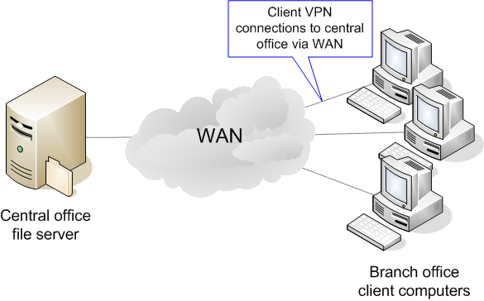
There are numerous disadvantages to this file-sharing configuration however. First, data security and integrity can be easily compromised: if users remove or copy data to their client computers. Security is thus inferior to that on the central servers. Second, data copied to branch client computers can quickly get out-of-sync with the data on the central server. Finally, and worst of all for branch-office users, file-access and usage performance can be low due to bandwidth constraints over the WAN. These disadvantages often convince organizations to locate file servers in branch offices.
Because sharing files from a central server or servers requires only basic IT administration skills, no prescriptive guidance on the subject is given in this document. For more information on these tasks, see the “File Server Management Overview” on the TechNet Web site at http://go.microsoft.com/fwlink/?LinkId=67417

Better Solution: Local Branch File Server, Distinct from the Central Site
Organizations that choose to place file servers in their branch locations enjoy a number of advantages. Communications with the central site and other parts of the organization typically do not require as much WAN bandwidth, lowering that cost. Moreover, the branch has no dependencies on corporate services for the day-to-day file serving to users in the branch office, so the reliability of the WAN connection to the central site is less of an issue. Users in the branch office will notice that files are accessible more quickly, because file sharing is provided by the local file server at LAN speeds.
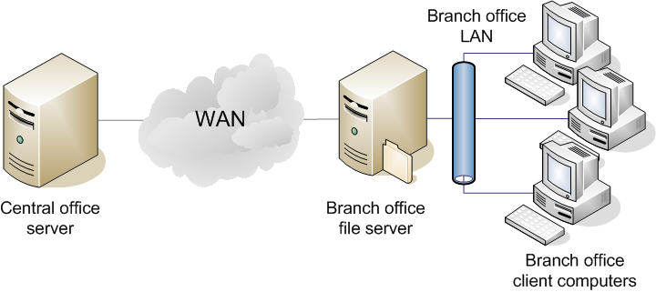
However, organizations that place a local file server in branch offices quickly encounter challenges as well. Branch office servers do not receive the same kind of attention as home office servers, frequently leaving branch office servers more vulnerable to attack for longer periods of time than home office servers. Moreover, technical support for the server must either come from the central site or be maintained locally; either option can be very expensive for mid-sized organizations. This compounds the other costs associated with maintaining local file servers in branches: organizations must pay all of the costs of hardware redundancy without gaining any of the benefits.
Because locally sharing files requires only basic IT administration skills, no prescriptive guidance on the subject is given in this document. For more information on these tasks, see “File Server Management Overview” on the TechNet Web site at http://go.microsoft.com/fwlink/?LinkId=67417 and “File server role: Configuring a file server” on the TechNet Web site at http://go.microsoft.com/fwlink/?LinkId=67418

Best Solution: Local Branch File Server Synchronized with the Central Site using Distributed File System (DFS) Technology in Windows Server 2003 R2
DFS Replication offers a number of advantages for branch offices. One of them is availability: if the branch file server goes down, files are still available from servers at the central office site (although at a slower speed than if they were accessed locally). DFS Replication keeps files stored locally in sync with central copies, allowing users in the branch office and in the central office to collaborate on documents without having to worry about them getting out of sync. Importantly, DFS Replication does all of this without using too much WAN bandwidth: DFS Replication uses Remote Differential Compression (RDC) to copy just the changes made to copies of files in different locations rather than copying the entire file. Moreover, DFS allows organizations to manage the bandwidth that can be used for replication.
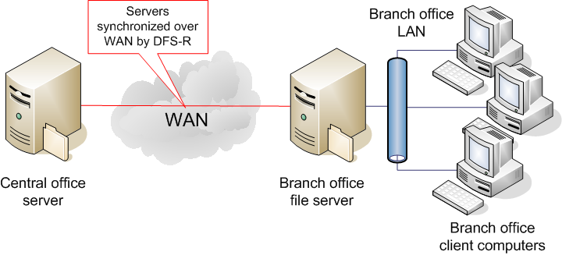
Using the DFS technology in Windows Server 2003 R2 to provide these benefits to branch offices still poses some challenges to organizations that choose this route. Such organizations must still buy the branch server and accompanying licenses, as well as provide technical support for the branch file server. Organizations choosing to use this technology must also have security processes in place at the branch-office level: the presence of sensitive data in more than one location automatically increases the attack surface of the organization as a whole.

Distributed File System Replication
Next this document explains how to set up and configure DFS Replication and DFS Namespaces for a branch office file server scenario.

Install the Distributed File System
Before you begin, you must install the DFS Management Snap-in and the DFS Replication Service. As a security measure, many Windows Server 2003 R2 features are not installed or enabled by default. You must add features such as DFS after you install Windows Server 2003 R2. This guide presumes that you already have Windows Server 2003 R2 installed on your servers. To use DFS Replication, you must first update the schema to install the Active Directory components of DFS Replication. You will update the schema in the following task.
Note
To perform the following task, you must be a member of the Domain Administrators group or you must have been delegated the appropriate authority. You must perform this step on your domain controller.
To upgrade the schema to install the Active Directory Components of DFS Replication:
1. Insert the Windows Server 2003 R2 CD2 into your CD drive.
2. From the Windows Server 2003 R2 desktop, click Start and select Run.
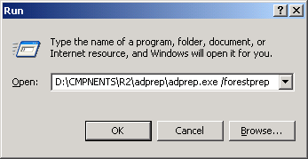
3. In the Open box, type D:\CMPNENTS\R2\adprep\adprep.exe /forestprep where D:\ is the CD drive on the server on which this document was prepared.

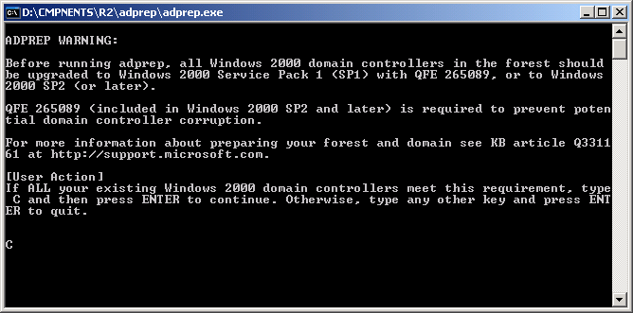
4. On the ADPREP WARNING command-line prompt screen, type C then press ENTER. Because you are using Windows Server 2003 R2, you can disregard the warning that appears.
Note
For more information on extending Active Directory schema, see “Extending Your Active Directory Schema in Windows Server 2003 R2” on the TechNet Web site at http://go.microsoft.com/fwlink/?LinkId=67423
Note
In order for DFS Replication to work, you must perform the following task on the domain controller and install the DFS Replication Service on at least two other servers.
To install DFS Management and DFS Replication service using Add or Remove Programs:
1. From the Windows Server 2003 R2 desktop of the domain controller (and any other member servers on which you wish to install DFS Replication Service), click Start, select Control Panel, and click Add or Remove Programs.
2. Click Add/Remove Windows Components.
3. Highlight Distributed File System and click Details.
4. Select DFS Management and DFS Replication Service (when you repeat this task on the other servers, you need select only DFS Replication Service), then click OK.
5. Click Next. DFS components will now install.
7. When prompted, insert the Windows Server 2003 R2 CD 2 in your CD drive and click OK.
8. On the Files Needed dialog, verify that D:\CMPNENTS\R2 appears (where D:\ is the CD drive on the server on which this document was prepared) and click OK. Browse to the appropriate location if it does not appear by default.
9. The installation will continue. Installation of DFS management takes several minutes because the installation includes the Microsoft .NET Framework 2.0.
10. On the Complete Windows Component Wizard page, click Finish. This concludes the installation.
11. Close the Add or Remove Programs window.
Note
Repeat these steps on the other two member servers, but in Step 4, select only DFS Replication Service.

Distributed File System Namespaces
The tasks in this section describe the process of namespace deployment. To complete all tasks, you need a minimum of two servers configured as follows:
• One server must be running Windows Server 2003 R2. This is the server you will use to perform the tasks presented in the following sections. (If you have not done so already, be sure to install the management tools and DFS Replication Service. For details, see the section Install the Distributed File System earlier in this article.)
• The second server must be running either Windows Server 2003 R2 or Windows Server 2003 SP1 if you want to take advantage of all DFS Namespaces features. Note: Windows Server 2003 R2 might disable some DFS Namespace features if the second server is running Windows 2000 Server or if the second server is not running Windows Server 2003 SP1 or Windows Server 2003 R2.
To create domain-based namespaces and enable DFS Replication in these tasks, you must have Active Directory deployed, and you must have extended the schema to include the new DFS Replication objects in Active Directory. For details, see the section Install the Distributed File System earlier in this article.

Create a DFS Namespace
Important
To create domain-based namespaces and enable DFS Replication in these tasks, you must have Active Directory deployed, and you must have extended the schema to include the new DFS Replication objects in Active Directory.
For details, see the section "Install the Distributed File System" earlier in this article.
To create a DFS namespace:
1. In the left console tree of the DFS Management console, right-click Namespaces and select New Namespace.
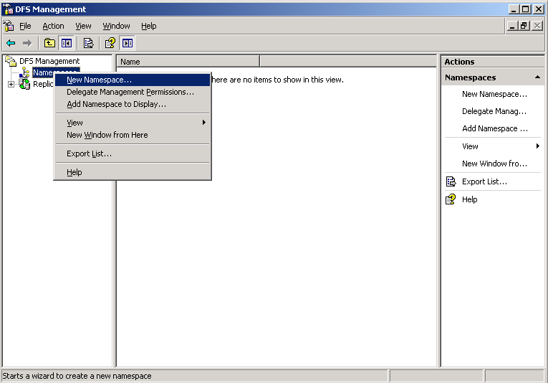
2. Click Browse on the Namespace Server page of the New Namespace Wizard.
3. Type in the name of the server or some portion of the server name and press Check Names. Select the desired server from the resultant list and click OK.
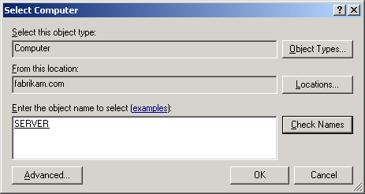
4. After the Select Computer dialog closes on the Namespace Server page of the New Namespace Wizard, click Next.
5. On the Namespace Name and Settings page, type in a name for your namespace (in this example, Public) and click Next.
6. On the Namespace Type page, select Domain-based namespace.
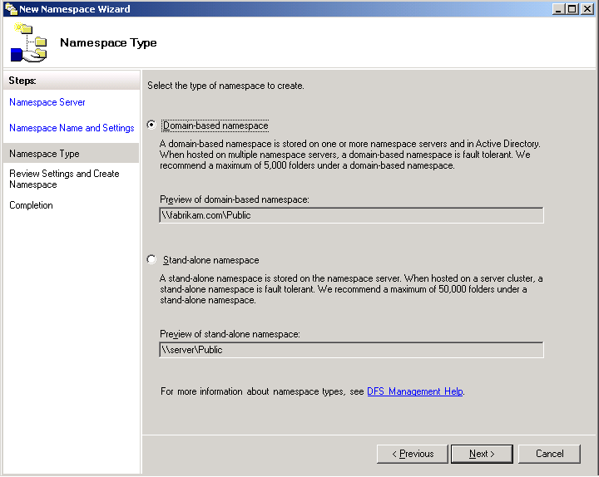
7. On the Review Settings and Create Namespace page, review your namespace settings and click Create.
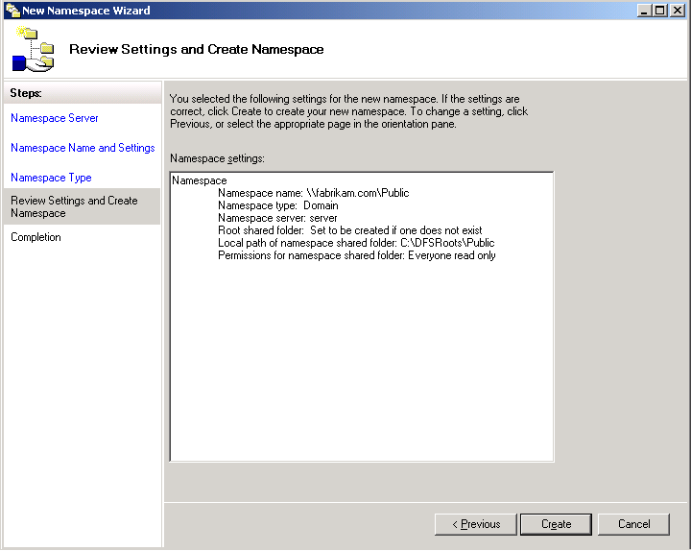
8. On the Completion page, wait for the creation process to complete and then click Close.
To verify that you successfully created a DFS Namespace:
1. When the New Namespace Wizard closes, on the DFS Management console, note your new namespace in the left console tree; this is your verification that you successfully created a DFS namespace. Double-click the namespace to view it
2. To browse your new Namespace, on the Windows Server 2003 desktop, click Start, select Run and type \\[Your Domain Name]\[Your Namespace Name] in the Open box.
3. Close the Windows Explorer window when you are through.

Add a Namespace Server
To add a namespace server:
1. In the left console tree of the DFS Management console, right-click \\[Your Domain Name]\[Your Namespace Name] and select Add Namespace Server.
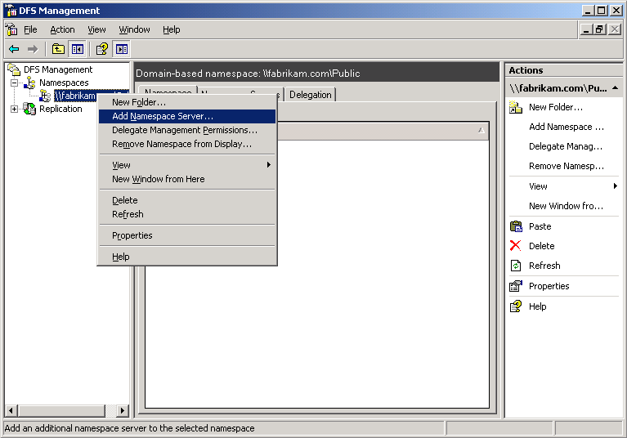
2. In the Add Namespace Server window, type in the name of the server you wish to add. You can click Browse to locate the appropriate server. Click OK to continue.
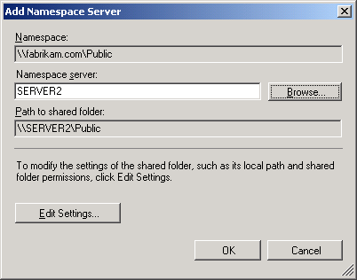
3. If a warning window appears, click Yes; this will automatically start the DFS service on the second server.
To verify that you successfully added the namespace server:
1. In the left console tree of the DFS Management window, click the \\[Your Domain Name]\[Your Namespace Name] node and select the Namespace Servers tab.
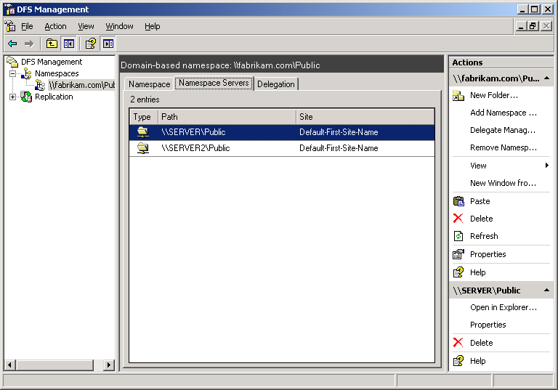
2. Notice that two UNC paths are listed. The site of each namespace server also appears. This is your verification that you successfully added the namespace server.

Delegate Management Permissions
To delegate management permissions:
1. In the left console tree of the DFS Management window, right-click the \\[Your Domain Name]\[Your Namespace Name] node and select Delegate Management Permissions.
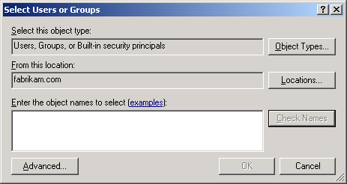
2. In the Select Users and Groups window, type in the name of the user or group you wish to grant permission to, click Check Names (select the user or group from the list if necessary), then click OK.
Note
Carefully identify and control the user or group to which you delegate permissions. You should create and use a DFS management security group for this purpose and use Active Directory Users and Computers to control membership.
To verify that you successfully delegated management permissions:
1. In the central pane of the DFS Management window, click Delegation.
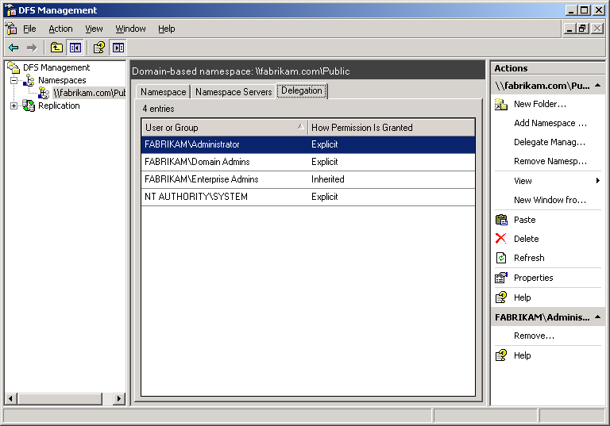
2. Note the user or group you just added now has explicit permission. This is your verification that you successfully delegated management permissions.
Note
The Administrator user or group added shows Explicit in the How Permission Is Granted column. Explicit means that you can remove the user or group from the delegation list if you right-click the user or group, and then click Remove. Any users or groups that show Inherited have inherited management permissions from Active Directory, and you cannot use the DFS Management snap-in to remove them from the delegation list. Users with Inherited permissions must be removed via Active Directory. For example, if you follow the best practice and use a DFS management security group in Active Directory, users added to the group receive inherited permissions and you must control their permissions through Active Directory Users and Computers.

Add Folders to a Namespace
To add folders to a namespace:
1. In the left console tree of the DFS Management window, right-click the \\[Your Domain Name]\[Your Namespace Name] node and select New Folder.
2. In the New Folder window, type in the name of the new folder and click OK. In this example the new folder is 'Documents'.
3. In the left console tree of the DFS Management window, note the new folder.
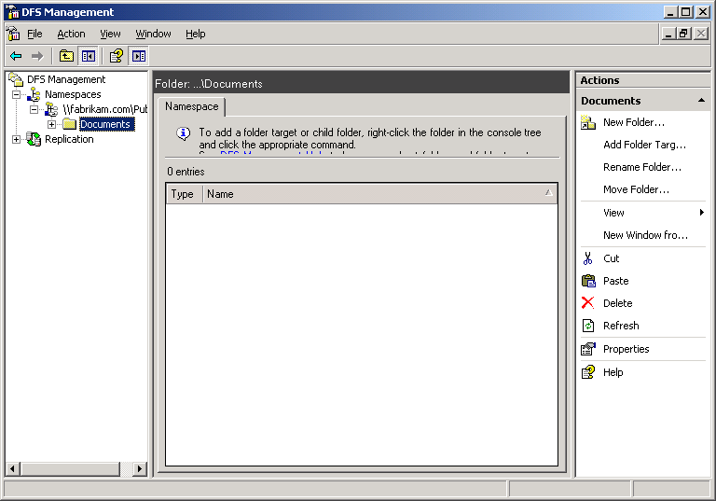
4. In the left console tree of the DFS Management window, right-click the folder you just created and select New Folder. This will create a new folder within the folder you just created.
5. In the New Folder window, again type the name of the folder. Click Add.
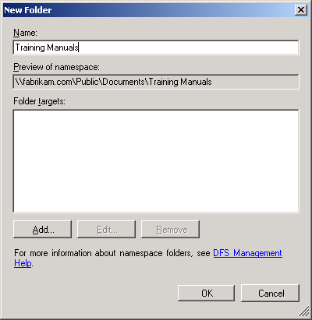
6. In the Add Folder Target window, enter the name of the shared folder to host the new folder in the Namespace. If the folder does not exist, you must create it. You can also choose Browse to locate a folder or create a new one. In this example the target folder is Training Manuals.
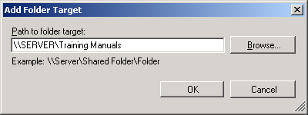
7. In the New Folder window, click OK.
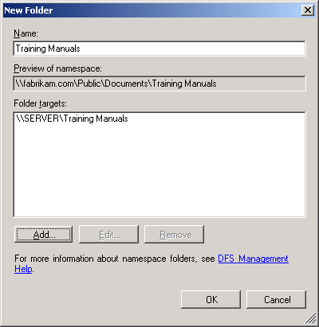
8. Expand the first folder you created, and click the second folder.
Note
The different icons differentiate folders with targets from folders without targets. Notice there is a single path shown. This means that only one server hosts the folder target that corresponds to the new folder. If that server becomes unavailable, the shared folder is also unavailable.
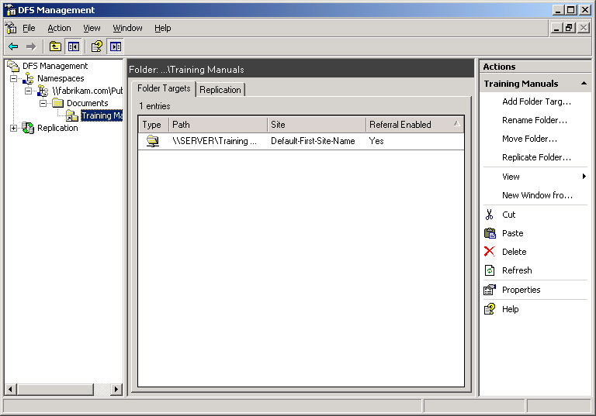
9. In the left console tree of the DFS Management window, right-click the second folder you created and select Add Folder Target. Click Browse.
10. In the Browse for Shared Folders window, click Browse again, then enter the name of another server on your domain (in this example, 'Server2') and click Check Names. Click OK.
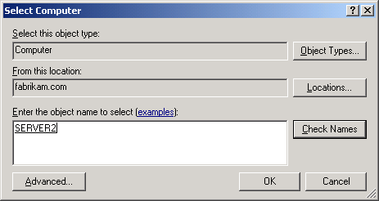
11. On the Browse for Shared Folders screen, click New Shared Folder.
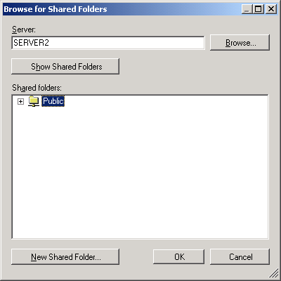
12. In the Create Share window, type the name of the new shared folder and the local path where you want to create the share. If the folder does not exist, you must create it now. You can also click Browse to select a shared folder. Also, enter the name for this share and select the permissions. Click OK three times to close all three windows.
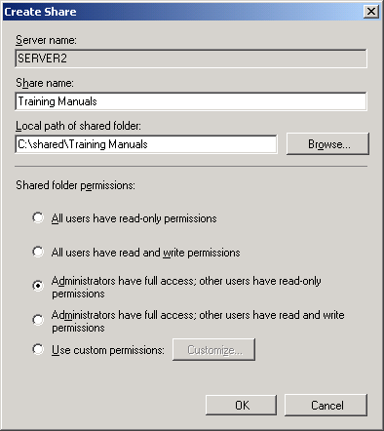
13. In the Replication warning, select No. (We will explore Replication later.)
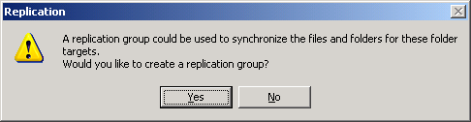
To verify that you successfully added folders to the namespace:
1. In the center pane of the DFS Management snap-in, note that there are now two targets for the second folder you created. This is your verification that you successfully added folders to the namespace.
2. Continue to make as many folders as you like. Remember that you can arrange them in hierarchies as in Windows Explorer, and you can choose whether or not to assign targets.

Use DFS Replication to Replicate a Folder in the Namespace
To use DFS Replication to replicate a folder in the namespace:
1. In the console tree in the left console pane of the DFS Management snap-in, right-click the second folder you created (the one with two targets) and select Replicate Folder.
2. On the Replication Group and Replicated Folder Name page, accept the defaults and click Next.
3. On the Replication Eligibility page, accept the defaults (which will be the two shares you targeted earlier) and click Next.
4. On the Start Service page, click OK to start the service.
5. On the Primary Folder Target page, select either target and click Next. If one of the two targets had contains more up-to-date content, you should select that target.
6. On the Topology Selection page, ensure that Full Mesh is selected and click Next.
Note
A full-mesh replication group topology allows each member of the replication group to replicate with every other member. This topology works well when there are ten or fewer members in the replication group. A full-mesh topology is not recommended if you have more than ten members in the replication group.
Another topology is the hub-and-spoke topology. This topology requires three or more members. For each spoke member, you can choose a required hub member and an optional second hub member for redundancy—this optional hub ensures that a spoke member can still replicate if one of the hub members is unavailable. (Note that if you specify two hub members, the hub members will have a full-mesh topology between them.)
When choosing a topology, keep in mind that two one-way connections are created between the members you choose. These two connections allow data to flow in both directions. For example, in a hub and spoke topology, data will flow from the hub members to the spoke members and from the spoke members to the hub members. If you want to set up a one-way connection between two servers, you can disable individual connections after you complete the wizard.
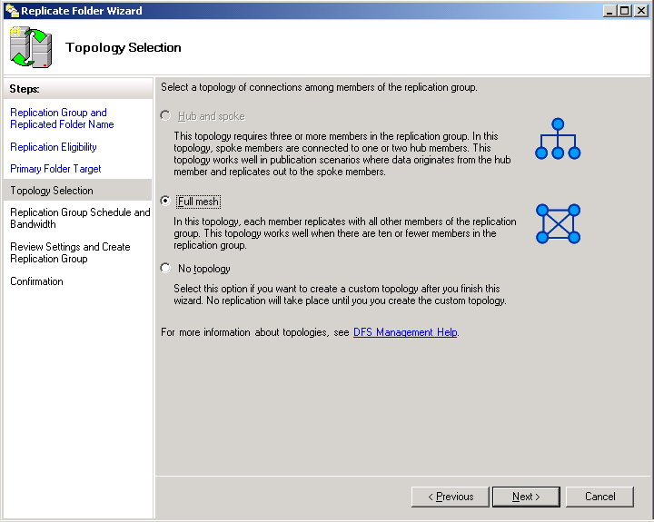
7. On the Replication Group Schedule and Bandwidth page, ensure that Replicate continuously using the specified bandwidth is selected, and that the bandwidth is set to Full, and click Next. This selection best keeps your folders in synchronization.
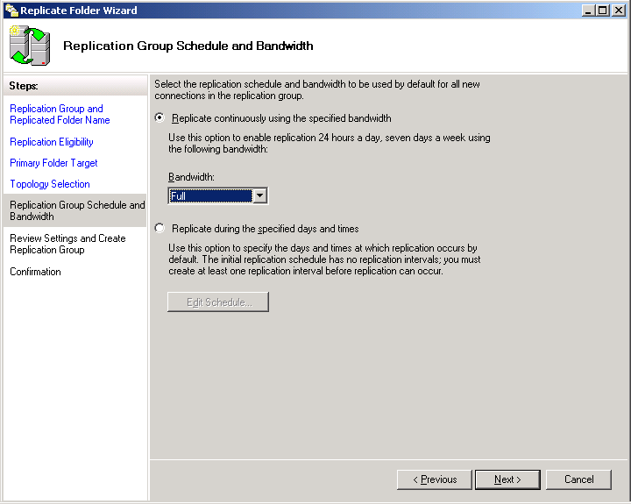
8. On the Review Settings and Create Replication Group page, review the settings and click Create.
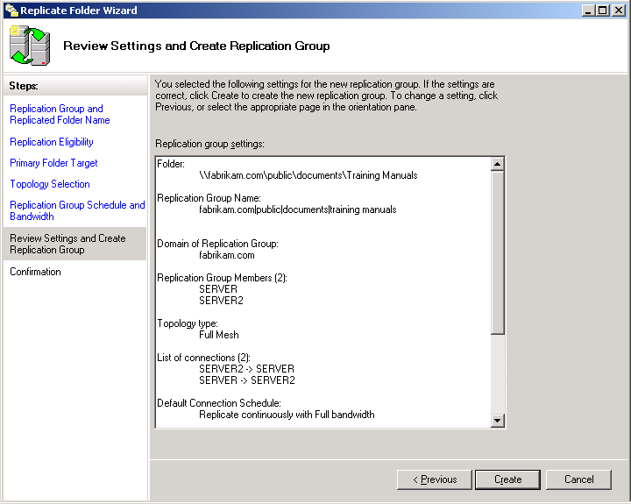
9. On the Confirmation page, wait for the process to complete then click Close.
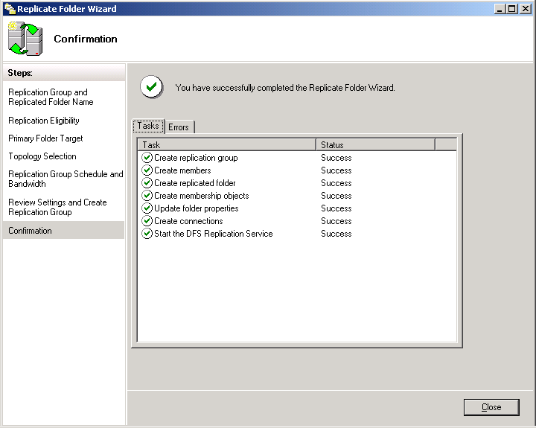
10. On the Replication Delay message, click OK. This information indicates that the replication will not necessarily begin immediately. (Select Do not show this again to ensure that this message will not show up again while you test.)
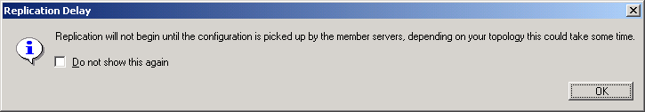
To verify that you successfully used DFS Replication to replicate a folder in the namespace:
1. In the DFS Management snap-in, expand Replication in the console tree in the left console pane and select the new replication group. This is your verification that you successfully used DFS Replication to replicate the folder in the namespace.
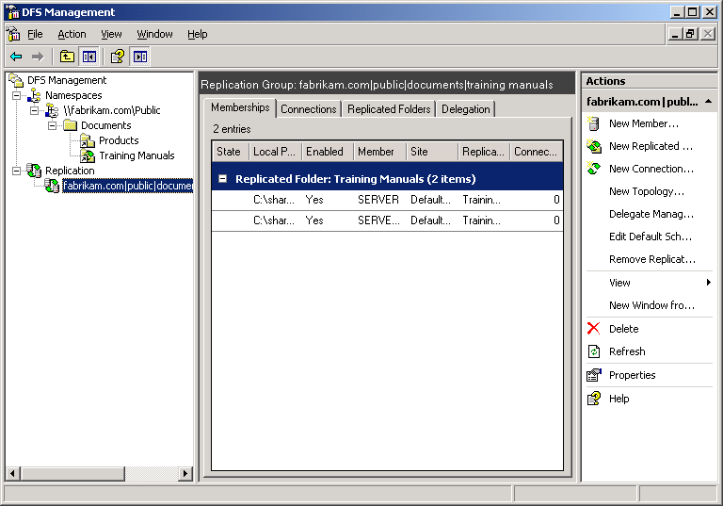

Test Failover Functionality in DFS
To test failover:
1. Double-click the third folder you created. Right-click that folder in the folder tree, click Properties, then select the DFS tab. Notice that only one folder target is listed in the referral list. Your client computer is currently connected to this folder target. Click OK.
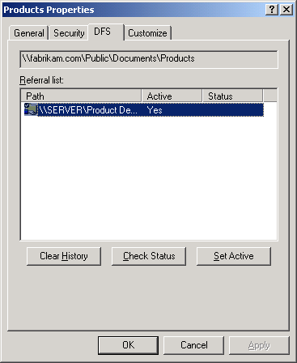
2. Return to the DFS Management window, select the second folder (the one with two targets) in the left console tree, then right-click one of the folder targets and select Disable Folder Target.
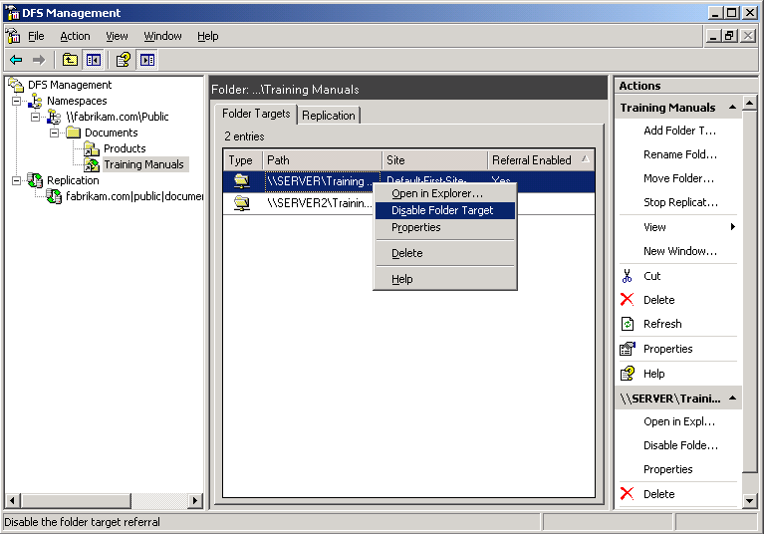
3. Return to Windows Explorer and repeat steps 1 and 2. These steps should continue to work because another server continues to host the namespace and the shared folder. This is your verification that the failover works.

Additional Resources
For more information about DFS Replication and DFS Namespaces, see:
- "Overview of the Distributed File System Solution in Microsoft Windows Server 2003 R2" on the Windows Server 2003 R2 page on the Microsoft Web site at http://go.microsoft.com/fwlink/?LinkId=46921
- “DFS Management” on the TechNet Web site at http://go.microsoft.com/fwlink/?LinkId=67421
- “Step-by-Step Guide for the Distributed File System Solution in Windows Server 2003 R2” on the TechNet Web site at http://go.microsoft.com/fwlink/?LinkId=67424
For more information about Windows Server 2003 R2 and the Windows Server System, see:
- the Windows Server 2003 R2 home page on the Microsoft Web site at http://go.microsoft.com/fwlink/?LinkId=51540
- the Windows Server System home page on the Microsoft Web site at http://go.microsoft.com/fwlink/?LinkId=49867

