
Equipment Maintenance

Benefits
- Work the way you want
Equipment Maintenance gives you
extraordinary flexibility throughout
your service/repair organization. Define
defaults, options, and control information
— including default bill-to addresses,
equipment types, services provided, and
work performance codes.

- Streamline processes
Enter your customer’s existing or new
equipment information, equipment details,
and other information — such as warranty
and preventive maintenance codes —
all from a single screen. Whether you’re
entering a new piece of equipment on
the fly or performing look-ups, retrieving
customer information has never been
easier.

- Manage information better
Keep a complete history of all work orders,
equipment, and sites, which can be stored
in summary or detail, and accessed on
screen or in report form. With detailed
tracking information at your fingertips,
you can better manage specific accounts
or areas for your service business and
offer your customers the best in
personalized service.

- Automate maintenance tasking
Let Equipment Maintenance take care
of preventive maintenance tasking.
Equipment Maintenance can automatically create tickets for the periodic preventive maintenance events required for selected equipment; create standard task lists that can be printed for use as field checklists;
and generate materials lists for ordering
and pickup prior to on-site service.

- Match personnel to tasks
Keep current, accurate records of
technician skill levels, employee and
company licenses, and pending licensing expirations for local authorities and
business partner requirements. Equipment Management filters your employee database so that you can match the right technician with the right job.

Microsoft Dynamics™ SL

Track and control every aspect of routine and unscheduled equipment maintenance. Microsoft Dynamics SL Equipment Maintenance automates the work order process, allowing your maintenance department to generate work orders more quickly and accurately, track work orders
with user-defined criteria (making time stamps obsolete), perform detailed accounting procedures with ease, and execute all of your maintenance/ repair procedures with maximum efficiency.

Enter
detailed information for
any piece of equipment you service from a single screen.

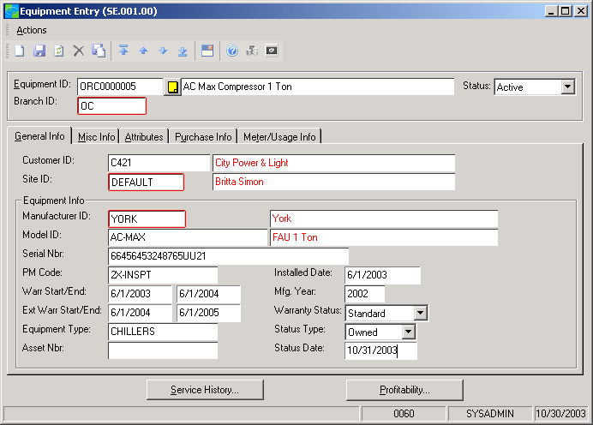

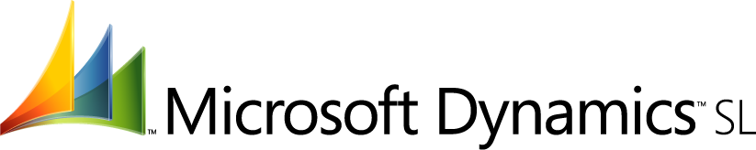

features

BENEFITS

Multi-level User-Defined Defaults | Accelerate data entry by using a wide range of default field values —  including items as universal as the current date and as specific as call types,  problem codes, or credit history codes.
Rapid Entry and Access | Capture crucial service call information and perform time-critical tasks like  creating work orders “on-the-go.” Access call history, customer information,  and equipment information quickly for reference or for added entry.
Data Access Controls | User-defined tables with customizable view/edit features allow you to control who may access, change, or edit data.
Detailed Record Keeping | Document detailed equipment attributes, including purchase information,  using a single screen. Customers will appreciate the level of information  you have about their equipment and its many detailed components.
Equipment Profitability Tracking | Track profitability for any piece of equipment and review its service history.  View data by months and year-to-date.
Proactive Recommendations | Equipment Maintenance helps you make proactive recommendations about our customers’ equipment before a disaster occurs that would affect day-to-day operations.
Flexible Assignment | Assign technicians according to site, skill, license requirements, or individual equipment assignment. Assign costs according to your specific accounting requirements.
Flexible Scheduling | Schedule routine inspections according to calendar or metering criteria  such as mileage, hours, or equipment cycles/uses.
Up-to-the-Minute Information  Management | Access detail or summary information for work orders, equipment, and site information — including manufacturer/model information, serial and asset numbers, warranty status, call history, and complete equipment performance records. Information can be viewed either on screen or in print.
Seasonal Tasking | Enter a Season Code to assign preventive maintenance schedules for specific periods of the year.
Dispatch Integration | Integrate your equipment maintenance tasks with your dispatch services without overwhelming dispatchers with preventive maintenance calls.

For more information about Microsoft Dynamics™ SL, visit: http://www.microsoft.com/dynamics/sl

This document is for information purposes only.
MICROSOFT MAKES NO WARRANTIES, EXPRESS, IMPLIED, OR STATUTORY, AS TO THE INFORMATION IN THIS DOCUMENT.

© 2005 Microsoft Corporation. All rights reserved.
Microsoft, The Microsoft Dynamics Logo, are either registered trademarks or trademarks of Microsoft Corporation or Microsoft Business Solutions ApS in the United States and/or other countries. Microsoft Business Solutions ApS is a subsidiary of Microsoft Corporation.

