
About Scotland – facts and figures

Population: 5,078,400 (2004)

Area: 78,132 sq. km

GDP: £77,929 million (2003)

GDP per head: £15,409 (2003)

Labour force: 2,573,000 Apr – Jun 04

Employment: 2,413,000 Apr – Jun 04

Average weekly wage: £436.80 (Apr 03 – full time employment)
Flag: St Andrew’s Cross – the ‘Saltire’
Capital: Edinburgh
Cities: Aberdeen, Dundee, Edinburgh, Glasgow, Inverness and Stirling

Major industries: engineering, electronics, biotechnology, financial services, oil and gas, tourism, research and development and the creative industries including digital media

Business Strengths - Financial Services
Financial services generate £6bn (over 6%) of Scottish GDP employing 113,000 people directly and 90,000 in a range of related industries. Between 2000 and 2005 financial services in Scotland grew by 36%, significantly faster than the UK financial services industry as a whole.

Energy - Oil & Gas, Renewable Energy
Scotland is rich in natural energy resources - the majority of the UK's oil production and around half of its gas production comes from fields based in the continental shelf around Scotland.
Scotland already sources 16% of its electricity from renewable sources, and has one of the most challenging targets in Europe: to achieve 40% of electricity generation from renewables by 2020.

Life Sciences - Scotland has one of the largest and fastest growing life sciences communities in Europe. We're also home to some 15% of the UK's life sciences companies, adding up to over 590 organisations and 29,500 people.
Tourism - A record number of overseas visitors came to Scotland in 2005 - 2.4m tourists a 50% increase on 2001. Business tourism is worth £905m to Scotland, and accounts for 21% of total tourism spend.
Key employers - Ardana science, HBOS, IBM, NCR, JP Morgan, ProStrakan, BP, Royal Bank of Scotland, Scottish and Newcastle, Scottish Power, Standard Life, Sun Microsystems Scottish and Southern Energy, and the public sector.

Education - 14 universities, 7 specialist higher education institutions and 46 further education colleges. Over 50,000 non-Scots choose to study in Scotland each year.

Politics - Since 1999 Scotland has had its own parliament. It has the power to pass laws on all devolved matters which includes health, education, the environment, the arts and has the power to vary the basic rate of income tax (currently 22 pence in the pound) in Scotland by up to 3 pence in the pound. The Scottish government, known as the Scottish Executive, is currently a coalition between the Scottish Labour Party and the Scottish Liberal Democrats.

Scotland is part of the United Kingdom (UK), which also includes England, Wales and Northern Ireland. The UK is part of the European Union (EU) and the Commonwealth.

Currency - Pound Sterling (£)

Area - Scotland covers 79,000 square kilometres of land.

About the Scottish Parliament

In 1998, the Scotland Act was passed by the UK Parliament at Westminster and led to the establishment of the first Scottish Parliament since 1707 - the end result of many years of campaigning and the beginning of a new era of devolved government in Scotland.

The Parliament sat for the first time on 12 May 1999 and took up its full legislative powers on 1July 1999. 129 Members of the Scottish Parliament (MSPs) meet in our building at Holyrood, in the heart of Edinburgh.
The Parliament exists to determine, debate, decide and legislate on issues of importance to the people of Scotland, and in doing so, it holds the Scottish Executive (government of Scotland) to account.
Scotland's new Parliament sits at the foot of Edinburgh's famous Royal Mile in front of the spectacular Holyrood Park and Salisbury Crags. Constructed from a mixture of steel, oak, and granite, the complex building has been hailed as one of the most innovative designs in Britain today.
Drawing inspiration from the surrounding landscape, the flower paintings by Charles Rennie Mackintosh and the upturned boats on the seashore, Enric Miralles, one of the world's premier architects, developed a design that he said was a building "growing out of the land". The building was formally opened by Her Majesty The Queen on 9 October 2004 and almost 1 million people have now visited Holyrood.
Find out more at www.scottish.parliament.uk
For general enquiries: 0131 348 5000 or 0845 278 1999 (local call rate)
Text phone: 0845 270 0152 RNID Typetalk calls welcome.
E-mail: sp.info@scottish.parliament.uk

For further information, Sally Coyne: 0131 348 6265
the media contact is: E-mail: sally.coyne@scottish.parliament.uk

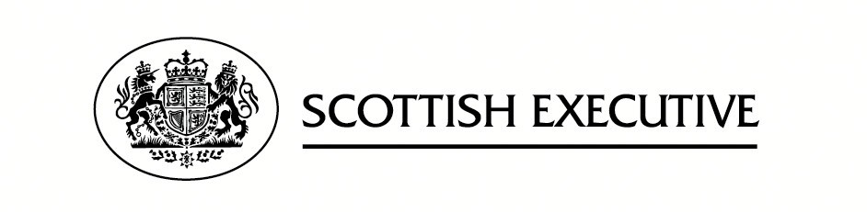

About the Scottish Executive
The Scottish Executive is the devolved government for Scotland.
It is responsible for most of the issues of day-to-day concern to the people of Scotland, including health, education, justice, rural affairs, and transport.
It manages an annual budget of more than £27 billion in the financial year 2005-2006 which is due to rise to over £30 billion in 2007-2008.

The Executive was established in 1999, following the first elections to the Scottish Parliament. It is a coalition between the Scottish Labour Party and the Scottish Liberal Democrat Party.
The Executive is led by a First Minister who is nominated by the Parliament and in turn appoints the other Scottish Ministers who make up the Cabinet. Executive civil servants are accountable to Scottish Ministers, who are themselves accountable to the Scottish Parliament.
You can find out more about the Executive at www.scotland.gov.uk and more about Scotland at www.scotlandistheplace.com

Press enquires to: Susan Dalgety 0131 244 4080
susan.dalgety@scotland.gsi.gov.uk


About Scottish Development International

Scottish Development International works to attract inward investment and knowledge to Scotland in order to help the economy grow. SDI also works to help Scottish companies do more business overseas and to promote Scotland as a good place to live, work and do business. It is jointly operated by the Scottish Executive and Scottish Enterprise. Its work is guided by the global connections theme of the Scottish Executive's Smart Successful Scotland strategy for economic development in Scotland.
www.scottishdevelopmentinternational.com
Press enquiries to: Stephen Sharp 0141 228 7364 / 07786 126 629 stephen.sharp@scotent.co.uk

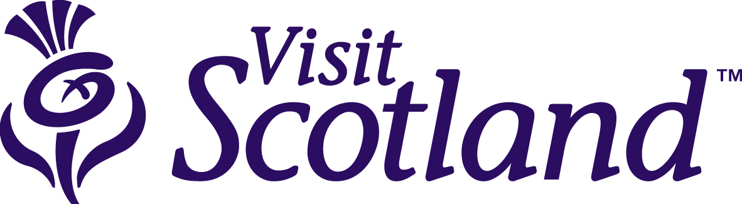About VisitScotland

VisitScotland’s role is to provide leadership, direction and support to the tourism industry through marketing Scotland at home and overseas with the ultimate goal of generating jobs and wealth. Our aim is to make Scotland a must-visit, must-return destination where visitors’ needs come first and tourism makes a vital contribution to economic growth. Indeed, our ambition shared with the tourism industry and the Scottish Executive is to drive the value of tourism to the Scottish economy from £4.2 billion to £6.3 billion in the next decade.

Business tourism – meetings, conferences, incentive programmes and corporate hospitality – will play a central role in helping us achieve this ambition. Already, business tourism accounts for almost a quarter of tourism spend. It’s a lucrative market with spend per night by business visitors being 80% higher than that of leisure visitors. More information on VisitScotland can be found at: www.visitscotland.org.

Press information: Chris Maguire 0131 472 2210
chris.maguire@visitscotland.com

