CIO Scorecard Fosters Strategic Performance Management Culture
Customer Profile
As the worldwide leader in software for business and personal computing, the vision of Microsoft Corporation is to enable people and businesses throughout the world to realize their full potential. Employing more than 90,000 people, Microsoft had revenues exceeding US $51 billion for the year ending June 2007.
Situation
Initial CIO Scorecards had an operational focus and did not achieve the level of executive support needed to effectively create a performance driven culture. Lack of change control undermined the accuracy and accountability of the scorecard.
Solution
Microsoft IT utilized well-defined processes based on best practices and the Microsoft Business Intelligence stack to develop a mature CIO Scorecard aligned to the Microsoft corporate strategy. The solution included:
- Microsoft Office PerformancePoint Server 2007 Monitoring and Analytics
- Microsoft Office SharePoint Server 2007
- Microsoft SQL Server 2008
Benefits
- A CIO Scorecard that is aligned to corporate objectives and strategies.
- A CIO Scorecard that enables, sustains, and effectively drives performance across the organization.
- A CIO Scorecard with a high level of confidence achieved through a well-defined change control process.
Published: January 2009
Microsoft IT falls under strict corporate scrutiny to demonstrate its business value and return on investment. The CIO Scorecard at Microsoft helps to strategically align the organization with corporate and fiscal objectives, manage organizational performance, and demonstrate the value of IT across the enterprise. The CIO Scorecard has matured to a level that enables, sustains, and drives business strategy execution.

Introduction
Microsoft Information Technology (Microsoft IT) uses scorecards as their vehicle for measuring their performance as an organization. It is the promise that they make to their business partners and to Microsoft corporate, to ensure that they are driving the right activities for successful execution of their strategies.
Microsoft IT scorecards have evolved over the last couple of years. Initial versions had an operational focus and did not achieve the level of executive support needed to effectively create a performance driven culture. With every year, the scorecard became more balanced and strategic, broadening its scope, and enabling the IT organization to align to corporate objectives. Today the CIO Scorecard, through a series of implemented processes and best practices, has achieved a level of maturity that enables, sustains, and effectively drives the performance of the IT organization.
This business case document contains best practices for planning, developing, and implementing the CIO Scorecard to enable performance management in the organization. While the process focuses on the IT organization and the CIO Scorecard, the process can be applied to other organizations that are ready to embrace a performance management culture.
This document is aimed at IT executives who want to embrace a performance management culture and who look to implement an organizational scorecard by leveraging the best practices and processes developed in the Microsoft IT organization.
Solution
Microsoft IT took a phased approach to the CIO Scorecard project by defining planning, developing, and implementing as the major phases. They used a series of tollgates as their checkpoints during these phases to keep the project on track. A single point of contact or program owner was key to facilitating the project through each phase and ensuring that the project milestones stayed on target and on track. The following business case goes through the step-by-step process and examples of how the CIO at Microsoft aligned IT to the company strategy, cascaded down IT objectives through organizational commitments, and executed the entire process using a CIO Scorecard.
Phase One: Planning the CIO Scorecard
The process of developing and implementing a CIO Scorecard can be a lengthy and complex undertaking without a proper and robust planning process in place. Investing time and resources in the planning process increases the likelihood of implementing a successful scorecard. The key milestones in the planning process were to:
“The scorecard is our vehicle for measuring our performance as an organization. It is the promise we make to our business partners and to corporate, to ensure that we are driving the right activities for successful execution of our strategies.”
Tony Scott
CIO
Microsoft Corporation
- Obtain executive sponsorship
- Assemble the scorecard project team
- Determine the scorecard model and structure
- Develop a work back plan

Obtain Executive Sponsorship
One of the initial tasks of the planning phase is to obtain an executive sponsor. This top-down approach is more effective than a bottom-up approach, which typically takes more time and has a higher risk of failure.
Executive sponsorship is critical, especially in the planning phase, as the scorecard definition process should be an integral part of the strategy definition for an organization. In addition to this, the scorecard needs to be monitored continuously and it should generate improvement actions to address performance gaps. Without the appropriate level of support, these actions fail to generate the needed change across the organization to improve performance and the effectiveness of the scorecard is diminished.
To obtain this sponsorship, the proposal needs to be clear on the value it will provide the organization. Following is a summary of some of the key selling points:
- Enables direct alignment to corporate objectives
- Creates a common platform for monitoring and managing performance
- Drives towards a performance driven culture with clear definition for accountability
Once executive sponsorship has been achieved, the next step is to form a team with key stakeholders that can help define and drive the scorecard implementation across the organization.
Assemble the Scorecard Project Team
During planning, the scorecard will go through several iterations and reviews. The average timeframe for planning a CIO Scorecard is between three to six months. It is important to include key stakeholders during planning sessions, but you should limit the number, as too many stakeholders can slow down the decision making process. The planning team should include the following members:
- Key stakeholders: The executive who sponsors the scorecard and the executive team.
- Virtual scorecard team: A community of business managers and chiefs of staff who understand the details of each business unit.
A good communication mechanism is to create a distribution group with community stakeholders and keep them updated via e-mail on the decisions being taken.
During the planning process, expect to face resistance and criticism for decisions being taken. Obtaining community feedback is good but you should be prepared to escalate to the executive team where appropriate when decisions or recommendations cannot be made. The community needs to feel that they are part of the solution; otherwise, the scorecard can face a challenge on adoption. Use a stakeholder analysis form to identify each stakeholder’s level of commitment to the project.
Table 1. Stakeholder Analysis Example
Level of Commitment | Executive Stakeholder | Stakeholder #1 | Stakeholder #2 | Stakeholder #3
Enthusiastic Support  Will work hard to make it happen |  |  | X ●
Help It Work  Will lend appropriate support | X ● | X ● |  | ●
Hesitant
Holds some reservations; will not volunteer
Indifferent
Will not help; will not hurt
Uncooperative
Will have to be prodded
Opposed
Will openly act on and state opposition
Hostile
Will block at all costs
Not Yet Informed  Involve when appropriate |  |  |  | X
Legend: X = Where they are ● = Where you want them to be

Determine the Scorecard Model and Structure
The structure of a scorecard can have a significant impact on how it enables performance management in the organization. There are different models that can be used depending on the level of accountability and change that is intended to be driven.
In creating the CIO Scorecard, IT management will have to make a decision on how to best structure the CIO Scorecard to create the desired results in the organization.
Microsoft IT determined that the CIO Scorecard would be a collection of aligned scorecards, each having a specific purpose, audience, and focus. In addition to the main CIO Scorecard, these scorecards span vertically across the organization, aligning each IT business unit (Sales, Finance, Legal, and so on) to the same objectives for which the CIO is accountable.
The CIO Scorecard is also included in the broader Sales and Marketing scorecard set that is aligned across the organizations. The CIO Scorecard was developed in coordination with the Sale and Marketing yearly update and monthly publication cycle. It is included in the quarterly review process at the executive level for leaders across groups outside of Microsoft IT.
Determining the scorecard model and structure involves deciding on how deep within the organizational structure change needs to be driven. The primary considerations are the number of scorecards to be developed, the depth of the organization, the audience, the purpose, and the focus.
The following table summarizes examples of the types of scorecards that can be used. The table is useful for defining the audience, main purpose, focus, and the size of each scorecard. Once the model is defined and all necessary scorecards have been identified for implementation, time estimates can be calculated to use in the development of the work back plan.
Table 2. Scorecard Model Example
Level | Audience | Purpose | Focus | # Metrics*
Level 0 | CxO; Board | Business scorecard visible to CxO-level management. | High Level/  Strategic | < 15 metrics
Level 1 | CIO;  CIO Directs | Used by CIO and the leadership team to manage key commitments and critical success factors across the organization. | High Level/  Operational | < 30 metrics
Level 2 | IT General Managers (GMs); Directors; Managers; Employees | Used by IT Senior Leadership to measure, align, and drive performance in each respective organization. | Operational | < 15 metrics per organization
Business Partners | Business Partners; Solution Delivery Teams; IT Business Units | Scorecards used for assessing the performance of programs, Key Performance Indicators (KPIs), and relationships across each IT business partner segment. | High Level/  Operational | < 15 metrics  for each segment
* Less than 15 metrics per Level 2 organization or Business Partner is optimal, but the number of metrics defined should be based the actual number required to effectively manage the complexities of your business model.

Develop a Work Back Plan
Once you have determined the scorecard model and have an idea of how many scorecards need to be implemented, a detailed work back plan will help determine the length of the project and key milestones.
The first step to implementing a scorecard in the organization is to determine a specific launch date and plan back from that date. Determining the estimated length of the project will depend on how deep in the organization input will be gathered and the number of metrics and scorecards that will be developed.
Locking each version at every milestone reached is key to effectively defining the scorecard. Changes to scorecard definitions should be discouraged and tightly controlled. A change request process with an established approval process is essential to managing any changes needed during the definition process. Details on how to implement a change request process are outlined in the "Phase Three: Implementing the CIO Scorecard" section of this document.
Key scorecard milestones to include in the work back plan are shown in the following table.
Table 3. Key Scorecard Milestone Examples
Plan/Develop Milestones | Implement/Launch Milestones
Kick off meeting with stakeholder team | Implement top-level scorecard
Obtain corporate alignment guidelines | Implement all levels scorecards
Finalize scorecard model | Review and test with all stakeholders
Lock first version of top-level scorecard metrics | Final review with executive stakeholders
Lock complete operational definitions | Deploy scorecards into production
Review and sign-off on operational definitions | Limited launch to key stakeholders
Lock second version of top-level scorecard metrics | Populate first cycle of scorecard
Lock all metric targets and enforce change request | Publish and review first cycle
Lock all levels (L0, L1, L2) of scorecard metrics | Executive e-mail to entire organization on launch
Review and final sign-off (all levels) | Drive performance management

Key takeaways from planning the CIO Scorecard
- It is important to carefully select the project team. Too many members can randomize the project, while too few can isolate it.
- Locking in progress at each milestone helps drive the project along. Resist the urge and pressure to change at each review cycle.
- Setting early expectations and communicating progress ensures a smooth project.

Phase Two: Developing the CIO Scorecard
Only once a robust planning process is established and communicated to all project members and key stakeholders can the process of defining and developing the CIO Scorecard start. The power of the scorecard is that it can help organizations establish strategic direction and it can drive accountability to achieve that direction. The process of defining direction starts with aligning to the corporate strategic objectives and defining how the organization contributes and is accountable to that strategy. The main milestones Microsoft IT followed to develop the CIO Scorecard were to:
- Align and cascade company objectives
- Define key performance indicators
- Manage change
- Review and signoff

Align and Cascade Company Objectives
In defining strategic direction, an organization must take into account the higher-level corporate objectives that the company is driving towards. Not doing so can create a siloed organizational strategy that does not align with where the company is headed and can be at risk of becoming irrelevant. As more companies push towards cost efficiency initiatives and consolidation, aligning to corporate objectives becomes a key requirement to ensuring business relevance.
In mature companies that have embraced well-defined strategic mapping, this process can be as simple as cascading those initiatives down to each respective organization and defining organizational level objectives and key performance indicators that drive towards those initiatives. Less mature companies will need to spend time clearly defining the strategic objectives intended to be driven across the company. At Microsoft, the corporate strategic objectives were already clearly defined and cascaded down to each organization during the yearly business planning and commitment setting process. This facilitated the process for Microsoft IT to align to corporate objectives.
Table 4. Scorecard Alignment Example
Corporate-level Objectives | Organizational- level Objective | Organizational- level KPI Scope | Organizational-level  Initiatives and Projects
Demonstrate Value | Deliver case study materials to the sales force | Number of case study offerings per quarter | Drive awareness  Deliver white papers and business cases
Improve Satisfaction | Obtain high level of internal client satisfaction ratings | Overall User Net Satisfaction (NSAT) with IT | Improve service availability  Improve support service level agreement (SLA)
Enable the Business | Deliver top strategic IT programs on time and on budget | Percentage of programs delivered on time  Percentage of programs delivered on budget | Strengthen governance and enforce program tollgate reviews

For Microsoft IT, the scorecard planning and development process became the foundation of the organization’s business planning and commitment setting process for the fiscal year. The scorecard clearly articulated how Microsoft IT aligned to the corporate objectives, how it intended to measure its progress, and what it needed to deliver to reach those objectives. Through the organizational commitment setting process, accountability for each objective and KPI was distributed to executive owners that were held accountable for executing and delivering according to the plan. This process effectively tied performance to a transparent, well-defined, and measurable scorecard system that enabled corporate accountability and fostered a strategic performance management culture within the organization.
“During previous years the scorecard would change dramatically due to lack of planning and change management. Having a robust plan in place with defined locked milestones and processes enabled IT leadership to effectively define the scorecard without discarding previous progress made.”
Lynn Kepl
General Manager
Microsoft IT Client Experience and Business Operations
Define Key Performance Indicators
The strategic planning and objective alignment processes are the key drivers to ensuring the scorecard is properly defined with the "right" set of metrics. Scorecards are often developed to metrics and not to an organization's KPI. While KPIs are metrics, metrics are not always KPIs. Metrics can represent the measurement of any business activity where KPIs always reflect strategic value drivers, measuring the performance of an organization in achieving its goals and objectives. Failed scorecard development exercises often jump directly into the metric definition process without spending the time to plan, strategically align, and truly understand the behavior that KPIs are driving. Table 4 shows an example of how to properly align and select these KPIs by aligning to corporate objectives and cascading them into the organization.
Once the proper set of KPIs are selected, each one needs to be defined in detail to remove any discrepancies and subjectivity on what it means, how it is calculated, and why people should care about it.
Microsoft IT developed a detailed operational definition template that was used to define all of the CIO Scorecard KPIs and metrics. Once defined, each definition was reviewed in detail by the executive team and only those metrics that reached overall stakeholder agreement were signed off and locked in place.
Table 5. Operational Definition Template Example
Main Section
Metric Name: | Provide a concise metric name that clearly describes what this metric is intended to measure.
Operational Definition: | Describe what this metric is intended to measure and how it will be measured.
Impact Section
Opportunity Definition: | Identify the opportunity/business problem to be improved that relates to the performance of this metric. Briefly explain why management should be concerned with the monitoring and improvement of this metric.
Stakeholder Impacted: | Identify primary stakeholders impacted by the performance of this metric and the type of impact.
Other Impacts: | Identify any IT business process, initiatives, or other metrics directly or indirectly impacted by this metric.
Data Section
Detailed Calculation: | Detailed calculation definition/formula/query used for calculating the actual value for this metric.
Data Source: | Data source where data is being used and calculated for actual value. For example, HR Database, Sales System, and Data warehouse. Provide link to reports if available.
Data Type: | Identify the type of data values used, including:  Direction: Increasing is better, decreasing is better, or trend.  Format: # number, $ dollars, % percentage  Frequency: Monthly, quarterly, semiannual, or annual
Target Section
Baseline: | Current actual level of performance.
Year End Target  (Yellow): | Target thresholds to make the metric yellow.
Year End Target  (Green): | Target thresholds to make the metric green.
Year End Target  (Stretch): | Threshold to exceed green target.
Control Range: | Target thresholds to make the metric yellow.
Ownership Section
Metric Owner Executive: | Owner accountable for performance. This should be at the GM level and above. If more than one is included, joint ownership is assumed.
Data Provider Accountable: | Person responsible for ensuring the metric value is reported on time in the scorecard.

By using an operational definition template, the Microsoft IT executive team was better equipped to not only understand how metrics are measured, but more importantly, what they drive and why their performance is critical to executing the strategic plan.
The main challenge during this process is to be able to continue to evolve the maturity of how metrics are defined, how they are measured, what behaviors they drive, and how effective they are at driving the strategy. For Microsoft IT, this is a continuous improvement process where metrics are implemented, monitored, and adjusted when necessary. Change is essential to evolving the maturity of the scorecard, but properly managing that change is critical to a successful evolution of the scorecard. During initial implementations of the CIO Scorecard, Microsoft IT did not have an established process for managing metric and scorecard changes. Microsoft IT realized that the lack of a controlled process could lead to unauthorized changes taking place in the metric definitions. Changes, such as target threshold and calculation changes, could undermine the accuracy and accountability of the scorecard and the overall performance management system. By using Quality Business Excellence (QBE) (a Microsoft approach to Six Sigma), Microsoft IT was able to identify this as a problem, analyze its root cause, and implement a robust change control process aimed at improving the accuracy of the scorecard and ensuring confidence in the performance management system.
Manage Change
Change will happen at every stage of the scorecard process. A successful scorecard implementation depends on a robust change request process to be implemented and adopted. During the planning and development phases, changes in scorecard and metric definitions peak at its highest volume. This is to be expected as the scorecard in those stages behaves as a working document. As recommended in the Planning phase, the work back plan needs to include phased milestones where each version of the scorecard definition is locked in place and changes beyond that point forward need to be processed through the change request process. The same approach is taken once the final scorecard is implemented.
Microsoft IT developed a simple form powered by Microsoft InfoPath® Form Services that takes the requestor through the process of modifying a metric definition, providing business justification for the change, and submitting it for approval. The workflow process collates all requests in each cycle and redirects them to be approved by the executive metric owner and the scorecard owner. Once the metric receives all levels of approval, the change is implemented into the scorecard system.
Implementing the change request process has enabled a stronger sense of trust and accountability to the CIO Scorecard. The organization feels confident that the scorecard system has the proper controls in place to carry forward with accurately measuring the business performance of the organization.
Key takeaways from the Manage Change milestone
- Implement a robust change control process that is integrated with the scorecard system/back end, if possible. Stand-alone request forms can serve as a first version. A well-integrated solution with automated workflow processes enabled will provide the scalability and accuracy needed to manage the process effectively.
- Resist the pressure to bypass the change request and approval process. All changes, simple and complex, at the very least need to be properly documented, tracked, and approved.
- Communicate to the broad scorecard community on a monthly basis a summary of the changes implemented, the volume of requests received and approved, and the rhythm/calendar for requesting and implementing changes. This reassures stakeholders that there is a strong sense of accountability and accuracy in the scorecard process.
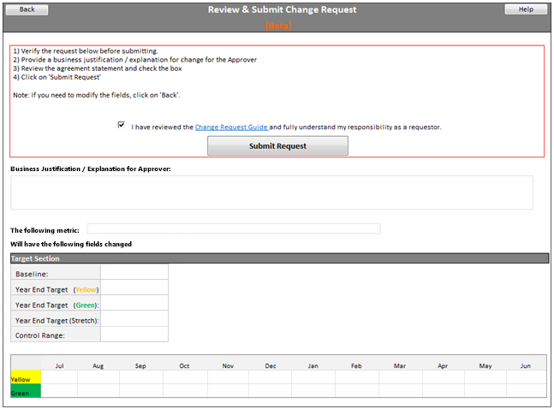
Figure 1. Change request form example
Review and Signoff
Microsoft IT utilized tollgates (checkpoints) to drive the project team forward towards finalizing the definition of the CIO Scorecard. At each tollgate, the scorecard would be locked for changes and any request to change the scorecard beyond the lock date would need to go through the change request process.
Microsoft IT took a hierarchical approach to the review and signoff, starting with the top-level scorecard, Level 0 (top 15 KPIs), and progressively working down through all levels. This top-down approach made the project timeline much more efficient as it allowed the definition and implementation processes to work in parallel from one level to the next.
During the signoff process, a package consisting of all the scorecard metric definitions is compiled and reviewed in detail. The executive team reviews and signs off on each metric collectively as a team. The key to this process is to have everyone reach agreement on all metric definitions, as these metrics will measure the performance of the organization and ultimately the performance of each executive leader in the organization.
One of the lessons learned by Microsoft IT was that if a metric is affecting what is happening in another scorecard, possibly one from another organization, there needs to be an extra step in the process where the metric is reviewed and signed off on by those stakeholders.
Key takeaways from the Review and Signoff milestone
- Reach collective agreement on metric and scorecard definitions before proceeding further. The discussion forces the executive team to further understand and refine how to go about achieving its strategic objectives.
- Look towards using leading indicators that can give a forward look at future performance versus a rearview look at past performance as you evolve the scorecard.
- Implement a change control process.

Phase Three: Implementing the CIO Scorecard
With the defined, locked scorecard in place and complete metric definitions finalized, the scorecard is at a stage where it is ready to be implemented utilizing tools that will facilitate the deployment of the scorecard across the organization. Once implemented, final reviews are scheduled with all the stakeholders and the executive team to finalize and deploy the scorecard into production. During these final reviews, last minute modifications to scorecard and metric definitions will be requested. It is important that all requests be passed through the established change request process to maintain quality and accountability.
“Driving business performance management is the main business capability of the CIO Scorecard program. It enables the organization to be forward looking and strategic while at the same time driving operational excellence into our current processes and operations”
Davor Golac
CIO Scorecard Program Owner
Along with selecting a solution to implement and finalize the scorecard, the project team worked on defining the communications plan, creating the cadence and operation processes, and establishing the mechanisms to drive performance management across the organization.
The main milestones Microsoft IT followed for the implementation of the CIO Scorecard were:
- Business intelligence solution
- Launch and communication
- Operations and review
- Drive performance management

Business Intelligence Solution
Over the past years, Microsoft IT has evolved the implementation of the CIO Scorecard, starting from simple solutions using Excel® and PowerPoint®, to more robust solutions utilizing the Microsoft Business Intelligence stack. Moving into a business intelligence solution has provided the CIO Scorecard with greater capabilities to deliver rich business intelligence not only to power users, but also to the entire organization. This expanded adoption of the CIO Scorecard powered by business intelligence has been the key enabler for instilling a performance management focus into the culture of Microsoft IT and thus enabling a system that drives business excellence. Additionally, the business intelligence solution has provided other benefits such as improved data quality, enhanced data analysis and reporting functionality, automated feeds from data sources, robust user-level security, data auditing, and backup.
For Microsoft IT the benefits and ease of implementation of the Microsoft Business Intelligence stack provided the right solution for implementing the CIO Scorecard. Without a system in place, the operational complexities and scalability challenges will most likely result in a CIO Scorecard that is outdated and does not achieve the level of adoption desired to create an impact in the organization.
The CIO Scorecard is based on a service offering from the Microsoft IT Engineering. The service uses the following products in the Microsoft Business Intelligence stack:
- Microsoft Office PerformancePoint® Server 2007 Monitoring and Analytics
- Microsoft Office SharePoint® Server 2007
- Microsoft SQL Server® 2008
This centralized internal service has been able to use the Microsoft Business Intelligence stack to develop a scalable cost-efficient platform that now is able to power not only the CIO Scorecard, but also many more performance management solutions across the Microsoft enterprise.
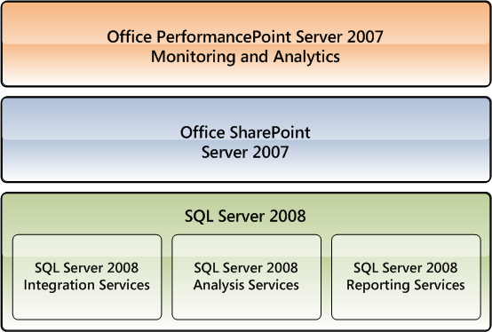
Figure 2. CIO Scorecard uses the Microsoft Business Intelligence stack
By leveraging this solution, the CIO Scorecard provides all users with access to rich business intelligence tools that improves the ability of the user to better understand the health of the organization and of key performance indicators. For example, metrics that are underperforming are required to have commentaries and improvement plans in place that will let the user know the root cause of the problem and the actions to be taken to get it back on track. Commentaries and additional metric information such as definition, calculation, and trend graphs are accessible through an InfoCenter feature that is accessed directly in the scorecard by clicking on the desired metric. The platform also allows for integration with additional analytical tools such as Microsoft ProClarity® that can provide a detailed look at the data and analysis behind each metric.
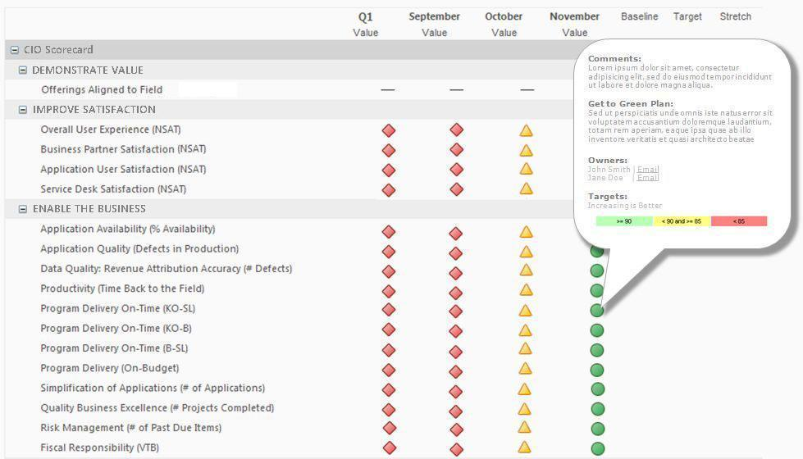
Figure 3. Example of CIO Scorecard view
Launch and Communication
The scorecard in itself is a primary communication vehicle on the strategy and performance of an organization. As such, all communications to the organization referring to strategy and performance should include references to the scorecard. At launch, the CIO Scorecard was communicated to the entire organization in the form of an e-mail communication from the CIO. Following that launch on a quarterly basis, the CIO provides Quarterly Business Update e-mail messages where the scorecard quarterly performance is summarized and metric highlights and lowlights are identified. These communications encourage the organization to understand what is key to business performance. It also allows for managers across all levels of the organization to realign projects and initiatives to those top strategic performance drivers.
Additionally, the CIO has a weekly e-mail communication where updates are provided on the latest developments across the organization. These are also used to highlight specific metrics that need attention.
Having communications sent out from the CIO to the entire organization provides good coverage and reinforces the importance of the scorecard.
Drive Performance Management
The step of moving from measuring and reporting performance to driving and managing performance is a step that every scorecard program should aim towards. While there are several methodologies that offer extensive processes and playbooks for implementing and driving performance management, the simplest approaches can prove to be the most efficient.
To simplify this concept, performance management can be seen as the corrective action or change that takes place to move from an underperforming status back into a performing one. A simple yet effective model that graphically represents this concept is the Plan, Do, Check, Act (PDCA) cycle.
The PDCA cycle (also known as the Deming cycle) summarizes the intended purpose of the scorecard process. Plan involves setting the right strategic objectives, targets, and plans. Do is the actual work, business process, and projects taking place across the organization. Check is the process of measuring, monitoring, and reporting the performance of the work that is taking place according to the plan set. Finally, Act is the actions and change that takes place to get back on plan when needed.
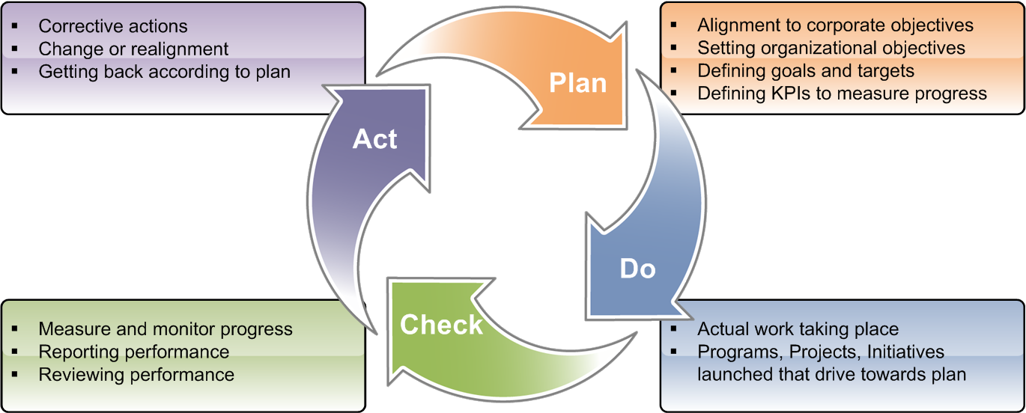
Figure 4. PDCA or Deming cycle
Additional methodologies such as Balanced Scorecard, Hoshin Kanri, and Six Sigma contain concepts that help drive the organization to focus on performance management. Microsoft IT has used these concepts as part of the planning, development, and implementation of the CIO Scorecard. For example, the Balanced Scorecard methodology developed by Kaplan and Norton is used in the CIO Scorecard as the framework for aligning objectives to the corporate strategy, mapping the organizational strategy, and balancing KPIs across different financial, customer, process, and people quadrants. Hoshin Kanri methodology developed by Dr. Yoji Akao shows the process of how to set strategic direction and manage the organization towards that direction. Six Sigma methodology, originally developed at Motorola, is used for solving business process inefficiencies that impact quality and the bottom line.
The Microsoft IT CIO Scorecard has been a powerful tool that has helped management drive and foster performance management into the organization’s culture. That said, there are additional areas of opportunity to continue to improve on these processes and methodologies.
Key takeaways from the Drive Performance Management milestone
- The scorecard is an effective tool that can help management analyze and identify where corrective actions need to take place. Driving performance management depends on how management uses the business intelligence provided via the scorecard to take the appropriate corrective action to enable change in the organization’s performance.
- Executive compensation linked to scorecard performance can drive incentive towards higher levels of business performance.
- Improve current performance management processes before creating new ones. Adding additional processes can be met with resistance across the organization.

Conclusion
The Microsoft IT CIO Scorecard planning, development, and implementation processes described in this business case study are intended to share the best practices developed in Microsoft IT to facilitate the implementation of scorecard programs for customers and partners. For Microsoft IT, these processes have evolved with each cycle. This document is by no means comprehensive. Performance management practices such as the ones driven by the CIO Scorecard are by nature processes that need to continue to be improved and matured.
As organizations look to drive down costs and refocus on business priorities, enabling this type of management system can provide organizations with the tools and processes needed to enable a high performing organization in any economic environment.

For More Information
For more information about Microsoft products or services, call the Microsoft Sales Information Center at (800) 426-9400. In Canada, call the Microsoft Canada information Centre at (800) 563-9048. Outside the 50 United States and Canada, please contact your local Microsoft subsidiary. To access information via the World Wide Web, go to:
http://www.microsoft.com
http://www.microsoft.com/technet/itshowcase
© 2009 Microsoft Corporation. All rights reserved.
Microsoft, Excel, InfoPath, PerformancePoint, PowerPoint, ProClarity, SharePoint, and SQL Server are either registered trademarks or trademarks of Microsoft Corporation in the United States and/or other countries. The names of actual companies and products mentioned herein may be the trademarks of their respective owners.
This document is for informational purposes only. MICROSOFT MAKES NO WARRANTIES, EXPRESS OR IMPLIED, IN THIS SUMMARY.

