Windows Azure
Customer Solution Case Study
 | 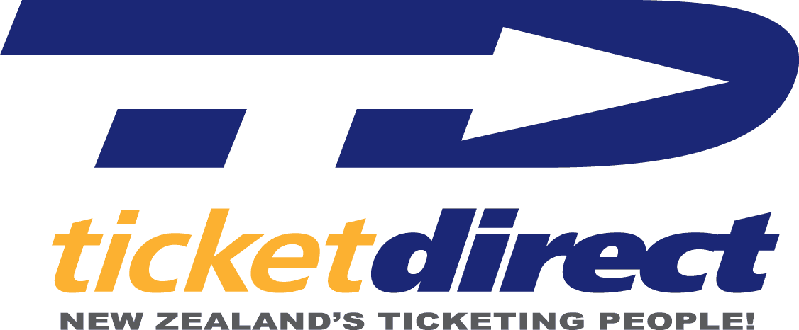 |  |   Ticket Seller Finds Ideal Business Solution in Hosted Computing Platform

Overview  Country or Region: New Zealand  Industry: Media and entertainment industry  Customer Profile  TicketDirect International, based in Dunedin, New Zealand, provides online and on-premises ticketing services for a network of 80 sporting and cultural venues in New Zealand and Australia.  Business Situation  TicketDirect wanted to improve its ability to sell tickets quickly and better manage the highly elastic peak loads commonly seen when big events go on sale.  Solution  TicketDirect has begun using Windows Azure™ to move to a cloud computing model that offers highly scalable processing and data storage capabilities and reduces hardware and IT costs.  Benefits  - Reduced costs and greater IT agility  - Familiar tools and flexible development  - Powerful database capabilities  - A trusted platform for future growth |  |  | “Now we’ll be able to apply more of our internal resources to delivering an even better user experience, since we won’t have to use those resources for managing and troubleshooting hardware platforms.”  Matthew Davey, Founder, TicketDirect
 |  |  | New Zealand–based TicketDirect International has grown into a major ticketing service for venues in Australia and New Zealand. The company’s focus on excellent customer service led it to look for a better way to handle peak system loads during major event ticket sales. Working with Microsoft® Gold Certified Partner Intergen, TicketDirect has begun redesigning its system to work from a “cloud computing” environment using the Windows Azure™ platform. The company is rebuilding its customer application as a Windows Azure application and migrating its data to a Microsoft SQL Azure™ database. By moving to an off-premises, cloud solution, TicketDirect is able to easily and cost-efficiently scale its computing resources in response to real-time demand while simultaneously giving up the cost of maintaining its own hardware. This move frees IT resources to focus on more customer-centered needs.
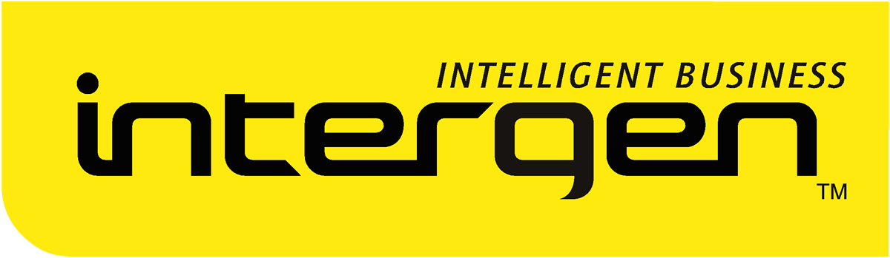 |  |  | 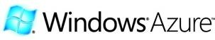

Situation
In the past ten years, TicketDirect International has grown from a small rugby-specific ticketing business into the major ticketing service in New Zealand for sporting and cultural events. Based in Dunedin, TicketDirect provides online and on-premises ticketing services for 80 venues in New Zealand and Australia. The company was responsible for 45 percent of professionally ticketed event sales in New Zealand in the first half of 2009.

TicketDirect has managed this rapid growth in the face of competition like United States–based Ticketmaster and Australia’s Ticketek by focusing on the customer experience and providing venues with an alternative to the traditional ticketing business process. Many large ticketing companies have taken ticketing away from individual venues—providing their own staff and infrastructure and collecting all ticketing fees—thereby reducing a valuable revenue source for the venue. Local venues also give up pricing power and any direct access to customer relations management and sales data. TicketDirect provides venues with access to a sophisticated technological infrastructure that allows them to retain control of their operations and keep the majority of ticketing fees.

The TicketDirect system is built around an internally developed ticketing system called Castellan. The system is built on a foundation of the Microsoft® Visual Basic® 6 development system and it runs against Microsoft SQL Server® 7 and SQL Server 2000 databases. Castellan makes extensive use of SQL Server programmability such as stored procedures and stored functions to reliably sell tickets as quickly as possible. Venues are able to sell tickets for each other through the TicketDirect network with the user application and Internet connectivity.
"We want to give the public a scalable, reliable ticketing service that will ensure they have the absolute best experience at their event, right from their first step toward the venue."
Matthew Davey, Founder, TicketDirect International

The nature of the industry is such that periods of slow, steady sales are interspersed with brief periods of massive demand. “The problem in the ticketing business is that we have highly variable load patterns, so we have highly elastic needs,” explains Matthew Davey, Founder, TicketDirect. “We can be selling a few hundred tickets an hour for most of the week, but when a big event goes on sale at 9:00 in the morning, we get an enormous spike in load against our application.”

Handling such widely variable demand in a cost-effective way has been an industry challenge. “Traditionally that has been very difficult, if not impossible, to solve, because it requires that you’re able to dramatically increase your capacity for a very short period of time,” says Davey. “To manage those demand spikes ourselves, we’d need to purchase a large number of servers, which would be lying idle most of the time. It would be a huge waste of money and resources for hardware, rack space, electricity, and the personnel to maintain it. It’s economically infeasible.”

The Castellan system, which has traditional client/server architecture, handles server demand spikes by limiting the number of requests passed on to the server. This keeps server demand manageable, but requires sacrificing some of the responsiveness of the user experience. In order to achieve its goal of the best possible user experience while also selling tickets as quickly as possible, TicketDirect needed a solution that could stretch beyond traditional client/server architecture in a cost-effective way. “We want to give the public a scalable, reliable ticketing service that will ensure they have the absolute best experience at their event, right from their first step toward the venue,” notes Davey.”
Solution
TicketDirect International has a long history working with Microsoft Gold Certified Partner Intergen, which was involved in early testing and development with the Windows Azure™ platform. The Windows Azure platform is an Internet-scale cloud services platform that is hosted in Microsoft data centers. It provides an operating system and a set of developer services that can be used individually or together. Also, Windows Azure affordably fits the needs of customers by offering a scalable infrastructure with a pay-as-you-go model.
“The Windows Azure platform is uniquely well-suited to a ticketing business. Now we can achieve better elastic scale by turning on and turning off capacity at will and only paying for what we use.”
Chris Auld, Director of Strategy and Innovation, Intergen

Choosing the Right Platform
“We’ve been working with Microsoft products since the day our company was founded,” notes Chris Auld, Director of Strategy and Innovation at Intergen. “We’re 100 percent dedicated to Microsoft, and we were working with Windows Azure for several months prior to the product announcement in 2008. When I saw the opportunities offered by this technology, the company that I immediately thought of was TicketDirect, because it can give them an enormous competitive advantage in the market.

“The Windows Azure platform is uniquely well-suited to a ticketing business,” continues Auld. “Before this, nobody had cracked the problem of the dramatic scale-up and scale-back needed to handle peak loads. Without the cloud-based, pay-as-you-go model, it’s hard to do that. Now we can achieve better elastic scale by turning on and turning off capacity at will and only paying for what we use.”

Windows Azure also integrates well with the tools that developers were already using, like the Microsoft Visual Studio® development system and the Microsoft .NET Framework. “One of the luxuries with the Windows Azure platform is that we get to use the .NET Framework and Visual Studio, which are the nicest enterprise-grade integrated development platforms,” says Auld.

Intergen saw that Microsoft offered integrated “cloud-based” relational database features well suited to the needs of TicketDirect. “Their Windows Azure application needs to have quite sophisticated logic running very close to the data layer,” explains Auld. “A unique component of the Windows Azure platform is SQL Azure, which gives us the full power of a relational database management system, including the ability to execute code right within the data tier. We looked at Amazon EC2, but to get the same functionality would have required much greater costs and management. With Windows Azure and SQL Azure, we get all of that cloud readiness right out of the box.”

Migrating to Windows Azure
TicketDirect and Intergen chose a phased approach to migrating different portions of the ticketing system to the Windows Azure platform. In the first phase, they are taking advantage of the scalability of SQL Azure™ to improve the speed of ticket sales. “We want to be able to sell out an event as fast as customers can buy tickets,” says Davey. “So we needed to look at building a new Web-based front end and moving sophisticated logic, like seat-picking algorithms, from SQL Server up into SQL Azure.”

The development team looked first at the existing Castellan data model and decided how best to migrate it to SQL Azure, including determining the most cost-effective usage patterns. The team did a lot of architectural work to ensure that they built the new solution on an architecture that was well aligned to the way that Windows Azure charges for usage. “Our solution involves spinning up tens or hundreds of new SQL Azure databases and moving data into them just for peak sales periods,” explains Auld. “After that, we collect all of the data from those databases back into a single database, and the other databases go away. The beauty is that we only pay for those databases during the time we use them.”
"Windows Azure allows us to use a code farm development scheme, so we can port our database to the cloud while continuing to use our legacy application to talk to the cloud-hosted database."
Matthew Davey, Founder, TicketDirect International

For TicketDirect, one key feature of Windows Azure is its backward-compatibility with the existing Visual Basic 6 application as it develops the new solution in phases. Davey says, “Having support for things like the existing SQL Server authentication authorization is an amazing capability for us, because it means we can keep using our existing application with only minor changes to connect with a database in SQL Azure as we go through the process of migrating to a new application.”

As a development platform, Windows Azure offers significant benefits for Intergen and TicketDirect. The internal development team found it very straightforward to apply their existing knowledge of Microsoft development tools without a steep learning curve. They can also easily work on different parts of the project in parallel. “We need to continue supporting the existing Visual Basic application while we’re building a new Web-based front end. Windows Azure allows us to use a code farm development scheme, so we can port our database to the cloud while continuing to use our legacy application to talk to the cloud-hosted database,” says Davey.

Developing for a hosted platform has also meant that the team can focus more on the business logic and user experience and less on the underlying systems. “With Windows Azure, we’re able to take things like system maintenance and monitoring for granted,” says Auld. “That’s all transparent to us as users. We don’t have to worry about backups. We get all of that built in, and someone else takes care of it. We can pay our money and sleep peacefully at night.”

In addition to migrating its databases to SQL Azure, TicketDirect has a parallel effort working on building its new browser-based sales application and plans to incorporate the Microsoft Silverlight™ 3 browser plug-in technology to improve user experience. “TicketDirect uses Adobe Flash at the moment for seat selection, but we have a parallel project running to rebuild all of the seat selection technology in Silverlight 3 to improve user experience. We’re investigating a number of Silverlight features, like the use of Deep Zoom to allow customers to view the field as it would look from a particular seat. We’re also likely to use Silverlight as the replacement technology for the Visual Basic front end.”

The Silverlight application will be delivered to venues as an out-of-browser application which will use Windows® Communication Foundation (WCF) services hosted within Windows Azure to communicate with the data store. In the final phase of migration, the existing Castellan Visual Basic application will be rewritten as a Windows Azure application.

Benefits
By making the move from a traditional computing model to a cloud-based model, TicketDirect International can reduce costs and reallocate IT resources to focus on business problems, rather than system maintenance. Choosing Windows Azure has provided it with a powerful, feature-rich development platform from a trusted vendor.
Reduced Costs and Greater IT Agility
By moving to a cloud solution, TicketDirect saves money in two important ways. By using hosted servers, the company saves the direct hardware cost of purchasing numerous extra servers that could accommodate peak loads but which would sit idle much of the time. “In terms of cost savings, it’s almost infinite,” says Davey. “With the Windows Azure platform, all we do is spin up extra databases on demand, and we’re ready to start selling. We’ll be able to easily handle ticketing for multiple large events on the same day.”

In addition, TicketDirect can reallocate IT resources. “Where we’ve really differentiated ourselves in the past has been the user experience of our platform,” says Davey. “Now we’ll be able to apply more of our internal resources to delivering an even better user experience, since we won’t have to use those resources for managing and troubleshooting hardware platforms.”

Familiar Tools and Flexible Development
The developers at TicketDirect and Intergen have found it easy to develop for the Windows Azure platform. “The fact that Windows Azure is so tightly integrated with Visual Studio means that existing .NET development shops can continue to use existing approaches, tools, and best practices to develop for Windows Azure,” says Auld.
“Without SQL Azure, we wouldn’t be able to do this. And that means we couldn’t do it on any cloud platform other than Windows Azure.”
Chris Auld, Director of Strategy and Innovation, Intergen

The fact that the platform includes backward compatibility for existing Visual Basic 6 applications means that the development team can easily migrate their data storage and application to the cloud in phases, to simplify development and minimize risk.

Powerful Database Capabilities
Intergen and TicketDirect have made SQL Azure a key component of their new ticketing solution, and they have found it uniquely suited to the project, especially due to its database capabilities. “SQL Azure is really a cloud-optimized database system,” states Auld. “It is the shining light in this project. Without SQL Azure, we wouldn’t be able to do this. And that means we couldn’t do it on any cloud platform other than Windows Azure.”

A Trusted Platform for Future Growth
TicketDirect believes it has chosen the right platform for this project, and that it will serve the business well as the company continues to grow. “I’m a whole lot more confident about things working correctly with a big vendor like Microsoft than I would be trying to do this stuff ourselves,” says Davey. “As TicketDirect expands globally, we’ll be able to take advantage of Microsoft’s worldwide data centers, which will help launch us further ahead of our competitors with the world’s fastest and most scalable ticketing system.”

Windows Azure Platform
The Windows Azure platform provides an excellent foundation for expanding online product and service offerings. The main components include:
For More Information
For more information about Microsoft products and services, call the Microsoft Sales Information Center at (800) 426-9400. In Canada, call the Microsoft Canada Information Centre at (877) 568-2495. Customers in the United States and Canada who are deaf or hard-of-hearing can reach Microsoft text telephone (TTY/TDD) services at (800) 892-5234. Outside the 50 United States and Canada, please contact your local Microsoft subsidiary. To access information using the World Wide Web, go to:
www.microsoft.com

For more information about Intergen products and services, call (64) 4 472 2021 or visit the Web site at: www.intergen.co.nz

For more information about TicketDirect International products and services, call 0800-4-TICKET or visit the Web site at: www.ticketdirect.co.nz

Additional Resources:
Download: Windows Azure Platform Training Kit
View: Dave Campbell: Inside SQL Services
View: Getting Started with SQL Azure

This case study is for informational purposes only. MICROSOFT MAKES NO WARRANTIES, EXPRESS OR IMPLIED, IN THIS SUMMARY.

Document published November 2009

Software and Services  - Windows Azure Platform  - Microsoft SQL Azure  - Windows Azure  - Microsoft Server Product Portfolio  - Microsoft SQL Server 2000  - Microsoft SQL Server 7 | - Technologies  - Microsoft .NET Framework  - Microsoft Silverlight 3  - Microsoft Visual Studio  - Microsoft Visual Basic 6  - Microsoft Visual Studio

- Windows Azure. Windows Azure is the development, service hosting, and service management environment for the Windows Azure platform. Windows Azure provides developers with on-demand compute and storage to host, scale, and manage Web applications on the Internet through Microsoft data centers. In addition, Windows Azure serves developers’ connectivity needs through the following services.
- The Service Bus connects services and applications across network boundaries to help developers build distributed applications.
- The Access Control Service provides federated, claims-based access control for REST Web services.
- Microsoft SQL Azure. Microsoft SQL Azure offers the first cloud-based relational and self-managed database service built on Microsoft SQL Server 2008 technologies.

To learn more about the Windows Azure platform, visit:
www.windowsazure.com

