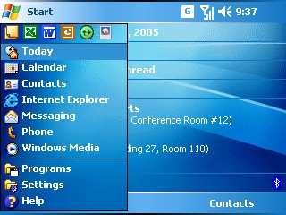
Microsoft Corp. is working with device manufacturers, independent software vendors (ISVs) and mobile operators to create a new generation of sleek and powerful Windows Mobile™-based devices for people who want to stay connected while on the go. Windows Mobile software creates new opportunities for industry partners, allows greater productivity for mobile professionals, and provides industry-leading multimedia integration for end users across a range of form factors, including Smartphones, Pocket PCs and Portable Media Centers.
Experience more with Windows Mobile 5.0

Windows Mobile 5.0, the newest installment of Microsoft’s software for mobile devices, is powering an entirely new generation of phones, personal digital assistants (PDAs) and media players. Based on feedback from partners and end users alike, Microsoft® Windows Mobile 5.0 delivers new productivity enhancements, offers an increasingly rich multimedia experience, provides mobile operators and device-maker partners with more opportunities to develop differentiated devices, and allows end users to better customize devices to fit their needs.

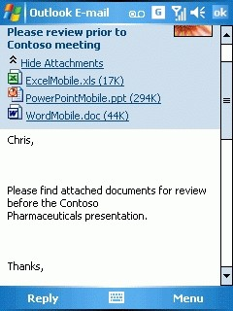
Enhanced Business Productivity
Open e-mail attachments
Windows Mobile 5.0 offers updates that make device users even more productive when working away from the desktop:
- Microsoft Office software for Windows Mobile. For Windows Mobile 5.0-based Pocket PCs, Word Mobile now supports tables, lists and embedded images, giving workers greater flexibility to create, edit or review documents. Excel Mobile allows users to view and create charts and graphs, and PowerPoint® Mobile allows users to view and rehearse presentations while on the go. The back seat of a taxi or an airplane now can be a mobile office.
- Persistent storage. Persistent storage has been added to Windows Mobile 5.0-based Pocket PCs, which will help ensure that users don’t lose important data when devices run out of battery power. In addition, overall device efficiency has been improved, yielding as much as 30 percent more battery life.
- Faster access to e-mail. Windows Mobile 5.0 users have faster access to e-mail and information and an improved experience with MSN® Messenger. MSN Messenger now offers seamless instant messaging (IM) access for friends and colleagues; and faster, one-key access to Hotmail® and MSN inboxes within Outlook®.
- ActiveSync® 4.1 support. Windows Mobile 5.0 offers users new features such as the ability to sync pictures in contacts and wirelessly sync over Bluetooth®, as well as an improved partnership wizard and an improved overall synchronization experience.
- Security. Windows Mobile 5.0 is compliant with the FIPS 140-2 standard.

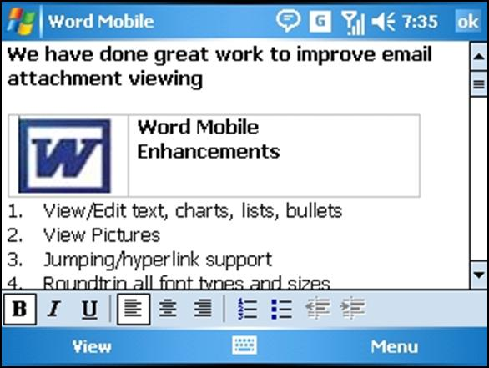
Superior Multimedia Experience
Windows Mobile 5.0 now includes Windows Media® Player 10 Mobile, adds support for technologies such as hard drives and Universal Serial Bus (USB) 2.0, and enables improved media content organization, making it an amazing platform for multimedia devices:
- Easy synchronization. Users can easily sync media files, playlists and song ratings right from Windows Media Player 10 Mobile on their desktop PC, and listen to them on their mobile device.
- New formats and content. Windows Media Player 10 Mobile supports a variety of file formats including Windows Media Audio, Windows Media Video and MP3. Customers can now access more than 1 million protected digital songs and videos from online services such as Napster, CinemaNow, MusicNow, Movielink and MSN Music.
Create, edit or review documents
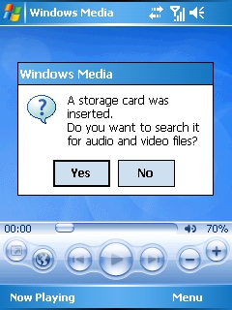
- Hard drive and USB 2.0 support. Windows Mobile 5.0 adds support for integrated hard drives, allowing users to carry several gigabytes of music or information right on their phone or PDA, and provides added support for USB 2.0, which greatly increases file transfer speeds and synchronization of information between PCs and Windows Mobile-based devices.

Ability to Customize
Windows Mobile 5.0 includes numerous enhancements that allow device manufacturers, developers and end users to customize the Windows Mobile user experience, add new functionalities to specific devices, and develop new applications:
- For end users. End users now can take a picture from their phone and easily assign it to a contact for display not only in the Contacts application, but also in the caller ID window and e-mail message header when that contact calls or sends e-mail. Pictures also can be assigned on a PC in Outlook and synchronized to a user’s device.
Play media files with Windows Media Player 10 Mobile
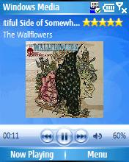
- For operators and device-makers. With Windows Mobile 5.0, device-makers can take advantage of wireless technologies including 3G and Wi-Fi. Windows Mobile 5.0 enables partners to build devices for Universal Mobile Telecommunications Service (UMTS) networks and supports simultaneous voice and data transfer. Windows Mobile 5.0 also adds support for Wi-Fi in Smartphones, which allows for a new generation of small, connected devices. In addition, device-makers and mobile operators now have greater flexibility to customize branded device experiences and can take advantage of extensible menus and new soft keys to build new features, such as push-to-talk (PTT), right into the phone dialer.
- For developers. Developers can take advantage of a host of new managed code and APIs in addition to a new ARM-based emulator, which enables them to build applications more quickly and add new functionality to applications. The new APIs include Camera Capture, which can integrate camera functionality with third-party applications; State and Notification Broker; Contact Picker; enhanced messaging and Pocket Outlook Object Model (POOM); as well as powerful new graphics APIs for Direct3D®, DirectDraw® and DirectShow®.
Listen to music on your Smartphone or Pocket PC

Microsoft, Windows Mobile, PowerPoint, MSN, Hotmail, Outlook, ActiveSync, Windows Media, Direct3D, DirectDraw and DirectShow are either registered trademarks or trademarks of Microsoft Corp. in the United States and/or other countries.
Bluetooth is a trademark owned by the Bluetooth SIG Inc., and any use of such marks by Microsoft Corp. is under license.
The names of actual companies and products mentioned herein may be the trademarks of their respective owners.

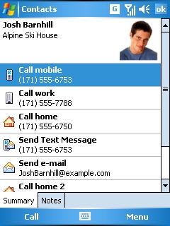
For more information, U.S. press only:
Weber Shandwick Windows Mobile and Embedded PR Team, (425) 452-5400, usmedteam@webershanwick.com

For more information, international press only:
Weber Shandwick EMEA Windows Mobile and Embedded PR Team, +44 207 067 0500, emeamedteam@webershandwick.com
Customize your contact list with pictures, e-mail and more

For more information, APAC press only:
Weber Shandwick APAC Windows Mobile and Embedded PR Team, 65 6825 8000, apacmedteam@webershandwick.com

