Managing Activation Using the Volume Activation Management Tool (VAMT)

A Guide for Infrastructure Administrators

White Paper

Microsoft Corporation  
2010

Legal Notice

The information contained in this document represents the current view of Microsoft Corporation on the issues discussed as of the date of publication. Because Microsoft must respond to changing market conditions, it should not be interpreted to be a commitment on the part of Microsoft, and Microsoft cannot guarantee the accuracy of any information presented after the date of publication.

This White Paper is for informational purposes only. MICROSOFT MAKES NO WARRANTIES, EXPRESS, IMPLIED OR STATUTORY, AS TO THE INFORMATION IN THIS DOCUMENT.

Complying with all applicable copyright laws is the responsibility of the user. Without limiting the rights under copyright, no part of this document may be reproduced, stored in or introduced into a retrieval system, or transmitted in any form or by any means (electronic, mechanical, photocopying, recording, or otherwise), or for any purpose, without the express written permission of Microsoft Corporation.

Microsoft may have patents, patent applications, trademarks, copyrights, or other intellectual property rights covering subject matter in this document. Except as expressly provided in any written license agreement from Microsoft, the furnishing of this document does not give you any license to these patents, trademarks, copyrights, or other intellectual property.

© 2010 Microsoft Corporation. All rights reserved.

Microsoft and product names identified in this document are either registered trademarks or trademarks of Microsoft Corporation in the U.S.A. and/or other countries. The names of actual companies and products mentioned herein may be the trademarks of their respective owners.

Contents

What Is VAMT? 4

How Can VAMT Help in My Environment? 4

Discover computers and products 5

Manage product keys 5

Manage activations 6

Online activation 7

Proxy activation 7

KMS client activation 8

Activation in disconnected environments 8

Local reactivation 9

Activation status 9

Scripting options 9

How Can I Learn More? 9

# What Is VAMT?

The Volume Activation Management Tool, or VAMT, is a free Microsoft tool to help administrators perform many tasks related to Windows product activation, using a single tool.

VAMT 1.2 released as part of the [Windows Automated Installation Kit](http://go.microsoft.com/fwlink/?LinkId=136976) (AIK), supports Windows Vista and later, and Windows Server 2008 and later. VAMT 1.2 can perform activations with a Multiple Activation Key (MAK), and enables Key Management Service (KMS) client activations.[1]

VAMT 2.0 includes several significant improvements over VAMT 1.2. It supports all of the above Windows operating systems plus Office 2010, Visio 2010 and Project 2010. VAMT 2.0 is a Microsoft Management Console (MMC) snap-in for a consistent administration experience, and is available as a [standalone download](http://go.microsoft.com/fwlink/?LinkId=183042). This version additionally enables administrators to manage KMS host and retail keys and activations. Admins may optionally use a Command Line Interface to script VAMT tasks vs. using the interactive GUI.

This document explains VAMT 2.0 and its benefits in more detail. We use Windows systems as our focus, but all of the capabilities apply also to Office 2010 products.

# How Can VAMT Help in My Environment?

VAMT can be an important tool to help you centrally manage and automate a range of activities related to Windows activation. Core benefits of VAMT include:

* The ability to protect product keys by retaining them only in the VAMT console, vs. including a key in an image or distributing it in plain text
* Perform activations without each system having to connect and activate with Microsoft activation services
* Inventory and monitor systems in the environment from an activation and licensing standpoint

VAMT enables you to manage Multiple Activation Key (MAK), Key Management Service (KMS), and retail product keys—whether you obtained them from the Volume Licensing Service Center (VLSC) or from a Microsoft subscription program such as MSDN—and product activations using those keys.

VAMT enables you to remotely activate managed systems. You can perform MAK, KMS host, KMS client, and retail activations. VAMT uses WMI to remotely manage activations and other related tasks on managed systems.

VAMT also can assist with license compliance, letting you monitor license state for the systems under management, so you know whether they are licensed and running genuine Windows.

The following pages highlight VAMT’s capabilities.

## Discover computers and products

A typical first step using VAMT is to discover computers in your environment, then add them into VAMT. To manage activation on the systems in your environment, you must discover and catalog those systems in VAMT. VAMT provides multiple ways by which physical and virtual systems can be discovered.

After you add the target systems to VAMT, the next step is to discover products installed on them. VAMT discovers Windows Vista, Windows 7, Windows Server 2008, Windows Server 2008 R2 and Office 2010 client products. VAMT also discovers computers running prior volume license operating system versions (Windows XP SP2 and Windows Server 2003 SP1 or later).[2] However, VAMT does not provide any data or support for product keys and activations of these machines. See [*Product Activation Using VAMT 2.0*](http://go.microsoft.com/fwlink/?LinkId=184609) for details on how to discover computers and installed products.

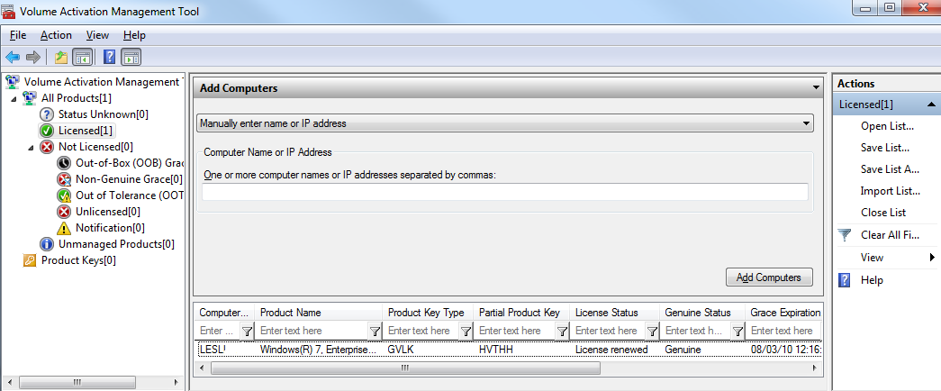

## Manage product keys

Depending on your organization’s volume license agreement(s) and/or subscription programs, you may be eligible for a number of product keys. Managing keys for numerous product versions and editions can be challenging. VAMT can help to manage your MAKs, KMS host keys, and even retail product keys (e.g., for software acquired via an MSDN, TechNet or Microsoft Partner Network subscription).

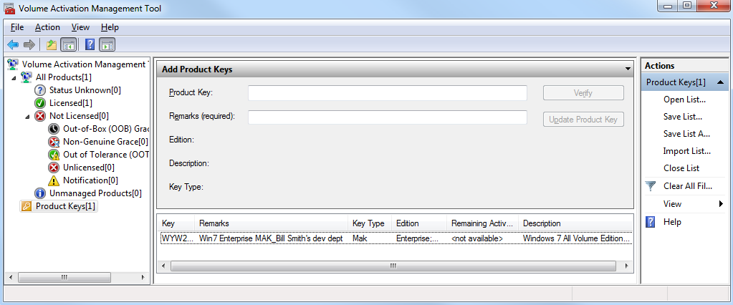

Product key management with VAMT enables:

* Single local console to manage keys for Windows client, Windows Server and Office 2010
* Installation of the keys on remote managed systems through WMI
* Tracking remaining activations on MAKs[3]

Read [*Manage Product Keys Using VAMT 2.0*](http://go.microsoft.com/fwlink/?LinkId=184609) for details on how to use VAMT to manage your product keys.

## Manage activations

Product activation is required for all installations of Windows client and server, and Microsoft Office client starting with Windows Vista and Microsoft Office 2010. Product activation helps confirm the integrity and reliability of the software that you will be using within your environment. You can use VAMT to manage MAK, KMS and retail activations, including transitioning a system from one activation method to another. Here are some common activation scenarios that VAMT can help with:

* KMS activation is generally the preferred method for network-connected systems. You can use VAMT to set up and activate your KMS host, and then to activate target KMS client systems.
* MAK activation is commonly suitable for lab computers, small offices or branch locations, or for computers used by remote workers. VAMT can help you activate computers in all of these cases, whether or not the systems are connected to the core organizational network, or even the internet.
* Systems activated using MAK or retail keys may need to be redeployed into the general production environment, where KMS activation is used. VAMT simplifies changing to KMS activation in such transitions.

To perform activations, VAMT utilizes two primary activation processes, online and proxy. We explain each activation process below. We also cover other activation options available in VAMT. These include KMS client activation, activation in disconnected environments, and local reactivation after reimaging. Read [*Product Activation Using VAMT 2.0*](http://go.microsoft.com/fwlink/?LinkId=184609) for details on how to perform many types of activations using VAMT.

### Online activation

With online activation[4], each system individually connects to and activates with Microsoft activation servers. You can use online activation for MAK, KMS host, and retail activations. To perform online activation with the VAMT console, you add a key to VAMT, install the key on the target system(s), and then select Online Activate to complete the activation process. VAMT does not store activation confirmation information when you perform online activations.

### Proxy activation

With proxy activation, the VAMT host computer connects to Microsoft on behalf of multiple systems. You can use proxy activation for all of your MAK, KMS host or client, and retail activations.

To perform proxy activation for systems connected to the VAMT console, you add a key to VAMT, install the key on the target computers, and then select Proxy Activate. The VAMT console sends the installation ID (IID) collected from each computer to Microsoft activation servers with a single connection. VAMT obtains the corresponding confirmation IDs (CID) and distributes them to the target systems, completing activation. With proxy activation, VAMT stores all this information in a Computer Information List .xml file (CIL). The diagram below shows the proxy activation process.

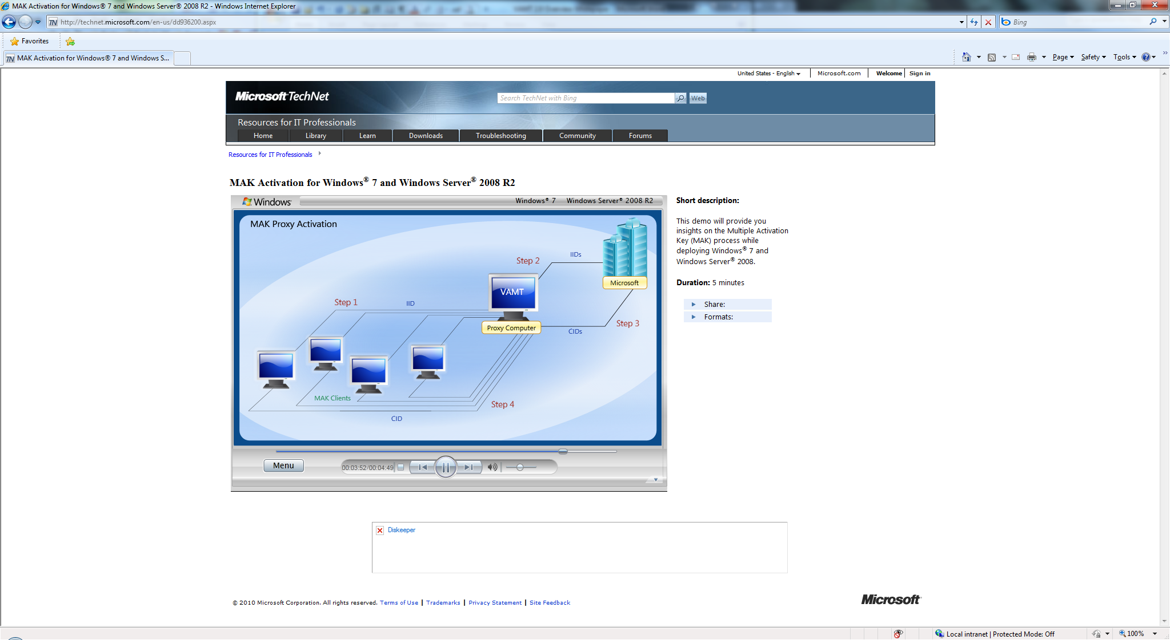

Because VAMT does not store activation confirmation information with online activation, proxy activation is necessary if you want to save the activation confirmation information for any of the activations performed using VAMT. We recommend storing a backup copy of the CIL as a standard practice. The confirmation data also can be helpful in case of disaster recovery.

Additionally, you would use proxy activation if you plan to reactivate after reimaging using VAMT, explained below. Optionally, you also can use proxy activation if you prefer that the computers not connect directly with Microsoft activation servers.

### KMS client activation

If you are switching computers from MAK to KMS activation, you can use VAMT to apply KMS client setup keys, and then to activate those systems. It is easy to install a KMS client setup key using VAMT because the keys are embedded in the tool. You do not have to manually add a key to the console.

### Activation in disconnected environments

Some environments may be completely disconnected from the internet or the core organizational network, such as branch offices and high-security zones within a production environment. *High-security zones* are network segments air-gapped or separated by a firewall that limits or prevents communication to and from other network segments. VAMT can simplify the activation process for the systems in this environment.

Here we describe a solution that you can use when the systems are networked within the firewalled or disconnected environment. Basically, you set up one VAMT host in the disconnected environment, and a second VAMT host in the core network. Data is transported between the hosts in the two environments on removable media.

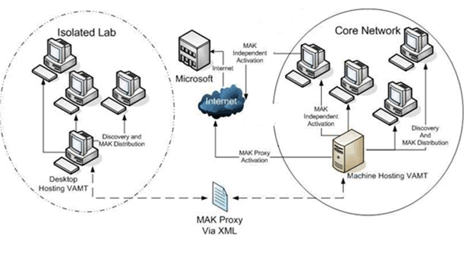

Using proxy activation, collect the IIDs on the first VAMT host and save them on removable media. The admin takes the media to the second VAMT host and imports the IIDs into that console. The second host connects with Microsoft, sends over the IIDs, and obtains the CIDs. The admin exports the CIDs onto the removable media. After transporting the file back to the first VAMT host, the CIDs are applied, completing the activation process. Read [*Activation in Disconnected Environments Using VAMT 2.0*](http://go.microsoft.com/fwlink/?LinkId=184609) for a more detailed explanation of this process. Microsoft enumerates other options for activation in disconnected environments in a white paper, [*Volume Activation in Disconnected Environments*](http://go.microsoft.com/fwlink/?LinkId=155224).

### Local reactivation

If your systems require frequent reimaging, as in testing or training labs, using proxy activation with VAMT can facilitate reactivating the systems. After reimaging, you can apply the same CID that was saved in the .xml CIL file. You can reapply the CID without limit, if the hardware has not changed significantly. By applying the same CID, you conserve remaining activations on the product key. Microsoft enumerates other options for activation in development environments in a white paper, [*Windows Activation in Development and Test Environments*](http://go.microsoft.com/fwlink/?LinkId=155223).

## Activation status

VAMT lets you check the current activation status of managed computers. Available data include license state (e.g., Licensed, Out-of-Box Grace, Notification), genuine status, Windows edition, and the last 5 characters of the product key installed. Knowing a computer’s status can be useful in several situations.

* User experience—Windows will enter a notifications experience after a grace period expires. The system will continue to operate with full functionality, but the notifications may be confusing or annoying to end users. With VAMT, admins can determine the activation status of remote managed systems and take steps to activate those that are in a grace period.
* Helpdesk support—Activation status information may be useful for helpdesk technicians to help troubleshoot a user’s computer.
* License compliance—Using VAMT, it is easy to determine whether or not a given system is licensed and genuine. With this knowledge, admins can take corrective action as appropriate.

## Scripting options

In addition to the MMC interface, you can use a Command Line Interface that can be scripted to run VAMT tasks without the interactive UI. Typical usage includes nightly or weekly automatic updates to the products list, or embedding VAMT tasks into other automated tasks. An example of a typical script is to refresh product status for an existing CIL file and use an alternative credential.

VAMT /r /i myproducts.CIL /o vamtout.CIL /user mydomain\myusername /password *

# How Can I Learn More?

For more information about using VAMT, review the [VAMT 2.0 “how to” documents](http://go.microsoft.com/fwlink/?LinkId=184609). You can watch video demos of several VAMT tasks at [www.technet.com/volumeactivation](http://www.technet.com/volumeactivation).[5] The Helpfile in the [VAMT 2.0 download](http://go.microsoft.com/fwlink/?LinkId=183042) has detailed information on how to perform many tasks using the tool.

To learn more about volume activation, visit [www.technet.com/volumeactivation](http://www.technet.com/volumeactivation). Also, check the [Genuine Windows Team Blog](http://windowsteamblog.com/blogs/genuinewindows/default.aspx) for what’s new.

1. KMS and MAK are the two activation methods available for volume licensing versions of Windows client and server operating systems, and Office 2010. For information on activating with KMS or MAK, visit [www.technet.com/volumeactivation](http://www.technet.com/volumeactivation).
2. VAMT discovers these prior version systems to manage any Office 2010 client installations on these versions.
3. Determining remaining activations is not available for KMS host or retail keys.
4. Online activation is alternatively referred to as independent activation in other volume activation documentation.
5. Several of these demos use VAMT 1.2 but the process is the same using VAMT 2.0.