Microsoft Software Assurance Benefit Programs

Fulfillment guide for Software Assurance Benefit for Open customers
1 Jan 2005

Home Usage Program
E-learning Media kits
TechNet Online Concierge Chat IDs

Fulfillment process for Home Usage Program for Open Customer

Each license of an Office application covered by Software Assurance gives right to one license of Office Professional for home usage. This program is being extended to other application as well.

There are today 2 mechanisms to fulfill the Home licenses to the employees
- The employee pick up the license he is entitled to on a Microsoft e-shopping web site using a company specific program code provided by the employer. The employee pays by credit card an admin cost of 28€. Involvement of the employer is minimum
- The company chooses for a bulk shipment of licenses and distributes licenses to their employees. The cost per license is reduced to 10€ (NEW)
This scenario is though accessible only from a minimum of 20 licenses
In both scenarios, the employee receives from Microsoft a free support at installation.

Find here below a detailed description on how to proceed.

A) Employee pick up process.
Everything starts on the web site for managing Open License: eopen
https://eopen.microsoft.com
The benefit administrator (customer or dealer) must receive the program code related to his contract.

1) Accessing the license details on e-open
You need a Passport Identification to login. If you have no, you will be prompted to make one.
Once on e-open, you use the menu “agreement summary” and will add your agreement (authorization number(s)) to the view (if not yet done).
For doing so, you take the menu “Add agreement” and type in the Open authorization number and one license number ordered under this agreement. You will then see, listed on the screen, all the licenses numbers ordered under this authorization number(s).
By clicking on the license number, you will access the details of all the software ordered on that license number (license detail view – see screen 1)

On this view, you can have access to your Volume Licensing keys and to the Software Assurance benefits; Home Usage Program and Tech Net concierge ID.

Screen 1 – e-open license detail view
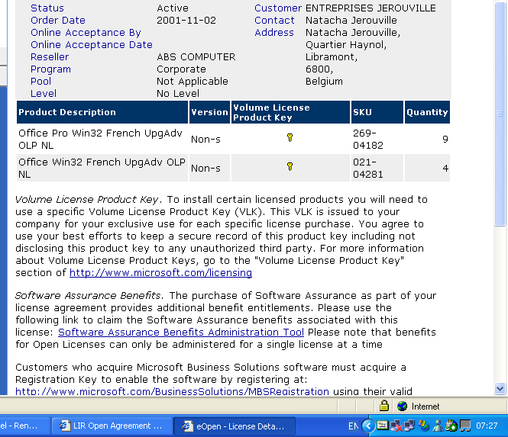

2) Accessing the Benefit administration tool
On the license detail view, click on the link “Software Assurance Benefit administration tool” (see screen 1)
This link leads you to a profiling page pre-filled with your passport information. Complete and adapt the data and click OK.
You go through a screen with the term and conditions and after accepting, you reach the benefit administration screen. (Screen 2)

Screen 2 : Benefit summary view
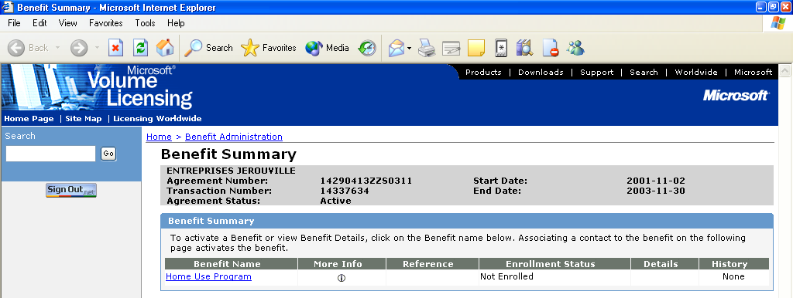

3) Activating the Home Usage Program benefit
When first coming on the site, the Open customer may see the benefits for which his company is eligible for this license number (HUP and/or Technet online concierge).
The status “not enrolled” means that the benefit has not yet been activated.
For activating the benefit HUP, you click on the link ‘Home Usage Program’ (screen 2)
- Fill in the contact detail of the person in charge of managing the program.
It could be anyone within or outside the company.
- Give the domain name(s) used by your company (for further security checking)
- Validate and get a screen with all the details related to the benefits including the number of HUP licenses available. (Screen 3 – benefit details view)
You have finished the activation process and are ready to use the HUP.

Screen 3 – Benefit detail view
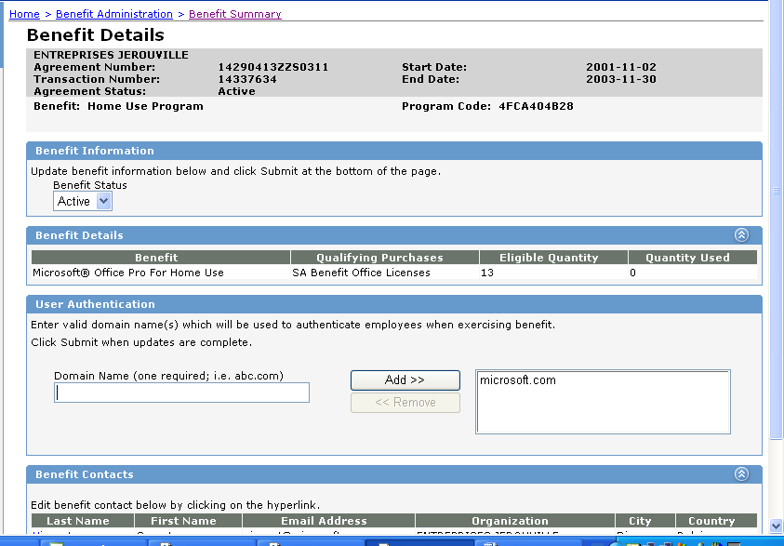

You may now go back on the Benefit Summary page and see that the HUP is activated (enrolled) and see the unique code “program code” that your employees will need to order the Home license(s). (see screen 3 – 4)

Screen 4 – Benefit Summary view
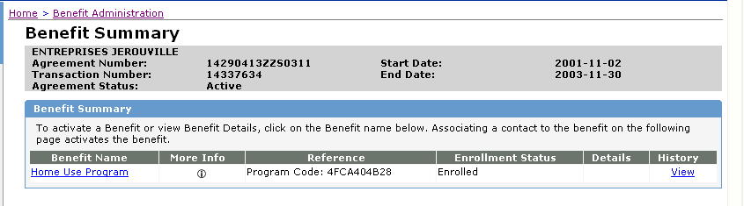

4) Ordering licenses.
The process for ordering licenses is operated by the employee himself. It is a usual e-shopping web site process. Each employee using at the office an Office license covered by SA is eligible to order 1 Office Pro license (and only one) on this site.
Availability of other application will follow later.
He will need :
- the name of the e-shopping site : https://hup.microsoft.com
- his professional e-mail address
- the program code described in step 3) (“activating the benefit”)
- his credit card (28.44 Euro to pay for media, admin and shipping costs)
When landing on the hup.microsoft.com site, the employee his asked for his name, professional e-mail and program code. The process is then stopped and an e-mail is sent to the employee after validation of his credentials (a few minutes). The e-mail contains the link back to the HUP e-shopping home page. (Screen 5)

Screen 5 – Home Use program – landing page
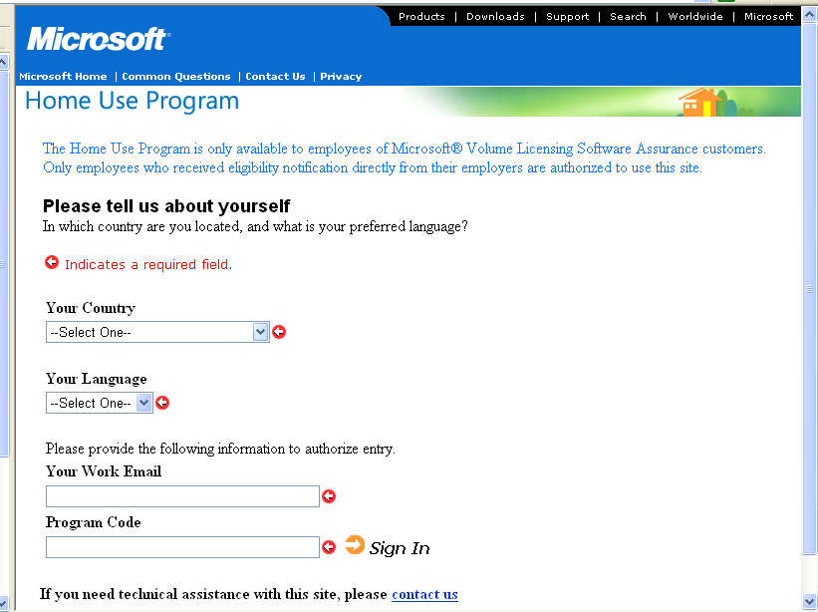

After signed in, the employee may proceed with his request through a self assisted e-shopping process.
The requested license(s) is shipped to the address specified by the employee in the shopping process.
The employee his kept aware about the ordering/shipping process by e-mail on the e-mail address that he communicated during the shopping process

The benefit management for e-open customer is done by license numbers.

B) Bulk shipment
The bulk shipment option has been requested by customers and introduced in Feb 2004.
The process is operated by phone at the SA Contact center 0800/72293
The bulk shipment process for HUP will go live on Thursday Feb 5th 2004.
The bulk shipment process is as follows:
- The Benefit Administrator (BA) contacts the Software Assurance Contact Centre and requests a bulk shipment order.
- The Contact Centre will take the order details and confirm.
- As there is a requirement to sign terms and conditions, the Contact Centre will send the order form to the BA to be signed.
- Once the BA returns the order form including payment, the order will be fulfilled within 4 weeks.

A list of FAQs is shown below.

Frequently Asked Questions on the bulk shipment

- Who can submit a Bulk Shipment request?
The Benefit Administrator (BA) is the only member of an organization who may submit a Bulk Shipment order form on behalf of that organization to which they are registered as the BA.

- How does the BA submit the Bulk Shipment request?
The Benefit Administrator should contact the BA Call centre

- Does the BA have to complete a Bulk Shipment order form?
No, the BA Call centre will complete the order form based on the information provided to them by the BA. Once the form has been completed, BA Call centre will fax/email a copy of the order form and the HUP Terms and Conditions to the BA for review, verification and signature.

- What information will be required by BA Call centre for an order to be placed?
- Office product required
- Quantity of product
- Language of product
- Shipment Address
- Billing Address
- Credit card details (If payment is being made by credit card, cardholder must also sign the order form)
- BA signature (Acceptance of Terms and Conditions)

- Can the Bulk Shipment process accommodate multiple shipment addresses?
No. Currently a separate order form will have to be completed for each shipment address.

- Is there a difference in the shipping price per product unit under the Bulk Shipment process against the standard process?
Yes! Currently the standard HUP shipment price per unit is €21.95. Under the Bulk Shipment process the cost is €14.00 per unit excluding VAT. This equates to a discount of about 36%.

- What payment options are there available to the customer?
The customer can pay by:
- Credit card
- Bank transfer
- Cheque

- Is there the option for the customer to pay cash-on-delivery?
No! Prepayment is the only option. Shipment of product will be initiated only upon receipt of payment.

- Under the Bulk Shipment process, is there an option for individual employees to pay separately or must the payment be made centrally for the entire order?
Under the current process, one central payment must be received per order.

- Is it possible for a customer to receive a Performa invoice upon request so that payment can be released from their accounts department?
Yes! Microsoft will generate a Performa invoice and will send it to the customer upon request.

- When can a customer expect delivery of the shipment once payment has been made?
Delivery is country-specific but the lead time of 4 weeks is standard. Shipment of product will be initiated only upon receipt of payment.

- What if the customer calls to cancel their order?
If the BA Call centre agent has already received an order confirmation email from the Fulfilment Centre, the Agent will need to contact the HUP Contact Centre at HUPvalue@msdirectservices.com to have the order cancelled.

- What if a customer wants to change their order?
1. If the order has already shipped and…
A. The customer wants to order more product:
A new and separate order will need to be processed for the additional quantity requested.

B. The customer wants to order less product:
Follow the returns process.

2. If the order has NOT already shipped and the customer wants to order more OR less product:
A new order will need to be processed for the new quantity requested and the original order would need to be cancelled..

- What if the product I received is damaged?
The BA Call Center Agent should process a new order for the quantity of damaged goods and mark the order with “replacement for damaged goods, do not charge customer”. The damaged goods do not need to be returned to Microsoft but should be disposed of.

- Are refunds (returns) supported?
Refunds are only supported within 30 days of receipt of goods by the customer. Return postage will be at the customer’s expense. Refunds are only valid on unopened product.

- What is the minimum quantity of product required in order to avail of the Bulk Shipment order process?
The minimum quantity is 100 units

- Is there a maximum quantity of units which may be purchased?
The only limitation to the number of units of a given product which may be ordered is dependent on the number of eligible licenses for home use under the terms of the Enrolment.

- What if the credit card provided for payment is declined?
If a credit card is declined, a ‘declined’ email will be sent to the customer informing them to contact BA Call centre. BA Call centre should take the new card information from the customer and contact the Fulfilment Centre with this information for final processing. Due to customer privacy regulations, this credit card information must either be faxed to the Fulfilment Centre or handed off over the phone. Email should not be used.

- If a credit card is declined and a new credit card number is provided, is a new signature required from the customer?
Only if the new cardholder name is different to the original signatory.

- What if the cardholder is not the Benefit Administrator?
If the cardholder is not the Benefit Administrator, then 2 signatures will be required: One signature from the Benefit Administrator authorizing the order on behalf of the customer and one signature from the cardholder authorizing the charge to their card.

Fulfillment process for E-learning Program for Open Customer

E-learning CDs for Open customer are not fulfilled by any kind of tool.
The customer eligible for receiving e-learning licences may order the media kit through the standard Dealer/disti order process.
There is 3 media kit available for respectively e-learning for Application, System and Server. They are proposed in different language. An updated Media kit will be available every 6 months (Jan – June) with the new titles and new localization.
Find hereafter the product codes for those media kits.
Part Number | Item Name | Product Family
T95-00001 | SA E-Learning(Clnt) Win32 English Disk Kit MVL CD | SA E-Learning(Client)
T95-00006 | SA E-Learning(Clnt) Win32 Dutch Disk Kit MVL CD | SA E-Learning(Client)
T95-00007 | SA E-Learning(Clnt) Win32 French Disk Kit MVL CD | SA E-Learning(Client)
T95-00008 | SA E-Learning(Clnt) Win32 German Disk Kit MVL CD | SA E-Learning(Client)
T96-00004 | SA E-Learning(IW) Win32 Dutch Disk Kit MVL CD | SA E-Learning(IW)
T96-00005 | SA E-Learning(IW) Win32 English Disk Kit MVL CD | SA E-Learning(IW)
T96-00006 | SA E-Learning(IW) Win32 French Disk Kit MVL CD | SA E-Learning(IW)
T96-00007 | SA E-Learning(IW) Win32 German Disk Kit MVL CD | SA E-Learning(IW)
T97-00005 | SA E-Learning(Svr) Win32 English Disk Kit MVL CD | SA E-Learning(Server)

Fulfillment process for IDs for usage of Technet On Line Concierge for Open Customer

For each server license covered by Software Assurance, the Open customer receive one ID for accessing the service “Technet Online Concierge Chat”
Those IDs are distributed on the SA benefit Web site as it is for the Home Usage Program code.
The process to follow is exactly the same as the one described here above for the HUP
What the you needs to have access to this information is the Authorization number and license number on which the licenses have been ordered and your passport password.

