“DSHARP”
And Display Research in the Hardware Devices Group
Microsoft Research
(http://www.research.microsoft.com/research/hardware)

For the past four years, Microsoft’s Hardware Devices Research Group has been looking at the physical mechanisms that connect people to computers. We are interested in the emerging field of un-tethered computing, and are also looking for ways to make the conventional desktop PC experience more functional, more convenient, and more exciting.

The range of potential interaction mechanisms extends far beyond keyboard, mouse, and monitor. The scope of our device research is correspondingly broad. We have experimented with sensors to measure the position, velocity, activity, and (indirectly) even the mood of people as input to computers. Where sensors do not exist commercially, we have fabricated MEMS (Micro-Electro-Mechanical-Systems) devices to do the job, pushing our work down to the fundamental level.

“DSHARP” - A Wide Screen Multi-Projector Display

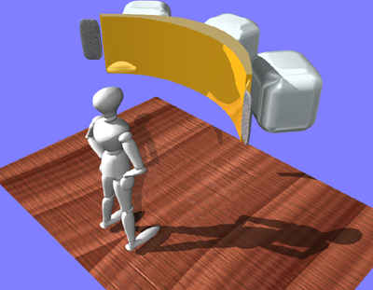

Ever since the personal computer became sufficiently powerful to support impressive graphics, users have longed for increasingly capable display devices. Cathode ray tube or CRT displays are now generally affordable with a 21” diagonal. Flat panel displays can be obtained in such sizes but are expensive. However, most users possess displays whose display surface area is less than 10% of their physical workspace area. How might users cope and benefit with displays having 25% to 35% of their desk area? This question has been an issue of interest for many researchers. To examine this issue, several research groups within Microsoft Research, along with the Microsoft Hardware product group have tested several models to measure their effectiveness for productivity applications.

“DSHARP” (which arose from an acronym, viz. Display System implementing High Aspect Ratios with Projection) is the current code name for display technology that uses three XGA DLP projectors. This combination yields a screen having an area of about 12 inches high by 48 inches wide comprising a 4:1 aspect ratio. Rather than have a very wide flat display (which MSR refers to as “billboard mode” and its attendant perspective distortion), the desire was to have the display curve around the user.

Such displays are expected to be increasingly useful in producing more visually pleasing environments as well as improving the quality of the work environment. From a quality of life perspective, users need to deal with increasing amounts of information and reduce the time requirements for its management, such displays as the “DSHARP” display with its large high brightness surface and sound integrations are expected to greatly enhance the user experience of many people. Furthermore, tests have shown that user navigational skills are greatly enhanced on large displays coupled with increased productivity. This makes such displays not only exciting to use but practical as well.

Our investigation of the properties and uses of large displays has been conducted in collaboration with other groups inside and outside of MSR. The effort is collectively known as Broadbench.

For more information on “DSHARP,” display research in the Hardware Devices Group, or Microsoft Research, please contact:

Peter Wootton
Waggener Edstrom
peterw@wagged.com.
503-443-7000

Microsoft is a registered trademark of Microsoft Corporation in the United States and/or other countries.

