How to Use the Microsoft Office Live Meeting 2005 SharePoint Web Parts
The Microsoft® Office Live Meeting 2005 SharePoint Web Parts integrate Microsoft Office Live Meeting 2005 with Microsoft Windows® SharePoint® Services and Microsoft Office SharePoint Portal Server. Through this integration, SharePoint Portal users can:
- Start a Meet Now session, view upcoming Live Meetings, and view recently made recordings—all from your SharePoint Portal, without having to log in or remember passwords.
- Publish meetings and recording into a shared event calendar.
- Access Live Meeting Manager with a single click.
You can use two web parts: the My Upcoming Live Meetings web part, and the My Live Meeting Recordings web part.

Using the My Upcoming Live Meetings Web Part
The following screen shot shows an example of the My Upcoming Live Meetings web part:
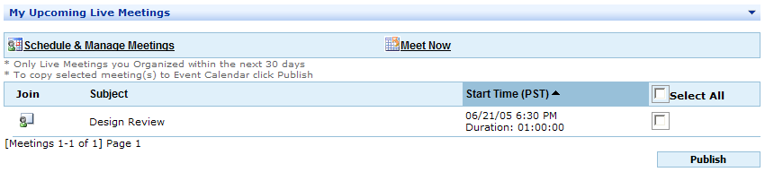

Sort your list of meetings
- Click either the Subject or Start Time column heading to sort the list by that heading.
An arrow appears next to the header indicating whether or not the column is being sorted in ascending (arrow pointing up) or descending (arrow pointing down) order.
- Optionally, to reverse the sort order, click the column heading again.

Join a Meeting
- Click the Join icon next to the meeting that you want to join.
The web part displays the entry page for your meeting, with your name and meeting password automatically filled in.
Note: If the meeting is protected by an Access Control List (ACL), you might be required to log in.

Start a Meet Now Session
- Click Meet Now.
Note: If you have not previously conducted a Meet Now session, the web part requires you to log in.

Schedule a Live Meeting session
- Click Schedule & Manage Meetings.
The web part logs you in to Live Meeting Manager and displays the My Home page.
- Use Live Meeting Manager as you normally would to schedule the Live Meeting session.

Publish a meeting to the SharePoint Portal shared event calendar
- In the far right column, click the checkbox next to the meeting that you want to publish.
- Click Publish.
- In the confirmation dialog is shown, click Confirm.

Using the My Live Meeting Recordings Web Part
The following screen shot shows an example of the My Live Meeting Recordings web part:
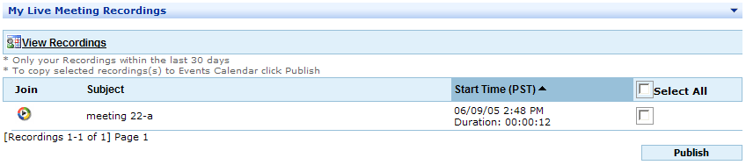

View a recording
- Click the Join icon next to the recording that you want to view.
Note: If the meeting is protected by an Access Control List (ACL), you might be required to log in.

Publish a recording to the Live SharePoint shared event calendar
- In the far right column, click the checkbox next to the recording that you want to publish.
- Click Publish.
- In the confirmation dialog is shown, click Confirm.

