# D:\Users\zowens\Desktop\Microsoft Documents\Brand\Media Bank\Azure\SQL Azure\SQL-Azure_rgb.pngdatasheet_header_wave copy.pngbackpage_background copy.jpg

Getting Started with SQL Azure

**Author**

Selcin Turkarslan

**Technical Reviewer**

David Robinson, Lubor Kollar

**Published**July 2010

**Summary**This document provides guidelines on how to sign up for SQL Azure and how to get started creating SQL Azure servers and databases.

Copyright

This is a preliminary document and may be changed substantially prior to final commercial release of the software described herein.

The information contained in this document represents the current view of Microsoft Corporation on the issues discussed as of the date of publication. Because Microsoft must respond to changing market conditions, it should not be interpreted to be a commitment on   
the part of Microsoft, and Microsoft cannot guarantee the accuracy of any information presented after the date of publication.

This document is for informational purposes only. MICROSOFT MAKES NO WARRANTIES, EXPRESS, IMPLIED, OR STATUTORY, AS TO THE INFORMATION IN THIS DOCUMENT.

Complying with all applicable copyright laws is the responsibility of the user. Without limiting   
the rights under copyright, no part of this document may be reproduced, stored in, or introduced into a retrieval system, or transmitted in any form or by any means (electronic, mechanical, photocopying, recording, or otherwise), or for any purpose, without the express written permission of Microsoft Corporation.

Microsoft may have patents, patent applications, trademarks, copyrights, or other intellectual property rights covering subject matter in this document. Except as expressly provided in any written license agreement from Microsoft, the furnishing of this document does not give you any license to these patents, trademarks, copyrights, or other intellectual property.

© 2010 Microsoft Corporation. All rights reserved.

Microsoft, ADO.NET Data Services, Cloud Services, Live Services, .NET Services, SharePoint Services, SQL Azure, SQL Azure Database, SQL Server, SQL Server Express, Sync Framework,   
Visual Studio, Windows Live, and Windows Server are trademarks of the Microsoft   
group of companies.

All other trademarks are property of their respective owners.

**Getting Started with SQL Azure**

Microsoft SQL Azure Database is a cloud-based relational database platform built on SQL Server technologies. By using SQL Azure, you can easily provision and deploy relational database solutions to the cloud. SQL Azure Database is the relational database service on the [Windows Azure platform](http://www.microsoft.com/windowsazure/windowsazure/).

To start using SQL Azure, you must first purchase a Windows Azure Platform subscription. To purchase a Windows Azure Platform subscription, you can either visit the [Windows Azure Platform](http://www.microsoft.com/windowsazure/offers/) offers page or the Microsoft Online Services Customer Portal. The [Microsoft Online Services Customer Portal](https://mocp.microsoftonline.com/site/default.aspx) allows you to purchase a subscription to the SQL Azure platform and to other Microsoft Online Services. Follow these four steps to purchase a Windows Azure Platform subscription:

1. If you are on the [Windows Azure Platform](http://www.microsoft.com/windowsazure/offers/) offers page, choose one of the available offers and click **Buy**. Then, go to step 3.
2. If you are on the [Microsoft Online Customer Portal](https://mocp.microsoftonline.com/site/default.aspx), click **Sign in** on the upper-right corner.
3. Microsoft Online Services Customer Portal will ask you to sign in with your Windows LiveID account. After you type your Windows Live e-mail address and password, click **Sign in**. If you don’t have a Windows LiveID account, visit [Windows LiveID sign-up page](https://accountservices.passport.net/reg.srf?sl=1&vv=550&lc=1033) and get a Windows LiveID account for your account administrator or owner. For more information on Windows LiveID, see [Windows Live ID Online Help](http://help.live.com/help.aspx?project=liveidv1&market=en-us).
4. To purchase a subscription from Microsoft Online Services Customer Portal, click the **Services** panel at the Microsoft Online Services Customer Portal. Add services to your shopping cart. If you have already chosen an offer on the [Windows Azure Platform](http://www.microsoft.com/windowsazure/offers/) offers page, this offer will be shown at the **Shopping Cart** automatically. For more information on Microsoft Online Customer Portal, see [Microsoft Online Customer Portal Help](http://www.microsoft.com/online/help/en-us/mocp/index.html?page=html%2Ff9a74cd3-c940-4946-9095-433708a74552.htm).

**Important:** A single account may contain zero or more subscriptions. An account represents the way that you establish a billing relationship with Microsoft. A single Windows Azure Platform subscription can contain multiple services, such as Windows Azure, Windows Azure AppFabric, and SQL Azure.

The following image demonstrates the available offers on the [Windows Azure Platform](http://www.microsoft.com/windowsazure/offers/) offers page. As an example, choose **Windows Azure Platform Introductory Special** and click **Buy**. After your purchase is complete, you will receive a confirmation notification in e-mail with instructions for accessing your account in the SQL Azure platform.

Note: The Windows Azure Platform Introductory Special will end on October 31, 2010 and all usage will then be charged at the standard rates.

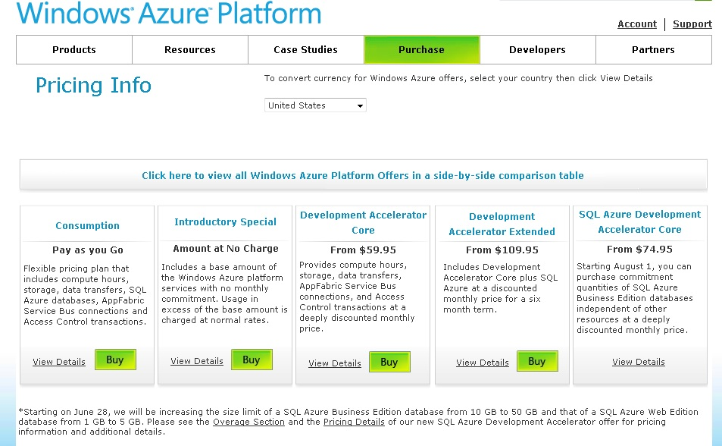

This opens the **Microsoft Online Services Customer Portal Sign up** page. Use your Windows Live Id and password to sign in.

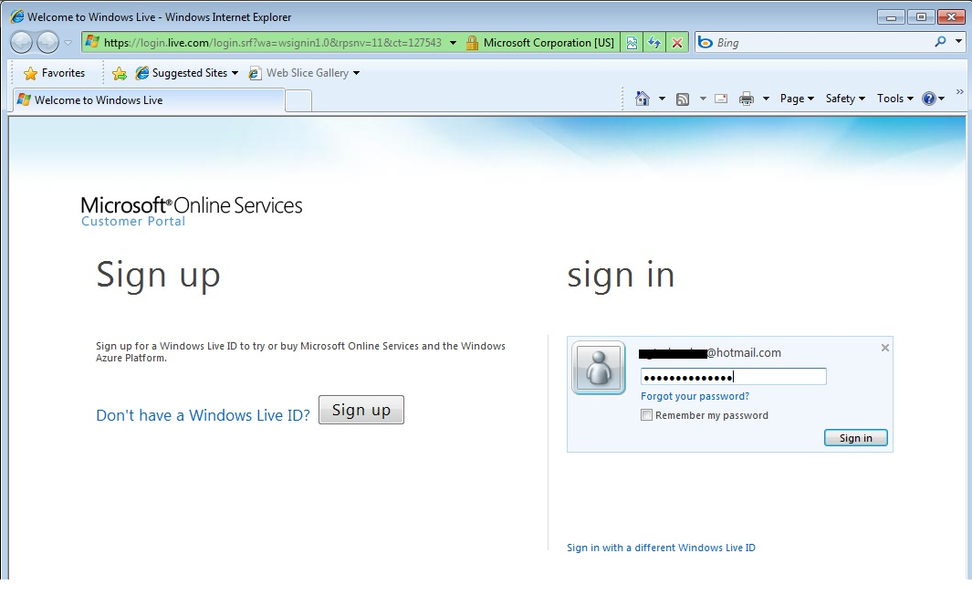

After you type your Windows Live e-mail address and password, click **Sign In**. The Microsoft Online Services Customer portal will show up. Click **Shopping Cart**. Review your purchase details in the **Shopping Cart** and click **Checkout**.

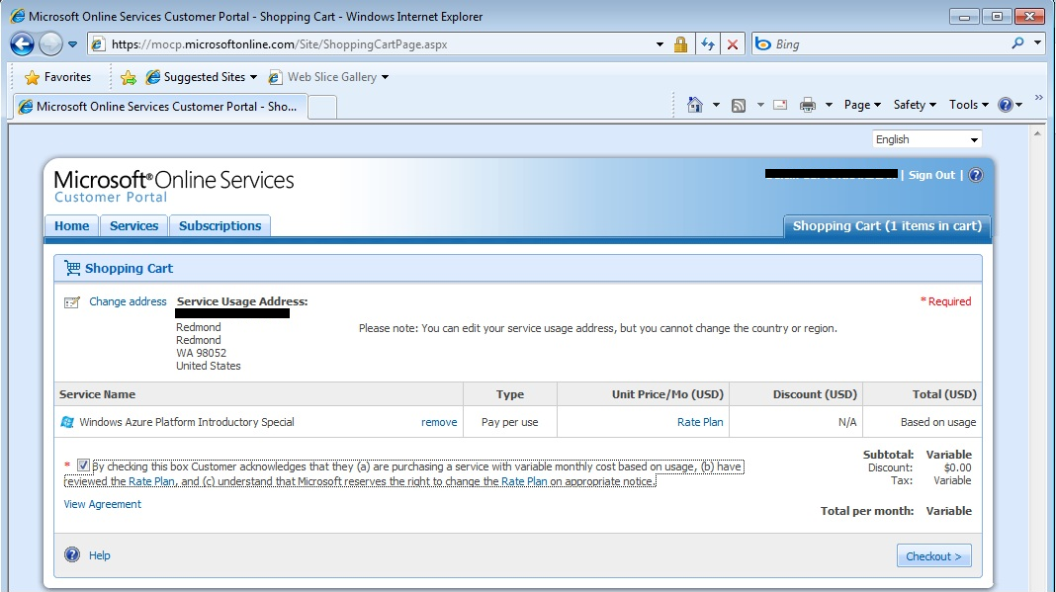

Then, the Microsoft Online Services Customer Portal asks you to enter the payment options. Choose **New credit card** option and click **Next**.

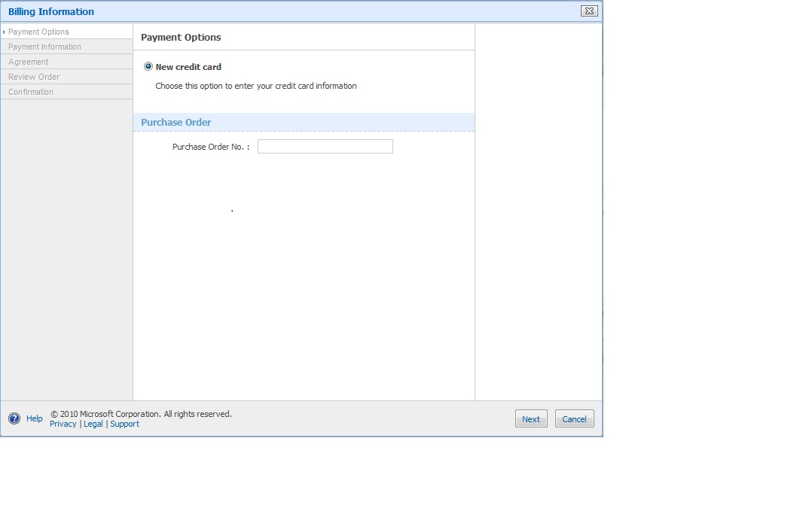

Note: When you want to purchase your subscription to the service through Microsoft Online Services Customer Portal, you will be prompted to enter information regarding your account owner. The account owner or account administrator is the person who signs up for the SQL Azure platform and other Microsoft Online Services. As an account owner, you own the billing relationship with Microsoft. Account Administrators can log in to the Microsoft Online Services Customer Portal to manage their subscriptions and to the SQL Azure portal to manage their SQL Azure servers.

Enter **Payment Information** and **Billing Information** as shown in the following window.

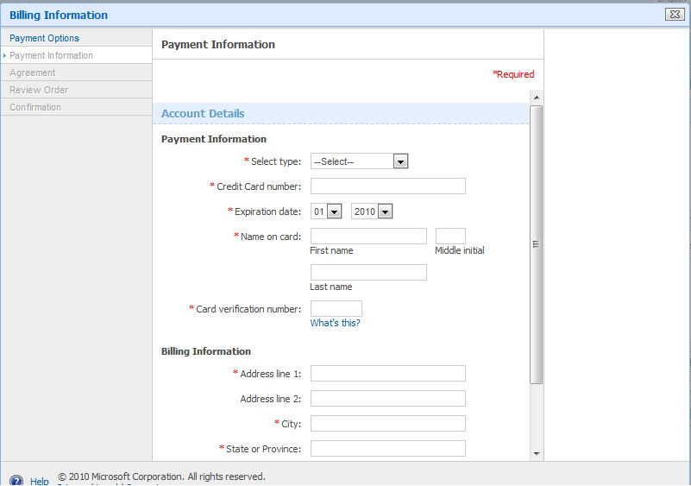

Next, read the Microsoft Online Subscription Agreement. Accept the Terms and Conditions by clicking the check box. Enter your **Full name** and **Title**, and click **I Accept**.

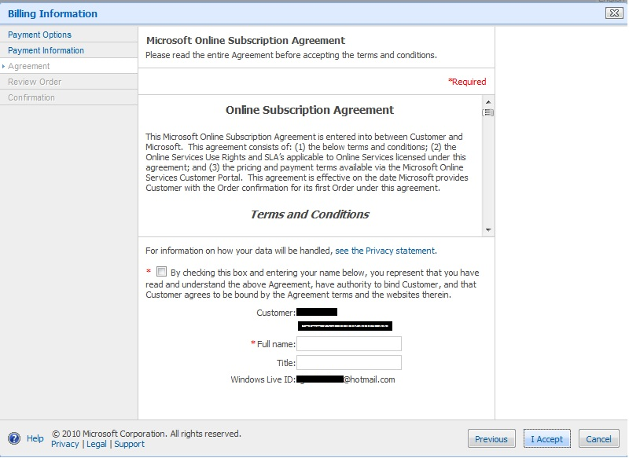

Review and confirm the order as shown in the next page. Once you review all, click **Confirm Order**.

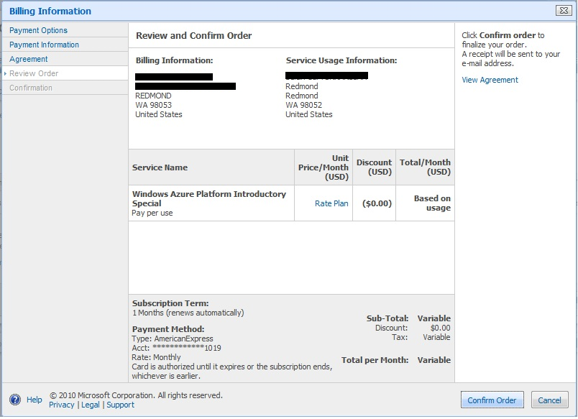

After you click **Confirm Order**, the following **Confirmation** page appears. Click **Proceed to activation…**.

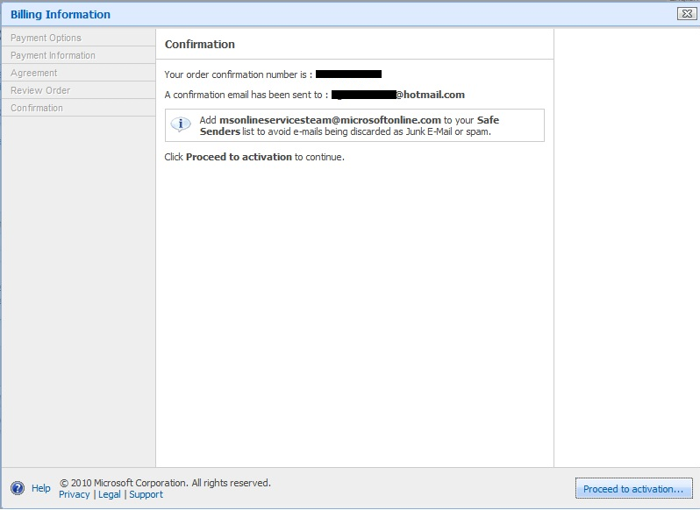

This opens the **Service Activation** page. In the **Service Activation** page, enter *SQLAzure\_Introductory* as a subscription name and click **Next**.

The subscription name will be used to identify the subscription on bills. It will also be used to name your project in the Windows Azure Platform. One subscription refers to one project. Make sure to name each subscription uniquely based on your business needs. As an account administrator, you can purchase one or more subscriptions of each offer except the **Windows Azure Platform Introductory Special** offer.

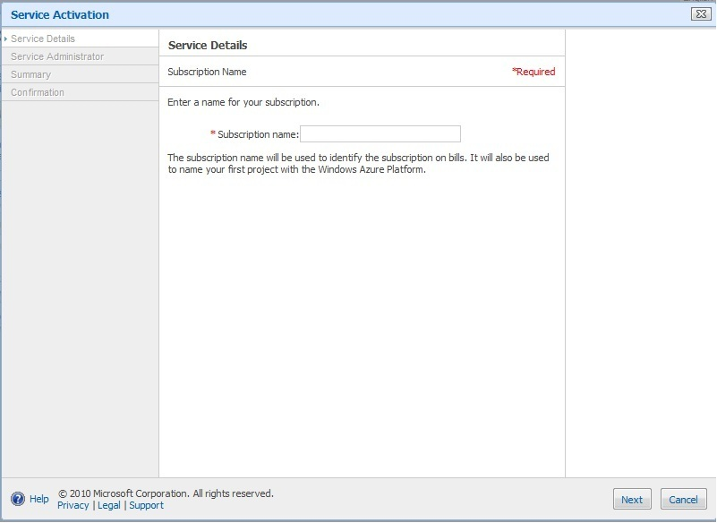

Then, Microsoft Online Services Customer Portal asks you to enter contact details for the person in your company who will be responsible for setting up and managing your service. This person is called the service administrator, and is assigned by the account owner. The service administrator defaults to the account owner from your profile, in case your service administrator is the same as your account owner. If your service administrator is not the same as your account owner, he/she can only access the SQL Azure portal and manage their servers. The service administrators cannot manage the subscriptions via the Microsoft Online Services Customer Portal but the account administrators can.

As soon as activation is complete, an e-mail message is sent to the account owner and the service administrator, outlining the next steps to take.

Enter the information in the **Service Activation** window and click **Next**.

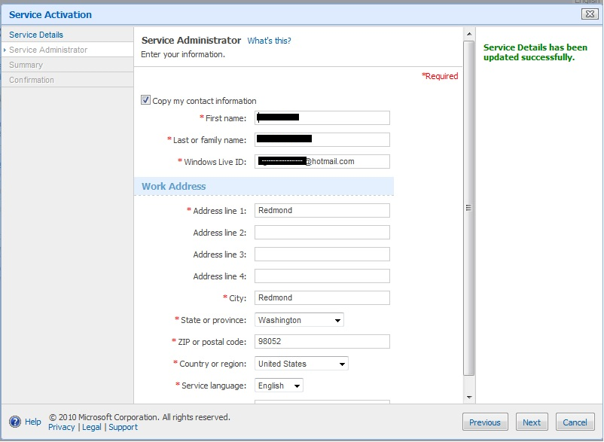

Then, you will see the **Summary** page as follows. Review all the information and click **Finish**.

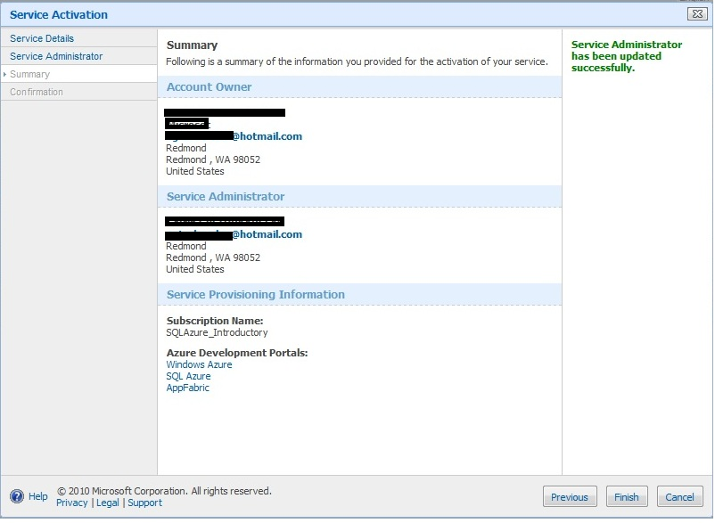

After you click **Finish** on the **Summary** page, **Confirmation** window appears. Click **Close**.

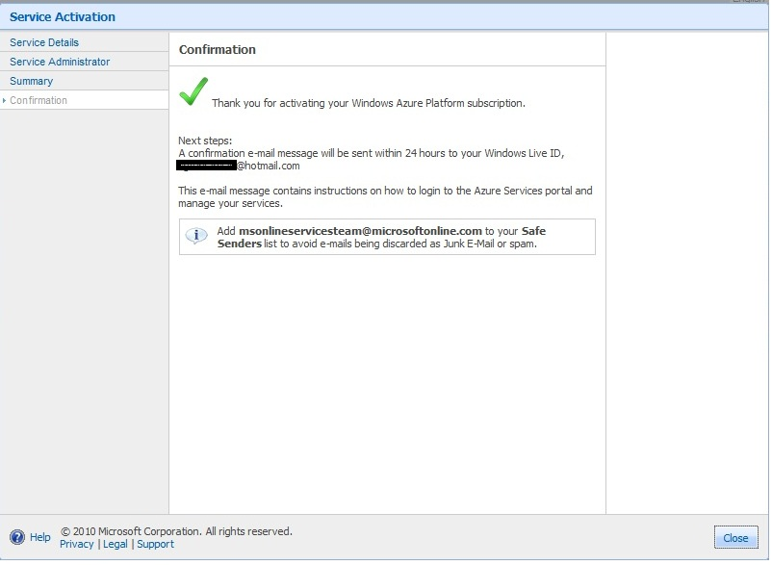

At this point, a confirmation e-mail message will be sent to your Windows Live ID account. You can see the status of your subscription under the **Subscriptions** tab at the Microsoft Online Services Customer Portal.

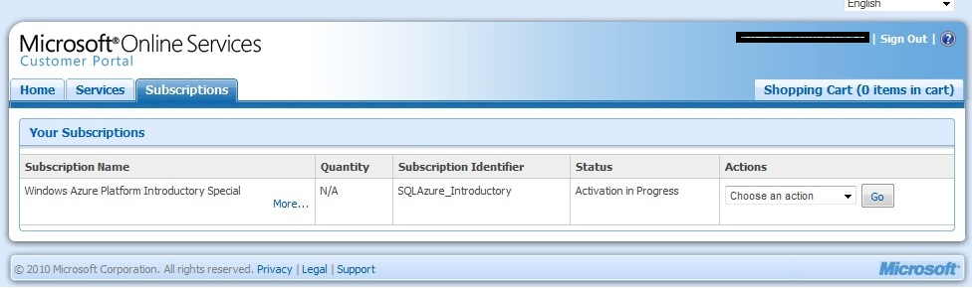

After purchasing a Windows Azure Platform subscription, you will receive an email, which will show you how to activate your account. The following image shows an example confirmation email. In the confirmation email, click **Microsoft SQL Azure** and sign in with your Windows Live ID username and password.

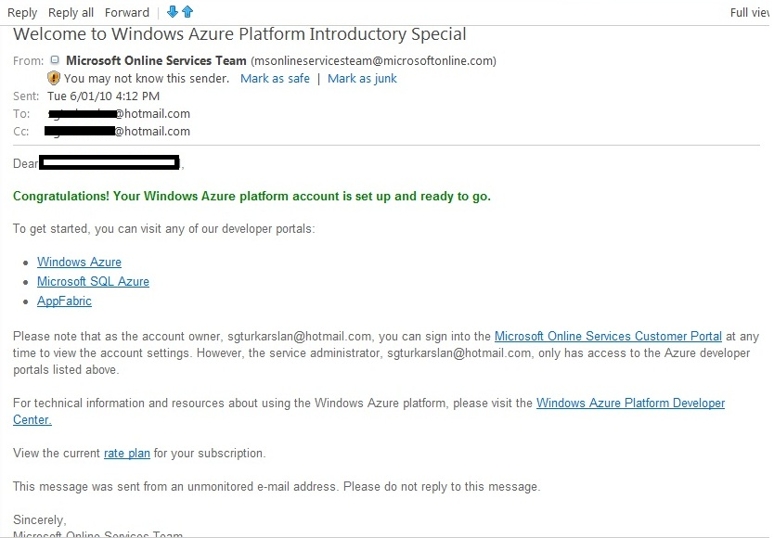

After creating and activating your subscription, you can create your server at the [SQL Azure Developer Portal](https://sql.azure.com/ProjectViewer.aspx). Once you sign in the SQL Azure Portal, a list of projects you have created will show up. By default, the subscription name will be used to name your project. Check the **Status** column to verify if your subscription is **Enabled** or not. For more information, see [Status Codes for SQL Azure Accounts](http://msdn.microsoft.com/en-us/library/ee730905.aspx).

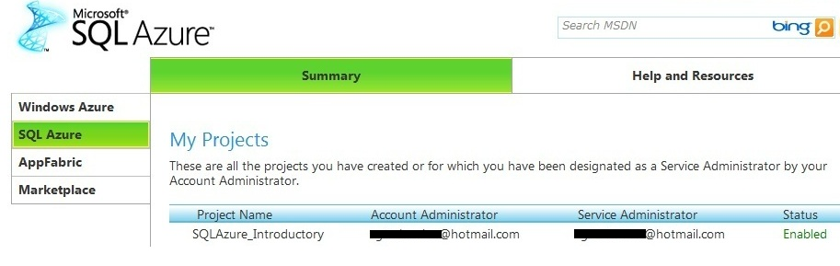

When you click the project name, SQL Azure Portal asks you to read and accept the **Terms of Use**.

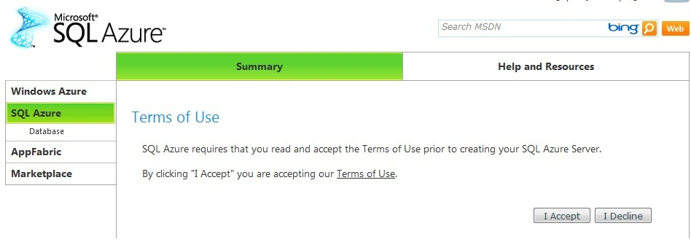

Click **I Accept**. Then, you can create your logical server. Choose the location that is closest to you to avoid extra bandwidth costs and achieve better performance. For more information on bandwidth costs, see [Accounts and Billing in SQL Azure](http://msdn.microsoft.com/en-us/library/ee621788.aspx).

Note: One subscription maps to one logical SQL Azure server 1:1. A SQL Azure server is a logical server and contains one or more databases.

Enter **Administrator Username** and **Password**, click **Create Server**.

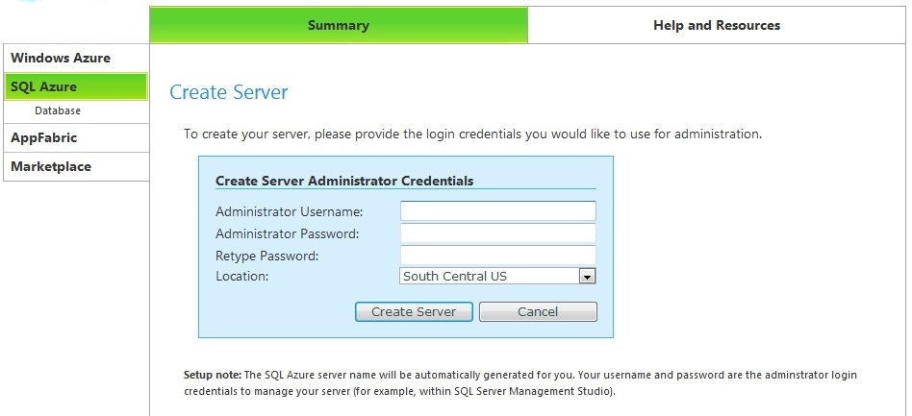

After you click **Create Server**, the provisioning process creates an SQL Azure server, a database named **master**, and a login that is the server-level principal of your SQL Azure server. That login is similar to the server-level principal, **sa**, for an instance of SQL Server on your premises.

Note: Once you create your server, you can create your SQL Azure databases either by using the SQL Azure portal or connecting to the master database and running the CREATE DATABASE statement. A **master** database is created automatically. You must be connected to the **master** database whenever you **CREATE**, **ALTER**, or **DROP** databases. If you do not specify a database in the connection string, you will be connected to the **master** database by default. Each SQL Azure server has a fully qualified unique domain name, such as *servername.database.windows.net*. The *servername* refers to the name of your SQL Azure server.

Next, the **Server Administration** page appears.

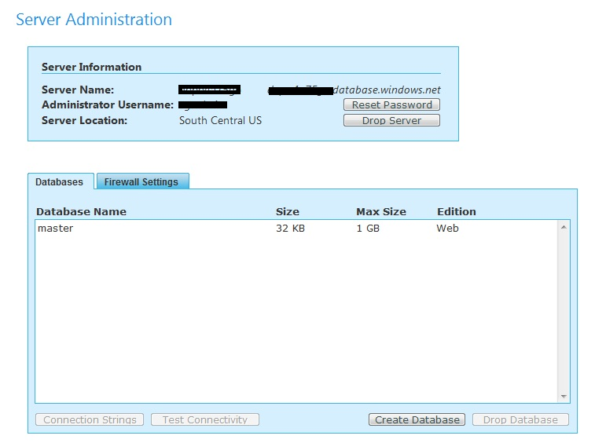

Click **Create Database** to create a new database.

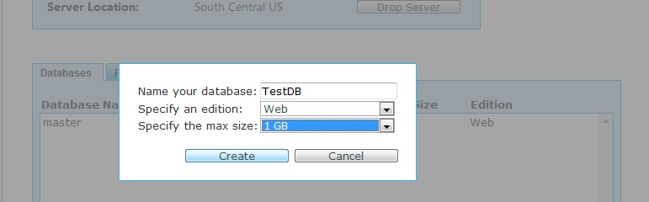

Type *TestDB* and choose *1GB Web Edition* database and click **Create**. For more information on different database sizes and editions, see [Accounts and Billing in SQL Azure](http://msdn.microsoft.com/en-us/library/ee621788.aspx).

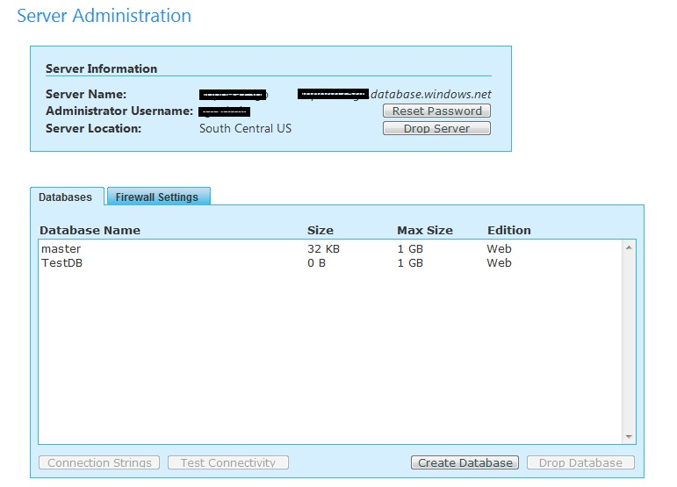

If you want to see an example connection string that can be used to connect to your SQL Azure database, select *TestDB* database, click **Connection Strings**. This will provide ADO.NET and ODBC connection strings that can be used in your application.

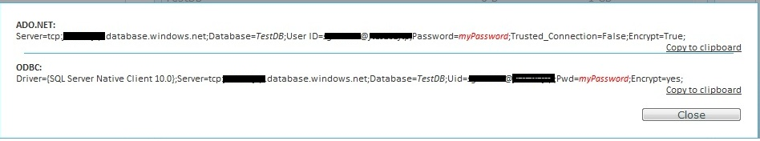

Select your SQL Azure database and click **Test Connectivity**. Enter your Username and Password as shown below and click **Connect**. Initially, all access to your SQL Azure server is blocked by the SQL Azure firewall; connection attempts originating from the Internet or Windows Azure will not be able to reach your SQL Azure server. Therefore, the connection will not succeed.

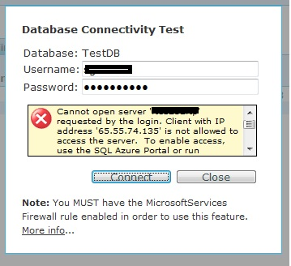

Similarly, if you want to connect to your SQL Azure server by using the **sqlcmd** utility and if the connections are blocked by the SQL Azure firewall, an error message is returned by the service:

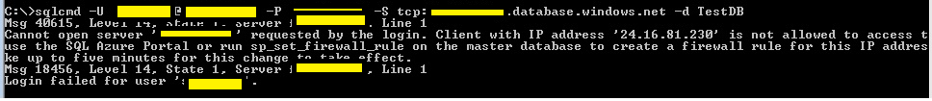

Note: When a computer attempts to connect to your SQL Azure server from the Internet, the SQL Azure firewall checks the originating IP address of the request against the full set of firewall settings. If the IP address of the request is not within one of the ranges specified, the connection attempt is blocked and does not reach the SQL Azure server. If you want to connect to the SQL Azure server and the connection is blocked by the SQL Azure firewall, the service returns an error message.

In order to begin using your SQL Azure server, you must specify one or more firewall settings that enable access to your SQL Azure server on the SQL Azure Portal. Use the firewall settings to specify which IP address ranges from the Internet are allowed, and whether or not Windows Azure applications can attempt to connect to your SQL Azure server.

To do that, click the **Firewall Settings** tab on the **Server Administration** page.

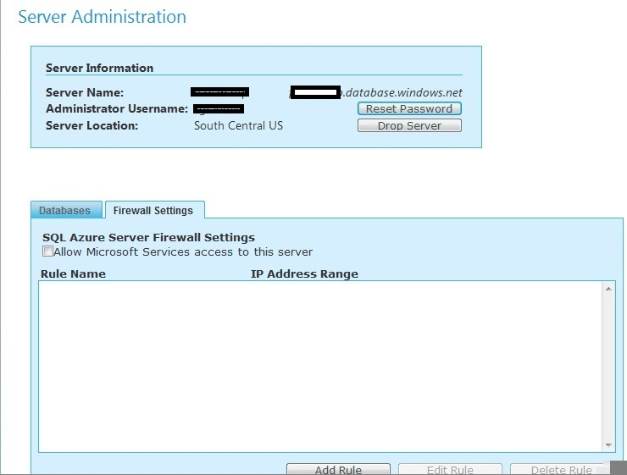

If you want Windows Azure applications to be able to connect to your SQL Azure server, you must click **Allow Microsoft Services access to this server**. This will add a new firewall rule, which is called as *MicrosoftServices* and its IP Address Range would be *0.0.0.0 – 0.0.0.0* by default.

If you want to add a new firewall setting for Internet-based connections, click **Add Rule**. In the dialog box, specify a unique name in the **Name** field with the corresponding **IP address range**. Then select **Submit**. The IP address of your computer must be within the IP address range of one of the firewall settings. For more information, see [SQL Azure Firewall](http://msdn.microsoft.com/en-us/library/ee621782.aspx) and [SQL Azure Connectivity Troubleshooting Guide](http://blogs.msdn.com/b/sqlazure/archive/2010/03/22/9982979.aspx).

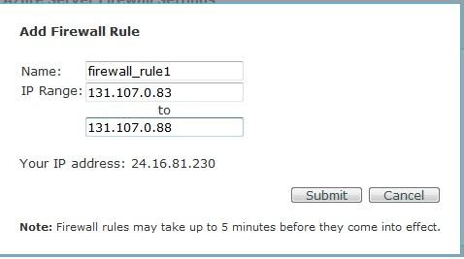

The following images demonstrate the firewall rules that are enabled in this subscription.

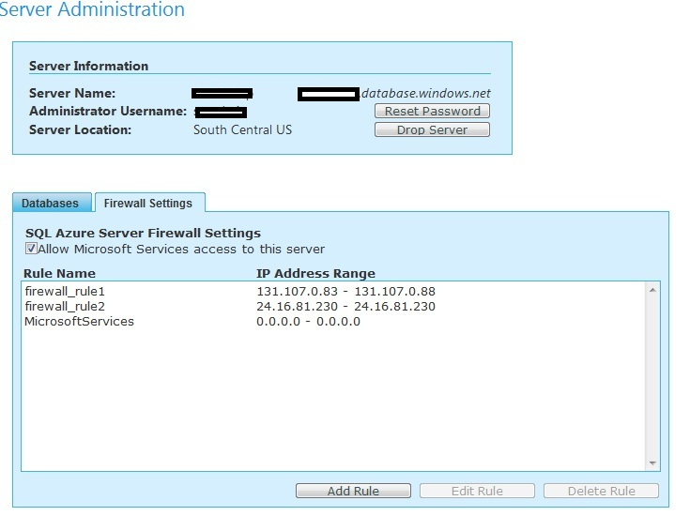

To modify the existing firewall rule, select the rule and click **Edit Rule**.

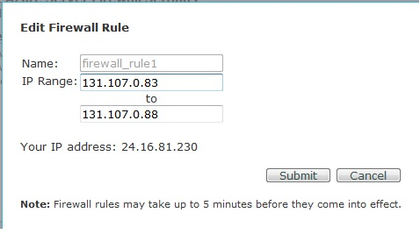

After you create your SQL Azure server, databases, and set the firewall rules, you can connect to your SQL Azure database either by using the **sqlcmd** utility or SQL Server 2008 R2 Management Studio. For more information, see [Developing and Deploying with SQL Azure](http://social.technet.microsoft.com/wiki/contents/articles/developing-and-deploying-with-sql-azure.aspx).

Just like SQL Server, SQL Azure allows you to create additional logins and users. For more information, see [Managing Databases and Logins in SQL Azure](http://msdn.microsoft.com/en-us/library/ee336235.aspx).

In addition, SQL Azure allows you to use a subset of the Transact-SQL query language to query a database and to insert, update, and delete data in tables in a database. For more information, see [Transact-SQL Reference](http://msdn.microsoft.com/en-us/library/ee336281.aspx).

When you write applications for SQL Azure, you can use one of the .NET Framework programming languages, which come with Visual Studio 2008 or later: Microsoft Visual Basic, Microsoft Visual C#, or Microsoft Visual C++. You can also use the ADO.NET data provider for SQL Server, the SQL Server 2008 Native Client ODBC driver, and the SQL Server 2008 Driver for PHP version 1.1. For more information, see [Development Guide](http://msdn.microsoft.com/en-us/library/ee336225.aspx).

**References:**

* [SQL Azure Portal](http://www.microsoft.com/azure/sql.mspx)
* [SQL Azure Developer Center](http://msdn.microsoft.com/en-us/windowsazure/sqlazure/default.aspx)
* [SQL Azure Documentation](http://msdn.microsoft.com/en-us/library/ee336279.aspx)
* [SQL Azure Team Blog](http://blogs.msdn.com/sqlazure/)