
Microsoft Office Word 2007
February 2006

Table of Contents

Cover is for
position only

Overview of Microsoft Office Word 2007 1
Create Professional Documents Effortlessly 1
Share Your Documents Confidently 2
Connect Your Documents to Important Business Information 3
Manage Content with Office SharePoint Server 2007 4
Create Professional Documents Effortlessly 5
Results-Oriented User Interface 5
The Building Blocks Feature 5
Formatting Features 7
Quick Styles 7
Document Themes 8
Shared Diagramming and Charting 9
Equation Builder 10
Additional New Features 10
Typography 10
Citations and References 11
Contextual Spell Checking 12
Share Your Documents Confidently 12
Reviewing Capabilities 12
The Document Comparison Feature 12
Create a Review or Approval Workflow 14
Save as PDF or XPS 15
Document Inspector 16
Apply a Digital Signature 17
Improved Reading Experience 19
Managing Content with Office SharePoint Server 2007 19
Information Rights Management 20
Records Management 20
Information Management Policies 20
Keeping Your Content Safer with Office SharePoint Server 2007 21
Connect Your Documents to Important Business Information 22
Word XML Format 22
Data Binding 22
Document Controls 23
The Document Information Panel 24
Summary 25
Resources 26
System Requirements 27

Overview of Microsoft Office Word 2007
Welcome to Microsoft® Office Word 2007, included in the 2007 release of the Microsoft Office system of products. Office Word 2007 is a powerful authoring program that gives you the ability to create and share professional-looking documents by combining a comprehensive set of writing tools with an easy-to-use interface.
Office Word 2007 helps information workers create professional-looking documents more quickly than ever before. With the host of new tools, you can spend more time writing and less time formatting documents. In addition, Office Word 2007 documents can be integrated with business processes and back-end systems. The new Word XML Format is a compact, robust file format offering smaller file sizes and improved recovery of corrupt documents.
This document provides an overview of Office Word 2007, with an emphasis on new and improved features. It also covers Office Word 2007 in action to demonstrate its exciting new capabilities.

Create Professional Documents Effortlessly
Together with a new results-oriented interface, Office Word 2007 gives you the tools you need to create professional-looking documents.
- New! A streamlined user interface presents the right tools to you when you need them.
- New! Add Building Blocks of predefined content and reduce the errors associated with copying and pasting frequently used content.
- New! Quick styles save you time by quickly formatting text and tables throughout your document.
- New! Document themes apply the same colors, fonts, and effects to your documents for a consistent look.
- New! Charting and diagramming tools help you add a professional look to documents. Shared diagramming and charting with Microsoft Office Excel® 2007 spreadsheet software and the Microsoft Office PowerPoint® 2007 presentation graphics program help ensure a consistent look across your documents, spreadsheets, and presentations.
- New! The Equation Builder helps you construct mathematical equations using real mathematical symbols, prebuilt equations, and automatic formatting.
- New! Live word count keeps track of the number of words in your document as you type.
- Improved! Typographic capabilities offer new fonts and better on-screen reading.
- New! Citations and references give you the ability to search databases of predefined references and add them to your document with a single click.
- New! Contextual Spell Checking helps ensure you are using the right word in the right place.

Share Your Documents Confidently
With Office Word 2007, you can share documents with colleagues to gather feedback efficiently. You can help prevent unwanted distribution of your documents and help ensure that private comments or hidden text are removed prior to publishing. It is now also easier to provide feedback on important documents or participate in review and approval workflows when working with Microsoft Office SharePoint® Server 2007.
- New! The Document Comparison feature makes it possible for you to conduct more thorough reviews by comparing two versions of a document, including moved text and changes, within tables—even if you do not know who made the changes.
- New! The tri-pane review panel makes it easy to detect the smallest changes between two versions of a document when comparing or combining changes from two reviewers.
- New! Initiate the review and approval workflow process directly from Office Word 2007. If you are using Office SharePoint Server 2007, you can simplify the document review and approval process.
- New! Save as Portable Document Format (PDF) or an XML Paper Specification (XPS) file option gives you the ability to create “fixed” versions of your documents for sharing with people who may not have Word.
- New! The Document Inspector feature helps you detect and remove unwanted comments, personally identifiable information, hidden text, or other information from the document so that private information stays that way.
- New! Digital Signatures can be added to a document to help others verify that content has not been changed since it was published.
- Enhanced! Read Mode offers you an immersive, full-screen reading experience that makes online reading easier, reducing the need to print.

Connect Your Documents to Important Business Information
With Office Word 2007, you can build compliance and consistency into your document publishing processes with new tools for creating and deploying structured document templates.
- New! Word XML Format gives developers the ability to integrate external information sources into your Office Word 2007 documents using document controls and Data Bindings.
- New! The Document Information Panel makes it possible for you to enter and track document information using the custom Microsoft Office InfoPath® 2007 information-gathering program forms or information from Office SharePoint Server 2007 document libraries. The result is a deep integration of content management capability directly inside Office Word 2007 documents.
- New! Document Controls help you structure the document authoring process by requiring specific types of information or by adding sections of documents that may not be edited or reformatted.

Manage Content with Office SharePoint Server 2007
Office Word 2007 can be used with Office SharePoint Server 2007 to provide more effective ways to manage content. As a result, it is now easier to help ensure consistency across your company and comply with regulations.
- New! Managed document repositories can be accessed from within Office Word 2007, so you have greater control over document versions.
- New! Information management policies consistently enforce the labeling, auditing, and expiration of documents stored in Office SharePoint Server 2007 managed document repositories.

Office Word 2007 in Action
As the senior product marketing manager for Fabrikam, Inc., a manufacturing company, Carol Philips oversees creating quarterly updates that are distributed to internal employees. Office Word 2007 gives Carol a wide array of new tools to make the process of creating and publishing this content more efficient.

Create Professional Documents Effortlessly
Whatever types of documents you need to develop in your work, you want them to look great. Unfortunately, this has often meant that you spend less time on creating first-rate content and more time on minutiae such as formatting, searching for information, and copying and pasting frequently used information from other documents. Office Word 2007 has been updated to help you create professional-looking documents more quickly than ever before.

Results-Oriented User Interface
With the new results-oriented Microsoft Office system user interface, you can produce better results more quickly by finding the tools you need when you need them. Office Word 2007 recognizes which features you are currently using and then tailors the interface accordingly. You no longer have to navigate complex menus or open multiple toolbars to make a small format change or change a drawing. The right tools are available when you need them—and the tools that you do not need do not appear.
Office Word 2007 in Action
The new results-oriented Microsoft Office system user interface provides Carol with the right tools when she needs them. If she adds a table to a document she is creating, the table formatting commands automatically appear—and the tools she does not need are hidden.

The Building Blocks Feature
Some information in your documents always remains the same, no matter what type of document you are creating. In the past, you probably spent hours finding and reentering repetitive information, such as company contact information, team biographies, legal disclaimers, or standard proposal text. Locating and retyping this information every time you create a document can waste a lot of time.
With the new Building Blocks feature in Office Word 2007, you can save time and reduce errors by creating “building blocks” of frequently used information that can be easily updated and shared. To insert this standard information, simply select the content you want from the Building Blocks menu and insert it into your document.
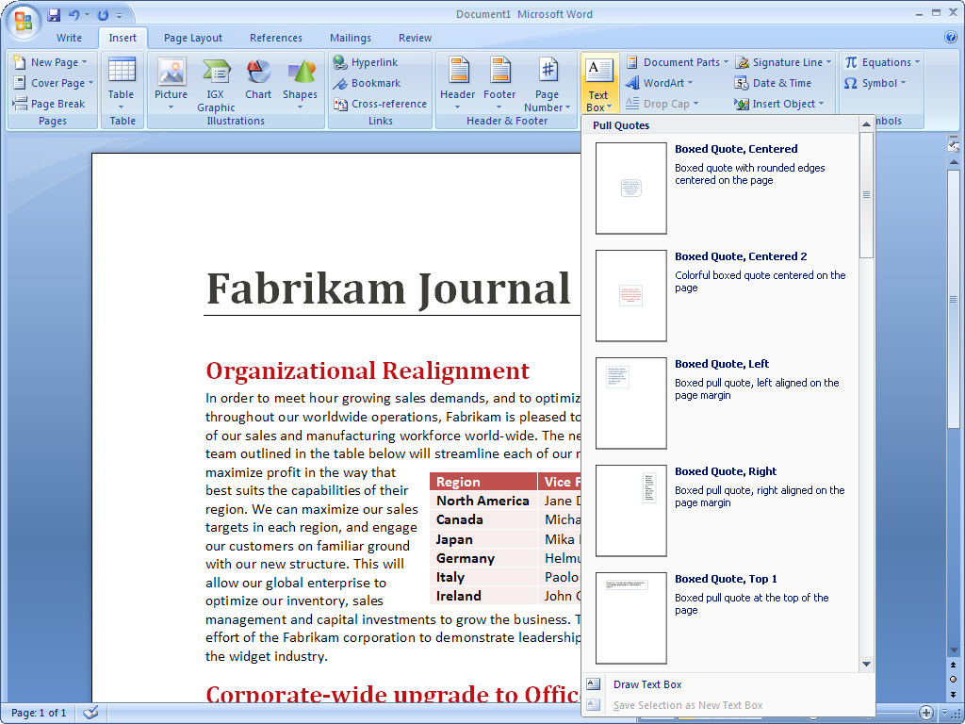
Figure 1: Adding Building Blocks to an Office Word 2007 document.
Office Word 2007 in Action
To speed the process of adding the content that appears in every quarterly report, Carol uses the Building Blocks feature. In every quarterly report, she needs a legal disclaimer, company contact information, and a photo and biography of the executive team. She simply uses the Building Blocks menu to select the prebuilt content she needs. The most up-to-date content is automatically added to her report.

Formatting Features
Office Word 2007 offers a wide range of new and upgraded formatting capabilities to help you create professional-looking, consistent documents quickly and easily. Using document themes, you can quickly apply font, color, and style changes to an entire document with a single click of the mouse. Table Quick Styles help you format complex tables with ease. And with the new Live Preview feature, you can view your changes easily, so you no longer have to undo or redo formatting selections.

Quick Styles
With the Quick Styles feature you can change how documents look with a single click. You can modify fonts, colors, margins, table formatting, and other elements by simply choosing a different format. Simply select the text you want to change and then choose the style you want from the Quick Style gallery.
For your convenience, you can create a Quick Style and add it to the gallery that shows your frequently used styles. Quick Styles provide the added benefit of being very flexible; you can update them whenever you need from within Office Word 2007.
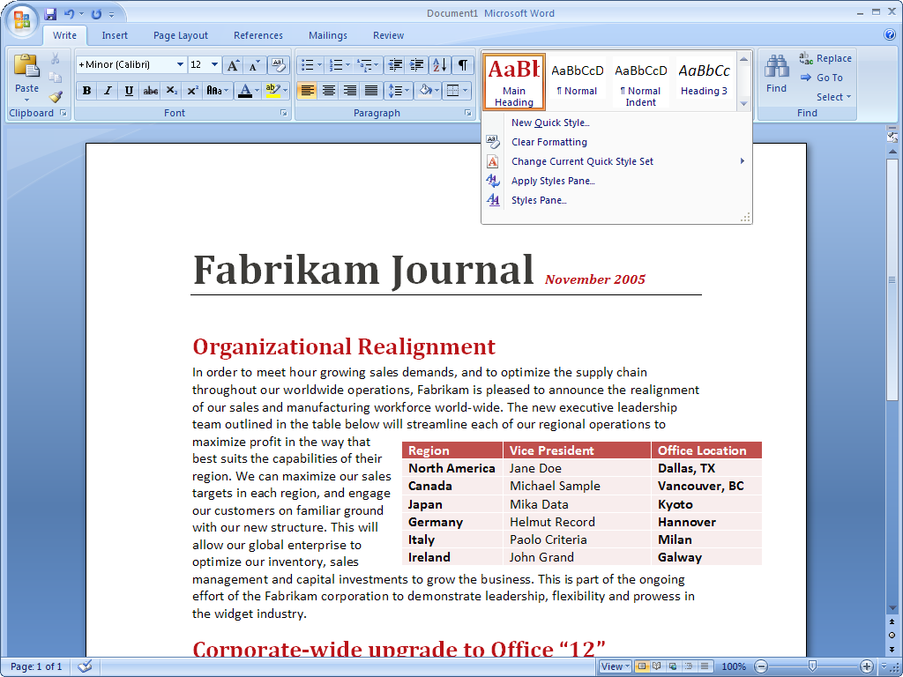
Figure 2: Using Quick Styles in an Office Word 2007 document.
Office Word 2007 in Action
Carol now spends a lot less time formatting her quarterly updates and a lot more time writing them. She simply selects the right Quick Style—and quickly changes fonts, colors, margins, table formatting, and other elements throughout the document.

Document Themes
Document themes provide the foundation for the overall look of your document. The theme defines the major and minor fonts used in the document, the color palette for the document, and the effects used for shapes, charts, and diagrams inserted into the document. By basing all the content of a document on the same theme, you can help ensure a consistent look and make dramatic changes easily when updating the document or reusing the content.

Shared Diagramming and Charting
Using new graphics tools and document themes, you can now produce a professional-quality graphic with only a few clicks.
Charting in the Microsoft Office system makes it easy to create great-looking charts. Simply choose the chart type, the layout, and the format from visual galleries of predefined options. You can also reuse content by saving your favorite charts as chart templates.
Because the diagramming and charting tools are shared between Office Word 2007, Office Excel 2007, and Office PowerPoint 2007, you can produce consistent, professional-quality results across the Microsoft Office system.
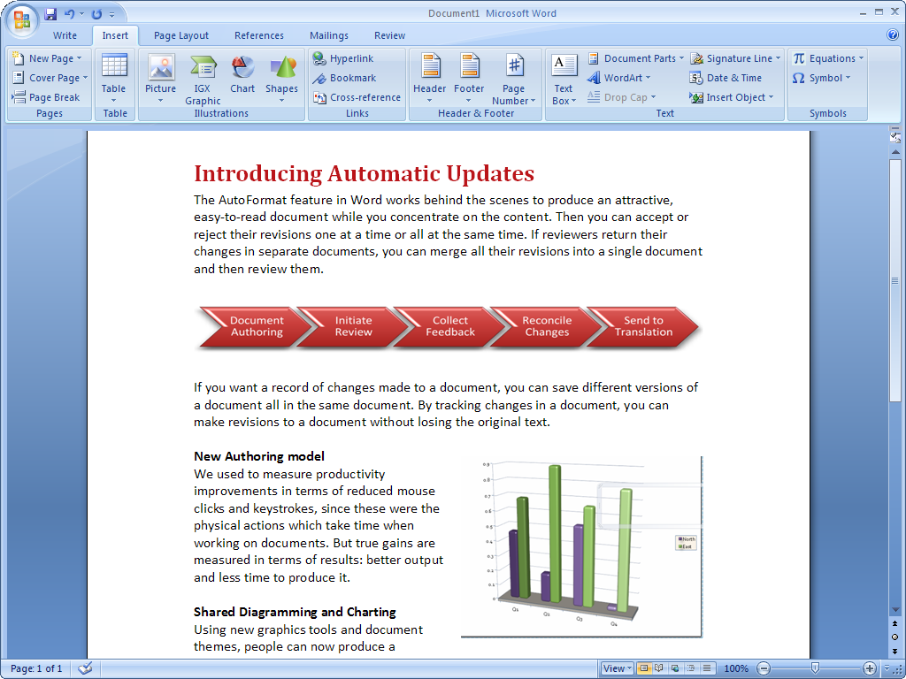
Figure 3: Examples of new charting and diagramming capabilities.

Equation Builder
A new Equation Builder is built right into the Office Word 2007 user interface, a boon to all people who work in education, research, or another industry that requires equation capabilities. With a new point and click-and-insert interface, inserting live, editable mathematical equations is easy—no matter whether you are creating fractions, integrals, or trigonometric functions.
Office Word 2007 in Action
Because Fabrikam is a manufacturing company, Carol often needs to include equations in her documents to illustrate points for a scientific audience. With Equation Builder, she no longer has to manipulate special characters or insert a graphic just to include an equation. Instead, she can create and edit equations directly within Office Word 2007.

Additional New Features
Office Word 2007 offers many other significant enhancements that make working with documents simpler. A new Live Word Count keeps track of the number of words in your document as you type, so you do not have to keep checking manually. The improved predictability in bulleting and numbers reduces the difficulty of achieving exact formatting in your documents. In addition, a new Mail Merge tab is built right into the interface to simplify the process of sending mass mailings.

Typography
Office Word 2007 improves the look of documents by providing better typographic tools. These capabilities include new, award-winning typefaces that provide you with a clean, fresh look to your documents. The new typefaces have been designed for clarity and reading, and are integrated into all the new templates offered as part of the Microsoft Office system. Office Word 2007 also includes improved ClearType support for better on-screen rendering. Plus, for advanced users, Office Word 2007 offers OpenType capabilities for fine typographic control.

Citations and References
Depending on your industry or target audience, how you manage citations and references can vary widely. The Word Reference Builder helps you manage and format the references in your document automatically. After identifying the references used in your documents, you can then use the Word Reference Builder to automatically reformat bibliographies and citations according to one of many commonly used style guides, including Associated Press (AP), Modern Language Association (MLA), Chicago Manual of Style, International Formats, and American Medical Association (AMA). All you have to do is select the style you need; Office Word 2007 then formats citations automatically. You no longer have to guess whether you are using citations properly, or waste time fussing with the correct format.
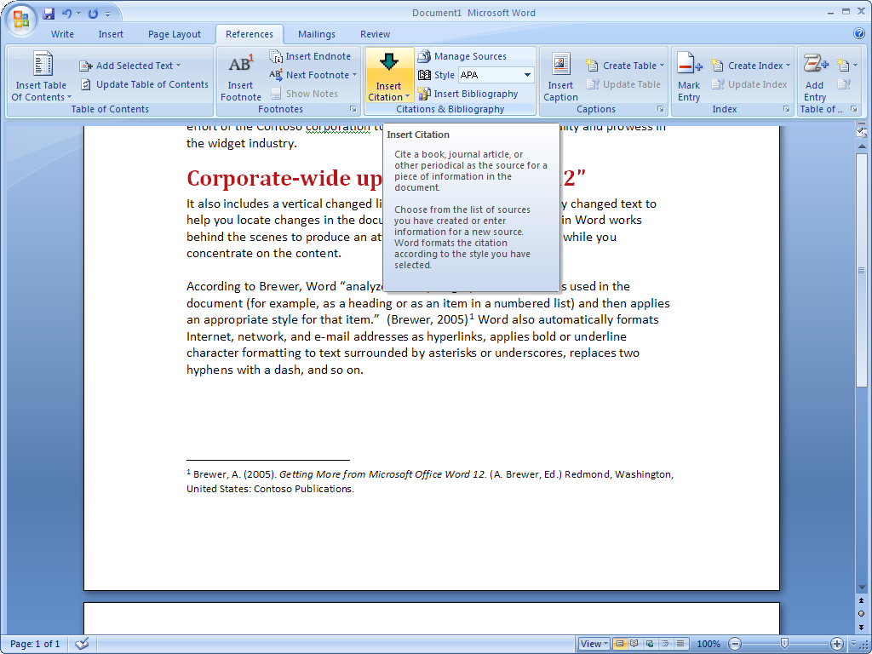
Figure 4: Inserting a citation into an Office Word 2007 document.
Office Word 2007 in Action
In her quarterly updates, Carol often cites research publications. Like many businesses, Fabrikam uses the Chicago citation style. All she needs to do is select Chicago style on the Reference Builder, enter her information, and click Enter. Office Word 2007 does the rest.

Contextual Spell Checking
The spell checking feature in previous releases of Word has been improved to deliver more than correct spelling; now, it also verifies that you are using the word in the right context. For example, it now recognizes the right context for words like “their” and “there.” This improved feature helps you avoid common mistakes and common misuse of tricky words.

Share Your Documents Confidently
Do you need to share your documents and get feedback more quickly? Or do you want to convert your work to a fixed format so that others can view it more easily? Whatever your needs, Office Word 2007 offers a wealth of new features and an all-new commenting experience designed to make sharing and reviewing documents even easier.

Reviewing Capabilities
For many companies, the process of reading, reviewing, and comparing documents can be cumbersome. Unfortunately, ineffective processes reduce your productivity. Office Word 2007 offers new reviewing features that make it easy for you to conduct fast, yet thorough, review and approval work cycles using the tools you are most comfortable with. In addition, the new Review tab organizes the reviewer’s tools so that they are clear and the reviewer can be more efficient.

The Document Comparison Feature
People often need to compare two versions of a document to see what has changed, even if they do not know who made those changes. This step can be critically important when seeking out changes in documents that might radically alter its overall meaning.
With the new Document Comparison feature, you can easily see the difference between two different documents by comparing them side by side. You can also use the new tri-pane review panel to view the two different documents, as well as one document that combines the changes from each. Simultaneous scrolling for all three views makes it easy to follow the changes systematically through a document.
It is also easier than ever to conduct more thorough reviews because Office Word 2007 tracks moved text and changes within tables. As a result, it is easier to see what portions of a document have changed.
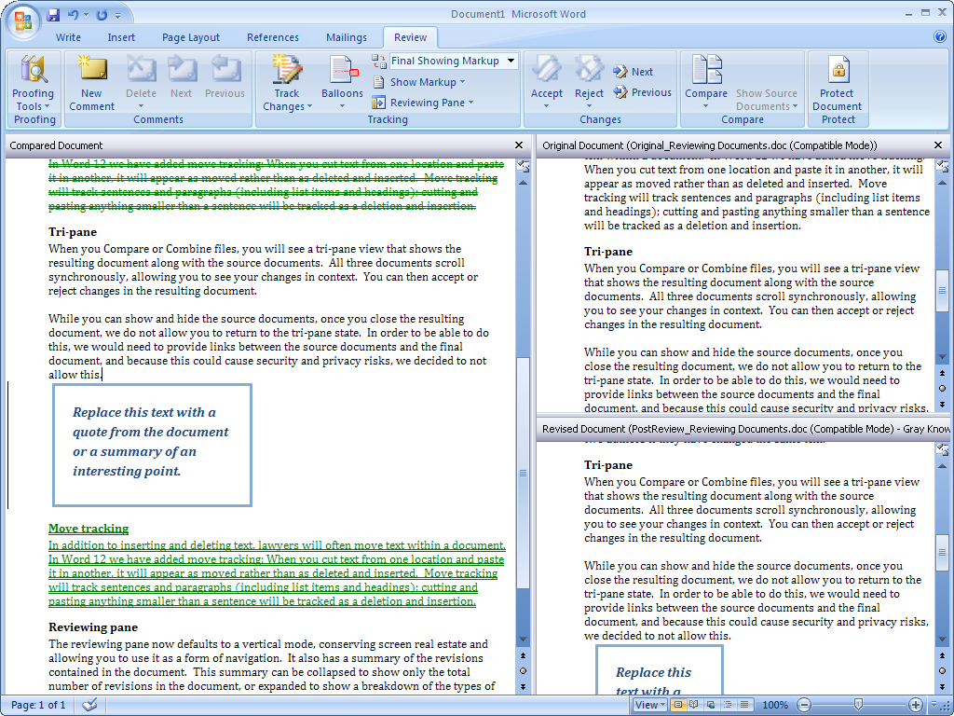
Figure 5: Comparing two versions of a document in Office Word 2007.
Office Word 2007 in Action
The Document Comparison feature greatly simplifies the reviewing process for Carol. After she has sent documents to the executive team and other stakeholders to review, she can open their revised documents and compare them side by side. She also uses the tri-pane review panel to combine changes from two documents into one—and then view all three documents simultaneously. Because all documents scroll when she views one, it is easier to review all the changes at one time and edit her final draft.

Create a Review or Approval Workflow
Managing the review and approval cycle often can be frustrating and time-consuming. In the past, you probably sent an e-mail message with an attachment to everyone who needed to review a document. Then you had to track down who had submitted their reviews and who had not responded. And finally, you had to save all the review documents in one place.
If you are using Office Word 2007 with Office SharePoint Server 2007, you can take advantage of the review and approval workflow directly from Office Word 2007. This feature reduces cycle times for important document processes. To initiate a document review workflow, simply load the document into a document library directly from Office Word 2007.
Document libraries are preconfigured to initiate and manage the review process. Reviewers are automatically sent an e-mail message to notify them of the review; when they finish reviewing, documents are posted in the document library where they are readily accessible. Then you can use the new commenting and document comparison capabilities so that when you open the reviewed document, Office Word 2007 also opens the original.
Office Word 2007 in Action
Fabrikam uses Office SharePoint Server 2007 with the Microsoft Office system. When Carol is ready to share her quarterly update for review, she uploads her draft into a SharePoint document library. Her reviewers are automatically sent an invitation to review her document together with a deadline. Now Carol gets her reviewed documents back more quickly without having to spend valuable time managing the review process.
Fabrikam also uses Microsoft Windows® SharePoint Services to limit who can access confidential information. For example, many of the documents Carol creates have confidential information that she may not want anyone outside her immediate team to access. Now she can limit access to those documents to the people who need to see them.

Save as PDF or XPS
Sometimes you may need to save your Word document in a “fixed” file format so that other people who may not have Word can view it. Word now supports saving your document as a Portable Document Format (PDF) or XML Paper Specification (XPS) file. Now you can post your documents on the Internet, or share them with others, knowing that other users can view them regardless of the type of computer or applications they are using.
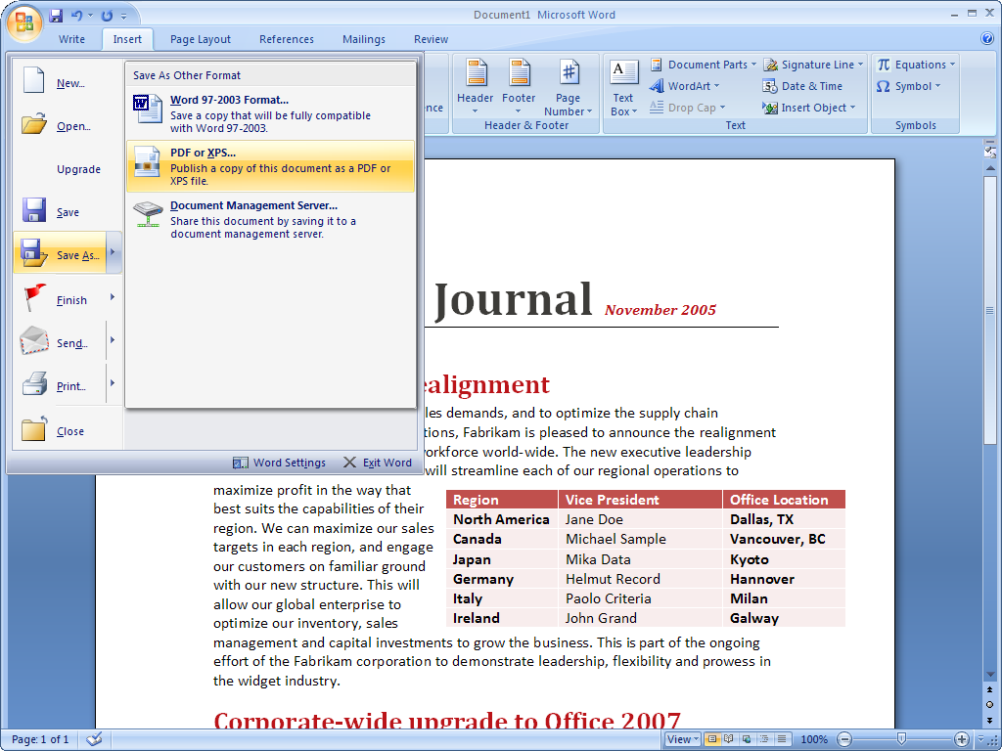
Figure 6: Saving an Office Word 2007 file as a PDF.

Document Inspector
Sometimes you may not want to show who authored a document, or you need to make sure that all comments have been removed. Document Inspector helps you keep your confidential information private by removing personally identifiable information, comments, and tracked changes from documents. It can also search for and remove hidden text.
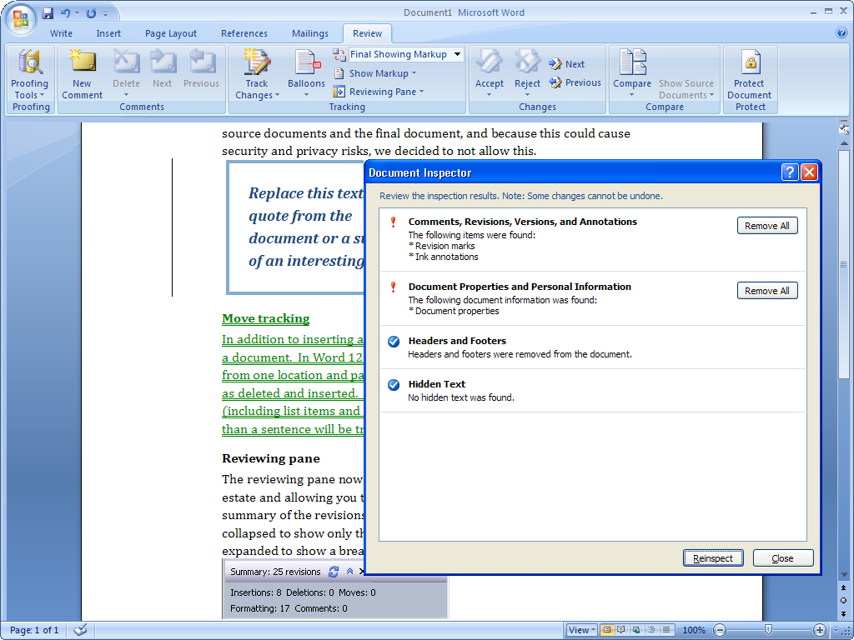
Figure 7: Using Document Inspector to remove comments.

Apply a Digital Signature
Office Word 2007 helps you provide others with a digital signature that lets others know that the document has not been modified since you created it. A signature line can be added to each document to require a digital signature for documents that are edited by others. People reading digitally signed documents can easily verify that the document has not changed since it was signed.
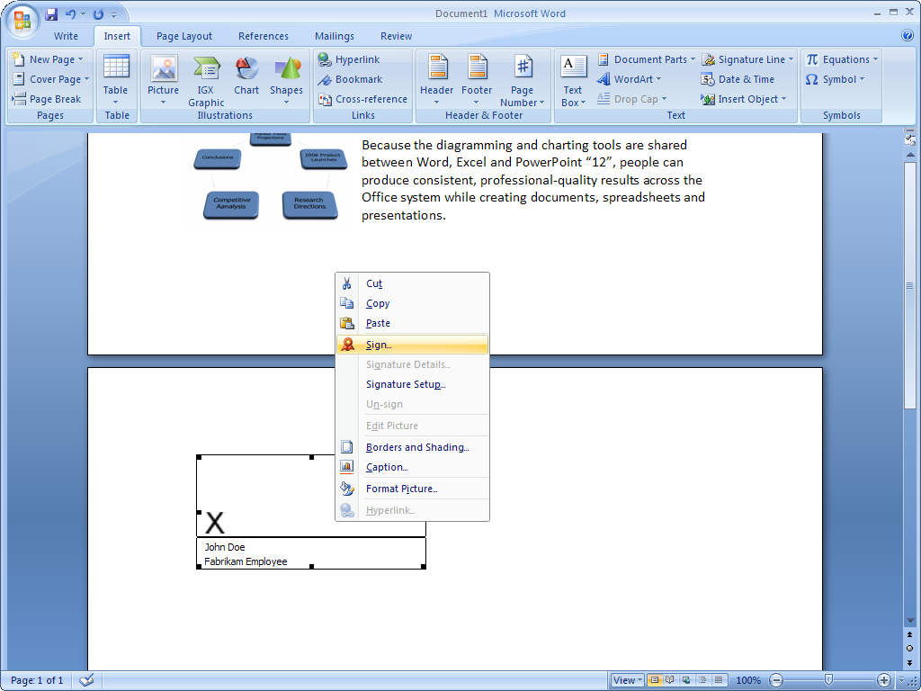
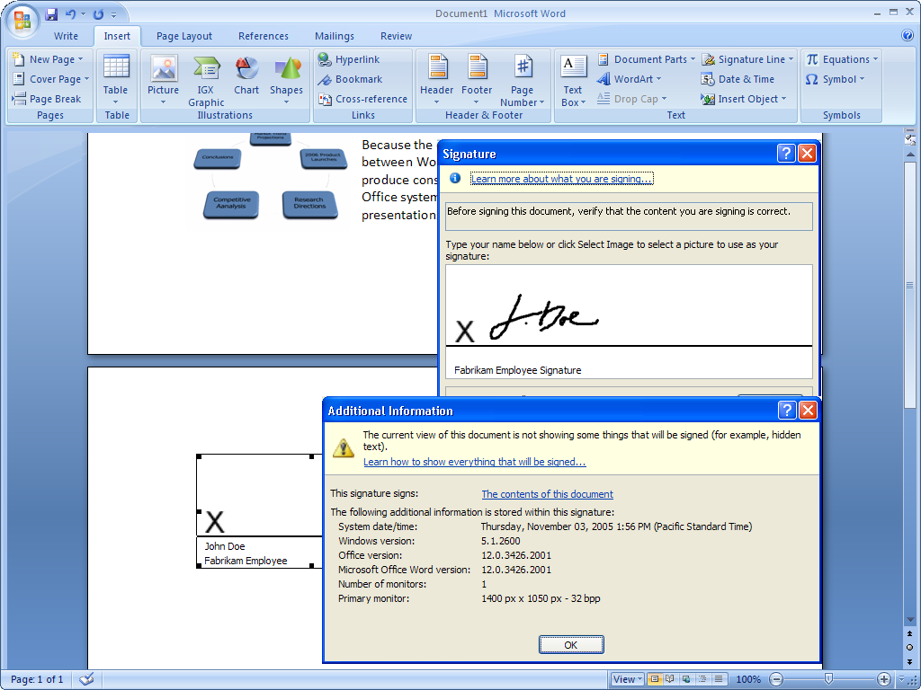
Figures 8 and 9: Digitally signing an Office Word 2007 document.
Office Word 2007 in Action
Before Carol sends out her final quarterly report, she uses the Document Inspector feature to protect her company’s confidential information by removing any hidden text, comments, and document properties. Then she digitally signs her quarterly report to demonstrate that she was the last person to edit it.

Improved Reading Experience
Office Word 2007 features a brand-new, immersive, full-screen reading experience. When you open Word documents in Read Mode, all but the most essential tools on the user interface are hidden. These “lightweight on-the-page controls” are more intuitive and include view settings, navigation, research, and reviewing tools—but nothing else. The result is an uncluttered yet richly featured on-screen reading experience.
Office Word 2007 in Action
Carol has a specific layout and page size she uses for her quarterly reports. In the past she had to print out every page of her document to help ensure it looked good. Now, with Read Mode, she can design, review, and modify her document—without having to print it at all.

Managing Content with Office SharePoint Server 2007
Companies are increasingly challenged with compliance regulations. Although many have started using electronic business and document management processes, it can be difficult to start managing and auditing electronic business records.
When a document has been completed and is ready to be shared, you need to be confident that it is not inadvertently shared with people who should not see it. You should also be confident that your documents do not include unintentional content or editing marks that call out words that the recipient’s dictionary does not recognize. Furthermore, you should be able to restrict access to the content within your documents; they may include potentially sensitive information that may come to light after they have been publicly distributed. Finally, you may also need to indicate that your presentation is the document of record that indicates an official company policy or procedure for a given topic.
Using Office Word 2007 with Office SharePoint Server 2007 and Microsoft Windows Rights Management Services, users have many more ways to protect and manage their information.

Information Rights Management
You may need to protect and control access of company information, especially if you are creating documents with confidential information. By using the Microsoft Office system with Windows Rights Management Services for Microsoft Windows Server™ 2003, you can assign permissions that prevent others from copying, printing, or editing your presentation.

Records Management
Office SharePoint Server 2007 provides a managed document repository built on Windows SharePoint Services to store the document record, or the master document, in a Records Repository. You can upload documents to this repository directly from Office Word 2007. This ability provides a way for people to publish documents without having to resort to an external tool or Web browser interface.

Information Management Policies
When using Office SharePoint Server 2007, you can apply information management policies that consistently enforce the labeling, auditing, and expiration of documents. You can configure policies for a specific storage location or content type. For example, organizations can help ensure that all documents are stored the same way by setting the expiration dates on common criteria, such as the end of the fiscal year.
Office SharePoint Server 2007 supports a set of information management policies that can be defined for an entire site or a specific list, library, or content type. You can also create a policy statement informing users how the content is governed. For Word documents, this policy statement is embedded in the document. For instance, the policy statement might indicate that a document will expire after a certain period of time or that it is sensitive information that should not be communicated outside the company. It can even provide a contact name if the recipient needs more information.

Keeping Your Content Safer with Office SharePoint Server 2007
It can be extremely challenging to implement consistent information management policies across an organization that has a wide range of sites. To solve this issue, Office SharePoint Server 2007 helps policy decision-makers—such as IT staff, records managers, or compliance officers—to define site policies that users can apply without worrying about the specific details. Each site policy can include any number of settings, like labeling expiration or auditing. As a result, you can add an extra layer of security to your documents by designating access to them. For example, if you only want to give a certain department access to presentations, you can easily define it to require the correct credentials.

Connect Your Documents to Important Business Information
An important part of efforts at ensuring corporate compliance is creating documents across the company in a consistent way. Office Word 2007 offers improved tools to enhance the creation of structured document templates that guide people through the process of creating heavily structured or regulated documents. They go far beyond typographic formatting and document layouts to give you the tools you need to build sophisticated document templates. In turn, you can now help ensure that everyone in your organization is creating documents with the correct content and formatting every time.

Word XML Format
The new Word XML Format is a compact, robust file format that makes possible better integration of documents with external information sources. The Word XML Formats include a separate XML data store to help separate the content of the document from the layout and presentation, making important business information easy to update and highly portable.

Data Binding
Because Office Word 2007 offers the ability to bind parts of a document to external information sources, it is now faster and easier than ever to incorporate the right information without having to force people to use clumsy cut-and-paste methods. Too often, people add important business information to documents using the cut-and-paste tools, resulting in documents that contain outdated, unmanaged information. This prevents people from sharing a single version of business information when circulating documents, which can result in expensive misunderstandings.
The new Data Binding feature in Office Word 2007 helps alleviate this issue by providing a way to build document templates that have live connections to external information sources. By “binding” document contents to XML sources, documents now stay connected to important business information. When you use Data Binding with the new Word XML Formats, you can easily update the XML data store (stored within the Word file) to help ensure the content of the Word document is updated.
XML integration through Data Binding helps ensure organizations can build and deploy structured document templates that help users get the right information into their documents without troubling them with extensive searches in external applications.

Document Controls
Document Controls let template builders determine user behavior according to predefined rules. As just one example, a “date picker” control can be included in a document to make sure the proper date format is chosen. Drop-down lists and other familiar controls can be added to help ensure proper data entry into the document.
Template builders can also specify which parts of a document may be edited and which may not. This new feature helps ensure important information—such as legal disclaimer text or routing information—is not removed during the editing process.
Office Word 2007 in Action
Like everyone else at Fabrikam, Carol uses structured document templates that help ensure that they all contain the same information and are consistent no matter who is using them. As a result, no matter what kind of document she needs to create, she is sure to have the right information already in place. For example, her documents always contain a company descriptor and legal text. These portions can be marked as sections of a document that may not be edited—and she can, therefore, rest assured that the information is always correct and up to date.

The Document Information Panel
Document-level metadata tracks important information about your document, and managing document metadata is a critical aspect of good content management systems and tools. The most common examples of metadata can be found in the property window in earlier releases of Word. These examples include details such as who authored the document and when it was created. But if you are administering a review or approval process, you might want to track different information. For instance, you might need to know how many times a certain person has edited a document. In fact, the type of information companies need to track can vary widely, in which case you can designate the types of information you track.
To help with this process, Office Word 2007 offers a new feature called the Document Information Panel, which can be used to define what information is associated with a document type. This ability, in turn, helps you track that information inside Office Word 2007 documents. Windows SharePoint Services or any custom metadata can be incorporated into the Document Information Panel, enabling sophisticated document management solutions to be built directly into your Office Word 2007 document templates.
For example, consider a document stored in a SharePoint document library and enabled with a special Document Information Panel. You open the document and make changes. When you are finished, you are prompted for information: Did you make any changes? Do you approve the document? When the Document Information Panel is updated, the information is sent back to the SharePoint document library along with the document, where it is used in list displays and integrated with other Windows SharePoint Services Web parts for advanced document management.

Summary
In the Microsoft Office 2003 Editions, the previous release of the Microsoft Office system, the primary focus was to use XML to bridge the gap between documents and important information. The 2007 release of the Microsoft Office system takes that concept a step further. Its deep integration with Windows SharePoint Services and Office SharePoint Server 2007 makes it possible for you to define information that can be reused. This leads to an overall simplification of tasks.
In fact, simplification is a hallmark of the Microsoft Office system. Office Word 2007 now offers a range of features to help you get your work done more efficiently and more quickly. Office Word 2007 delivers a new, results-oriented interface that presents the tools people need when they need them. It adds new, easy-to-use quick formatting controls, mathematical equation editing, and predefined and customizable “building blocks” for adding commonly used content, like citations, references, headers, and footers. In addition, Office Word 2007 document templates can be structured and deployed across organizations to standardize document formats and can be used to connect and present information stored in back-end systems using the new Data Binding capability.

Resources
For more information about Office Word 2007, please refer to the following resources:
Office Word 2007 Overview
http://www.microsoft.com/office/preview/programs/word/overview.mspx
Office Word 2007 Demo
http://www.microsoft.com/office/preview/programs/word/demo.mspx
Office Word 2007 Why Upgrade
http://www.microsoft.com/office/preview/word/why.mspx
Office Word 2007 Top 10 Benefits (Reasons to Upgrade)
http://www.microsoft.com/office/preview/programs/word/top10.mspx
Office Word 2007 FAQs
http://www.microsoft.com/office/preview/programs/word/faq.mspx
Office Word 2007 Highlights Tab http://www.microsoft.com/office/preview/programs/word/highlights.mspx
Office Word 2007 New Interface Tab
http://www.microsoft.com/office/preview/programs/word/newui.mspx

System Requirements
For complete system requirements, visit www.microsoft.com/office/preview/beta/sysreq.mspx.

This document is developed prior to the product’s release to manufacturing, and as such, we cannot guarantee that all details included herein will be exactly as what is found in the shipping product. The information contained in this document represents the current view of Microsoft Corporation on the issues discussed as of the date of publication. Because Microsoft must respond to changing market conditions, this document should not be interpreted to be a commitment on the part of Microsoft, and Microsoft cannot guarantee the accuracy of any information presented after the date of publication. The information represents the product at the time this document was printed and should be used for planning purposes only. Information is subject to change at any time without prior notice.

This document is for informational purposes only. MICROSOFT MAKES NO WARRANTIES, EXPRESS OR IMPLIED, IN THIS DOCUMENT.

© 2006 Microsoft Corporation. All rights reserved.

Microsoft, Excel, InfoPath, the Office logo, PowerPoint, SharePoint, Windows, and Windows Server are either registered trademarks or trademarks of Microsoft Corporation in the United States and/or other countries. All other trademarks are property of their respective owners.

