Duet™ for Microsoft Office and SAP Version 1.0
Improve the efficiency of your organization’s decision making process, utilize and interact with SAP data, seamlessly participate in best-practice mySAP™ ERP processes - all from a familiar Microsoft Office Professional 2003 user interface.

Duet Version 1.0 will be a set of Employee and Manager Self Service applications built on extensible infrastructure connecting Microsoft Office Professional 2003 and mySAP™ ERP 2004. Specifically, the Duet Version 1.0 application scenarios are:
● Time Management.
Use the Microsoft Office Outlook calendar to report time in SAP software, streamlining time entry while ensuring time-reporting compliance.
● Budget Monitoring.
Receive SAP reports in your Outlook Inbox and work with them offline, allowing managers to effectively monitor the budget by being proactively alerted to time-critical information.
Duet will connect the Microsoft Office 2003 Editions to SAP by extending well established structured SAP business processes into familiar Microsoft Office environment. SAP information only accessible to a hand full of users before, now empowers majority of corporate worker.

● Organization Management.
Access up-to-date information about employees, open positions, and organizational structures, as well as managerial approvals that are integrated from SAP software into the Outlook contacts area and Microsoft Office Professional 2003 documents.
● Leave Management.
Add leave requests as calendar items integrated with SAP approval guidelines and business defined processes.
Using Duet Version 1.0 information workers can perform corporate-driven tasks using the following features:
● Report Distribution.
Information workers can display analytic and transactional reports from SAP applications in formatted or customized Microsoft Office Excel sheets.
● Alerts and Notifications.
Employees can receive event-based alerts and notifications in Outlook from multiple back ends on the basis of business rules they set.
● Form-based approval process.
Using standard or customized Outlook forms, information workers can perform business tasks that require form-based approval of authorized users.
● Offline Capabilities.
With Duet Version 1.0, information workers can fill out forms and adjust data offline, with data synchronization and form submission to SAP applications occurring automatically when workers are again online.
● Personalization.
From Outlook, information workers gain role-based and personalized access to, and adjustment of, information in SAP applications.
● Real-Time Contextual Intelligence.
With Duet Version 1.0, information workers can obtain contextual information from SAP applications while performing daily tasks in Outlook.

Duet Organizational Benefits
The Duet product will bridge the gap between the best desktop productivity tools – Microsoft Office Professional 2003 - and the best-practice processes implemented and governed by mySAP™ ERP 2004.
The immediate organizational benefits include:
● Reduce complexity of every day tasks.
Duet Version 1.0 will embed mySAP™ ERP processes, touching information workers, into Microsoft Office 2003 Professional applications; thus reducing complexity of more advanced tasks and increasing transparency of simpler tasks traditionally handled via dedicated SAP user interface.
● React to information in real-time.
Duet will enable information workers to view information from, and trigger processes in, mySAP™ ERP 2004 within the context of Microsoft Office documents and e-mail messages, helping to eliminate time-consuming and costly manual processes associated with information discovery and resolution.
● Work with familiar applications.
Duet will empower information workers to perform a greater portion of their daily tasks and initiate business processes in SAP systems from within the familiar, comfortable Microsoft Office environment.
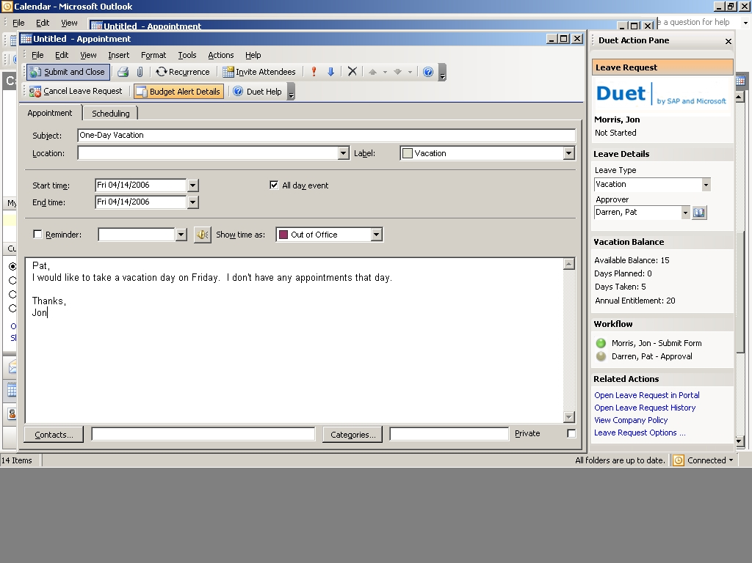
Duet applications will enable users to interact and act upon SAP information and participate in structured processes right in user interface of Microsoft Office Professional 2003 applications.

● Leverage existing investments.
By making it easier to connect Microsoft Office Professional 2003 applications to mySAP™ ERP 2004 system, Duet will help organizations realize greater value from both their SAP and their Microsoft Office investments across all users. In addition, because Duet Version 1.0 product runs within the familiar, comfortable Microsoft Office environment, costs associated with downtime and training are minimized.

● Improve collaboration and decision-making.
Duet will empower information workers to communicate critical, up-to-date business information using Microsoft Office Professional 2003 applications seamlessly interoperating with mySAP™ ERP 2004 system. With references to those information sources in the context of a document, decision makers will have access to a current, consistent view of that information, enabling them to collaborate and make better business decisions more efficiently; while ensuring any regulatory compliance.

System Requirements—Server
• Microsoft Windows Server 2003 or higher
• Microsoft Windows .NET Framework 2.0 or higher
• Microsoft Exchange Server 2003 or higher
• SAP Composite Application Framework Runtime
• mySAP™ ERP 2004 or higher
System Requirements—Client
• Microsoft Office 2003 Professional Enterprise Edition
• Microsoft Windows 2000 Professional or higher
• Microsoft Windows .NET Framework 2.0 or higher

For more information, please visit www.duet.com.

©200x Microsoft Corporation. All rights reserved.
This document is for informational purposes only MICROSOFT MAKES NO WARRANTIES, EXPRESS OR IMPLIED, IN THIS SUMMARY.
Microsoft and Duet are either registered trademarks or trademarks of Microsoft Corporation in the United States and/or other countries. The names of actual companies and products mentioned herein may be the trademarks of their respective owners.

© 2005 by SAP AG. All rights reserved. SAP, R/3, mySAP, mySAP.com, xApps, xApp, SAP NetWeaver, and other SAP products and services mentioned herein as well as their respective logos are trademarks or registered trademarks of SAP AG in Germany and in several other countries all over the world. All other product and service names mentioned are the trademarks of their respective companies. Data contained in this document serves informational purposes only. National product specifications may vary.

