
Snap-Ins
Snap-Ins

Microsoft Dynamics Snap

Snap-ins developed for Microsoft Office

Business Processes that are familiar to your people
- Familiar Employees will be able to access and incorporate vital business data using the Microsoft Office programs they already know.
- Convenient Enter timesheets and time-off requests through Microsoft Office Outlook® calendar, submit for approval, and update Microsoft Dynamics data automatically.
- Controlled Set user access privileges to specific Microsoft Dynamics data, ensuring the right information is available to the right individuals to do their jobs most effectively.
- Accurate Access real-time data directly from Microsoft Dynamics applications, ensuring data is current, and eliminating errors caused by re-keying.
- Easy Select the Microsoft Dynamics data you need to complete forms or letters and insert them with a single click.
- Productive No need to attend training to learn new applications: users simply access the Microsoft Dynamics data they need using Microsoft Office Word, Microsoft Office Excel® and Outlook.
- Integrated Maximize your existing investment through innovative integration of Microsoft Office and Microsoft Dynamics solutions.
- Extensible Use shared source code to enhance or customize the shipped solutions or to use them as examples to build new composite applications.
- Downloadable Go to www.GotDotNet.com to download these applications and begin increasing productivity in your organization today!

Increase productivity by enabling Microsoft Office users to interact with Microsoft Dynamics™ business information as they create documents, collaborate, and manage their calendar – all without leaving Microsoft Office.

The Microsoft Dynamics Snap-Ins were developed to give your organization an easy, intuitive way to extend access to customer, sales, project, manufacturing and other business-critical data to your users by letting them access all of this within Microsoft Office rather than a separate business management solutions.

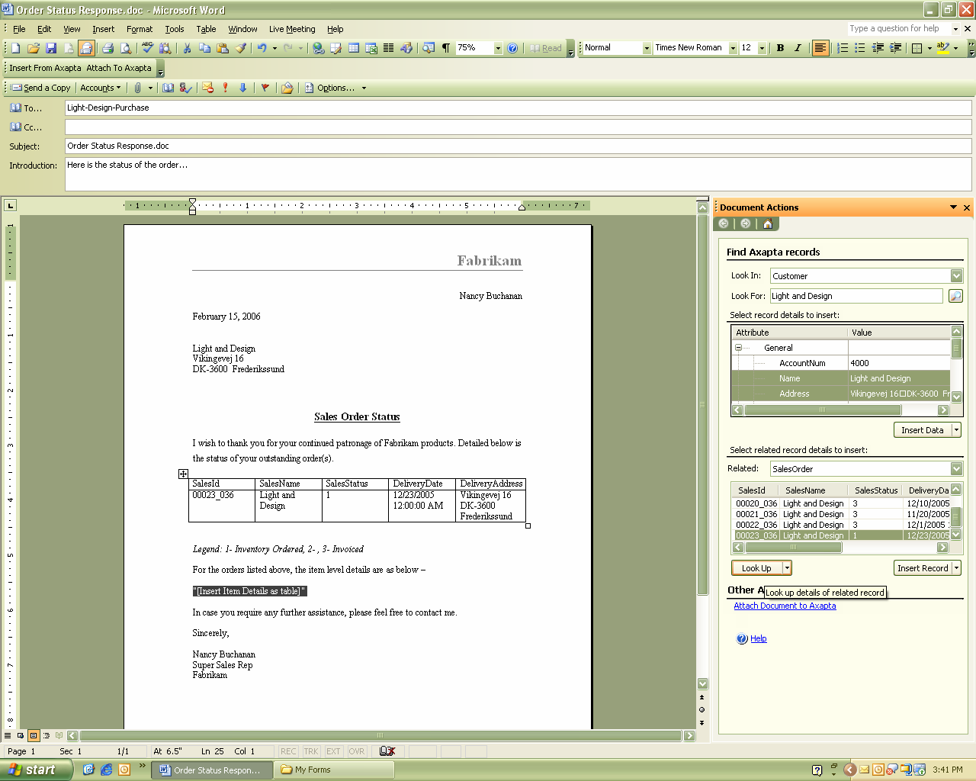
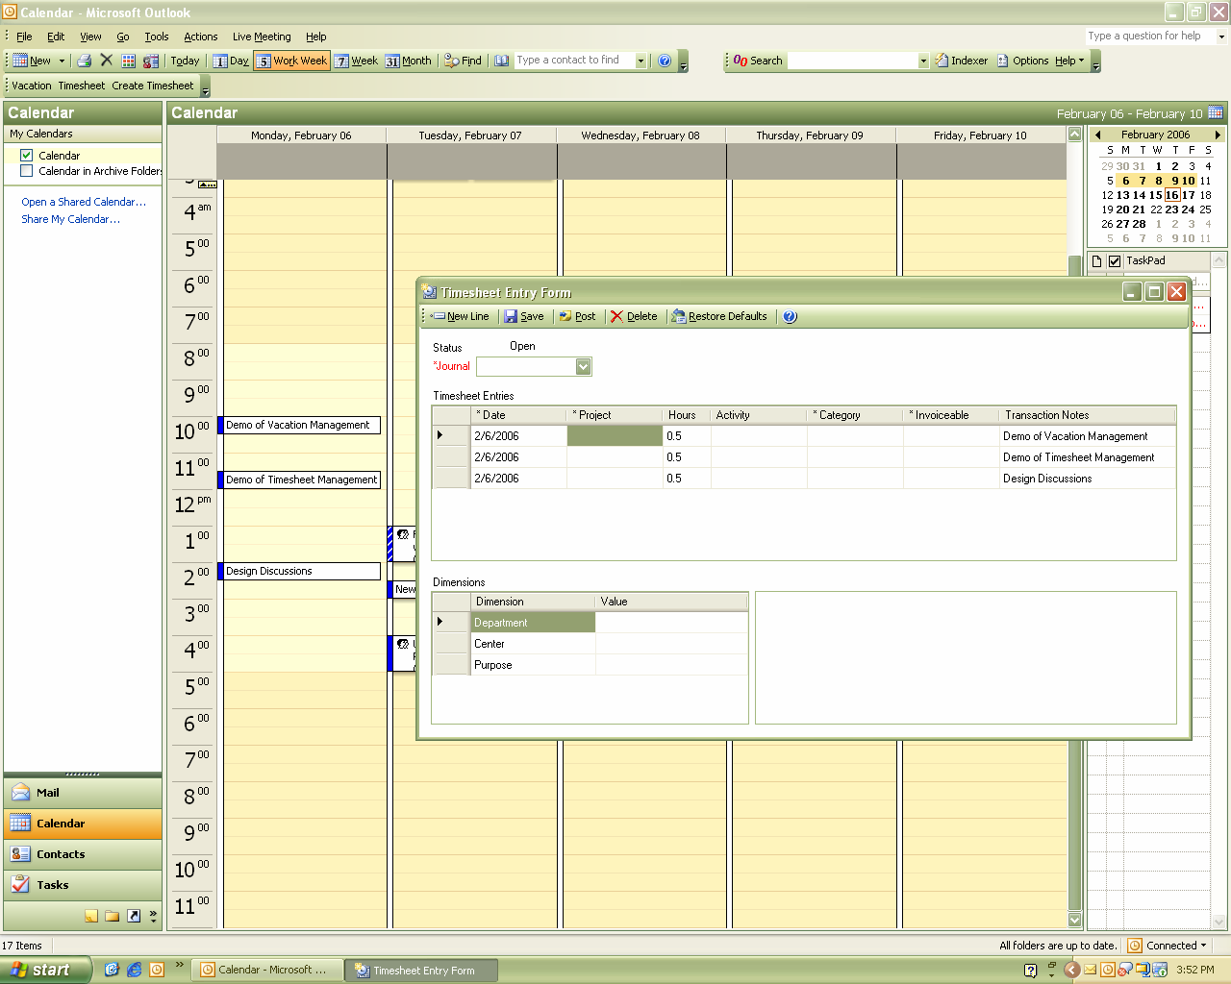
Easily look up and insert Microsoft Dynamics data into documents.
Create timesheets directly from Outlook Calendar items.

Pull data from your Microsoft Dynamics™ AX and Microsoft Dynamics™ CRM solutions and insert it into Microsoft Office spreadsheets, e-mails, business forms and letters.



Snap-Ins

Features

Business Data Lookup Snap-In (developed for Microsoft Dynamics AX) | Integrates Microsoft Dynamics AX information with Microsoft Office. From Word, Excel and Outlook, business workers can browse, search and insert Microsoft Dynamics AX data via a Task Pane interface. For example, a sales person responding to a customer request for order status can open the Business Data Lookup task pane in Word, locate the Microsoft Dynamics AX sales order information, copy over the relevant data into the Word document and e-mail it to the customer. The information is accurate and up to date, and the user didn’t need to leave Office to capture and insert it. After completing the Word document, the user can swiftly attach the document to the customer’s record in Microsoft Dynamics AX, again without leaving Office.
Business Data Lookup Snap-In  (developed for Microsoft Dynamics CRM) | Integrates Microsoft Dynamics CRM information with Microsoft Office. From Word, Excel and Outlook, business workers can browse, search and insert Microsoft Dynamics CRM data via a Task Pane interface. For example, a sales manager wants to review the latest campaign to analyze customer contacts and response distributions. From within Excel, she opens the Business Data Lookup task pane and copies the relevant CRM information to her workbook for analysis, and can easily share the analysis with others in the organization.
Timesheet Snap-In  (developed for Microsoft Dynamics AX) | Allows users to use Outlook to view or submit time entries for tasks that are performed on a periodic basis. This solution integrates Microsoft Dynamics AX time entries tightly with Outlook appointments and meetings, automatically filling in the data and helping track changes the user makes to linked appointments or meetings. This saves users the time and trouble of correlating those tasks, and significantly reduces the possibility of errors. Very useful for Dynamics AX customers in service industries or who have a requirement for employees to track how they allocate their time across multiple internal projects.
Vacation Management Snap-In  (developed for Microsoft Dynamics AX) | Allows users to submit vacation requests using Outlook. This triggers an e-mail to the approver, who can view details of the request along with the requestor’s vacation history, and approve or reject the request.

For more information about Microsoft Dynamics, visit: http://www.microsoft.com/dynamics/default.mspx

This document is for information purposes only.MICROSOFT MAKES NO WARRANTIES, EXPRESS, IMPLIED, OR STATUTORY, AS TO THE INFORMATION IN THIS DOCUMENT.
© 2005 Microsoft Corporation. All rights reserved.
Microsoft, Axapta, Microsoft CRM, Microsoft Dynamics, Microsoft Office Excel, Microsoft Office Outlook, the Microsoft logo and the Microsoft Dynamics logo, are either registered trademarks or trademarks of Microsoft Corporation or Microsoft Business Solutions ApS in the United States and/or other countries. Microsoft Business Solutions ApS is a subsidiary of Microsoft Corporation.

