
SAP with Microsoft SQL Server 2005:
Best Practices for High Availability, Maximum Performance, and Scalability
SQL Server Technical Article

Writers: Juergen Thomas
Technical Reviewers: Bernardo Zamora, Sanjay Mishra, Elke Bregler, Clas Hortien, Martin Merdes Dr. Christian Hiller
Project Editor: Digital One, info@virtualse.com
Designer: Digital One, info@virtualse.com

Published: June 30, 2006
Updated: Second Edition
Applies To: SQL Server 2005 SP1

Summary: This white paper describes best practices that customers, system integrators, and partners can use to design and install more reliable, high availability SAP implementations that deliver improved performance, scalability, and security by using SQL Server 2005. The paper describes typical architectures, installation and configuration, and performance monitoring and tuning. The paper also describes special considerations for SAP BW and for 64-bit computing configurations.
Copyright
The information contained in this document represents the current view of Microsoft Corporation on the issues discussed as of the date of publication. Because Microsoft must respond to changing market conditions, it should not be interpreted to be a commitment on the part of Microsoft, and Microsoft cannot guarantee the accuracy of any information presented after the date of publication.

This White Paper is for informational purposes only. MICROSOFT MAKES NO WARRANTIES, EXPRESS, IMPLIED OR STATUTORY, AS TO THE INFORMATION IN THIS DOCUMENT.

Complying with all applicable copyright laws is the responsibility of the user. Without limiting the rights under copyright, no part of this document may be reproduced, stored in or introduced into a retrieval system, or transmitted in any form or by any means (electronic, mechanical, photocopying, recording, or otherwise), or for any purpose, without the express written permission of Microsoft Corporation.

Microsoft may have patents, patent applications, trademarks, copyrights, or other intellectual property rights covering subject matter in this document. Except as expressly provided in any written license agreement from Microsoft, the furnishing of this document does not give you any license to these patents, trademarks, copyrights, or other intellectual property.

Unless otherwise noted, the example companies, organizations, products, domain names, e-mail addresses, logos, people, places and events depicted herein are fictitious, and no association with any real company, organization, product, domain name, email address, logo, person, place or event is intended or should be inferred.

© 2005 Microsoft Corporation. All rights reserved.

Microsoft®, Microsoft® SQL Server™, Microsoft® SQL Server™ 2005 Enterprise Edition, Microsoft® SQL Server™ 2005 Express Edition, Microsoft® SQL Server™ 2005 (64-bit), Microsoft® SQL Server™ 2000, Microsoft® SQL Server™ 7.0, Microsoft® SQL Server™ 6.0, Microsoft® Windows®, Microsoft® Windows Server™, Microsoft® Windows Server™ 2003, Microsoft® Windows Server™ 2003 x64 Editions, Microsoft® Windows Server™ 2000, Microsoft® Windows NT® 3.51, Microsoft® .NET, and Microsoft® Office System are either registered trademarks or trademarks of Microsoft Corporation in the United States and/or other countries.

The names of actual companies and products mentioned herein may be the trademarks of their respective owners.

Table of Contents
Executive Summary 1
Introduction 2
SAP Multi-Level Client Server Architecture 5
Installation and Configuration 17
SQL Server 2005 Availability Features 32
Performance Monitoring and Tuning 54
Special Considerations for SAP BW 70
64-Bit Computing Configurations 75
Solution Architecture 80
Important SAP OSS Notes related to SQL Server 96
Related Links and Online Resources 97
Related Links and Online Resources 97

Executive Summary
Companies face numerous challenges managing and integrating information across enterprise business processes. Customers need faster analysis and deeper business insight to improve their decision making and to respond to changing business needs. Companies frequently choose an Enterprise Resource Planning (ERP) solution to fulfill these business requirements. The current leading ERP applications are the mySAP™ ERP and SAP® R/3® industry solutions from SAP AG.
mySAP ERP is comprised of a comprehensive range of products that empower the enterprise with a flexible, end-to-end solution. mySAP solutions can increase business productivity, enhance operational efficiency, and improve the Total Cost of Ownership (TCO). mySAP solutions also offer the scalability needed to manage ever-increasing workloads. mySAP solutions enable companies to pinpoint inefficiencies in current business operations and to provide the resources needed to extend best practices to the entire value chain.
A critical challenge in implementing a mySAP solution is in the selection of a data platform that can deliver the advanced features and capabilities needed to support most demanding workloads. Microsoft® SQL Server™ 2005 is the database of choice for deploying more secure, reliable, highly available, high-performance, and scalable mySAP installations.
SQL Server 2005 is an integrated data management and analysis solution. SQL Server 2005 enables SAP customers of varying sizes to share data across multiple platforms, applications, and devices, while making it easier to connect to internal and external systems. SQL Server 2005 high-availability features can minimize downtime in SAP implementations. SQL Server 2005 improves productivity by making it easier to create robust database extensions at a lower cost.
mySAP solutions running on SQL Server 2005 realize native performance improvements. SQL Server 2005 contains built-in tools that simplify installation and make it easier to deploy and manage SAP implementations. In addition, the SQL Server 2005 engine dynamically tunes database parameters automatically to respond to changing usage characteristics.
This white paper describes best practices that customers, system integrators, and partners can use to design, deploy, and operate high availability SAP implementations with SQL Server 2005. This paper is provided to highlight that the common aspects of SAP with SQL Server 2005 implementations reflect the specific characteristics of SAP business applications.
The paper describes typical architectures, installation and configuration, and performance monitoring and tuning including how to resolve common problems. The paper also describes special considerations for SAP® Business Information Warehouse (SAP BW) and for 64-bit computing configurations.
The paper assumes that the reader has at least a general understanding of mySAP ERP solutions and Microsoft SQL Server database concepts and features. The SAP with SQL Server 2005 best practices described in this white paper were developed using the combined experiences of thousands of SAP customers worldwide.

Introduction
SAP AG is a recognized leader in providing collaborative business solutions for all types of industries in major markets. SAP delivers powerful solutions to more than 26,150 customers in 96,400 installations with 12 million users in over 120 countries around the world. SAP software offers distinct solutions that address the needs of small and mid-size businesses and provides enterprise-scale solutions for global organizations.
SAP is the world's largest inter-enterprise software company and the world's third-largest independent software supplier overall. Today, SAP employs more than 32,000 people in 50 countries. With enhanced collaboration provided by more than 1,500 partners, SAP professionals are positioned to provide high-level customer support and services.
SAP industry solutions offer multi-platform support for business processes in more than 25 distinct industries including high technology, retail, public sector, and financial services. mySAP ERP products can optimize business processes and improve collaboration and integration across the extended enterprise.
mySAP ERP solutions use SAP NetWeaver™ as its comprehensive integration and application platform. SAP NetWeaver works with existing IT infrastructures to enable and manage change.

SAP — Microsoft Alliance
Since 1993, SAP and Microsoft have been working together to provide deeply integrated Microsoft platform and SAP solutions. SAP and Microsoft have a strong, long-term relationship that is driven by customer satisfaction.
As a result of this close cooperation, Microsoft is currently the most selected platform for R/3 and mySAP deployments:
- More than 46,000 SAP application installations run on Microsoft® Windows®; more than all other platforms combined. In addition, over 50% percent of all new SAP deployments run on Microsoft Windows.
- More than 20,000 customers worldwide are running SAP applications with SQL Server. 40 percent of all new R/3 and mySAP deployments use SQL Server.
- The number SAP installations using SQL Server has grown in every quarter since 1993.
In addition, SAP and Microsoft are positioned to provide integrated business value. Examples include extending mySAP through the SAP Connector for Microsoft® .NET, accessing mySAP business processes through the Microsoft® Office System and using SQL Server Business Intelligence (BI) features such as Reporting Services to directly access SAP BW.

SAP Solutions and SQL Server
SAP and Microsoft have been working together to develop tight integration between SAP solutions and SQL Server:
- SAP R/3 for Microsoft® Windows NT® 3.51 was released in 1994. By mid-1995, SAP began using R/3 with SQL Server™ 6.0 in customer implementations.
- In response to SAP customer demand, in 1998 Microsoft released SQL Server 7.0 with features that improved scalability performance on SAP systems. 7.0 is the first SQL Server version on a complete new code base. SQL Server 7.0 was redesigned to accommodate feature requirements that made it a better platform for SAP.
- The release of Microsoft® SQL Server™ 2000 included features that dramatically improved the performance and administration on SAP systems. Using standard benchmarks, SQL Server 2000 performed best on a commodity hardware platform running the Microsoft® Windows Server™ operating system. SQL Server 2000 also was the first SQL Server released as 64Bit version. This expanded the range of the Windows/SQL Server well into high-end database computing.
- At the end of 2005, Microsoft shipped SQL Server 2005. The first SQL Server release covering 2 different 64Bit platforms with x64 and IA64 plus a 32Bit platform with x86. SQL Server 2005 is a major step in functionality beyond SQL Server 2000. Functionality which will enhance the way SAP applications are run and administrated.

SAP with SQL Server 2005
Today, Microsoft® SQL Server™ 2005 Enterprise Edition is the foundation of a tightly integrated data platform that can be used to share and apply company information. Microsoft worked with SAP to help tune SQL Server 2005 Enterprise Edition to ensure maximum performance, reliability, and enhanced interoperability under SAP workload.
The advantages of using SAP with SQL Server 2005 include:
- Improves performance. Enhancements in SQL Server 2005 enable tune-up and auto-administration features on SAP application deployments.
- Supports very large databases. mySAP and R/3 installations running on SQL Server 2005 can accommodate larger and more complex databases. Multi-terabyte (TB) databases and 45,000 tables in a single mySAP database are becoming increasingly more common.
- Offers advanced capabilities as standard features. Customers can take advantage of SQL Server 2005 advanced capabilities such as Database Mirroring, Online Index Create, Database Snapshots, etc.
- Contains comprehensive data management features. These data management features include advanced data mining, integration services, Extraction Transformation and Loading (ETL), BI, high availability, manageability, and security.
- Runs on standard commodity servers and storage. SAP customers have two options for licensing SQL Server 2005. When SQL Server 2005 is licensed through Microsoft and is used for more than one application, the database is licensed per processor, not per core, as is common with some competitors. This reduces the cost by a factor of three or greater. When SQL Server 2005 is licensed through SAP and is used for one application only, even greater savings can be realized.
- Allows for scalability using standard commodity hardware. SQL Server 2005 is highly scalable and can allow for future growth using standard commodity servers and storage. In addition, SQL Server 2005 takes advantage of some of the latest hardware architectures. mySAP on SQL Server 2005 can now run workload levels on four-processor commodity servers that, only four years ago, would have required a 32-processor server and a one-million dollar investment.
- Offers the most compelling TCO. SQL Server offers the best TCO for SAP implementations including lower management costs. Meta research concluded that Windows offers two to three times better TCO than other enterprise platforms when used in ERP scenarios.

SQL Server 2005 Enterprise Edition
SQL Server 2005 Enterprise Edition is a comprehensive, integrated end-to-end data solution that delivers a more secure, reliable, and productive platform for enterprise data and BI applications. SQL Server 2005 delivers new and improved features that are tightly integrated with mySAP products based on the following support considerations:
- For SAP products, SQL Server 2005 uses Windows Server 2003, Service Pack 1 and later. SAP and SQL Server 2005 are supported on the 32-bit, Itanium 64 (IA64), and x64 computing platforms.
- SQL Server 2005 is qualified for use on SAP products that run on the SAP 6.40 kernel and later. This includes SAP R/3 4.7E, most of the NetWeaver 2004 products such as mySAP ERP Central Component (ECC 5.0) and mySAP™ Supply Chain Management (mySAP SCM 4.1), and SAP NetWeaver 2004S products. In particular, SAP supports SQL Server 2005 on SAP BW 3.5 and later.
- SQL Server 2005 is not supported on older SAP products. So far only products with 6.20 Basis and versions to-date have been supported. One exception is R/3 4.6C which meanwhile is supported running against SQL Server 2005 as well.
SQL Server is part of the Windows Server System™, a comprehensive and integrated server infrastructure that simplifies the development, deployment, and operation of information systems.

What’s New in SQL Server 2005
SQL Server 2005 Enterprise Edition contains new features and improvements including:
- Enterprise data management. SQL Server 2005 reduces application downtime and increases scalability and performance, availability, manageability, and security.
- Developer productivity. SQL Server 2005 includes many new technologies that significantly increase developer productivity.
- Business intelligence. SQL Server 2005 enhances Microsoft's leadership in BI through innovations in scalability, data integration, development tools, and rich analytics including comprehensive integration, analysis, and reporting capabilities.
- Highly productive developer environment. SQL Server 2005 provides a rich, powerful, and integrated single development environment that allows developers to more easily create robust database extensions at a lower cost.
When deployed with SQL Server 2005 Enterprise Edition, SAP provides:
- Enterprise class high availability and scalability. SQL Server 2005 can support very demanding mySAP and R/3 implementations out-of-the-box. SQL Server 2005 high availability capabilities can minimize downtime in SAP implementations.
- Easy installation and management. SQL Server 2005 contains built-in tools that simplify installation and make it easy to deploy and manage SAP implementations. The SQL Server 2005 engine dynamically tunes database parameters to respond to changing usage characteristics.

SAP Multi-Level Client Server Architecture
This section describes how the mySAP architecture relates to SQL Server 2005 including an overview of the NetWeaver Application Server, formerly the SAP Web Application Server. This section also describes security features, statement execution, database schema, and information for migrating and upgrading to SQL Server 2005.
Note that some of the information described in this section is unique to mySAP products and does not necessarily follow the practices used by SQL Server 2005 in other types of applications.
All SAP products employ a multi-tiered client-server architecture as shown in the following diagram.
The SAP multi-tiered client-server architecture is comprised of three levels:
- Presentation tier. This tier supports SAP Graphic User Interfaces (GUIs) such as SAP GUI, SAP WebGUI, and other products that connect to the SAP NetWeaver Application Server using one of the supported interfaces. The Presentation tier also enables applications to access SAP using Web Services. For example, applications including smart clients and Microsoft Office applications which integrate SAP data such as when Microsoft Excel is used with Web Services.
- Application tier. This tier can contain multiple SAP NetWeaver Application Server instances, with each instance pointing to the same database server. Each application server instance is typically run on separate server hardware. However, the Application tier and Database tier can run on the same server hardware on small scale systems and in some very large hardware configurations.
- Database tier. This tier supports the SAP database including mySAP or R/3 and other SAP applications that are hosted on SQL Server 2005. The Database tier typically runs one database schema for each SAP product using separate server hardware. The database servers can be connected to a SAN, NAS, or locally-attached storage.

SAP NetWeaver Application Server
The SAP NetWeaver Application Server is the base architecture of most of SAP’s products. The SAP Netweaver Application Server has the basic task running Business logic developed in ABAP or in Java. For this purpose, the Netweaver Application Server includes an ABAP and Java Virtual machine, a lot of infrastructure services as well as proprietary and standardized interfaces like WebServices/HTTP/SOAP.

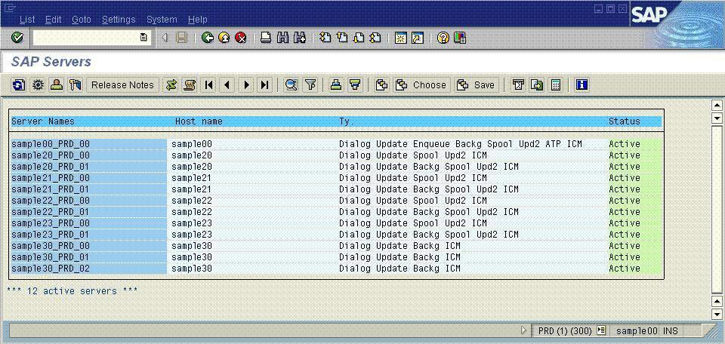
SAP Servers
On the left, the SAP Application Servers sample shows examples of instances for one R/3 system that use multiple hardware servers. Some of the servers are running more than one SAP NetWeaver Application Server instance.

A SAP system can contain dozens of NetWeaver Application Server instances running on multiple servers. All of those instances of one system would work against one database.

SAP NetWeaver Application Server Architecture
SAP NetWeaver Application Server is the main building block for deploying highly scalable SAP Web applications and Web services.
The SAP NetWeaver Application Server architecture contains a number of interfaces as shown in the following diagram.
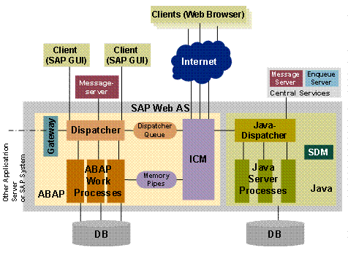

The SAP NetWeaver Application Server User tier (also called the Presentation layer) connects to the SAP NetWeaver Application Server Layer through the HyperText Transfer Protocol (HTTP)/ Simple Object Access Protocol (SOAP), Web Services, Remote Function Calls (RFC), or the proprietary Diag interfaces. The User tier is handled by so called Dialog processes, which are dedicated to user interaction on the SAP application server.
The SAP NetWeaver Application Server Layer contains the following logical components:
- Virtual machines (ABAP and JAVA). The ABAP virtual machine (VM) is the heart of SAP NetWeaver Application Server. Nearly all business report logic runs through the ABAP VM. The Java VM is also used to process business logic, especially by newer generations of SAP products like SAP Enterprise Portals and SAP XI.
- Dispatcher (Queue Manager). The Dispatcher accepts requests coming from different types of interfaces. The Dispatcher queues and distributes requests to other SAP processes. The Dispatcher maintains communication with Presentation tier layer.
The first time a request from the Presentation tier is made to SAP NetWeaver Application Server, it is assigned to the Dispatcher process of a particular instance. The Dispatcher process locates a free process in the instance with the requested functionality. All of the different processes in one instance communicate with the Dispatcher process.
- Central services. Central services include Batch Scheduling, Memory Services, and Enqueue Services.
- Data persistence layer. Each VM has a data persistence layer that operates on different schemas within the SAP database. Shared transactions (database transactions) cannot be performed between the ABAP and Java VMs.
- Message server. This server is the communication port for the SAP CI. The message server handles all communication with other instances within the same system. It also handles the initial communication to establish a client session with the Dispatcher of a particular instance.
Be aware that the SAP ABAP stack and the SAP JAVA stack of the SAP Netweaver Application Server are installable separately. Means during installation it can be decided whether both or only one of the stack should be installed.
For more information, see “SAP NetWeaver: Providing the Foundation to Enable and Manage Change” at:
http://www.sap.com/solutions/netweaver/index.epx

SAP NetWeaver Application Server with Windows
In most of the following section, we will discuss the SAP ABAP stack of the SAP Netweaver Application Server only. In contrast to products developed on a Windows platform such as SQL Server 2005, SAP NetWeaver Application Server is a multi-process application, not a multi-thread application.
The SAP processes that are configurable within one SAP NetWeaver Application Server instance include:
- Dialog process. This process handles user interaction initiated from the Presentation tier. Normally, there are multiple processes offering dialog services in each instance.
- Update process. SAP processes execute asynchronous changes on the database. There has to be at least one update process for each system. There can be instances without an update process. Usually one configures multiple Update processes as well
- Batch process. This process handles long running, non-interactive jobs in the background, e.g. Payroll Calculation. SAP product tasks can be scheduled to run at a certain point in time or event based.
- Enqueue process. This process handles SAP logical locking management. There must be at least one Enqueue process for each SAP system. This process runs only on the SAP Central Instance and is a single point of failure. Therefore the efforts to use failover clustering for the SAP CI.
In some cases, when there is a gap between a user confirmation and the end of an asynchronous update, a SAP object such as the Material or Customer needs to be locked before the database is accessed. In these cases, the Enqueue process handles the locking and unlocking of requests on the SAP NetWeaver Application Server Layer system-wide. This avoids extensive locking on the database level which could harm concurrency severely. The Enqueue process keeps the database from being flooded with locks and blocks objects not yet released. It is worth to note that the level of locking of the Enqueue is on Object basis. Such an object locked could translate into many database rows in different database tables.
- Spool process. This process enables print services for a SAP system. The process sends a print request to the Windows spool manager.
- Message server process. This process allows for communication between the different NetWeaver Application Server instances within one SAP system. The message server runs on the SAP CI and as well is a single point of failure
- Gateway process. This process is responsible for external communication between NetWeaver Application Servers.

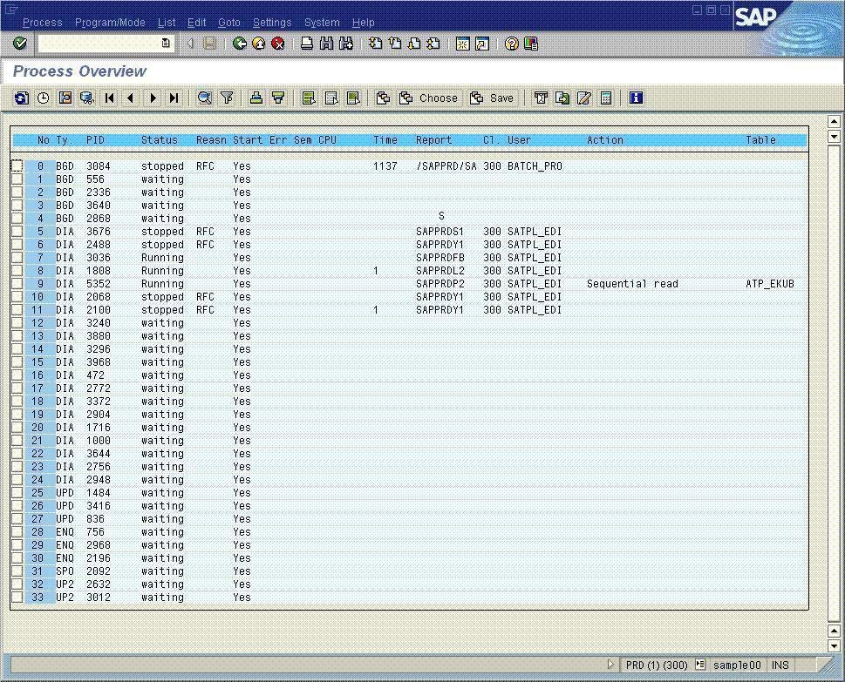
SAP Process Overview
On the left, the sample lists different processes in one SAP instance of a SAP system running multiple instances. The sample does not show the dispatcher, message server, or gateway process.
One specific SAP NetWeaver Application Server instance represents a collection of processes. The NetWeaver Application Server Layer can be distributed over several servers to perform processes. In the commodity server space it is common to run one SAP application server instance per server. On bigger hardware one can find configurations with multiple SAP application instances on one server. Different SAP application instances of SAP NetWeaver Application Server can be configured differently based on the user or job assignments to those instances.
SAP NetWeaver Application Server instances can be configured to enable only one or two types of processes or nearly all types of processes. The specific configuration depends on the size of the SAP system and on the available hardware.

User and User Request Assignment to SAP processes
SAP has various methods of assigning users in the login phase to a specific application server instance. The login request will first contact the SAP Message Server process. This process will check whether there is a special assignment for the user who wants to login. If this is the case, the user will get assigned to a specific SAP application instance based on such an assignment and eventually workload on different application instances if the assignment defined a group of application instances. If there is no special assignment defined, the message server will assign the user to an application instance based on workload consideration. The login request will then be transferred to the dispatcher process of that application instance. The dispatcher will now assign the login request to a free dialog process within its application instance. After a successful login, the user will remain within the boundary of this SAP application instance. A transfer to another instance is not possible.
After the successful login, the user now starts to work by calling a SAP Transaction like ‘Creating a customer order’. Such a request now goes directly from the Graphical user Interface of the user to the dispatcher of the SAP application instance. The dispatcher will check for a free dialog process and if found, will assign the request to that free dialog process. As soon as the request is completed, the user context is rolled out of the dialog process again, so that the process can be used to server requests from other users. Means there is no fixed assignment of a SAP user to a process within a SAP instance, but only a fixed assignment to a SAP instance. The dispatcher within the SAP instance balances incoming requests of logged in users and active requests on the process resources available. If there are no processes of the type required available, a queue in the dispatcher will build up.

Memory Management of SAP ABAP Engine
As described above a user is kept within an instance and the context of such a user can be ‘rolled in’ and ‘rolled out’ of a work process of an instance. For this purpose all SAP process share memory called ‘Roll Memory’. This area is used to keep user contexts around where a user context describes authorizations of the user, eventually points to data the user still has allocated.
Another important memory area of the SAP Application server (ABAP as well as Java) is the so called table buffers. All the customizing information of the particular SAP Business modules is stored in database tables. In order not to retrieve this kind of information thousands of times from the database, this kind of data which usually is not getting modified at all, on the application server instances. This reduces the number of database statements by a huge portion.
The third structure of SAP memory management which is worth to discuss applies to the SAP ABAP application instance only. Like all Virtual Machines, The ABAP VM has the need for having memory dispatchable to user contexts which load data from the database. SAP calls this memory which can be accessed by each of the processes within one application instance ‘Extended Memory’ (EM). It is used to store data a user loads from database during performing a user’s request. Since many user contexts can be executed in parallel by the different SAP processes of one instance and one user can read substantial amounts of data from the database, the amount of Extended Memory needed, can be quite a few GigaBytes these days. For 32Bit which was the first Windows platform SAP got ported 12 years ago, the 2GB address space of 32Bit would have been to restrictive. Therefore targeting a solution to realize the SAP Extended Memory via Shared Memory between the processes was not an option. Instead SAP went the way of realizing their Extended Memory over a so called Memory Mapped File. This Memory Mapped File can be accessed by every one of the SAP processes of an instance. A SAP process can map segments of the Memory Mapped File into the particular SAP process. Segments mapped into one process can not be accessed by another process of SAP. The advantage of the Memory Mapped File is that its size is limited by the real memory plus the size of the pagefile and not by the Virtual Address Space of the particular platform. However there is a slight disadvantage with this method of realizing SAP Extended Memory. When a user context gets rolled out of a SAP process again after the request’s execution finished, the SAP process will unmap the memory segments again it ‘borrowed’ from the SAP Extended Memory. For the Windows Memory Management this unmap operation leaves memory segments which got changed without associated process. These two facts are reason for the Windows Memory Management to page out these memory segments preventively to the Windows Pagefile as long as there is CPU available. This leads to the fact that one will observe a very high rate of page-out operations towards the Windows Pagefile, running a SAP ABAP application instance. The higher the workload, the higher the page-out rate will be. In extreme cases it could be as high as writing a constant stream of 20MB/sec to the Windows Pagefile. However do not get to wrong conclusions based on this fact. The page-out rate in such cases itself does not tell anything about experiencing a situation of memory pressure. In order to evaluate whether there is memory pressure, one needs to evaluate the page-in rate from Windows Pagefile. Only if the page-in rate is high as well, one could be suspicious of memory pressure.
A fourth very big chunk of memory allocated by a SAP ABAP instance will be the so called Program Buffer, caching pre-compiled ABAP reports instead of steadily re-reading those from the database. Usually this part of buffer has a size of 500+MB. This buffer is realized as shared memory which can be accessed by each of the SAP processes within an instance
Besides the 4 different memory areas described, there is over another dozen more or less smaller shared memory areas a SAP ABAP application instance creates and which are shared amongst the processes of such an instance. None of these memory areas will be shared between different SAP Instances.

SAP Connections to SQL Server
Each of the SAP processes establishes connections to SQL Server 2005. There is no sharing of connections between the different SAP processes of an instance. Every one of the processes establishes these connections at startup and keeps these connections until the process is shutdown. Therefore one usually can observe multiple hundred or even more than a thousand connections established to SQL Server if the complete SAP system is up and running. In former releases of SQL Server the number of connections SAP processes needed to open against SQL server became highly inflated by the fact that SQL Server under certain circumstances did not allow using one connection for executing another statement while the first statement on the connection did not finish yet. This shortcoming got resolved with SQL Server 2005. With introduction of MARS (Multiple Active Result Sets), multiple open client-side cursors can use one connection. In contrast to earlier SQL Server releases, the number of connections of a SAP process to SQL Server 2005 now is limited to two connections for each SAP process as shown in the following diagram.
The first connection SAP established is used for modification of data and in rare cases where a read-committed isolation level is needed for reading some data. On the second connection, SAP reads most of the data on an uncommitted read isolation level (Dirty Read). SAP introduced this principle in 1993/94 for all databases but Oracle. There is no disadvantage doing so since the SAP Netweaver Application Server is designed to deal with eventual Phantom Records or other anomalies which can be introduced by reading uncommitted data. So imagine a SAP system with 10 application server instances on 10 different small servers. Every one of the application server instances is configured with an average of 30 SAP processes. In such a case it means that the SAP application layer of such a system will open 10 X 30 X 2 = 600 connections to SQL Server 2005

Security Context of SAP Transactions
mySAP benefits from SQL Server 2005 Integrated Security for strong, more trustworthy installations. The security context of SAP transactions is established during the installation of SAP NetWeaver Application Server:
- SAP creates two Windows users named SAPService<SID>, for example, SAPServicePRD and <SID>adm such as PRDadm. The <SID> represents the three-character SAP System ID (<SID>).
- Windows users are created as logins. In SQL Server 2005, two Windows users log in by using Integrated Security. SAP recommends installing SQL Server 2005 Integrated Security to accept connections only. For SAP databases, these two logins are assigned to the SQL Server ‘sysadmin’ role. The only exception where SQL Server needs to be installed in ‘mixed’ security is when SAP Java application parts are accessing SQL Server 2005. JDBC Drivers used by SAP do not support Integrated Security so far.
- A SQL Server login is created for each user owning a schema in the SAP database. Each user is assigned to the SQL Server ‘serveradmin’ role. Each user owning a schema in the SAP database is assigned to the database ‘dbo’ role.
- After the SAP process, SAPService<SID> establishes a connection using Integrated Security. The process acts as a user owning a schema in the SAP database by executing setuser <SID>.
For troubleshooting, note the following:
- When accessing a SAP database with SQL Server 2005 query tools, the
setuser <SID>
command must be executed before data can be read.
- Because the SAP customer can install more than one schema in one SAP database, ensure that the schema is correct. Most schemas have a set of objects that are named in the same manner in both schemas.

The preceding SAP security considerations involve the last two releases of the SAP NetWeaver Application Server, which are supported by SQL Server 2005. In older releases, a SAP database could contain only one schema owned by the database role ‘dbo’.

SAP Statement Execution
The NetWeaver Application Server executes a combination of parameterized statements and static Stored Procedures against SQL Server 2005. If using Stored Procedures one single SQL Statement is wrapped into a Stored Procedure. Reasons for this way of statement execution are historically influenced. The intention of using parameterized statements or Stored Procedures is to cache and reuse the execution plans. This keeps the number of statement compilations and recompilations extremely low (usually in the low single digits per second).
In case of using Stored Procedures, SAP can dynamically create those based on changes to the ABAP Code the SQL Statements wrapped in those Stored Procedures. After a change of ABAP Source code, new Stored Procedures will be created for all SQL Statements within the changed ABAP Function. The usage of Stored procedures got eliminated entirely with all products relying on Netweaver 2004S. With these newer products SAP relies entirely on parameterized SQL Statements.
In addition:
- SAP uses a minimum number of adhoc queries, less than one per second.
- There is a relatively low number of database locks since 99.9 percent of all reads are uncommitted. The number of database locks typically ranges from a few hundred to a few thousand. Especially hardly any Shared locks are seen.
- With SQL Server 2005, all SAP statement and Stored Procedure executions are prepared by using the SAP application.
- With SQL Server 2005, SAP only supports the OLE DB programming interface integrated in SQL Native Access Client (SNAC). SNAC needs to be installed on each application server to allow the SAP NetWeaver Application Server to connect to SQL Server 2005. SNAC contains the Client APIs of SQL Server 2005. SNAC is deployed by SQL Server only and is independent of Microsoft Data Access Components (MDAC).

SAP Database Schema
SAP business applications database schema can include up to 45,000 tables, depending on the SAP product.
- Clustered and non-clustered indexes. Nearly all tables use the primary key constraint of SQL Server 2005. This results in a clustered index over the fields of the primary key. No other constraints are used. Nearly 20 to 25 percent of the tables have one or more non-clustered indexes. The order of deployed, non-clustered indexes can be changed. In addition, a clustered index can be made non-clustered and conversely, a non-clustered index can become a clustered index.
- Additional indexes. In standard deployment, there are many tables with multiple non-clustered indexes defined on. It is very common that customers create additional indexes to suite their customization of SAP business logic or customer-coded ABAP business logic. Indexed views or indexes on computed columns cannot be created within SAP.
- Index column order. The order of index columns is non-standard with most unselective columns first. The order of index columns follows the order of columns in the table like defined in the SAP Data Dictionary. Except for the Primary Key index, the order of the columns is free and can be changed (although this is usually unnecessary). The order of the columns in the primary key index may not be changed since an ABAP construct might rely on the defined order of the primary key.
- Index creation. Creating indexes or changing existing indexes must be performed over the SAP Index Maintenance Transaction so that SAP has the ability to export the index.

Collation and Code Page
All SAP products use code page (cp) 850_BIN or 850_BIN2 as the server code page with the exception of the SAP® Mobile Sales client and SAP® Business One. This does not relate to the SAP database only, but it relates to the complete SQL Server instance the SAP database is running on. There is a significant difference between SQL Server cp850_BIN and cp850_BIN2 which affects Unicode sort orders. Therefore codepage cp850_BIN is not suitable to run either SAP JAVA schemas or SAP Unicode schemas.
Installing SQL Server 2005 cp850_BIN2 must be chosen as code page for the complete SQL server 2005 instance as shown in the screenshot below.
While upgrading a database which got installed under older releases of SAP applications from SQL Server 2000 to SQL Server 2005, these databases need to be converted to cp850_BIN2. This needs to happen while still running on SQL Server 2000 and prior to the upgrade to SQL Server 2005. Please consult SAP OSS Note 600027 for the procedure and for an executable which performs this conversion. After it is made sure that the SAP database is on cp850_BIN2, the upgrade to SQL Server 2005 can be started.

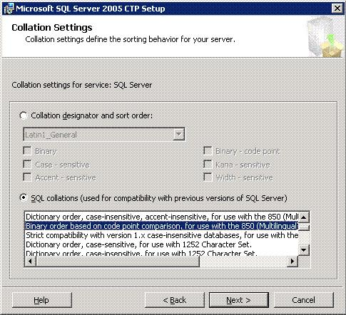
SQL Server 2005 Setup Screen
On the left, the sample shows the code page selection screen during a SQL Server 2005 installation. For SAP with SQL Server 2005, select:
Binary Order based on code point comparison, for use with 850 (Multilingual)
Do not choose the former selection:
Binary sort order for cp850

Data Types Used by SAP
SAP uses simple data types including:
- Variable length character types only
- Normal integers and a few small integers
- Float and decimal, especially for the SAP BW fact tables
In addition, for SQL Server 2005 the varbinary(max) datatype is used instead of the image datatype for Blob and Clob fields. The data type is changed from image to varbinary(max) as a metadata operation only while performing the post-upgrade steps after a successful SQL Server 2005 upgrade. No data movement takes place when changing the datatype. See SAP OSS Note 799058 for more information.
Note that SAP does not use user-defined data types and SQL variants.

Upgrading from SQL Server 2000 to SQL Server 2005
When SQL Server 2000 is upgraded to SQL Server 2005, no severe changes are required in the physical data structure. SAP products running with a SAP 6.40 kernel, are supported to run on SQL Server 2005 as well as new products of Netweaver 2004S. As of October 2006, SAP will support SAP R/3 4.6C to run on SQL Server 2005 as well. For more information please check SAP OSS Note 905634 Check the SAP Product Support Matrix for more details.
There are the two alternative methods of upgrading to SQL Server 2005:
- Uninstall SQL Server 2000 and install SQL Server 2005. Then attach the SQL Server 2000 SAP databases to SQL Server 2005.
- Install SQL Server 2005 in the same location without uninstalling SQL Server 2000.
As already mentioned above, before uninstalling the SQL Server 2000 instance, verify that the SAP database is on code page cp850_BIN2 . See SAP OSS Note 600027 for more information.
Once the SQL Server 2000 database is attached to SQL Server 2005, a special version of SAP SAPINST needs to be run to adapt the database to some of the SQL Server 2005 features that are used by SAP. See SAP OSS Note 799058 for more information.
There is no SAP related direct upgrade from SQL Server 7.0 to SQL Server 2005 with SAP products. For such systems an upgrade over SQL Server 2000 is necessary.

Migration Considerations for SAP Products
Migrating SAP products from a non-SQL Server platform to a SQL Server 2005 platform is generally supported by SAP under these conditions:
- SAP only supports the SAP Migration toolkit as the tool for migrating the SAP database schema and data from a non-SQL Server database to SQL Server 2005. No other tools are supported.
- The migration is a complete data unload on the source system and a complete data load on the destination system.
- Only objects including tables, views, and indexes created by using SAP object maintenance transactions are migrated. No objects created purely on the database are migrated, for example, when an index is created on the database.
- With some tuning in the migration processing one can achieve a throughput of 200GB/h during the data export and import phase
- Typically, 5 to 6 TB data volumes can be migrated over a weekend according to companies, which specialize in such migrations.
- Most of the aspects of a heterogeneous database migration also apply for the migration from a non-Unicode to a Unicode SAP system
The migration itself needs to be executed under the lead of a person who is certified for SAP platform migrations by SAP. SAP does offer trainings to achieve this grade of certification. Microsoft so far does not offer such a service. However there is a variety of 3rd Party Partners offering these services.
The method and the tuning done for the export and import part of a heterogeneous SAP migration to the SQL Server platform is applicable for a Unicode migration and vice versa. The critical time window which needs to be minimized is the time of the export and import. There are steps which can increase throughput of such an export/import phase.
- Leverage the application servers for exporting and importing instead running the export/import processes on the database server. With such a configuration often 30-40 of such processes could run simultaneously
- Re-organize larger tables on the destination system before exporting. Facing a Unicode Migration with SQL Server as destination as well, it can make sense to run dbcc indexdefrag as online data reorganization tool on several of the big tables. Other databases might have some online reorganization tools as well.
- Split large tables into multiple jobs. However be careful with the ‘where clauses’ SAP tools may define for each of the export parts. These ‘where clause’s may not line up with existing indexes, so that each of the export jobs would perform a full table scan. Something one wanted to avoid with the step of splitting the export in multiple parts. Therefore adjust the ‘where clause’ for each of the export statements manually if they do not align with existing indexes on that table.

Installation and Configuration
The cornerstone of a successful SAP with SQL Server 2005 installation is careful planning. For example, no installation should begin before all prerequisite tasks are finished, such as defining the machine names, developing the physical layout of the SAP product database, and sizing the disk space requirements.

SQL Server Installation with SAP
The installation of SAP products does not require SQL Server 2005 to be configured in a special way, with the exception of the code page. For more information, see “Collation and Code Page” in the preceding section.
Before SAP starts the data import, it automatically changes a few SQL Server configuration parameters such as the network packet size in order to provide optimum performance during the initial import of SAP data.
During the initial data load, the SAP database is set to the simple recovery model. Most of those settings are reversed when the data load and the installation of the SAP product is completed.

Volume and Growth Projections
Projections for the volume and growth of SAP product databases over time are often underestimated. The growth rate is typically higher than expected. When the growth projections are in error, SAP products can require reconfiguration and adaptation on the hardware or on the database in order to satisfy hardware growth requirements.
Note that any sizing of an SAP system must be done by a SAP-certified hardware partner.
For the initial configuration, ensure that the size of the database is sufficient to sustain the first six to 12 months of production. In addition, assume that each subsequent release of a SAP product will tend to increase the weekly or monthly growth rate, as compared to its predecessor. For example:
- For mid-range companies, the mySAP or SAP BW database can grow from 2 to 5 GB each week.
- For larger companies, the database can grow from 10 to 12 GB each week.
- For very large implementations, the database can grow from 20 to 30 GB each month.
Even if SAP archiving is used, in most of the customer systems one could observe a steady and consistent growth rate in database size over time. Therefore it does not matter if a database of 2TB volume might suddenly encounter 800GB or more free space after severe data archiving. SQL Server does not encounter any disadvantage having such huge freespace. Since SQL Server backups only contain used blocks, there also are no increased efforts in administrating in case of having larger portions of unused space in the database. This unused space should not lead to the desire to shrink the SAP database. Besides the fact that shrinking the database could be a longer process since data may need to be moved, it also can result in extents where the logical and physical order are opposite. Something which disturbed some sophisticated storage backend logic in the past. It also is not recommended at all using the option ‘autoshrink’ for a SAP database.

Number and Size of SQL Server Data Files
The number of data files is chosen during SAP product installation. Three data files (the default SAP typically uses) are appropriate for the majority of smaller SAP installations. In SQL Server 2005, data access performance within a data file is not related to the size of the data file, but to its concurrency on internal administration pages within the data file.
For the best performance, the ideal number of data files for the SAP installation is typically equal to the number of CPU or processor cores dedicated to SQL Server 2005 at a 1:1 ratio. For example, a dual-core processor such as an Advanced Micro Devices® (AMD) Opteron™ or dual-core Intel® Xeon® or Itanium® processor, counts as two CPU cores. A four-processor dual-core server counts as eight cores and therefore eight data files would be recommended. This recommendation should be targeted for new installations. Is there a problem with a system having 2 or 3 processor cores working against one data file? Usually not. However in cases where e.g. 6 CPU cores were working against one data file, we could observe concurrency issues on some internal administration pages of SAP queuing tables. Therefore target 1:1 in a fresh installation, so that one has some way to grow. Use events like SAP Unicode migration to adapt the number of data files to the changed conditions since the last installation.
However, additional data files are sometimes required when there is a handling issue such as when data files become too large to handle in copying or other activities.
For the best distribution, create the data files of the same size and distribute the files evenly. Each data file can be assigned to the same number of spindles, making the disk input/output (I/O) system easy to maintain. When the data file size needs to be increased, increase each of the data files by the same amount. This will allow you to maintain an approximately equal amount of free space in each file.
In addition, if data files are added to an established database, make the size of the new files equal to the free space of the existing data files. This allows SQL Server 2005 to distribute new data evenly between the old and new data files.
The considerations for defining the number and size of data files include:
- Establishing a Unicode system. Use the 1:1 ratio between CPU cores and data files when installing a new system or migrating a system from non-Unicode to Unicode characters. Assume that the implementation of a particular SAP product typically increases in stages, indicating that a much larger database server might be required in the future.
- Evaluating disk configurations. Evaluate the available storage hardware including the number of disk arrays and partitions, and the amount of available storage space on disk arrays.
- Estimating database growth. Consider the estimated database growth during production. In order to stay flexible in disk configurations, avoid using very large data files. Very large data files can create problems in handling, for example, setting up sandbox systems, copying, and so on.
- Evaluating non-production environments. Keep in mind that each SAP production system is supported by test and development systems. This means the test system needs to be synchronized with the production database periodically. A sandbox system that is based on the SAP production system might also be required.
- Increasing the number of data files. In some cases the infrastructure might require more than three data files with more CPU cores available. However, too many data files often increase monitoring requirements. The use of a large number of data files should be avoided.
- Setting autogrowth. Using autogrowth is highly recommended for all data files, even if the autogrowth of a data file limits the proportional fill functionality of SQL Server over the data files. It is better to have some uneven distributed data than to have SAP components such as mySAP stop running. When automatic growth is used, set each data file to a 10 percent growth allowance.

Proportional Fill
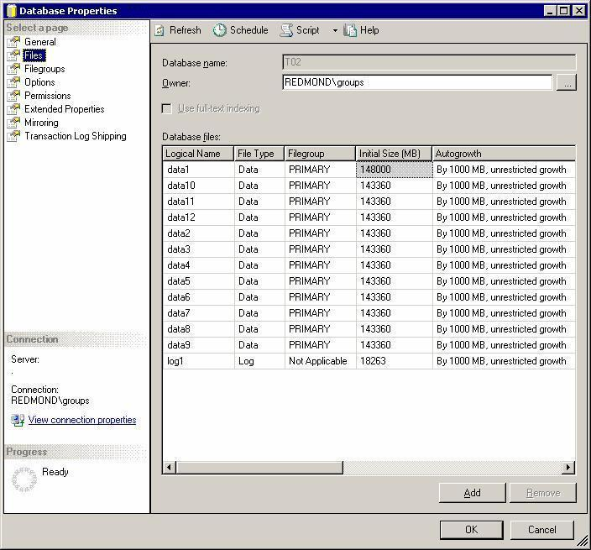
On the left, the sample demonstrates the proportional fill feature, which is used to spread the data between the data files according to each file’s available free space. The considerations for using the proportional fill include:
- Extending the data file size. As volume increases, manually extend the size of the data files by the same amount. Assume that each file was created to the same size.
- Proportionally fill the data files. When data is inserted into the database, the data files are filled proportionally using the free space in each data file.
If the data files were created to the same size, SQL Server 2005 distributes the data of each table evenly over the existing files. This makes the read/write workload even, simplifies placing the data files over a storage backend, and avoids hot spots on specific disks.
- Recalculating the proportional fill factor. Periodically, SQL Server re-calculates the proportional fill factor for each file based on the available free space. When one of the data files becomes full, the proportional fill goes out of balance. In this case, it fills the other files, grows only one of the files, and fills this file. Then it grows the next file, and so on.
- Setting autogrowth. Avoid situations where automatic growth is set by manually increasing the size of the data files proportionally in advance. Although the data files can be manually manipulated proactively, leave autogrowth on as a safety measure in case of an emergency such as when the database runs full.

SAP and SQL Server Filegroups
SQL Server 2005 allows for the creation of filegroups in order placing individual tables into dedicated locations. SQL Server filegroups are similar to Oracle® tablespaces.
SQL Server 2005 collects the SAP data and each of the SAP data files in the default filegroup, unless otherwise specified in the Create Table statement. See “Number and Size of SQL Server Data Files” for more information.
Filegroups require more complex administrative. Therefore, SAP does not support SQL Server filegroups. Using filegroups in SAP databases can lead to errors in SAP release upgrades or failures while applying support packages because SAP products cannot create objects in filegroups.

Number of Log Files for SAP Databases
The number of log files is chosen during SAP product installation. Because the SQL Server 2005 transaction log is written sequentially, typically only one transaction log file is required. The considerations for defining the number and size of log files include:
- Using multiple log files. Multiple physical log files on different partitions do not improve performance. Multiple log files are generally used on an exception basis only when there is a lack of space on one partition. SQL Server 2005 cannot write to multiple log files in parallel. In order to ensure that the transaction log file does not get lost in a hardware failure, duplicate the log in storage by using at least RAID 1.
- Setting the physical log file size. It is important to create a physical log file that is of a sufficient size, even if the log file is set to autogrow. The SAP installation program typically uses a default log file size of 1 GB. For a SAP installation, set the initial size of the transaction log file to 5 GB. In most high-end SAP systems, the size of the transaction log file ranges from 10 to 20 GB. Operations which can create large volumes of data in the transaction log files are operations around creating or re-creating indexes. Another scenario can be suspending SQL Server 2005 database mirroring. If database mirroring is suspended the data not sent to the mirror will remain in the transaction log. Remaining suspended for many hours or even multiple days, can lead to the fact that a high volume of quite some GigaBytes of transaction log records needs to be stored in the transaction log.
- Setting the size of virtual log files. Internally, the physical log file is administered by virtual log files. The size and number of virtual log files depends on the size of the physical log file, plus the growth portion. For performance reasons, it is better to have fewer larger virtual log files, rather than a large number of small virtual log files. During installation, SAP initially configures the growth factor of the log file to 50 percent, which is recommended.

tempdb Considerations
Tempdb is the temporary database for SQL Server 2005. Tempdb is used by queries to execute large join, sort, and group operations when the SQL Server buffer pool is cannot provide enough memory. For SQL Server 2005 tempdb is also heavily used by base features including Snapshot Isolation Level, which is used for online index maintenance or to assemble data that is pushed into text/image or varchar(max)/varbinary(max) datatype columns.
SAP products such as mySAP™ ERP or mySAP CRM, and SAP BW each stress tempdb in different ways and have different performance requirements. Basically, the usage of tempdb differs according to the type of workload. The two types of workloads are an online transaction workload as in the case of mySAP™ ERP or CRM, and mySAP Enterprise Portal (mySAP EP) and an Online Analytical Processing (OLAP) oriented workload such as those created by SAP BW:
- Online transaction type workloads (OLTP). mySAP products with online transaction workloads including mySAP CRM and mySAP ERP, use tempdb infrequently for larger join operations, aggregation, and smaller sorts. tempdb typically does not load or sort gigabytes of data. Overall system performance is less dependent on throughput capabilities of tempdb. For installation, set the tempdb space from 1 to 2 GB with six to eight spindles. For SAN storage, tempdb can share space with the tempdb log files.
- OLAP-oriented workloads. For SAP BW, tempdb can expand to larger sizes. For example, join operations, especially those that fully scan the fact table of a cube, can use gigabytes of space to store temporary result sets, large sorts, or hash probes or to build aggregates. In these cases, tempdb is used to perform most of the work since the memory space usually is not sufficient to process gigabytes of data. In extreme cases, when the whole fact table is read in order to build an aggregate, tempdb can grow to the size of the fact table, up to several hundred gigabytes.
- SAP BW tempdb performance. For SAP BW, tempdb I/O performance can become a major bottleneck when executing reporting queries that use the fact table or perform aggregation. In order to prevent bottlenecks, set the tempdb size to 1.5 times the space of the largest fact table. Manage tempdb strictly like a normal SAP BW database. Eventually use one data file of tempdb on the same partition with each data file of the SAP BW database. In this case, the tempdb space should provide fast read/write performance. In addition, do not place tempdb data files together on disks that contain the transaction logs of any databases.

Multi-Instance Support for SAP Components
SAP products support running multiple instances of SQL Server 2005 on the same server. However, running the database of the SAP production system together with other application databases on one server is not recommended. Multiple instance SAP configurations are typically used to run test, development, and demo systems on one server.
An alternative is to run two or three SAP databases on one SQL Server 2005 instance. The advantage of having multiple SAP databases handled by one SQL Server 2005 instance is easy administration. The trade-off is that different SAP systems must share the resources of one SQL Server 2005 instance including data cache, processors, and tempdb. The resources used by each instance can be restricted, although adding this restriction entails more administration overhead.
In order to restrict resources taken by eventual different SQL Server instances on one server, one can use the SQL Server configurations:
affinity mask
max server memory
Both of those configuration parameters are discussed later. The problem with managing the CPU resource consumption of SQL server instances with ‘affinity mask’ can be:
- The granularity of one CPU (as displayed by Windows task manager – Dual-Core processor = 2 CPU, Hyperthreading = 2 CPUs) might not be fine enough
- Setting affinity mask might be too strict and does not give enough flexibility for the specific usage (think about a system used for an afternoon in a trainings class).
For such cases it is recommendable to leverage Windows WSRM for CPU resource restrictions of SQL Server. WSRM does provide more flexibility in granularity as well as in throttling. E.g. WSRM will start throttling down the CPU consumption of an instance to its defined limits, if the overall CPU consumption on the server goes beyond 75%. However it is not recommended to use WSRM for restricting the memory consumption of a SQL Server Instance. This better is done with ‘max server memory’ configuration of SQL Server. About the usage of WSRM with SQL Server, please refer to:
http://www.microsoft.com/technet/prodtechnol/sql/2000/deploy/64bitconsolidation.mspx

SAP Database Configuration
This section describes the settings that are used by a SQL Server 2005 instance running a SAP database. It also discusses the special settings for SAP with SQL Server 2005 Lock Manager.
Most of the SQL Server 2005 parameters described in this section are set correctly when the SAP software is installed. These installation settings cover most needs, even on high-end systems. These parameters setting are typically changed only occasionally such as to improve performance.
Note that most of the tuning and balancing on memory allocations, I/O, and so on within the SQL Server instance is automated.

SQL Server Configuration for SAP
SQL Server 2005 contains approximately 50 instance global configuration parameters that are usually accessed using the command (Stored Procedure), sp_configure. These configuration parameters can increase the flexibility and uptime of SQL Server 2005. Typically, only a small number of these configuration parameters require a change to be made in order to run SAP products proficiently. There also are no different settings of configuration parameters necessary dependent on SAP products running against SQL Server. One base setting fits the needs of all the different SAP products.
This section describes the parameters that are commonly used for tuning the SAP workload.

affinity mask
The affinity mask parameter defines the specific processors on which SQL Server threads can execute. When SQL Server 2005 runs as the dedicated database server or with a SAP application, the affinity mask parameter uses the default setting of 0.
The 0 setting permits SQL Server threads to execute on all processors. In most situations, the 0 setting provides the best performance because it avoids trapping SQL Server connections on a specific processor, while leaving capacity on other processors. The 0 setting is used with dedicated database servers and SAP two-tier configurations.
One could use the affinity mask parameter in cases when multiple SQL Server instances and a number of SAP instances run on consolidated hardware. For example:
- When multiple instances of SQL Server run on a single server.
- To assign each SQL Server instance to particular processes on the server.
The affinity mask parameter is represented as a binary pattern that is expressed by a decimal number. The affinity mask parameter settings are shown in the following table.
 | affinity mask
First processor only | 1
Second processor only | 2
First and second processor only | 3
First four processors | 15
First eight processors | 255

However there might be better possibilities than using affinity mask to address such a consolidation scenario of running multiple SQL Server Instances. See here for more information.

affinity I/O mask
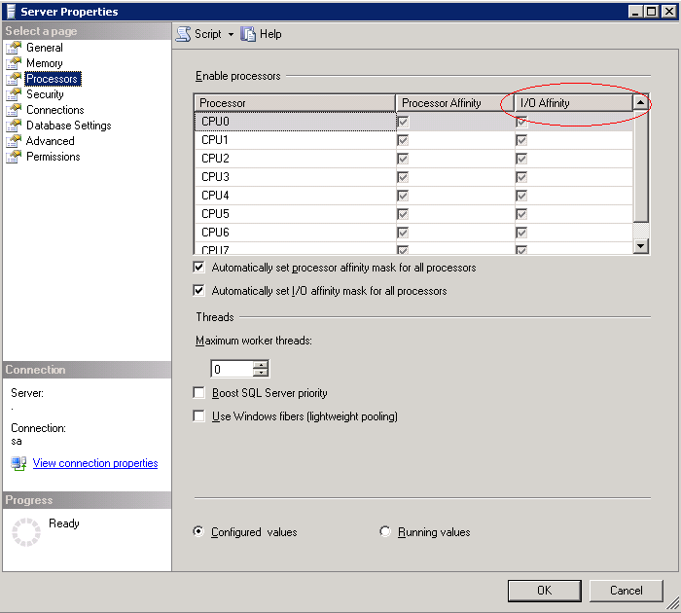
The affinity I/O mask parameter defines the specific processors on which SQL Server I/O threads can execute. The affinity I/O mask parameter has a default setting of 0 indicating that SQL Server threads are allowed to execute on all processors.
The affinity I/O mask parameter is defined according to the same conditions as the affinity mask parameter. It is best to use the default setting of 0.
On the left, the sample shows that the affinity mask and affinity I/O mask parameters are set to 0 (the default) in the Server Properties dialog box.

awe enabled
The awe enabled parameter is used to extend SQL Server Buffer pool beyond the virtual address space on 32Bit for high-end database servers. Address Windowing Extensions (AWE) should not be used with any of the 64-bit platforms. AWE administrated memory only can be used for data pages. Caches and structures such as statement or procedure cache, lock structures, and buffer headers will remain in the virtual address space and will not use memory accessed over AWE functionality.
- In order to use the awe enabled parameter, the /PAE option must be set in the boot.ini file of the Windows operating system.
- The user context used to start SQL Server requires local permissions to ‘lock pages in memory’.
- For SAP, the 3 GB virtual address space is typically used although some customer scenarios only may require a 2 GB virtual address space. The 3 GB memory is enabled by adding the /3gb option in the boot line in the boot.ini file.
In some cases, using AWE on 32-Bit servers with up to 16 GB of real memory a positive customer experience for some SAP workloads can be achieved. However, using more than 16 GB of memory on a 32-bit SQL Server 2005 platform under a SAP workload is not recommended. If more than 16 GB of memory would be required, it is recommended to move to a 64-bit computing platform. See the “64-Bit Computing Configurations” section for more information.
For SAP to use up to 16 GB of real memory, set the max server memory parameter to a fixed value of 14 to 15 GB maximum and assign the set working set size parameter to 0. During startup, SQL Server allocates the AWE portion of the memory immediately.
Note that the memory usage of the SQL Server process is not indicated correctly by the Windows Server 2003 Task Manager. The footprint of the SQL Server process shows a very low number of bytes that does not reflect reality.
However, the commit charge under the Performance tab of the Windows Server 2003 Task Manager indicates when a large amount of memory was allocated. The allocation of AWE memory can extend the startup time of SQL Server to for about a minute.

lightweight pooling
The lightweight pooling parameter is not recommended in general because it results in only minor performance improvements. This parameter is typically used for benchmark workloads that are extremely uniform.
Note that in the past, activating lightweight pooling (set to 1) was recommended for running a server based on the Unisys ES7000 architecture.

max degree of parallelism
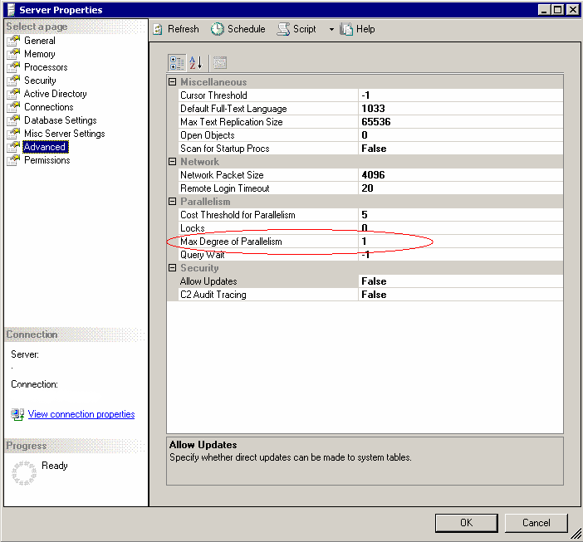
The max degree of parallelism parameter defines the maximum number of threads (CPUs) that can be used for parallel query execution. The max degree of parallelism parameter has a default setting of 0 after installation. This means all processors can be used in parallel to execute a query.
Before a potential parallel query is executed, SQL Server 2005 checks the available resources such as processors, available worker threads, and memory to determine the number of processors to use for the query. Based on those checks, it is likely that a query is not executed using all CPU Cores available, but only using a few or even only one.
This dynamic for parallel query execution is based on higher resource consumption. Multiple streams of data get sorted in parallel and are merged afterwards, making the consumption of buffers in the cache higher. In addition, the momentary CPU consumption of a single query usually increases with the degree of parallelism.
Especially in cases where multiple executions of complex queries already run by consuming CPU and memory one can encounter the effects of this kind of dynamic runtime decision in parallel execution. A typical example would be the load SAP BW applies to the database. A few complex queries might benefit from being executed on multiple CPU cores, but the majority might be executed single threaded in order not to over-commit processor resources and memory since the first few queries executed in parallel already leverage majority of CPU and memory.
Although a query executed in parallel can be much faster, there is a point at which the parallel query execution becomes inefficient and can even extend the execution time. For example, parallel queries performing small joins and aggregations on small data sets might be inefficient. Due to different degrees of parallelism chosen at execution time, response times for one query can be different depending on resource availability such as CPU and memory. The most severe effect reported however are varying response times experienced by SAP system end-users. End-users as well as administrators usually seek for predictability of the system. Predictability in reliability, but more important in performance is the usual End-user demand. Especially predictability of performance is weakened by allowing SQL Server to execute queries in parallel. Therefore the following recommendations based on the workload profile of different SAP products should are made:
- SAP On-Line Transaction Processing (OLTP) workload products. Less than one percent of queries benefit from parallel execution. Most of the heavier queries are executed by using batch jobs. In this case, set the max degree of parallelism parameter to 1.
- SAP BW. The number of SAP BW queries that can be executed in parallel can be up to 10 percent. Due to the high percentage of heavy, resource consuming queries, most SAP BW queries would typically be executed serially. In this case, set the max degree of parallelism parameter to 1 for the daily user workload. Set the parameter to 0 on occasions when aggregates are being built or rebuilt and during the delta load.
- Offline Database Administration. For Offline Database Administration tasks set max degree of parallelism to 0. This will speed up tasks like creating indexes, rebuilding indexes (if one wants to perform those offline), checkdb and other related tasks are running faster being able to leverage more CPUs
Toggling the setting of max degree of parallelism is possible online.

max server memory / min server memory
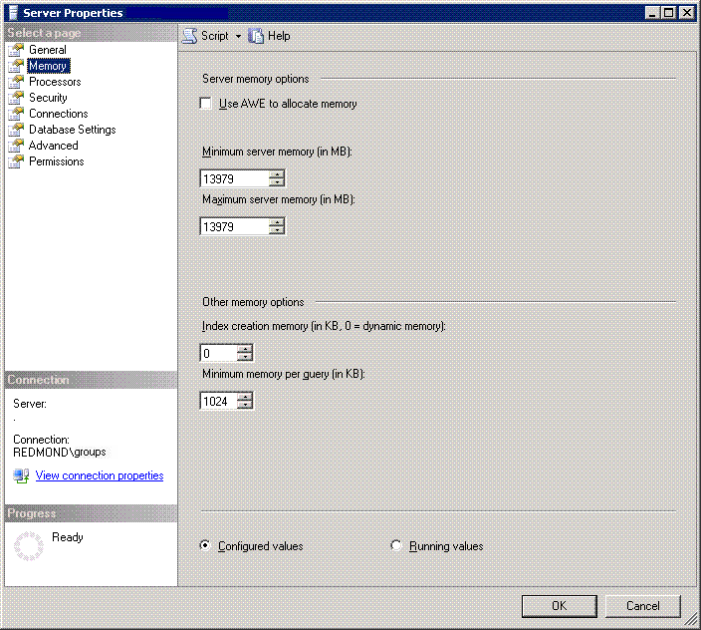
SQL Server 2005 can adapt its memory consumption to the workload. When the max server memory (MB) and min server memory (MB) parameters are set to the defaults (2147483647 and 0, respectively), SQL Server allocates memory dynamically within the range of the real memory. Use this setting for a dedicated database server that does not leverage AWE.
The memory setting becomes more restrictive when SAP components are running on the same server. In this case, at a minimum, an upper boundary should be defined for SQL Server.
Assume that even a lightly loaded two-tier SAP installation requires at least 3 GB of memory to be allocated in order to run the SAP instance. Eventually, more memory will be required. If the SAP instance is heavily loaded, the memory requirements would range from up to 16 GB.
Note that these two parameters can be adjusted on the fly, even for AWE-allocated memory.
In dedicated database server configurations, a fixed memory allocation can be set on dedicated database servers. However, ensure that some memory is left for the operating system.

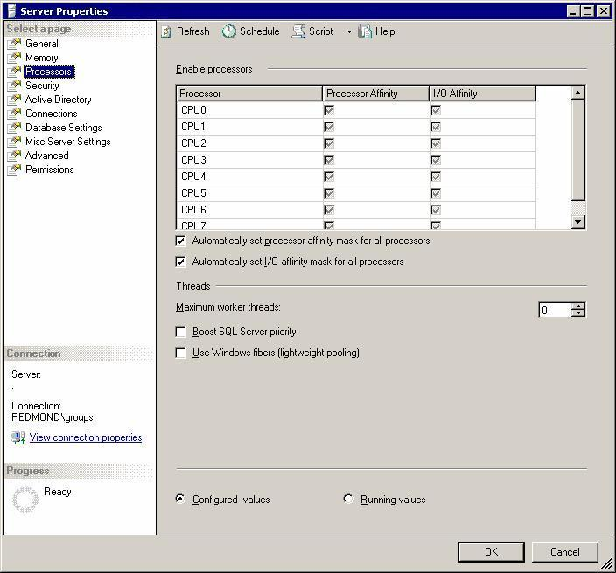
max worker threads
The max worker threads parameter defines the maximum number of worker threads that are available to handle user requests.
In contrast to competitor databases, an incoming connection to SQL Server 2005 does not result in a shadow process. Rather, the incoming connection is assigned to a scheduler thread. One scheduler thread is assigned to each of the processors or cores (CPUs) on which SQL Server is allowed to run. See the “affinity mask” section above.

Incoming connections are assigned to the scheduler threads in a round-robin manner. This provides an even distribution of the hundreds of connections, or in many cases, more than thousand of connections that can result in large three-tier SAP systems.
Every scheduler thread has a pool of worker threads. When a query request arrives over a connection, the scheduler thread assigns a worker thread, which executes the query request. Then the worker thread is available to serve another connection.
There is no 1:1 relationship between the number of connections and worker threads. SQL Server 2005 can reassign connections to other schedulers if the original scheduler is overloaded, thereby avoiding an uneven CPU load.
For SQL Server 2005, the max worker threads parameter is dynamic and should remain at the default of 0. Note that this setting is different from the one used with SQL Server 2000, where a value had to be set since the logic used was not dynamic. The dynamic built into SQL Server 2005 will decide based on the platform (32Bit or 64Bit) and on the number of CPU Cores available on the maximum number of worker threads. The actual number of worker threads can be evaluated with this query:
select max_workers_count from sys.dm_os_sys_info

network packet size
The network packet size parameter determines the size of packets transmitted over the network. SQL Server 2005 allocates three buffers that use the parameter size for every connection. This parameter does not have an effect if the application request contains a different value. At connection time, SAP NetWeaver Application Server overwrites the network packet size parameter in SQL Server 2005 when it is set to other than 8192.
Because 8192 is set by the SAP client application, the network buffers are allocated outside of the SQL Server buffer pool, but in the SQL Server virtual address space. SQL Server usually leaves a virtual address space of approximately 300 to 350 megabytes (MB) outside the buffer pool. In large SAP systems, up to 150 MB of the 300 to 350 MB can be allocated by the network buffers. In turn, this can lead to problems with the virtual address space in a 32-bit computing environment.
As a workaround, SQL Server can be forced to leave more virtual address space by adding –gxxx, with xxx=number specifying MB – default =256 MB in SQL Server 2005, as a start up parameter to define a value above 256 MB. This is not a problem in 64-bit computing platforms.

priority boost
The priority boost parameter defines the priority of SQL Server processes. Having the value set to 1 gives SQL Server processes a slightly higher priority. The current recommendation is to set the priority boost parameter to 0, which leaves SQL Server processes with a normal priority.
In the past, SAP and Microsoft have recommended having the priority boost parameter set to 1. However, this recommendation changed recently to having the priority boost parameter set to 0, due to situations where operating system network threads were starved in favor of the SQL Server process, thereby causing failure situations and transaction rollbacks.
In addition, due to improvements in SQL Server 2005 and Windows Server 2003, the advantages formerly achieved by increasing the priority of SQL Server processes have been minimized.

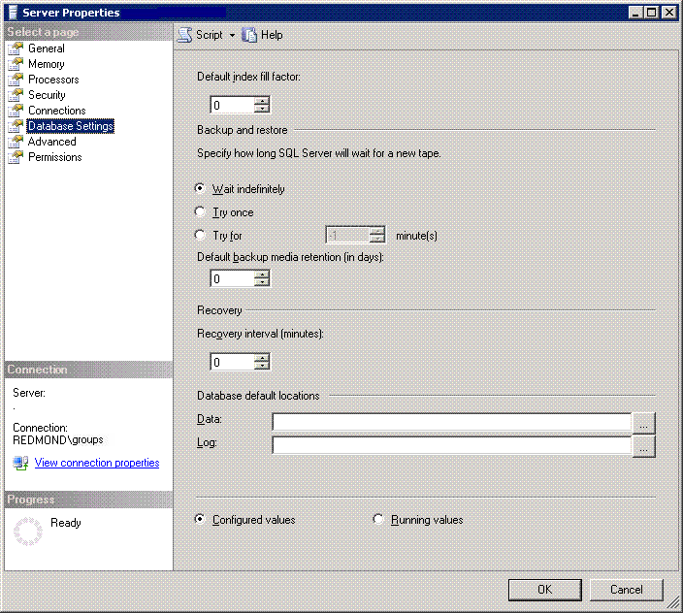
recovery interval (min)
The recovery interval (min) parameter is used to control the checkpoint interval. SAP recommends using the default setting of 0. In customer scenarios, using 0 causes a checkpoint interval to occur every 30 to 60 seconds in situations where no other event triggered a checkpoint such as Commit.
SQL Server checkpoint intervals are extremely sensitive with disk resources. SQL Server works to avoid overloading the I/O during checkpoint writes. In the past, there have been no customer issues with I/O flooding caused by SQL Server checkpoints.
In contrast to competitor databases, the mySAP space does not require this value to be adjusted in order to achieve better control of checkpoint effects.

set working set size
The set working set size parameter was initially used to keep memory allocated by SQL Server from being paged out to the pagefile. In the past, mySAP used a set working set size parameter of 1 during the SAP product installation. The current recommendation is to set the parameter to 0.
Within the last two years, there have been concerns about the effect of having this parameter set to 1. It has been the source of some problems in high-end database servers. In addition, this parameter no longer has an effect on SQL Server 2005. At present this parameter is used only to avoid setup application failures.

SAP Settings for SQL Server Lock Manager
SQL Server introduced new locking mechanisms with the development of SQL Server 7.0. The goal of the design called Dynamic Locking was to:
Provide row level locks for most of the operations and save Locking costs for non-concurrent operations which would acquire a lot of locks
If one acquires a lock at higher granularity than row, it can cover more rows there by consuming fewer lock resources (each lock structure takes approximately 100 bytes) and the locking overhead. But this comes at a price of lower concurrency. So for example, if one wants to select all the rows of a table one will prevent locking all rows specifically by acquiring a lock on table level. However this will block any concurrent modifying transaction. Similarly, if every individual row gets locked, one will get higher concurrency but add overhead of acquiring/releasing locks on each row and lot more locking resources. Most of the Select statements of SAP will not cause a lock on a row since the reads are executed as so called ‘dirty reads’ (as explained here). Most of the other queries submitted by SAP products are ending up with normal row locks since most modifications are done on a per row basis. In a first step in the dynamic locking algorithms SQL Server will decide for a locking granularity based on data evaluated and estimated through query compilation like cardinality estimations or estimations on rows being processed. The locking granularities could be row, page or table locks. If a lock granularity of page or table lock is desired for starting the execution of the query, one might not get that lock granularity since other conflicting locks would block the execution. In such cases the lock granularity to start with gets lowered. While locking granularity is chosen at the start of query execution, there also is a possibility to change lock granularity during the execution. SQL Server may choose to escalate the lock to coarser level of granularity depending on the number of locks acquired and the availability of memory at run time. Changing lock granularity while executing, SQL Server only supports escalating the locks to the table level. Locks can only be escalated from rows to the table or pages to the table level. Locks are never escalated from rows to the parent page or from pages to the owning table partition. As in trying to start a query with page or table level lock, if trying to escalate the lock granularity during the execution will encounter conflicting locks, the attempt will fail and the query continues to execute in row lock granularity.

Triggering Lock Escalation:
A lock escalation is triggered when any of the following conditions is true
- The number of locks held (different from acquired) by a statement on an index or a heap within a statement exceeds the threshold (currently set to 5000 (approx)). These locks include intent locks as well. Note the lock escalation will not trigger if
- The transaction acquires 2,500 locks each on two index/heap(s) in a single statement.
- The transaction acquires 2,500 locks on the non-clustered index and 2,500 locks on the corresponding base table in a single statement.
- The same heap/index is referenced more than one time in a statement; the locks on each instance of those are counted separately. So for example, in the case of a self-join on a table t1, if each instance has 3000 locks within the statement, it will not trigger lock escalation
- The memory taken by lock resources > 40% of the non-AWE (32-bit) or regular (64-bit) enabled memory when the locks configuration option is set to 0, the default value. In this case, the lock memory is allocated dynamically as needed.

A scenario where one could see SQL Server to go for table level locks from the beginning could be a query like:
update TABLE1 set PRICE=PRICE*1.1
Assuming that table1 would contain like 1 Mio rows, it is likely (dependent on some other schema conditions) that SQL Server would try to start with a table lock executing the query. If any other existing lock would conflict with the table level lock, the next cheapest solution might be to acquire page locks. If that again could be hindered by conflicting locks, the query will start with row level locks. However after having 5000 locks acquired on one heap or index, SQL Server will check again for escalating to a table level lock.
Looking at such a scenario with the SAP deployed stored procedure sap_lock
one could find the following entries for a table lock in the first few column of the result set:
Query executed under Table Lock
Tablename spid dbid IndId Type Resource Mode Status
---------------------------------------- ------ ------ ------ ---- ---------------
TABLE1 100 5 0 TAB X GRANT

A case where the same update statement is executed under page level locks the output of the fist few columns of the sap_lock output could look like:

Tablename spid dbid IndId Type Resource Mode Status
---------------------------------------- ------ ------ ------ ---- ---------------
TABLE1 51 7 0 TAB IX GRANT
TABLE1 51 7 1 PAG 1:379004 X GRANT
TABLE1 51 7 1 PAG 4:24363 X GRANT
TABLE1 51 7 1 PAG 4:24430 X GRANT
TABLE1 51 7 1 PAG 1:24685 X GRANT

In this case, the table lock is IX indicating that lower granular X locks are held within the table by the same session.

Output of the sap_lock where the update statement is executed using row level locks would look like:
Tablename spid dbid IndId Type Resource Mode Status
---------------------------------------- ------ ------ ------ ---- ---------------
TABLE1 51 7 0 TAB IX GRANT
TABLE1 51 7 1 PAG 1:379004 IX GRANT
TADIR 51 7 1 KEY (190147febc17) X GRANT
TADIR 51 7 1 KEY (450197cb2748) X GRANT
TADIR 51 7 1 KEY (9902ae588d11) X GRANT

Again the IX locks on the table and page are indicating lower granular X locks on the table and on the specific page, which in essence only can be row level locks.
Another typical example where SQL Server might try to use a higher granularity level could be:
update TABLE1 with (UPDLOCK) set PRICE=PRICE*1.1
where STATUS = ‘NEW’

In this, the lock granularity SQL Server would like to start with is dependent on the fact whether an index exists on the column STATUS and how big the expected result set would be. Like before, assuming table TABLE1 would have 1 Mio rows and due to the absence of an index on the column VALID, the whole table would need to be scanned in order to locate the rows fitting the predicate of the Where clause. Therefore it is highly likely that SQL Server would try to start with a different granularity than row level locking. Dependent on competing conflicting locks, the granularity is decided then.
In both cases an index on the column STATUS would help to increase the chances of row level locks, under the assumption that the majority of values in column STATUS do have different values than ‘NEW’.

How to monitor table lock escalation
In order to detect table lock escalations one can use SQL Server startup trace flag 611. Each lock escalation will be reported into the SQL Server errorlog. Additional to the occurrence and the time stamp of the occurrence, the SQL Statement Handle is reported as well. Taking that handle and executing
select text from sys.dm_exec_sql_text(<handle>)
E.g. select text from sys.dm_exec_sql_text(0x03000500275CDB1E2E0BB000959700000100000000000000)
one gets the text of the query and hence can get to the affected table(s).

How to restrict dynamic locking to a minimum
The locking granularity chosen to start the query with can be controlled and overwritten explicitly by executing sp_indexoption stored procedure on affected tables and indexes. This is done during the installation of SAP products on several tables in the SAP database schema already. For example, typical queuing tables include VBHDR, VBMOD, and VBDATA, which store update requests, and ARFCRDATA, ARFCSDATA, TRFCQUEUE. See SAP OSS Note 327494 for more information. Don’t be confused about the fact that this note is for SQL Server 2000. The section describing dynamic locking and the how SAP deals with it is applicable to SQL Server 2005 as well. The command to check such a setting would be
SELECT INDEXPROPERTY(OBJECT_ID('<table name>'), ‘<index_name>’,
' IsPageLockDisallowed')

To suppress lock escalations to table locks taking place, one has two possibilities:
- TraceFlag-1211: It disables lock escalation at the current threshold (5000) on a per index/heap per statement basis. When this trace flag is in effect, the locks are never escalated. It also instructs SQL Sever to ignore the memory acquired by the lock manager up to a maximum statically allocated lock memory or 60% of non-AWE(32-bit)/regular(64-bit) of the dynamically allocated memory. At this time an out of lock memory error is generated. This can potentially be damaging as a misbehaving application can exhaust SQL Server memory by acquiring large number of locks. This, in the worst case, can stall the Server or degrade its performance to an unacceptable level. For these reasons, a caution must be exercised when using this trace flag
- TraceFlag-1224: This trace flag is similar to trace flag 1211 with one key difference. It enables lock escalation when lock manager acquires 40% of the statically allocated memory or (40%) non-AWE(32-bit)/regular(64-bit) dynamically allocated memory. Additionally, if this memory cannot be allocated due to other components taking up more memory, the lock escalation can be triggered earlier. SQL Server will generate an out of memory error when memory allocated to lock manager exceeds the statically allocated memory or 60% of non-AWE(32-bit)/regular memory for dynamic allocation.
If both trace flags (1211 and 1224) are set at the same time, the trace flag 1211 takes precedence. You can use dbcc tracestatus (-1) command to find the status of all trace flags enabled in SQL Server.

Are there big chances ever hitting situation where a page or table lock will block other concurrent accesses in the daily productive live with SAP products? With SAP standard delivered coding the only situations observed so far was around the table DDLOG deleting massive amount of rows in one delete statement. In some cases one could observe other than row level locks in customer written ABAP programs where customers tried to change massive amounts of rows with one statement by having hardly an restrictions in where clauses. Another occasion where it could be observed where customer written reports performing updates where the where clause of the update statement was not sufficiently supported by existing and SAP deployed indices on the affected tables.
Due to the fact that SAP reads dirty most of the time, the number of locks held by SAP applications usually is very low in the hundreds and few thousands. Also given the fact that the buffer sizes for SQL Server running under SAP workloads are going into the GigaBytes, an escalation because of lock structures occupying 40% of the buffer pool never has been observed.

SQL Server 2005 Availability Features
Availability concepts around SQL Server always should start with measures on the availability of the data on the primary database server. Leveraging all types of storage redundancy or other features first should be explored and maximized, before one thinks about other high availability features involving secondary database servers.

This section should not elaborate deeper into disk level redundancy, nor should the usual RAID concepts be explained here. As described in different configurations here in this whitepaper, the minimum RAID level of any part of SAP user database should be RAID-5 at least, preferably even mirrored. Having not the slightest redundancy measure on disk level simply is not acceptable. More on different RAID levels can be found on:
http://en.wikipedia.org/wiki/RAID1#Standard_RAID_levels
or on this whitepaper which also explains some other storage features of SQL Server applicable for SAP. Please note that not all described measure in this whitepaper are applicable for databases related to SAP applications:
http://www.microsoft.com/technet/prodtechnol/sql/2005/physdbstor.mspx

Besides RAID levels on the storage steps like using multiple Host or Fiber Adapter cards which can failover work are steps to take in high-end servers. Other than that SQL Server 2005 does offer a new feature for proving on physical consistency of pages.

Checksum on Pages
Additionally SQL Server does provide different checks so that pages written to storage do not get corrupted. So far these checks of SQL Server are done reading those pages from storage. The level of checks are configurable on a per database level. So far SQL Server only checked whether chunks of 512Bytes within one page got written at the same time. This was the so called ‘torn page detection’. With SQL Server 2005 a more strict check on physical consistency got introduced on a page level. This is to build a checksum on a page before writing it to the storage, saving that checksum in the page header and verify the checksum during reading the page next time by re-calculating and comparing the checksum saved on the page with the one being calculated.
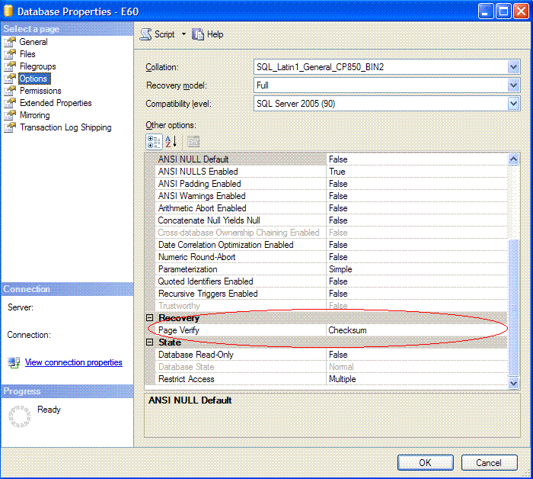

Using checksum compared to ‘torn page detection’ which was used so far, can increase resource consumption slightly. Dependent on the I/O volume, an increase of up to 5% CPU resource consumption can be observed. Be aware that databases which are getting upgrades from SQL Server 2000, restored from a SQL Server 2000 or SQL Server 2000 databases getting attached remain on the level those have been before (usually torn page detection). Means ‘checksum’ checks are not activated. However databases which get created under SQL Server 2005 will automatically have ‘checksum’ checks enabled. Enabling ‘checksum’ on a database which got updated from SQL Server 2000 will trigger checksumming pages which get written newly only. There is no process checksumming all the pages which are contained in the database in a background manner. Means protection by checksum will hardly get to 100% in the immediate time frame. Executing a backup against pages with torn page or checksum data, the backup code does check on torn pages or checksum before writing the page to the backup device.

Backup and Recovery Improvements
SAP products can take advantage of new SQL Server 2005 backup capabilities including fine-grained online repairs, parallel transaction log backups and online backups and some severe improvements in the recovery processing. Unlike other databases, a special backup tool like sapdba never got developed by SAP for SQL Server since SQL Server did have own graphical User interfaces since over a decade.

Online Backups
In SQL Server 2005, online backups perform only one data backup at a time for each database. The backup and restore functionality includes FullText catalogs. The point in time which is stored by the backup on the backup medium is NOT the point in time when the backup started, but is a point in time which is very close to the end of the backup. This is possible due to the fact that the online backup is just going sequentially through the database in one or multiple threads and just reads the data as it is at that point in time on disk. Additionally the changes documented in the transaction log during the time the online backup ran, are added to the backup. This makes the online backup extremely fast, because changes happening meanwhile are not interfering with the backup. Restoring such a backup the extents stored on disk will be copied to the database as copied to the backup medium. After that step is done, the change records which are stored on the medium as well get applied to the database. From a load perspective, a backup hardly consumes CPU, but can create substantial I/O load.

Changes and improvements applicable for SAP related databases in this area made in SQL Server 2005 are:
- Transaction log backup execution. The restriction of not being able to execute a Transaction Log backup while an Online Backup was in execution. This limitation is removed with SQL Server 2005 and increases the safety level on the customer side and the ability to restore to a point-in-time, even to the timeframe during which the online backup ran.
- Single page restoration with the database online. SQL Server 2005 can restore single pages from online and transaction log backups while the rest of the database remains online. This is an advantage in common support cases including cases where page corruption of one or a few pages results in destroying data. In such cases, a SAP customer does not need to restore terabytes of data in order to get the database physically consistent again. Instead, a customer can just restore the few corrupt pages while the rest of the data remains accessible.
- Recovery Phase. In SQL Server 2005, a database in the recovery phase becomes available after all of the transactions not covered by the last checkpoint are redone. The recovery phase consists of three main phases that change data on the database; the redo phase and the undo phase.
- Analysis Phase. This is a pass through of the transaction log. It gets read in order to find out when the last checkpoint has been made and to find out other important marks needed for Recovery.
- Redo phase. In the redo phase, data modification recorded in the SQL Server transaction log after the last checkpoint is executed is written to the data files. In contrast to earlier SQL Server releases, SQL Server 2005 opens the database after this phase. Any uncommitted data residing in the data files after the redo phase performed is protected by database locks. This prevents the data that is to be rolled back in the next phase of the recovery process from being accessed.
- Undo phase. In the undo phase, the data from uncommitted transactions is rolled back. The database is available when the undo begins. In most cases, the undo phase takes significantly longer than the redo phase.
These improvements in recovery lead to faster failover time for server clustering (MSCS) and faster failover for synchronous database mirroring with failover. In SAP database mirroring configurations, fast recovery reduces downtime triggered by problems to a minimum.

What did not get really improved in these processes is the progress indication of each of those 3 phases. The first phase of analysis usually is pretty accurate. However in the second and third phase extreme cases sometimes can be seen where estimations of hours for Redo are written into SQL Server Errorlog. In such a case the best thing to do is to use Windows Perfmon and check the read rate on the partition the transaction log resides on. Then take the size of the transaction log and divide it by the read rate. That at least gives an accurate worst case estimation for the assumption that the transaction log was completely filled up at the time the incident happened.

Database Backup Methods
The overall goal of a backup strategy should be to minimize the loss of data by having Online Backup plus Transaction Log backups available to a point as close as possible to the disaster. Therefore best practices is trying to execute one online backup per day plus as many transaction log backups as possible during the day. With extreme large SAP databases, it might be necessary to execute a differential database backup instead of an online backup and to defer the online backup to the weekend to avoid resource constraints. Ideally a transaction log backup is executed in a 1-5min period. Dependent on the volume of the SAP database there are different possibilities to perform backups. The overall goal of a backup strategy also is dependent on the facilities and infrastructure a company already has. The most common methods are:
- In the small area of a few hundred Gigabyte or up into the lower Terabyte area, it can be feasible to perform SQL Server Online backups against direct attached tape libraries. At this point in time (September 2006), there are tapes on the market which store 400GB uncompressed data per cartridge. However the SAP landscape does contain more than one productive SAP product usually and also does contain test and development systems. Therefore the number of tape drives or libraries might become increasingly high and eventually a serious investment cost. Performance characteristics of SQL Server Online backup are pretty much throttled only by disk throughput and by possible throughput for the direct attached tape arrays. Means the better the read I/O throughput and the better the possible write throughput to the tapes, the faster the backup will perform. There hardly is any CPU involved. There hardly is any synchronization with other SQL Server activity necessary for the backup. Therefore most of the resources leveraged during SQL Server Online backup in such a configuration is I/O bandwidth. It is recommendable to attach the local tape drive/library with separate controller cards in order to maximize throughput.
- In the more high-end area of volumes well into Terabytes, the investment into local attached tape libraries for many of the customers is too expensive or does simply take too long to execute. Especially the run time of a backup can be reduced dramatically using SQL Server Snapshot backup which can be leveraged by SAN/NAS storage vendors. In such a case, the hardware vendor’s software interacts with SQL Server in order to tell SQL Server that a Snapshot is planned. SQL Server will freeze all write activity to the database, which should be targeted and gives control back to the calling software of the hardware vendor. Then the SAN/NAS storage vendor is performing the activities to duplicate or to prepare the duplication of the database. Ideally this process takes less than one minute. The hardware vendor’s software then will hand back control to SQL Server. SQL Server at this point will open write I/O to the database again and will note a snapshot backup being executed successfully. Dependent on the SAN/NAS hardware vendor one does have a snapshot backup available at that point in time which is a complete clone (means eating up as many disk space as the origin) or at least a process running creating such a clone over the next few hours. If such a clone exists, one can pull this clone to tape devices which are either local attached or centralized. But the phase of getting the backup to tapes would be a less critical one from timing perspective.
- Other customers of mid ranged to high volumes into the Terabyte area are executing SQL Server online Backup against direct attached disk devices. These might be less expensive devices or those might be located on SAN/NAS storage as well. After the backup succeeded the backup is either pulled to local attached tapes or to centralized tape devices. The success of this method is solely dependent on disk I/O throughput and the configuration of the storage devices. It for sure is not advisable to use the partitions as backup destinations which contain the SQL Server data files which are getting backed up. This would overload those partitions by the extreme contrary workload of reading and writing. It also proved to be best practice to even use totally separate spindles for the partitions containing the data files and work as destination for the backup. E.g. to achieve a backup throughput of 1TB/h, one need to sustain around 277MB/sec on read I/O and 277MB/sec on write I/O on the other side. It definitely is possible to achieve these levels of throughput, but as obvious with these numbers needs good planning and configuration of the storage backend.
- Using centralized backup facilities (corporate backup) is something a lot of customers turned to in order to minimize investments for many local attached tape devices/libraries. A lot of customers using this kind of configuration for backup are executing the online backup against disk storage devices like described above and then pull the backup at convenient time over to tapes. Therefore the same performance considerations in terms of I/O would exist. Another focus in such a configuration should be maximizing efficiency on tape drive usage. Ideally one would leverage tape drives for the smallest time possible for each of the individual backups. For that purpose compressing the SQL Server Online Backup on the database server side and pull the compressed amount data over to the centralized backup infrastructure will help. There is third party backup software available which performs backups and compresses those backups. So on the server side, one will have a compressed SQL Server Online backup on local tapes. The usual compression ratio one can expect is around a factor of 2.5 to 3. No doubt compression while performing the backup will cost CPU.

Validating a backup
The fact that a backup either of the database or the transaction log is written to tape or another device and gets stored there for weeks to come, does not guarantee at all that such a backup is restorable. In the past there always were cases where tapes figured out not to be readable anymore. Or in case tapes were readable, content on the tape was damaged and hence backups failed to restore. Some of these cases led to customers loosing weeks of data. Therefore just storing backup sets in a vault is not good enough. One of the most simple solutions independent on the way the backup infrastructure looks is to restore the backup against a sandbox system in a regular manner. The sandbox hardware does not need to be a server of the most modern kind. The storage also does not need to be the newest and best. The question to be answered by such a periodic task is whether the backup residing on tape or some other device can be restored. Time to restore is not the primary goal. After the backup got successfully restored one as well could use the database to run a physical consistency check on the restored database. Again, time is not the issue. It doesn’t matter if the check takes two days for a database in the Terabytes. Another possibility would be to execute a ‘restore verifyonly’ towards the Online Backup (not possible in all the backup methods named above). In opposite to SQL Server 2000, SQL Server 2005 did enhance the checks of verifyonly to a point where page IDs get checked, so that one gets a high confidence in the fact that the page formats still are fine on the backup. Using verifyonly to check on the backup, it could make sense to use a new backup option of SQL Server 2005. The option is called ‘Checksum’ and will create a checksum over the backup streams. These streams will be verified while performing a ‘restore verifyonly’. Hence one can make sure that what was written to the backup device(s) got stored the same way.
Despite all the checks on could do, the exercise of periodically restoring a backup also as an exercise for personal still is something one should target to establish as best practices.

Media Reliability
SQL Server 2005 delivers a number of media reliability improvements including:
- Backup with multiple destinations. With SQL Server 2005, a backup can write to up to four different destinations. Multiple sets of tapes can be written for the same backup. When redundant backups are written, the tapes from each destination set are interchangeable with the same tape in the other sets. For example, if a tape from one destination set is lost, the same tape from one of the other sets can be used instead.
- Verification of page restores. Verifyonly like mentioned above investigates the physical structure of a page. The linkage between the pages and the accuracy of the allocation pages is not checked.
- Restore sequence reliability. The SQL Server 2005 restore sequence continues despite physical inconsistency in order to give customers an opportunity to repair errors. The restore sequence continues as far as possible before the database needs to be repaired.

High Availability Considerations

Besides the very well known and used methods of using Log Shipping and Microsoft Cluster Services (MSCS), SQL Server 2005 introduced a new High Availability method called Database Mirroring. In this chapter, we take a look at the different methods and changes with SQL Server 2005.
However none of these method named here are making sound backup/restore procedures for a productive system obsolete. To think that one never would end up in a situation where the productive database needs to be restored in the primary location proved wrong in the life cycle of SAP systems so far. Therefore any of the three HA methods mentioned here, need to be supported by a good and appropriate Backup/Restore plan of the productive system. For more on backup/restore see here

Log Shipping
SQL Server 2005 supports log shipping to feed transaction logs from one database to another on a constant basis. Continually backing up the transaction logs from a primary database, and then copying and restoring the logs to a secondary database, keeps the databases synchronized. This provides a backup server for disaster recovery and also offers a means to offload query processing from the primary server to a read-only destination server.
Log shipping is recommended for use in a variety of scenarios. Some customers are using it across geographically distant data centers as part of their disaster recovery configuration. Note that with log shipping there is no automatic failover and committed transactions can be lost. This is dependent on the frequency with which transaction log backups are performed.
Advantages of SQL Server Log shipping however are:
- Multiple images of the productive database can be supported
- More than one destination can be supported with log shipping
- Wide distances can be covered with log shipping limited only by the network bandwidth needed for the copy of the transaction log backup files
- One can keep a database image hours behind production by delaying the restore of the transaction log backups against the log shipping destination.

Microsoft Cluster Services MSCS
mySAP with SQL Server 2005 architectures can leverage failover clustering. In SQL Server 2005, failover clustering offers a complete, fault tolerant server solution that supports high availability and data integrity, and reduces the costs associated with downtime.
SQL Server 2005 failover clustering exploits Microsoft Windows Clustering Services (MSCS) to create fault-tolerant virtual servers that enable fast failover in the event of a database server or critical line-of-business (LOB) application failure.
A typical Microsoft clustering scenario includes running the SAP Central Instance (CI) on one of the cluster nodes and SQL Server 2005 on the other cluster node. In this case, if the primary node for SQL Server 2005 or for the SAP CI fails, or if that node is taken offline for maintenance, the clustered components will start on the active cluster node with no service interruption.
For more information, see “Failover Clustering” in the MSDN Library at
http://msdn.microsoft.com/library/default.asp?url=/library/en-us/adminsql/ad_clustering_7t9v.asp

For SQL Server 2005 the setup in a MSCS environment did change. Like with the SQL Server setup of SQL Server 2000 IA64, a promotion of a non-clustered node to a clustered node is not possible anymore. This affects the way how SAP systems needs to be installed in a different order than before. Please check the latest OSS notes in regards to the way of installing a SAP system against SQL server 2000 IA64 (like OSS note #387879) or SQL Server 2005 in an MSCS environment. For installations against SQL Server 2005 also download the latest SAP Installation Master DVDs from the SAP Service Market Place. SAP Installation documentation of the most recent releases should reflect the changed way of in stalling.
Another change in SQL Server 2005 setup is to support Mountpoints in a MSCS environment.
Advantages MSCS setups offer are:
- Automatic failover initiated when hardware of SQL Server instance becomes unresponsive.
However one of the disadvantages of MSCS setups is that all the nodes cooperating are working against one database image. Means there is no way to compensate for physical consistency problems which get introduced within the I/O path due to failing components.

Database Mirroring
Database mirroring is a new feature which became general available for production usage with SQL Server 2005 Service Pack1 (SP1).
Database mirroring can ensure that a transactionally-consistent, hot-standby mySAP database is rapidly available in the event of a database failure.
The principle of Database Mirroring is to transfer transaction log entries from the so called ‘principal’ server directly to the ‘mirror’ server every time those transaction log records would be persisted in the transaction log file of the principal server.
SQL Server 2005 offers these three different modes of Database Mirroring:
Operating Mode | Transaction safety | Transfer mechanism | Quorum required | Witness server | Failover Type
High Availability | FULL | Synchronous | Y | Y | Automatic or Manual
High Protection | FULL | Synchronous | N | N | Manual only
High Performance | OFF | Asynchronous | N | N/A | Forced only
Database Mirroring configurations and SAP leverage

Comparing the features of the different configurations of Database Mirroring with Log Shipping and MSCS functionality, one could state the following:
- Like Log shipping Database Mirroring does provide the possibility of two separated database images. However unlike Log Shipping, Database Mirroring can be setup in a way that no committed transactions are lost.
- Like MSCS Database Mirroring does provide dependent on the setup an automatic failover for applications like SAP ABAP Application server.
- Database Mirroring can also provide a database image close to production with non-measurable performance impact.
One restriction of Database Mirroring one has to be aware of is the fact that only one destination can be targeted. The granularity of mirroring is a single database. However more than one databases of one SQL Server instance can be mirrored.
The system administrators are able to manually force a failover. It also is possible to suspend active mirroring in order to perform maintenance on one of the servers. As long as database mirroring is suspended, the transaction log records are collected in the transaction log of the active database. Even transaction log backups will not delete these records. Means the time mirroring stays suspended should be limited. After database mirroring does get resumed, it goes into a phase of synchronization. In this phase all the changes are transmitted to the mirror server additional to the current changes which queue up at the end of the data to be synchronized. Means the volume of data changed during the suspended period and the network bandwidth will decide on the time it takes to synchronize.

In the following chapters the three mirroring configurations for use with the two SAP Application server architectures and the setup of the SAP components on database mirroring are discussed. Database Mirroring will not be described in all its details in this whitepaper. Therefore it is recommended to read more detailed descriptions before implementing database mirroring. For a very detailed description of SQL Server 2005 Database Mirroring and more technical details, we would recommend reading the following articles:
http://www.microsoft.com/technet/prodtechnol/sql/2005/dbmirror.mspx

and
http://www.microsoft.com/technet/prodtechnol/sql/2005/technologies/dbm_best_pract.mspx

Asynchronous Mirroring
Configuring Database Mirroring in asynchronous mode, the transaction log records are sent asynchronously to the mirrored server. The principal database server does not wait for the mirror server to acknowledge the receipt of the transaction log records before confirming the commit to the SAP application. As a result a long latency in transmission of the records and the confirmation will not affect the response times on the principal server.
Asynchronous mirroring does not guarantee that all transactions committed on the principal server will be saved to the mirrored server. In case of a crash of the principal server there is a chance that the last few committed transactions on the principal server can get lost. Therefore it is not possible with asynchronous mirroring, to have automatic failover. A failover to the mirror server needs to be initiated manually in this configuration. Asynchronous mirroring can be used in disaster recovery scenarios when:
- When small loss of the last few transaction is tolerable
- When the database is mirrored to a remote site across over longer distances, which would introduce too long latency times.
Currently, most SAP customers use log shipping under similar conditions. Using asynchronous mirroring instead is an effective alternative that improves transactional consistency and, most importantly, provides a mirrored image of the database that is closer to the principal image of the database. The main disadvantage compared to log shipping is that changes on the principle side are getting propagated within split seconds and will get applied to the mirror database. Therefore using database mirroring human errors cannot be compensated by delaying the restore of transaction log records like this is possible with SQL Server log Shipping.
Theoretically a manual failover could be initiated at any point in time. SAP processes would reconnect to the mirror server after the failover completed. But all open and running transactions would be rolled back. Therefore if the manual failover takes place controlled and planned, it is recommendable to shut down the SAP ABAP application stack and manually force the failover to the mirror and then restart the SAP applications.

Synchronous Mirroring
For synchronous mirroring, the primary server confirms the transaction to the SAP application only after acknowledgement from the mirrored server is received. This configuration offers two-phased transactional consistency. Instead of having only a single copy of the data on shared storage, there are two separate and consistent copies. This database mirroring configuration will result in a performance impact on the principal database server and the SAP application. In the way how the SAP ABAP Application Server based Logic is executed mainly using asynchronous database updates, it is expected that the performance impact mainly affects the SAP update processes and eventual SAP batch processes. For the Dialog part of the SAP Business Logic there hardly should be an impact. Whereas Java based SAP logic might be affected across the board since there is no separation in processes or threads performing database reading and writing. The performance impact mainly results from the fact that the principle server will wait on the Mirror server to acknowledge having received and stored the Transaction log Buffer sent. Since the transport layer for these packages is regular TCP/IP (no other protocols are supported), delays on waiting for the mirror acknowledge are calculated by the transmission time of the packages plus the time it takes to persist the transaction log records on the mirror side. No doubt distance and network bandwidth are decisive factors for this more variable part of the delay. Extreme distance or too small network bandwidth drastically limits scalability of a SAP system. Result of extreme high database response times for SAP ABAP upgrade processing usually develops into severe blocking lock scenarios around tables storing number ranges or other critical resources. Therefore the distance to bridge with Database Mirroring should be moderate, for a SAP OLTP kind of workload less than 100 miles with experience collected so far. The average throughput of such a network link between principal and mirror should be able to sustain 5-10MB/sec for medium to large systems and 10-20MB/sec for high-end systems.

Synchronous Mirroring with Failover
Automatic failover requires the addition of a witness instance of SQL Server, which can be a Microsoft® SQL Server™ 2005 Express Edition server or any other SQL Server 2005 release. The witness server provides the quorum logic necessary in automatic failover clusters in cases where two of the three servers need to agree on failover. If the database on the principal server goes down, the witness and mirrored servers form a quorum and then arbitrate to bring the mirrored database on the mirror server online and redirect clients to the mirrored server. Not all SAP components are able to leverage an automatic failover by Database Mirroring. Reason is the fact that the client re-direct functionally is implemented in ADO.NET as well as in the new SQL Server Native Access Client (SNAC). SNAC is covering ODBC and OLE DB. Since SAP Executables of the SAP ABAP Stack are using SNAC when connecting to SQL Server 2005, the SAP ABAP based components are able to leverage the Automatic Failover capabilities of Database mirroring. However the JDBC drivers used by SAP so far do not support this automatic client re-direct feature. Hence SAP components based on the SAP JAVA stack are not able to use automatic failover capabilities and rely on manual failover.
Be aware that the automatic failover is somehow a bit more complex than the failover logics of MSCS. In contrast to MSCS, Database Mirroring needs to take into account the mirroring state in order to avoid a situation where the mirror becomes productive, but did not receive all committed transactions from the principal before the automatic failover kicked in. E.g. Due to some storage problems Database Mirroring might fail and does go into a suspended mode, however the witness still get responses on his communication path to the principal. Means the witness does not recognize immediately that there is a problem of the principal server, but only knows of the fact that mirroring went into suspended mode due to failure conditions. If the database instance is either rebooted or is shutdown minutes later, the witness now will detect, that the mirrored database on the principal is not available anymore. However given the fact that database mirroring went into suspended state minutes before, no automatic failover is issued. One would have to perform the failover manually with the possible risk that committed transactions got executed on the principle after database mirroring stopped due to failure conditions. With this mode the distance between the two database servers should be limited. From a pure workload perspective distances of less than 100 miles should be feasible given an excellent network bandwidth. However keep in mind, in case of a failover there could be a severe performance impact by all the communication between the SAP application tier and the mirror server going over the very same distances as well. The usage of synchronous database mirroring with automatic failover is ideal in scenarios where MSCS for SQL Server has been used in the past. Dependent on the traffic between the application server instances and the database server throughput conditions might even be more demanding than for a pure synchronous solution w/o automatic failover.

Configuring SAP Applications for Database Mirroring
There are three steps for configuring SAP applications for Database Mirroring.
The first step of preparation is related to the way SAP uses Database Schemas within SQL Server. As described here, SAP creates one or more SQL Server login(s) and maps them to different schemas within the SAP database. This kind of login(s) would have to be created on the mirror side as well. However creating these logins on the mirror side would create a different login ID than on the principal server. Hence the ID of the login stored in the master database of the mirror and the one stored in the mirrored database do not match. The goal is to make sure, that the ids of the SQL logins in the master database of the mirror match with the IDs which got mapped in the mirrored database.
The best way to achieve this is to back up the master database on the principal side and to restore it on the mirror side. The easiest way to achieve that the same IDs for the SQL Server logins are created on the principal and mirror side, is to install SQL Server on the mirror side, back up the master database on the principal side, and to restore that backup on the mirror side. Before restoring the backup of the principal side on the mirror side, make sure that tempdb is located on the same drives on the mirror and on the principal. After the database restore, you have to delete the principal server name from the restored master database on the mirror side with sp_dropserver. To add he server name of the mirror use the stored procedure sp_addserver. Then start to synchronize the principal with the mirror side.

The second step is to synchronize the principle and the mirror side. The usual way of doing so is to take any kind of online backup of the principal side and restore that backup on the mirror side with the option not to open the database for user transactions. Afterwards apply all transaction log backups meanwhile taken on the principal. At the point in time where all the transaction log backups got restored, stop backing up transaction logs on the principal side and establish mirroring between principal and mirror like described in Books online or the whitepaper mentioned earlier. After mirroring is successfully established re-enable regular backups of the transaction log on the principle server.

The third step would be to prepare the SAP ABAP and JAVA stack in the best way so that either an automatic or manual failover can be achieved with none or minimal downtime. Please note that this step is required specifically for the SAP application design and as such might not be necessary for other applications. For the particular situation of an automatic or manual failover this means that one needs to supply the name of the mirror server in SAP profiles and environment, so that in the absence of the principals, restarting SAP processes or new starting SAP instances do have the information of the existence of a mirror server and can connect to the mirror server if the principal does not respond. In detail the following changes need to be made:
- User Environment of the User <SID>adm. Change the environment parameter MSSQL_SERVER. The parameter usually has the value of the database server assigned. It needs to be changed adding the mirror server name and the failover database in this way:
MSSQL_SERVER=<principal>;FailoverPartner= <mirror>;Database=<DBname>
- Changes in Default.pfl. The parameter dbs/mss/server (for releases before 6.20: dbs/oledb/server) which usually contains the database server name as well needs to be changed to contain the information on the mirror as well. This change would look like:
dbs/mss/server=<principal>;FailoverPartner= <mirror>;Database=<DBname>
- In order to keep the transport and correction system working despite the fact that the current database server is the mirror after a failover, the DBHOST parameter in the TMS domain profile needs to be changed as well. Usually DBHOST just has the database server name assigned. Like in the other two cases the alternate mirror name and database name need to be assigned. The information for that parameter would look like:
DBHOST=<principal>;FailoverPartner= <mirror>;Database=<DBname>

E.g.: dbs/mss/server = tstsapdb1;FailoverPartner=tstsapdb2;Database=TST

Monitoring Database Mirroring
Monitoring Database Mirroring with performance Monitor counters can give very important data on evaluating eventual bottlenecks in the system. One can monitor counters of the principal and the mirror side from either one of the instances.
In the asynchronous configuration the most critical counter to observe is the ‘Log Send Queue’ which gives indication how many KB of data is queued up in the transaction log of the principal side. Means these are changes which might be committed on the principal side, but were not transferred so far to the mirror side.
It is normal to find the counter not being at the value 0 all the time, but see a few KB queued up sometimes. Additionally, it is interesting to check the ‘Bytes Sent/sec’. This gives an indication on the performance or bandwidth of the network connection. A third counter to monitor for the principal will be ‘Log Bytes Sent/sec’. The shorter the transactions are the bigger the difference between ‘Bytes Sent/sec’ and ‘Log Bytes Sent/sec’ will be due to the overhead every submitted package will experience. See screenshot below for those three counters.

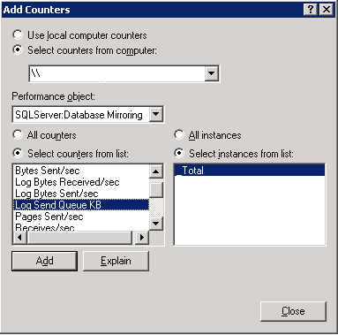

On the other side it is interesting to monitor the receiving side, means the mirror server. The less critical queue which can exist under all configurations of database mirroring is the queue which can build up in the transaction log of the mirror server. This queue refers to data, which has been transmitted to the mirror server, but has not yet been applied to the mirror database. This kind of queue is less critical since the data already is transferred to the mirror side. Hence no changes will get lost in case of the principal server failing. Such a queue only can delay the recovery time a bit and hence the failover time (either automatic or manual). The performance counter used to monitor this queue is ‘Redo Queue KB’. It is normal that this value is not always 0, but a few KB.

For synchronous mirroring configurations two very important counters to monitor are giving information on the delay transactions are experiencing by the synchronous mirroring configuration. The two counters are ‘Transaction Delay’ out of the performance object ‘SQLServer:Database Mirroring’ and ‘Transactions/sec’ which can be found in performance counter object SQLServer:Databases. The first counter will show the accumulated delay time of all transactions waiting on acknowledgements from the mirror side at that point in time. To set this number in perspective it needs to be divided by the number transactions/sec delivers. The result will be the average delay per transaction which is introduced by synchronous mirroring.
See the graphics below for an example of monitoring these two counters and their relationship to each other.

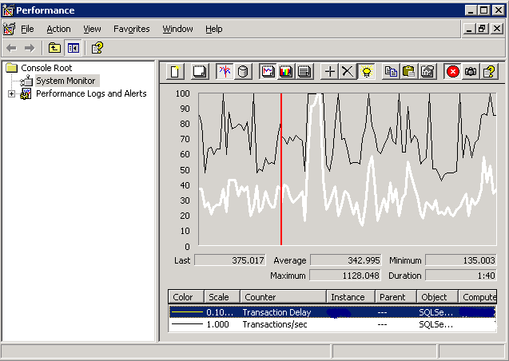

Principle Configuration Considerations for Database Mirroring
There are some things to keep in mind when trying to design a solution using SQL server Database Mirroring as HA solution.
- Each database can only have one mirror. It is not possible to mirror a database to two different destinations.
- Log Shipping can be used in addition to Database Mirroring on the same database to create slightly out of sync images of the database in multiple other destinations additional to the mirrored image.
- Distances and network bandwidth are determining about the success of such a configuration. Keep in mind that in case of a failover of the activity to the mirror, the whole traffic between application server and database server will go over the network to the mirror server. Having the mirror many miles way from the principal could introduce substantial increase of response time on the SAP side.
- When is it reasonable to replace Log-shipping with Database Mirroring? There are advantages and disadvantage replacing Log-shipping with Database Mirroring. On the advantage side, the mirrored database will be closer to the state of the real productive database. One of the disadvantages of mirroring is that one can not keep the database image behind for a certain amount of hours in order to catch human errors. A change on the principal database is transmitted and applied to the mirror in milliseconds or in seconds (dependent on the configuration). Another disadvantage of database mirroring can be the requirement on network infrastructure. Even using asynchronous database mirroring, one requires enough network bandwidth available at all time. Shared network infrastructures used heavily by employees between the two locations can take a serious toll on bandwidth and hence can hinder success in operations with database mirroring. The bandwidth needs to be available constantly. Having enough bandwidth, the distance acceptable depends on the configuration of mirroring, the latency experienced (in the synchronous case), the type of SAP application and the type of workload. In the asynchronous configuration distances of 100 miles and more should be feasible under ideal and reliable conditions. Assuming good enough bandwidth and reliability by the network for synchronous configuration the distance will define the latency. With SAP workload characterized by relative small transactions, the distance should be kept small. At this point in time, one should assume that under SAP workload characteristics a distance of 100 miles definitely is on the edge for synchronous mirroring. Dependent on the specific customer implementation even smaller distances might result in substantial performance impact already. Therefore one should be careful planning synchronous mirroring over dozens of miles (see also #7)
- When to replace Microsoft Cluster Services by Database Mirroring? Like in the former item, there are disadvantages and advantages using mirroring instead of MSCS. One disadvantage certainly is that one needs additional investment into storage infrastructure in order to keep a second image. Ideally the second image is not kept on the same SAN or NAS device. Another disadvantage is that mirroring might not always automatically failover (see next item). There are scenarios, which would avoid an automatic failover, but require a manual failover (see next item). However the big advantage for using mirroring would be to have a second image of the database within the same datacenter. Having such a second database image near line is becoming more and more focus of HA planning.
- If you choose Automatic Failover be aware of situations where an automatic failover does not take place simply because the Failover logic does assume a situation where transactions could have been committed on the principal after database mirroring already stopped due to a failure condition. However the Witness instance does not have an issue communicating with the principal using the same mechanisms as the mirror. Despite the Witness realizing that Database Mirroring did stop, it does not see a reason to initiate failover since the database on the principal still seems to be available. However if the principal SQL Server instance is shut down manually, the witness does now realize the condition of having lost the principal. However due to the fact that the manual shutdown of the principal eventually occurred minutes after Database Mirroring failed, one has to assume that transactions on the principle could have been committed after Database Mirroring failed. Therefore the current implementation of Database Mirroring reacts very conservatively by leaving it up to the system administrator to initiate a manual failover. This is a significant difference to MSCS where one works on one image of the database and a failover is issued no matter what the conditions are.
- Starting with Database Mirroring it is best to start with Asynchronous Mirroring first. This will make it possible to detect whether there are severe issues with network bandwidth or network reliability for the configuration used. If throughput problems already show up in the asynchronous mirroring configuration, it does not make sense at all to take the step to the synchronous configuration. If the asynchronous configuration did not show any problems or bottlenecks of any kind, you could move to synchronous mirroring w/o failover if the distance is acceptable from a latency point of view. Again evaluate the performance and the impact on the system thoroughly.
- Dedicating a Network Adapter to Mirroring? This is possible. One can assign a TCP/IP Address to an additional network adapter in the two servers. These TCP/IP addresses would be used to define the two TCP/IP endpoints in the database mirroring setup. With this configuration database mirroring traffic would go through two dedicated network adapters.
- Usage of Bulk Logged or Simple Recovery model. The principal database can not be put into one of these recovery models in order to reduce transaction log entries while creating indexes or performing bulk load activity. The only supported recovery model for database mirroring is Full. This might have some impact on the layout of the transaction log when bigger indexes need to be created. In order to facilitate bulk-logged recovery model, one would need to stop database mirroring, establish Log Shipping between the two SQL Server instances. To go back to Database Mirroring after the activity under bulk-logged recovery model is finished the principal side is switched back to full recovery model. On the mirror side all the transaction log backups get applied to the mirror database. Then one can setup Database Mirroring between the two SQL Server instances again.
- Scheduled tasks and jobs in SQL server Agent need to be duplicated and adapted. Since the mirror server does have a different name and msdb is not failed over, one needs to duplicate and adapt all the scheduled tasks executed on the principal on the mirror. It makes sense to think about name conventions to make clear which of the scheduled tasks is supposed to run on which server. But this is something which needs to be done manually. Also activating and de-activating those tasks after a failover is a manual step which needs to be done to e.g. ensure transaction log backups taking place on the mirror after failover.

Database Snapshots
A SQL Server 2005 database snapshot instantly creates a completely new set of data files that are used to store the original state of the pages at a point in time. No additional log file is created. A database snapshot does affect performance on the originating database due to a higher I/O load and a little more commutation time.
A database snapshot is extremely space efficient because it does not require a complete copy of the data. A database snapshot shares unchanged pages with the original database and only requires extra storage for the changed pages. After the snapshot is created and a page is changed for the first time, SQL Server 2005 copies the original page to the snapshot files (copy-on-write).
The SQL Server snapshot appears to the outside as a read-only version of the original database which was frozen at a point in time. Therefore it can be used to recover from eventual operator or user error by instantly being able to query a snapshot in a read-only manner.
There are two basic scenarios for creating a snapshot:
- Snapshot of the mirrored database. Create one or multiple snapshots on the mirrored database in a database mirroring configuration to catch a human error like deleting or manipulating data. In this case, the snapshot of the mirrored database can be used for retrieving the original data. It is possible to have kind of a rolling window of multiple snapshots. However be aware of performance implications in form of CPU and I/O. Since SAP applications already perform updates at the point a user logs into the system, this kind of database snapshot is not suitable for creating a second frozen image of a database to run SAP applications against.
- Snapshot on the primary database. Create a database snapshot on the primary database when critical changes or imports are run and a failure or errors might entail complete restoration of the database. For example, applying SAP support packages or transports are not reversible, except by restoring the database to its earlier state, which entails a huge effort. In this case, a database snapshot can be used as a backup to revert the state of the database to the time when the snapshot was taken.
Multiple SQL Server 2005 database snapshots of a database can be created. However, as more snapshots are created, the CPU and I/O load increases. Note there are severe differences to database snapshots or database clones hardware vendor can provide with their storage infrastructure. In opposite to database snapshots on the hardware side, SQL Server database snapshots cannot be:
- Used as source for SQL Server Online Backups.
- A clone of a SQL Server database snapshot cannot be created because a database snapshot does not permit background copying.
- The SQL Server database snapshot cannot be changed or attached to another server as a duplicate database in order to use it as a basis for a sandbox or test system.
Be aware that SQL Server Database Snapshot technology is used by SQL Server 2005 consistency check commands like DBCC CHECKDB or DBCC CHECKTABLE. In both cases a snapshot of the complete database is created and the checkdb command runs against the snapshot. This can have performance implications especially for customers scripting their consistency checks of the database as DBCC CHECKTABLE commands for a subset or for all the tables within the database. Creating a snapshot, performing a check on a table and destroying the snapshot in loop over many tables will take substantially more time than such a script used to take in SQL Server 2000. It might be worth to check whether a complete DBCC CHECKDB might not even be faster than checking a portion of the tables only with DBCC CHECKTABLE.

Besides features designed to improve protection and availability of data, SQL Server 2005 did introduce some features which enhance the availability of data during administrative or operational tasks. Besides having online tools like dbcc indexdefrag() (in SQL Server 2005: Alter index … REORGANIZE) already delivered in SQL Server 2000, efforts were made to decrease administrative scenarios requiring offline operations. One of the reasons for more or less long downtimes in the past was the creation or rebuild of table indexes. An improvement which should help for such cases got introduced in SQL Server 2005
Where could this feature be used with SAP applications? A first very good area to leverage this feature can be while applying SAP Support Packages. Since there is no way currently rolling back SAP Support Packages, a Database Snapshot could be issued before the first Support Package is applied. If something goes wrong while applying Support Packages and the system needs to be rolled back to the starting point, this can be done in an easy manner with a Database Snapshot. The same is true for applying huge amounts of critical SAP transports.

Online Indexing
Online Indexing is a new feature of SQL Server 2005 that allows index maintenance modifications to be performed online in systems such as SAP systems of any kind.
In SQL Server 2005, index creation can be performed in online or offline mode. In online mode, parallel change activity on the table is allowed. Index maintenance is performed offline by default with the table locked exclusively for this purpose.
With online indexing, SQL Server 2005 introduces a new parameter to the index DDL commands. For example, simple command syntax includes:
Create index [x~0] on x (a) with (online = on)
Drop index x.[x~0] with (online = on)
In addition, during index creation, the number of CPUs used can be defined, overriding the global setting for parallelism:
Create index x~0 on x (a) with (online = on, maxdop=2)
where maxdop=2 indicates that two CPUs are used.
Modifications to the table are allowed when an index is built, recreated, or dropped, online. During this process, a transaction will not be blocked if it hits the primary table. Modifications to the table or index create, rebuild, or drop are not blocked. Index maintenance continues while the application runs.
Online indexing can be used to create, rebuild, drop, or reorganize an index including BLOBs/CLOBs and to use index-based constraints such as the primary key. SQL Server 2005 tracks the transactions that were created during the index operation. Because this process can be performed during production, maintenance that would otherwise have required downtime or caused blocking on the system can be performed.
Creating an online index can take up longer using an online clause. Because there is no blocking, the SAP applications are unaffected during the index creation. Online Index creation also does use new methods of versioning which got introduced in SQL Server 2005. Therefore one can eventually increased tempdb usage during creating an index online.
As of June 2006 online indexing is not directly supported by the SAP Application Servers. Releases after Netweaver 2004S will support SQL Server Online Index for all index creations, but indexes created during SAP release upgrades. In the SAP Database Monitoring transactions one will find a screen which allows enabling online index creation support globally for the SAP system. With the current releases the following workaround can be executed:
- Create the index required in the development system via SAP table maintenance transaction
- Check the name and the order of the columns of that index on the database
- Create an index with the same name and the exact same column order with the ‘online’ option on the productive system with SQL Server methods using SQL Management Studio.
- Transport the correction of the index creation through test or quality assurance systems to the productive SAP system.
- Executing the transport on production, it will be checked whether the exact same index does exist in the database already. If yes, only the missing Data Dictionary entries in the SAP Data Dictionary will be made.
With this method, SQL Server 2005 online index creation is usable and was used in productive customer’s systems dozens of times already.

There are small restrictions impacting the usage of online index create which would apply to SAP database schemes:
- LOB columns being part of INCLUDE column clause
- Clustered index operations with LOB columns being part of a base table. This does not impact the reorganization of BLOB/CLOB columns

One thing to note is that SQL Server 2005 Database Mirroring as described here is not supporting any other recovery model than FULL. For creating or re-creating indexes this can have very severe conferences of having all the changes documented in SQL Server errorlog. Especially rebuilding a clustered index, this requires quite a large volume in the transaction log of SQL Server. The table below can give a rough idea about the ratio between the data in the database and the transaction log volume created by the different activities:
Test Number | Test Name | Log-to-Data Ratio
1 | Create nonclustered online index | 1.15
2 | Rebuild CI | 1.34
3 | Rebuild nonclustered Index (clustered index exists) | 1.14

Other considerations for Index Creation
Besides the consideration of space, time offline or online creating or re-creating indexes, another consideration is to where the data should be sorted. Creating an index, the index keys or in case of a clustered index, the whole data is sorted. Whenever possible SQL Server tries to perform sort operations in memory. However with a lot of volume for keys or data, SQL Server only can sort chunks of the keys or the data and needs to use disk space to store intermediate results. The default case is to take space of the database files. However there is a possibility to take space out of tempdb as well using the option SORT_IN_TEMPDBDB. The advantage is that I/O while creating an index can be distributed over more spindles including tempdb partitions eventually (if tempdb does not share partitions with the SAP database). Another advantage observed is that indexes created with SORT_IN_TEMPDBDB usually tend to have more contiguous space usage and hence might end up performing better scanning such indexes. When rebuilding a clustered index the option SORT_IN_TEMPDBDB is not needed since the data already is sorted and does not get resorted while the index rebuilds

Online Reorganization of BLOB/CLOB data
With introducing Online Index Reorganization, SQL Server 2005 introduced a possibility to reorganize BLOB/CLOB. So far SQL Server 2000 was not able to re-organize CLOB/BLOB data stored in columns of the datatypes image/text/ntext. The only possibilities to get such kind of data re-organized was to load the whole table content into a new table (select … into) and then rename the tables or to unload the table content with bcp and reload the table using bcp. Both methods being offline operations from the SAP application point of view. With SQL Server 2005, there is the possibility to re-organize CLOB/BLOB data of datatypes image/text/ntext/varchar(max)/ nvarchar(max)/varbinary(max) in an online fashion. Basis is the new command
Alter Index … REORGANIZE WITH (LOB_COMPACTION=ON)
The REORGANIZE option basically is the syntax to call what was introduced as dbcc indexdefrag in SQL Server 2000. The basic functionality does work the same way. With the new ‘alter index’ command structure like shown above, it also is possible to include CLOB/BLOB columns. Like normal pages, BLOB/CLOB content which is offloaded to specific pages to hold the content, it is possible that these pages fragments over the time if a lot of changes apply either to existing rows or a lot of content gets inserted and deleted. Therefore it can make sense to re-organize the CLOB/BLOB content as well when the base table is re-organized anyway. As mentioned above the execution is online just like dbcc indexdefrag was so far. Unlike Online Index build this process is single threaded and the # of CPUs can not be configured.

Availability considerations beyond SQL Server
It is not good enough to have the database side available within a SAP landscape only. Sure without the database server side or without SAP databases available the SAP landscape can be down. But on the other side, there is a whole layer of SAP application Servers which better should be available in order to conduct business. There also is the problem of eventually keeping a whole Disaster Recovery Center in synch with production. In order to achieve maximum availability of the existing productive SAP landscape and to be able to swiftly fail over to a Disaster Recovery Center, there are some easy steps which can help tremendously

Using Virtual Names for SAP Application Servers
One of the basic steps to enable a fast swap-out of hardware within a productive system or to execute a fail over to a disaster recovery center, is the separation of the physical server name the SAP instance runs on and the name it really responds to. Having these two names separated allows very easily to transfer the virtual name to any other given hardware might it be in the same data center or in a remote data center without huge renaming issues within SAP profiles or other settings within SAP applications.
Introducing Virtual names can be done with the following steps:
- IP Addresses need to be assigned static
- The Virtual Name does get an own TCP/IP Address assigned
- Enter the Virtual Server Name with the assigned TCP/IP Address into DNS
- Add the following Registry Entries to the Windows Server 2003 Registry:
  - HKEY_LOCAL_MACHINE\SYSTEM\CurrentControlSet\Services\lanmanserver\parameters
  - Add Multi_String_Value OptionalNames. Put Virtual Server Name in Value Field
  - HKEY_LOCAL_MACHINE\SYSTEM\CurrentControlSet\Control\Lsa\MSV1_0
  - Add Multi_String_Value BackConnectionHostNames Put Virtual Server Name in Value Field
- Add new IP address to NIC:
Control Panel -> Network Connections -> properties of correct network card -> click on Internet Protocol (TCP/IP) -> Properties -> Advanced -> Add new IP address in the IP addresses section of tab IP Settings. Use the same subnet mask as the original entry.
- Reboot server
- Change user environment of user which does start SAP Service (usually SAPService<SID>), add:
SAPLOCALHOST = <alias name, e.g. saptst20>
SAPLOCALHOSTFULL = <alias name, e.g. saptst20>
- Add SAPLOCALHOST and SAPLOCALHOSTFULL to Instance and Start profile –Needed to show the virtual server name in SM51,etc

With these few steps one can assign a virtual name to a server very swiftly on demand. Assuming a scenario where the production and test system are in two different datacenters, the assignment of virtual names makes it extremely easy just to move the virtual names of the production server to the test servers in the failover data center. The usage of virtual server names for SAP instances really comes to great power in combination with the usage of SAP logon groups, batch groups, RFC groups and Update groups. Imagine a scenario where one of the application servers should be taken out for hardware maintenance. It is possible to block the application server instance for new user logins. As soon as the instance does not have any active users logged in anymore and no running batch jobs anymore, it can be shut down. Now the virtual server name immediately can be assigned to another server (which does have the SAP ABAP or Java stack pre-installed for the particular system) and immediately can be brought back in production. No changes on logon groups, batch groups or RFC groups are necessary.
Independent of the usage of virtual server names, in order to achieve a good flexibility in order to swap server or instances, it is highly recommended not to assign Users directly to specific servers, but use SAP Logon Groups and other abstraction functionalities SAP does offer.

Performance Monitoring and Tuning
SQL Server 2005 does not require additional tools or extra resources to maintain SAP applications. SQL Server 2005 offers advanced query optimization that automatically improves query performance and response time.
In addition, SQL Server 2005 auto-tuning adjusts resources dynamically and tunes database parameters to respond to changing workloads and usage characteristics without manual intervention. Routine tasks are automated. Memory and lock resources and file sizes are adjusted dynamically.

SQL Server Side Performance Monitoring
This section describes the SQL Server 2005 performance monitoring tools and features. In particular, SQL Server 2005 introduces a number of new Dynamic Management Views (DMVs). These DMVs permit a wide variety of options for monitoring SQL Server internals. Many of the DMVs will be implemented into the SAP Database Monitor over time.

SQL Server Profiler
SQL Server Profiler monitors the query performance of SQL statements executed by SQL Server 2005. However, this tool cannot aggregate query performance data. Instead, SQL Server Profiler lists each execution of a query separately, causing enormous amounts of data to be written eventually.
Due to SAP user management and its scheduling of user requests, it is not possible to restrict profiling on user names or specific connections to SQL Server. For this reason, SQL Server Profiler should be used only to profile and monitor a system with lower activity. It is not generally used in SAP production systems.
In most cases, SAP systems are monitored by using SAP tools such as SAP Database Monitor or the features described in the “SAP Performance Tuning” section.
When using SQL server profiler it makes sense to store the trace in a file. After ending the tracing activity it is best to open the trace and store it in a database table for further analysis. Something like that will allow analyzing the probably huge amount of entries with SQL statements and hence will make it easier to find out expensive statements.

Dynamic Management View
SQL Server 2005 contains a number of new DMVs. These DMVs give greater transparency and visibility into the database for proactive health and performance monitoring.

sys.dm_exec_query_stats
The sys.dm_exec_query_stats DMV stores aggregated performance data for queries that were run since SQL Server was started. This data can be used to provide a trend analysis of how the system is performing.
The data provided in this view is similar to the data from SAP Database Monitor. This view also contains additional data that is not available in earlier versions of SQL Server and SAP including:
- A Select statement against this view displays performance statistics on statements in the statement cache and some statements already flushed out of the cache. However, data on queries executed a number of hours earlier on a busy system can be flushed.
- A trace event is created in order to flush the statistics. The event and performance data can use the SQL Server trace framework or the SQL Server Profiler.
For sys.dm_exec_query_stats, a query is identified using sql_handle. This handle obtains the text of the query. The execution plan of the query is obtained using plan_handle. The result is an XML type query plan.
Examples of queries leveraging this view include:
select * from sys.dm_exec_query_stats
This query lists the performance figures of all queries in statement cache.
select * from sys.dm_exec_sql_text(sql_handle)
This example shows the SQL statement text where the specific handle was read from the result set of the first query.
select query_plan from sys.dm_exec_query_plan(plan_handle)
This query shows the query plan.
The results from this DMV contain columns with performance metrics for each query including:
- Physical reads and writes.
- Logical reads and writes.
- Time spent in common language runtime (CLR) for all statements referring to a CLR function.
- Number of executions.
- Worker time showing the time spent in processing.
- Elapsed end-to-end time from the point when the request came into SQL Server to the time when the result is returned including statement execution and wait times.
- Average per executions calculated from the columns displayed.

See different examples of queries which can be used to retrieve different types of information from sys.dm_exec_query_stats.
- Example 1 - Show Queries executed more than 1000 times with longest execution times per execution:
  - select top 50 total_elapsed_time/execution_count, * from sys.dm_exec_query_stats where execution_count > 1000 order by total_elapsed_time/execution_count desc
- Example 2 - Show Queries executed more than 1000 times with highest logical reads per execution
  - SELECT TOP 50 (qs.total_logical_reads + qs.total_logical_writes) /qs.execution_count as [Avg IO], qs.execution_count, SUBSTRING(qt.text,(qs.statement_start_offset/2 +1), (case when qs.statement_end_offset = -1 then len(convert(nvarchar(max), qt.text)) * 2 else qs.statement_end_offset end -qs.statement_start_offset)/2) as query_text, qt.dbid, dbname=db_name(qt.dbid), qt.objectid, qs.sql_handle, qs.plan_handle FROM sys.dm_exec_query_stats qs cross apply sys.dm_exec_sql_text(qs.sql_handle) as qt
where qs.execution_count > 1000 ORDER BY [Avg IO] DESC
- “Give me all the Statements accessing a certain table”
  - SELECT qs.execution_count, SUBSTRING(qt.text,qs.statement_start_offset/2 +1, (case when qs.statement_end_offset = -1 then len(convert(nvarchar(max), qt.text)) * 2
else qs.statement_end_offset end -qs.statement_start_offset)/2) as query_text, qt.dbid, dbname=db_name(qt.dbid), qt.objectid FROM sys.dm_exec_query_stats qs
cross apply sys.dm_exec_sql_text(qs.sql_handle) as qt
where qt.text like '%<table_name>%'
ORDER BY qs.execution_count DESC
- BE CAREFUL – this particular query can run a few minutes, and cost one CPU and memory

This data offered by sys.dm_exec_query_stats already is integrated into the SAP Database monitor for SQL Server (see graphic below)

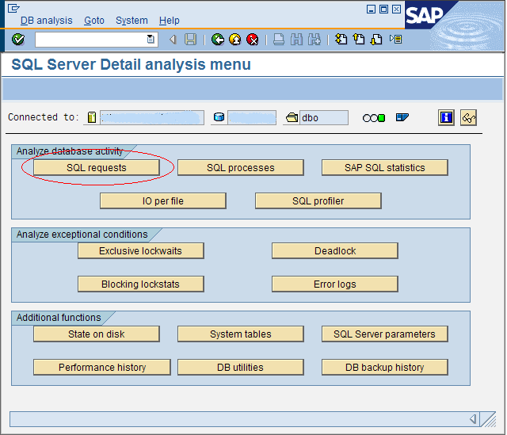

Monitoring Index Usage
SAP production systems that have been active for many years have received periodic SAP release upgrades and custom changes. In some cases, when SAP release upgrades are made, custom programmed functionality can be discontinued, leaving related database structures such as database indexes in the database. In this case, the sys.dm_db_index_usage_stats DMV is used to collect and track the usage of each index and assist in determining which indexes are actually in use.

sys.dm_db_index_usage_stats
In a SAP landscape over a period of time, the custom indexes on tables for particular programs can change. For example, due to business or program changes, some indexes might no longer have relevance. In addition, a non-clustered index created previously by a customer can consume extra space.
The sys.dm_db_index_usage_stats view monitors index utilization. This view shows where index utilization is occurring on the aggregate and identifies queries and indexes that are not being used.
The sys.dm_db_index_usage_stats view:
- Determines whether indexes are actually being used.
- Lists the index, categorized by user and system, and indicates how the indexes have been used. It lists the category of usage of indexes as user queries (read or modify data) and system usage (update statistics, consistency checks).
sys.dm_db_index_usage_stats counts the data during the up-time of the database server. When SQL Server is shut down, the data is lost. The data is used to analyze whether custom deployed indexes are still in use. The data is tracked on a long-term basis to ensure that special periods are covered such as month-end or quarter-end reporting.
Do not use the data to delete SAP standard indexes. In some cases changes in the usage of SAP functionality or changes in customization or in leveraging new SAP functionality might require SAP indexes to be deployed during the installation of the SAP product. For this reason, do not delete SAP deployed indexes even when those shown are not used.
The following table shows the data of the user category including the categorization of seeks, scans, and lookups in SQL Server 2005.

name | user_-seeks | user_-scans | user_-lookups | user_-updates | last_-user_-  seek | last_-user_  scan | last_-user_  lookup | last_-user_  update
TBTCO^9 | 0 | 3 | 0 | 37402 | NULL | 5/20/05 18:12 | NULL | 5/23/05 13:48
TBTCO__0 | 97294 | 12 | 10463 | 37402 | 5/23/05 13:48 | 5/23/05 4:00 | 5/23/05 13:45 | 5/23/05 13:48
TBTCO__5 | 13 | 0 | 0 | 37107 | 5/23/05 2:30 | NULL | NULL | 5/23/05 13:48
TBTCO__1 | 0 | 0 | 0 | 37107 | NULL | NULL | NULL | 5/23/05 13:48
TBTCO__3 | 6399 | 0 | 0 | 37402 | 5/23/05 13:45 | NULL | NULL | 5/23/05 13:48
TBTCO__7 | 4078 | 4 | 0 | 37402 | 5/23/05 13:45 | 5/23/05 4:00 | NULL | 5/23/05 13:48
- A seek accesses a table that uses the index B-Tree; the scan does not indicate the number of rows being retrieved. A seek can read the whole table using the index
B-Tree.
- A scan reads the data layer without the index B-Tree, for example, to scan the table’s data layer to create an index.
- A lookup can only occur on a clustered index when additional non-clustered indexes are defined on the table. The term lookup categorizes a seek on a non-clustered index. In this case, a clustered index is used to retrieve the data rows when the non-clustered index does not cover the query. The sum of all seeks on non-clustered indexes is greater or equal to the lookups on the clustered index.
- Updates show how often an index has been updated for data modifications. An update modification does not always trigger an index update. With SQL Server 2005, only indexes affected directly by the updated date are changed.
An example of a query which finds non-used indexes in the current database includes:
select object_name(object_id), i.name
from sys.indexes i
where i.index_id NOT IN (select s.index_id
from sys.dm_db_index_usage_stats s
where s.object_id=i.object_id and i.index_id=s.index_id )
order by object_name(object_id) asc

sys.dm_db_missing_index_details
Three more DMVs got introduced to point out Missing indices. For each given query SQL Server 2005 Query Optimizer knows what the most optimal indexes would be. In case such indexes do not exist and an alternative index needs to be chosen, SQL Server 2005 would note such cases when the optimal index would provide a substantial better performance. So far this new feature is restricted to suggest non-clustered indexes on normal tables only. It does not take indexed view into calculation. It also has a limit of suggesting 500 indexes only. After a list of 500 indexes is noted, it does not add new suggestions to the list. The list will be emptied with restarting the SQL Server instance. As with the former DMV, there is no persistency layer for this DMV. Especially for SAP applications with a limitation of defining indices with 16 columns only, the index recommendation often figure out to contain more than 16 columns and hence might be hard to adapt. Even with indexes which could be created with the SAP Table Maintenance transaction one should be careful creating each an every index possible. Keep in mind every index creates additional resource consumption in space and maintenance of the table and indices during modifying operations. Before creating such a suggested index, one should investigate which SAP ABAP or JAVA logic did cause the statements in need of such indices and eventually discuss Application coding changes to avoid creating dozens of new indices.

There are three different DMVs which store the data around indices missing:
- sys.dm_db_missing_index_groups: Represents so called index groups. An index group represents one or more missing indexes. In this table the index group id is mapped into the specific index IDs. As a result one will find one entry for a query just missing one index, two entries for a query missing two indices, etc
- sys.dm_db_missing_index_group_stats: Stores costing and eventual usage data for specific an index group.
- sys.dm_db_missing_index_details: Contains the suggestions of the index structure which is missing

To detect the 50 indices which would have most impact of all the indices recorded as missing one would run this query
SELECT TOP 50 convert(int,(user_seeks + user_scans) * avg_total_user_cost * (avg_user_impact * 0.01)) as index_advantage, migs.group_handle, migs.user_seeks, migs.user_scans, object_name(mid.object_id) as tablename, mid.equality_columns, mid.inequality_columns, mid.included_columns
FROM sys.dm_db_missing_index_group_stats migs, sys.dm_db_missing_index_details mid, sys.dm_db_missing_index_groups mig
where migs.group_handle = mig.index_group_handle and mid.index_handle=mig.index_handle
ORDER BY index_advantage desc

The output of this query would look like:
IndexAdvantage | group_handle | user_seeks | user_scans | tablename | equality_columns | Inequality_columns | Included_columns
3981807 | 915 | 1019368 | 0 | EKPO | [MANDT],  [LOEKZ],  [MATNR], ELIKZ] | NULL | [EBELN],  [EBELP],  [WERKS]
131916 | 12 | 2141 | 0 | VBAK | [MANDT],  [BSTNK],  [KUNNR] | [AUDAT] | NULL
33762 | 146 | 237 | 0 | SMSGL | [MANDT],  [ARCHIVED],  [APPID] | [ERRLEVELN] | [LOGNUM]
31212 | 8 | 15372 | 0 | SETLEA | [MANDT],  [SETCLASS],  [SETNAME],  [VALSIGN] | [LINEID] | NULL
19030 | 1461 | 102 | 0 | ECMCT | [RCLNT],  [RRCTY],  [RVERS],  [RYEAR] | [RLDNR],  [PLEVL] | [RUNIT],  [RITEM],  [TSL09], [HSL09]

The last 3 columns contain the column names of the columns which should be included in the recommended indices. When you create such an index, order the columns in the index by adding the columns listed in ‘equality_columns’ first, then add ‘inequality_columns’ and at last the columns listed under ‘included-columns’. This at least is a sound rule to build so called covering indices (indices which cover the select list as well as the where clause of the query). If you only want to optimize for the where clause, then define the new index with all the ‘equality_columns’ and then add the most selective of the columns suggested under ‘inequality_columns’.

SAP Performance Tuning
SQL Server 2005 contains features for monitoring performance and, to a certain degree, resource consumption. Similarly, SAP systems provide a number of key features for performance tuning. These features leverage SQL Server specific functionality, as well as some functionality that is SAP specific.

Common Performance Problems
The principal problem classes that might require performance tuning include:
- The entire system is slow. The entire SAP system is sluggish and slow, the system does not perform as anticipated, and it continues to perform slowly. SAP end users experience slow response times executing most business transactions.
- Certain SAP business transactions are slow. One certain transaction or job experiences a slowdown and remains in that state. This causes SAP end user complaints and a few batch jobs can be affected or slowdown.
- Certain SAP functionality or jobs have intermittent slowdowns. Some SAP functionality or jobs run fast most of the time, but slowly at other times, such as a slowdown that lasts for a few hours or a day. In this case, jobs might run fast for days at a time until another slowdown occurs.

System Performance is Poor
When SAP system performance is poor, determine which component is having problems before checking the database server. In a three-tier SAP landscape, the database server might not be the immediate cause of low system performance.
The first step is to analyze which of the SAP layers introduces the general slowdown. Use the SAP ST03 transaction to:
- Check the performance of the SAP application servers.
- List the different categories of the SAP workload (dialog, update, batch, and so on). Check the response times and the time spent in different stages of the overall system.
- Check the response time of the database.
- Check the time it takes the SAP application server to deliver the data to the SAP user interface at the end user’s computer (also listed in the ST03 transaction).
- Check the aggregated data over several days and weeks.

ST03 Monitoring Transaction
Use the ST03 monitoring transaction to determine which SAP component is having a problem. ST03 differentiates between problems such as CPU consumed on the SAP application server, user requests waiting for the application server, database response time performance, and time to deliver data to the user interface.

Overall Performance (One Day)
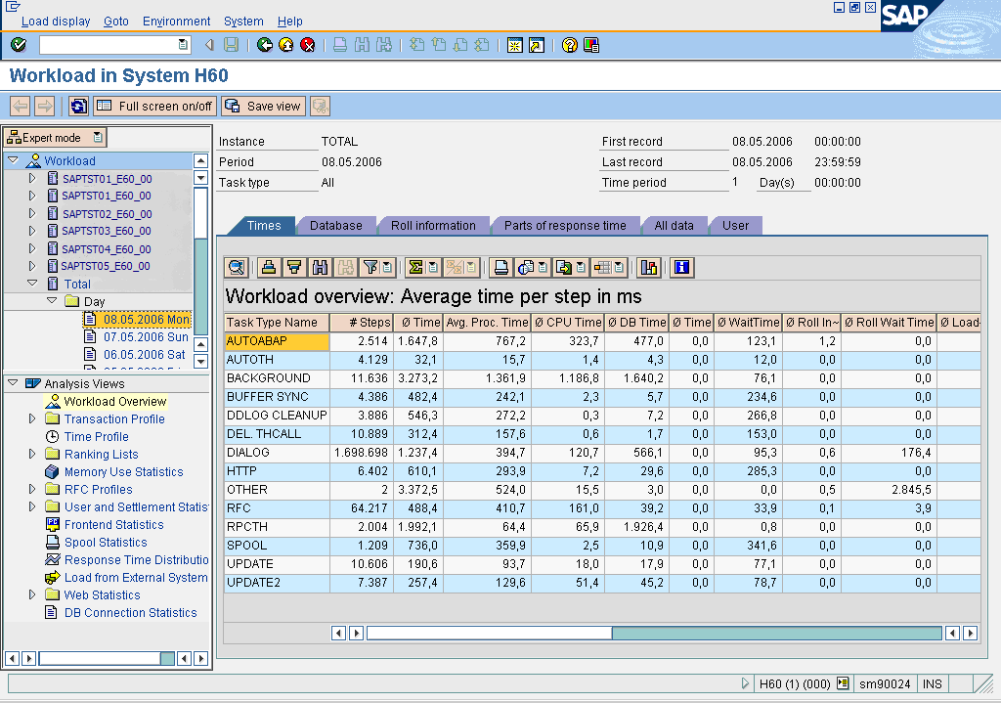
On the left, the ST03 sample shows the performance of an entire system of nine application servers for a one day period. ST03 row entries show the different SAP process types in the grid. The columns show the measurements for different components.
The ST03 sample shows the dialog process (in row six) has an overall response of 775.9 milliseconds (ms) for each SAP Dialogstep (SAP unit of work).
In addition, the dialog process shows 224.7 ms were spent using the application servers CPUs, with 282.4 ms on average spent accessing the database.
Note that the database response time for the dialog process should be below 50 percent and not higher than 50 to 60 percent for normal interactive SAP transactions.

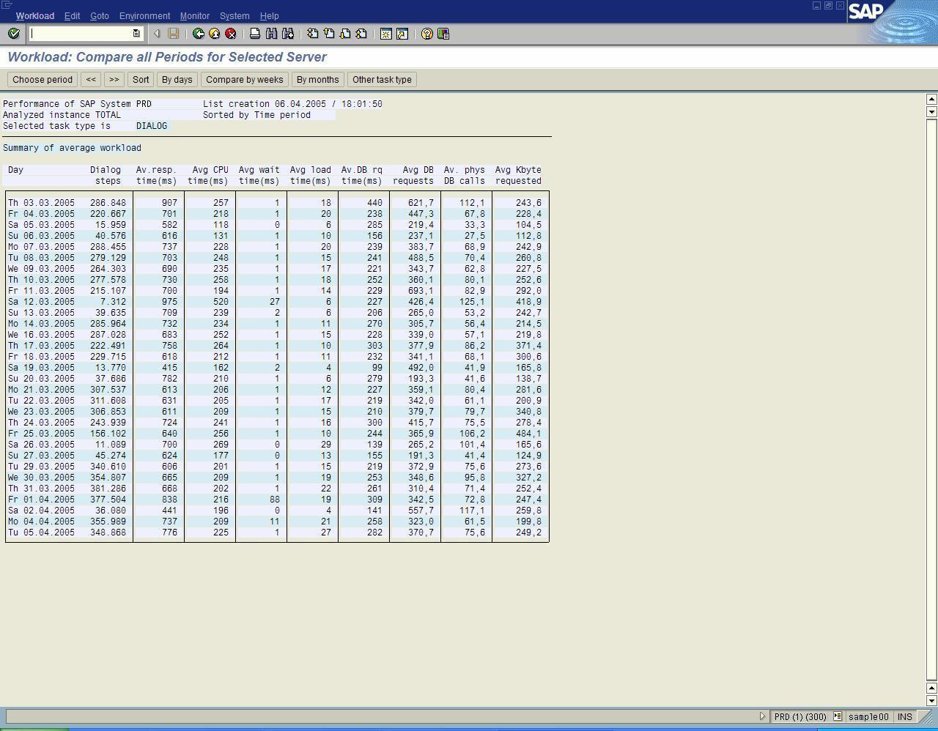
Performance (Several Days)
On the left, the ST03 sample provides a summary of performance over the last 30 days such as the times spent in the different components. ST03 provides an overview of the work generated by the SAP application layer and shows all process types. Note that the sample shows a history of the number of dialog steps.

Severe changes to components such as application server hardware or database server hardware should become visible by hopefully lowering the response times in the particular column.

Database Server Causes Slowdown
If the database is the main contributor to the slow performance, check CPU consumption and I/O performance. Observe the disk I/O performance counters in Windows Performance Monitor for each disk separately. These counters report the volume of the I/O and its performance (response time). Often disk access statistics measured directly in SAN devices show faster access times. However, SQL Server 2005 experiences response times such as those reported by Windows Performance Monitor. If the response times are not satisfactory, SQL Server 2005 experiences slow I/O performance.

CPU is Pegged
When the CPU is pegged, check the SQL Server configuration max degree of parallelism parameter. See the preceding “SQL Server Installation with SAP” section. If this setting is other than 1, set it to 1. Having the parameter set to other than 1 could permit a few queries to use most of the CPU on the server, thereby increasing the I/O volume by a factor of 2 to 4.
If the max degree of parallelism parameter is set to 1, check the threads that can be run in SQL Server 2005 by executing the SQL statements described below. In system processes such as the SQL Server 2005 DMV, the start time of a statement and the handle to the statement are displayed.
- Execute in SQL Query Window:
select * from sys.dm_exec_requests
- Check statements running longest on threads.
- Use sql_handle to get the SQL statement.
- Execute in SQL Query Window:
select * from sys.dm_exec_sql_text(<sql_handle>)
- Check the statements for their selectivity. Determine if there are statements that do not contain specific Where clause restrictions and return large amounts of data.

I/O is Very Slow
A lot of SAP customers’ performance escalations are related to I/O backend problems. The most common observation is that SAP systems record extremely slow response times from the database. However, the CPU is not being utilized for the database.
Having enough bandwidth for reading and writing, combined with a fast response time, is vital, especially for high-end database servers.
The most common errors observed include:
- Too few disks are utilized. The data is spread on a too small number of spindles. This causes high I/O request times in general or during certain phases of the daily cycle of a system. Keep in mind that a single disk is able to sustain a limited number of I/O operations per second only (IOPS). If we look at single reads of SQL Server in a format of 8K, 100-120 IOPS can be sustained with sufficient performance. If SQL Server does read in 64K chunks some more IOPS might be possible. But at the end there are limits which under normal productive SAP databases are clearly below 200 IOPS one disk can do. The advantage of large caches provided by SAN devices becomes very obvious. Even if the cache hit ratio is pretty low compared to the buffer pool of SQL Server. But if only every second or third read I/O SQL server executes can be supplied out of the cache of such a SAN device, one needs less disks in order to satisfy a certain Read/Write workload
- An incorrect partition offset was selected for SAN partitions. This can cause a severe problem since one I/O issued by SQL Server can map into two I/O on the SAN backend. Consult with the SAN hardware vendor to determine the correct setup of storage for Windows OS. Please note that the way to setup can differ from the way such devices need to be configured for UNIX
- There are too few Host Based Adapters (HBA). Host Based Adapters do have limitations in throughput. A 2GigBit Adapter is good for providing a throughput of 160-180MB/sec with a good performance. Beyond this, the Adapter starts to become a bottleneck.
- The queue depth of such an HBA is left as the default of 32, instead of setting it to 128 or even 255. Check with the storage hardware vendor for the proper settings and maximum values.
- SecurePath or PowerPath software was incorrectly configured in failover mode, instead of workload balancing mode. These two software programs provided by two different SAN vendors can be setup in a way to provide failover between two HBAs or can be configured to provide load balancing. The latter configuration is preferred.
- Backup activity was not included when calculating the I/O bandwidth demands. SQL Server online backup reading tremendous amounts of data can create an additional I/O workload. On systems which are used around the clock it often is difficult to define a time period with a low workload. Therefore the possibility of scheduling a backup in a time of low activity might hardly exist. In order to backup 100GB in one hour to a backup medium another 40MB/sec not to be read in parallel to the already existing workload. Not having any I/O bandwidth left for SQL Server online backup, certainly can cause performance issues and slow down backup activity.

I/O Usage Patterns
As it concerns the disk usage patterns, SQL Server 2005 can read four different formats:
- 8 KB read. The most common format is a single page 8 KB read that is used with most SAP products with an OLTP characteristic (greater than 90 percent) workload.
- 64 KB read. The 64 KB format is typically used for tape media backup when a block format of 64 KB is recommended to resolve performance issues. This format reads a whole extent and can be observed frequently in SAP BW. In this case, SQL Server 2005 reads ahead during index scans.
- 256 KB read. SQL Server 2005 reads the allocation order within different data files, such as for index creation, using an allocation oriented scan such as a table scan. 256 KB reads might be used in SAP BW. These reads are rarely seen in SAP products having an OLTP workload.
- 1 MB read. During the disk backup, SQL Server 2005 reads 1 MB blocks of data over the network to a central tape library in order to speed up the backup. 1 MB reads are SAP-independent.
SAP products with an OLTP type of workload require a balanced system layout with excellent I/O performance on the database side:
- The read pattern primarily includes 8 KB pages and random reads from SQL Server 2005.
- For writes, the transaction log performance has to be excellent, with writes in the 10 KB to 32 KB range. The maximum block length for a write into the SQL Server transaction log is 64K.
SAP BW and mySAP SCM are applications where read performance is very important and the most critical reads are performed in a 64 KB format. These particular SAP products typically perform critical queries such as joins over various tables. In addition, time critical processes, such as in SAP BW, require excellent write performance. In SAP BW, performance on tempdb is also critical.
Windows Performance Monitor can determine the average I/O performance values. In this case, measure I/O performance for at least 15 minutes, usually for one hour minimum, in order to ensure that the values are representative of actual performance.
In high-end systems, I/O SQL Server data files perform in the following range:
- Up to 10 ms is good.
- 10 to 20 ms is acceptable. Less than 20 ms is acceptable for an I/O against data files.
- 20 to 30 ms is not acceptable.
- Above 30 ms shows an effect on the performance of the system and it is usually not acceptable, especially in high-end systems.
SQL Server transaction log file performance can be categorized in the following range:
- Up to 10 ms is good.
- 10 to 20 ms is acceptable.
- Over 20 ms indicates that CPU resources of the database server are not fully utilized.
SQL Server 2005 has multiple 64 KB buffers to which the SQL threads write their transaction log entries. If one thread executes a commit, the transaction log buffer holding the commit record needs to be flushed. The thread writing the commit record has to wait until the acknowledgement of a successful I/O write of the buffer is returned by the I/O subsystem. If this takes a long time, the thread waits and it cannot be used.
There are limitations on how many outstanding I/Os to the transaction log are acceptable. Independent on the number of I/Os, there also is a limit of how much outstanding volume is acceptable. If one of those limits is exceeded, SQL Server will not issue any more write I/Os towards the transaction log. In cases where I/O performance against the SQL server transaction log is extremely low such situations of exceeding these limits could occur. In such a case a drop in the workload of SQL server could be observed or at least SQL server hardly will be able to leverage existing CPU resources.

SQL Server 2005 I/O Performance
SQL Server 2005 measures I/O performance as a built-in function. For example, notice the SQL command:
select * from sys.dm_io_virtual_file_stats(<db_id>,-1)
This gives the number of read I/Os and write I/Os and the bytes read and written to each file of the specified database. The stall time of read or write activity for each file is calculated as:
the number the sum of the ‘read stall time’ divided by the number of reads
or
the number the sum of the ‘write stall time’ divided by the number of bytes written.
Like in this SQL Statement:
select io_stall_read_ms/num_of_reads as stall_per_read, io_stall_write_ms/num_of_writes as stall_per_write
from sys.dm_io_virtual_file_stats(<db_id>,-1)

This DMV can also be used to find out whether the proportional fill is working properly, as described here.
The output also indicates whether all files show similar performance. The numbers get accumulated over the entire run time of the SQL Server instance from startup. For this reason, these numbers can be much lower than those indicated by current Windows Performance Monitor measurements under a very high workload of a system. If a system does have a very high workload during a few hours only, but the rest of the day the performance is great the values this DMV can show are not reflecting the entire truth. The accumulated output data might hide such timeframes with poor I/O time accurately and the data cannot be reset. Therefore using Windows Performance Monitor to find out more about the I/O performance distribution throughout the day makes a lot of sense.

Slow SAP Transactions Hamper the User Experience
When only a few transactions are slow, restrict the problem to specific SAP transactions or jobs. The SAP NetWeaver Application Server design assigns the user request to a SAP process at runtime. If the problem can be reproduced, the executions can be traced by using the SAP ST05 SQL Trace transaction to filter conditions such as the user name, a specific SAP process within an instance, or a specific SAP report. The ST05 transaction runs locally on the application server. ST05 can trace activity on the specific application server on which it runs.

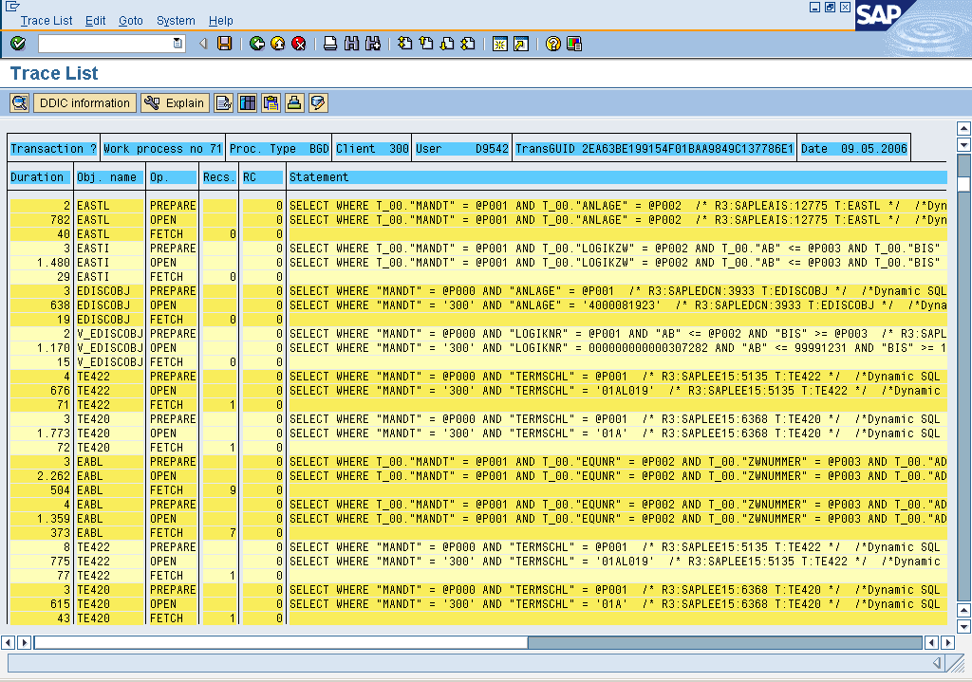
ST05 SQL Trace Transaction
On the left, the sample shows the ST05 transaction with the SQL statements that were executed against the database with the duration shown in microseconds.
For many statements, two or three lines are shown in order to characterize the different phases of statement execution. The SAP Open phase is typically used to determine the performance of the execution.

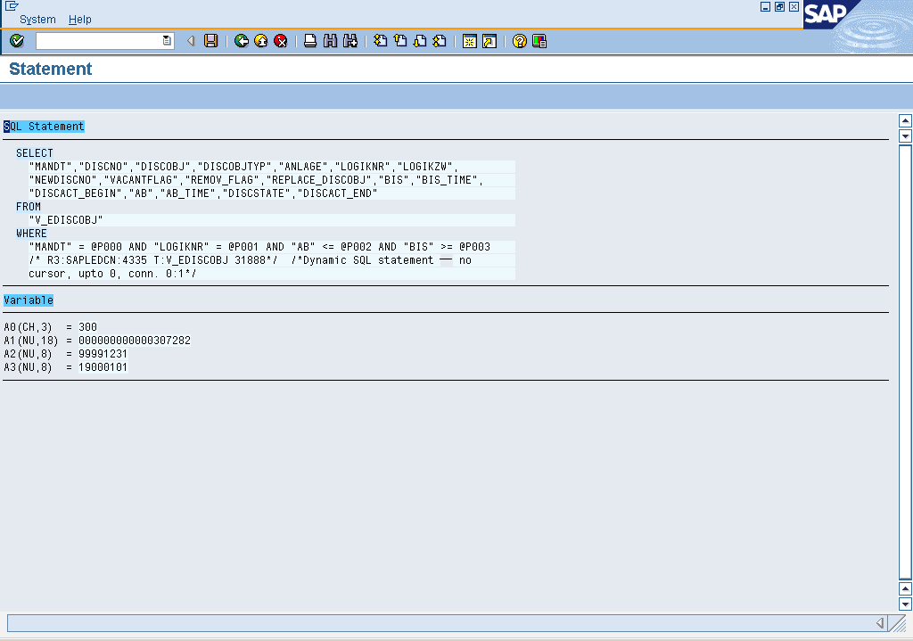
The SAP Fetch phase is used to count the time required to retrieve the data from the database server to the application server. Most often the Fetch time is the smaller amount of time, unless large numbers of rows are returned.
In ST05, double click the open line of a statement to display the full statement and the parameters submitted to the statement. At the end of the statement text, the Stored Procedure name or the Dynamic SQL statement string provides SQL Server port-specific information about how the SQL statement from ABAP was executed in SQL Server 2005.
This comment indicates when which of the two connections was used for the statement and whether a server side cursor (extremely rarely) was used. For example, the description conn 0:1 indicates that the uncommitted read connection (dirty read) of the SAP process was used to execute the statement.

On the left, the ST05 sample shows that, by marking the statement, the ABAP coding that triggers the database statement can be reviewed. This permits a deeper analysis of the ABAP code to be performed in order to achieve improvements.
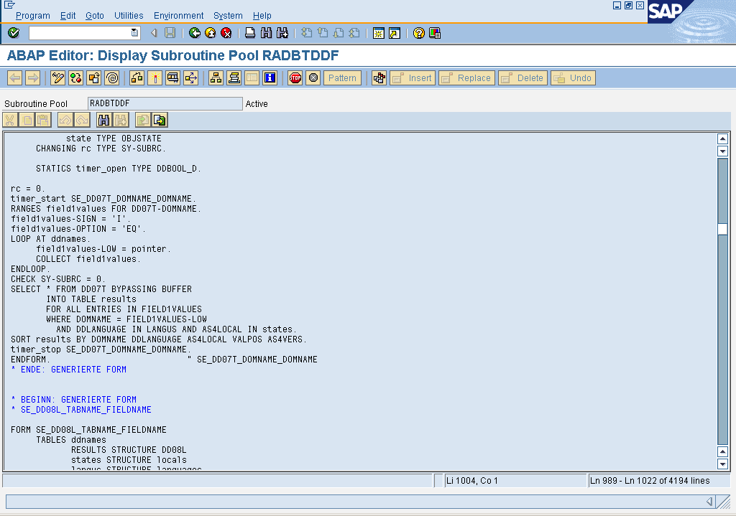

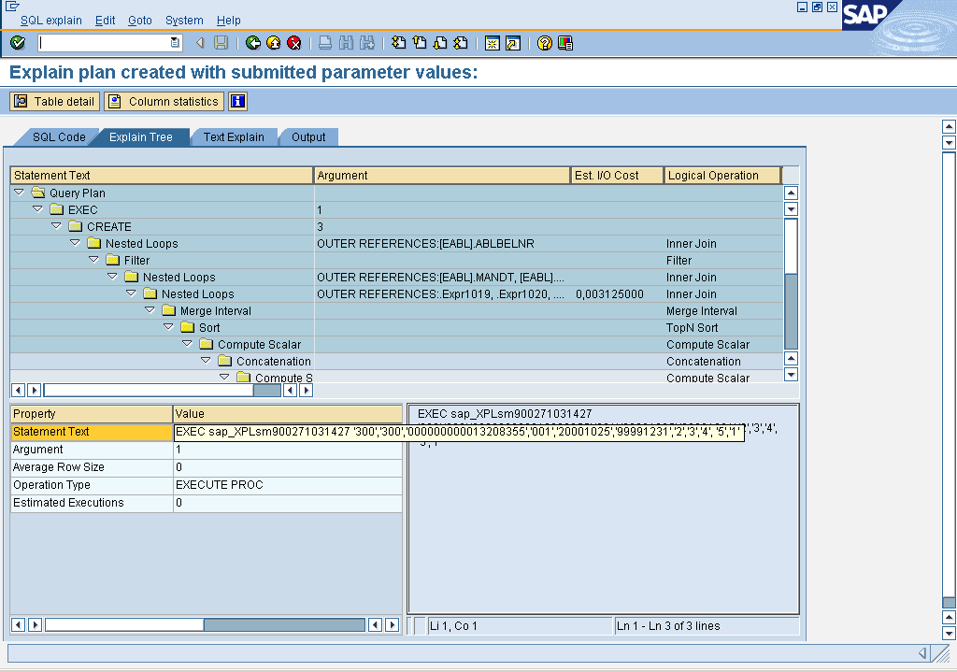
On the left, the next sample shows that the Query Plan Display of SQL Server 2005 can also be used to view the query execution plan. If the analysis is performed immediately after the trace is taken, the query execution plan still existing in the cache is displayed. If the analysis is performed at a later time after the trace is taken and the query execution plan is no longer in cache, a new query execution plan is created. Unfortunately, there is no easy way to determine if the execution plan is in cache or if it was newly generated.

ST04 Database Monitoring Transaction
The ST04 transaction is typically the only way SAP support can monitor the database in depth. ST04 displays all types of data collected in the database instance. ST04 can be used to check values including the cache hit ratio, errorlogs of SQL Server, and different values such as wait statistics.
The ST04 transaction pages display an overview, details, query statistics, query performance statistics, and query details as follows.

Overview Page
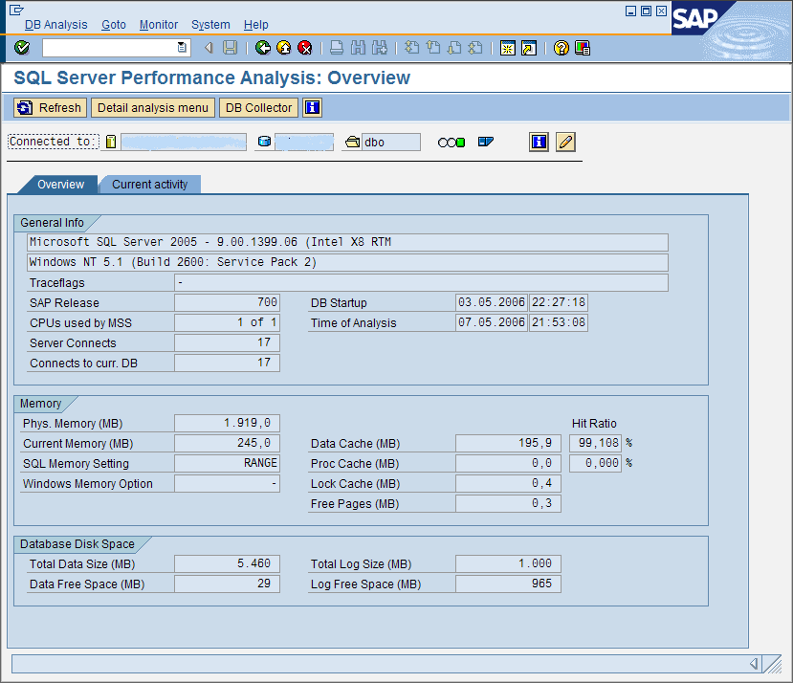
On the left, the ST04 Overview page provides general SQL Server 2005 information including the operating system release on which SQL Server runs. The most important information includes the cache hit ratio numbers of SQL server Buffer pool and Statement Cache and the trace flags used.

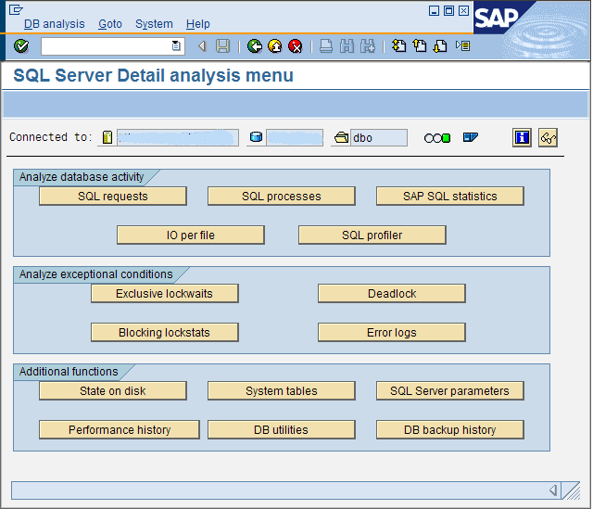
Details Page
On the left, the ST04 Details page selections include:
- Checks on the errorlogs and provides a list of deadlocks.
- Checks for immediate blocking lock situations or statistics on lock situations of over one minute.
- Checks for performance problems using SAP statistics on Stored Procedures.

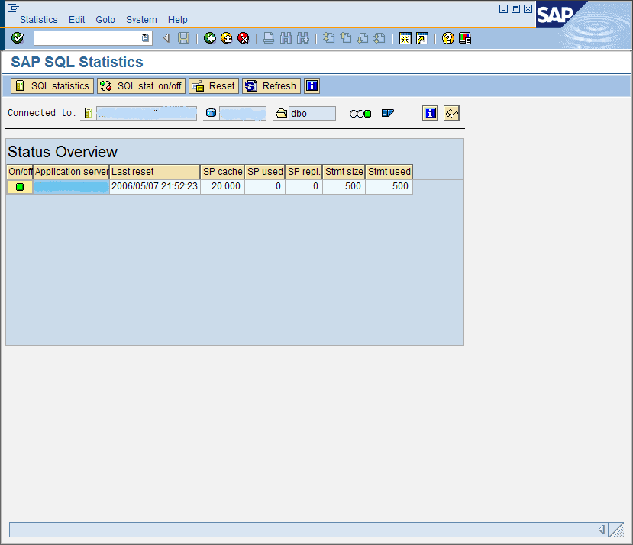
Query Statistics Page
On the left, the ST04 Query Statistics page shows the performance data accumulated by each application server or for selected application servers.

Query Performance Statistics Page
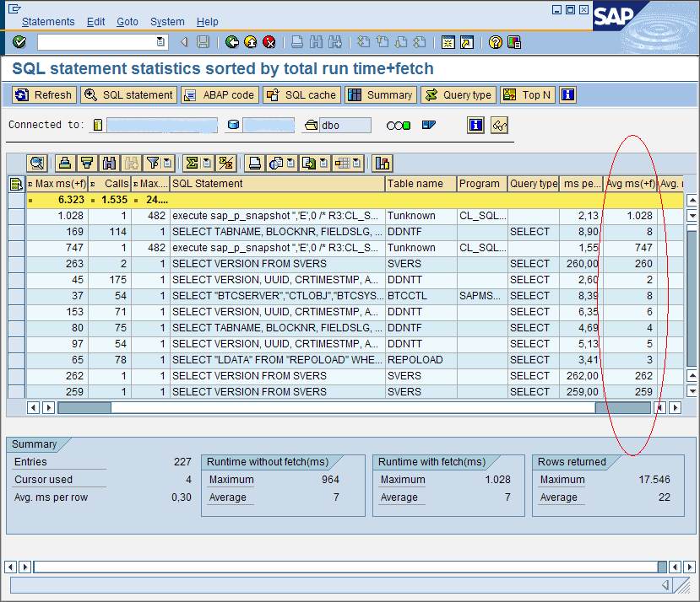
On the left, the next sample shows the ST04 Query Performance Statistics page. ST04 displays the performance numbers for the top executed queries. The list is sorted by the sum of execution times including the fetch time, maximum execution time per query, number of executions, average rows returned per execution, and average execution time. See the column presenting the average execution time marked in red. From this page one can get to the query execution plan again, which has been displayed before already. One also can jump to the ABAP source Code location.

Special Considerations for SAP BW
Although SAP BW uses the same basic SQL Server configuration as other SAP products, using SAP BW with SQL Server 2005 has some special considerations. This section describes these considerations including the layout of tempdb for SAP BW and the specific methods for investigating SAP BW performance issues.

SAP BW Queries
The best way to investigate performance issues with SAP BW is to repeat and trace the queries. Similar to other OLAP warehouse products, SAP BW tries to buffer queries and associated results. The base foundations allow a query to be run manually for investigation. SAP BW queries are named and stored in the SAP BW cache.
Using the SAP BW transaction code RSRT, a SAP BW query can run repeatedly in order perform investigations. The RSRT transaction helps to rule out issues on the client side, such as the client reporting or network issues on the way to the client.
The RSRT transaction can be used with the option to Execute + Debug. To use this option:
- Browse for a query or type the name of the query.
- Select the query display option such as List, BEX Broadcaster (SAP BW Business Explorer Broadcaster), or HTML (HyperText Markup Language).
- Click Execute + Debug to display a pop-up window that enables certain items to be selected. In addition, a second window can appear requesting query parameters.
The most important selections are:
- Display Aggregate Found. Indicates if SAP BW is using any aggregates for the query.
- Display Run Schedule. This selection is below Display SQL Query. The selection presents the SQL statement that is generated and sent to SQL Server and to the query plan.
- Do Not Use Cache. Do not use SAP BW cache to execute the query in the database server.
When the transaction is executed, SAP BW shows the SQL statement and the query plan. After reviewing the information, click Back (green button) in the top SAP BW menu list to send the query to SQL Server.
When a multi-provider is used, the transaction shows and runs all SQL queries created for the different infocubes in the multi-provider. In some cases, more than one query is produced for each cube such as in hierarchical processing. In this case, a single SAP BW query might be comprised of more than 20 SQL queries.
This type of investigation is performed instead of using SQL Server Profiler or the SAP ST05 SQL Trace because of the manner in which SAP BW functions. From the query side, SAP BW builds a view for the complex queries by executing joins, and then executes a Select statement without any further restrictions against that view (no Where clause in the Select statement). Then SAP BW deletes the view again.
A statement cannot be re-executed because randomized names are always used for the views, and the origin view was already dropped. The best way to address this issue is to investigate from the SAP BW side.

SAP BW Table Partitioning
In SQL Server 2005, table partitioning can be used to improve performance and scalability and increase ease of administration of SAP BW implementations. Table partitioning has been fully implemented in SAP BW, starting with release 3.5.
Table partitioning applies to tables and indexes residing in a single database. Table partitioning breaks a single object into multiple manageable parts in a manner that is transparent to the application.
For SAP BW, data deletion is a resource consuming process because the transaction log volume which is generated by deleting millions of rows on a row by row basis. Not to mention the time such a process can take. For this purpose partitioning a table and deleting whole partition(s) instead of row by row is way more efficient and less resource draining. Tables SAP implemented SQL Server 2005 table partitioning against so far are BW PSA tables, F-Fact tables, and E-Fact tables.

Range Partitioning
In SQL Server 2005, an un-partitioned table contains a data layer, with one or more index B-Trees on top. In the data layer, the data is sorted according to the clustered index key if there is a clustered index on the table.
With range partitioning, the physical structures for the data layer and the index B-Tree are aligned with the partitioned data, making it easy to move a partition. Whether an index contains the column with which the partition is aligned or not, B-Trees are aligned with the partition column.
Notice the following example diagram.
When a partition is deleted from a partitioned table, the partition is switched into a non-partitioned table of the same structure using a metadata operation that takes only one or two seconds. No data is moved. The status of the table and its partitions will be like shown in the following diagram.
Once a partition is transformed into this new non-partitioned table, the table can be dropped, truncated or archived. Dropping the table of millions of rows which represented one partition of a partitioned SAP BW table will take minimal time. It just is a matter of a few seconds. However the deleted rows cannot be restored from the transaction logs.
SAP supports SQL Server 2005 range partitioning on the following classes of tables in SAP BW versions 3.5 and higher:
- Persistent Staging Area (PSA) table. This is the main table for the staging data coming from the outside into SAP BW. Here the partition criteria is the ‘LoadID’. The LoadID is an artificial partitioning key for PSA tables that correlates to the number of rows per partition.
- F-Fact (part of a SAP BW InfoCube). The F-Fact table in the cube allows duplicate rows. The F-Fact table contains the ‘Request ID’. This is the request that is associated with loading the data into the cube. The Request ID is the dimension to which the partitions are lined. Each new load gets stored in its own partition.
- E-Fact table (part of a SAP BW InfoCube). The partitioning of the E-Fact table is not mandatory, but it is recommended because the data from F-Fact table is compressed into the E-Fact table. Duplicates in the F-Fact table get rolled up into one row, making the E-Fact table smaller. Since the Request ID is not part of the
E-Fact table, the implementation of SAP uses the time dimension for partitioning. Either the month or the fiscal year can be used for E-Fact tables. The time range is defined at the creation time of the cube.

Missing or Outdated Optimizer Statistics
The Auto Update Statistics and Auto Create features in SQL Server 2005 do not work as expected for small tables of less than 500 rows. See SAP OSS Note 542468 for more information. Following the instructions in the SAP OSS Note is strongly recommended.
For a quick test, use the Query Analyzer to run update statistics commands directly. The Query Analyzer can send SQL statements directly to SQL Server, bypassing SAP BW. Because the problem only occurs on small tables, it is sufficient to update the information on the dimension tables. See SAP OSS Note 542468 for more information. The recommendation is to use SQL Server scheduled or manually updated statistics on an exception basis only. SAP typically relies on SQL Server Auto Update Statistics.

Creating Aggregates
Materialized aggregates and pre-aggregated query results are important for SAP BW. In cases where many well defined reports are running on a daily basis, typical practice is to create SAP BW aggregates to pre-aggregate reports or parts of reports. When there are hundreds of interactive users, it is vital to build SAP BW aggregates for well known reports. Creating SAP BW aggregates avoids marginalizing database resources to perform aggregation on the fly while executing reports.
When SAP BW aggregates are created against a SAP BW cube, performance is improved by using the aggregates during the interactive query phase. However, during the delta load phase, these aggregates need to get updated (rolled-up), which extends the run time of the delta load phase. The alternative to this trade-off is to marginalize resources in order to read huge volumes of data from the fact tables of the SAP BW cubes.

Parallelism for Initial Creation of Aggregates
Aggregates in SAP BW are essential for good query performance. However, creating aggregates is typically a time and resource consuming process, especially when a scan and join is performed on a very large fact table. A large aggregate might involve a fact table with millions of rows. Alternatively, an aggregate might contain fewer than 100 rows, although SQL Server might have to scan and join 500 million rows to obtain this result. Note that creating an aggregate always includes a ‘group by’ on the SQL statement level.
In particular, parallelism is useful when the creation of an aggregate requires a large query to scan and join the fact table of the cube with a number of dimension tables that are usually small. When parallelism is turned on, SQL Server uses all CPUs to process this query in parallel using multiple threads, depending on the specific setting. Using parallelism can achieve better performance than using only one CPU. However, as discussed earlier, the max degree of parallelism parameter is used for the purpose of creating aggregates and indexes only. It is not used for online reporting.

Block Size in SAP BW
Because creating an aggregate can be very resource intensive, SAP BW provides the option to split the process into <n> steps. For example, suppose the SAP BW F-Fact table has 10 million rows.
- When block size is set to a value larger than 10 million, SAP BW uses one step to create the aggregate.
- When the block size is set to one million, SAP BW uses 10 steps to create the aggregate. In this case, SAP BW searches the query for a Where clause that contains an additional "artificial" filter that scans only one million rows per step.
- The challenge is to define the artificial filter. Because SAP BW calculates the block size automatically, it might not be possible to enter some ranges manually, depending on the data distribution.
Use the SAP BW SPRO transaction to set the block size for an aggregate. To run SPRO, select SAP Reference IMG, then Business Information Warehouse, then General SAP BW Settings, and then Parameters for Aggregates. In SAP BW 3.5, the default block size for the fact table is 100 million rows.
- Benefits of using a smaller block size. With a smaller block size, each of the steps can be run serially using far fewer resources than creating an aggregate using one large block size. The drawback is that a large fact table must be scanned multiple times. Smart table partitioning eliminates partitions in the scan process.
- Setting the block size. There is no optimal setting for the block size. The size is dependent on the type of aggregate, the size of the fact table, and the available physical resources such as the number of CPUs and amount of physical memory. One solution is to create the aggregate using one large block size to see if there are performance issues and/or increased tempdb usage. If this occurs, reduce the block size and create the aggregate in multiple steps.

Aggregate Compression
Using compression for aggregates means removing the Request ID, as described in the following section "Cube Compression". Compression reduces the size of aggregate tables. This improves query performance and saves space.
Use the SAP BW RSA1 transaction to start compression. To run RSA1, select InfoProvider on the left side and then right-click on the cube where the aggregates are to be compressed. In the pop-up window, click Manage. In the next window, select Rollup and then mark Compress after rollup in the Aggregates check box.

Analyzing Aggregate Creation on a Database Level
Aggregates in SAP BW are normal database tables that are created and then filled. An Execute + Debug button is not used in this process. The SAP ST05 transaction or an SQL Profiler trace can be used to view SQL statements that are sent to the database to create the aggregate. See the “Performance Monitoring and Tuning” section for more information.
The aggregate can be created using one large query or a set of queries, depending on the specific settings in SAP BW such as the block size.

Loading and Maintaining Infocubes

Indexes on the Fact Table
Initial loads of infocubes often insert many millions of rows into the fact table, usually "/BIC/F....". In this case, SAP BW creates a few indexes on every fact table. These indexes improve query performance, but slow down inserts, updates, and deletions. However, for the initial load of an infocube, it is best practice to drop the indexes before the load. This improves the load time dramatically. Then recreate the indexes after the load. After creating a new infocube and performing an initial load, refer to the “Missing or Outdated Optimizer Statistics” section for more information.

Cube Compression
Cube compression in SAP BW can have a massive impact on database tables. On a database level, every infocube uses the E-Fact table and F-Fact table. The E-Fact table contains rows without a Request ID; the F-Fact table contains rows with a Request ID. SAP BW stores a Request ID in the fact tables of the infocubes. Every load job that inserts data into the cube is given a new Request ID.
The rows in the fact tables are identified by a number of key columns. Because of the Request ID, a unique row can occur many times. This allows data from a certain load job to be deleted if necessary. However, creating aggregates or running queries directly on the cube increases space requirements and processing power.
Cube compression removes the Request ID and combines all rows with the same key columns. Depending on load job history, the reduction in the number of rows can be huge. The result is placed in the E-Fact table. The SAP BW RSA1 transaction can be used to initiate cube compression.
Select the infocube after selecting InfoProvider on the left side. Right-click on the cube to show a pop-up window and then select Manage. In the next window, select Collapse to activate the compression.

64-Bit Computing Configurations
SQL Server 2005 Enterprise Edition for SAP products is supported on the 32-bit, Itanium 64 (IA64), and x64 computing platforms. For the most demanding applications, SAP 64-bit products, and Microsoft® SQL Server™ 2005 (64-bit) and Microsoft® Windows Server™ 2003 x64 Editions can be used to enable SAP customers to implement large-scale deployments. 64-bit computing allows the largest SAP workloads to be processed by offering a sizeable amount of memory including SAP BW and Unicode implementations.
In many organizations, SAP applications have outgrown the memory addressing capabilities of 32-bit platforms. For example, frequent out-of-memory errors can occur when running large batch jobs SAP application instances. In this situation, working around programmatically around the limitation of 32-bit SAP processes complicated and expensive.
In addition, the increase of CPU processing power has pushed the addressing of memory to the limits of the 32-bit computing. Some organizations will need to upgrade to a 64-bit platform as 32-bit server hardware reaches the end of its lifecycle.

32-Bit Computing Architecture
The typical 32-bit architecture limits computing power in memory intensive processing and might produce bottlenecks and slowdowns.
- Limited memory addressability. 32-bit computing uses a flat, 32-bit virtual address space that can be addressed to 4 GB. In this case, 2 GB or 3 GB are directly addressable by an application process whereas 1GB or 2 GB are only addressable by the operating system. The 32-bit architecture’s 4 GB virtual address memory ceiling can inhibit growth, degrade overall performance, and increase costs since each server has a limited processing capability.
- Limited development opportunities. Existing 32-bit architectures might not meet the demanding workloads in a SAP environment. For example, 32-bit computing may not allow adequate amounts of RAM to perform processes in a convenient way.
- SAP announcements for future platform. SAP announced in April 2006 that their software releases targeting 2007 will be 64Bit only software. Means 32Bit as such will be a dead platform in the SAP space very soon.

64-Bit Computing Architecture
The use of 64-bit processors is steadily increasing. 64-bit computing offers extended memory management, allowing more memory to be addressed in a linear manner. 64-bit computing also provides greater memory access than its 32-bit predecessors and speeds numeric calculations. 64-bit computing eliminates the 4 GB memory barrier inherent with 32-bit systems, enables larger I/O buffering, and improves throughput.
64-bit computing supports up to 2 TB of physical memory and offers an extensive virtual memory address space. The 64-bit architecture allows virtual memory to be addressed in a flat address space of up to 16 TB, divided evenly between user mode and kernel mode. This gives native 64-bit applications 8 TB of virtual address space.

SQL Server 2005, Enterprise Edition (64-bit)
SQL Server 2005 Enterprise Edition (64-bit) supports both the IA64 and x64 computing platforms and makes no distinction between these platforms in regard to their limitations. SQL Server 2005 (64-bit) provides an increased linear address space, without requiring the use of an additional layer such as AWE.
In terms of memory handling, the 32-bit virtual memory constraints can inhibit the use of SQL Server 2005 and slow performance in memory-intensive applications. This includes SAP products that store and process large amounts of data in memory. Notice the following comparison of 64-bit memory addressability on quotas:
- 32-bit computing. For a complex query, a quota in SQL Server 2005 can be assigned no more than 25 percent of the data buffers for sort, group, or hash operations. Assuming a virtual address space of 3 GB is configured for SQL Server 2005, roughly 700 MB could be assigned for this query at best. When more space is needed, parts of the intermediate data of the query are pushed to disk in tempdb. Usage of AWE would not change this behavior.
- 64-bit computing. If the same complex query were run on SQL Server 2005 (64-bit) on a server with 64 GB of memory, the query can be assigned up to 16 GB of memory to perform joins, sorts, and grouping, leaving only a very small number of queries needing tempdb. Most queries can be performed fully in memory using the data buffers available to SQL Server 2005 (64-bit), greatly improving performance.
In addition, having the capability to address more than 64 GB of memory directly provides opportunities that were previously unavailable due to the drawbacks of the 32-bit platform. Doubling or quadrupling memory in a dramatic manner can reduce the I/O rate. This improves the response time by a factor of 2 to 4 and lowers investment costs for I/O hardware. In addition, SQL Server 2005 (64-bit) can be expanded in workload areas that could not be touched with 32-bit platforms.
Due to the processing power of the most recent 64Bit processor becoming so powerful, one should keep in mind that one configures a dedicated database server used in a SAP landscape with enough memory to really be able to leverage the CPU resources. One should configure around 4GB of memory for one processor core (disregard Hyperthreading).

Special Configurations for SQL Server 2005 64Bit Editions
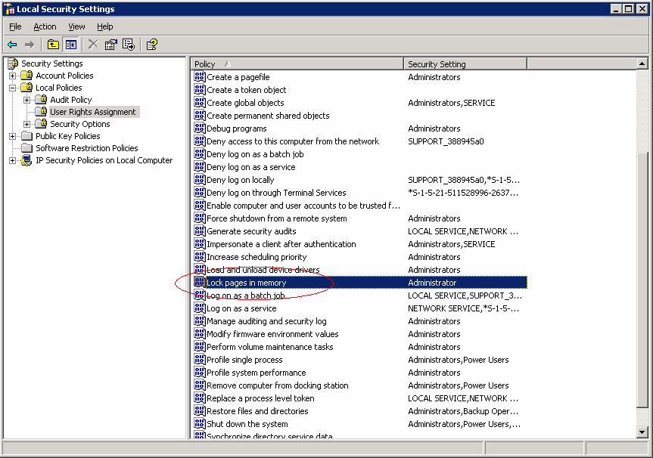
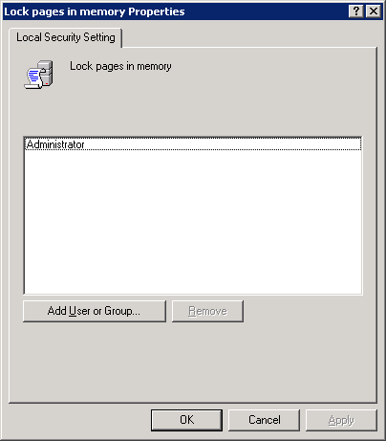
There are hardly any difference between SQL Server 2005 configurations on 32Bit and 64Bit. The most significant difference is that AWE does not need to be used anymore. Despite the fact that it still is available as configuration parameter, there is no need to take use of it. However one should use one configuration step not used in 32Bit editions so far. In order to avoid SQL Server buffer pool pages being paged out into the Windows page file(s) one needs to allow the privilege to ‘lock pages in memory’ for the user context which starts SQL Server Services. This needs to be done in the local security settings like demonstrated in this graphics.

Microsoft x64 Computing Platform
The SQL Server 2005 (64-bit) x64 computing platform is a Microsoft architecture that extends the x86 instruction set to 64 bits. SQL Server 2005 uses Windows Server 2003 x64 Editions and requires drivers and software specifically compiled for the x64 instruction set. Windows Server 2003 x64 Editions supports both the AMD Opteron and Intel processors with Extended Memory Technology (EM64T).
The Microsoft x64 platform offers support both for 32-bit and 64-bit computing. Existing 32-bit software can be used without being recompiled. The x64 computing platform can act as an x86 processor when an x64 system is booted into a 32-bit operating system.
Note that the SQL Server 2005 (64-bit) x64 platform does not run 64-bit IA64 versions of the Windows Server operating system or 64-bit IA64 drivers that are compiled for Itanium. Basically the 64-bit IA64 platform is not compatible with the SQL Server 2005 (64-bit) x64 platform. Different sets of executables are required.
This platform meanwhile established itself as commodity 64Bit platform. It already is used successfully for SAP Application Tier and for SAP database servers in small, mid-sized and even higher-end SAP R/3 and SAP BW systems. The advantage of this platform is a nearly unbeatable price/performance ratio. With all the commodity servers on the market supporting x64, SAP, Microsoft and a lot of third party software vendors supporting x64, customers using commodity platform servers should plan ahead moving to 64Bit.
From a performance point of view, commodity platform servers are basically doubling pure computing performance nearly every 18 months. Comparing a 9 year old four processor Pentium Pro 200 database server performance to the most recent and fastest 4 processor Dual-Core x64 server on Windows, one can observe a 35 times higher CPU performance with the most recent server running on x64 Windows. Despite steady increases of SAP Workload in customer scenarios, more and more productive SAP landscapes can be realized on inexpensive commodity type hardware.

64-Bit Memory and CPU Limitations
The general memory limitations both for the 32-bit and 64-bit computing platforms are shown in the following table.
General Memory Limits | 32-bit | 64-bit
Total virtual address space | 4 GB | 16 TB
Virtual address space per 32-bit process | 2 GB (3 GB if the system is booted with the /3gb switch)  4 GB if compiled with /LARGEADDRESSAWARE  2 GB otherwise | Not applicable
Virtual address space per 64-bit process | Not applicable | 8 TB
Paged pool | 470 MB | 128 GB
Non-paged pool | 256 MB | 128 GB
System cache | 1 GB | 1 TB
The physical memory and CPU limitations for the 32-bit and 64-bit Windows operating systems are shown in the following table.
Physical Memory and CPU Limits | 32-bit | 64-bit
Windows Server 2003 Standard Edition | 4 GB/1 to 4 CPUs | 32 GB/1 to 4 CPUs
Windows Server 2003 Enterprise Edition | 64 GB/1 to 8 CPUs | 1 TB/1 to 8 CPUs
Windows Server 2003 Datacenter Edition | 64 GB/1 to 32 CPUs | 1 TB/1 to 64 CPUs

Migration to SQL Server 2005 (64-bit)
Despite the fact that the binaries of the IA64 and x64 platforms and the 32-bit platform are not interchangeable, the SQL Server 2005 on-disk structures between all three supported platforms (IA64, x64 and x86) are the same. This means migrating from a 32-bit computing platform to one of the 64-bit platforms can be handled easily either by copying the database files to the new 64-bit hardware or by restoring a backup from the 32-bit platform to the 64-bit platform.

SAP Applications on a 64-Bit Platform
The main problem with running SAP application instances using 32-bit computing is that the address space for a single process of the SAP instance is limited to 3 GB. Due to SAP’s extensive buffering for the NetWeaver Application Server, those buffers use a large amount of memory in the address space of a process. Over the last six years, SAP releases have nearly doubled their demand on memory.
In fact, situations where SAP users are performing processing that reaches the upper limits of the 32-bit x86 platform are becoming more frequent. In particular, the usage of SAP Unicode products increases the problem because the Unicode products address memory in a severe manner. For SAP Unicode products, the recommendation is to use a 64-bit platform to run the SAP Application Server Layer.
In addition, 64-bit computing is in demand with the SAP® Advanced Planning & Optimization (SAP APO) component of mySAP SCM. In particular, the SAP APO liveCache is an in-memory database where 64-bit addressability is mandatory.

All recent SAP products are available on IA64 and x64. This includes ABAP and Java Stack. Due to higher memory resource consumption on the application server side by SAP Unicode systems, one should consider SAP Unicode implementations on 64Bit exclusively. Especially for all SAP applications demanding a lot of memory resources like SCM Livecache or SAP ABAP stack for R/3, BW and other products are available on both 64Bit platforms.
SAP meanwhile announced in April 2006 that SAP product releases entering the market from the year 2007 on, will be 64Bit releases only. Microsoft plans to support these SAP product releases with 64Bit SQL Server 2005 and later 64Bit releases of SQL Server only.
Transition to 64Bit with SAP is not a one or nothing move. The transition can be done server by server or system by system. SAP does support platform heterogeneous systems between the three different platforms. Pretty common might in the past already was to run a bigger IA64 database server in a high-end system, but leaving the SAP application server tier on x86 commodity application server. This still can be done using x64 servers for the SAP application tier. Even having the SAP Central Instance running in a cluster with the IA64 database server and having the rest of application server instances on x86 or x64 does work since SAP stores the SAP executables on the Central Instance in platform dependent directories.

Configuring a 64Bit server for running a SAP ABAP instance, one should calculate 4GB real memory per processor core to really be able to fully leverage the processor resources available. The same is true for SAP JAVA instances.

Solution Architecture
This section describes typical reference architectures that are capable of supporting small scale, mid-sized, and the largest, most demanding SAP implementations. The architectures show the basic elements that can be used in a variety of implementation scenarios. This section also provides an example of Microsoft Information Technology’s (IT) running SAP with SQL Server 2005 implementation.
In practice, each SAP implementation will need to be adapted and designed jointly with a SAP-certified hardware vendor in order to address the customer’s unique requirements, for example, pre-existing infrastructures, business models, or business impact assessments.
Each of the mySAP with SQL Server 2005 reference architectures meets the following requirements:
- High availability. The architectures are designed for high availability to provide the best performance and to ensure fault tolerance.
- Scalability. Additional servers can be added quickly and easily without disrupting the existing site, enabling SAP installations to rapidly increase the number of concurrent users.
- Support for large volumes of data. The application and database configuration can grow from hundreds of gigabytes to multi-terabyte databases.

Hardware
The SAP with SQL Server 2005 reference architectures are designed to use commodity servers as well as high end server architectures and storage that is available from leading hardware vendors. Especially leveraging commodity type architectures reduces the TCO and ensures that maintenance and support costs can be well-managed.

Architectural Considerations
The mySAP with SQL Server 2005 architectures are designed to provide maximum availability and improved reliability by offering multiple levels of failover support and redundancy including:
- Failover clustering. SQL Server 2005 can run two to eight server nodes in a failover cluster to provide redundancy in the event of server downtime.
- Database Mirroring. As an alternative to Failover Clustering, Database Mirroring is introduced.
- RAID. Common Redundant Array of Independent Disks (RAID) is used to provide redundancy in the event of a disk failure.
- Storage. Storage Access Network (SAN) and Network Attached Storage (NAS) technologies can be designed with complete redundancy to ensure data integrity and avoid data loss. SQL Server 2005 is optimized for native integration with SAN hardware.

High-Availability measures
SAP products in combination with SQL Server 2005 can leverage failover clustering as one of the High Availability methods. A typical Microsoft clustering scenario includes running the SAP Central Instance (CI) on one of the cluster nodes and SQL Server 2005 on the other cluster node. In this case, if the primary node for SQL Server 2005 or for the SAP CI fails, or if that node is taken offline for maintenance, the clustered components will start on the active cluster node with no service interruption.
Another possibility to achieve high-availability could be to still use MSCS to cluster the SAP Central Instance in an active-passive cluster or use SAP’s Replicated Enqueue Technology and have SQL Server 2005 using Database Mirroring which got introduced in this document already. The possibility of traditional log-shipping also would be possible. For more details on High-Availability and other measures see here

RAID
SAP applications with SQL Server 2005 should leverage common RAID levels including 1, 5, 1+0, and 0+1, as shown in the following diagrams. For the best performance with full recoverability, customers frequently use RAID 0+1. RAID 5 can be used as a lower cost alternative. The choice of RAID level is dependent on the workload and this choice can directly affect the way SQL Server 2005 performs.
Note that RAID levels greater than 10 (1 + 0) offer additional fault tolerance or performance improvements. However, systems using RAID 10 and greater tend to be proprietary. For more information about specific RAID system capabilities, contact the hardware vendor.
For more information on general RAID levels check on this link: http://en.wikipedia.org/wiki/RAID1#Standard_RAID_levels
or on this whitepaper which also explains some other storage features of SQL Server eventually applicable for SAP. However please note that not all the described measures in the whitepaper pointed to are applicable for databases related to SAP applications:
http://www.microsoft.com/technet/prodtechnol/sql/2005/physdbstor.mspx

Small Scale Solution
The small scale solution for using mySAP and SAP BW with SQL Server 2005 typically has the following characteristics:
- Support for 100 or less concurrent users depending on the workload
- A lower SAP batch workload
- No major differences between SAP products (mySAP and SAP BW)
This architecture is commonly used in small scale SAP development or test systems.
Architecture | Description
Server
SAP NetWeaver Application Server / SQL Server 2005 Database | 1 commodity server having 2 to 4 processors (CPUs) with 4 gigabytes (GB) RAM per CPU core.  4-8 GB random access memory (RAM) are assigned to support SQL Server 2005.
High-Availability Measure | None
RAID | RAID 0+1, 1+0
Local Storage
mySAP Storage Requirements | For data files (assuming RAID 1 or similar):  - 4 partitions with 6 disks minimum  For transaction log (assuming RAID 1 or similar):  - 1 partition with 4-6 disks minimum  For tempdb and log (assuming RAID 1 or similar):  - 1 partition for each disk with 4 disks minimum
SAP BW Storage Requirements | For data files (assuming RAID 1 or similar):  - 4 partitions with 6 to 8 disks minimum  For transaction log (assuming RAID 1 or similar):  - 1 partition with 4 to 6 disks minimum  For tempdb and log (assuming RAID 1 or similar):  - 1 partition with 8 disks minimum  The recommended storage requirements for the data files and transaction log of mySAP and for SAP BW hardly are different. However SAP BW loads tempdb significantly higher in volume and workload.

Mid-Size Solution for mySAP
The mid-size solution for mySAP with SQL Server 2005 has the following characteristics:
- Support for 250 or more concurrent users depending on the workload
- A low to medium SAP batch workload
- Differences between products (mySAP and SAP BW)
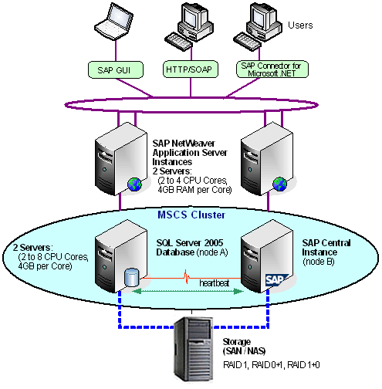
Architecture | Description
Servers
SAP NetWeaver Application Server Instances | 2 commodity servers with each having 2 to 4 processors, with 4 GB RAM per CPU core.
SQL Server 2005 Database Server / SAP Central Instance (CI) Server | 2 commodity servers with each having 2 to 4 processors, with 4 GB RAM per CPU core. Up to 24GB GB RAM is assigned to support SQL Server 2005.
High-Availability Measure | Set to active-to-passive mode failover clustering, running SAP CI on the second node.  Clusters are networked storage configurations that are dependent on a shared storage infrastructure.
RAID | RAID 1, 0+1, 1+0
Networked Storage
SAN | SAN, NAS, or locally-attached storage. Storage devices can use a multi-cluster device, according to the Windows Hardware Compatibility List (HCL).
mySAP Storage Requirements | For data files (assuming RAID 1 or similar):  - 4 partitions for each disk with 8-14 disks minimum  For transaction log (assuming RAID 1 or similar):  - 1 partition for each disk with 8-12 disks minimum  For tempdb and log (assuming RAID 1 or similar):  - 1 partition for each disk with 4-8 disks

Midsize Solution for mySAP using SQL Server 2005 Database Mirroring

Architecture | Description
Servers
SAP NetWeaver Application Server Instances | 2 or 3 commodity servers with each having 2 to 4 processors, each with 4 GB RAM per CPU core.
SQL Server 2005 Database Server  SAP Central Instance (CI) Server | 2 commodity servers with each having 2 to 4 processors, with 4GB per CPU core  MSCS solution on 2 small 2 processor servers with 4GB each using traditional SAP CI clustering or Replicated Standalone Enqueue
High-Availability Measure | Database: Using SQL Server 2005 Database Monitoring  SAP: Using MSCS Clustering using traditional CI Clustering or Standalone Replicated Enqueue.
RAID | RAID 1, 0+1, 1+0
Networked Storage
SAN | SAN, NAS, or locally-attached storage. Storage devices can use a multi-cluster device, according to the Windows Hardware Compatibility List (HCL).
mySAP Storage Requirements | For data files (assuming RAID 1 or similar):  - 4 partitions for each disk with 8-14 disks minimum  For transaction log (assuming RAID 1 or similar):  - 1 partition for each disk with 8-12 disks minimum  For tempdb and log (assuming RAID 1 or similar):  - 1 partition for each disk with 4-8 disks
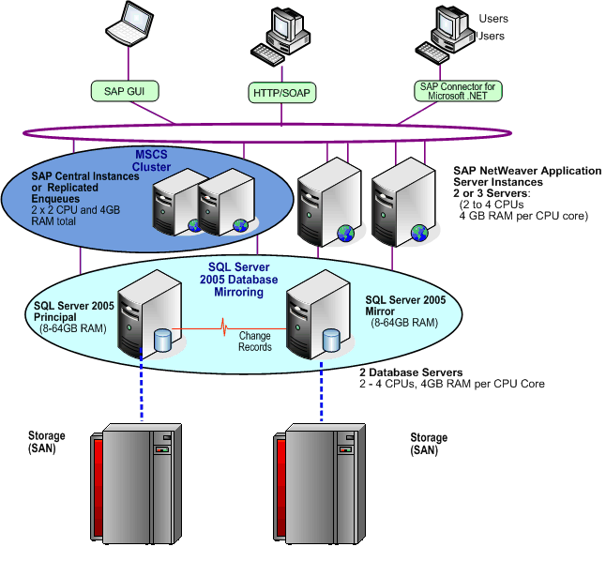

Large Solution for mySAP
The large size solution for mySAP with SQL Server 2005 has the following characteristics:
- Support for 250 or more concurrent users depending on the workload
- A high SAP batch workload
- Differences between products (mySAP and SAP BW)
Architecture | Description
Servers
SAP NetWeaver Application Server Instances | 4 to n processor commodity servers with 2 to 4 processors, with 4 GB RAM per CPU core.
SQL Server 2005 Database Server / SAP Central Instance (CI) Server | 2 servers, commodity or non-commodity, with up to 64 processors and up to 512 GB RAM.
High-Availability Measure | Set to active-to-passive mode failover Clustering, running SAP CI on the second node.  Eventually, use pure SQL Server active-to-active clustering between Productive Database Instance and Test Database Instance.  Clusters are networked storage configurations that are dependent on a shared storage infrastructure.
RAID | Per the vendor’s networked storage installation requirements.
Networked Storage
SAN | SAN or rarely using locally-attached storage. Storage devices must be on a multi-cluster device according to the HCL.
mySAP Storage Requirements | 100 to 250 disks:  1 data file / processor core

Large solution for mySAP with SQL Server Database Mirroring
Architecture | Description
Servers
SAP NetWeaver Application Server Instances | 4 to n processor commodity servers with 2 to 4 processors with 4 GB RAM per CPU core.
SQL Server 2005 Database Server  SAP Central Instance (CI) Server | 2 servers, commodity or non-commodity, with up to 64 processors and up to 512 GB RAM.  MSCS solution on 2 small 2 processor servers with 4GB each using traditional SAP CI clustering or Replicated Standalone Enqueue
High-Availability Measure | Database: SQL Server 2005 Database Mirroring on the Database Level.  SAP: Using MSCS Clustering using traditional CI Clustering or Standalone Replicated Enqueue.
RAID | Per the vendor’s networked storage installation requirements.
Networked Storage
SAN | Two separate SAN or rarely using locally-attached storage. Storage devices must be on a multi-cluster device according to the HCL.
mySAP Storage Requirements | 100 to 250 disks:  1 data file / processor core
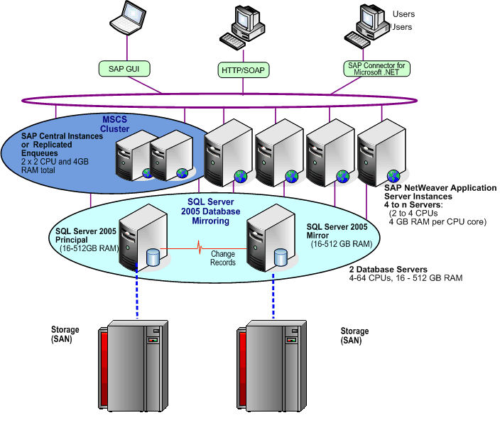

High Availability Solution for SAP BW

The high availability solution for SAP BW with SQL Server 2005 has the following characteristics:
- Support for 250 or more concurrent users depending on the workload
- Differences between products (mySAP and SAP BW)
Architecture | Description
Servers
SAP NetWeaver Application Server Instances | 1 to n commodity servers with 2 to 4 processors, with 4 GB RAM per CPU core.
SQL Server 2005 Database Server / SAP Central Instance (CI) Server | 2 servers, commodity or non-commodity, with up to 64 processors and up to 512 GB RAM.
High-Availability Measure | Set to active-to-passive mode failover clustering.  Eventually use pure SQL Server active-to-active clustering between the Productive Database Instance and Test Database Instance.  Clusters are networked storage configurations that are dependent on a shared storage infrastructure.
RAID | Per the vendor’s networked storage installation requirements.
Networked Storage
SAN | SAN or rarely using locally-attached storage. Storage devices must be on a multi-cluster device according to the HCL.
SAP BW Storage Requirements | 80 to 250 disks:  1 data file / processor core

Microsoft IT SAP Solution Architecture
Microsoft IT uses a large scale mySAP with SQL Server implementation to support Microsoft’s business processes and operations. The Microsoft IT SAP solution has the following characteristics:
- Support for 200 to 600 or more concurrent users depending on the workload
- A high SAP batch load responsible for over 65 percent of the workload
- 2.8 TB database
- SQL Server 2005 Database Mirroring for high availability
Architecture | Description
Servers
SAP NetWeaver Application Server Instances | 6 x64 Hewlett-Packard® (HP) ProLiant DL585 4 processor commodity servers with each having 32 GB RAM.
SQL Server 2005 Database Server | 2 servers with each having x64 HP DL585 4 processors (dual-core) with each having 48 GB RAM.
High-Availability Measure | SQL Server 2005 Database Mirroring.
RAID | Raid 0+1
Networked Storage
SAN | EMC2® Clariion® CX series  12 logical drives
mySAP Storage Requirements | 180 disks:  12 data files / database

Usage of SAN or NAS Storage
As described in the architectures above, mostly SAN and NAS storage is used. These days especially SAN storage is mostly seen in bigger environments. However on should be clear about the fact, that in most of the bigger customer environments one SAN frame or cabinet solely might be dedicated to the productive database of a bigger SAP system. Thereby it doesn’t play a role whether it is R/3 or BW. Throughput requirements against the database of the SAP product might be as high that it is not possible to leverage the plenty of disk space still available on the disks for any test systems or even other software like Exchange. Especially in high-end customer deployments, attempts to share the disks of a SAN device with other database often had to be stopped in order to achieve deterministic and solid performance for the main productive SAP database. Sure, some of the smaller and less loaded databases could be placed consolidated into one SAN/NAS frame, but as mentioned before most customers using SAN are dedicating a SAN frame for their most important productive SAP databases. Even if consolidation of databases is possible to achieve, one needs to think about one SAN/NAS device as a single point of failure. Means one should group databases of SAP products and 3rd party products in a way on SAN devices that certain workflows (like working through customer orders or creating deliveries) still could be executed despite the fact that 3 or 4 different products with associated databases are needed for executing that workflow. One also needs to keep in mind that the user community could develop very different usage times for different pieces of SAP products. E.g. The high time of SAP SCM usage might be over the weekend, whereas during the week the user community would not mind a down time. Whereas in case of SAP BW, the user community might not care about BW being available on the weekend, but does insist on 24x5 during normal business days.
Besides consolidation aspects, SAN/NAS devices often are chosen due to features which enable to execute so called Snapshot Backups using the Windows VSS or SQL Server’s VDI interface. Nearly every one of the bigger SAN/NAS vendors does offer such features, which proved to work great for specific customer situations. Another advantage of SAN/NAS devices usually is the huge cache of multiple GBs these devices are equipped with. This at the end means that not every I/O operation coming from SQL server really hits the underlying disks, but can be served out of those caches. Experience is that the cache hit ratio of these caches is nowhere close cache hit ratios of SQL Server, but that one certainly can get more I/O throughput per disk compared to direct attached storage with small caches on the controllers.

Usage of Synchronous Storage Replication
Most of the main SAN/NAS vendors are offering Storage Replication mechanisms between different frames/devices/cabinets of their hardware. The usual scenario addressed with such features is to keep 2 devices located in different database centers in sync. From database point of view such a synchronous storage replication could help to ensure not to loose a committed transaction in case production or production datacenter encounters a disastrous outage.
As in the chapter of Database Mirroring where synchronous SQL Server 2005 Database Mirroring is discussed, the distance between the two storage devices set up for synchronous replication is vital for the performance impact. The part of I/O most sensitive to delays in SQL Server or in all relational databases following the ACID concepts, is persisting change records (so called transaction log records) to disk. In opposite to other I/O activity initiated by database Checkpoint Writers or Lazywriters which is asynchronous, the I/O to persist transaction log records to disk is synchronous I/O. Means the thread which just triggered the I/O by a transaction commit it received, needs to wait until the acknowledge comes back from the disk subsystem before it can continue to acknowledge a successful commit to the application. During the time this thread waits to hear back from the disk subsystem, it cannot accept any other work. More I/O wait time on acknowledge from the disk subsystem then leads to two unfavorable issues:
- With too high of a wait time, one will end up in a situation where CPU resources available could not be leveraged anymore.
- Database Locks by SAP Update processing or other processing changing data will be held longer and could trigger cascading blocking lock scenarios
It is unavoidable that synchronous storage replication does contribute to higher wait time for synchronous I/O. On the SAN side, the confirmation for the successful I/O only can be given with the replication of the changed storage block succeeded. Hence the latency introduced into synchronous I/Os has a major role to impact the performance of the system. The following considerations should be made:
- Different hardware vendors do have different granularities of block sizes for storage replication. Some hardware vendors have small of small size of 8 or 64K which need to be propagated if a change happens, some others are known to have block sizes of 1MB for replication. The smaller the granularity, the better. In some cases the granularity depends on the configuration of the SAN storage.
- Some hardware vendors lock down a block of a certain size for any changes if a portion of that block needs to be replicated. In such a case the size of the block locked often is bigger than the portion which gets synchronized. E.g. let’s assume a storage device can replicate blocks in the sizes of 8KB. A transaction log write is issued with a length of 20KB. This means 3 blocks need to be replicated to the second frame. However due to the way the stripping got configured on the storage backend, the volume being locked down for changes while the replication of the 3 blocks was executed might be of a size of 940KB. Means all subsequent reads which would affect this 940KB locked down are blocked. Since transaction log writes usually write sequentially into the transaction log files, such kind of lockdown of bigger storage blocks on the SAN backend can impact performance in a major way. A workaround can be an alternative stripping which will reduce the volume of the storage block locked down or host based stripping. However latter could come with the price needing an additional volume manager software in order to use MSCS.
- The latency time introduced by synchronous storage replication is not the same than a ping between the two storage devices. Even over 100 Miles, a ping between the two devices might take 3-4ms. However this does not necessarily reflect the time it takes to replicate a block in storage. The time for replication could be way higher due to the fact that there are additional software components which are involved.
- No doubt, the longer the distance the higher the latency.
- In order to get a feel for the impact of synchronous storage replication it is best to perform some tests with the devices close together. This will get a good indication for the ‘fixed’ costs of the synchronous storage replication. This will allow as well tuning this kind of replication from the storage side. As a second step after the performance is sufficient using synchronous storage replication with devices close by, it does make sense to perform the same tests on the desired distance.

In regards to acceptable performance levels and some more technical details on storage, please check in this document here

Note Microsoft does not provide certification of third-party solutions. For more information, see KB913945 - Microsoft does not certify that third-party products will work with Microsoft SQL Server.

Usage of Direct Attached Storage
There still are a lot of configurations, especially in SAP development, test and sandbox systems where direct attached storage can make sense. In all the cases where none of the sophisticated Snapshot or replication features of SAN/NAS storage is demanded, an alternative to consolidate storage on SAN/NAS can be the usage of local storage built up upon SAS (Serial Attached SCSI) or SATA (Serial ATA) technology. Hardware partners certified for SAP usually have these kinds of arrays in their offer. Compared to consolidate development, test, sandbox or trainings systems on SAN/NAS, using local attached storage of that type might be a viable less expensive alternative or might suite the particular environment in a better way. One disadvantage compared to SAN/NAS devices is that there is not as plenty of cache available in the I/O path. The caches are usually on the controllers and are not sized as the caches in SAN/NAS devices. Hence a higher percentage of I/O operations hit the disks and hence the disks are loaded higher for similar workloads.

Important SAP OSS Notes related to SQL Server

62988 Service Packs for MS SQL Server
159316 Reorganizing tables under SQL Server
327494 Configuration Parameters for SQL Server 2000
542468 Activate manual statistics generation on infocubes in BW
600027 Installing the correct MS SQL Server Code Page
652634 FOR ALL ENTRIES performance with Microsoft SQL Server
666805 MS SQL Server: Migration from 32-Bit to 64-Bit
683447 SAP Tools for MS SQL Server
767691 Migration of SAP Systems to/from MS SQL Server
799058 Setting up Microsoft SQL Server 2005
879941 Configuration Parameter for SQL Server 2005
905634 SAP Release Planning for SQL Server 2005
924288 Installation of 6.x based SAP systems on MS SQL Server 2005
965145 Installation of 46C Systems on MS SQL Server 2005
965908 SQL Server Database Mirroring and SAP Applications

Related Links and Online Resources
Microsoft SQL Server 2005:
http://www.microsoft.com/sql/2005/productinfo/overview.mspx
Windows Server 2003:
http://www.microsoft.com/windowsserver2003

Microsoft – SAP Customer Information Center:
http://www.microsoft-sap.com/
http://www.microsoft-sap.com/technology.aspx
mySAP and SAP R/3 on SQL Server 2005 courses for administrators: http://www.microsoft-sap.com/events.aspx

SAP AG:
http://www.sap.com/index.epx
SAP NetWeaver:
http://www.sap.com/solutions/netweaver/index.epx

SAP SDN SAP on SQL Server:
https://sdn.sap.com/irj/sdn/mssql

Note that the SAP OSS Notes and SAP Product Support Matrix are only available to registered customers of SAP AG.

Failover Clustering in the MSDN Library:
http://msdn.microsoft.com/library/default.asp?url=/library/en-us/adminsql/ad_clustering_7t9v.asp

RAID Levels and SQL Server in the MSDN Library:
http://msdn.microsoft.com/library/default.asp?url=/library/en-us/optimsql/odp_tun_1_87jm.asp
General information on common RAID levels:
http://msdn.microsoft.com/library/default.asp?url=/library/en-us/optimsql/odp_tun_1_0m5g.asp

For more information:
http://www.microsoft.com/sql/!href()

Did this paper help you? Please give us your feedback. On a scale of 1 (poor) to 5 (excellent), how would you rate this paper?!href(mailto: sqlfback@microsoft.com?subject=Feedback: SAP with Microsoft SQL Server 2005: Best Practices for High Availability, Maximum Performance, and Scalability)

As of the third quarter of 2005.
The SAP/Microsoft joint development on product Duet.
For more information, see “Microsoft – SAP Customer Information Center” at http://microsoft-sap.com/
For more information, see “Microsoft SQL Server 2005” at http://www.microsoft.com/sql/2005/productinfo/overview.mspx
For more information, see “What's New in SQL Server 2005” at http://www.microsoft.com/sql/2005/productinfo/overview.mspx#ECAA
For more information, see “Microsoft – SAP Customer Information Center” at http://www.microsoft-sap.com/technology.aspx
The SAP OSS Notes are only available to registered customers of SAP AG.
The SAP Product Support Matrix is only available to registered customers of SAP AG.
Product listings are for reference only. The listings do not represent final or actual product names or convey equal functionality between the 32-bit and 64-bit versions of Windows.
tempdb is typically 1.5 times the size of largest SAP fact table.

