Interactive Display

Technical Overview

Overview
Interactive Display is a novel interactive display technology developed by Microsoft Research. The outputs of two video cameras are combined behind a transparent projection display to produce an image of objects on the display surface. An otherwise normal sheet of acrylic plastic is transformed into a high-bandwidth input/output surface suitable for gesture-based interaction.

With two cameras the system can determine if a given object is on the display surface or above it. Interactive Display’s image processing acts as a filter that only displays objects on the display surface, which allows for high-resolution touch images. For example, a high-resolution image of a paper document can be captured using a high-resolution still or CMOS video cameras.

Interactive Display’s capabilities are illustrated in this photograph of an interactive drawing program adding strokes derived from the touch image to a drawing image while using a cycling color map:

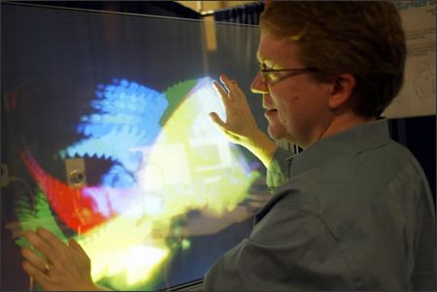

Components
The physical configuration of Interactive Display is illustrated in the graphic below:

A pair of commonly available FireWire web cameras are mounted behind the display surface such that each camera can see all four corners of the display. A DNP HoloScreen material is applied to the rear surface of the acrylic display surface. The HoloScreen is a special refractive holographic film that scatters light from a rear projector when the incident light is at a particular angle. The material is transparent to all other light, and so is suitable for applications where traditional projection display surfaces would be overwhelmed by ambient light. Additionally the screen is transparent in the near-infrared range. It is also possible to mount the display surface horizontally to make a table. A microphone is rigidly attached to the display surface to enable the simple detection of “knocking” on the display. When the customer taps the display with their knuckle or hand, the tap is detected by finding large peaks in the digitized audio signal. This detection can be used to simulate clicks or generate “forward” or “next slide” events. Note that while the tap detector determines that a tap event occurred, the touch image may be used to determine where the event occurred. For example, a tap on the left side of the screen may generate a “previous” event, while a tap on the right a “next” event. Aside from the microphone, there are no externally visible wires, which makes Interactive Display appropriate for public applications.

Core Scenarios
- Interactive Display technology can be used in environments like retail storefronts, where ambient light streaming through windows precludes traditional rear-projection screens.
- Interactive Display enables direct eye contact (or eye-to-eye) video conferencing.
- Interactive Display provides a new user interface for computing that supports multi-touch, gesture and multiple customers at the same time. These capabilities can be used for high-end, interactive marketing events and trade show presentations.
- With the ability to project on a transparent display, Interactive Display enables scenarios where projected graphics are overlaid onto imagery from the real world. Augmented reality technology supports the creation of training scenarios and other interactive learning aids.
- Interactive Display makes it possible to determine who is interacting with the display surface through face recognition technology. This means that Interactive Display can determine whether the user is looking at the display and possibly where on the display the user is looking. Such capabilities are relevant in multi-user and collaborative scenarios. This analysis can be conducted with the cameras completely concealed behind the display surface.

Documentation
The Interactive Display innovation is described in a research paper (Wilson, A. Interactive Display: An Imaging Touch Screen and Display for Gesture-Based Interaction, International Conference on Multimodal Interfaces). Several links to press articles and pointers to demo videos can be found here.

Caveats
- Interactive Display offers less accuracy and fidelity in detecting touch location than other touch screen solutions based on single 2D pointer input.
- Interactive Display’s depth-sensing capabilities have not been realized as part of the current prototype implementation.

Related Work

Differentiating Features
- While other common touch screen technologies are only able to handle one 2D pointer inputs, Interactive Display can handle multiple, simultaneous inputs. In addition, Interactive Display is able to deliver information on the shape of the objects on the display surface.
- Interactive Display can transform any surface into a high-bandwidth input/output human machine interface.
- Interactive Display enables a new set of applications by allowing the placement of the touch plane at an arbitrary depth above the display. Placement of multiple planes at various depths can be defined depending on the application.

Demo/Prototype

Development Status
Interactive Display is currently a research prototype. Several proof-of-concept software applications were developed at Microsoft Research in order to explore the capabilities of the technology, including an interactive drawing program that adds strokes derived from the touch image to a drawing image while using a cycling color map (see photograph earlier in this document).

Technical Specifications
- The Interactive Display software is implemented in C++.
- The current system uses two standard FireWire web cameras operating at 30 Hz.
- The system uses a short throw projector (WT600 or WT610) but also works well with cheaper video projectors.

