Interactive Image Cut Out

Technical overview

Overview
Microsoft Research Asia has developed Interactive Image Cut Out, a system for selecting and removing an object in a picture or photograph from its background. The customer can then compose the result on a different background to create a new scene. The solution optimizes an explicit energy function over the entire image considering both color similarity and grading information. Interactive Image Cut Out works even if foreground and background colors are similar.

Components
Interactive Image Cut Out happens in three steps:

- Object marking:
In this first, coarse step the customer quickly identifies the object of interest by marking quick mouse strokes, using left-click for foreground and right-click for background. The system will optimize the boundary using its implementation of a region based graph cut image segmentation algorithm and provide instant feedback of the optimized object boundary.
- Boundary editing:
In the refinement step, the customer can edit a polygon boundary model. Interactive Image Cut Out allows editing the polygon directly or using an overriding brush. The computer then optimizes the boundary based on the polygon location and the image information.
- The final step extracts the cut out object.

Core Scenarios
The following screenshot demonstrates the results produced by altering a photo using the Interactive Image Cut Out technique:

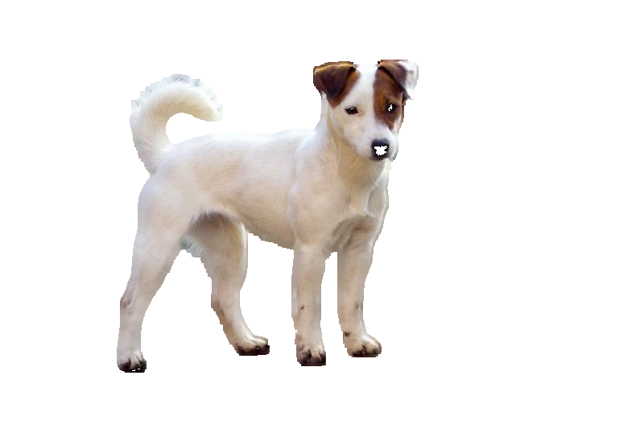


Documentation
A video explaining the concept behind Interactive Image Cut Out and the features of the prototype tool was produced for SIGGRAPH 2004. The video explicitly showcases a competitive comparison between Interactive Image Cut Out and a feature in Adobe’s Photoshop called "Magnetic Lasso". A PowerPoint presentation shown at the same conference explains this technology further.

Caveats
- The currently available implementation of Interactive Image Cut Out is at the prototype stage.

Related Work

Differentiating Features
Compared with other competing solutions, such as Magnetic Lasso in Photoshop, Interactive Image Cut Out is faster to separate the foreground and produces high quality intermediate results. To refine the boundary in detail Interactive Image Cut Out only needs to edit a few polygon vertices, which is easier and faster. Interactive Image Cut Out provides instant feedback to the customer when manually refining a cut out object.

Demo/Prototype
Microsoft Research Asia implemented a fully functional prototype that allows using the Interactive Image Cut Out solution today. In addition a video exists that explains Interactive Image Cut Out from end to end.

Development Status
This screenshot shows the current prototype UI:

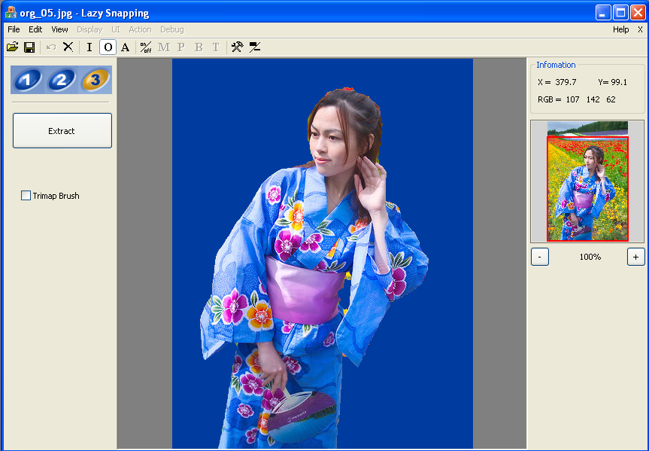

Technical Specifications
- The Interactive Image Cut Out prototype is packaged as a single executable.
- File size of the executable: ~325 KB

