Personalized Facial Sketch

Technical Overview

Overview
Microsoft Research has developed Personalized Facial Sketch, a technology that allows customers to generate a personalized cartoon from an input image. The program instantly generates a library of cartoon likenesses in the “Manga” Japanese Anime styling with a variety of moods, expressions, and accessories. Customers can also use the program to distort the cartoon to create a caricature. This system is currently used by HomeStyle+ for Outlook in Japan.

The process to generate a personalized facial sketch is presented to the customer in an easy-to-use wizard format. Customers can easily create humorous cartoon-style drawings of friends or family members and use them to personalize communications (such as IM and e-mail). The cartoon output includes the cartoon face (generated from the image) along with a selection of cartoon expressions and simple animations. The cartoon can be used in many different ways including adding them to e-mail signatures and using them as IM display pictures. Cartoon Wizard has the potential to appeal to a wide range of customers who like to personalize or add fun to their computing experience.

The following graphics show some sample outputs:

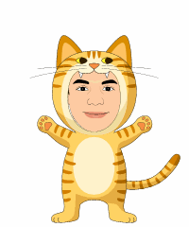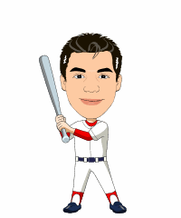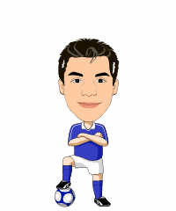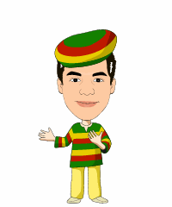

Components
The Microsoft Personalized Facial Sketch non-photorealistic rendering system takes a human face (via digital photo) as input and outputs a sketch that exhibits the drawing style of a set of training examples provided by an artist. The current system was trained against a set of images in the style of Japanese Anime cartooning known as “Manga”.

The system uses a learned rendering approach, and is trained using a series of sample photos along with their portrait equivalents. Once trained, it then will output a drawing B that relates to input B in the same manner that the training images related to each other. To do this, it first decomposes the source image into components that are structurally related to each other such as the eyes, mouth, or hair. After these components are separately processed, they are carefully recomposed to render the final result.

Please refer to the following graphics for a visual representation of the technology:

The following screenshots illustrate a few selected steps of the wizard process.

The wizard takes a photograph as input. The software will automatically detect the human face within it and mark it with a rectangle. Customers can move the rectangle and adjust the width/height.

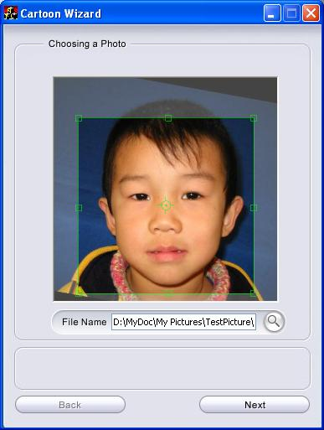

Personalized Facial Sketch allows the customer to choose from several pre-defined cartoon styles (e.g., Chinese Male or Caucasian Female). The wizard offers different ethnicities and genders. The customer can also choose between vector-based and pixel-based cartoon styles.

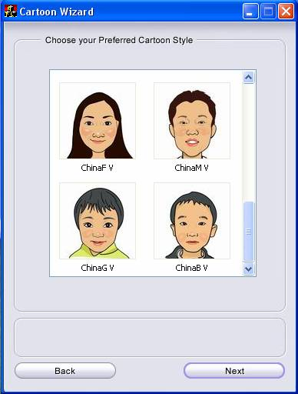

In the next step the tool recognizes the facial features in a photograph. The customer can manually refine the result and modify or distort the features by dragging the green poly lines.

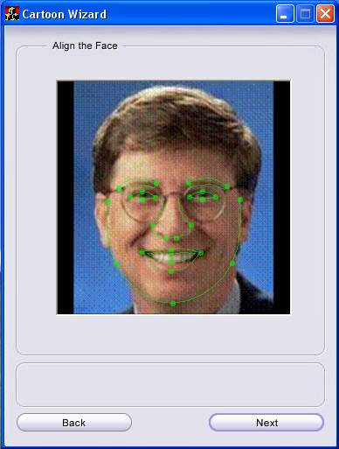

In the next step the customer gets to choose a hair style for the cartoon.
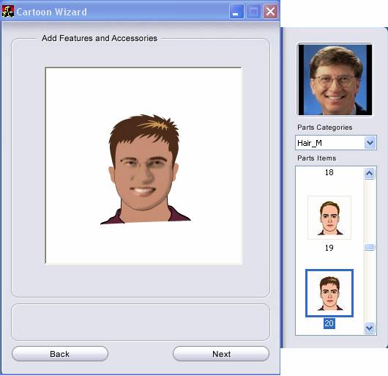

Core Scenarios
- E-mailing
- Gaming
- Web page integration
  - Forum avatars
  - Board avatars
  - Blog avatars
- Instant Messaging
  - Static/dynamic display pictures
  - Buddy icons
- Mobile graphics downloads
- Online greeting cards
- Mobile phone background
- Children’s entertainment and learning
- Other advanced avatar-related applications (mobile, education/training, other)

Documentation

Related Work
Personalized Facial Sketch has been released in several Microsoft products. Initially it was used in the Japanese version of Office (Outlook: HomeStyle+, version 1.0, in 2003, and version 2.0 in 2004).

Differentiating Features
Cartoon and avatar generation is a fairly common technology. Microsoft’s Personalized Facial Sketch differentiates itself from other solutions in that it offers personalized cartoons that are life-like to the original photo).

Demo/Prototype

Development Status
Personalized Facial Sketch is a mature solution that has been thoroughly tested. The code base is part of several commercially available Microsoft products.

Technical Specifications
- Recommended photo properties:
  - Front-face photo
  - Sufficient resolution (e.g. > 250K pixels)
  - Good lighting
- The system is designed to achieve a high level of accuracy, thereby minimizing the customer’s need to make manual adjustments. (This assumes that the customer’s photos conform to the recommendations provided in the wizard’s Help file).
- The current solution runs on Windows XP and Windows Vista.
- The executable has a footprint of ~400 KB.

