Employee Purchase Program
Benefit Administration
User Guide

A reference guide for administering the Employee Purchase Plan Benefit

September 2003

© 2003 Microsoft Corporation. All rights reserved.
This document is for informational purposes only. Microsoft makes no warranties, express or implied, in this summary.
Microsoft, FrontPage, InfoPath, OneNote, Outlook, PowerPoint, SharePoint, Windows, and Visio are either registered trademarks or trademarks of Microsoft Corporation in the United States and/or other countries.
The example companies, organizations, products, domain names, e-mail addresses, logos, people, places, and events depicted herein are fictitious. No association with any real company, organization, product, domain name, email address, logo, person, places, or events is intended or should be inferred.

Employee Purchase Program
The Employee Purchase Program (EPP) allows your employees to obtain Microsoft products at reduced prices. A Program Code and valid Company Email or Company Name provides access to the Microsoft Employee Purchase Program site.

This guide covers the following topics:
Employee Purchase Program Benefit Rules
Activating the Employee Purchase Program Benefit
Viewing Employee Purchase Program Benefit Details
Updating User Authentication for the Employee Purchase Program Benefit
Updating Benefit Contact Information for the Employee Purchase Plan Benefit
Changing the Benefit Contact for the Employee Purchase Program Benefit
Acquiring a New Program Code for the Employee Purchase Program Benefit
Placing a Hold on the Employee Purchase Program Benefit
Viewing the Employee Purchase Program Benefit History
Actions on the Employee Purchase Program Benefit
Employee Purchase Program Enrollment Email
Using the Employee Purchase Program Benefit
Additional Notes
Assistance with the Employee Purchase Program Benefit
Glossary of Terms

Employee Purchase Program Benefit Rules

- A maximum of 3 copies of a particular product (SKU) is allowed. Any number of SKUs may be purchased.
- Employees are responsible for payment for the product (as well as taxes and shipping costs).
- Employees and benefits administrators must be authenticated by valid email domain (or company name) in addition to assigned Program Code.

Return to Topic List

Activating the Employee Purchase Program Benefit

To determine if activation is necessary, check the Enrollment Status of the Employee Purchase Program benefit on the Benefit Summary window.
If the status is Not Enrolled, you must activate the benefit in order to begin using it. If the status is Enrolled, activation has already been completed.

To activate the Employee Purchase Program benefit:

- Click on the Employee Purchase Program link in the Benefit column.

Note: If the link to Employee Purchase Plan is not active it means that you have not purchased the required number of products to use this benefit (but you have purchased some qualifying products otherwise the benefit would not be shown on the window).
If the link to Employee Purchase Plan is not displayed, it means that either you do not have benefit administration rights for the benefit, or no qualifying products have been purchased.

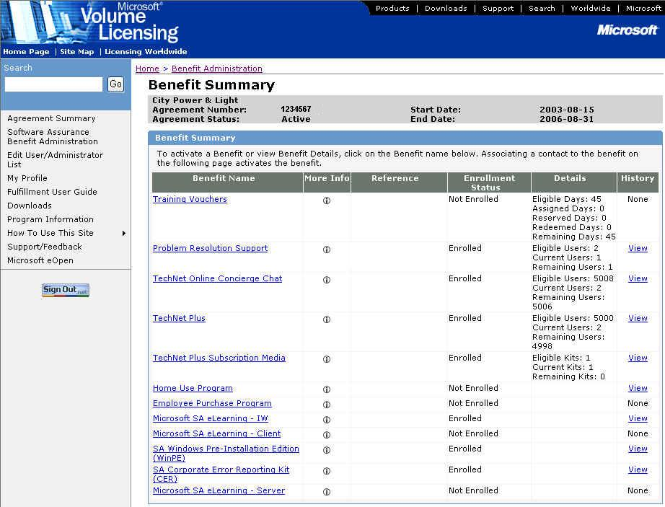

- The Choose Existing Benefit Contact window appears.

Note: This window only appears if another benefit for this agreement has been activated. If this is the first benefit activated for the agreement, the Activate Benefit window appears (see Step 5).

Note: To activate the Employee Purchase Program benefit, one benefit contact must be specified. The benefit contact will be the person responsible for providing the Program Code to the company’s employees. Please be sure the contact you specify is the proper person.
To search the list of existing benefit contacts, enter the First Name and/or Last Name and click OK.

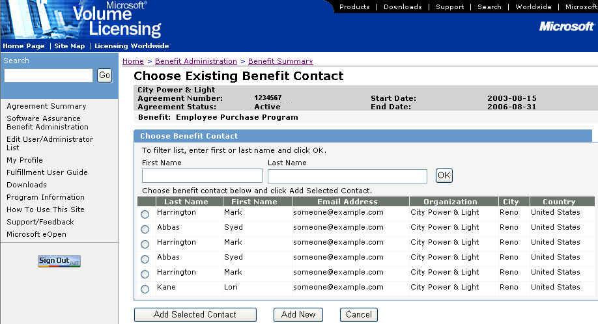

- If the person you wish to designate as the benefit contact is shown on the Choose Existing Benefit Contact window, select the radio button next to their name and click Add Selected Contact. (Go to Step 5.)

- If the person you wish to designate as the benefit contact is not shown on the Choose Existing Benefit Contact window, click Add New.

- The Activate Benefit window appears.

If you selected an existing contact, their information will be shown in the Benefit Subscriber Detail section of the window. The information will be grayed out and you cannot be modified. (If you need to modify the contact information for the person selected, see Updating Benefit Contact Information for the Employee Purchase Program Benefit.)
If you did not select an existing contact, enter the information about the Benefit Contact. The organization information will be pre-populated.

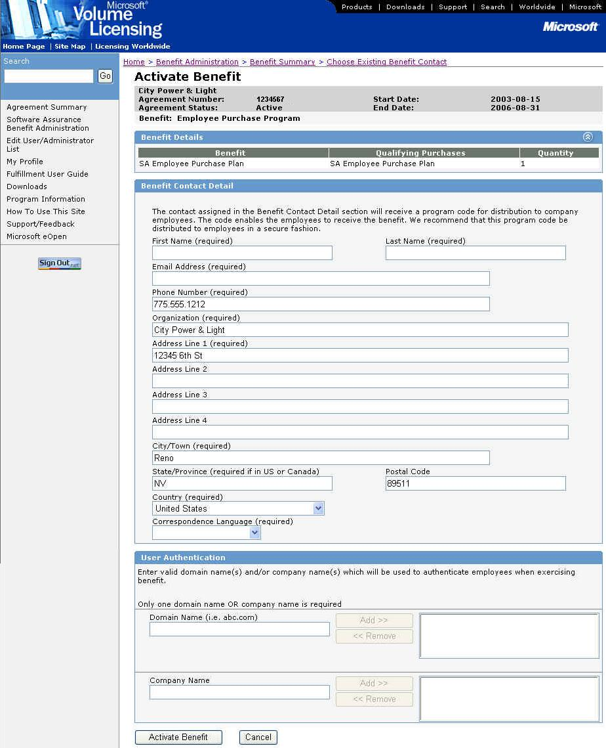

- In the User Authentication section of the window, enter a Domain Name and/or Company Name and then click Add>>. Add as many domain names and company names as is appropriate. If you accidentally add the wrong domain name or company name, highlight the erroneous entry and click <<Remove. Only one Domain Name or Company Name is required for activation.

- The Domain Name(s) and/or Company Name(s) will be used to authenticate the employee when they log into the Employee Purchase Program website.
- Up to 50 Domain Names (each may be a maximum of 40 characters) and 50 Company Names (each may be a maximum of 40 characters) can be entered.
- Domain names and company names can be added after the activation process. See Updating User Authentication Information for the Employee Purchase Program Benefit for more information.

- Click Activate Benefit.

Note: If you click Cancel, a confirmation dialog box stating “Canceling will cause you to lose all changes. Are you sure you want to cancel?” will appear. If you click OK, all changes will be deleted and the Benefit Summary window appears. If you click Cancel, you will return to the Activate Benefit window.

- The Benefit Activation Confirmation window appears.

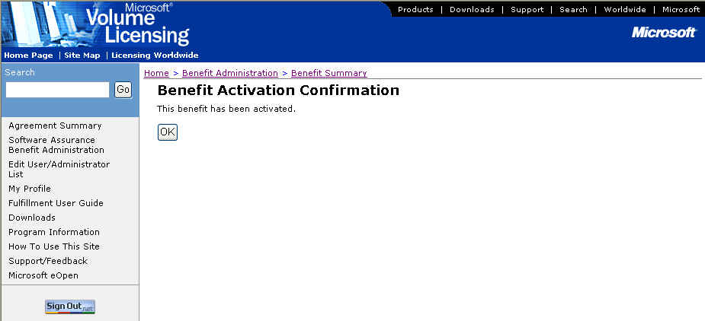

- Click OK to display the Benefit Details window.

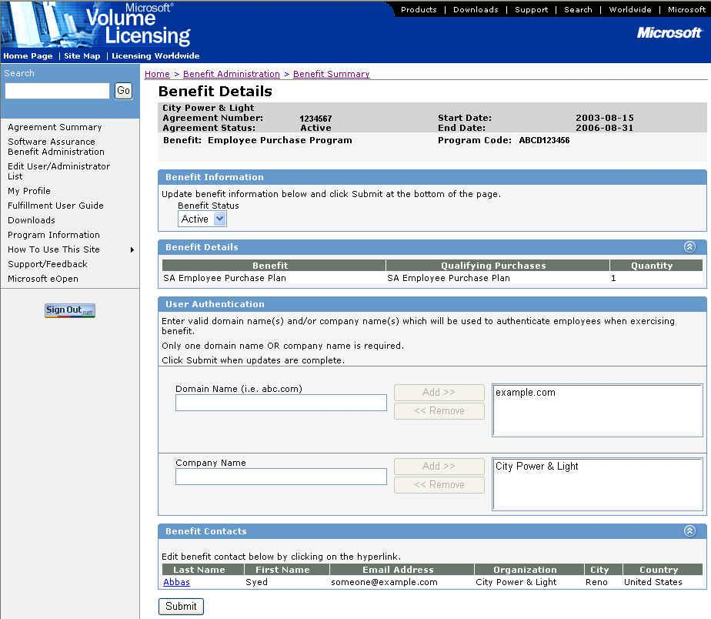

Once the benefit has been activated:
- The Enrollment Status on the Benefits Summary window is changed to Enrolled and the History column value changes to View. To view the benefit history, see Viewing the Employee Purchase Program Benefit History.
- A Program Code has been assigned which your employees will need to access the Employee Purchase Program website (in addition to their corporate email address and/or company name). The Program Code can be viewed on the Benefit Details window or on the Benefit Summary window (in the Reference column).
- The benefit contact specified during activation will receive an email with program information, information for the company Intranet, and an email template to use when informing eligible employees of the Employee Purchase Program benefit. See Employee Purchase Program Enrollment Email for complete text of the email.
- If you need to change the designated benefit contact, see Changing the Benefit Contact for the Employee Purchase Program Benefit for more information.

Return to Topic List

Viewing Employee Purchase Program Benefit Details

To view the Employee Purchase Program benefit details:

- On the Benefit Summary window, click on the Employee Purchase Program link in the Benefit column.

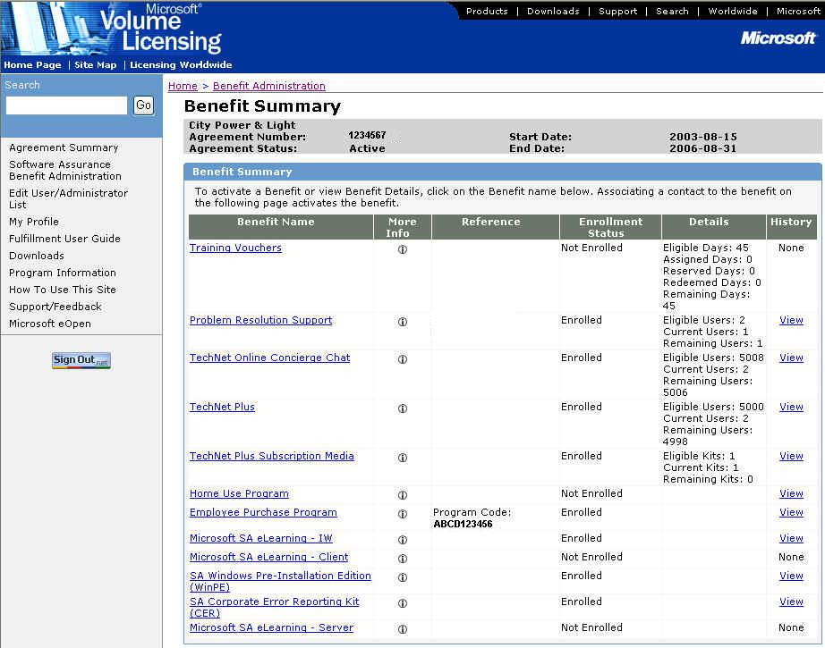

- The Benefit Details window appears showing the benefit information.

Benefit Summary Header – The Program Code is necessary for employees to access the Employee Purchase Program website.
Benefit Information – Benefit status is shown and can be changed in this section. The available benefit statuses are:
- Active – Benefit is available for consumption.
- Hold – Prevents use of existing benefit.
- Ended – Benefit subscription has come to an end. This status can be set by the Benefit Administrator when changing the benefit contact or acquiring a new Program Code. This status can also be set by Microsoft administrators.
- Inactive – Prevents the use of the existing benefit. This status can only be set by Microsoft administrators.
- Expired – Indicates that the agreement/benefit has reached the end date. This status is set automatically by the MVLS system.
- HAR (Held Awaiting Reactivation) – Indicates that the subscription has been placed into a transitory state where the subscription may not be used to consume a benefit. The subscription has not been ended and may be reactivated at a later date with the existing associated contact information. This status is set only by the MVLS system.
Benefit Details – This section displays the qualifying products that were purchased to earn the Employee Purchase Program benefit.
User Authentication – User authentication for the Employee Purchase Program website is accomplished by validating Program Code and either the corporate email domain name or company name when the employee logs into the website. See Updating User Authentication Information for the Home Use Program Benefit for more information.
Benefit Contacts – For the Employee Purchase Program only one benefit contact is required (and was entered during the activation process).
- To update the contact details, see Updating Benefit Contact Information for the Employee Purchase Program Benefit.
- To change the benefit contact, see Changing the Benefit Contact for the Employee Purchase Program Benefit.

Return to Topic List

Updating User Authentication Information for the Employee Purchase Program Benefit

User authentication for the Employee Purchase Program website is accomplished by validating Program Code and corporate email domain name (or company name) when the employee logs into the website.

To update user authentication for the Employee Purchase Program benefit:

- On the Benefit Summary window, click on the Employee Purchase Program hyperlink in the Benefit column.

- The Benefit Details window appears showing the benefit information.

To add a domain name or company name:
- Enter the domain name in the Domain Name or Company Name field.
- Click Add>>.
- Repeat steps 1 and 2 until you have added all appropriate domain names and/or company names.
- Click Submit to save the changes.

To remove a domain name or company name:
- Highlight the domain name or company name you wish to remove in the right-hand box.
- Click <<Remove.
- Repeat steps 1 and 2 until you have removed all appropriate domain names or company names.
- Click Submit to save the changes.

Return to Topic List

Updating Benefit Contact Information for the Employee Purchase Plan Benefit

There is only one benefit contact for the Employee Purchase Program benefit. The benefit contact, assigned during benefit activation, is the person responsible for informing eligible employees about the program and the information needed to access the Employee Purchase Plan website.

To update the benefit contact information:

- On the Benefit Summary window, click on the Employee Purchase Program hyperlink in the Benefit column.

- The Benefit Details window appears showing the benefit information.

- Click on the Last Name hyperlink. The Edit Benefit Contact Detail window appears.

Note: Use the Edit Benefit Contact Detail window to edit an existing contact’s information. This window should not be used to “replace” or “create” a new contact.

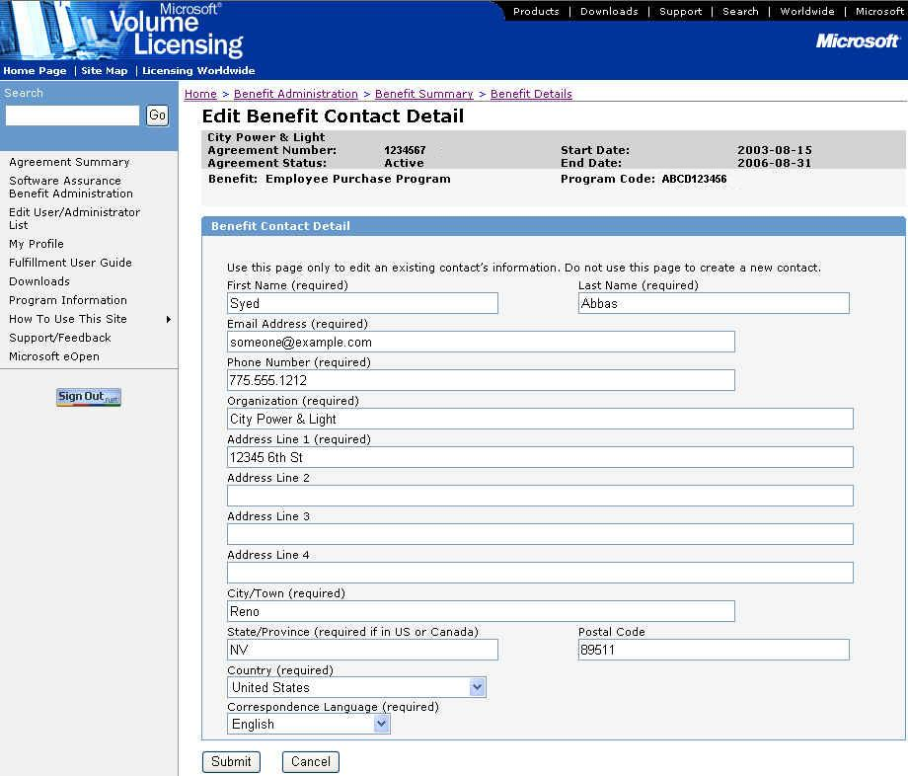

- Edit the contact information and click Submit. The Benefit Details window is displayed.

Return to Topic List

Changing the Benefit Contact for the Employee Purchase Program Benefit
If you need to change the designated benefit contact (assigned during activation), you must end the benefit (set the benefit status to Ended) and then activate the benefit.

Ending the Employee Purchase Program benefit:

- On the Benefit Summary window, click on the Employee Purchase Program hyperlink in the Benefit column.

- The Benefit Details window appears showing the benefit information.

- In the Benefit Status drop-down box, select the Ended status.

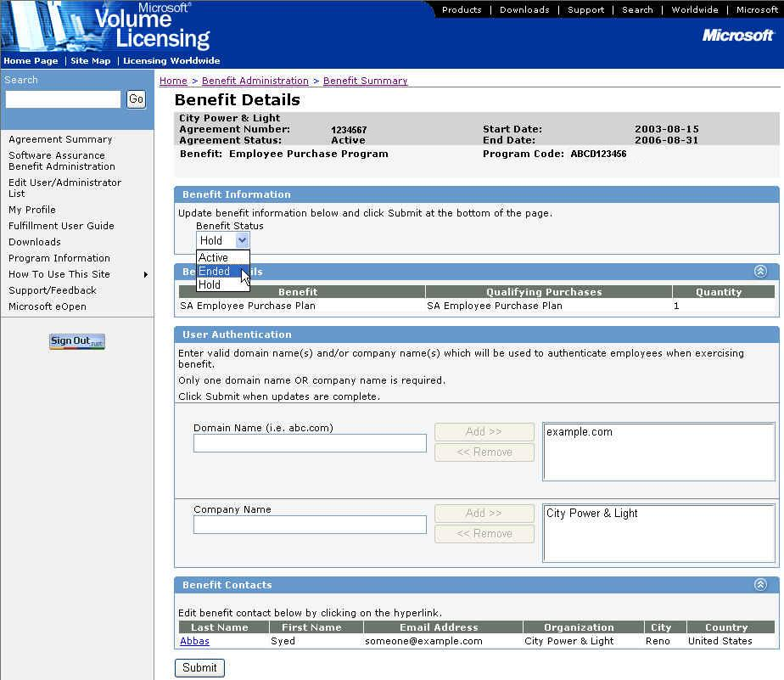

- Click Submit to change the status.

- A confirmation dialog box will appear asking “Are you sure you want to change the benefit status of selected subscription to Ended? This action cannot be undone”. Click OK to end the subscription or Cancel to cancel the status change.

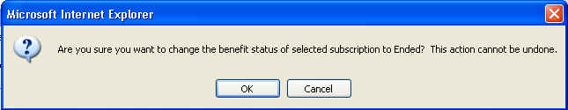

- When the status is changed, the Benefit Summary window is displayed. The Employee Purchase Program benefit will show the Enrollment Status as Not Enrolled.

Note: Once the status is set to Ended, the Program Code is no longer valid. When the benefit is activated, a new Program Code will be assigned. The new benefit contact will be notified of the new Program Code; all eligible employees must then be informed of the new Program Code.

Activating the Employee Purchase Program benefit:

This process is the same as the initial activation of the Employee Purchase Program benefit. When the benefit is activated, an automated email is sent to the designated benefit contact (see Employee Purchase Program Enrollment Email for the text of the email).

Note: All domain names and company names will have to be re-entered during activation if the benefit status was set to Ended.
See Activating the Employee Purchase Program Benefit for step-by-step instructions.

Return to Topic List

Acquiring a New Program Code for the Employee Purchase Program Benefit
If you need to acquire a new program code because it was compromised, you must end the benefit (set the benefit status to Ended) and then activate the benefit.

Ending the Employee Purchase Program benefit:

- On the Benefit Summary window, click on the Employee Purchase Program hyperlink in the Benefit column.

- The Benefit Details window appears showing the benefit information.

- In the Benefit Status drop-down box, select the Ended status.
Note: See Actions on the EPP Benefit to see which actions are allowed for the different Status settings.

- Click Submit to change the status.

- A confirmation dialog box will appear asking “Are you sure you want to change the benefit status of selected subscription to Ended? This action cannot be undone”. Click OK to end the subscription or Cancel to cancel the status change.

- When the status is changed, the Benefit Summary window is displayed. The Employee Purchase Program benefit will show the Enrollment Status as Not Enrolled.

Note: Once the status is set to Ended, the Program Code is no longer valid. When the benefit is activated, a new Program Code will be assigned. The benefit contact will be notified of the new Program Code; all eligible employees must then be informed of the new Program Code.

Activating the Employee Purchase Program benefit:

This process is the same as the initial activation of the Employee Purchase Program benefit. When the benefit is activated, an automated email is sent to the designated benefit contact (see Employee Purchase Program Enrollment Email for the text of the email).

Note: All domain names and company names will have to be re-entered during activation if the benefit status was set to Ended.
See Activating the Employee Purchase Program Benefit for step-by-step instructions.

Return to Topic List

Placing a Hold on the Employee Purchase Program Benefit

The Employee Purchase Program benefit should be placed on hold if you believe that the Program Code may have been compromised.
If you determine that the Program Code has not been compromised, set the Benefit Status back to Active (see instructions below). If the Program Code has been compromised and needs to be changed, the benefit status should be set to Ended. See Acquiring a New Program Code for the Employee Purchase Program Benefit for detailed instructions.

To place a hold on the Employee Purchase Program benefit:

- On the Benefit Summary window, click on the Employee Purchase Program hyperlink in the Benefit column.

- The Benefit Details window appears showing the benefit information.

- In the Benefit Status drop-down box, select the Hold status.
Note: See Actions on the EPP Benefit to see which actions are allowed for the different Status settings.

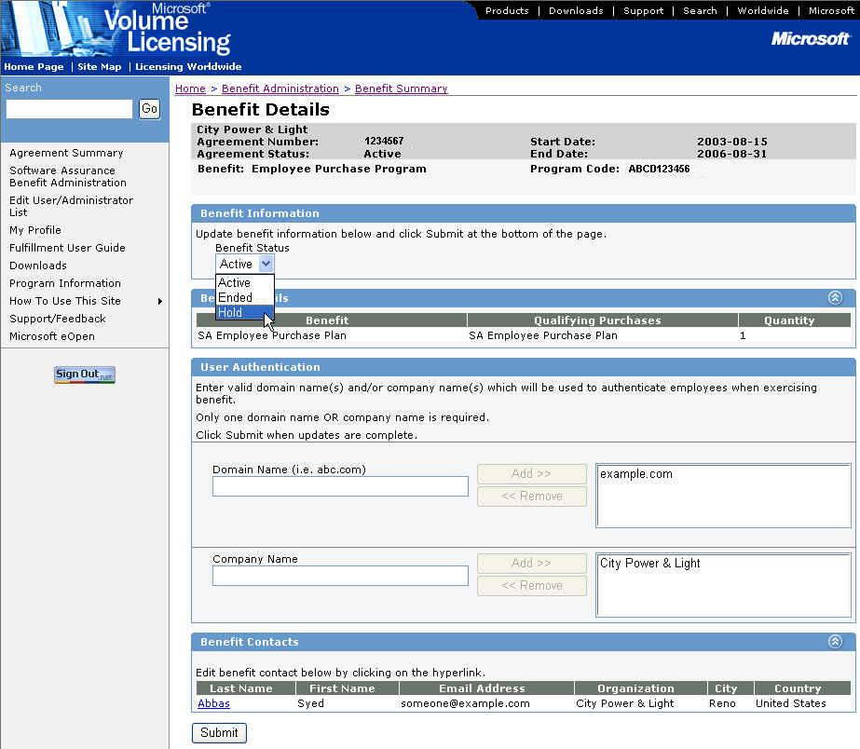

- Click Submit to change the status.

When the benefit is set back to Active status, the Program Code will not be changed.

To set the benefit status to Active:

- Repeat Steps 1 and 2 above.

- In the Benefit Status drop-down box, select the Active status.
Note: See Actions on the EPP Benefit to see which actions are allowed for the different Status settings.

- Click Submit to change the status.

When the benefit status is Active, the Program Code can be used on the Employee Purchase Program website.

Return to Topic List

Viewing the Employee Purchase Program Benefit History

To view the Employee Purchase Program benefit history:

- On the Benefit Summary window, click on the View hyperlink in the History column for the Employee Purchase Program.
Note: If the benefit is not currently Active, the history will not have a View link, instead the word None will be displayed without a hyperlink.

- The History window appears.
The History window displays information about the current and previously activated (and/or ended) subscriptions of the benefit under the agreement.

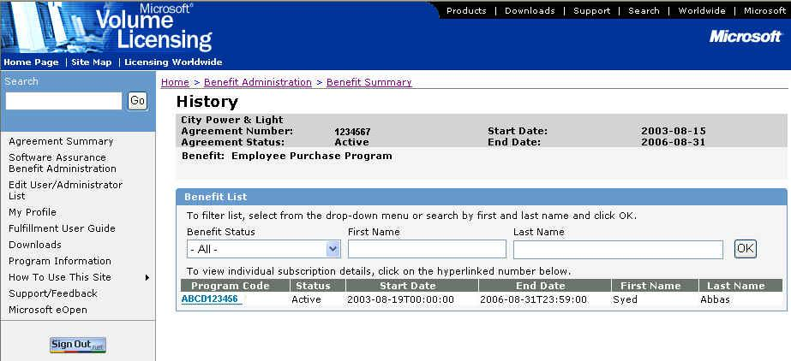

- To see subscription information, click on the appropriate Program Code in the Program Code column. Depending on the subscription status, you will be able to view or edit the subscription on the Benefit Details window. See Actions on the Employee Purchase Program Benefit for more information.

Return to Topic List

Actions on the Employee Purchase Program Benefit

Different actions can be taken on the Employee Purchase Program benefit based on the current status. The table below outlines these actions and when they can be performed.
Benefit Name | Subscription  Status | Edit Contact Detail * | Edit User Authentication ** | Status Change in UI  (Allowed - Change To)
EPP | Active | Yes | Yes | Yes - Hold, Ended
EPP | Expired | No | No | Yes - Ended
EPP | Ended | No | No | No
EPP | HAR | No | No | Yes - Ended  (Active - Process Only)
EPP | Hold | Yes | Yes | Yes - Active, Ended
EPP | Inactive | No | No | Yes - Ended

Return to Topic List

Employee Purchase Program Enrollment Email

When the Employee Purchase Program benefit is activated, the benefit contact specified during the activation process (usually the Benefit Administrator) will receive an automated email. The email contains program information, as well as an email template to use when sending program information to eligible employees.

Text of the Employee Purchase Program enrollment email:

Subject: Your Microsoft® Software Assurance Employee Purchase Program (EPP) benefit is now available

From: <Benefit Administrator Email Address>

Body:
Dear <First Name> <Last Name>,

Please note that the contents of this email have been created by the Microsoft Worldwide Software Assurance enhancements team and are being sent to you by Microsoft, on behalf of your Benefit Administrator <Insert BA Name> within your organization.

Welcome to Microsoft® Software Assurance enhancements. As a Software Assurance customer, your organization is eligible for benefits which can help you get the most value from up-to-date technology. The Microsoft Employee Purchase Program (EPP) is one of these enhancements and you have been selected as the Benefits Contact. In this capacity, you will be responsible for the deployment of this benefit within your organization.

As part of the EPP offering, employees within your organization are eligible to purchase a variety of some of Microsoft’s most popular consumer software and hardware at discounted prices. These products are for employees’ personal use and can be delivered to them.

How do your employees obtain this EPP benefit?
They can order online at the Microsoft EPP web site. In order to access this web site, your employees must use the unique program code provided below for your organization. Please retain this program code and only distribute it to employees within your organization.

To access the Microsoft EPP site, your employees should follow the steps below:
- Go to https://epp.microsoft.com/
- Choose your preferred country and language
- Enter your corporate email address, company name and program code
- Place your order on-line and it will be shipped to you

The unique Program Code is: <Program Code>
Please note that this program code is only valid for the duration of your Software Assurance coverage, under your Microsoft Volume Licensing Agreement.

How do you communicate this benefit to your employees?
In order to help you communicate this benefit, Microsoft has attached an email template that is available for you to customize and send to your employees to inform them of the availability of EPP. Please be sure to include the Program Code provided above in the email.

The use and deployment of the Microsoft Software Assurance EPP benefit is subject to the terms and conditions of your Microsoft Volume License Agreement, the Product Use Rights (PUR) and the applicable eligibility criteria set forth in the Microsoft Product List and the MVLS web site.

If you have any questions about the Microsoft Employee Purchase Program or need additional information or materials, you may email or phone our support centre. Contact details are provided in the Support/Feedback link on the MVLS < MVLS is the hyperlink, takes the user to: https://licensing.microsoft.com > web page.

Once again, we welcome you to Microsoft Software Assurance enhancements! We trust you will enjoy these benefits and we look forward to your participation and feedback. Feedback for your country or region can be provided at https://licensing.microsoft.com by clicking on the Support/Feedback link.

Thank You,

Microsoft, on behalf of your Benefits Administrator

--------------------------------------------------------------

EPP TEMPLATE NOTIFICATION EMAIL
Heading: Microsoft Employee Purchase Program now available

As part of a new offering from Microsoft, you are eligible to purchase some of Microsoft's most popular consumer software and hardware at discounted prices. This offering includes products such as Microsoft® Office XP Professional, Microsoft Windows® XP Professional, Microsoft Money 2003 and some of the newest games and hardware! You may purchase up to three copies of any product available.

To access the Microsoft Employee Purchase Program web site, please follow the steps below:
- Go to https://epp.microsoft.com/ and insert the following program code <Insert Program Code here>
Note: this program code is assigned to our organization for our sole use in accessing this site. You may not share this number with anyone outside our organization.
- Choose your preferred country and language
- Enter your corporate email address, company name and program code
- Place your order on-line and it will be shipped to you

Please note that MSEPP member exclusive offers are valid only while supplies last. Orders cannot be shipped to PO boxes. Your Microsoft EPP purchases are conditioned on your employee status. See https://epp.microsoft.com/ for details.

We trust you will enjoy this benefit and look forward to your participation.

Yours sincerely,

<Insert Your Contact Details>
© 2003 Microsoft Corporation. All rights reserved. Microsoft, Windows, Encarta and SideWinder are either registered trademarks or trademarks of Microsoft Corporation in the U.S. and/or other countries.

Return to Topic List

Using the Employee Purchase Program Benefit

To use the Employee Purchase Program benefit:

- Send email to the employees eligible to participate in the Employee Purchase Program or post the information on your Intranet. The email should contain the assigned Program Code, link to the Employee Purchase Program website, and any other information about the program you wish to provide. See the email template provided in the Employee Purchase Program Enrollment Email.

- Employees will click on the link in the email or on the Intranet web page. On the Employee Purchase Program website, the employee will select their country and language (once the language is selected, the page refreshes in the appropriate language), then enter the Program Code, Work Email, and/or Company Name.

- The system will validate the Program Code and the email domain. If the email domain does not match with the Program Code, the company name is used as secondary authorization.

- The Localized Product Search Page is displayed. The employee then selects the products they wish to order.

Note: Only 3 of a particular product (SKU) may be ordered. Any number of SKUs may be ordered.

- The employee will enter their customer information, including shipping name and address, billing name and address, and contact email information.

- The system verifies the information and calculates shipping costs. On the Checkout page, the employee enters their payment information. (Acceptable payment methods vary by region.)

- After submitting the order, the Order Confirmation window is displayed. The employee should print this page for future reference. In addition, the employee receives an order confirmation email.

- The employee receives the products ordered from the vendor.

Return to Topic List

Additional Notes

- If you believe the Program Code has been compromised, you can place the benefit on hold (while you confirm) or end the benefit and then acquire a new Program Code. See Placing a Hold on the Employee Purchase Program Benefit or Acquiring a New Program Code for the Employee Purchase Program Benefit for more information.

Return to Topic List

Assistance with the Employee Purchase Plan Benefit

For assistance administering the Employee Purchase Program benefit, go to the MVLS Support page (select Support from the left navigation bar on the MVLS site).
For assistance with the Employee Purchase Program website, click Contact Us on the website.

Return to Topic List

Glossary of Terms

Benefit Status – The available benefit statuses are:
- Active – Benefit is available for consumption.
- Hold – Prevents use of existing benefit.
- Ended – Benefit subscription has come to an end. This status can be set by the Benefit Administrator when changing the benefit contact or acquiring a new Program Code. This status can also be set by Microsoft administrators.
- Inactive – Prevents the use of the existing benefit. This status can only be set by Microsoft administrators.
- Expired – Indicates that the agreement/benefit has reached the end date. This status is set automatically by the MVLS system.

Company Code – The name the company is referred to or is knows as publicly. The name could potentially include division names (e.g., Microsoft, Microsoft.com).

Domain Name – Email domains upon which company employees conduct official business (e.g., microsoft.com).

Program Code – Unique code used to provide access for a company’s employees to the Employee Purchase Program website.

Return to Topic List

