
Microsoft Office Outlook 2007 with Business Contact Manager
February 2006

Table of Contents

Cover is for
position only

Overview of Microsoft Office Outlook 2007 with Business Contact Manager 1
Organize Your Customer Information in One Place 2
Manage Sales Activities 3
Create and Track Marketing Activities 4
Centralize Project Information 4
Manage All Your Customer Information in One Place 5
Organize and Manage Contacts in Outlook 5
Link Communications to Your Customer Records 7
Customize Your Information 8
Integrate Customer and Financial Information 9
Improve Security with Multiuser Access 10
Access Customer Information Anywhere 12
Import Contact Information 12
Position Your Company for Growth 12
Integrate with Third-Party Applications 13
Manage and Forecast Sales Opportunities 14
Track Leads and Opportunities in One Place 14
Get a Dashboard View of Your Sales Pipeline 15
Generate Standard and Customized Reports 16
Convert Opportunities to Quotes, Orders, or Invoices 18
Create and Track Marketing Activities 19
Create Targeted Mailing Lists for Print and E-Mail Marketing 19
Personalize Your Communications 21
Track Marketing Campaigns 22
Assess Your Marketing Efforts 22
Manage Project-Related Information in One Place 23
Track All Project Information in One Place 23
Share Project Information Easily 25
Simplify Project Tasks 25
Summary 26
Resources 27
System Requirements 28

Overview of Microsoft Office Outlook 2007 with Business Contact Manager
Small businesses face many of the same challenges as larger companies, but with far fewer resources. Competition is fierce, time is always in short supply, and limited budgets often limit marketing capabilities. One of the most challenging aspects of running a business is developing a customer base—and then maintaining it. Companies need to be able to respond to customer inquiries, manage customer relations, and follow up on sales leads. And to do this, they need an effective, easy-to-use contact management solution.
Although there are many customer relationship management (CRM) software solutions available, most are tailored to the needs of larger companies and demand a large investment in capital expense and employee training. They also may not integrate well with the other applications typically found in smaller businesses. To be effective, small businesses need a contact management solution that is attractively priced, readily integrates with their other applications, and can easily be learned by their employees without extensive training. Microsoft® Office Outlook® 2007 with Business Contact Manager is that solution. By combining robust contact management features with the Microsoft Office Outlook 2007 messaging and collaboration client, small businesses can easily centralize contact and customer information using the Outlook user interface with which they are already familiar.
Office Outlook 2007 with Business Contact Manager integrates new tracking and reporting capabilities with Office Outlook 2007 to help businesses more easily manage sales leads and opportunities throughout the sales process, and service their customers after the sale. Now small businesses can manage marketing campaign activities in-house. Office Outlook 2007 with Business Contact Manager provides effective tools for creating targeted mailing lists, personalizing and distributing print and e-mail marketing materials, and tracking results. And Office Outlook 2007 with Business Contact Manager provides tools for centralizing project information and following up on project-related tasks.
This document provides an overview of the benefits of Office Outlook 2007 with Business Contact Manager. It also takes a close look at Office Outlook 2007 with Business Contact Manager in action, providing examples of how some of its features might be used.
Office Outlook 2007 with Business Contact Manager in Action: Overview
Aaron Con has owned Contoso Landscaping, a residential and commercial landscape design company, for 20 years. Contoso Landscaping started out as a one-man company, but today Aaron employs a full staff, including his design team, two account managers, and an office manager. These days, Aaron oversees the sales and marketing processes for the company. He and his team rely on Office Outlook 2007 with Business Contact Manager to consolidate their customer information, help forecast and manage sales opportunities, track marketing projects, and monitor the results.

Organize Your Customer Information in One Place
Use Office Outlook 2007 with Business Contact Manager to consolidate your contact and customer information and simplify customer information management.
- Consolidate contacts and customer information. Gain access to all information related to each contact—including e-mail messages, phone calls, appointments, tasks, notes, and documents—from one place.
- Customize contact and customer information. Capture the information that is most relevant to your sales and business processes.
- Share customer information with coworkers. Provide password-protected network access and share information using more secure multiuser features.
- Stay connected when you are out of the office. When you are on the road, you can work offline on your laptop or Pocket PC—and then synchronize information when you return.
- View customer financial history at a glance. When used with Microsoft Office Small Business Accounting, you can see all your customer financial and communication history in Office Outlook 2007 with Business Contact Manager.
- Simplify billing. When you use Office Outlook 2007 with Business Contact Manager with Office Small Business Accounting 2006, you can track billable time on your Outlook calendar and then convert it into invoices.
- Integrate with custom applications. With the software development kit (SDK), technology developers and consultants can customize Office Outlook 2007 with Business Contact Manager to integrate with other line-of-business applications.

Manage Sales Activities
Follow up on sales leads and opportunities and track activities throughout the sales process:
- Manage your sales leads and activities in one place. Contact information, sources of leads, communications history, documents, appointments, and tasks all are collected and managed in the familiar Outlook environment.
- Manage sales opportunities. Track and monitor opportunities by type, sales stage, products and services offered, projected amount of sales, and probability of closing. Then easily assign leads to your employees.
- Identify your best opportunities. Gain insight into your best sales opportunities by tracking prospects and customers from initial contact through closing and after the sale.
- Convert sales opportunities into quotes, orders, and invoices. When used with Office Small Business Accounting 2006, Office Outlook 2007 with Business Contact Manager can automatically turn opportunities into quotes, orders, and invoices.
- Forecast sales and prioritize tasks. The new information dashboard provides a customizable view of your company’s sales pipeline so that you can forecast sales and prioritize activities.
- Analyze your data. Choose from an array of customer, prospect, and opportunity reports with advanced capabilities to help you sort and filter information. You can drill deeper for more details and export your findings to Microsoft Office Excel® 2007 spreadsheet software for further analysis.

Create and Track Marketing Activities
Easy-to-use tools help you create and distribute personalized marketing communications, and then monitor the results in-house.
- Get step-by-step guidance for creating your campaigns. New guides lead you through the process of developing your marketing campaign activities.
- Market more effectively with personalized communications. Create targeted mailing lists by filtering prospect and customer data—and then use the improved e-mail merge feature with Microsoft Office Publisher 2007, Microsoft Office Word 2007, and HTML.
- Track marketing campaign activity by customer. Each marketing campaign you send to your contacts is automatically included in their communications history.
- Measure your campaign’s success. The new Marketing Campaign tracking feature helps you determine the success of your overall campaign, so you can target your activities in the future.

Centralize Project Information
New capabilities help you manage project-related tasks and information in one place and share project-related information with others in the company.
- Track, view, and access project activities and tasks in one place. The new Business Projects feature in Office Outlook 2007 with Business Contact Manager centralizes all your project information, including activities, e-mail messages, meetings, notes, and attachments.
- Assign project tasks to others. With the new Project Tasks feature, you can assign tasks to others and automatically transfer the task information to their task lists, Outlook To-Do Bar, and Outlook reminders.

Manage All Your Customer Information in One Place
Customer data can be located in many different places—from paper-based files and notes to electronic formats such as e-mail messages, documents and spreadsheets, and databases. These different formats can lead to duplicate entries, information that has been entered incorrectly, and confusing synchronization processes.
Office Outlook 2007 with Business Contact Manager takes a unique approach to storing customer information. First, it is easy to access because it is all stored in a single location. Second, this information is all located in an environment that you already know and use—Outlook.

Organize and Manage Contacts in Outlook
All contact information appears within the Outlook user interface, which is already familiar to many people, so very little training is required to get up and running quickly. Organizing contacts is simple. You can separate personal and business contacts in different address books, and you can identify each customer as an Account or Business Contact. You can also create your own categories as you need them.
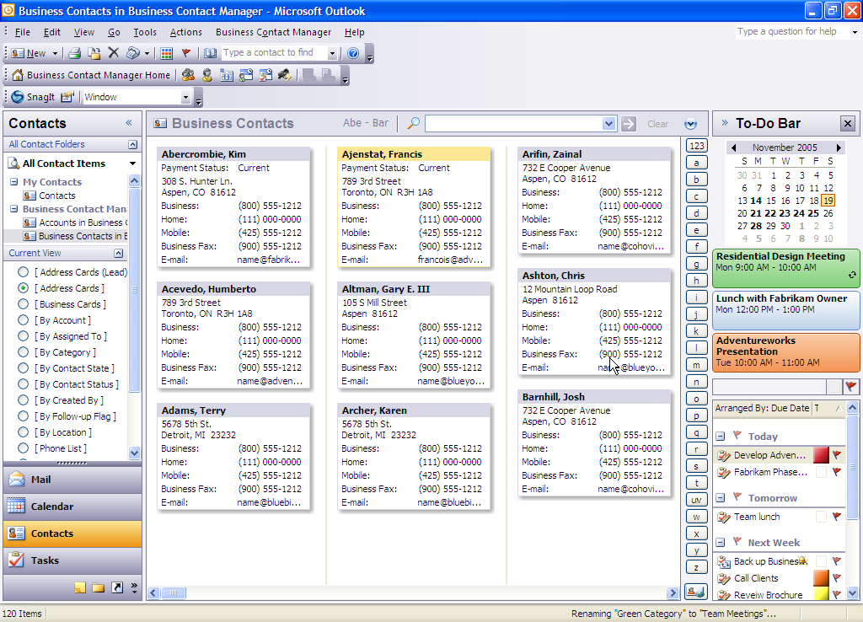
Figure 1: Viewing business contact information
Office Outlook 2007 with Business Contact Manager in Action: Consolidated view of contacts
Aaron and his employees used to store contact and customer information in separate Outlook address books, and they maintained separate client-related documents in Excel and Word, as well as handwritten paper files and notebooks. As a result, they often wasted time searching for contact and customer information. Now they store everything in Office Outlook 2007 with Business Contact Manager, and Aaron no longer wastes time searching for information. He also does not need to worry about duplicate entries or information that has not been synchronized.

Link Communications to Your Customer Records
Office Outlook 2007 with Business Contact Manager automatically links incoming and outgoing e-mail messages, notes, appointments, and tasks to the appropriate contact record. For instance, if one of your customers sends you an e-mail message, that e-mail message automatically links to the contact record. In this way, a comprehensive e-mail trail is at your fingertips whenever you need it, and you no longer need to search for specific messages.
In addition to tracking e-mail messages, you can use Office Outlook 2007 with Business Contact Manager to associate phone call logs, Microsoft Office system files, scanned documents, and faxed materials with your contact records. When you are working on a Word document or Excel spreadsheet, you can automatically associate it with a Business Contact or Account so that it appears in the communications history.

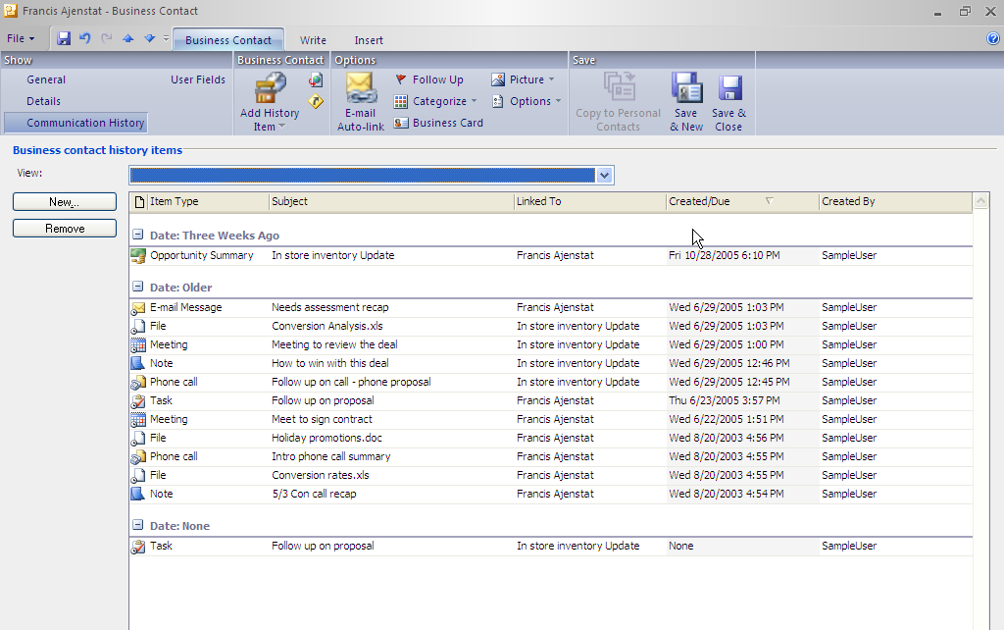
Figure 2: Managing contact-related information
Office Outlook 2007 with Business Contact Manager in Action: Centralized history of communications
Aaron used to waste a lot of time searching through old e-mail messages and sifting through documents on the network. Now he has a complete record of his company’s communications with each contact and customer in one place. For example, he can open a contact record and quickly view the date of the last e-mail communication and whether the most recent plans have been created and mailed.

Customize Your Information
With Office Outlook 2007 with Business Contact Manager, you can create new fields and categories that help tailor contact and customer information to your specific business needs. You can add new fields or change the options in a drop-down menu. For example, you may want to differentiate between two types of customers, such as wholesale and retail. No matter how you configure Office Outlook 2007 with Business Contact Manager, all your information is synchronized and appears on all screens. As a result, you stay more organized and work more efficiently.
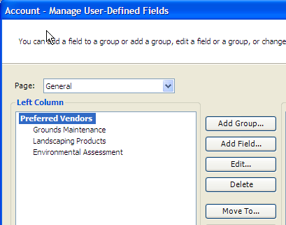
Figure 3: Customizing contact groups
Office Outlook 2007 with Business Contact Manager in Action: Customized fields
Contoso’s customers fall into two categories: residential and commercial. Aaron and his team have configured Office Outlook 2007 with Business Contact Manager to display these two groups. Whenever anyone enters a new contact, he or she also fills out a custom field that shows which group the contact belongs to. Then whenever Aaron opens a contact record, he can tell quickly which group it belongs to and alert the appropriate account manager of changes.

Integrate Customer and Financial Information
When you use Office Outlook 2007 with Business Contact Manager and Office Small Business Accounting 2006 together, data entered in either application automatically flows to the other, so you always get a complete financial picture of your customer in Office Outlook 2007 with Business Contact Manager. You can access customer financial history, including overall sales and accounts receivable as well as individual quotes, orders, invoices, and payments.
Tracking billable time can be a time-consuming and inaccurate process—and it is even more tedious to consolidate those hours and send out an invoice. When used with Office Small Business Accounting 2006, Office Outlook 2007 with Business Contact Manager helps you to track billable time and appointments directly from appointments, phone logs, and project tasks. Simply mark a calendar appointment as billable. Then you can easily consolidate your customer billings in Office Small Business Accounting and create an invoice.
Office Outlook 2007 with Business Contact Manager in Action: Billable hours
Office Outlook 2007 with Business Contact Manager has transformed how Contoso employees track billable hours. In the past, each landscape designer’s billable hours were listed on separate timesheets each week. It took hours for Darren Parker, the Contoso office manager, to compile all the data into a spreadsheet that was organized by project. Now, however, Darren and the other designers schedule client meetings and design hours in Outlook and mark the time as billable—and this information is automatically compiled. Darren then uses Office Small Business Accounting 2006 to generate an invoice quickly and easily.

Improve Security with Multiuser Access
Many different people may need access to information to do their jobs. If you are currently storing that information in a document or spreadsheet on your hard disk—or if you are the only person with access to a specific customer-management application—getting information to someone else can be difficult.
Many small businesses do not have the IT staff to set up multiuser applications that require server capabilities. As a result, you may not have sufficient processes for sharing information.
Office Outlook 2007 with Business Contact Manager makes it easy to network even if you do not have a server. With layers of password protection, you can designate who within your company should have access to your customer and prospect data.
Office Outlook 2007 with Business Contact Manager in Action: Multiuser access
As the office manager, Darren is the first point of contact for customer calls. Using Office Outlook 2007 with Business Contact Manager, he can now provide more effective customer service. For example, customers may call to request copies of their project plans. Darren simply opens the customer contact field, and all documents related to that particular customer automatically appear. He can then send those plans in e-mail right away without having to dig through other applications or wait for the landscape designer to provide the documents. He can even record the call so that the conversation is available for future reference. As a result, Darren is more efficient—and the customer has received excellent service.

Access Customer Information Anywhere
Using Office Outlook 2007 with Business Contact Manager, you can go on the road with confidence, knowing you have access to your vital contact information even when you are offline. You can view and enter information for all features of Office Outlook 2007 with Business Contact Manager from your laptop or your Pocket PC when you are out of the office, and synchronize your data when you return.
Office Outlook 2007 with Business Contact Manager in Action: Remote access
The landscape designers spend a lot of time in the field. They all have laptops that hold their client information, which gives them contact information and full communications history, so they can return calls when they have a free moment. When they return to the office, they synchronize to make sure they are up to date.

Import Contact Information
What if your customer information currently is stored in another application? Migrating contact information to a new system can be a daunting process. Office Outlook 2007 with Business Contact Manager makes it easy. Whether you are using Word, Excel, Access, or other software such as ACT!, import tools help you to quickly migrate your information to Office Outlook 2007 with Business Contact Manager.

Position Your Company for Growth
For most small companies, a desktop solution that helps manage customer contacts and sales opportunities is sufficient—for now. As your business grows, you may need to upgrade to a customer relationship management (CRM) solution. Office Outlook 2007 with Business Contact Manager is the ideal solution because it provides a clear upgrade path to Microsoft Business Solutions CRM. Microsoft CRM is a fully featured and customizable server-based customer relationship management solution that helps large networks of users to view, update, and share complete customer information across teams and departments.

Integrate with Third-Party Applications
One of the biggest challenges facing small businesses with custom business applications is synchronizing the data from those applications with their contact management software. In fact, most companies end up retyping information—a process that wastes time and makes it difficult to produce consistent information.
Office Outlook 2007 with Business Contact Manager offers a software development kit (SDK) so that your technology developers and consultants can integrate your contact management solutions with industry-specific applications. You can also work directly with IT consultants to customize Office Outlook 2007 with Business Contact Manager for your specific needs.

Manage and Forecast Sales Opportunities
Just like contact information, sales leads and opportunities can reside in many places—such as software programs, printed documents, paper files, and handwritten notes. As a result, people often spend a lot of time searching through these different resources to get an idea of how the business is doing, both today and in the future. Using Office Outlook 2007 with Business Contact Manager, you can manage all your sales leads and opportunities in one place, and get a consolidated view of your sales pipeline.

Track Leads and Opportunities in One Place
Track all the information related to sales leads and opportunities in one place, including contact information, communications history, documents, sources of leads, products and services offered, projected amount of each sale, and the probability of closing the sale. Then you can view all your leads and opportunities and determine the probability of each. As a result, you get an accurate view of your sales pipeline and can determine your cash flow for the next few months. You also can reassign leads.
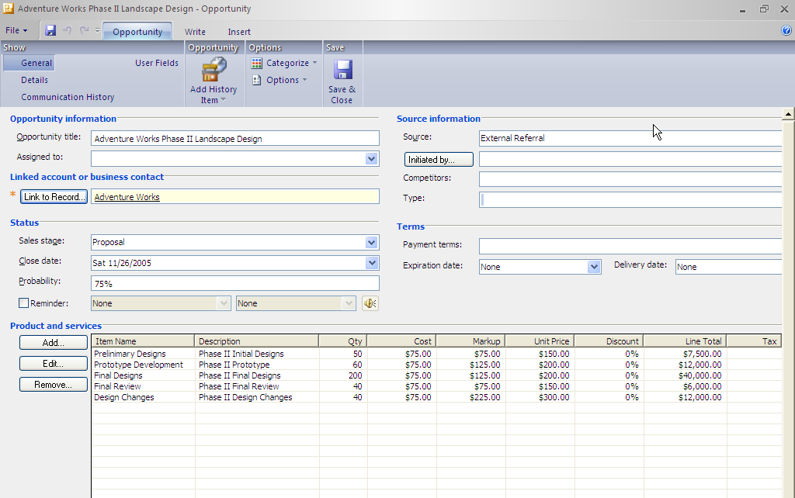
Figure 4: Viewing business opportunity records
Office Outlook 2007 with Business Contact Manager in action: Sales pipeline
Managing Contoso Landscaping’s sales opportunities is easier than ever. After Aaron enters contact information, he can then insert the source of the lead, projected amount of sale, and even the probability of closing the sale. Then he can view his sales leads in a variety of ways, assess the value of his sales pipeline, and project his cash flow for the coming months. Furthermore, he can see all the sales leads that exist in the company, or he can view leads by account. And every time he contacts his sales prospects, he records it in their profiles and schedules a follow-up call. The result is that Aaron can manage and close sales more proactively than ever.

Get a Dashboard View of Your Sales Pipeline
Often, it can be challenging to get a complete at-a-glance view of lead and sales information—yet this data is vital for planning and prioritizing sales activities. The new information dashboard is a fully customizable feature that provides a snapshot of important sales metrics so that you can prioritize your tasks.
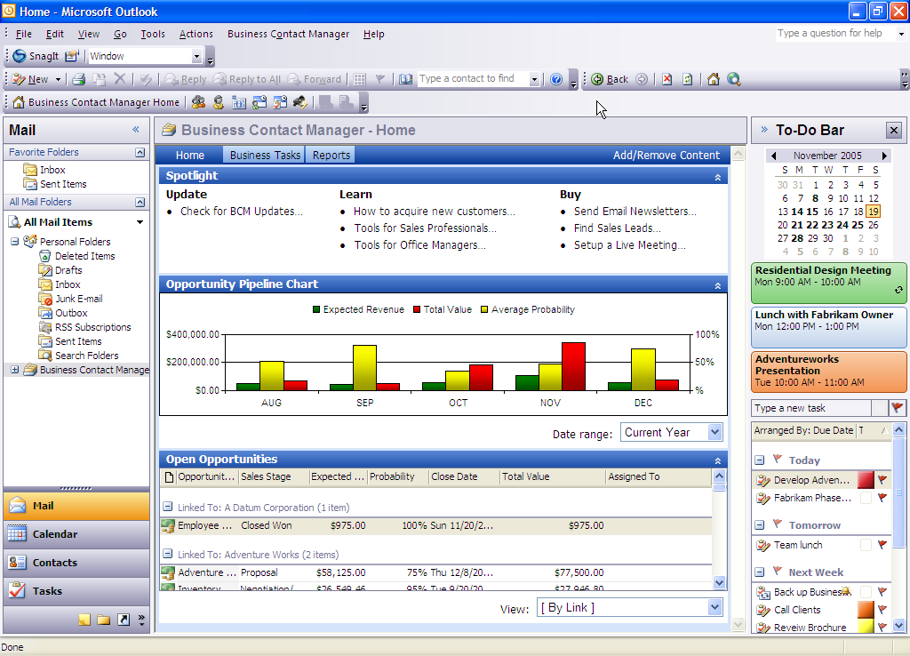
Figure 5: Using the dashboard for a snapshot of business metrics
Office Outlook 2007 with Business Contact Manager in Action: Dashboard
Aaron regularly uses the dashboard to get a quick snapshot of the sales pipeline so that he can forecast the probability of closing each sale. As a result, he can get a quick view of how much business the company will have during the next three to six months and prioritize his resources accordingly.

Generate Standard and Customized Reports
Traditionally, it has been difficult for smaller businesses to analyze customer data effectively because of limited reporting options. And of those options, even fewer can be easily customized. Office Outlook 2007 with Business Contact Manager offers new report-filtering capabilities that help you sort data based on the criteria that is most important to your business. Choose from a complete selection of customer and prospect reports, then use advanced customization features to tailor those reports to your needs. You can drill down for more details and export reports to Excel for further analysis. Plus, you can always save your customized reports for future use. Reports are a great tool to help you define new activities; for instance, you can run a report that looks for contacts with certain criteria—and then use it as the basis for a new marketing campaign.
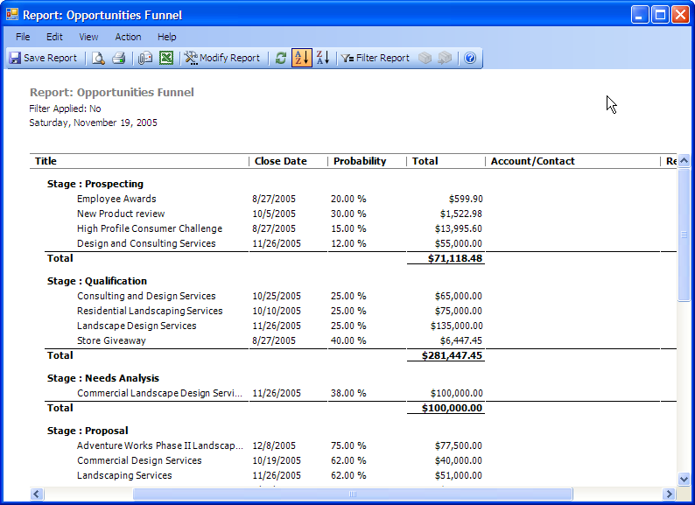
Figure 6: Funneling business reports to Excel
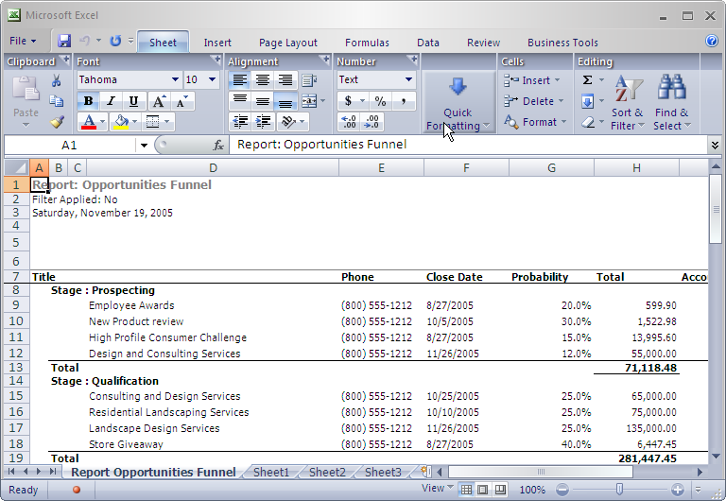
Figure 7: Viewing and analyzing reports in Excel
Office Outlook 2007 with Business Contact Manager in Action: Reports
If Aaron needs more detailed information and advanced reports, he can export data to Excel for more in-depth analysis. Using Excel, he can slice and dice data to generate the detailed reporting he needs.

Convert Opportunities to Quotes, Orders, or Invoices
When used with Office Small Business Accounting, Office Outlook 2007 with Business Contact Manager helps you turn sales opportunities into quick quotes, orders, or invoices in just a few easy steps—without having to transfer data from one application to another. And all your contact data is automatically integrated with Office Small Business Accounting.

Create and Track Marketing Activities
Office Outlook 2007 with Business Contact Manager provides an easy-to-use guide that leads you through the process of creating marketing campaigns, including compiling your mailing list, distributing materials, and then tracking your results.
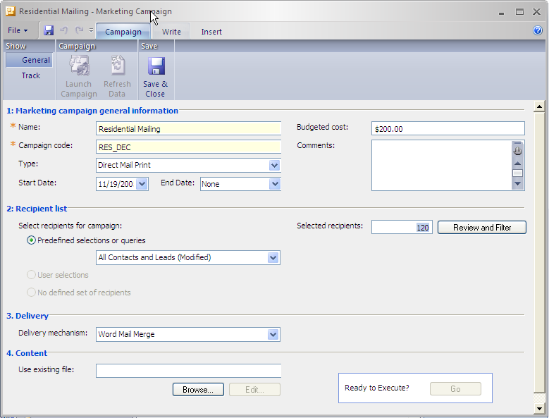
Figure 8: Using the four-step guide to create marketing campaigns

Create Targeted Mailing Lists for Print and E-Mail Marketing
You no longer have to sort through all your different contact lists just to create a mailing. Office Outlook 2007 with Business Contact Manager consolidates all your contacts in one place, making it easy to create mailing lists by filtering customer and prospect data into targeted lists for print and e-mail marketing campaigns.
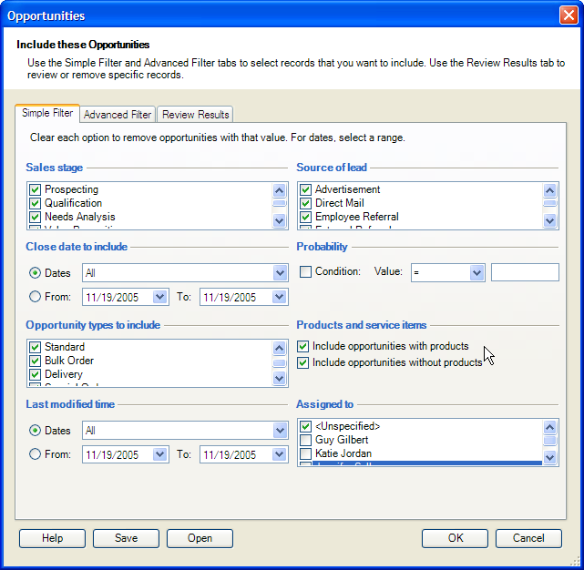
Figure 9: Filtering contact lists to create custom mailing lists
Office Outlook 2007 with Business Contact Manager in Action: Mailing lists
Aaron also manages Contoso Landscaping’s marketing through Office Outlook 2007 with Business Contact Manager. He used to spend hours compiling, checking, and then rechecking his lists to send a mailing every few months. Now he filters customer and prospect data into several different lists and sends highly targeted mailings to smaller groups every month.

Personalize Your Communications
Office Outlook 2007 with Business Contact Manager makes it simple to create personalized communications. Simply use the improved mail Merge capabilities to personalize marketing publications created in Office Publisher 2007, Office Word 2007, ListBuilder, or HTML. As a result, you can boost the effectiveness of your marketing materials in a fraction of the time.
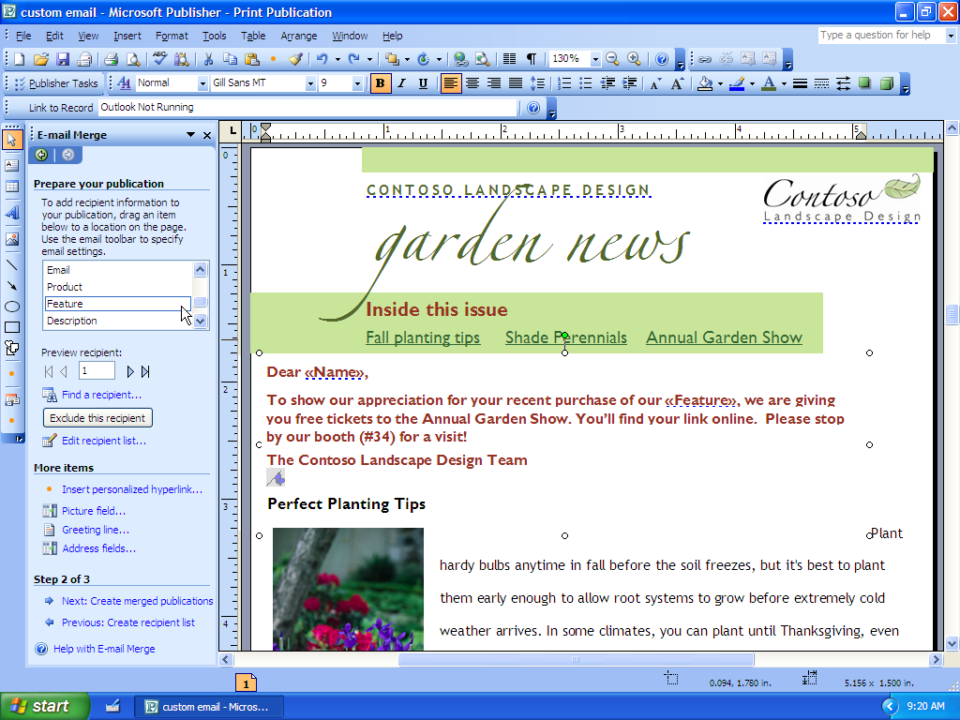
Figure 10: Personalizing your marketing materials in Office Publisher 2007

Track Marketing Campaigns
Office Outlook 2007 with Business Contact Manager eliminates the need for you to manually track each mailing sent. Every marketing piece or campaign can be linked to its recipients, so it is easy to assess the effectiveness of each campaign.
Office Outlook 2007 with Business Contact Manager in Action: Marketing campaign management
Aaron uses Office Publisher 2007 to create e-mail newsletters that help him stay in touch with prospects and customers. These provide landscaping advice, showcase recent designs, and highlight a special offer they can respond to. He uses the mail merge feature in Office Outlook 2007 with Business Contact Manager to personalize the newsletters when he sends them. Each newsletter campaign is automatically recorded in each recipient’s contact information, and he can easily track the response to each of his publications and special offers.

Assess Your Marketing Efforts
To make marketing more cost-effective, you can take advantage of the marketing campaign tracking features in Office Outlook 2007 with Business Contact Manager to gain insight into your marketing efforts. First, mailings sent are automatically associated with the communications history of the recipients. Then you can track responses to these campaigns. Plus, each time you create a new lead, you can also record its source. Finally, when you determine the overall response to campaigns, you get a complete picture of which campaigns work—and which do not. The result is that you improve and refine each successive campaign for maximum impact.
Office Outlook 2007 with Business Contact Manager in Action: Marketing campaign tracking
Aaron regularly assesses the effectiveness of each campaign. Every time he sends out a newsletter, the mailing is automatically included in the communications history of the customer who receives it. When responses to offers come in, he appends each contact record with the appropriate information. Finally, he determines which offer has been most popular. In the future, he can target those customers with similar offers.

Manage Project-Related Information in One Place
When employees do not have access to the information they need, managing project information and tasks can take far more time than it should. At the same time, it can be hard to follow up on the things you need to do if they are stored in different locations.
Office Outlook 2007 with Business Contact Manager takes the hassle out of juggling the tasks associated with projects, jobs, and clients by giving you a single place in which to store all tasks and information. New capabilities streamline activities and communications related to projects and make it easier to follow up on project tasks.

Track All Project Information in One Place
The Business Projects feature boosts your access to project information, so you can work more efficiently. Just as you can link e-mail messages, notes, appointments, and tasks to individual contacts, you can also link them to specific projects you are working on. You can associate e-mail messages, meetings, documents, notes, and tasks to a specific project. The information is readily available, whenever and however you need it—and you can easily share it with others in the company.
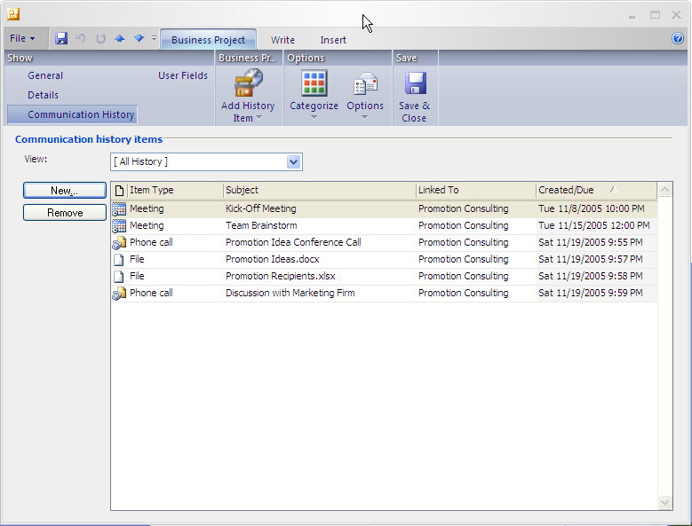
Figure 11: Creating project tasks
Office Outlook 2007 with Business Contact Manager in Action: Centralized project information
Contoso Landscaping now has one centralized storage repository for all project-related information because it is all stored in Office Outlook 2007 with Business Contact Manager. For example, all client project plans are linked to the appropriate customers. This has streamlined the way the company does business because it is easier and faster to find project-related information.

Share Project Information Easily
Office Outlook 2007 with Business Contact Manager offers multiuse capabilities for project tracking information. Now you can easily share project information across the company using more secure, multiuser access capabilities. Simply designate who should have access to project-related data.

Simplify Project Tasks
Following up on project tasks can sometimes be a cumbersome process, especially when you need to assign tasks to someone else. With the Project Tasks feature, you can assign project tasks quickly and easily. This task information is automatically transferred to individual task lists. They appear on the Outlook To-Do Bar and within Outlook reminders—so they are easy to follow up.
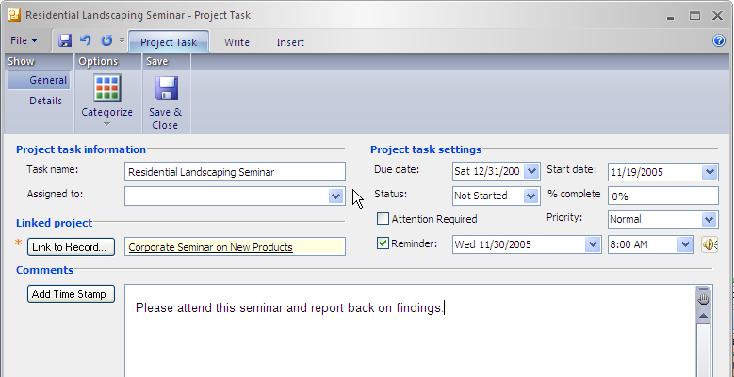
Figure 12: Delegating project tasks
Office Outlook 2007 with Business Contact Manager in Action: Project task management
The two account managers, Sandra Martinez and Michael Holm, allocate work to the landscape architects. To do this, they assign tasks that show up on individual Outlook To-Do Bars. For example, after Sandra signs on a new client, she then assigns a task to one of the landscape architects to schedule a meeting with the client.

Summary
Office Outlook 2007 with Business Contact Manager is designed to provide small businesses of fewer than 50 employees with powerful, easy-to-use capabilities that help centralize customer information, manage sales and marketing activities, and manage tasks.
With a range of new and improved features, you can now manage all your contact information directly from within the familiar Outlook interface—quickly, easily, and effectively. You can also create and monitor marketing campaigns to assess their success and improve your planning. And you can manage your project-related tasks more efficiently, giving you more time to concentrate on managing and growing your business.
Office Outlook 2007 with Business Contact Manager is easily customizable, so it can be tailored to meet your specific needs. Whether you need custom fields, custom reports, or need to integrate with a unique application, it provides a solution that meets your needs today and can grow as your company grows.

Resources
For more information about Office Outlook 2007 with Business Contact Manager, please refer to the following resources:
Office Outlook 2007 with Business Contact Manager Highlights Tab
http://www.microsoft.com/office/preview/programs/outlookbcm/highlights.mspx
Office Outlook 2007 with Business Contact Manager New Interface Tab
http://www.microsoft.com/office/preview/programs/outlookbcm/newui.mspx
Office Outlook 2007 with Business Contact Manager Why Upgrade
http://www.microsoft.com/office/preview/programs/outlookbcm/why.mspx
Office Outlook 2007 with Business Contact Manager FAQs
http://www.microsoft.com/office/preview/programs/outlookbcm/faq.mspx
Office Outlook 2007 with Business Contact Manager Overview
http://www.microsoft.com/office/preview/programs/outlookbcm/overview.mspx
Office Outlook 2007 with Business Contact Manager Top 10 Benefits (Reasons to Upgrade)
http://www.microsoft.com/office/preview/programs/outlookbcm/why.mspx

System Requirements
For complete system requirements, visit www.microsoft.com/office/preview/beta/sysreq.mspx.
This document is developed prior to the product’s release to manufacturing, and as such, we cannot guarantee that all details included herein will be exactly as what is found in the shipping product. The information contained in this document represents the current view of Microsoft Corporation on the issues discussed as of the date of publication. Because Microsoft must respond to changing market conditions, this document should not be interpreted to be a commitment on the part of Microsoft, and Microsoft cannot guarantee the accuracy of any information presented after the date of publication. The information represents the product at the time this document was printed and should be used for planning purposes only. Information is subject to change at any time without prior notice.

This document is for informational purposes only. MICROSOFT MAKES NO WARRANTIES, EXPRESS OR IMPLIED, IN THIS DOCUMENT.

© 2006 Microsoft Corporation. All rights reserved.

Microsoft, the Office logo, Excel, and Outlook are either registered trademarks or trademarks of Microsoft Corporation in the United States and/or other countries. All other trademarks are property of their respective owners.

