Overview  Country or Region: Asia & Middle East  Industry: Construction & Mining  Customer Profile  With 40,000 employees, Leighton International is a leading construction group that undertakes civil engineering, building, mining and offshore projects in Asia and the Middle East.  Business Situation  Leighton International’s operating sites are can be remote and inhospitable, with communications often dependent on low bandwidth satellite links. File servers were locally set up, making them difficult to monitor and back up.  Solution  New functionality in Windows Server® 2008 enabled sites to centralise file storage in Singapore without significantly impacting network performance. Mail servers were centralised in Singapore using Exchange Server 2007.  Benefits  - Higher availability for on-site servers  - Guaranteed enforcement of company back up policy  - Improved security  - Better overall system support  - Reduction in management costs |  |  | “It’s amazing when you think that we can remotely and reliably support systems in the middle of oceans and jungles, and not incur any significant drop in performance.”  Michael Clothier, Team Leader, Infrastructure and Windows, Infoplex
 |  |  | Leighton International is a subsidiary of the Australian Leighton Group, managing over 30 infrastructure and mining projects across Asia. Reliance on low-bandwidth satellite links at highly remote and inhospitable sites meant that mail and file servers had to be located onsite. This decentralised architecture exposed Leighton International to several liabilities. If a server became inoperable, technical staff could take days to reach the project site, during which time user access, mail and documentation could be unavailable. In addition, the high-latency network link inhibited effective offsite replication. In 2009, Leighton International centralised IT infrastructure at a data centre in Singapore using Windows Server 2008 Distributed File System (DFS). As a result, staff in remote sites have improved server availability, network security and back up performance.
 |  |  | 

Situation
Leighton International is a subsidiary of Australia’s largest project development and contracting company, Leighton Group. Employing 40,000 staff, the company manages and executes civil engineering, infrastructure, building, mining, offshore and rail projects in Brunei, India, Indonesia, Malaysia, Qatar, Saudi Arabia, Singapore, Sri Lanka and the United Arab Emirates.

Many of Leighton International’s 30 operating sites are in remote and inhospitable locations. Its mines on Borneo are located in jungles that are many hours’ drive from the nearest town and its gas pipe-laying operations are conducted from offshore barges.
“The low-bandwidth connections we had severely restricted head office’s capacity to back up files and mail without slowing or interrupting site communications.” Michael Clothier, Team Leader, Infrastructure and Windows, Infoplex.

As the company commenced new projects, it installed on-site file servers that ran off generators. The more remote sites were dependent on low-bandwidth, high latency, 512 kilobit per second (Kb/s) satellite links to country-based wide area networks (WANs) with each country operating its own domain structure. Although this infrastructure enabled Leighton International to set up new sites in hostile locations very quickly, the company’s technology support subsidiary, Infoplex, had to contend with numerous challenges.

“Although it worked well at a site-level, at an international level, this distributed infrastructure was difficult to manage,” says Michael Clothier, Team Leader, Infrastructure and Windows, Infoplex. “Email routing across the business was complex and the servers suffered from low availability.

In addition, low bandwidth and the potential unavailability of servers made it difficult for Leighton International to enforce group-wide backup protocols and long-term document storage policy.

“Because there were few, if any, offsite backups, disaster recovery was a potential minefield. However, the low-bandwidth connections we had severely restricted head office’s capacity to back up files and mail without slowing or interrupting site communications,” says Clothier.

Lastly, local IT administration was problematic. Finding qualified staff who could be based on-site was difficult, and those who were employed on-site needed unconstrained file and domain access to support the self-contained site IT infrastructure. This exposed the company to potential liabilities.

Solution
In June 2008, Infoplex staff working in conjunction with Microsoft began to design a new IT infrastructure. Their objectives were to find a way to regularly and easily back up all files and mail, simplify the mail domain structure, reduce security risks and improve onsite server availability.

“What we wanted was to establish a centralised data repository where we could ensure backups were maintained and files archived in line with company policy,” says Clothier.

Staff worked out that they could take advantage of feature upgrades in Microsoft® Exchange Server 2007 and Windows Server® 2008 on which it was running. This would enable them to take file backup off-site, despite the highly constrained bandwidth.

“The Distributed File System in Windows Server 2008 scans all the files on the primary server – in this case the site servers – and compares them to see exactly where any changes have been made,” says Cooper. “Then when the files are replicated, the server only updates the part of the file that has changed rather than the whole file, so there is a dramatic reduction in bandwidth requirements.”
Windows Server 2008 also includes Microsoft-developed Server Message
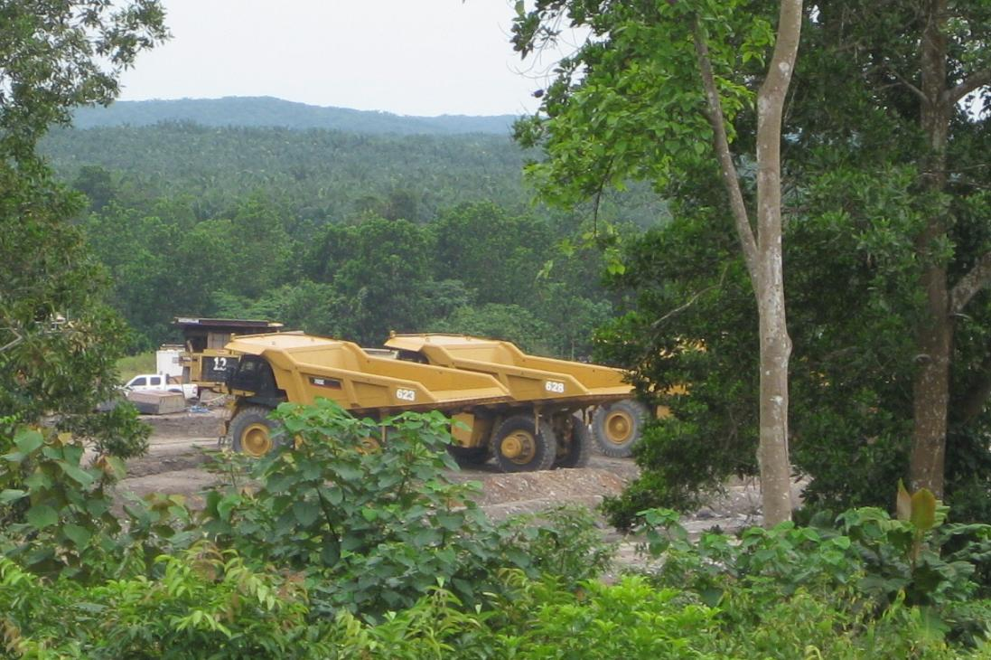
One of Leighton International’s operating sites in the interior of Borneo.
Block 2 (SMB2) network protocol technology. By combining multiple server requests into single actions, SMB2 reduces client-server traffic and in effect adjusts the internet file size to optimise the WAN link.

Now that it was feasible to centralise file storage and backup, staff looked at how they could reconfigure the mail system.
“We can monitor site servers for errors and disk space, wherever they are. Consequently, its very easy for us to forestall server breakdowns and provision new servers, so our sites suffer fewer servers outages and our email is more reliable.”
Michael Clothier, Team Leader, Infrastructure and Windows, Infoplex

“Exchange Server 2007 has a Standby Continuous Replication (SCR) technology that combines high service and data availability with resilience,” explains Clothier. “This is a disaster recovery technology that means that data is automatically and efficiently replicated to a backup server, so that in the event of a server failure, a replacement mail server can become operational almost immediately.”

In August 2008, Infoplex began to decommission Leighton International’s site mail servers. It replaced them with client applications that link via the WAN to a central Microsoft Exchange Server 2007 domain network in the company’s Singapore data centre. In addition, Infoplex commissioned Windows Server 2008 machines in Singapore that replicated all site information and provided a central repository of Leighton International files.

Finally, Infoplex deployed WAN accelerators to expedite regular WAN traffic and help ensure that routine communications did not clog the high-latency 512 Kb/s links.

Benefits
The centralised file and mail infrastructure has dramatically improved the performance and reliability of Leighton International’s remote onsite systems.

Hostile environments
With the servers centrally located in Singapore, systems staff can now support network access and file availability in exceptionally hostile and remote terrain.

“We can monitor site servers for errors and disc space, wherever they are,” says Clothier. “Consequently, it’s very easy for us to forestall server breakdowns and provision new servers so our sites suffer fewer server outages and our email is more reliable.”

Leighton international has installed the new infrastructure on two ocean barges that are laying oil pipelines in waters off the Indian coast. The barges have to support 30–40 users each on a standard 512Kb/s satellite link.

“It’s amazing when you think we can remotely and reliably support systems in the middle of oceans or jungles, and not incur any drop in performance,” says Clothier.

Assured backup
By devising a way to systematically back up all mail and project files, Leighton International can conform to company data storage protocols.
“The Distributed File System (DFS) in Windows Server 2008 has cut replication time by approximately three quarters, which helps support staff replicate all onsite data without swamping the satellite link,” says Clothier.

“Instead of trying to replicate 100 gigabytes of data at a time, we often only need to replicate 3 or 4 gigabytes,” adds Cooper. “Plus now we can do it when we want to, and do it off-site.”

In addition all mail is carefully archived in Singapore, and staff have confidence that they can access historical emails whenever they need them.

“Project staff aren’t hitting storage limits on their local mail server, so they don’t store mail on their hard drives,” says Clothier.

Onsite security
Administration is now carefully delegated and local staff no longer need extensive privileges.

“Now our exchange server infrastructure has a multi-tiered firewall, with an audited login process. Only data centre staff have full access rights, and all the logins can be tracked,” says Clothier. This gives us a much higher degree of security.”

Windows Server 2008
For More Information
For more information about Microsoft products and services, call 132058 or visit our Website at: www.microsoft.com/australia/business/bi/

For more information about Leighton Infoplex products and services, call
1300 729 533 or visit the Web site at: www.infoplex.com.au

For more information about Leighton International products and services, call +971 4 423 0300 or visit the Web site at: www.leightonint.com/v1/

This case study is for informational purposes only. MICROSOFT MAKES NO WARRANTIES, EXPRESS OR IMPLIED, IN THIS SUMMARY.

Document published September 2009

Software and Services
- Products
- Microsoft Exchange Server 2007
- Windows Server 2008

Windows Server 2008, with built-in Web and virtualization technologies, enables you to increase the reliability and flexibility of your server infrastructure. New virtualisation tools, Web resources, and security enhancements help you save time, reduce costs, and provide a platform for a dynamic and optimized datacenter. Powerful new tools like IIS 7.0, Server Manager, and Windows® PowerShell, allow you to have more control over your servers and streamline Web, configuration, and management tasks. Advanced security and reliability enhancements like Network Access Protection and the Read-Only Domain Controller option for Active Directory Domain Services harden the operating system and help protect your server environment to ensure you have a solid foundation on which to build your business.

For more information, go to:
www.microsoft.com/windowsserver2008

