Overview
Mobile devices are a critical part of your IT infrastructure; they connect information workers to your corporate network wherever and whenever they need access to corporate data. Managing these devices has been a challenge. System Center Mobile Device Manager 2008 and Exchange Server 2007 combine to make Windows Mobile 6.1 devices first-class citizens in your IT infrastructure by helping you address evolving needs around security and management while connecting end users to the information they need, where and when they need it. Mobile Device Manager product delivers on three core areas — Security Management with full Active Directory integration and support for over 130 security policy settings, Device Management for OTA provisioning, inventory, and reporting, and an IPsec-based Mobile VPN connectivity to secure your Windows Mobile 6.1 platform. Exchange Server 2007 provides industry-leading unified communications access for mobile devices, and key Security Management features for mobile devices. In addition to comprehensive Security Management features, System Center Mobile Device Manager 2008 has a full suite of robust device management capabilities, including software updates, inventory, and over the air provisioning of mobile devices and a Mobile VPN to secure the device platform and network access. This document provides an overview of key device management capabilities of System Center Mobile Device Manager 2008 and Exchange Server 2007. Exchange provides best-in-class unified communications and mobile messaging support, while SCMDM is a comprehensive device management solution for Windows Mobile 6.1 devices.
Microsoft System Center Mobile Device Manager 2008
System Center Mobile Device Manager (SCMDM) 2008 is a comprehensive management solution that is designed to enable efficient control of Windows Mobile 6.1 devices and provide reliable, low-cost, and consistent manageability that works well with your existing Microsoft infrastructure, and helps enable more secure access to the corporate network. SCMDM adds mobile device management to the rest of your corporate asset management capabilities, giving you a single point of unified management for all corporate Windows Mobile 6.1 devices. SCMDM extends your management environment to mobile devices by delivering:
- Full integration with Active Directory. Mobile devices can be joined to Active Directory domains, and they can receive over 130 Group Policy settings so you can define user and device groups, and automatically apply consistent settings for mobile device usage.
- Self-service device provisioning and bootstrapping so that you can quickly set up new devices.
- Full inventory data for all enrolled devices in the enterprise in one console, including device model, make, and software updates deployed. SCMDM is designed to work well with existing Microsoft monitoring and reporting tools, with the ability to run robust reports based on SQL Server 2005.
- Rich software targeting capabilities so you can deploy targeted firmware and software updates. Software distribution is based on Microsoft’s proven and widely deployed WSUS 3.0 technology.
- Enterprise-level control over which applications may, and may not, be run on managed devices. SCMDM’s application allow and deny features empower you to decide which software applications and hardware features may run on which devices for productivity, compliance, or other reasons.
SCMDM 2008 breaks new ground by including powerful IPsec-based mobile VPN capabilities. It provides a robust, high-security way for mobile devices to connect to line-of-business applications data on the corporate network, using industry standard protocols (including IKEv2 and MobIKE). Performance optimization is achieved via Fast Reconnect and Session Persistence, and the IPsec tunneling encapsulates all underlying traffic, including any SSL traffic from another source such as ISA Server 2006, to protect critical IT assets and secure the mobile device platform.
Microsoft Exchange Server 2007
Exchange Server 2007 is the world’s premier messaging solution that helps you give your users a reliable messaging system with built-in protection against spam and viruses with built-in, anywhere access to e-mail, voice mail, calendars, and contacts from a wide variety of devices. Exchange Server 2007 includes powerful mobile device support as part of the base product, including full wireless synchronization of contacts, calendar data, tasks, and e-mail, voice mail, and fax messages. The Exchange 2007 Standard Client Access License includes HTML mail, enhanced password policies (including password history, expiration, complexity, and reset policies), remote and local device wipe and PIN recovery, and device, storage card, and S/MIME encryption. The Enterprise Client Access License adds mobile security management features, including:
- Mobile application allow/block lists to control which applications can run on the device. For example, administrators can disable the use of personal mail services, Internet Explorer, or unsigned applications
- Hardware disablements features including disabling camera and storage cards
- Network control policies that let you control user access to individual device capabilities (including Bluetooth, WiFi, and IrDA) and behaviors (use of built-in version of Internet Explorer or IM client)
Exchange 2007 + SCMDM 2008: Comprehensive Management and Mobility
SCMDM 2008 and Exchange 2007 naturally complement each other: SCMDM 2008 focuses on comprehensive mobile device management, while Exchange 2007 delivers secure mobile messaging access and mobile device security management features outlined above.
SCMDM offers VPN access to all network resources, including Exchange and to SharePoint; supports automated software deployment; tracks and reports on assets and makes mobile devices fully managed, first-class citizens of the corporate network. Together, Exchange Server 2007 and SCMDM 2008 give you a complete unified communications, mobile messaging, device management and security solution for your IT network. | 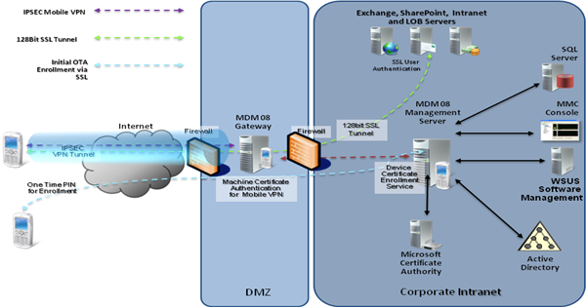
Additional Information
For more information on System Center Mobile Device Manager, see www.windowsmobile.com
For more information on Exchange 2007, see http://www.microsoft.com/exchange/
For more information on Windows Mobile devices for business, see http://www.microsoft.com/windowsmobile/enterprise/
©2007 Microsoft Corporation. All rights reserved. This data sheet is for informational purposes only. MICROSOFT MAKES NO WARRANTIES, EXPRESS OR IMPLIED, IN THIS SUMMARY. Microsoft, FrontPage, System Center, Exchange Server, Windows, the Windows logo, Windows Mobile, Windows Server, and Windows Server System are either registered trademarks or trademarks of Microsoft Corporation in the United States and/or other countries. All other trademarks are property of the respective owners.

