Microsoft Office Language Pack 2007

Microsoft Office Multi-Language Pack 2007

Microsoft® Office Language Packs address the needs of multilingual individuals who routinely create or edit documents and presentations in different languages. They enable computers to be shared by speakers of different languages. And they provide the flexibility of switching the entire user experience, including menus, help messages and document proofing tools to any of 37 available languages.

Create, edit, and proof documents in multiple languages

Office Language Pack document proofing tools enable users to proof Office 2007 documents in your chosen language, as well as in selected companion languages.

Document proofing tools include*:

* Spelling checkers
* Grammar and style checkers
* Thesauri
* Hyphenators
* Autocorrect lists
* AutoSummarize capabilities
* Translation dictionaries
* Input Method Editors (IMEs) for East Asian languages

*Not all document proofing tools are available for each language. Consult the 2007 Office Language Packs table below for more details.

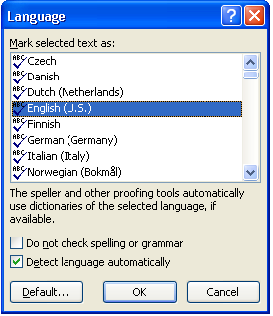

Selecting an installed proofing language

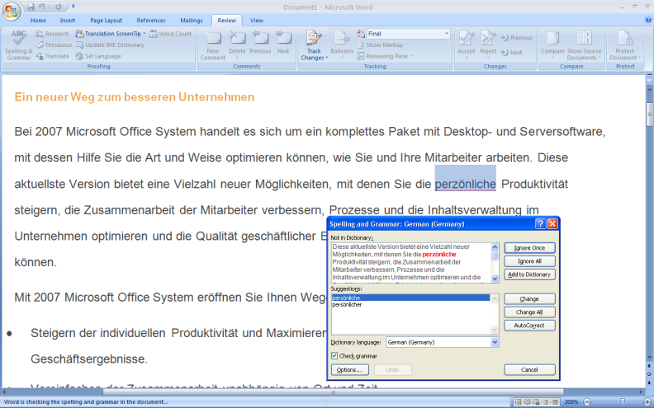

Performing a spell check on a German language document

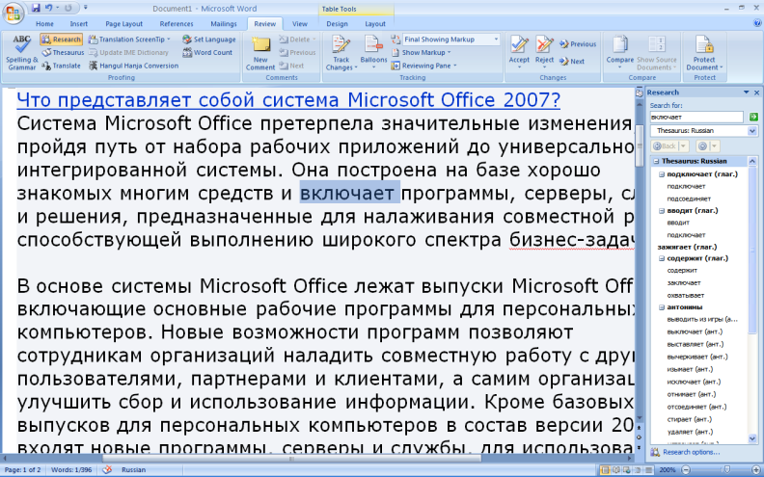

Using the Russian Thesaurus

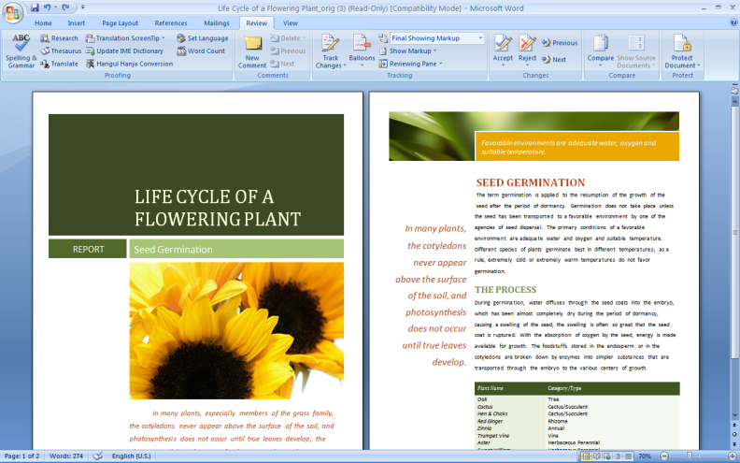Work more comfortably with Office 2007 programs

With the Office Language Packs you can easily switch the user interface and dialog boxes of Office applications between 37 available languages.

Change the menu language for the following 2007 Office system programs*:

* Microsoft® Office Access™ 2007
* Microsoft® Office Excel® 2007
* Microsoft® Office Groove® 2007
* Microsoft® Office InfoPath® 2007
* Microsoft® Office OneNote® 2007
* Microsoft® Office Outlook® 2007
* Microsoft® Office PowerPoint® 2007
* Microsoft® Office Project 2007
* Microsoft® Office Publisher 2007
* Microsoft® Office SharePoint® Designer 2007
* Microsoft® Office Visio® 2007
* Microsoft® Office Word 2007

*Not all program menus are available for each language. Consult the 2007 Office Language Packs table below for more details.

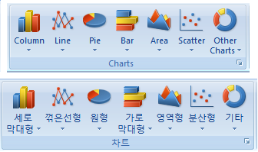

Change the language of Office program menus

Editing an English language document using an English language User Interface

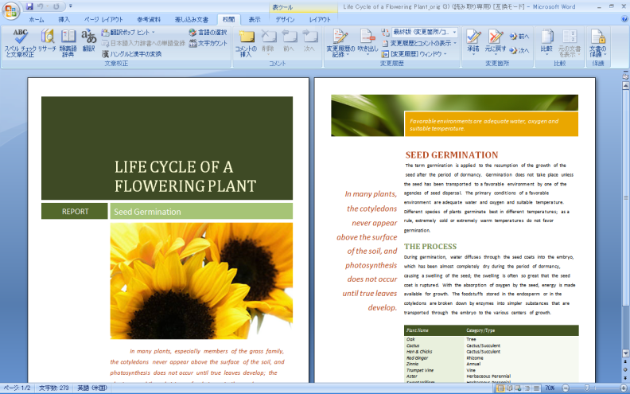

Editing an English language document using a Japanese language User Interface

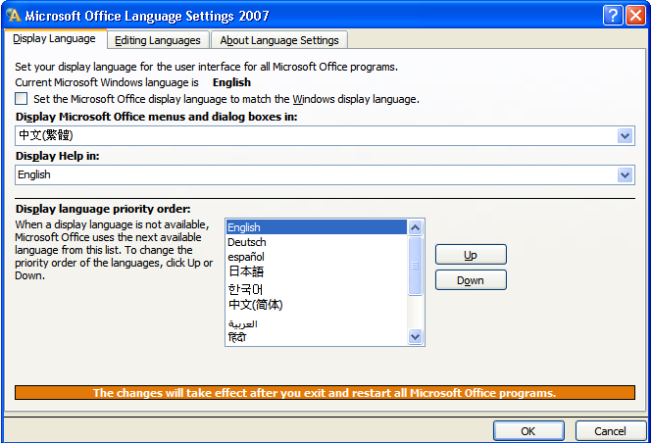

Easily switch between installed languages. Enable User Interface, help and proofing tools separately if desired

Get up-to-date help in your language

Office Language Packs enable you to read context-sensitive help in any of 37 available languages, and to connect directly with localized Office Online Web sites to view help articles, demos, training, and tips & tricks that are continually updated.

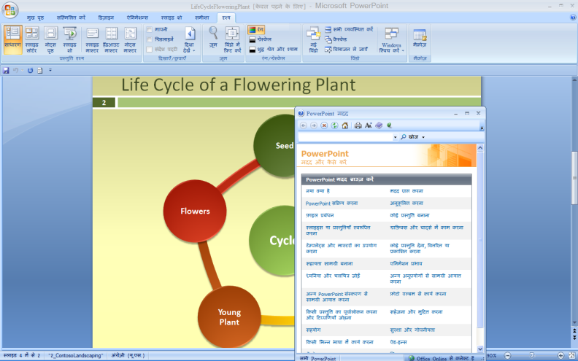

Get help from Office Online in your preferred installed language

Access document templates from Office Online

Office Language Packs connect you to free Office Online templates in the language of your choice. Office Online templates are easy to install, add pre-built designs and business logic to your applications and documents, and help you to save time.

System Requirements

To use Microsoft® Office Language Packs, you need:

* 500-MHz or faster processor
* 256 MB of RAM or higher
* 2 GB of hard disk space necessary for installation; a portion of this hard disk space will be freed after installation
* 750MB-1.5GB of hard disk space per language installed
* CD-ROM drive
* 1024 × 768 or higher-resolution monitor
* Windows® XP with Service Pack 2 or later or Microsoft Windows Server® 2003 or later required
* 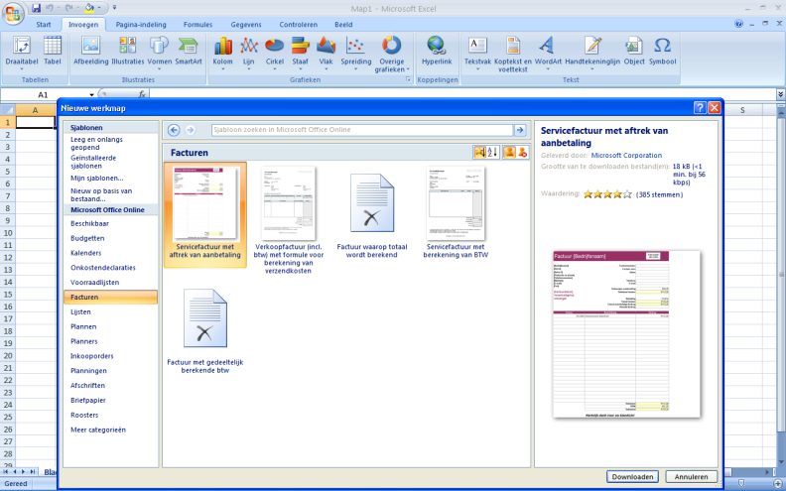One or more of the following 2007 Microsoft Office system  products installed: Microsoft Office Home and Student 2007, Microsoft Office Standard 2007, Microsoft Office Basic 2007, Microsoft Office Small Business 2007, Microsoft Office Professional 2007, Microsoft Office Professional Plus 2007, Microsoft Office Enterprise 2007, Microsoft Office Ultimate 2007, Microsoft Office Word 2007, Microsoft Office Excel® 2007, Microsoft Office Outlook® 2007, Microsoft Office PowerPoint® 2007, Microsoft Office Access 2007, Microsoft Office OneNote® 2007, Microsoft Office Visio® 2007, Microsoft Office Project 2007, Microsoft Office InfoPath® 2007, Microsoft Office SharePoint® Designer 2007,Microsoft Office Publisher 2007, Microsoft Office Groove® 2007.

A comprehensive set of tools for the multilingual user

Office Language Packs enable Document Proofing Tools, Localized User Interface, and Help and User Assistance Tools for 37 different languages. Individual language packs are sold separately* exclusively on the Office Online Web site, or the complete set can be purchased as the Microsoft Office Multi-Language Pack 2007 in retail stores or via Microsoft Volume Licensing programs.

Office Language Packs can be installed on any language version of 2007 Office programs. Multiple language packs can be installed on the same machine, but must be purchased separately.

Download a Dutch invoice template for Excel from Office Online using the Dutch language pack

For more information go to [**www.microsoft.com/office/languagepacks**](http://www.microsoft.com/office/languagepacks)

*The English language pack is not sold separately and is only available as part of the Office Multi-Language Pack 2007.

This table details specific tools and capabilities for each individual Office Language Pack. Some language packs include document proofing tools for regional companion languages. These are grouped on the table with the related major language, and their names have been indented. Additionally, Office Language Packs include proofing tools for selected major languages. These are indicated in the ‘Extras’ column. The Office Multi-Language Pack 2007 contains the complete set of tools shown on this table.

