
Microsoft Office OneNote 2007
February 2006
Cover is for
position only

Table of Contents

Cover is for
position only

Overview of Microsoft Office OneNote 2007 1
What’s New in Office OneNote 2007 1
Gather Everything in One Place 2
Find What You Are Looking for Quickly 4
Work Together More Effectively 5
Gather Everything in One Place 7
Going Beyond Pencil and Paper 7
Write Anywhere 7
New! Table Support 11
A Rich Environment for Gathering Information 12
Recording Audio and Video 17
Recording Audio 17
Recording Video Notes 17
Capturing Handwritten Notes and Drawings 18
Saving Notes 19
Automatic Save 20
Helping to Protect Section Content 21
Find What You Are Looking for Quickly 22
Organized by Design 22
The Hierarchy of an Office OneNote 2007 Notebook 23
Notebook Section Tabs 23
Page Tab Features 24
Search for Details Quickly 24
Highlighting Search Results 24
Note Flags 27
Work Together More Effectively 29
Sharing Notes Using E-Mail 29
Publish Notes to a Web Site or to a Windows SharePoint Services Web Site 30
Real-Time Sharing in Office OneNote 2007 30
Summary 34
Resources 35
System Requirements 36

Overview of Microsoft Office OneNote 2007
Welcome to the Microsoft® Office OneNote® 2007 note-taking program, included in the 2007 release of the Microsoft Office system of products. The Office system is an integrated system of programs, servers, and services for information workers.
You can use Office OneNote 2007 to gather virtually any type of information—from typed text, audio, and video to handwritten notes and drawings, technical graphics, and research from the Web and other applications. It provides powerful search tools to find information quickly as well as easy-to-use sharing tools that help you manage information overload and work with others more effectively.
In an age of information overload, Office OneNote 2007 helps you keep your thoughts and your work organized. It provides a centralized place to capture and structure your ideas. It helps you retrieve the information you need more quickly than ever; and it gives you easy-to-use tools to help you share ideas and collaborate with others. The bottom line? Office OneNote 2007 provides a unique set of capabilities that help you work more effectively in the face of an ever-growing volume of information.

What’s New in Office OneNote 2007
Office OneNote 2007 includes a range of improvements and new tools that make it easier than ever to gather, find, and collaborate on information. Microsoft has made major investments to help you search for content faster and more flexibly, including major investments that you can use to search for information in multiple types of content. Office OneNote 2007 offers stronger integration with other Office system products and improves collaboration between team members. Yet you can also distinguish between personal and “group” notebooks so that you can organize your information while working with others more effectively.

New and improved features for gathering information:
- Content Lasso (see page 10)
- Drawing tools (see page 11)
- Improved table support (see page 12)
- Embedded files (see page 14)
- Insert color printouts from other applications (see page 16)
- Improved integration with mobile devices (see page 17)
- Import/export application programming interfaces (see page 18)
- Next-generation ink parser (see page 21)

New and improved features for finding information
- Hyperlinks to other OneNote pages and other applications (see page 16)
- Drag-and-drop support for notebooks and sections (see page 26)
- Improved navigation and organization features in the user interface (see page 26)
- Faster search (see page 28)
- Search for content in images (see page 29)
- Search for content in audio and video (see page 29)
- Enhanced integration with the Microsoft Office Outlook® 2007 messaging and collaboration client (see page 31)

New and improved features for working together better
- Enhanced notebook sharing (see page 35)
- Ability to place notebooks anywhere (see page 22)
- Support for multiple notebooks (see page 22)

Gather Everything in One Place
Most people have no single place where they can capture all the different pieces of information that they use in the course of their work. Some information resides in e-mail messages, some is stored on Web sites, and some details might reside in a video presentation or on a pad of paper. It is difficult and time consuming to transcribe notes and to try to synthesize all these disparate bits of information—yet all of this information informs your work. Wouldn’t it be nice to gather all these different pieces of information in one place and have it all at your fingertips?
Office OneNote 2007 provides such a place—for text, graphics, audio, video, and more.
- Collect virtually any type of information: Office OneNote 2007 helps you gather typed text, audio, video, digital handwritten notes, digital hand drawn diagrams and pictures, graphics and photos from the Internet, and information from other Office system applications.
- Back up your critical information: Office OneNote 2007 automatically saves and backs up all the information stored in your notebooks, so you never have to worry about losing important information again.
- Capture and capitalize on the content of a meeting: Office OneNote 2007 gives you the flexibility to capture the creativity and energy from meetings, and provides a living repository of information from every gathering, keeping everyone on the same page.
- Gather more accurate and comprehensive information: Synchronize typed or handwritten annotations with recorded audio and video.
- Annotate anything: You can annotate any content entered into Office OneNote 2007, and you can organize information on the page in whatever way meets your needs. New drawing tools and enhanced support for tables make it easier than ever to manage information in Office OneNote 2007.
- Be more productive while mobile: You can view OneNote information on a Smartphone or Pocket PC; you can even gather new information, including pictures, and easily integrate this information into OneNote.
- Transfer notes to and from other Office system applications: Copy, paste, or print information into and from other Office applications such as Microsoft Office Word 2007, Office Outlook 2007, and the Microsoft Office PowerPoint® 2007 presentation graphics program.
- Connect your notes and information to business systems: A full export application programming interface (API) provides a seamless and user-friendly link to business systems. You can reduce errors and avoid entering the same data in multiple systems by connecting Office OneNote 2007 directly to the other systems you use.

Find What You Are Looking for Quickly
All too often, the time it takes to find information on your system takes away from the time you have to do something productive with that information—and ultimately that reduces your ability to make an impact. Office OneNote 2007 makes it easy to organize and find the information that you and your teammates need.
- Search everything in OneNote: The powerful keyword search features of Office OneNote 2007 help you find saved information quickly. Office OneNote 2007 searches typed text as well as handwritten notes, the text in pictures, and scanned documents, even spoken words in audio recordings.
- Organize information flexibly: You can navigate your notebooks quickly and easily with the new Office OneNote 2007 organizational and navigational pane. You can drag and drop Office OneNote 2007 notebooks and sections to organize your information in the way that works best for you. Hyperlinks help you link pages within your notebooks, so you can quickly move among related ideas in different notebook areas.
- Manage tasks, contacts, and meetings together with Office Outlook 2007: Two-way task synchronization between Office OneNote 2007 and Office Outlook 2007 makes it easy to keep track of action items and other important information.
- Highlight important items and tasks: You can highlight important ideas or action items with customizable Note Flags. You can review all your note flags in the Note Flags Summary Task Pane and synchronize to-do items automatically with your task lists in Outlook.
- Manage personal and group information more easily: Office OneNote 2007 now supports multiple notebooks, so you can create certain notebooks for tracking personal information and other notebooks for information you want to share. You can put your notebooks where your IT team can back them up and index them. Then they can become part of the institutional knowledge base.

Work Together More Effectively
Working today increasingly means working with other people, whether with coworkers across the hall or customers around the world. It can be frustrating and difficult to get everyone on the same page. Office OneNote 2007 makes it easy for you to share information and work with others more effectively—whether online or offline.
- Work together better: You can work with others using shared notebooks—either simultaneously or at different times from different locations.
- Create a team knowledge base: OneNote makes it easy to create a shared information repository for briefing new teams, sharing best practices, or avoiding duplicate work.
- Share information easily: You can share your notes and notebooks using Outlook. You can also publish your notes as HTML pages to a Web or intranet site.
- Work together in real time: You can use a live sharing session to work together in real time with people in different locations.
- Share only what you want with whom you want: You can retain control of your notes and notebooks by specifying which portions of your notebooks to share and which to keep private. Password protection and encryption on specific sections of your notebooks help ensure that only those to whom you grant access can view these sections.

Office OneNote 2007 in Action
Nicole Holliday is an Account Manager for Fabrikam, Inc., a manufacturing company. She is preparing to meet Robert Brown, the newly hired Purchasing Manager at one of her enterprise accounts. On the plane ride to the customer account, she refreshes her memory by opening Office Outlook 2007 and finding the last meeting appointment that she had with Robert’s predecessor. By clicking a link within Outlook, Nicole can bring up all the notes she took in Office OneNote 2007 that are associated with this meeting. Reviewing these notes gives her a firm grasp on the client’s business situation and helps her prepare answers for the open questions from the previous meeting.
The meeting with Robert goes well. Nicole jots down notes within Office OneNote 2007. They agree to meet regularly once a month. Nicole opens a “create appointment” formlet within Office OneNote 2007 and types “meeting with Robert at 11 A.M. first Thursday of every month” within the appropriate fields. From Office OneNote 2007, she adds this as a new recurring meeting to her Office Outlook 2007 calendar and sends the meeting request to Robert. Nicole flags Robert’s questions for follow up within two days and adds them to her Office Outlook 2007 task list.

Gather Everything in One Place
So much information residing in so many places. Wouldn’t it be great if you could bring together, in one place, all the ideas and the meeting notes, the Web research, and everything else that you need to do your work? That is what Office OneNote 2007 is all about: giving you the ability to gather, organize, and integrate, in one virtual notebook all the information that your work requires.
Office OneNote 2007 can enhance the everyday acts of gathering and organizing information—and can facilitate integrating your work and ideas into the electronically-enabled fabric of your life. It helps you “take notes,” yes, but Office OneNote 2007 also moves you far beyond the limitations of pen and paper while retaining the same fundamental flexibility.

Going Beyond Pencil and Paper

Write Anywhere
When you take notes using a pencil and paper, you can place your pencil anywhere you want on the page and just start writing. Office OneNote 2007 provides the same flexibility. Simply click anywhere on the OneNote page surface and you can start capturing your ideas.
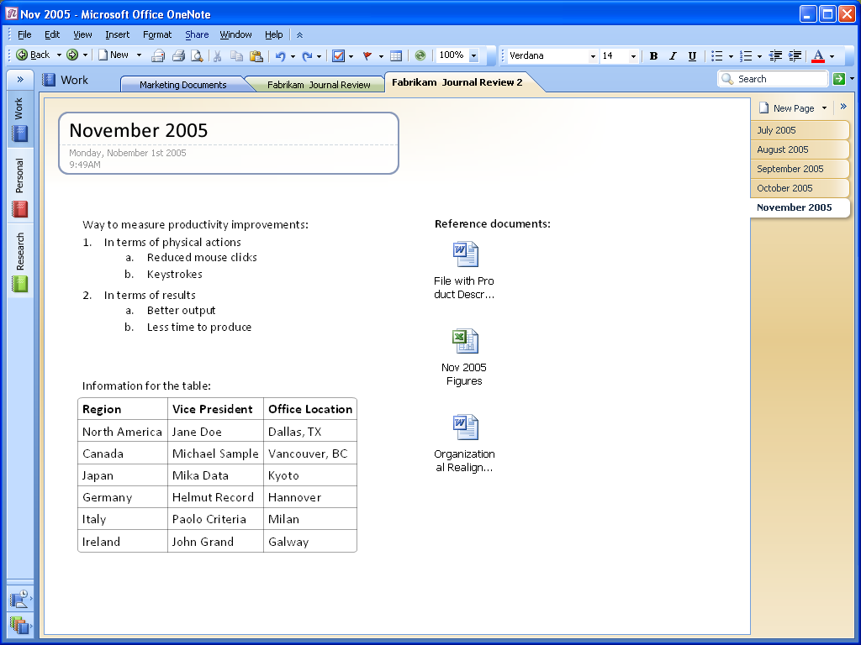
Figure 1: Write anywhere on the screen.
With Office OneNote 2007, you can easily group related matters. For example, before a meeting you might create an area for notes—a “container”—titled Agenda, a second area titled Attendees, and a third titled To Do. During the meeting, you can quickly add relevant information to any of those three areas—or click somewhere else on the page to start a completely new thought. You can even move whole note containers by clicking a container’s outline—visible when the cursor hovers over the container—and dragging it elsewhere on the page. By dragging one container to another container, you can combine containers. Also, by selecting text or an image in one container and dragging it away from that container, you can split one container into two. You can also cut or copy a container and paste it on another page altogether.

New! Content Lasso Tool
A new feature in Office OneNote 2007 is the Content Lasso tool, which you can use to select one or more containers and images by encircling them with your cursor. You can then move, cut, or copy these items as you see fit.
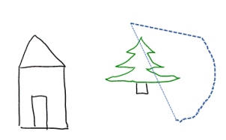
⬇
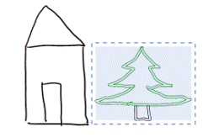
Figure 2: You can use the Content Lasso tool to select and move text
and graphics easily.

New! Drawing Tools
Office OneNote 2007 makes it easy to create simple drawings in your notebook. You can use the new suite of drawing tools to add basic shapes and lines, so you can express and capture your ideas visually.

Figure 3: Easily add basic shapes and lines to your pages.
You can easily create and manipulate any of the basic shapes using your keyboard and mouse. A toolbar puts all the drawing tools within easy reach. It also includes buttons that you can use to manipulate shapes easily and to insert the same shape again until you instruct it to insert a different shape.
Figure 4: The Drawing Toolbar makes it easy to select and insert shapes into your OneNote pages.
Because Office OneNote 2007 treats shapes as ink, you can easily erase the wrong shape with the eraser tool.

New! Table Support
The previous version of OneNote made it easy to capture text, to outline ideas in a nested hierarchy, and to use bulleted and numbered lists. Its support for tables, however, was not as strong.
Office OneNote 2007 offers greatly enhanced support for tables. You can paste tables from the Web or from other Microsoft Office system applications, and they retain their character as tables. You can also build your own tables quickly and intuitively, just by pressing the Tab key between the columns you want to create.
For example: if you type the word “Product,” then press the Tab key, Office OneNote 2007 creates a table automatically. Type the word “Quantity,” press the Tab key once more, and type the word “Price.” You have created a table with three columns in it.
You could continue to add columns in this manner. Once you have created the number of columns you need, press the Enter key to begin a new row within the table. The entire process is illustrated in Figure 5.
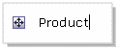



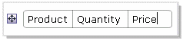
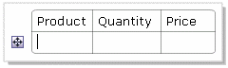
Figure 5: Building tables is easy in Office OneNote 2007.
Office OneNote 2007 also makes it easy to modify and expand tables through keystrokes. Below are some commonly used keystroke shortcuts for modifying tables.
Action | Shortcut
Create more lines inside the last cell of a table. | Press ALT+ENTER.
Insert a row at the end of the table. | Press ENTER or TAB in the last cell.
Insert a row anywhere in the table. | Press CTRL+ENTER.
Insert a row above the current row. | Press ENTER in the beginning of the row.
Delete a row. | Select the row by clicking the row handle and press DELETE or BACKSPACE.
Delete column. | Select the column by clicking the arrow that appears at the top of the column and press DELETE or BACKSPACE.
Swap rows. | Select the row, press Cut (CTRL+C), then press Paste (CTRL+V) at the beginning of the row before which you want to insert the cut row.
Split a table. | Press BACKSPACE or DELETE at the beginning of an empty row.
Merge tables. | Press BACKSPACE or DELETE in the empty space between two tables.

A Rich Environment for Gathering Information
Office OneNote 2007 enhances the information-gathering experience with rich authoring and word-processing features. You can format text using different fonts and sizes, as well as bold, italic, and underline styles. You can highlight text, apply colors to text, and use a variety of bulleted and numbered list styles. Office OneNote 2007 recognizes the AutoCorrect entries and spelling checking tools that you use in other Office system applications, including any personal dictionaries you have created. You can experience this rich authoring experience in every container.
The information-gathering advantages of Office OneNote 2007 become even more apparent when your work involves more than text. You can drag graphics from your desktop, an open application, or an open Web site onto the OneNote page and then position them wherever you want. You can also cut and paste information from other OneNote pages and other Microsoft Office system applications, including:
- Pictures and text from Office Word 2007 documents
- Graphs, charts, text, or even entire slides from Office PowerPoint 2007 presentations
- Columns and rows of numbers and charts from Microsoft Office Excel® 2007 spreadsheets
Indeed, you can paste into Office OneNote 2007 virtually anything that can be captured using the standard cut-and-paste features of the Microsoft Windows® operating system, including hyperlinks to other files and Web sites. When you copy and paste information from a Web site to a OneNote page, the source URL is automatically inserted with the information, so you can click the link and quickly return to the source of the information if you need to. This feature lets you conduct research more efficiently by capturing all of the information you need in one place.
When you copy and paste handwritten digital ink notes created in OneNote on a Tablet PC into other programs, the handwriting is automatically converted to text. Drawings are pasted as picture files.

New! Embedded Files
In addition to the ability to cut and paste between Office system applications, you can use Office OneNote 2007 to embed whole files in a OneNote notebook. You can drag and drop any file from Windows onto a OneNote page, or you can insert the file into the page using the File option on the Insert menu. If you are managing a big project, you are likely to use different types of documents to track pieces of the project. Now you can keep these documents in Office OneNote 2007 together with everything else.

New! Inserting Color Printouts
You could use OneNote 2003 to insert a document as a black-and-white image on a OneNote page. Office OneNote 2007 takes that capability much further. Now, you can insert as an image any document that your computer can print, and you can insert it as a color image.
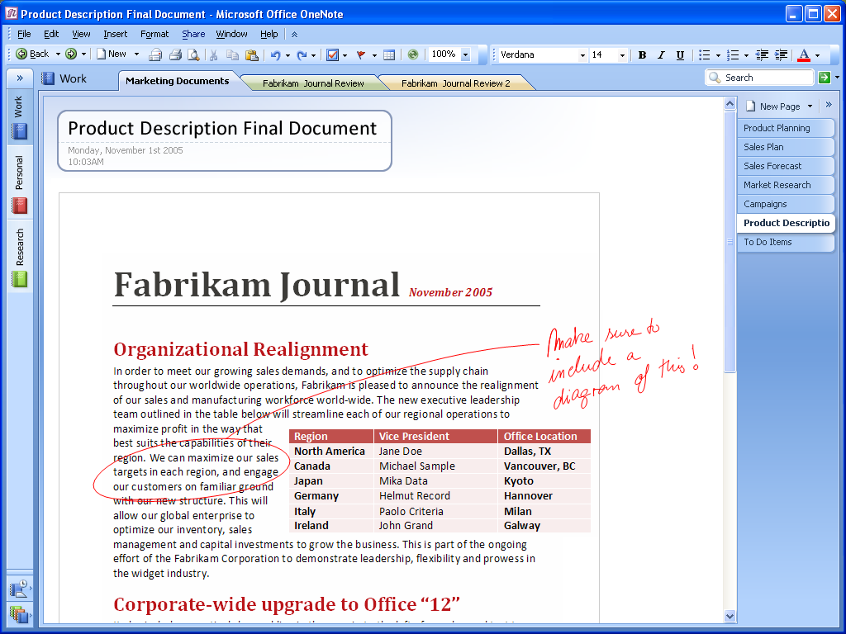
Figure 6: You can insert as a color image any document that your computer can print.

New! Hyperlinking
Now you can insert links and jump between OneNote pages—in the same notebook or in other notebooks. In fact, you can now create hyperlinks to any location or document from within OneNote. You can also create links to OneNote pages from any other document or location.
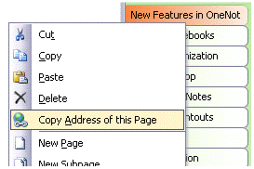
Figure 7: Office OneNote 2007 makes it easy to embed hyperlinks.
Office OneNote 2007 supports links to specific portions of other documents, presentations, and Web pages. You can also insert links to individual contacts, e-mail messages, and calendar items in Office Outlook 2007, thus creating a strong web of connections between all the people, places, and events that you need to do your work. OneNote is the place where all those connections come together.
Another enhancement in Office OneNote 2007 is the ability to create “friendly” names for hyperlinks. Just as in other Microsoft Office system programs, you can select a long hyperlink and rename it to something more straightforward and friendly, such as “Team SharePoint Site.”
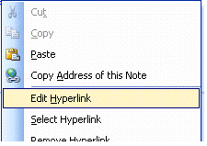
Figure 8: Office OneNote 2007 makes it easy to create hyperlinks with friendly names.

Improved! Windows Mobile®-based Smartphone and Pocket PC Integration
Office OneNote 2007 makes it easier than ever to integrate your Windows Mobile-based Smartphone or Pocket PC into your information-gathering toolset. You can take specified parts of your Office OneNote 2007 notebook with you when you are only carrying your Smartphone. You can capture new information on your Smartphone or Pocket PC and quickly integrate it into the fabric of your OneNote Notebook. You can even use the camera on your Smartphone to capture images and store them in your OneNote information repository, with any text in the picture becoming part of your searchable index.

New! Import/Export Application Programming Interfaces
Microsoft is opening OneNote to still more sharing opportunities. It is publishing the application programming interfaces (APIs) to Office OneNote 2007 so that partners and developers can extend the capabilities of Office OneNote 2007 even further. With these APIs exposed, developers can make it easy to import content and data directly into Office OneNote 2007 from their applications. It is also easy to move information captured in Office OneNote 2007 into other applications, such as document-management applications and more.
Office OneNote 2007 in Action
At the airport lounge, Nicole finds that she has a few extra minutes. She uses the camera on her Windows Mobile-based Smartphone to snap a picture of a handout that Robert provided. After plugging her Smartphone into her PC, the picture of the handout is imported into Office OneNote 2007, where all of the information is scanned using Optical Character Recognition (OCR) technology. The text in the image becomes searchable before Nicole even gets in line to board her plane.
Back at the office, Nicole needs to document her conversation with Robert in Fabrikam’s CRM system. Because she captured the information in Office OneNote 2007 using a special OneNote template that Fabrikam had created with predefined fields such as customer name, date, assessment of opportunity, issues from the meeting, and next steps, Nicole simply sent the entire page to her CRM system, enabling others to track the progress of her customer discussions. What used to take an hour to do after each call took only a moment, and Nicole is free to focus on calling new leads instead of filling out more forms.

Recording Audio and Video
Office OneNote 2007 takes information gathering beyond the traditional boundaries of text and graphics by enabling you to record linked audio and video notes. Audio and video notes are particularly valuable when you do not want to miss anything that someone says or does.

Recording Audio
If you have a microphone connected to or built into your computer, you can record audio by clicking the Record Audio Only button in the Audio and Video Recording toolbar. Office OneNote 2007 identifies when the audio recording starts, and—as you make notes on the page—it synchronizes what you have written with the audio. By doing this, Office OneNote 2007 tracks the audio that occurred at the exact moment each note was typed or written.
Later, if you need to clarify a certain note, move your mouse cursor over the text in question. An icon of a speaker appears in the margin. Click this icon, and Office OneNote 2007 plays the audio that it recorded while you were writing that line in your notebook. You can also listen to the entire audio by clicking the speaker icon next to the date stamp in the container or by clicking the Play button in the Audio and Video Recording toolbar. If the See Playback button is selected in the Audio and Video Recording toolbar, Office OneNote 2007 highlights what you have written as the audio progresses. If you connect your computer to your phone using an inexpensive adaptor, you can record conference calls and link your notes to that audio as well.

Recording Video Notes
If you have a digital video camcorder or webcam attached to your computer, you can record video (and audio, if you have a microphone) by clicking the Record Video button in the Audio and Video Recording toolbar. Office OneNote 2007 captures the time and date when the video recording starts, and it synchronizes any annotations you make with the video. If you need to clarify something you have written, you can hover your mouse cursor over the text in question, and an icon of a speaker appears. Click the icon, then Office OneNote 2007 replays the video recorded when the annotation was made. You can also replay the entire video by clicking the speaker icon next to the date stamp in the container or by clicking the Play button in the Audio and Video Recording toolbar. If the See Playback button is selected in the Audio and Video Recording toolbar, OneNote then highlights what you have written as the video progresses.

Capturing Handwritten Notes and Drawings
If you use a computer with a pen input device, you can use your digital pen to take handwritten notes or draw pictures and diagrams in Office OneNote 2007 (see Figure 9). If you are using a Tablet PC, you can convert your handwriting to text (or leave it as handwriting, if you prefer). If you are not using a Tablet PC, Office OneNote 2007 recognizes your handwriting as a graphic, which cannot be converted to text.
Figure 9: With Office OneNote 2007, you can write by hand and insert drawings with a pen input device.
You can also easily mix handwriting and text on the same page. You can change the order of handwritten items in a list using drag and drop, and you can also add bullets and numbering to your handwritten notes and mark them with Note Flags. The OneNote search engine treats handwriting entered on a Tablet PC the same as text. You can use the search capabilities of Office OneNote 2007 to find information entered as handwriting or text, and Office OneNote 2007 finds the entry either way.
In a meeting, you may draw a diagram to illustrate a point or brainstorm all over the page as if on a whiteboard. If you do not have a pen input device, you can use your mouse to draw and sketch diagrams with the pen feature in Office OneNote 2007, which offers a variety of ink styles to choose from, including different colors and thicknesses. Office OneNote 2007 even provides highlighters in different colors and an eraser that you can control with your mouse or pen input device to erase your mistakes.

New! Next-generation Ink Parser
While most people run Office OneNote 2007 on a desktop or laptop computer, some people use OneNote on a Tablet PC. Because Office OneNote 2007 takes advantage of the new Tablet PC Ink parser, the inking experience in Office OneNote 2007 is better than ever. Office OneNote 2007 continuously evaluates and revisits ink input. Ink structures can be created, destroyed, and recreated while you are writing—yet you do not notice a thing. This ongoing analysis of your inking activities provides a handwriting recognition and ink-to-text conversion experience that is more accurate and robust than ever.

Saving Notes
We have all experienced the frustration of searching for a particular file that we know is on our computer, but cannot find, either because we do not remember where we saved it or because we accidentally saved it in an incorrect location. Office OneNote 2007 eliminates this frustration by automating saves and keeping track of where the information in your notebooks resides.

Automatic Save
Once you write something down on paper, it is always there. OneNote offers the same kind of convenience. There is no Save button in OneNote—everything is automatically saved as you write it. Even if you turn off the computer or close the program quickly, you do not need to worry about losing important information—it is already saved.

New! Support for Multiple Notebooks
You can use Office OneNote 2007 to create multiple notebooks, so it is easy to organize your work by project, special topics, or anything else.

New! Notebooks Anywhere
You can place your Office OneNote 2007 notebooks anywhere you want with Office OneNote 2007, including on a network file server. If you have file folders on a local disk that you use for work with specific clients or projects, you can put the Office OneNote 2007 notebook associated with that client or project in the same folder. That makes it much easier to keep all your work together. It also makes it easy to back up all your work when you back up your project files.
Your notebooks are always available, regardless of where you store them—on your computer or somewhere on a network. If you expect to use different computers at different times, storing your Office OneNote 2007 notebooks on a network helps ensure that you can always access your notebook, regardless of the system you use to access it.
If a notebook is regularly stored on a network location, Office OneNote 2007 maintains a full offline copy of the notebook on the computer where you open the notebook. That way, if you travel with the notebook, you have a copy of the notebook with you; Office OneNote 2007 automatically merges any changes when you reconnect to the network.

Helping to Protect Section Content
You can help protect sensitive sections of your notebook with passwords. Using Office OneNote 2007 section protection encrypts those sections. When you try to access a protected section, you must first enter your password to view the page contents.
Office OneNote 2007 saves your password in memory so that you do not have to reenter it every time you go back to the section. If you leave Office OneNote 2007 for more than a specified period (the default period is 10 minutes, but you can configure this in OneNote preferences), Office OneNote 2007 relocks protected sections, and you must enter your password to open those sections.
Office OneNote 2007 in Action
Jane Clayton, a Fabrikam Product Marketing Manager, needs to create a presentation for the annual board meeting. She gathers research into Office OneNote 2007 on her desktop computer from a variety of sources: She clips sections of Web pages, copies revenue tables from spreadsheets, scans several paper documents, drags in previous presentations and Portable Document Format (PDF) files, records audio interviews with key experts, and even points to a video from a competitor’s Web site. All of the content that she captures is searchable within Office OneNote 2007, so Jane can find specific project information regardless of the format quickly. She can even specify a search within an audio or video recording if she needs to do so.
As Jane copies this content, when she wants to take related notes, she can link those notes in Office OneNote 2007 back to the relevant content. These notes maintain links back to the relevant document, Web page, or video stream, so she can always refer back to the context behind her notes. In many cases, she chooses to annotate on or to the side of the documents within Office OneNote 2007; in other cases, she takes notes and then adds a link to the document. Office OneNote 2007 also helps her to easily organize her thoughts and ideas into a logical outline for her presentation.

Find What You Are Looking for Quickly
The more time you spend looking for information on your system, the less time you have to do something valuable with it once you find it. Yet how do you get around that? You probably have information stored in e-mail messages, documents, slides, and spreadsheets. Multiple versions make it even harder to find precisely the information you want. And how can you find and easily retrieve the information in audio and video files?
Office OneNote 2007 makes it easy to organize and quickly retrieve the information you and your teammates need.

Organized by Design
As noted earlier, you can click anywhere on the Office OneNote 2007 page surface and start writing. But what is a OneNote page, and what are its key features? Let’s take a look at the distinction between OneNote pages and sections, which are simply different kinds of containers for organizing information.
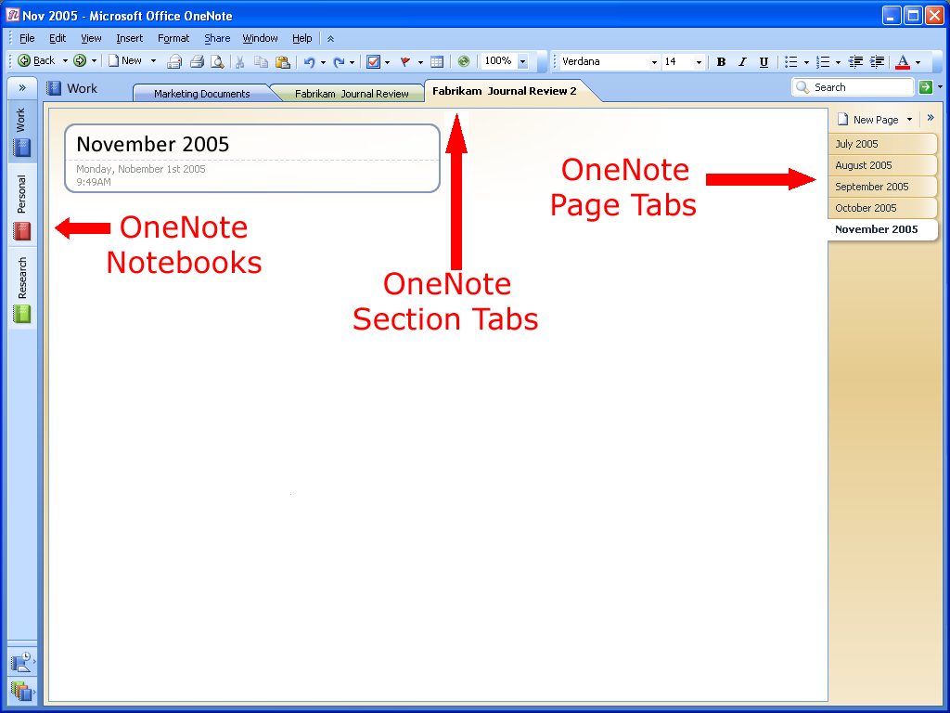
Figure 10: An Office OneNote 2007 page

The Hierarchy of an Office OneNote 2007 Notebook
An Office OneNote 2007 notebook contains one or more sections; sections contain one or more pages. Sections appear as colored tabs on the top portion of the Office OneNote 2007 page surface (see Figure 10). The pages in a given section appear as tabs along the vertical axis of the OneNote page surface.

Notebook Section Tabs
Near the top of the OneNote page are tabs representing the sections within a notebook, which are much like sections in a three-ring binder. You can create as many sections as you need and customize them by naming them after different projects, types of meetings, or anything you want. For example, project managers might have a different notebook for each project, with different sections for each component of a project (such as vendor meetings, client meetings, and project timelines).

New! Improved Navigation and Organization
Office OneNote 2007 features a mini-bar and a navigation pane, both of which make it easy to organize and navigate Office OneNote 2007. The mini-bar (on the left-hand side of Figure 10) shows which notebooks are open at any given moment. By clicking a notebook icon, you can easily move between open notebooks. Across the top of the OneNote workspace you still see the familiar tabs associated with notebook sections.
By clicking the arrow at the top of the mini-bar, you can expand the mini-bar into the navigation pane, which shows more detail about the notebooks and embedded sections. You can click a section in a notebook and jump to that section, making navigation across multiple notebooks and sections much easier.

New! Drag-and-Drop Notebook Organization
Office OneNote 2007 incorporates an intuitive drag-and-drop interface, which you can use to reorganize your notebooks, sections, and pages quickly. For example, you can click a section tab and then drag it to another location among the section tabs.
If you want to move whole sections to specific locations among multiple notebooks, you can use Office OneNote 2007 to open multiple navigation panes, and then drag one or more sections between notebooks easily.

Page Tab Features
Along the right side of the Office OneNote 2007 page display there are tabs for the individual pages within each notebook section. Clicking a tab takes you to the corresponding page. Hovering the mouse or pen over these page tabs quickly gives you information for each page, including the page title and creation date.
By clicking the arrow in the top right-hand corner of the page surface (next to the New Page button in Figure 10), you can choose whether to display the pages by the names entered in the page header region or, in a collapsed format, by page number. You can move your page tabs to the left of the page if you prefer by clicking Options on the Tools menu, choosing the Display category in the Options dialog box, and checking Page tabs appear on the left. This is particularly useful if you are a left-handed user of a Tablet PC. You can reorder page tabs by dragging and dropping them into the order that best meets your needs. You can also resize the page tabs by dragging the border between the tabs and the OneNote page surface to the right or left.

Search for Details Quickly
The Find feature in Office OneNote 2007 helps you keep track of important information. When you enter a keyword in the Find box at the top of the page display, Office OneNote 2007 quickly locates the information you seek—and not just on the page in front of you, but on any page in any section and in any open notebook. You can also limit the range of your search using the Search In pull-down menu.

Highlighting Search Results
Office OneNote 2007 highlights in yellow the page tabs that contain matches to your search query. When you press Enter or click the “next match” arrow, Office OneNote 2007 jumps quickly to the next match, across any notebook section, making it easy to search across multiple sections at the same time.
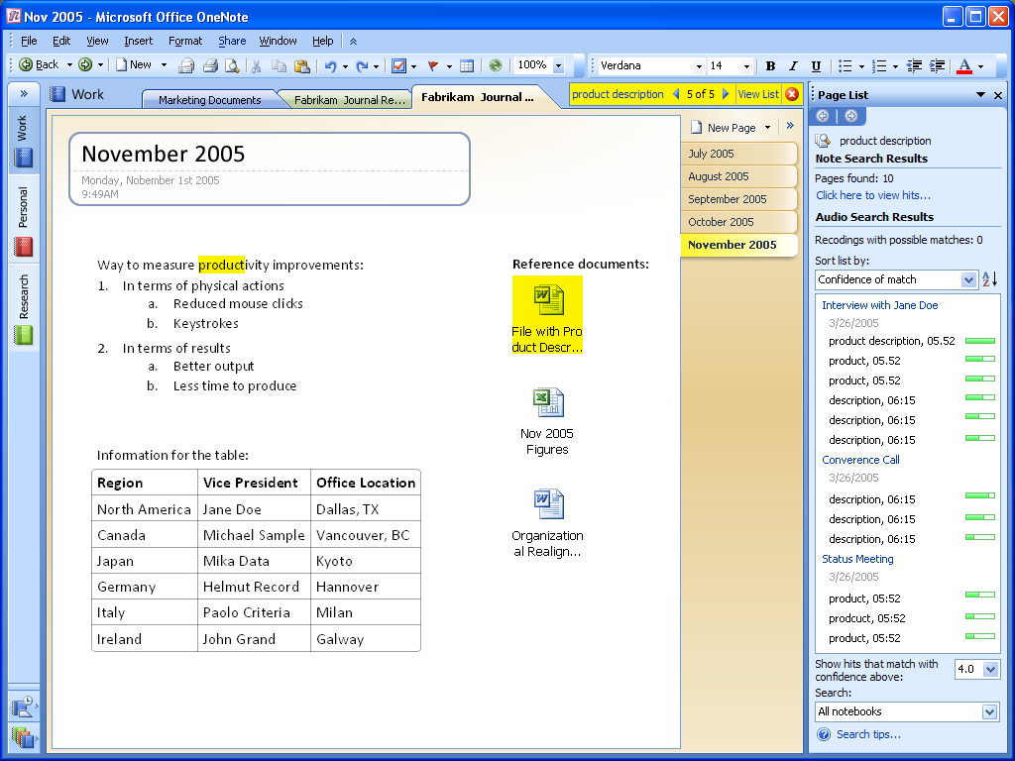
Figure 11: Find important information with just a few clicks.
In addition to jumping through the matches, you can click the View List button. Office OneNote 2007 displays a list of the OneNote pages containing the search term. By default, these results are grouped by section order, but they can be regrouped by date or title by clicking the Date or Title buttons in the Page List Task Pane.

New! Faster, Better Searching
Office OneNote 2007 dramatically improves your ability to find information in your notebooks. OneNote now caches the information in your notebooks in an index, which makes it easy to find information quickly. Moreover, Office OneNote 2007 provides you with powerful search features that help you narrow your results quickly. You can use “NEAR” in the search expression if you want to find only those pages where your search terms are in the same paragraph. For example, the search phrase “fast NEAR search” would identify only those pages where “fast” and “search” are in the same paragraph.

New! Search for Content in Images
While Office OneNote 2007 treats these imported graphics and imported file printouts as images, Office OneNote 2007 includes an optical character recognition (OCR) engine that automatically scans each image for text. If the OCR engine finds text within an image, it associates that text with that image and caches that text in the search index. In this way, the content in inserted images—whether they are CAD files with part names, Web pages pulled from the Internet, or any other kind of printout—become searchable. If you insert a photograph of a business card and then prompt Office OneNote 2007 to search for the company name appearing on the business card, a link to the image of the business card appears in the search results pane.

New! Search for Content in Audio and Video Notes
In addition to enabling you to find text in graphic images, Office OneNote 2007 can find text within audio and video files. Office OneNote 2007 relies on sophisticated speech-to-text tools and attempts to analyze audio and video files for recognizable content. For example, if you record a web cast that includes a discussion of the Astrodome, a search for references to the Astrodome would deliver a link to the audio file in which the Astrodome was discussed, just as it would deliver a link to the Web page in Figure 12. If you click the link in the search results window, Office OneNote 2007 opens the page with the embedded audio file and begins playing the recording at the point where the Astrodome came into the discussion.

Figure 12: Searching Office OneNote 2007 for the word "Astrodome" would point you to this image, printed into an Office OneNote 2007 page from the MSNBC Web site.

Note Flags
As mentioned on page 21, OneNote offers a set of Note Flags that can be used to mark key items, urgent notes, or notes that require follow-up. You can customize icons and names for your Note Flags, apply any combination of font color and highlighting to a Note Flag, and add check boxes to appear next to the note.
In addition to prioritizing and marking notes, you can use Note Flags to organize your information. The Note Flags Summary Task Pane makes it easy to manage and view all the items you have flagged with Note Flags, which can be viewed by page, by notebook section, or across all notebook sections. Clicking a flagged note in the Note Flags Summary Task Pane takes you to that note in your notebook sections. In this way, you can navigate through notes according to the flags. For example, you could customize a Note Flag as a “supervisor” flag and after a meeting, call up all the action items your supervisor had mentioned.

New! Find Flagged Notes Faster
The indexing feature of Office OneNote 2007 also helps you view a summary of all your note flags faster than ever before.

Improved! Enhanced Integration with Office Outlook 2007
Office OneNote 2007 offers more bi-directional synchronization with Office Outlook 2007. You can synchronize flagged tasks between Office OneNote 2007 and Office Outlook 2007, ensuring that an item flagged as a task in Office OneNote 2007 automatically appears as a task in Office Outlook 2007 (and vice versa). You can link meeting notes to items in your Office Outlook 2007 calendar or you can link an Office OneNote 2007 note about a customer to a customer in your Office Outlook 2007 contact list. You could easily access information about the meeting on your calendar or contact details associated with your customer by clicking through the Office OneNote 2007 interface—or quickly access the information in Office OneNote 2007 by clicking a link in your calendar or contacts list.

Work Together More Effectively
How effectively you can work with others in your organization depends greatly on the way your tools work. Today, it is difficult for teams to work together on projects when all users are not online at the same time, or when multiple users are trying to edit documents simultaneously. It is difficult to maintain version control when team members are constantly updating and sending files back and forth over e-mail. Moreover, the time spent overcoming communications, coordination, and information-sharing challenges can greatly reduce the effectiveness of the team.
With Office OneNote 2007, you have several easy ways to share important information and ideas more effectively, including sharing through e-mail, sharing by publishing notes to a Web site or Microsoft Windows SharePoint® Services Web site, or by publishing your notes as an HTML or Word 2007 file.
What is the best way for you to share the information you have gathered? Office OneNote 2007 even helps you figure that out. When you click Explain Choices on this Menu on the Share menu, Office OneNote 2007 opens a window that helps you understand your options for sharing information.

Sharing Notes Using E-Mail
By clicking the e-mail icon on the Standard toolbar (or using the E-mail Recipient option from the Send Page To command on the File menu), Office OneNote 2007 users working with Outlook 2003 or later can share their note pages with others. Office OneNote 2007 creates a special file consisting of copies of your selected pages and attaches the file to the message. It also automatically formats the information on the page (including graphics) as HTML code and puts it in the body of the e-mail message. So even recipients who do not have Office OneNote 2007 can read the information. If a page has linked audio or video files, Office OneNote 2007 also attaches a copy of these to the message if you have elected to do this by clicking Options on the Tools menu. E-mail message recipients who have OneNote can double-click the attachment and add that page to their own notebooks in a special section called Notes E-mailed to Me.
If you are using an older version of Outlook or are using other e-mail programs, you can still send OneNote notes to other e-mail recipients by manually attaching the file containing the selected pages to the message. Neither older versions of Outlook nor other e-mail programs convert the notes on the Office OneNote 2007 page to HTML for inclusion in the body of the message, but you can still copy and paste your notes into your e-mail program.

Publish Notes to a Web Site or to a Windows SharePoint Services Web Site
You can easily share information with others in a read-only form by publishing your notes in single-file Web page form that others can view with a Web browser or open and edit in Word 2007. Using the Publish as PDF or XPS… option on the File menu, you can create a copy of your OneNote page in a variety of formats, including a PDF file, a single file Web page, as a separate OneNote section, or as a Microsoft Word 2007 file. You can post the published file on a file share, Web site, or Windows SharePoint Services Web site. You can even send the files to others as an e-mail attachment. As when sending a page using e-mail, Office OneNote 2007 converts handwriting and drawings into pictures when it publishes the page in HTML format.

Real-Time Sharing in Office OneNote 2007
You can share information with others—and see their comments and additions, all in real time—using the Shared Session feature of Office OneNote 2007. You can create or join a peer-to-peer network session in which multiple users can interact on shared OneNote pages using the Live Sharing Session option on the Share menu.
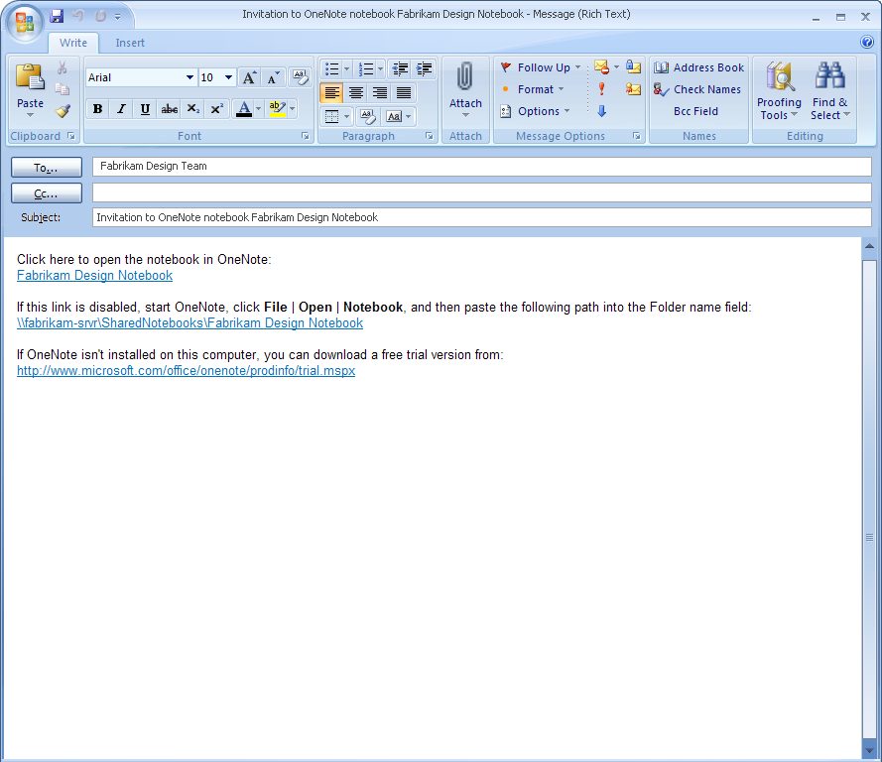
Figure 13: Sharing notes is easy with Office OneNote 2007.
Office OneNote 2007 makes it easy to invite other people to join a session. OneNote creates an e-mail message that you can use to invite participants. By clicking the link in the body of the e-mail message, the people you have invited can join the shared session. For example, you are in a teleconference and need to draw a diagram to explain to the other person what you are thinking. If both of you have Office OneNote 2007, you can work together on the shared page surface, using it like a combination notebook and whiteboard. Each of you can see the other’s drawings and notations in real time, which adds a powerful dimension to the phone conversation. You can invite as many people as you like—20 or more is quite possible—in various locations to work together.
You can use Office OneNote 2007 to broadcast note sessions to other OneNote users, so you can share your notes in real time without giving others the ability to interact with your notes. At the end of a shared session, each user retains a copy of the shared notes as part of his or her notebook, so there is no need to take a record of what was discussed.

Improved! Share Notebooks in Both Real Time and Non-Real Time
Office OneNote 2007 has extended the concept of shared notebooks beyond the real-time sharing delivered in OneNote 2003. Now you can create workbooks that multiple users can share both in real time and in non-real time. Two team members in two different locations can work in a shared notebook in real time if they want, just as they always have. Two other team members, though, may be unable to attend this real-time collaboration session because they are flying across the country. They have local copies of the shared notebook on their laptop systems, so they can work with the data they have at any time.
As soon as they regain network access, their copies of OneNote synchronize their local copies of the shared notebook and merge any changes introduced during the real-time collaboration session that occurred while they were in the air. The result? Within seconds, every member of the team sharing the Office OneNote 2007 notebook has current copies of all the information in the notebook—regardless of where they are and regardless of when the new information was introduced. Everyone remains on the same page, even if the page has been updated! And, if one of the team members that was flying earlier in the day subsequently updates to the shared notebook, all the other team members see those changes as soon as their local copies of Office OneNote 2007 reconcile the local copies of the shared notebook with the master copy of the notebook.
You can always retain control of your notes by sharing your notebook or sections of your notebook only when you want and with whom you want. You can allow some people to have access only to certain sections of your notebooks, and you can revoke access whenever it is appropriate.

Office OneNote 2007 in Action
When Jane is ready to begin creating her presentation, she exports her outline into a well-organized PowerPoint 2007 slide deck. She selects several slides from a presentation that she had captured in Office OneNote 2007 and adds them to the new presentation, where they slot in as new slides. She makes some edits and embeds the new presentation within her Office 2007 notes. Jane then sends the entire “bundle” of information—the PowerPoint 2007 presentation, her associated notes, other documents, and Web clippings, all wrapped up within a single Office OneNote 2007 file—to Carol Phillips, the Senior Product Marketing Manager for Fabrikam, for her comments. After reviewing the presentation and notes, Carol scribbles a quick suggestion next to the PowerPoint 2007 slides for Jane to do some more research on the competitor’s new product line. By using her Office OneNote 2007 notes, Jane can revisit the same Web pages where she had previously obtained competitive information and add the information to her presentation.
After she addresses her manager’s comments, Jane sends out a final version of the presentation to all the board members without all of the associated Office OneNote 2007 notes and work-in-progress commentary.

Summary
Office OneNote 2007 empowers you to gather, find, and collaborate on information. It helps you capture, organize, and share a wide variety of information types—from text and graphics to images and audio. It provides fast and powerful information search and retrieval capabilities, including the ability to scan images and audio files for searchable text.
Gather Everything in One Place You can use Office OneNote 2007 to manage the overabundance of information more efficiently by consolidating all the information you need to do your job in one place.
Find Information Quickly You can save time finding information because all of your information is in one place and organized the way you want. You can organize your note pages any way you want and save time finding information thanks to the powerful keyword search feature.
Work Together More Effectively Office OneNote 2007 makes it easy to be on the same page with your colleagues by sharing some or all of your notebooks. You can improve team productivity because notebooks and information are readily accessible and easy to share. You can help your team mates to be better prepared, make more informed decisions, and save time by centralizing all of your group’s information.

Resources
For more information about Office OneNote 2007, please refer to the following resources:
Office OneNote 2007 Highlights Tab
http://www.microsoft.com/office/preview/programs/onenote/highlights.mspx
Office OneNote 2007 New Interface Tab
http://www.microsoft.com/office/preview/programs/onenote/newui.mspx
Office OneNote 2007 Why Upgrade
http://www.microsoft.com/office/preview/programs/onenote/why.mspx
Office OneNote 2007 Demo Tab
http://www.microsoft.com/office/preview/programs/onenote/demo.mspx
Office OneNote 2007 FAQs
http://www.microsoft.com/office/preview/programs/onenote/faq.mspx
Office OneNote 2007 Overview
http://www.microsoft.com/office/preview/programs/onenote/overview.mspx
Office OneNote 2007 Top 10 Benefits (Reasons to Upgrade)
http://www.microsoft.com/office/preview/programs/onenote/top10.mspx

System Requirements
For complete system requirements, visit www.microsoft.com/office/preview/beta/sysreq.mspx.

This document is developed prior to the product’s release to manufacturing, and as such, we cannot guarantee that all details included herein will be exactly as what is found in the shipping product. The information contained in this document represents the current view of Microsoft Corporation on the issues discussed as of the date of publication. Because Microsoft must respond to changing market conditions, it should not be interpreted to be a commitment on the part of Microsoft, and Microsoft cannot guarantee the accuracy of any information presented after the date of publication. The information represents the product at the time this document was printed and should be used for planning purposes only. Information is subject to change at any time without prior notice.

This document is for informational purposes only. MICROSOFT MAKES NO WARRANTIES, EXPRESS OR IMPLIED, IN THIS DOCUMENT.

© 2006 Microsoft Corporation. All rights reserved.

Microsoft, Excel, the Office logo, PowerPoint, SharePoint, Windows, Windows Mobile, and Windows Server are either registered trademarks or trademarks of Microsoft Corporation in the United States and/or other countries. All other trademarks are property of their respective owners.

The OneNote Find feature does not search sections or folders you have archived with the Close command on the File menu. You can also narrow your search scope to a specific page range.
Handwriting and drawings in the notes are converted into picture files in the body of the e-mail message, but they retain their characteristics as handwriting and drawings in the attached .one file.

