Customer: Microsoft IT
Web Site: www.microsoft.com
Customer Size: 60,000
Country or Region: United States
Industry: IT Services

Customer Profile
Based in Redmond, Washington, Microsoft is a worldwide leader in software, services, and Internet technologies for personal and business computing.

Software and Services
- Windows Azure Platform
- Windows Azure
- Microsoft SQL Azure
- Technologies
- Active Directory Federation Services
- Microsoft ASP.NET
- Microsoft Silverlight
For more information about other Microsoft customer successes, please visit: www.microsoft.com/casestudies
“The Windows Azure platform allows us to dynamically scale the resources that we allocate to applications like our auction tool, which have a high variability in their resource requirements.”
 |  |  | 
Windows Azure
Microsoft Solution Case Study
 |  |  | Microsoft IT Moves Auction Tool to the Cloud, Makes it Easier for Employees to Donate
Tony Scott, Chief Information Officer, Microsoft

Microsoft IT runs an online auction to raise funds for United Way during Microsoft’s annual Giving Campaign. Employees donate and bid on items throughout the campaign using an online auction tool created by Microsoft IT. In the last Giving Campaign, Microsoft IT migrated the auction tool to the Windows Azure™ platform so that the tool could scale to meet the demands of campaign traffic.

Business Needs


As part of Microsoft’s annual Giving Campaign, Microsoft IT hosts an online auction to raise funds for United Way using an auction tool that it built. During the auction, fluctuating demand on the auction tool posed two challenges. The first was that the auction tool required dedicated hardware resources year-round even though the auction runs for only one month. The second was that demand during peak load taxed the capabilities of the hardware on which the auction ran.

Solution
So that the auction tool could scale to meet peak demands during the Giving Campaign and then reduce resource usage when the auction ended, Microsoft IT decided to migrate the auction tool to the Windows Azure™ platform. Windows Azure is an Internet-scale cloud services platform that is hosted in Microsoft® data centers.

A small, core team within Microsoft IT moved the application from a traditional Web application hosted in Microsoft Internet Information Services to Windows Azure. Because of a tight deadline, the team decided to keep the auction database on premises using Microsoft SQL Server® data management software.

Once the auction tool had been migrated, the team was able to take advantage of the Windows Azure platform to dramatically enhance the user experience using the Microsoft Silverlight™ browser plug-in and the Microsoft ASP.NET MVC and .NET RIA Services technologies. Using Silverlight, the team improved user navigation and personalization and added attractive touches like 3-D graphics and motion effects.

Benefits
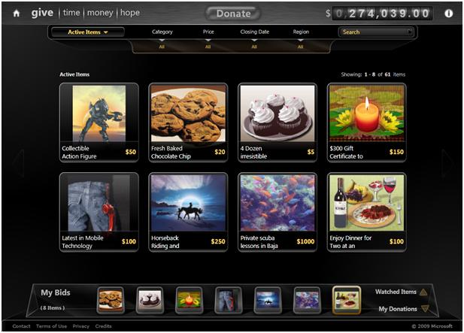
By moving the auction tool to Windows Azure, Microsoft IT capitalized on the ease of migration to provide better service with scalable resources and a seamless sign-in process.

Ease of Migration
Because Windows Azure offers flexible migration approaches, Microsoft IT was able to move only the Web servers that hosted the auction application to Windows Azure and maintain the database on premises while working under a tight deadline. The team expects to complete the migration of the database using Microsoft SQL Azure™ in time for next year’s auction.

Scalable Resources
In the final days of the auction, when traffic was at its heaviest, the team allocated additional resources to ensure adequate capacity and a consistent user experience. When the auction ended and usage declined, they reduced resources accordingly.
Seamless Sign-In
Using Active Directory® Federation Services, employees now sign in using their corporate intranet credentials. When connected to the corporate network, Active Directory Federation Services will authenticate employees automatically.

Familiar Technologies and Tools
The Windows Azure platform is supported by Microsoft development tools including the Microsoft Visual Studio® development system and Microsoft Expression® design software. The team used SketchFlow, a feature of Microsoft Expression Blend 3, to prototype and pilot the user interface of the auction tool and then gather feedback on the design in advance, reducing the risk of a having to embark on a drastic redesign of the user interface.
With Windows Azure, Microsoft IT made the most of its operational and development resources to provide a great way for Microsoft employees to raise money for United Way.

