

Microsoft® Office Communicator 2005 Feature Guide

Microsoft Corporation
Published: May, 2005
Version: 1.0

Abstract
Microsoft Office Communicator 2005 is an integrated communications client, enabling information workers to communicate in real time. As the recommended client for Microsoft Office Live Communications Server 2005, Communicator integrates with Microsoft Office System applications and enterprise telephony infrastructure. Certain elements of functionality, including telephony integration, require integration with other systems, which may require deployment of additional components from third parties, and hence additional cost.

The information contained in this document represents the current view of Microsoft Corporation on the issues discussed as of the date of publication. Because Microsoft must respond to changing market conditions, it should not be interpreted to be a commitment on the part of Microsoft, and Microsoft cannot guarantee the accuracy of any information presented after the date of publication.
This document is for informational purposes only. MICROSOFT MAKES NO WARRANTIES, EXPRESS OR IMPLIED, AS TO THE INFORMATION IN THIS DOCUMENT.
Complying with all applicable copyright laws is the responsibility of the user. Without limiting the rights under copyright, no part of this document may be reproduced, stored in or introduced into a retrieval system, or transmitted in any form or by any means (electronic, mechanical, photocopying, recording, or otherwise), or for any purpose, without the express written permission of Microsoft Corporation.
Microsoft may have patents, patent applications, trademarks, copyrights, or other intellectual property rights covering subject matter in this document. Except as expressly provided in any written license agreement from Microsoft, the furnishing of this document does not give you any license to these patents, trademarks, copyrights, or other intellectual property.
© 2005. Microsoft Corporation. All rights reserved.
Microsoft, Active Directory, Excel, the Office logo, Outlook, PowerPoint, SharePoint, Windows and Windows Server System are either registered trademarks or trademarks of Microsoft Corporation in the United States and/or other countries.
The names of actual companies and products mentioned herein may be the trademarks of their respective owners.

Contents
Contents 1
Overview of Microsoft Office Communicator 2005 2
Table 1: Microsoft Office Communicator 2005 Feature list 2
Key Scenarios for Communicator 5
Connect with people in the enterprise in real time 5
Connect the PC and the phone 5
Increase the velocity of your supply chain 5
Who is Communicator for? 5
Key Tenets 5
Communicator in Action 7
Presence and IM at work 7
Across Firewalls: Better Decisions, Fast 8
Parallel Communications 9
The right client for Live Communications Server federation and Public IM Connectivity 10
Presence enabled search- Searching for a contact- make long contact lists a thing of the past 12
Find-me follow me; Communicator in a unified communications scenario 13
Telephony integration- usable for end users and deployable for IT 14
A day in the life of a Communicator user- some key events in the day of Susan, Contoso Chemicals international business manager. 15
Summary 17

Overview of Microsoft Office Communicator 2005
Microsoft Office Communicator 2005 (Communicator) is an integrated communications client, enabling information workers to collaborate in real-time. It is the recommended client for Microsoft Office Live Communications Server 2005 (Live Communications Server) and provides a wide range of presence-integrated communications modalities, including IM, PC to PC Voice and Video, application sharing, integration with Microsoft Office Live Meeting (Live Meeting) as well as integrating with enterprise or public telephony infrastructure to provide features such as control of enterprise telephone systems and integrations with audio conferencing call providers.
Communicator’s Instant Messaging (IM), presence and 1:1 audio and video capability are provided to customers who have Live Communications Server 2005 Client Access Licenses (CALs) at no additional cost. For these customers, to use the telephony functionality (PBX integration for remote call control and PSTN audio conferencing) requires the purchase of the appropriate number of Live Communications Server Telephony CALs. Pricing for the Telephony CAL and other information are included in the “how to buy” section of the Live Communications Server product web site (www.microsoft.com/livecomm). The table below lists the key features in Communicator and defines which of those require the purchase of the Telephony CAL(s). This telephony integration requires integration with other systems (internal PBXs and external conferencing services), which may require deployment of additional components from third parties (e.g. telephony gateway capabilities from Siemens or Genesys or other partners, unless the PBX supports Communicator directly), and therefore additional cost.

Table 1: Microsoft Office Communicator 2005 Feature list
 | Feature included for customers with Live Communications Server 2005 CALs | Feature requires purchase of Live Communications Server Telephony CAL(s)
IM & Presence
Text based Instant Messaging (IM) conversations
Support for setting and viewing custom ‘notes’
Integration with Microsoft Exchange Server to publish and display Out of Office messages, and display schedule (Free/Busy) information
Enhanced, contextual presence (automatically reflect when a user has a meeting in their calendar, or is involved in a voice, video or telephony related call)
‘Tag’ contacts (receive pop-up notifications about the status change only of contacts a user is interested in)
Search for and communicate with contacts in the corporate address book and Microsoft Office Outlook® 2003 contacts without having to add them to a contact list first
Communicate with federated contacts (Communicator can also show an icon in the UI to identify federated contacts)
Save IM to file or to Email
Support for sign-in on multiple endpoints
Roster for multiparty conversations
Audio / Video
PC-PC Voice communication
PC-Phone Voice communication
PC-PC Video communication with CIF-sized video window, expandable to full screen and new, bandwidth efficient video codec
Integration with PC volume control during PBX calls
Collaboration
Ad-hoc data sharing capability for small groups (application sharing, whiteboarding) based on calling Windows NetMeeting functionality
Live Meeting integration – escalate to a Live Meeting session from an IM conversation
Extensibility / Deployment
Control of key features via Group Policy objects
‘Tabs’ can be used to extend the application
Telephony Integration
Remote Call Control of a PBX phone
Call management (dynamically forward, add people to call, transfer)
PBX call initiation from Communicator application
PBX incoming call notifications ‘toast’, integrated with corporate address list and Outlook contacts for reverse number look up
Rules-based call forwarding for PBX phone calls (forward calls based on where a user is signed in, or their presence, i.e. if they are away from their computer calls could automatically be forwarded to a cellphone)
PSTN (‘reservationless’) audio conferencing integration, with control of the conference (add/eject/mute participants, lock conference, end conference)

Key Scenarios for Communicator
The next section of this document outlines some of the key scenarios for use of Communicator, and also describes those scenarios in action.

Connect with people in the enterprise in real time
In a world of ‘communications overload’ where ‘virtual’ working continues to increase, existing forms of asynchronous communication are no longer sufficient. Communicator integrates rich communication capabilities to allow teams and information workers to more easily and efficiently communicate in real time.

Connect the PC and the phone
The enterprise telephone has been a key form of real-time communications for some time, although until today has not been well integrated with the PC. Communicator, with appropriate linkage between Live Communications Server and the enterprise phone system, bridges the gap between the enterprise phone and the PC.

Increase the velocity of your supply chain
Even with the best communications tools, being restricted to communicating within one enterprise is often not enough to meet the demands of business today. As the recommended client for Live Communications Server 2005, Communicator extends the reach of these solutions beyond the traditional boundary of the enterprise and helps enable faster reactions throughout your supply chain, with suppliers, partners and customers.

Who is Communicator for?
The focal point for Communicator is of course the information worker, its primary user on a day to day basis. In its design however, a lot of work has gone into ensuring that Communicator is easy to deploy for IT departments. Communicator is also a key component of Microsoft’s Real-Time Communications platform, built on the SIP/SIMPLE protocols and something that a corporate developers or independent software vendors (ISV) organizations can leverage to create solutions which address business needs.

Key Tenets
The following examples of Communicator in action are grouped around the following tenets:
- Integrated Communications
Communicator brings together a range of different communications modalities to users, enabling many different forms of real-time collaboration to take place.
- Ease of use
Ensuring that Communicator is intuitive and easy-to-use was a focal point during the product’s development cycle to enable information workers to get the most out of the product when in use.
- Reach
A key component of a solution delivered by Live Communications Server 2005 and Communicator is the ability to extend the reach of communications beyond the traditional boundary of the enterprise, whether that means making it easier for remote employees to stay connected, or to enable communications between different organizations.

Communicator in Action

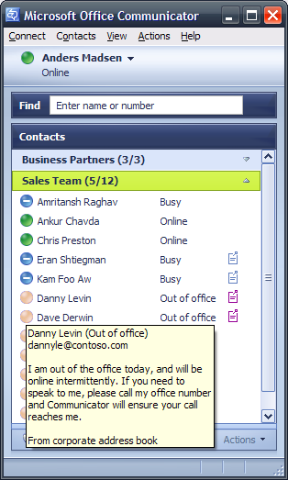
Presence and IM at work

Tenets: Integrated Communications; ease of use
Many companies are finding that IM is a widely used tool in their businesses, but is not controlled by the IT department. In this case companies have found that this is an IT hygiene issue, and in certain industries companies are being asked to log all IM conversations for regulatory reasons. Live Communications Server 2005, for which Communicator is the recommended client, is the right solution for these companies to help meet these needs. (see Live Communications Server documentation on the product’s web site on Microsoft.com (www.microsoft.com/livecomm) for more details). Communicator is designed to meet the needs of enterprises- it is an integrated communications client specifically designed for needs of that market
Office and application integration
The shift towards the “real-time enterprise” has not to date incorporated people in the mix- displaying presence of other users inside applications is a key step towards bringing people into this real-time mix. Integrating real-time communications capabilities, including presence, into other applications (including enterprise applications like ERP systems or productivity applications like spreadsheets or word processing) can allow information workers to get in contact with the right people to deal with a specific question, with a couple of clicks from within the application. Live Communications Server and Communicator deliver out of the box integration with Microsoft Office applications and can also form the basis of integration with other applications. Users can see the status of other users in those applications, and immediately initiate communications, without themselves having to launch separate communication application. This integration is not dependent on the user having the monitored contacts in their Communicator contact list.

Presence
Presence is a key component of an integrated communications solution. By giving users an indication of whether the person they wish to contact is available or not, users can be more efficient in how they contact people- fewer voicemails (as people do not call when they see that the person they want to communicate with is not available), and also who they contact- ask the person who is present a question rather than blasting the question to 10 people all at once.

Shrink geography- teamwork can be more effectively with a mix of scheduled meetings and ad hoc discussions
As teams are more and more geographically dispersed presence can be the glue that enables them to work together. With Communicator, users can tag contacts to see when they become available, and communicate instantly, across the office or around the world. Work that might have taken an entire working day for a single round of feedback can be completed faster as people use the overlapping working hours more effectively. Users can also find that they use their time more effectively as they get questions answered through the working week, rather than waiting for a single once a week synch meeting- in the past this has often been the only way for people to be able to speak to each other. With presence questions can be answered virtually any time, when convenient to both parties. (Sound familiar- it should- it is like the office of many years ago when everyone in the company worked under the same roof!)

Across Firewalls: Better Decisions, Fast

Tenets: Reach; ease of use.

Using Live Communications Server 2005’s ’outside user’ capability, businesses can extend the ability to use Communicator beyond the firewall. The requirement here is that a Live Communications Server access proxy is deployed in the DMZ of the enterprise.
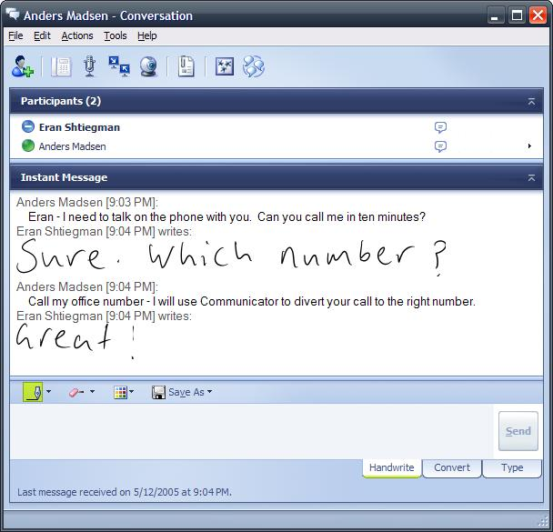
Using Communicator without a VPN
In this scenario, users do not need to establish a VPN connection into their enterprise networks to be signed in to Live Communications Server. Users might be in a coffee shop on a public wi-fi network, at home on a home network, or a customer site, where often basic Internet access is available even when VPN connections are not possible. Users are then more reachable, it is easy to be “present” even when not in the office. This is seamless from a user’s point of view and does not require any different steps to be taken than when they are in the office.

Presence, IM and telephony control
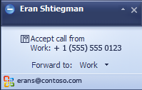
Users are able to be signed in, view all of their colleagues’ presence and exchange text and ink based IM. In addition users get many of the same telephony capabilities as they have in the office. They will get pop-ups when a call is addressed to their desk phone. This allows for a user to see who is calling (Communicator looks up the number provided by caller ID in the corporate address list or in Outlook 2003 personal contacts) and then decide to forward the call to a home phone, or mobile phone. This forwarding is transparent to the calling party. This is great way to be more responsive to important customers and colleagues. Unless an enterprise has deployed media relays from a third party PC based voice and video capabilities will not be possible in this case (they require a VPN to work outside a corporate firewall).

Parallel Communications

Tenets: Integrated Communications; ease of use

Traditionally communicating with one person has meant it is very difficult to get input from others to the conversation. Whether at a point of sale, in a customer call, or a conference call Communicator allows for parallel communications to add value and bring additional expertise into a conversation.

- At point of sale or call center- a customer facing rep can view the presence of experts in the rest of the organization and contact them, to get the right information for a customer

- A very common scenario as companies use more and more instant messaging. Individuals can be on a PSTN conference call and have side bar chats with individuals, for coaching or discussions around negotiations.
- Confirm with a colleague by IM, prior to “conferencing them in” to an existing communications session, that they are there, and that they can contribute. This means ad hoc conference calls can be more productive, with fewer false starts or voicemails.
Traditionally, such parallel conversations required interruptions, and had a low probability of success in finding the right person. With Communicator, managing more and more of an information worker’s communications the presence of co-workers will often be in the application that launched the conference call, and so it is easy, and non-intrusive to get the additional people into the discussion.

The right client for Live Communications Server federation and Public IM Connectivity

Tenets: Reach; Integrated Communications; Ease of Use
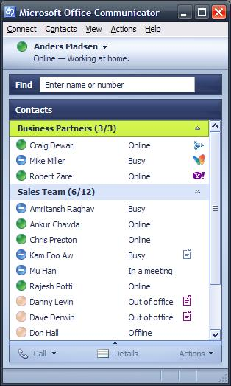
Communicator is the recommended client for communicating with contacts in other organizations via Live Communications Server based federation or contacts using public IM services using Public IM Connectivity. These capabilities are described in more detail in the Live Communications Server 2005 documentation on www.microsoft.com/livecomm

Adding contacts from another company, or business partner naturally improves the communications reach for an information worker- they can see the presence of business partners and communicate with them instantly. Communicator can also be used to initiate calls with such contacts, if the phone number is stored in the recipient of the call’s local Outlook contact list.

Communicator indicates when a contact is from outside a user’s organization and can also display an icon from the other organization (in the case of communications with contacts using public IM networks, the icon shown will represent the public IM network).

As described in the Live Communications Server documentation ,enterprise level authentication, encryption and archiving are applied to such communications, meaning that Live Communications Server and Communicator, with PIC are the right tools for business to business real-time communications.

Note that for most organizations, searching for a contact in another company’s directory is not enabled, and there is no searching for PIC contacts. In these cases users need to know the IM address (typically the email address) of the contact they wish to add. In the federated case this is because many organizations are unwilling to permit other organizations the ability to browse their directories.

Presence enabled search- Searching for a contact- make long contact lists a thing of the past

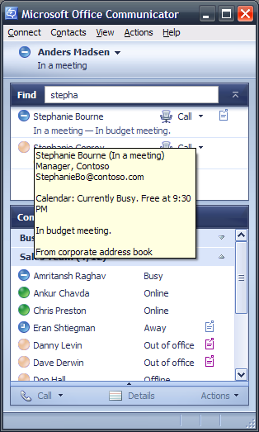
Tenets: Integrated Communications; ease of use; reach

With Communicator’s search capability users are able to find the right contact quickly and easily. The search input box is accessible from the main Communicator window, and is therefore easy to find. Searches are iterative, so users do not need to know a complete name of the people they are searching for. The search capability is searching the corporate directory (GAL) as well as the user’s local contact list in Outlook, the Windows Address Book, and also the user’s Communicator contact list, integrating different address books, and including people outside the organization.

The results from the search iterate down to the desired contact. Even if that person is not on the searcher’s contact list, extended presence is available (with schedule and out of office information being displayed if published), so after the search the user can easily see the best way to contact that person. All of Communicator’s communications modes are available from that search result (including “send an email” which is useful for a user if the person they have searched for is not available at that time).

This search capability, combined with Office integration, reduces the requirement for long contact lists. Users do not need to try to maintain long, unmanageable contact lists; instead they can keep the lists to core team members, and then use the search capability to find others in their company who they may wish to communicate with on an ad-hoc basis.

Find-me follow me; Communicator in a unified communications scenario

Tenets: Ease of use; integrated communications

One-number, “find me follow me” unified communications services have grown in popularity over the past few years. Communicator has many of the capabilities of these solutions, delivered in an integrated way, so that users do not need to learn additional applications for individual features. A single client can be used for presence and IM, PC based real-time communications, and also telephony control.

The ease of use of Communicator can also mean that users are able to take advantage of previously hard to discover and hard to use capabilities of telephony systems.
The telephony integration required for this scenario requires integration with other systems (internal PBXs and external conferencing services), which may require deployment of additional components from third parties (e.g. telephony gateway capabilities from Siemens or Genesys or other partners, unless the PBX supports Communicator directly), and therefore additional cost.

Tag a contact (follow)
A user can tag a contact on their contact list. This allows for a user to receive alerts when the person they have tagged changes status- e.g. when their meeting finishes, or when they get off the phone or sign in. This is similar to camping-on to a PBX extension, but gives the user the choice of communications modes when they are notified that the person they want to speak to is available. This can also reduce the amount of notification a user gets rather than the situation today where users are often notified when anyone on their contact list signs in. ACLs can be applied at the IT administrator level to control who is able to view whose presence.

Automated Call forwarding
Have calls automatically forwarded to another number (this allows for users to give out fewer numbers to their contacts)

Call forwarding can either be set by a user to always forward calls to another number, to forward calls when the user is not signed into Communicator and not active on any of their devices, or to forward to a specific number when a user is present on a specific device (e.g. forward calls to a desk phone to home when a user is active on Communicator on their home PC).

Real-time Call Forwarding
Now, when a call comes in on a user’s PBX phone, they will receive a notification on screen, which will use the supplied caller ID and integrate with the corporate address list and Outlook contacts to display information about the caller. The caller can forward this call with the click of a mouse to an alternative number – so if a user is working remotely and sees a call coming in from an important customer, they can divert that call to their cellphone or another phone where they are.

Missed call emails- allow for a user to get an email when they miss a phone call, the user can then click to call the originator of the call from that email.

Telephony integration- usable for end users and deployable for IT
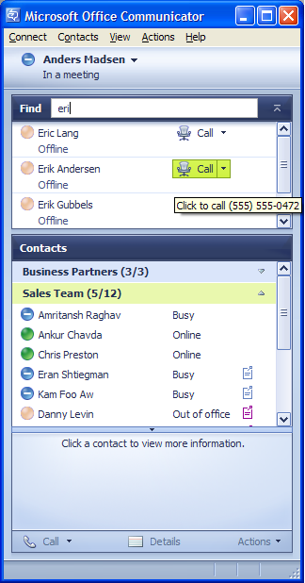
Tenets: Ease of Use; Integrated Communications; Reach

For end users enhanced telephony features have traditionally been challenging to use. The interface for the applications has been the three by four keypad on the phone, and applications have typically been deployed in silos, with an inconsistent set of commands for end users. With Communicator, the richness of the PC interface allows for end users to control their phones with confidence, with tool tips and visual guides for key capabilities.

Just as important as a rich interface is integration of a number of different applications in the same client. Users can start to use the IM capabilities and then adopt the call features, without having to change context.

For IT the solution provided by Communicator and Live Communications Server is designed to work within existing infrastructures. For presence and IM capabilities Live Communications Server is easily managed as part of the Windows Server System™, using standard management tools (see deployment guide on www.microsoft.com/livecomm for more details). This core capability is then extensible to telephony control by deploying a gateway to an existing PBX or IPBX, or through native integration, where available, from the PBX manufacturer (note that some companies may opt to deploy a gateway for heterogeneous PBX environments, even when some of the PBXs support native integration).
This telephony integration requires integration with other systems (internal PBXs and external conferencing services), which may require deployment of additional components from third parties (e.g. telephony gateway capabilities from Siemens or Genesys or other partners, unless the PBX supports Communicator directly), and therefore additional cost.

A day in the life of a Communicator user- some key events in the day of Susan, Contoso Chemicals international business manager.

Time | What happened | So what/What did Communicator do?
7.45am | Get a call from a European customer | Forwarded the call automatically as Susan was not present on any device
8.20am | Get to the office- No voicemails | Co-workers had seen Susan was offline and not tried to contact her, other calls had been diverted to a mobile
8.21am | Urgent IM from Latin America | Luis on the big Latin American sale had tagged Susan, so he was alerted when she arrived. No-one wasted any time leaving unnecessary messages, and the questions got answered
8.50am | IM from a public IM contact: Car pool arrangements for the afternoon have broken down- Susan needs to leave early to collect her daughter from school | Communicator’s PIC capabilities allow Susan to have important external contacts on her one integrated communications client- so she has a single place to manage all her real-time communications
9-10am | Conference call, co-ordinate the team around a tricky customer situation | Using group IM initiation and PSTN conferencing Susan pulls together a quick conference call around a customer issue. One of her team needs coaching- Susan gives him IM guidance as he is talking to the customer- problem solved
10-11.45 | Updating team site and other team management | Office 2003 integration allows for Susan to contact people with questions about documents posted to the team Windows SharePoint® Services (?) site, and to find the right accounting contact for a budget question for the Asia review tomorrow- even though Susan has never met her.
11.45 | Confirm working lunch- search for a contact, and then call them PC to PC | PC 2 PC voice and video call to confirm a working lunch with the accounting contact- video means they have now “met” each other and will find each other in the sandwich shop.
Lunch time | Partner calls from Europe- it’s 9pm there- it must be important- Susan takes the call | Screen pops and caller id mean that over a working lunch in front of their laptops Susan ignores several potential interrupts, until she get a call from a European customer. She is out of the office so she forwards the call to her mobile phone. Susan was in control of which interrupts to take.
Early afternoon | Susan continued to use Communicator as her integrated communications client through the rest of the work day | …
Late afternoon | Go to collect daughter from school, receive a call from an important partner on the way over | Susan is able to feel in control of her communications- she knows that Communicator is indicating her “out of office” presence to colleagues, and is forwarding external calls to her cell phone.
Evening | Log on from home; engage in encrypted, authenticated communication with Asian subsidiary about the review tomorrow. | Even though she is now at home Susan can use Live Communications Server 2005 and Communicator to do last minute prep with here Japanese colleagues- knowing that their conversations are authenticated and encrypted.

Summary

Microsoft Office Communicator 2005 is an integrated communications client , enabling information workers to collaborate in real-time. It is the recommended client for Live Communications Server 2005 and provides a wide range of presence-integrated communications modalities, including IM, PC to PC Voice and Video, application sharing, integration with Microsoft Office Live Meeting as well as integrating with enterprise or public telephony infrastructure to provide features such as control of enterprise telephone systems and integrations with audio conferencing call providers.

This document has described the key features available in Communicator as well as the key customer scenarios relevant to it. The real world examples of its usage are designed to give some insight of how it might be deployed in your organization as part of a real-time collaboration solution in combination with Live Communications Server 2005.

For more information on Live Communications Server 2005 and Microsoft Office Communicator 2005, please visit www.microsoft.com/livecomm where you will be able to find more in-depth information as well as download or order an evaluation edition of the software.

SIP- Session Initiation Protocol. SIMPLE- SIP with Instant Messaging and Presence Leveraging Extensions
This scenario would require PBX integration to be enabled, which requires an Live Communications Server 2005 Telephony CAL

