For more information about other Microsoft customer successes, please visit: www.microsoft.com/casestudies
Customer: Outback Steakhouse
Web Site: www.outback.com
Customer Size: 50,000 employees
Country or Region: United States
Industry: Retail—Food service
Partner: Thuzi
Web Site: www.thuzi.com

Customer Profile
Tampa, Florida–based Outback Steakhouse operates more than 1,230 restaurants in 50 states and 21 countries. The company’s annual revenues exceed U.S.$3 billion.

Software and Services
- Windows Azure Platform
- Microsoft SQL Azure
- Windows Azure

Windows Azure Platform
The Windows Azure platform provides an excellent foundation for expanding online product and service offerings. The main components include:
- Windows Azure
- AppFabric Service Bus
- AppFabric Access Control
- Microsoft SQL Azure

To learn more about the Windows Azure platform, visit:
www.microsoft.com/windowsazure

For more information about Microsoft in the foodservice industry, visit:
www.microsoft.com/foodservice

Windows Azure
Customer Solution Case Study
 | 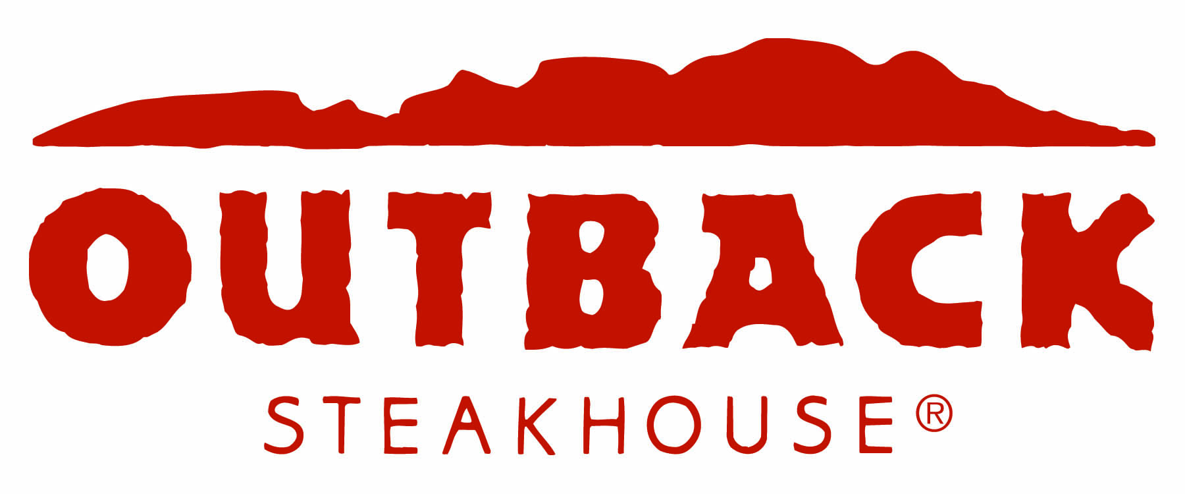 |  |   Restaurant Chain Boosts Guest Loyalty with Social Networking and Cloud Computing
“We are thrilled with the results of the effort, how quickly we grew our base of Facebook fans, and the technology that Thuzi provided to make the application so successful.”
Dan Dillon, Chief Marketing Officer, Outback Steakhouse
Outback Steakhouse wanted to encourage repeat guests by creating a social networking presence. Working with Microsoft Partner Thuzi, Outback offered a free Bloomin’ Onion coupon to the first 500,000 guests to sign up as Outback fans on the Outback Facebook Fan Page. The company developed the application on the Windows Azure platform in less than eight weeks, taking advantage of its familiar environment, flexibility, and scalability.

Business Needs
 |  |  | 

Outback Steakhouse is a favorite dining spot for people who want innovative dishes in a casual atmosphere. Outback wanted to encourage customers to visit its restaurants but wanted to use something other than traditional advertising to reach repeat and potential new guests.

Outback decided to create a “fan” page on the social networking site Facebook. The first 500,000 visitors to sign up as Outback fans would receive a coupon, through e-mail, for a free Bloomin’ Onion appetizer. Spurring interested parties to pass along information to their friends and family would achieve high exposure at a low cost.

“We wanted to quickly get an application into the market that would grow our fan base and drive traffic to our restaurants,” says Dan Dillon, Chief Marketing Officer for Outback Steakhouse.

But a viral campaign such as this needed its infrastructure and technology to be able to scale quickly to meet spikes in demand and to cost-effectively support an unknown number of respondents.

Solution
In mid-September 2009, Outback partnered with Thuzi, a Registered Member of the Microsoft Partner Network. Thuzi considered hosting the application in one of its data centers but hesitated at the up-front expenses to support the hoped-for response. “We weren’t sure when all the traffic would hit and what size the load would be,” explains Jim Zimmerman, Chief Technology Officer and Lead Developer for Thuzi. “Given that unpredictability, it didn’t make sense to spend U.S.$10,000 on the five or so servers necessary to run the Outback application in-house.”

Outback and Thuzi explored hosting services from Amazon, Google, and Microsoft. “Outback wanted its application to go live as soon as possible,” says Zimmerman. “With Amazon, we’d have had to set up the infrastructure and all the servers and make a lot of back-end services decisions. And the Google programming interface takes too long to learn.”

They selected the Windows Azure platform, an Internet-scale, cloud platform-as-a-service offering hosted in Microsoft data centers. “We had a lot more confidence going with Windows Azure—even though it hadn’t been released yet,” says Zimmerman. “It provided a more familiar, less expensive infrastructure and led us down a scalable path.”

It took less than two months to develop the Outback cloud-computing application. Developers built it as a Web application, establishing worker roles with caches and an asynchronous architecture to improve performance and scalability. They used Microsoft SQL Azure and the Table service in Windows Azure Storage Services for background processing. The application’s integration with its own cloud-based database makes it possible for Outback to run queries and produce reports.

Developers also set up a notification server to note coupons that bounced back due to incorrect e-mail addresses so that respondents would know that their coupons could not be delivered until they provided a working address. They were able to quickly fine-tune the logging infrastructure to catch e-mail address exceptions and upgrade graphics.

Future plans include using configuration and management application program interfaces (APIs) to automate the way that the application scales up and down. A program will respond to certain criteria and automatically start or stop instances so that the Outback application maintains responsiveness while minimizing costs.

Outback launched its application on November 5, 2009. The company hoped to achieve its goal of 500,000 fans within 30 days. It reached that goal without any issues in just 18 days. “We were pleased with the response to the offer and the opportunity to engage with our new Facebook fans,” says Dillon.

Benefits
For Outback Steakhouse, using Windows Azure meant developing an application in less than eight weeks and scaling it easily to support a huge customer response. “We are thrilled with the results of the effort, how quickly we grew our base of Facebook fans, and the technology that Thuzi provided to make the application so successful,” says Dillon.

Scalable, Cost-Effective Solution
Outback and Thuzi have found that the Windows Azure cloud platform is an easy way to support a variable number of users. “Using the Windows Azure platform offers the flexibility to pay only for the resources you need, rather than committing to a set capacity and investing in hardware,” says Zimmerman. “We instantly scale up to ensure coverage of the application’s peak usage times and scale back when extra coverage isn’t needed.”

Fast, Flexible Development
Outback benefited from the ease of development that comes with the Windows Azure cloud-computing platform. For instance, it could request adjustments and see those changes reflected promptly. “All response was quick and timely,” says Dillon. “We were able to edit the application on demand because of the combination of the technology’s adaptability and Thuzi’s responsiveness.”

Adds Zimmerman, “Deployments are a cinch with Windows Azure. Using worker roles to design the solution architecture means that Outback can build on this application to quickly and easily launch new online offerings.”

Positive, Reliable Guest Experience
By choosing Windows Azure, Outback can provide a consistent experience for its Facebook fans. “Everyone likes the application’s speed,” says Zimmerman. “Plus, Outback has its own separate application and database in the cloud, so it doesn’t have to worry about another application affecting performance.”

