Application Templates for Windows SharePoint Services 3.0
General Overview of all
Application Templates
Overview
Microsoft® Windows® SharePoint® Services 3.0 is technology of Windows Server® that offers an integrated portfolio of collaboration and communication services. Windows SharePoint Services is designed to connect people, information, processes and systems both within and beyond the organizational firewall. Downloadable at no additional charge, Windows SharePoint Services helps simplify the process of implementing and managing a team collaboration infrastructure.
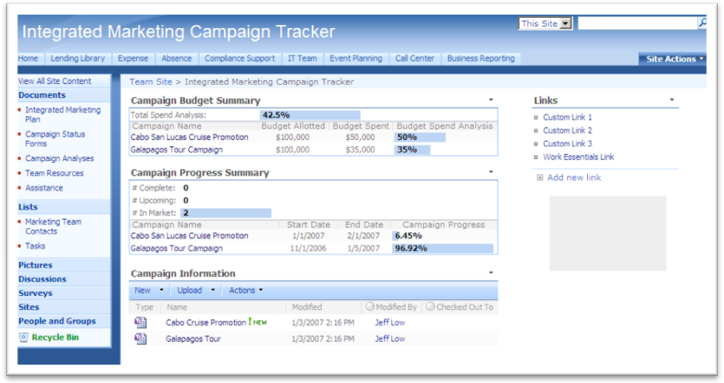
Home page view of the Integrated Marketing
Campaign Tracking application template.

In addition to providing a foundation for collaboration, Windows SharePoint Services is a platform for developing Web-based business applications. Microsoft has developed forty Application Templates to provide out-of-the-box, web-based business applications to address the needs of specific business processes such as organizing Room and Equipment Reservations, coordinating a Help Desk or even managing a company Sports League.
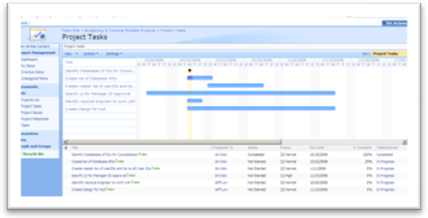
Project Tasks as a Gantt Chart in the Budgeting and
Tracking Multiple Projects application template.

Microsoft developed these application templates to be usable immediately after deployment. However, they also can function as a starting point for partners and developers looking to build more sophisticated Windows SharePoint Services solutions using Microsoft Office SharePoint Designer 2007.

Available Application Templates
Microsoft has developed forty application templates for Windows SharePoint Services 3.0 that can be downloaded at no extra charge. Each application template addresses a business scenario and provides a base of functionality that can be either used directly out of the box, or customized for company specific needs.

Applying Application Templates to Your Business
The application templates have also been grouped by scenario and mapped to common business areas within an organization. These groupings help put into context how the application templates can be applied to specific processes or sets of tasks, whether within business groups or for certain job functions.

Template Types: There are two types of Application Templates for Windows SharePoint Services 3.0, site admin templates and server admin templates, providing the right combination of integration with the Windows SharePoint Services platform and ease-of-deployment within an organization. To differentiate between these two types, all server admin templates are labeled with an asterisk (*) in the table.

Template Name | Description | Business Area
Absence Request and Vacation Schedule Management* | Help employees manage requests for out of office days, including listing days they will be unavailable who will cover their responsibilities while they are gone. | Human Resources
Board of Directors | Provide a single location for board meeting notes, tasks and issues and events. | Business Management / Finance
Budgeting and Tracking Multiple Projects* | Help track and budget multiple, interrelated sets of activities with project creation, tasks, Gantt Charts and common status designator tools. | Project Tracking / Product Management
Bug Database* | Help development teams collect and track information about bugs in their code including reproduction steps, category, comments, priority and severity of the bug. | IT / Operations
Business Performance Reporting | Help track customer satisfaction through surveys and online discussions. | Business Management / Finance
Call Center* | Help individuals manage the process of handling customer service requests from issue identification to cause analysis and resolution. | IT / Operations
Case Management for Government Agencies | Help manage tasks, documents and assignments related to government cases. | Specialized / Vertical (Government)
Change Request Management* | Help users track risks associated with a design change, including the ability to approve or reject the change. | Project Tracking / Product Management
Classroom Management | Help instructors store and organize course content, calendar items and announcements. | Specialized / Vertical (Education)
Clinical Trial Initiation and Management | Help manage the documents, tasks, issues and discussions needed to run a clinical trial. | Specialized / Vertical (Health Care)
Competitive Analysis Site | Help organize the results of competitor’s offerings through useful competitive analysis technique templates. | Sales / Marketing
Compliance Process Support Site* | Help both teams and executive sponsors manage compliance implementation endeavors by specifying control tasks and managing document libraries. | Business Management / Finance
Contacts Management* | Help teams manage contact information among team members, including synchronization with Microsoft Office Outlook® 2007. | Sales / Marketing
Discussion Database | Foster collaboration by helping teams discuss topics online or through Office Outlook 2007 RSS capabilities. | Project Tracking / Product Management
Disputed Invoice Management | Help accounts payable departments track information regarding invoices due to vendors, including value of early payment and reasons for delayed payment. | Business Management / Finance
Document Library and Review* | Help teams manage the document review cycle with a version-tracking document library including a threaded discussion to provide a feedback. | Project Tracking / Product Management
Employees Activities Site | Help employees create and sign up for activities and events sponsored by the company. | Human Resources
Employee Self-Service Benefits | Enable employees to locate and sign-up for benefits offered by their employer. | Human Resources
Employee Training Scheduling and Materials | Help schedule training as well as provide a location for employees to sign up and receive course material. | Human Resources
Equity Research | Provides a centralized location to help consolidate the research done to evaluate financial equities. | Specialized / Vertical (Financial Services)
Event Planning* | Help teams organize events through the use online registration, schedules, communication and feedback. | Specialized / Vertical (Professional Services)
Expense Reimbursement and Approval* | Manage elements of the expense approval process, helping to save time for approvers. | Business Management / Finance
Help Desk* | Help teams manage the process of handling service requests including managing identification of the root cause and tracking status. | IT / Operations
Integrated Marketing Campaign Tracking | Enable tracking of marketing campaign performance. | Sales / Marketing
Inventory Tracking* | This template helps organizations track elements associated with inventory by capturing manual input of updated inventory information notifying users when each part reaches the reorder quantity. | IT / Operations
IT Team Workspace* | Help teams manage the development, deployment and support of software projects by updating project tasks, issues, milestones and bugs. | IT / Operations
Job Requisition and Interview Management* | Enable your recruiting team to streamline the process of managing job requisitions and filling job openings. | Human Resources
Knowledge Base* | Enable employees to share knowledge resident within their organization. | Project Tracking / Product Management
Lending Library* | Help manage the physical assets in an organization’s library with check out / in functionality and automated overdue notification. | IT / Operations
Manufacturing Process Management | Help enable manufacturing engineering teams track the linear manufacturing process as well as issues that are blocking completion of a manufacturing task. | Specialized / Vertical (Manufacturing)
New Store Opening | Help teams manage the process of opening a new store including project and task management tools. | Specialized / Vertical (Retail)
Physical Asset Tracking and Management* | Help teams manage requests and tracking of physical assets such as location, condition, manufacturer, model, current owner and estimated value. | IT / Operations
Product and Marketing Requirements Planning* | Help organize the process of developing new products and marketing content through useful planning templates and collaboration tools. | Sales / Marketing
Project Tracking Workspace | Help small teams manage project information such as project issues, tasks and project status. | Project Tracking / Product Management
Request for Proposal | Help manage the process of creating and releasing RFPs as well as the collecting proposal submissions and acceptance notification. | Business Management / Finance
Room and Equipment Reservations* | Enable teams to manage the utilization of shared meeting rooms and equipment. | IT / Operations
Sales Lead Pipeline* | Help teams manage the sales pipeline by tracking leads, opportunities, contacts, and accounts. | Sales / Marketing
Sports League | Manage a company baseball league, including players, captains, schedule and statistics. | Specialized / Vertical (Consumer / Entertainment)
Team Work Site | Enable project teams to centrally store background documents, track calendar events and submit action items that result from team meetings. | Project Tracking / Product Management
Timecard Management | Help simplify the process of tracking hours spent on multiple projects through employee ‘punch-in / punch-out’ capabilities and reporting of work in progress and project hours worked to date. | Project Tracking / Product Management

Customizing SharePoint Sites and Templates
Office SharePoint Designer 2007 is a Web site development and management program that provides powerful tools to build, customize and contribute to Windows SharePoint Services sites. Using the latest Web design technologies and established standards, technical users are able to create and deploy interactive solutions without having to write or deploy complex code.
Office SharePoint Designer 2007 helps automate business process workflow such as document approval, custom event notification and other collaboration tasks with the workflow designer. It allows report creation data tracking applications using views and forms to gather and aggregate information from within the site and from locations on the Web. Advanced users can extend the power of Windows SharePoint Services with interactive Microsoft ASP.NET pages using the same powerful activity menus and control property grids previously found in the Microsoft Visual Studio® development system.

Master Pages
The Classroom Management application template with two different
master pages applied: “Horizon” (top) and “Block” (bottom)
Master pages are a feature of ASP.NET 2.0 that work the same way in Windows SharePoint Services 3.0 and Office SharePoint Server 2007 as they do in ASP.NET 2.0. Using master pages, you can create a single page template and then use that template as the basis for multiple pages in an application, instead of having to build each new page from scratch. Master pages enable you to apply site-wide look/feel and layout changes to a SharePoint site, including those sites created from the application templates.
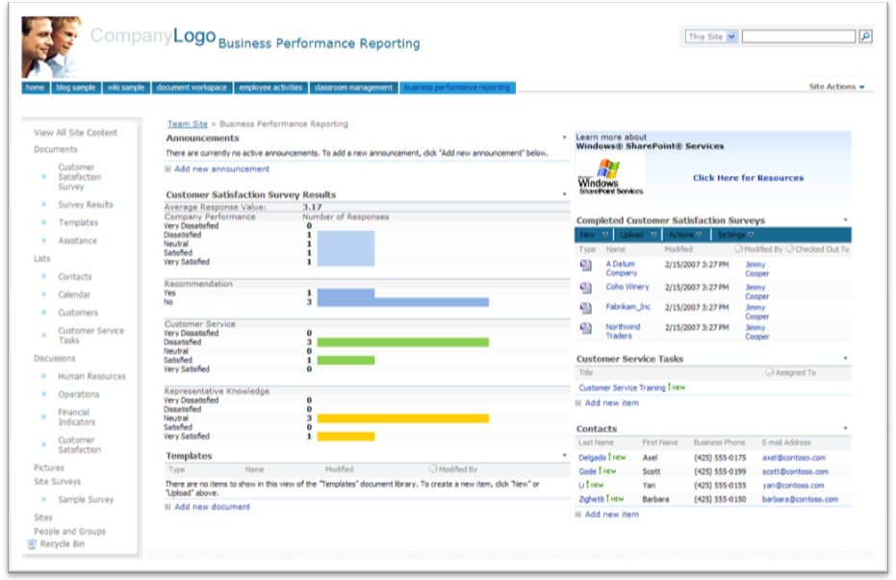
The Business Performance Reporting application template with the “Clarity” master page applied.
Microsoft has made available four sample master page sets compatible with the Application Templates for Windows SharePoint Services 3.0 to showcase some of the customization options master pages provide. The samples were built using Office SharePoint Designer 2007 and its full design-time support for master pages. To learn more about master pages and to download the four sample sets, visit: http://go.microsoft.com/fwlink/?LinkID=83236

More Information

For more information, please visit:

Application Templates for Windows SharePoint Services:
http://www.microsoft.com/sharepointapps
Includes detailed datasheets with functional and technical overviews, plus screenshots for each template.

Microsoft Windows SharePoint Services 3.0:
http://www.microsoft.com/sharepoint

Microsoft Office SharePoint Designer 2007:
http://office.microsoft.com/sharepointdesigner

Site admin templates are custom templates that are easy for any SharePoint site administrator to install into the template gallery without requiring server administration access.
Server admin templates are created as site definitions, enabling tighter integration and enhanced functionality within the Windows SharePoint Services platform. They require a server administrator to install.

