Application Template: GroupBoard Workspace 2007
Functional Overview for
Business Decision Makers

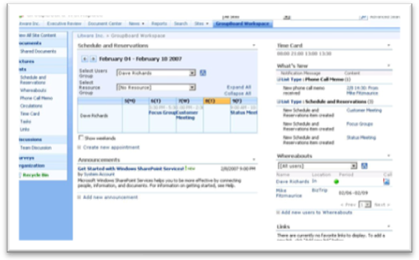
Description of Template
The GroupBoard Workspace 2007 application template for Microsoft® Windows® SharePoint® Services 3.0 creates a space for a group or team to connect and share information in a collaborative environment, improving team efficiency and productivity. The template helps track team member whereabouts and status, and includes a built-in timecard list and organization chart. Meetings can be scheduled with attendees, and meeting rooms and other resources can be reserved. It also enables members to share phone messages and circulate memos.

Sample Activities Performed in this Application Template
The following examples show the various ways Microsoft anticipates this template will be utilized in a typical organization. If you wish to add additional features, please ask your IT provider to research Microsoft Office SharePoint Designer 2007.

Toni Poe is an administrative assistant at Litware, Inc. A new team comprised of marketing, sales and technical members has been created to work on an upcoming product launch. Toni uses the GroupBoard Workspace 2007 application template to create a new site so members of the new team can communicate quickly and effectively. The team is located in a new building, so Toni adds new shared resources, such as conference rooms and projectors, to the GroupBoard Workspace site. She can group similar resources for easier discoverability. Team members can see the free/busy information for the shared resources as well as their colleagues on the home page.
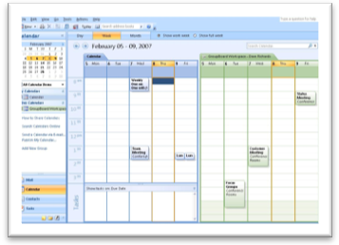
The GroupBoard Workspace meeting scheduler has familiar Microsoft Office Outlook® 2007 functionality, such as scheduling recurring meetings, checking participants free/busy times and creating a meeting workspace. Team members can be added to the meeting request individually or as a group. The calendar provides weekly views of the group, as well as daily, weekly and monthly views for each team member. Members can also connect the GroupBoard Workspace team calendar to their personal calendar in Office Outlook 2007 and see a side-by-side view of their upcoming appointments and meetings.

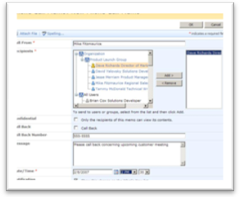
Non-salaried team members can quickly clock in and out to track their hours, overtime and vacation with built-in time card functionality. Time card settings can be adjusted to set standard office hours and add holidays. Team members can also keep track of who’s in and out of the office using the Whereabouts web part, easily editing their location to display when they are on vacation, a business trip or away for a few hours. And when important calls come in for the team, Toni can create and post messages directly to the GroupBoard Workspace site, enabling the recipient to collect and answer messages when out of the office.

GroupBoard Workspaces also introduces circulations, which replace the traditional memo or group email. Unlike memos or emails, team members can record that they have viewed the circulation. When each team member logs onto the GroupBoard Workspace site, they can view all their new meeting requests, phone memos and circulations in the “What’s New” web part. Team members can quickly view the item details, resolve new phone memos and confirm that they have viewed the circulations.

About Microsoft Windows SharePoint Services 3.0
Microsoft Windows SharePoint Services 3.0 is technology in Windows Server® that offers an integrated portfolio of collaboration and communication services designed to connect people, information, processes and systems both within and beyond the organizational firewall. Now available at no additional charge, the technology provides a platform for developing Web-based business applications. Application Templates provide out-of-the-box scenarios to address the needs of specific business processes.

More Information
For more information on the technologies described in this article, please visit:

Microsoft Windows SharePoint Services 3.0:
http://www.microsoft.com/sharepoint

Application Templates for Windows SharePoint Services:
http://www.microsoft.com/sharepointapps

