Published: October 2007
Microsoft® Office Communications Server 2007 Quality of Experience Monitoring Server Guide
Information in this document, including URL and other Internet Web site references, is subject to change without notice. Unless otherwise noted, the companies, organizations, products, domain names, e-mail addresses, logos, people, places, and events depicted in examples herein are fictitious. No association with any real company, organization, product, domain name, e-mail address, logo, person, place, or event is intended or should be inferred. Complying with all applicable copyright laws is the responsibility of the user. Without limiting the rights under copyright, no part of this document may be reproduced, stored in or introduced into a retrieval system, or transmitted in any form or by any means (electronic, mechanical, photocopying, recording, or otherwise), or for any purpose, without the express written permission of Microsoft Corporation.

Microsoft may have patents, patent applications, trademarks, copyrights, or other intellectual property rights covering subject matter in this document. Except as expressly provided in any written license agreement from Microsoft, the furnishing of this document does not give you any license to these patents, trademarks, copyrights, or other intellectual property.

© 2007 Microsoft Corporation. All rights reserved.

Microsoft, Active Directory, Internet Explorer, MS-DOS, Outlook, PowerPoint, SQL Server, Windows, Windows Server, and Windows Vista are trademarks of the Microsoft group of companies.

All other trademarks are property of their respective owners.

Contents
Introduction 1
Overview of Quality of Experience (QoE) Monitoring Server 1
Infrastructure Requirements and Prerequisites 1
Hardware Requirements 2
Software Requirements 3
Capacity Planning 3
Install and Configure Message Queuing 5
Install SQL Server 6
Install SQL Server Reporting Services 6
Install the QoE Monitoring Server Management Pack 7
Part I: Deploy the QoE Monitoring Server 7
Step 1: Install Files for QoE Monitoring Server 8
Step 2: Activate QoE Monitoring Server 8
Step 3: Configure Certificate 10
Step 4: Start Services 12
Step 5: Configure Associations 12
Step 6: Deploy QoE Monitoring Server Reports (Recommended) 13
Part II: View Media Quality 15
Mean Opinion Score (MOS) and Metrics 16
Performance Counters 20
Reports 22
Scenario and Other Report Collections 27
Part III: Monitoring and Reporting Strategies 32
Exclude Wireless or VPN Calls from Media Quality Alerting 32
Identify Specific WAN Link Hot Spots 33
Define Different Media Quality Requirements for Different Divisions 33
Part IV: Administer the QoE Monitoring Server 33
Specify Retention of Call Reports 34
Specify Network MOS Degradation Limit 35
Specify Network Locations to Monitor 36
Specify A/V Conferencing Servers and Mediation Servers to Monitor 39
Modify Alert Thresholds 40
Configure Certificates 43
Modify Associations with Pools and Mediation Servers 44
View the Status and Configuration of the QoE Monitoring Server 44
Part V: Metrics and Alerts 45
Part VI: Database Schema 50
Part VII: Troubleshooting 52
Appendix A: WMI Settings 55
Appendix B: Deactivate the QoE Monitoring Server 56
Appendix C: Command-Line Reference 57
Installing QoE Monitoring Server with Qms.msi 58
Activating QoE Monitoring Server 58

Introduction
Microsoft® Office Communications Server 2007, Quality of Experience Monitoring Server, is a new server role for Microsoft Office Communications Server 2007 Standard Edition or Enterprise Edition. The QoE Monitoring Server provides near real-time monitoring and service assessment of unified communications media.
This document presents the step-by-step tasks that you need to complete in order to deploy your Office Communications Server 2007, Quality of Experience Monitoring Server, and to monitor the media quality of experience for your Office Communications Server 2007 deployment.
For an in-depth discussion of planning considerations and guidance on designing your Office Communications Server 2007 topology, see the Microsoft Office Communications Server 2007 Planning Guide and Microsoft Office Communications Server 2007 Enterprise Voice Planning and Deployment Guide.

Overview of Quality of Experience (QoE) Monitoring Server
The QoE Monitoring Server provides the information that you need in order to better understand the media quality that your users are experiencing in your Office Communications Server 2007 deployment. The QoE Monitoring Server focuses on the media quality at the endpoints and provides a near real-time alerting and health model and includes standard reports that you can use as soon as you are up and running. With the QoE Monitoring Server in your deployment, you can do the following:
- Gather statistics on media quality at individual locations or based on a grouping of subnets.
- Proactively monitor and troubleshoot media quality of experience issues.
- Perform diagnostics in response to VoIP user complaints.
- View trends that can help you with post-deployment growth and measure results against the service level agreement.
The QoE Monitoring Server collects quality metrics at the end of each VoIP call from the participant endpoints, including IP phones, Microsoft Office Communicator 2007, the Microsoft Office Live Meeting 2007 client, and Microsoft Office Communications Server 2007 A/V Conferencing Server and Mediation Server. These quality metrics are aggregated and stored in a SQL database. The data can then be used to alert you to abnormal media quality conditions and also to generate routine media quality reports.

Infrastructure Requirements and Prerequisites
Before you deploy the QoE Monitoring Server, ensure that your IT infrastructure, network, and systems meet the requirements that are described in the Microsoft Office Communications Server 2007 Planning Guide. Hardware and operating system requirements for the QoE Monitoring Server can be found in “Server Platform Requirements” section of the Planning Guide.
The QoE Monitoring Server supports all Office Communications Server 2007 topologies. Figure 1 shows a sample topology that uses the QoE Monitoring Server. The QoE Monitoring Server can support multiple pools and Mediation Servers; however, a pool or Mediation Server can be associated with only one QoE Monitoring Server.

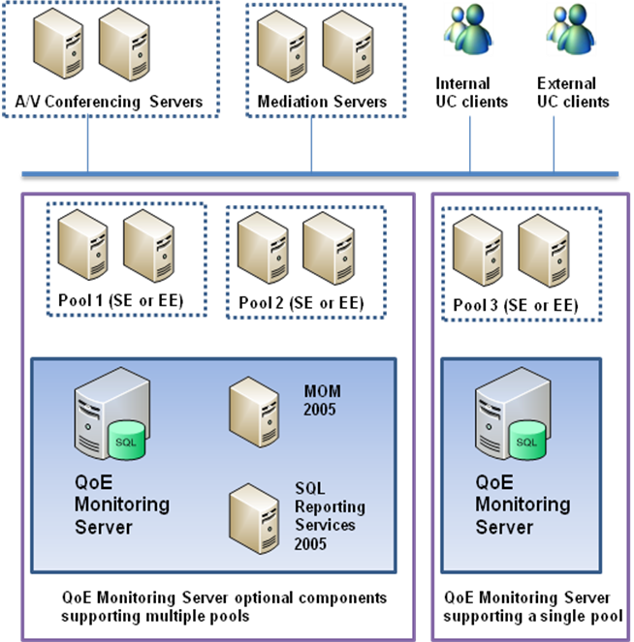
Figure 1. Sample Topology for QoE Monitoring Server with Multiple Pools or with a Single Pool
The QoE Monitoring Server cannot be collocated with other Office Communications Server 2007 server roles. Microsoft SQL Server™ can, however, be collocated with the QoE Monitoring Server, or it can be installed on a dedicated server.

Hardware Requirements
Each computer that will run the QoE Monitoring Server must meet the following hardware requirements for Standard Edition or Enterprise Edition Servers.
- PC with 2.6gigahertz (GHz) or faster dual processor
- 2 × 18 GB disk array for the operating system and page file on drive 1
- 36 GB, 15K RPM for database log file on drive 2
- 36 GB, 15K RPM for database files on drive 3
- 1 MB L2 per core
- 4 GB of RAM
- 1 gigabit per second (Gb/s) network adapter

Software Requirements
Each computer that will run the QoE Monitoring Server must meet the following software requirements.

Required Software
- Windows Server® 2003 Service Pack 1 (SP1) or R2 operating system in Standard, Enterprise, or Datacenter Edition.
- Message Queuing must be installed on the computer that will run the QoE Monitoring Server.
- Microsoft SQL Server™ 2000 SP4 or SQL Server 2005 SP1 or SP2 on the computer where you plan to deploy the QoE Monitoring Server database. SQL Server must have Windows integrated authentication mode enabled.

Recommended Software
- SQL Server 2005 SP2 on the computer where you plan to deploy the QoE Monitoring Server database. SQL Server must have Windows integrated authentication mode enabled.
- SQL Server 2005 Reporting Services SP2 (recommended) or SP1 on the computer that has the database for the QoE Monitoring Server or on a separate computer. For details about SQL Server 2005 Reporting Services, see SQL Server Reporting Services at http://r.office.microsoft.com/r/rlidOCS?clid=1033&p1=SQLReport.
- Microsoft Operations Manager (MOM) 2005 SP1 if you plan to deploy the QoE Monitoring Server MOM Pack to monitor audio/video quality.
Note
QoE Monitoring Server Management Pack is not supported with MOM 2007.

Capacity Planning
The following sections describe factors you should consider when planning to deploy QoE Monitoring Server.

QoE Monitoring Server Report Generation
If you are using the recommended hardware, the QoE Monitoring Server can handle up to 125 reports per second. Depending on your daily call volume and how much call traffic occurs during your busiest hour, you can estimate the number of reports generated per second for your environment by using the following formula:
Reports per second= (daily call volume * 0.80)/3600

The factor of 0.80 indicates that 80 percent of your daily call volume occurs during the busiest hour (3600 seconds). You can adjust this factor as needed.
For example, in an organization of 40,000 users who are using Microsoft unified communications to make an average of five calls per day, you would calculate the estimated reports per second as follows:
Reports per second = (200,000 * 0.80)/3600 = 44.4 reports per second

If your calculation exceeds 125 reports per second, you should deploy additional QoE Monitoring servers. If your calculation exceeds 40 reports per second, you should consider employing an offline reporting solution or limiting the number of reports that are generated during the busy hour.

QoE Monitoring Server Database
Required database size depends on call volume and on your call report retention settings. Each call report uses approximately 2.75KB of database storage. You can estimate how large your database needs to be by using this formula:
Database size = ((daily PC-to-PC call volume÷2) + (daily non PC-to-PC call volume)) × (call report size) × (call report retention days)

For example, by using the default call report retention time of 90 days for 10,000 users participating in an average of 5 PC-to-PC calls and 7 calls of other types per day, you would calculate the estimated database size as follows:
Database size = (((10,000 × 5)÷2) + (10,000×7)) × (2.75 KB) × (90) = 235 GB
Note
The retention time for call reports can be adjusted. For details, see Specify Retention of Call Reports later in this guide.

Reporting
The QoE Monitoring Server Report Pack provides a standard set of reports that have been designed to work with an active QoE Monitoring Server database. This approach simplifies deployment, but in some cases, such as the following, an offline reporting solution may be more appropriate:
- You wish to report against more than 20 million calls when SQL 2005 is used as the QoE Monitoring Server DB, or 4 million calls when SQL 2000 is used.
- Report volume, as reported by the “Number of metrics reports received per second” QoE Experience Monitoring Server performance counter, exceeds 40 reports per second for extended periods.

Install and Configure Message Queuing
Before you install the QoE Monitoring Server, you must install and configure Message Queuing on each server that will run the QoE Monitoring Server. The QoE Monitoring Server uses Message Queuing to ensure reliability when processing audio and video quality metrics reports.

Installation Prerequisites
- The computer that is running Message Queuing must be a member of a Windows Authorization Access group in order to authenticate users in a Microsoft Windows Server 2003 domain.
- Because Message Queuing relies on the Active Directory® Domain Services for encryption to the destination queue, Message Queuing requires the Active Directory Integration subcomponent, which is installed by default when you install Message Queuing.
- The privacy level must be set to either Body or Optional. The default setting is Optional.
To install Message Queuing
- Log on as a member of the Administrators group to the server that will be running the QoE Monitoring Server.
- Click Start, click Control Panel, and then click Add or Remove Programs.
- In the Add or Remove Programs dialog box, click Add/Remove Windows Components.
- On the Windows Components page, select the Application Server check box, and then click Details.
- In the Application Server dialog box, select the Message Queuing check box, and then click OK.
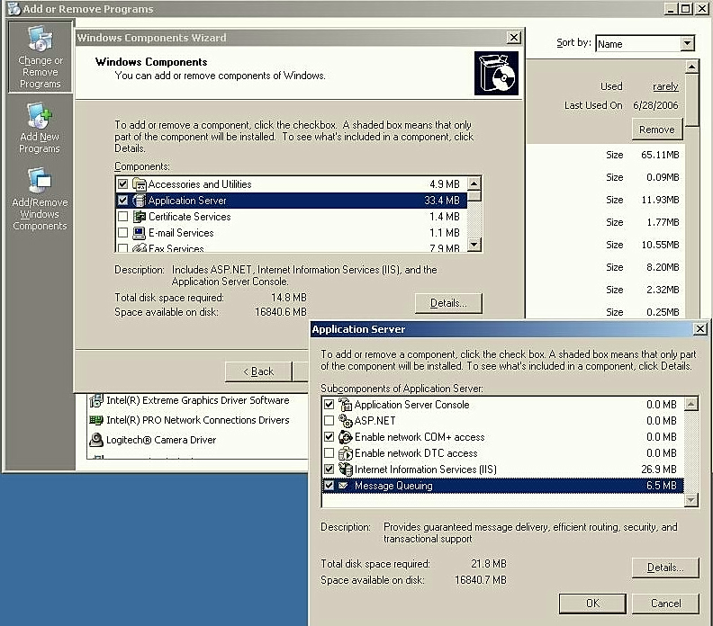
- On the Windows Components page, click Next.
- Accept the defaults in the wizard to complete the installation.

Install SQL Server
Microsoft SQL Server must be installed either on the computer that is running the QoE Monitoring Server or on a dedicated database server. Ensure that you have either SQL Server 2005 SP2 (recommended) or SP1 (32-bit or 64-bit) or SQL Server 2000 with Service Pack 4 installed. We recommend SQL Server 2005 SP1. For details about SQL Server 2005, see SQL Server 2005—Getting Started at http://r.office.microsoft.com/r/rlidOCS?clid=1033&p1=SQLgstart.

Install SQL Server Reporting Services
The optional SQL Server Reporting Services can generate detailed reports about the media quality of your Office Communications Server deployment. To view these reports, we recommend that you install SQL Server Reporting Services; otherwise, the only way to assess media quality is to write your own SQL queries against the QoE Monitoring Server database. Ensure that you have SQL Server Reporting Services 2005 with Server Pack 1 (SP1) or SP2. For details about SQL Server Reporting Service, see Installing SQL Server Reporting Services at http://r.office.microsoft.com/r/rlidOCS?clid=1033&p1=SQLReportInstall.

Install the QoE Monitoring Server Management Pack
You can monitor media quality by using the optional QoE Monitoring Server Management Pack. The QoE Monitoring Server Management Pack will sample performance counters that are published by the QoE Monitoring Server and that are based on defined thresholds, and it will generate alerts when it detects degradation of media quality. You can install the QoE Monitoring Server Management Pack on the same computer as the Office Communications Server MOM Pack or on any MOM server that can discover and monitor the QoE Monitoring Server. The management pack requires Microsoft Operations Manager (MOM) 2005 SP1. For more information about deploying MOM, see http://r.office.microsoft.com/r/rlidOCS?clid=1033&p1=MOMdeploy.
For instructions on installing the QoE Monitoring Server Management Pack, see Part V: Metrics and Alerts in this guide.

Part I: Deploy the QoE Monitoring Server
Before you begin to deploy the QoE Monitoring Server, ensure that you have downloaded and installed the Microsoft Office Communications Server 2007 QoE Monitoring Server installer package, OCSQms.msi. By default, the Web download installer will be installed at <drive>:\Office Communications Server\QMS\setup\i386\.
Note
After you install the Microsoft Office Communications Server 2007 QoE Monitoring Server installer package, the installer will appear in Add/Remove Programs. After you have installed the necessary files for QoE Monitoring Server, including the report pack if you choose to deploy it, you can remove the QoE Monitoring Server installer from Add/Remove Programs.
To deploy the QoE Monitoring Server, follow these steps:
- Step 1: Install Files for QoE Monitoring Server
- Step 2: Activate QoE Monitoring Server
- Step 3: Configure Certificate
- Step 4: Start Services
- Step 5: Configure Associations
- Step 6: Deploy QoE Monitoring Server Reports (recommended)
These steps are explained in detail in the following sections.
After you have deployed the QoE Monitoring Server, we recommend deploying the QoE Monitoring Server Management Pack. For details, see Part V: Metrics and Alerts in this guide.

Step 1: Install Files for QoE Monitoring Server
The installation package will install all the files that are necessary to run your server, as well as the administrative tools that you will need to configure your server.
By default, the files will be installed at %Program Files%\Microsoft Office Communications Server 2007\QoE Monitoring Server.
To install the program files
- Log on as a member of the Administrators group to the computer where you want to install the QoE Monitoring Server. If you want to activate the QoE Monitoring Server immediately after installation, you must also log on as a member of the DomainAdmins or RTCUniversalServerAdmins groups.
- Go to the location on your computer where you installed the Office Communications Server 2007 QoE Monitoring Server installer (by default, <drive>:\Office Communications Server\QMS\setup\i386\), and then double-click setup.exe.
- In the Deployment Wizard, at Step 1: Install Files for QoE Monitoring Server, click Install.
- On the Welcome to the Microsoft Office Communications Server 2007, QoE Monitoring Server Setup Wizard page, click Next.
- Review the license agreement, and then click I accept the terms in the license agreement if you agree to the terms of installation (required to continue installation). Click Next to continue.
- On the Install Location for Microsoft Office Communications Server 2007, QoE Monitoring Server page, accept the default or select a location to install the files, and then click Next.
- On the Confirm Installation page, click Next to confirm that you want to proceed with the installation.
- When the files have been installed and the wizard has completed, click Close to exit.
After you finish these tasks, you are ready to activate the QoE Monitoring Server.

Step 2: Activate QoE Monitoring Server
During this step, the QoE Monitoring Server will be activated, and information about the service will be published in Active Directory.
To activate the QoE Monitoring Server on a server other than the back-end database, you must install SQL-DMO on the computer. To install SQL-DMO, do one of the following:
- If you are using SQL Server 2000 SP4, you can install SQL-DMO by running SQL Server 2000 Setup and installing the client tools.
- The database server can be running either the 32-bit or 64-bit version of SQL Server 2005 SP1. In either case, you install SQL-DMO from the Backwards Compatibility Components package, which is included on the SQL Server 2005 installation CD. You can also download this package from the Microsoft Web site at: http://r.office.microsoft.com/r/rlidOCS?clid=1033&p1=sqlback.
Note
To activate a QoE Monitoring Server, you must be logged on to the server as a member of the DomainAdmins group or of the RTCUniversalServerAdmins group.
To activate the QoE Monitoring Server
- In the Deployment Wizard, at Step 2: Activate QoE Monitoring Server, click Run.
- On the Welcome to the QoE Monitoring Server Activation Wizard page, click Next.
- On the Select Service Account page, type the name of a new or existing service account to use for this server, and then type the password for the account. The default account is RTCComponentService. If you create a new account, ensure that you use a strong password that meets the Active Directory password requirements of your organization. When you are finished, click Next.
- On the Select SQL Server Instance page, in the SQL Server instance box, type the name of the database instance that will be used by the QoE Monitoring Server, and then click Next.
- On the Reuse Existing Database page, if you want to overwrite an existing QoE Monitoring Server database with a new database, then select the Replace any existing database check box. If you want to keep the default setting, which is to reuse the database, then clear the check box. When you are finished, click Next.
Note
To check if you have an existing database, check if your SQL Server instance contains a database name that is “QoEMetrics”.
- On the Location for Database Files page, type the location for the database files and the location of the database transaction logs. When you are finished, click Next.
Note
If your QoE Monitoring Server database is located on another computer, the Browse button will be disabled.
- On the Ready to Activate page, click Next.
- When the wizard has completed, select the View the log file when you click ‘Finish’ check box, and then click Finish.
- In the log file, verify that <Success> appears under the Execution Result column. Look for <Success> Execution Result at the end of each task to verify the server was activated. Close the log window when you finish.

Step 3: Configure Certificate
Each QoE Monitoring Server requires a certificate in order to use MTLS (TLS with mutual authentication). All Office Communications Server roles use MTLS to communicate with each server.
You can use the Certificates Wizard on a QoE Monitoring Server to do the following:
- Request, create, and assign a new Web certificate with enhanced key usage for server authentication.
- Assign an existing certificate.

To configure a new certificate
- In the Deployment Wizard, under Step 3: Configure Certificate, click Run.
- On the Welcome to the Certificate Wizard page, click Next.
- On the Available Certificate Tasks page, click Create a new certificate, and then click Next.
- On the Delayed or Immediate Request page, click Send the request immediately to an online certification authority, and then click Next.
- On the Name and Security Settings page, do the following:
- Under Name, enter a meaningful name for the certificate that this server will use for Office Communications Server communications.
- Under Bit length, select the bit length that you want to use for encryption. A higher bit length is more secure, but it can degrade performance.
- Clear the Mark cert as exportable check box.
- When you are finished, click Next.
- On the Organization Information page, type or select the name of your organization and organizational unit, and then click Next.
- On the Your Server’s Subject Name page, do the following:
- In Subject Name, verify that the server FQDN is displayed.
- Optionally, click Subject Alternate Name, and then type any alternate names that will identify the server during authentication.
Note
If either of the following is true, you must configure a certificate Subject Alternate Name:
- If the name of your SIP domain is different from that of the Active Directory domain, add the FQDN of the SIP domain as the Subject Alternate Name.
- If the internal FQDN that you plan to use for the Web Components Server is different from the external FQDN and you plan to configure the reverse proxy in the perimeter network for tunneling, add the external FQDN as the Subject Alternate Name.
- When you are finished, click Next.
- On the Geographical Information page, enter the Country/Region, State/Province, and City/Locality. Do not use abbreviations. When you are finished, click Next.
- On the Choose a Certification Authority page, do one of the following:
- Click Select a certificate authority from the list detected in your environment, and then click your certification authority (CA) in the list.
- Click Specify the certificate authority that will be used to request this certificate, and then type the name of your CA in the box. If you type an external CA name, a dialog box appears. Type the user name and password for the external CA, and then click OK.
- When you are finished, click Next.
- On the Request Summary page, review the settings that you specified, and then click Next.
- On the Certificates Wizard completed successfully page, click Assign.
- A dialog box appears and informs you that the settings were applied successfully. Click OK.
- Click Finish.
To configure an existing certificate
- In the Deployment Wizard, at Step 3: Configure Certificate, click Run.
- On the Welcome to the Certificate Wizard page, click Next.
- On the Available Certificate Tasks page, click Assign an existing certificate, and then click Next.
- On the Available Certificates page, select a certificate, and then click Next.
- On the Configure the Certificate(s) of your Server page, click Next.
- When the wizard has completed, click Finish.

Step 4: Start Services
After you have configured your certificates, you are ready to start the QoE Monitoring service. This step can be completed now, or it can be completed later, but it must be completed before you can start monitoring media quality.
Confirm that the Active Directory changes have replicated before you start the services. For more information about the Active Directory changes that occur when you deploy Office Communications Server, see the Microsoft Office Communications Server 2007 Active Directory Guide.
To start the services
- In the Deployment Wizard, at Step 4: Start Services, click Run.
- On the Welcome to the Start Services Wizard page, click Next.
- On the Start Office Communications Server 2007 services page, review the list of services that were found on the computer, and then click Next.
- When the wizard has completed, select the View the log when you click ‘Finish’ check box, and then click Finish.
- In the log file, verify that <Success> appears under the Execution Result column. Look for <Success> Execution Result at the end of each task to verify each service started successfully. Close the log window when you finish.
After you finish these tasks, you are ready to associate the QoE Monitoring Server with Office Communications pools and Mediation Servers whose media quality it will monitor.
Note
If a service does not respond to the wizard in a timely fashion, the log file will show that a service did not start successfully. If the log file shows that one or more services failed to start, run the Start Services Wizard again.

Step 5: Configure Associations
In order to monitor media quality on your Office Communications Server deployment, you need to associate the QoE Monitoring Server with pools and Mediation Servers. After an association is configured, the QoE Monitoring Server will begin receiving media quality reports from the users who are homed on the pools and from calls that are made through the Mediation Servers. This step can be completed now, or it can be completed later, but it needs to be completed before you can monitor media quality.
You use the Configure Associations Wizard in order to select the pools and Mediation Servers that you want the QoE Monitoring Server to monitor.
To configure associations
- In the Deployment Wizard, at Step 5: Configure Associations, click Run.
- On the Welcome to the QoE Monitoring Server Configure Associations Wizard page, click Next.
- On the Pool Selection page, select the Office Communications Server pools that you want to associate with the QoE Monitoring Server. When you are finished, click Next.
- On the Mediation Server Selection page, select the Mediation Servers that you want to associate with the QoE Monitoring Server. When you are finished, click Next.
- On the Confirmation page, click Next.
- When the wizard has completed, select the View the log when you click ‘Finish’ check box, and then click Finish.
- In the log file, verify that <Success> appears under the Execution Result column. Look for <Success> at the end of each task to verify that the associations were configured successfully. When you are finished, close the log window.
You can now view performance counters that describe the media quality for your Office Communications Server deployment. If you want to view reports that show summaries and trends of the media quality, you will need to deploy QoE Monitoring Server Report Pack as described in the following section.

Step 6: Deploy QoE Monitoring Server Reports (Recommended)
The QoE Monitoring Server Report Pack contains a set of standard reports that are published by Microsoft SQL Server 2005 Reporting Services. The reports are made available by a Web site that is published by the Report Manager.
After you have started your services for your QoE Monitoring Server, you can deploy the QoE Monitoring Server Report Pack to an instance of the Microsoft SQL Server 2005 Reporting Services. This step is optional.
Note
In order to deploy the QoE Monitoring Server Report Pack, the account that you are logged on with must be assigned to the Content Manager role of the Reporting Services instance that you will deploy the report pack to. For details about assigning users to a SQL Report Services role, see Creating, Modifying, and Deleting Role Assignments at http://r.office.microsoft.com/r/rlidOCS?clid=1033&p1=SQLRoleAssign.
To deploy QoE Monitoring Server Reports
- In the Deployment Wizard, at Step 6: Deploy QoE Monitoring Server Reports, click Run.
- On the Welcome to the QoE Monitoring Server Report Pack Deployment Wizard page, click Next.
- On the Specify Report Pack Account page, enter the name of a new or existing service account to use for this server, and then enter the password for the account. The default account is RTCQMSReportPack. For a new account, ensure that you use a strong password that meets the Active Directory password requirements of your organization. When you are finished, click Next.
- On the Report Pack Configuration page, enter the URL of the reporting server. Click Next to continue.
Caution
If you are publishing the reports to an HTTPS Web site, you must use the FQDN of the QoE Monitoring Server within the URL. Before you deploy the report pack, ensure that Require client certificate is disabled for the Web site. After you have finished deploying the report pack, you can re-enable Require client certificate if you want.
- On the Authorize Group page, you can use the Domain group box to grant read-only access, or you can manually configure read-only access. To do so, click the domain, type the name of the group that is to be granted read-only access to reports, and then click Next. Alternatively, you can manually configure read-only access after you have deployed the report pack, as described following this procedure.
Note
If the QoE Monitoring Server report pack is deployed onto a SQL Server Reporting Server that is in a different domain in the forest, then domain local groups cannot be used to grant read-only access. In this case, only global or universal groups can be used.
Caution
Members of this domain group will be granted read-only access to personal identifying information, such as the URIs and phone numbers of callers and callees, in the A/V metric reports.
- On the Ready to Deploy Report Pack page, click Next.
- When the wizard has completed, select the View the log when you click ‘Finish’ check box, and then click Finish.
- In the log file, verify that <Success> appears under the Execution Result column. Look for <Success> at the end of each task to verify that the report pack was deployed. When you are finished, close the log window.
You can now view reports by using the Reporting Services instance that you specified in the wizard. The format of the URL will be http://<fqdn>/reportserver?%2fQmsReport. For example, if the FQDN of your report server is qoe.contoso.com and you are using the HTTPS protocol, the URL will be https://qoe.contoso.com/reportserver?%2fQmsReport.

Note
Because the reporting server uses a different service account than that for the QoE Monitoring Server, you will need to ensure that you change the passwords of both the reporting server and QoE Monitoring Server accounts after they expire.
In addition to the service accounts, the data source of the QoE Monitoring Server report pack uses stored credentials to access the QoE Monitoring database. When the password is changed in this account, the stored credentials of the data source must also be updated. The data source of the report pack can be found in the QMSReport folder of the report pack. To access, open http(s)://<FQDN>/Reports.
To manually configure read-only access to reports
- At the URL that you specified on the Report Pack Configuration page during the previous procedure, open the SQL Reporting Services page.
- Click the QMSReport folder.
- Click the Properties tab.
- Click Security.
- Click New Role Assignment.
- In the New Role Assignment dialog box, in the Group or user name box, type the name of the group or user to whom you want to provide read-only access.
- Select the QMS Browser check box, and then click OK.

Part II: View Media Quality
The QoE Monitoring Server collects objective statistics that are associated with subjective perceptions of media quality. You can view individual performance counters, or you can view reports that provide a more centralized picture of media quality. You can also use Microsoft Operations Manager (MOM) to configure alerts that fire when your performance counters fall below a certain threshold. For more information on alerts, see Part V: Metrics and Alerts. With the QoE Monitoring Server Report Pack, you can generate and publish standard reports of the information that the QoE Monitoring Server collects. This section describes the following:
- Mean Opinion Score and Metrics. The types of MOS and metrics that are used to determine media quality.
- Performance Counters. Available performance counters that objectively measure factors that can affect perceived quality of experience.
- Reports. Out-of-box reports that are generated so that you have a centralized view of media quality.

Mean Opinion Score (MOS) and Metrics
The UC solution reports several different measures of voice quality in order to monitor the quality of the experience that is being delivered to end users. This section explains how voice quality is measured and the different scales that the QoE Monitoring Server uses.
The basis of all measures of voice quality is subjective testing: how a person perceives the quality of speech is affected by human perception, and so it is inherently subjective. There are several different methodologies for subjective testing. Most voice quality measures are based on an absolute categorization rating (ACR) scale.
In an ACR subjective test, a statistically significant number of people rate their quality of experience on a scale of 1 (bad) to 5 (excellent). The average of the scores is called a mean opinion score (MOS). The resulting MOS depends on the range of experiences that were exposed to the group and to the type of experience being rated. As a result, MOS values between tests cannot be compared unless the conditions are the same.
Because it is impractical to conduct subjective tests of voice quality for a live communication system, the UC solution generates ACR MOS values by using advanced algorithms to objectively predict the results of a subjective test. The UC solution provides two classes of MOS values, listening quality MOS (MOS-LQ) and conversational quality MOS (MOS-CQ).
MOS-LQ is the most commonly used MOS value within the VoIP (Voice over IP) industry. It measures the quality of audio for listening purposes only. MOS-LQ does not take into account any of bidirectional effects, such as delay and echo. MOS-CQ takes into account listening quality in each direction, as well as the bidirectional effects.
The UC solution makes use of both narrowband (8 kHz sample rate) and wideband (16 kHz sample rate) audio codecs. In order to provide consistency in the measuring of the MOS-LQ, all of the MOS-LQ values are reported on wideband MOS-LQ scale instead of the traditional narrowband MOS-LQ scale that other systems provide.
The difference between the wideband MOS-LQ scale and narrowband MOS-LQ is the range of the experience played to the group of people who were in the subjective test. In the case of narrowband MOS-LQ, the group is exposed to speech where only narrowband codecs are used, and so the listeners lose any audio frequency content above 4 kHz. For wideband MOS-LQ, the group is exposed to speech where both narrowband and wideband codecs are used. Since listeners prefer the additional audio frequency content that can be represented in wideband audio, narrowband codecs will have a lower score on a wideband MOS-LQ score than on a narrowband MOS-LQ scale. For example G.711 is typically sited as having a narrowband MOS-LQ score of ~4.1 but when compared to wideband codecs on a wideband MOS-LQ scale, G.711 may have a score of only approximately 3.5.

Metrics Descriptions
The UC solution provides several different MOS values:
- Listening MOS
- Sending MOS
- Network MOS
- Conversational MOS

Listening MOS is a prediction of the wideband Listening Quality (MOS-LQ)) of the audio stream that is played to the user. This value takes into consideration the audio fidelity and distortion and speech and noise levels, and from this data predicts how a large group of users would rate the quality of the audio they hear.

The Listening MOS varies depending on:
- The codec used
- A wideband or narrowband codec
- The characteristics of the audio capture device used by the person speaking (person sending the audio).
- Any transcoding or mixing that occurred
- Defects from packet loss or packet loss concealment
- The speech level and background noise of the person speaking (person sending the audio)

Due to the large number of factors that influence this value, it is most useful to view the Listening MOS statistically rather than by using a single call.

Sending MOS is a prediction of the wideband Listening Quality Mean Opinion Score (MOS-LQ) of the audio stream that is being sent from the user. This value takes into consideration the speech and noise levels of the user along with any distortions, and from this data predicts how a large group of users would rate the audio quality they hear.

The Sending MOS varies depending on:
- The user’s audio capture device characteristics
- The speech level and background noise of the user’s device

Due to the large number of factors that influence this value, it is most useful to view the Sending MOS statistically rather than by using a single value.

Network MOS is a prediction of the wideband Listening Quality Mean Opinion Score (MOS-LQ) of audio that is played to the user. This value takes into consideration only network factors such as codec used, packet loss, packet reorder, packet errors and jitter.

The difference between Network MOS and Listening MOS is that the Network MOS considers only the impact of the network on the listening quality, whereas Listening MOS also considers the payload (speech level, noise level, etc). This makes Network MOS useful for identifying network conditions impacting the audio quality being delivered.

For each codec, there is a maximum possible Network MOS that represents the best possible Listening Quality MOS under perfect network conditions. The following table shows the codec typically used in a scenario and the corresponding maximum Network MOS:
Table 1. Codecs Used in Scenarios with Maximum Network MOS
Scenario | Codec | Max NMOS
PC-PC call | RTAudio WB | 4.10
Conference call | Siren | 3.72
PC-PSTN call | RTAudio NB* | 2.95
PC-PSTN call | Siren* | 3.72

* The codec used in PC-PSTN can either be Siren or RTAudio NB depending on the configuration of the Mediation Server.
Because the maximum Network MOS varies depending on the scenario (because different codecs are used), it is usually more interesting to look at the average degradation of the Network MOS during the call. The average degradation can be broken down into how much is due to network jitter and how much is due to packet loss. For very small degradations, the cause of the degradation may not be available.

Conversational MOS is a prediction of the narrowband Conversational Quality (MOS-CQ) of the audio stream that is played to the user. This value takes into consideration the listening quality of the audio played and sent across the network, the speech and noise levels for both audio streams, and echoes. It represents how a large group of people would rate the quality of the connection for holding a conversation.

The Conversational MOS varies depending the same factors as Listening MOS, as well as the following:
- Echo
- Network delay
- Delay due to jitter buffering
- Delay due to devices
Due to the large number of factors that influence this value, it is most useful to view the Conversational MOS statistically rather than by using a single value.

Interpreting the MOS Metrics
The rich set of MOS and associated metrics provide a rich view into the quality of the experience being delivered to the end users and can be used to identify a wide range of issues. The basic approach to using the MOS metrics to identify quality affecting issues is to compare the current MOS metrics either against previously known good states or against similar conditions. Combined with filtering on different locations, time periods, call types, etc, the root cause can be narrowed down to lead to further investigation using the detailed metrics or other troubleshooting tools.
The following are a few examples of issues and how they can be identified through analysis of the metrics.

LAN Congestion
As a LAN becomes more congested with traffic, the rates of packet loss and amount of jitter will increase for calls that pass through the LAN. This increase in packet loss and jitter will be reflected in lower Network MOSs and higher average degradation for these calls. Using the QoE Trend reports, the lower Network MOSs can be seen for the past several weeks and can be used to identify the LAN that is exhibiting signs of congestion. The call list report for calls on that LAN will show higher degradation, jitter and packet loss when compared to calls made before the LAN was congested or when compared to calls made on similar un-congested networks.

Bad Devices or Device Drivers
The audio quality for a call is affected by the microphone device and associated driver used to capture the audio from the person speaking. If a new device is used or a new driver for the device is deployed that results in lower audio quality capture, this is reflected in lower Sending MOS. Using the device report, the Sending MOS for these devices can be compared to other devices and against historical data to isolate a problematic device or device driver which can then be addressed. It is important to note that to identify problematic devices or drivers, they must be deployed and used enough to generate sufficient data for analysis. A single rarely used problematic device will not be identifiable using this report.

Additional Metrics
Table 2 lists some additional metrics that are collected by the QoE Monitoring Server.
Table 2. Metrics and Descriptions
Metric | Description
Degradation average | Average fraction of network MOS degradation for the codec that was used for the entire call. The greater the degradation value, the greater the network has degraded the audio experience. Degradation average is used in the call list and trend report.
Jitter | Variation in the delay time of packets arriving at their destination. VoIP packets are sent at regular intervals from the sender to the receiver, but because of network latency the interval between packets can vary at the destination. This variation can affect media quality. Jitter is used to determine MOSs as well as in the call detail report.
Degradation jitter average | Average fraction of network MOS degradation that is caused by jitter on the network during the call. Degradation jitter average is the amount of jitter that contributed to Degradation Average. By examining this field, you can determine if jitter was the major contributor to Network MOS degradation.
Packet loss | Ratio of VoIP packets lost to the total number of VoIP packets that were sent. Packet loss is used for MOSs, call detail report, and performance counters.
Degradation packet loss average | Average fraction of network MOS degradation that is caused by packet loss on the network during the call. Degradation packet loss average is the amount of packet loss that contributed to Degradation Average. By examining this field, you can determine if packet loss was the major contributor to Network MOS degradation.
Delay | Average roundtrip time during the call for a packet to be sent over the network from the sender to the receiver and back. Delay is used in the worst performing endpoint calculation and displayed in call list reports.
Video bit rate | Average rate, in bits per second, of the encoding process for the video image. Video bit rate is used in performance counters as well as the call detail report.
Video frame loss | Average number of unique consecutive images, or video frames, lost during the call. Because video frames can span multiple packets, this value can be more useful than packet loss in evaluating video quality. Video frame loss is used in the call detail report.
Video frame rate | Rate, in frames per second, at which frames are produced in the call. Video frame rate is used in the call detail report.
Bandwidth estimation | Estimated available bandwidth in the call. Bandwidth estimation is used in the call detail report
Burst density | The fraction of RTP (Real-Time Transport Protocol) data packets within burst periods since the beginning of reception that were either lost or discarded. A burst period is a period in which a high proportion of packets are either lost or discarded due to late arrival. Burst density is used in the call detail report.
Burst length | The mean duration, expressed in milliseconds, of the burst periods that have occurred since the beginning of reception. Burst length is used in the call detail report.
Gap density | The fraction of RTP data packets in the gaps between bursts since the beginning of reception that were either lost or discarded. Gap density is used in the call detail report.
Gap length | The mean duration, expressed in milliseconds, of the gap periods that have occurred since the beginning of reception. Gap length is used in the call detail report.

Performance Counters
The QoE Monitoring Server publishes media quality performance counters. These counters provide an objective measure of factors that can affect perceived quality of experience. These counters will exist for the following:
- Location Each monitored location that has sent a report. In the case of automatic discovery, the instance name will be the subnet. When imported locations are used, the instance name will be the location name. For details about locations and automatic discovery, see Specify Network Locations to Monitor later in this guide.
- A/V Conferencing Server Each monitored A/V Conferencing Server instance that has sent a report. The name of the instance is the FQDN of the A/V Conferencing Server.
- Mediation Server Each monitored Mediation Server instance that has sent a report. The name of the instance is the FQDN of the Mediation Server.
Note
If a monitored location, A/V Conferencing Server, or Mediation Server does not participate in a call for 24 hours, its performance counter instances will be removed. Its instance will be created again when it participates in another call.
Table 3 shows a list of the available performance counters.
Table 3. Performance Counters
Counter | Description | Applies to | Alerts Enabled
Total number of audio calls | Total number of audio calls  Note In some cases, the number of calls that are reported by the system may not match the actual number of calls. For instance, if a call is made to a user’s computer but then is forwarded to that user’s mobile phone, then reports from two calls may be sent. | Locations, A/V Conferencing Servers, and Mediation Servers | No
Percentage of audio calls with failed media connectivity | Percentage of audio calls that fail to establish a media session | Locations, A/V Conferencing Servers, and Mediation Servers | Yes, when percentage exceeds 2% (default)
Percentage of audio calls with “poor” Network MOS Degradation | Percentage of calls where Network MOS degradation exceeds 1.0 (default) | Locations, A/V Conferencing Servers, and Mediation Servers | Yes, when percentage exceeds 2% (default)
Percentage of audio calls with “poor” network MOS jitter factor | Percentage of audio calls where jitter factor is the major contributor to “poor” network MOS | Locations, A/V Conferencing Servers, and Mediation Servers | No
Percentage of audio calls with poor network MOS packet loss factor | Percentage of audio calls where packet loss factor is the major contributor to poor network MOS | Locations, A/V Conferencing Servers, and Mediation Servers | No
Percentage of audio calls  experiencing high delay | Percentage of audio calls whose round trip time exceeds 500ms (default) | Locations, A/V Conferencing Servers, and Mediation Servers | Yes, when percentage exceeds 2% (default)
Total number of video calls | Total number of video calls | Locations and A/V Conferencing Servers | No
Percent video calls with low video bit rate | Percentage of video calls with average video bit rate less than 100,000 bps (default) | Locations and A/V Conferencing Servers | Yes, when percentage exceeds 2% (default)
Percent video calls with high video packet loss | Percentage of video calls in which more than 2% (default) of video packets are lost | Locations and A/V Conferencing Servers | Yes, when percentage exceeds 2% (default)

Reports
You obtain information about media quality by reviewing reports that are based on the data that the QoE Monitoring Server collects and uses to calculate mean opinion scores. If you installed SQL 2005 with Reporting Services, then you can view these reports at the Reporting Service instance that you specified during setup.
You need the Windows Internet Explorer® 7 Internet browser or Microsoft Internet Explorer 6 for Windows with all service packs applied and with scripting enabled on the QoE Monitoring Server on the computer which you plan to view the reports.
You can create your own reports, but the QoE Monitoring Server includes the following predefined reports:

QoE Monitoring Server generates the following reports:
- QoE summary
- QoE trends
- Worst performing endpoints
- Devices (not included for conference reports)
The reports are described in the following sections. The reports are collected in predefined scenarios, which are described later in this guide.

QoE Summary Report
The QoE summary report shows the sample size of calls and aggregate values for the following MOSs so that you can see at a glance the average level of media quality for audio calls whose quality was monitored:
- Conversational MOS
- Listening MOS
- Network MOS
- Sending MOS
If you click a metric in the report, a subreport displays a histogram that shows the distribution of scores for that metric.
For each MOS, the QoE Summary Report shows the average score for a prior period, as well as for the current period. The current period is the time range that is specified in the Period filter, and the period ends on the date and time specified in the Period End field of the report. The Prior Period is the same time range, but it ends on the start date of the Current Period. For example, Figure 2 shows a QoE Summary Report for the current week and for the week before. The Difference column shows the difference between the sample size and the MOSs for both periods of time. The larger the sample size, the more meaningful the average score.
Note
In general, a sample size of less than 30 has too large a margin of error to provide a useful MOS.
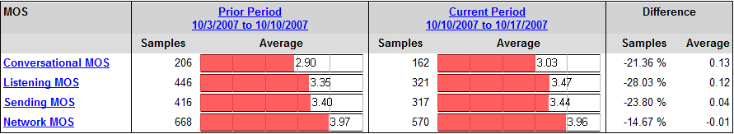

Figure 2. QoE Summary Report
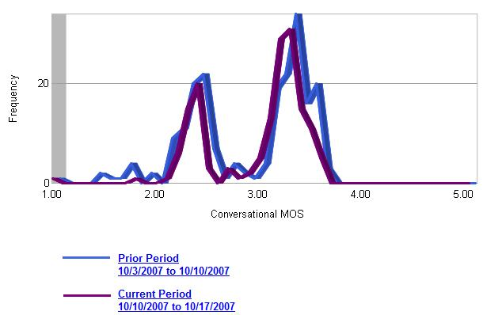
Figure 3. QoE Summary Report – Conversational MOS

QoE Trend Report
The QoE trend report shows changes in the MOSs over time so that you can see whether media quality is improving, declining, or staying the same. The following MOSs are reported:
- Conversational MOS
- Listening MOS
- Sending MOS
- Network MOS
- Network MOS Degradation
The QoE Trend Report displays the MOSs and the network MOS degradation over the period that is specified by the Period and Period Ends filters. For example, the QoE Trend Report in Figure 4 shows the MOSs over one week period with the specified end date. Each row shows a trend for a particular metric. The blue horizontal line represents the cumulative mean value for the MOSs that are shown. In this example, the Mean column shows the cumulative MOS for each metric for the previous week. The mean value can be calculated by using the following formula:
Mean = sum of (MOS * number of samples) / total number of samples

Using the above formula, the mean value for this example would be:
Conversational MOS Mean = (2.98*44 + 3.12*33 + 3.06*26 + 2.88*33 + 3.40*4 + 3.08*35 + 2.96*31) / (44 + 33 + 26 + 33 + 4 + 35 + 31) = 3.02

If you click the column heading, a Call List Report for that day will be displayed. For details about the Call List Report, see Call List later in this guide.
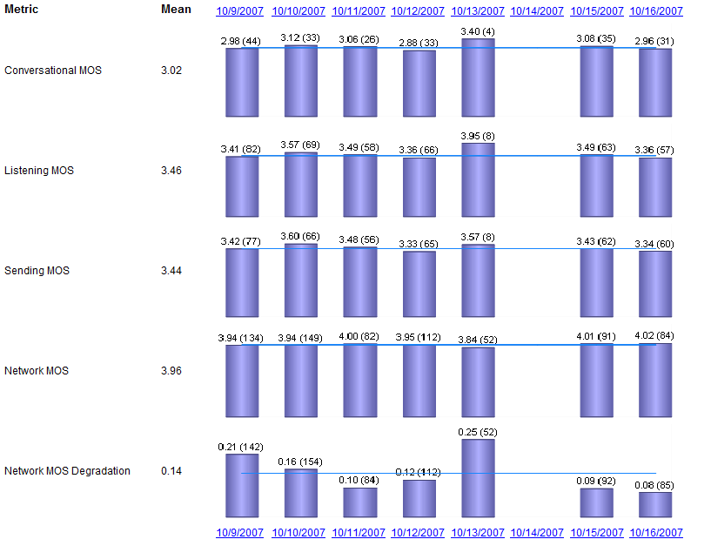
Figure 4. QoE Trend Report

Worst Performing Endpoints
The worst performing endpoints report shows the 100 endpoint with the lowest MOSs so that you can proactively correct poor performing endpoints even if the individual endpoint is not causing an alert.
By default, the Worst Performing Endpoints report lists the endpoints beginning with the worst performer. You can, however, sort each column as you choose. Because the conversational MOS, the sending MOS, and the listening MOS are not statistically valid if the sample size is too small, these values are included in the report only if the sample size is greater than 30.
Table 4 shows an example of a Worst Performing Endpoints report.

Table 4. Sample Worst Performing Endpoints report
Rank | Endpoint | IP Address | No. Calls | Endpoint Type | Average  Listening MOS | Average Sending MOS | Average Conver-sational MOS | Average  Network  MOS | % Calls w/degraded Network MOS | % High delay | % Failed Connect-ivity
0.19 | Jones.acme.com | 10.10.10.15 | 220 | Office  Communicator | 2.90 | 2.20 | 2.20 | 3.88 | 10.00% | 2.00% | 1.00%
0.16 | Frank.acme.com | 10.80.10.15 | 100 | IP Phone | 3.11 | 3.00 | 3.00 | 3.77 | 6.00% | 30.00% | 2.00%

Device Report
The device report, which is not included in conference reports, displays the number of calls that were made and the number of unique users, as well as the cumulative Conversational MOS, Sending MOS, and Listening MOS of the recipients for each device.
The device report captures the conversational MOS, sending MOS of the device, and the listening MOS on the receiving end in order to help you identify devices that are performing poorly. By default, the report will show all capture devices so that you can compare performance across devices. A typical device issue will manifest itself as echo and/or distortion. The following device report shows a sample of capture devices. For each device, it shows the number of calls that were made, how many unique users made calls, and the relevant MOSs.
Table 5. Device Report
Capture Device | No. Calls | No. Unique Users | Conversational MOS | Sending MOS (of device) | Listening MOS (of recipients)
Microphone (High Definition Audio Device) | 555 | 87 | 3.75 | 3.65 | 3.60
Echo Cancelling Speakerphone (USB Audio Device) | 365 | 48 | 3.75 | 4.25 | 4.13
Headset Microphone | 265 | 59 | 3.55 | 3.75 | 4.02
USB Audio CODEC | 86 | 23 | 3.39 | 3.21 | 3.35
Echo Cancelling Speakerphone(3) | 64 | 10 | 3.85 | 4.48 | 4.63
Echo Cancelling Speakerphone(4) | 48 | 7 | 4.05 | 4.55 | 4.30
Headset Microphone (USB Headset) | 32 | 4 |  | 4.71 | 4.19
Headset Microphone (OC Dongle) | 12 | 2 | 3.09 | 3.62 | 3.88
z

Scenario and Other Report Collections
The QoE Monitoring Server will generate the reports described in the previous section for the following common scenarios:
- PC-to-PC
- PC-to-PSTN
- PSTN-to-PC
- Conferences
Additionally, the QoE Monitoring Sever will generate collections of reports for the following:
- Call list
- Server health

PC-to-PC Report
The PC-to-PC scenario-based report summarizes the quality of experience for all calls in which both endpoints are either PCs that use Microsoft Office Communicator or IP phones. For the purposes of this report, a PC is either Office Communicator or an IP Phone. This report comprises the following standard reports: QoE Summary, QoE Trend, Worst Performing Endpoints, and Device.
For the QoE Summary, Trend, and Device reports, you can apply a set of filters. Table 6 describes the filters that are used for the PC-to-PC reports.
Table 6. Filter Settings for PC-to-PC report
Field | Description
Period | A time interval of one hour to four weeks (by default, the past week). Calls that have ended during the period are reported. The time displayed is the report server’s local time.
Location | Restricts reporting to calls in which endpoints are in one or more specified locations. Up to two locations may be selected. The default is all locations.
Caller/Callee within these locations | Further restricts the Location filter to calls in which the IP of the caller, the IP of the callee, or the IPs of both are in the selected locations. This filter cannot be applied when All locations is selected.
Exclude external calls | Restricts reporting to calls for which both endpoints are inside the organization’s network.
Media connectivity | Restricts reporting by Interactive Connectivity Establishment (ICE). Allowable filters are All (the default), Direct, Relay or HTTP-Proxy.
Client type | Restricts reporting to calls in which both parties are using the same client type. Allowable filters are Office Communicator, IP phone, or both.
Capture device | Restricts reporting to calls made with a specific capture device, such as a microphone. One capture device can be selected for a non-device report. Up to four capture devices can be selected for a device report. The default for both reports is all capture devices.

Additional filters are based on the threshold for the Worst Performing Endpoint Report. Use these filters to view endpoints based on MOSs or degradation level. Table 7 explains the fields and the default settings.
Table 7. Worst Performing Endpoint default settings
Field | Description | Min | Max
Listening MOS | Endpoints with at least 30 listening opinion samples and a listening MOS below the specified threshold. | 1 | 5
Conversational MOS | Endpoints with at least 30 conversational opinion samples and a conversational MOS below the specified threshold. | 1 | 5
Network MOS | All endpoints, regardless of sample size, with a network MOS below the specified threshold. | 1 | 5
Delay | Calls with a round trip time greater than the specified threshold. | 0 | 1000000
Degradation Level | Calls with network degradation average greater than the specified threshold. | 0.00 | 4.00

PC-to-PSTN and PSTN-to-PC
PC-to-PSTN scenario-based report summarizes the quality of experience for calls that were made in which the caller endpoint is a PC and the callee endpoint is a Mediation Server. PSTN-to-PC report summarizes the quality of experience for calls that were made in which the caller endpoint is a Mediation Server and the callee endpoint is a PC. For the purposes of this report, a PC is either Office Communicator or an IP Phone.
Both the PC-to-PSTN report and the PSTN-to-PC report comprise the same four standard reports (QoE Summary, Trend, Worst Performing Endpoints, and Device), as well as views for each standard report as defined in the PC-to-PC Report section.
The filter selections for the QoE Summary, Trend, and Device reports are different, however, from those for the PC-to-PC report. The following table shows the default settings for the PC-to-PSTN and PSTN-to PC-report.
Table 8. Filter settings for PC-to-PSTN and PSTN-to-PC reports
Field | Description
Period | Restricts reporting to a time interval of one hour to four weeks (by default, the past week). Calls that have ended during the period are reported. The time displayed is the report server’s local time.
Location | Restricts reporting to calls in which endpoints are in one or more specified locations. Only one location may be selected. The default is all locations.
Mediation Server | A single Mediation Server may be selected.
Exclude external calls | Restricts reporting to calls for which both endpoints are inside the organization’s network.
Media connectivity | Restricts reporting by Interactive Connectivity Establishment (ICE). Allowable filters are All (the default), Direct, Relay or HTTP-Proxy.
Capture device | Restricts reporting to calls made with a specific capture device, such as a microphone. One capture device can be selected for a non-device report. Up to four capture devices can be selected for a device report. The default for both reports is all capture devices.

The following table shows one additional filter that is available for the Worst Performing Endpoints Report.
Table 9. Additional Filter Setting for Worst Performing Endpoints
Field | Description
Include server | If True (the default), Mediation Servers that participated in a call will be included in the report.

Conference
The conference scenario-based report aggregates at the call level. Only calls in which an A/V Conferencing Server is involved are included. The QoE Monitoring Server collects a set of individual opinion scores for each participant in each conference rather than aggregating a single set of MOSs for each conference. This approach results in more precise aggregate MOSs because conferences with many participants have a greater impact on the aggregate MOSs than conferences with few participants.
The conference report comprises three standard reports (QoE Summary, Trend, and Worst Performing Endpoints), as well the same views for each standard report that were defined for the PC-to-PC report.
The filters that are available for this report are different from those for the PC-to-PC report. The following table shows the default settings for the Conference Report. The additional filters for the worst performing endpoint report are the same as those for the PC-to-PC report.
Table 10. Filter Settings for Conference
Field | Description
Period | Limits reporting to a time interval of one hour to four weeks (by default, the past week). Calls that have ended during the period are reported. The time displayed is the report server’s local time.
Pool | Limits reporting to calls that involve participants who are homed on a specified pool and all calls that are handled by an A/V Conferencing Server in the pool. A single pool can be specified.
A/V Conferencing Server | Limits reporting to calls that are handled by a specified A/V Conferencing Server in the pool that is specified by the Pool filter.
Exclude PSTN participants | Limits reporting to calls that do not involve any participants whose endpoint is a Mediation Server.
Exclude external participants | Restricts reporting to calls for which both endpoints are inside the organization’s network.
Media connectivity | Restricts reporting by Interactive Connectivity Establishment (ICE). Allowable filters are All (the default), Direct, Relay or HTTP-Proxy.

The following table shows one additional filter that is available for the Worst Performing Endpoints Report.
Table 11. Additional Filter Setting for Worst Performing Endpoints
Field | Description
Include server | If True (the default), A/V Conferencing Servers that participated in a call will be included in the report.

Call List
You can use a call list report to view the call history for each user over a specified period of time. The following table summarizes the filters used for the call list report. This report is available as an additional report on the home page of the reporting URL. This call list report is also available as a sub-report under other reports.
Table 12. Filter Settings for Call List Report
Field | Description
Period | A time interval of one hour to four weeks (by default, the past week). Calls that have ended during the period are reported. The time displayed is the report server’s local time.
URI (caller or callee) | Limits reporting to calls in which the SIP URI of one of the participants matches the SIP URI specified. Only the user name is required; by default, the SIP protocol identifier and the local domain name are optional.

The call list report will generate data for the following metrics:
- Call Times. The call times are based on the local time where the QoE Monitoring Server Report Pack is deployed.
- Network MOS. Minimum value from all audio streams in the call.
- Network Degradation. Maximum value from all audio streams in the call.
- Round Trip Time. Maximum value from all audio streams in the call.
- Connectivity. Value from the first audio media line in the call.
The following figure shows a sample report for the incoming and outgoing call list.
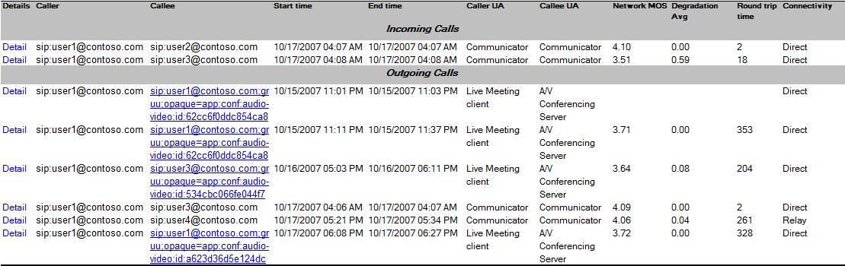
Figure 5. Call List Sample Report for Incoming Calls and Outgoing Calls

Call Detail Report
The call detail report provides the following detailed information about a call:
- Caller and callee endpoints and call time
- IP addresses, subnets, and capture and render devices of the caller and callee
- Codec used
- Packet information
- Jitter
- Bandwidth estimation
- Round trip time
- Burst density, burst gap density, burst duration, and burst gap duration
- Network MOS
- Degradation
More information about the metrics can be found in Additional Metrics earlier in this guide.
To view a call detail report
- In the Call List Report, in the Details column, click Details for the call whose details you want to view.

Server Health
The server health report identifies catastrophic problems with media quality for servers. The report displays the mean for the Conversational MOS and the Listening MOS over a period of time specified by the Period and Period Ends filters.
There are additional filters for this report. The following table explains the fields and default settings.
Table 13. Server Health Filter Default Settings
Field | Description
Server type | Mediation Server or an A/V Conferencing Server, but not both.
Period | A time interval of one hour to four weeks (by default, the past week). Calls that have ended during the period are reported. The time displayed is the report server’s local time.

The following sample server health report displays the mean scores for the Conversational and Listening MOS over four weeks for two Mediation Servers. Each column represents the mean score for that week. In each row, next to the metric, the mean score for the last 4 weeks is displayed. By clicking on the date at the top of the column, a Call List Report will be displayed for that week. For more details on the Call List Report, see the Call List section of this document.
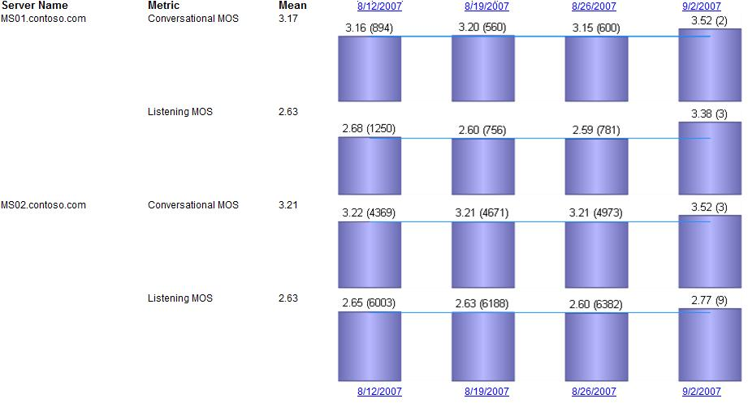
Figure 6. Sample Server Health Report for Mediation Servers

Part III: Monitoring and Reporting Strategies
This section of the document describes how to use monitoring and reporting for key scenarios.

Exclude Wireless or VPN Calls from Media Quality Alerting
If you want to exclude wireless or VPN calls from your media quality alerting, you can disable monitoring for specific locations, or you can create and import a list of locations that should not be monitored.

Disable Monitoring for Locations
If you are using automatic discovery and your wireless or VPN subnets have an easily identifiable subnet pattern, you can use the QoE Monitoring Server snap-in to disable monitoring for these locations. For details, see Specify Network Locations to Monitor later in this guide.

Import Locations
A more flexible approach is to create and import a list of locations and to specify in the list the locations that should not be monitored. Alternatively, the import list can contain only locations that you want to monitor. Keep in mind, however, that location filtering in the QoE Monitoring report pack will list only locations you have listed. For details, see Specify Network Locations to Monitor later in this guide.

Identify Specific WAN Link Hot Spots
If you want to identify specific WAN link hot spots, you can use the QoE Monitoring Report Pack. There are two different approaches to take.

Group All Subnet Regions
Use the imported location list and group together all subnets for specific regions. If you are using the PC-to-PC scenario reports, in the location filter choose the two locations that represent either side of the WAN link. Ensure that the Callee/Caller within these locations is set to Both. The resulting reports will only contain calls from the two regions. For details about importing locations, see Specify Network Locations to Monitor later in this guide.

Use a Sampling Technique
Instead of grouping all the subnet regions, use a sampling technique by creating a Location subset of the region’s subnets. For details about importing locations, see Specify Network Locations to Monitor later in this guide.

Define Different Media Quality Requirements for Different Divisions
If you have different business divisions that require different media quality, you may want to define your audio requirements accordingly.
For example, if your sales office has higher media quality requirements than your internal IT department, you should first define their alerting and Service Level Agreement (SLA) needs. Then use the QoE Monitoring Server snap-in to set specific alert thresholds to match. For SLA reporting, the best approach is to import locations and then use the location filter of the QoE Monitoring Server report pack to create specific reports. For details about importing locations, see Specify Network Locations to Monitor later in this guide.

Part IV: Administer the QoE Monitoring Server
In order to configure the QoE Monitoring Server, you use the QoE Monitoring Server snap-in. You use the snap-in to do the following:
- Specify Retention of Call Reports
- Specify the Network MOS Degradation Limit
- Specify the Network Locations to Monitor
- Specify A/V Conferencing Servers and Mediation Servers to Monitor
- Modify Alert Thresholds
- Configure Certificates
- Modify Associations with Pools and Mediation Servers
- View the Status and Configuration of the QoE Monitoring Server
These tasks are described in detail in the following sections.

Specify Retention of Call Reports
By default, call reports will be purged after 90 days. If you wish to retain reports for a longer or shorter period, you can do so from the QoE Monitoring Server snap-in.
To specify retention of call reports
- On a server that is running QoE Monitoring Server snap-in, log on as a member of the RTCUniversalServerAdmins group.
- Click Start, point to All Programs, point to Administrative Tools, and then click Quality of Experience Monitoring Server.
- In the console tree, expand QoE Monitoring Servers.
- Right-click the QoE Monitoring Server that you want to configure, and then click Properties.
- In the Properties dialog box, click the General tab.
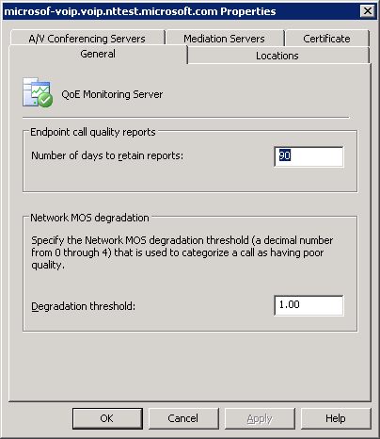
- In the Number of days to retain reports box, type the number of days that you want to retain call reports, and then click OK.

Specify Network MOS Degradation Limit
If network MOS degradation exceeds the degradation threshold that you specify, the QoE Monitoring Server MOM Console will display an alert. By default, the network MOS degradation is set to 1.00. Therefore, anytime the network MOS drops below 1.00 an alert will be displayed. You can customize this value by using the snap-in.
To specify the network MOS degradation limit
- On a server that is running the QoE Monitoring Server snap-in, log on as a member of the RTCUniversalServerAdmins group.
- Click Start, point to All Programs, point to Administrative Tools, and then click Quality of Experience Monitoring Server.
- In the console tree, expand QoE Monitoring Servers.
- Right-click the QoE Monitoring Server that you want to configure, and then click Properties.
- In the Properties dialog box, click the General tab. In the Degradation threshold box, type the degradation limit that you want, and then click OK.

Specify Network Locations to Monitor
You can let the QoE Monitoring Server automatically determine which subnets it will monitor. If your network is large or if the subnets are organized hierarchically, you may want to configure the monitoring locations yourself. These locations will be used for monitoring and reporting purposes.
The following options are available for determining the network locations that will be monitored:
- Automatic. The QoE Monitoring Server automatically chooses which endpoint subnets to monitor.
- Endpoint subnets (the default). The monitoring server will create subnet locations according to the subnet mask and IP address that are sent from supported call endpoints. This can be a good option for small organizations with a flat organization of subnets.
- Single Subnet Mask. The QoE Monitoring Server will create subnet locations by applying a single administrator-configured subnet mask to the IP addresses that are sent from supported endpoints. When you choose this option, the system’s list of subnets to be monitored will be reset. This is a good option if you want to break up the subnets for monitoring purposes.
- Imported. You can define a list of locations that you want to monitor. The list is enclosed in a comma-separated values file (.csv), and the file is imported by the QoE Monitoring Server. You can use such a list to logically group one or more subnets together, such as all wireless networks for a building or all subnets for a site. The following table shows the values, in order, that the file must contain for each location that you want to monitor.
Note
The following encodings are supported: ANSI, UTF-8, UTF-16-LE. UTF-16-BE can be converted to UTF-16-LE by using the Save As option in Notepad.
Table 14. CSV Fields
Field | Name | Description | Mandatory | Format
1 | Monitor Flag | Indicates whether the location will be monitored. Individual call quality reports from this location are available even if monitoring is disabled. | Yes | True,False,1, or 0  True | 1 : Enable monitoring for this location  False | 0 : Disable monitoring for this location
2 | Location Name | Name of the location. This name will be used as the performance counter instance name. | Yes | May be up to 128 characters in length, of valid characters and numbers. Location names must start with an alphabetic character. The following special characters are not allowed: "(", ")", "#", "\", or "/".
3 | Subnet 1 | A subnet | Yes | A valid IPV4 subnet address.
4 | Subnet bits 1 | The number of bits that will be used by the network portion of the subnet address in the Subnet 1 field | Yes (if previous subnet address is present) | A number between 1 and 32.
5 | Subnet 2 | The second subnet for the location. If no location is specified, this subnet is treated as a separate location for monitoring purposes. | No | A valid IPV4 subnet address.
6 | Subnet bits 2 | The number of bits that will be used by the network portion of the subnet address in the Subnet 2 field | Yes (if previous subnet address is present) | A number between 1 and 32.
 | …
 | …
5 | Subnet <n> | The last subnet for the location. If no location is specified, this subnet is treated as a separate location for monitoring purposes. | No | A valid IPV4 subnet address.
6 | Subnet bits <n> | The number of bits used that will be used by the network portion of the subnet address in the Subnet <n> field | Yes (if previous subnet address is present) | A number between 1 and 32.

The following example shows what the .csv file would look like for four locations named S-10.10.1.10, Contoso, Contoso-Wireless, and Contoso-VPN.
1,S-10.10.1.10,10.10.1.10,24
1,Contoso,10.20.1.1,24,10.20.2.1,24
0,Contoso-Wireless,10.80.1.1,24,10.80.2.1,24
False,Contoso-VPN,10.50.1.1,16

To specify locations for monitoring
- On the computer that is running the QoE Monitoring Server, log on as a member of the RTCUniversalServerAdmins group.
- Click Start, point to All Programs, point to Administrative Tools, and then click Quality of Experience Monitoring Server.
- In the console tree, expand QoE Monitoring Servers.
- Right-click the monitoring server you want to configure, and then click Properties..
- In the Properties dialog box, click the Locations tab.
- Do one of the following:
- To allow the locations to be automatically discovered from endpoint call quality reports, click Automatic. Click the type of automatic location discovery that you want to use. If you click Single subnet mask, type a subnet mask in the corresponding box. When the settings are as you want them, click OK. Skip the rest of this procedure.
- To logically group one or more subnets together, click Imported, and then click Import.
Note
Whenever you change the way that monitoring locations are discovered, the QoE Monitoring Server will stop monitoring the old locations and start monitoring the new locations as endpoint call quality reports arrive.
- On the Welcome to the QoE Monitoring Server Location Import Wizard page, click Next.
- On the Choose Source Location page, enter a location, or click Browse to select a location. Click Next to continue.
- On the Confirm Import page, click Next.
- When the wizard has completed, select the View the log when you click ‘Finish’ check box, and then click Finish.
- In the log file, verify that <Success> appears under the Execution Result column. Look for <Success> Execution Result at the end of each task to verify the locations were imported successfully. Close the log window when you finish.

Specify A/V Conferencing Servers and Mediation Servers to Monitor
You can configure which A/V Conferencing Servers and Mediation Servers you want QoE Monitoring Server to monitor. If you are not using the QoE Monitoring Server Management Pack, then it is not necessary to configure these settings.
To configure which A/V Conferencing Servers and Mediation Servers to monitor
- On the computer that is running the QoE Monitoring Server, log on as a member of the RTCUniversalServerAdmins group.
- Click Start, point to All Programs, point to Administrative Tools, and then click Quality of Experience Monitoring Server.
- In the console tree, expand QoE Monitoring Servers.
- Right-click the monitoring server that you want to configure, and then click Properties.
- Click one of the following tabs:
- A/V Conferencing Servers
- Mediation Servers
- For each A/V Conferencing Server or Mediation Server that you want to monitor, select the corresponding check box. For each A/V Conferencing Server or Mediation Server that you do not want to monitor, clear the corresponding check box.

Modify Alert Thresholds
The QoE Monitoring Server has default thresholds for factors that can affect media quality. If the specified thresholds are exceeded, the QoE Monitoring Server generates an alert. You can customize thresholds or modify default thresholds for each location, or you can edit thresholds for A/V Conferencing and Mediation Servers. If you are not using the QoE Monitoring Server Management Pack, then it is not necessary to configure these settings.
To customize alert thresholds for locations
- On the computer that is running the QoE Monitoring Server, log on as a member of the RTCUniversalServerAdmins group.
- Click Start, point to All Programs, point to Administrative Tools, and then click Quality of Experience Monitoring Server.
- In the console tree, expand QoE Monitoring Servers.
- Right-click the monitoring server that you want to configure, and then click Properties.
- In the Properties dialog box, click the Locations tab.
- Under Location settings, click Locations.
- For each location that you want to monitor, select the corresponding check box. For each location that you do not want to monitor, clear the corresponding check box.
- Click the location that you want to customize, and then click Thresholds.
- In the Location Settings dialog box, click Apply custom thresholds.
- Click the counter you want to edit, and then click Edit Thresholds.
- In the Edit Thresholds dialog box, in the Warning level box, type a warning level between 1% and 100%. The warning level must be less than or equal to the error level.
- In the Error level box, type an error level between 1% and 100%. The error level must be greater than or equal to the warning level.
- In the Minimum call volume box, type an integer greater than zero.
To edit default settings for locations
- On the computer that is running the QoE Monitoring Server, log on as a member of the RTCUniversalServerAdmins group.
- Click Start, point to All Programs, point to Administrative Tools, and then click Quality of Experience Monitoring Server.
- In the console tree, expand QoE Monitoring Servers.
- Right-click the monitoring server that you want to configure, and then click Properties.
- In the Properties dialog box, click the Locations tab.
- Under Location settings, click Locations.
- For each location that you want to monitor, select the corresponding check box. For each location that you do not want to monitor, clear the corresponding check box.
- Click the location that you want to customize, and then click Default.
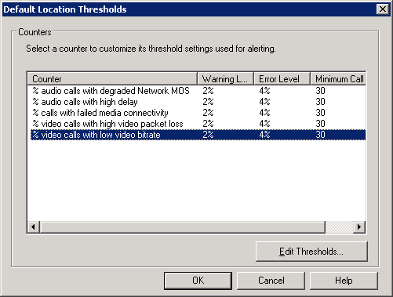
- Click the performance counter you want to edit, and then click Edit Thresholds.
- In the Edit Thresholds dialog box, in the Warning level box, type a warning level between 1% and 100%. The warning level must be less than or equal the error level.
- In the Error level box, type an error level between 1% and 100%. The error level must be greater than or equal to the warning level.
- In the Minimum call volume box, type an integer greater than zero.
To edit alert thresholds for A/V Conferencing Servers and Mediation Servers
- On the computer that is running the QoE Monitoring Server, log on as a member of the RTCUniversalServerAdmins group.
- Click Start, point to All Programs, point to Administrative Tools, and then click Quality of Experience Monitoring Server.
- In the console tree, expand QoE Monitoring Servers.
- Right-click the monitoring server that you want to configure, and then click Properties.
- Click one of the following tabs:
- A/V Conferencing Servers
- Mediation Servers
- Click Thresholds.
- Click Edit Thresholds.
- In the Edit Thresholds dialog box, in the Warning level box, type a warning level between 1% and 100%. The warning level must be less than or equal to the error level.
- In the Error level box, type an error level between 1% and 100%. The error level must be greater than or equal to the warning level.
- In the Minimum call volume box, type an integer greater than zero.

Configure Certificates
You can use the QoE Monitoring Server snap-in to create, modify, or delete a certificate.
In order to use the certificate to communicate with Office Communications Server 2007, you will need to configure the certificate that you assign for MTLS.
To create a new certificate
- On the computer that is running the QoE Monitoring Server, log on as a member of the RTCUniversalServerAdmins group.
- Click Start, point to All Programs, point to Administrative Tools, and then click Quality of Experience Monitoring Server.
- In the console tree, expand QoE Monitoring Servers.
- Right-click the monitoring server you want to create a certificate for, and then click Certificates.
The Office Communications Server Certificate Wizard will walk you through the steps of creating a new certificate.
To assign an existing certificate
- On the computer that is running the QoE Monitoring Server, log on as a member of the RTCUniversalServerAdmins group.
- Click Start, point to All Programs, point to Administrative Tools, and then click Quality of Experience Monitoring Server.
- In the console tree, expand QoE Monitoring Servers.
- Right-click the monitoring server that you want to configure, and then click Properties.
- In the Properties dialog box, click the Certificate tab.
- Click Select certificate.
- In the Select certificate dialog box, click the certificate that you want to assign to the QoE Monitoring Server, and then click OK.
To delete a certificate
- On the computer that is running the QoE Monitoring Server, log on as a member of the RTCUniversalServerAdmins group.
- Click Start, point to All Programs, point to Administrative Tools, and then click Quality of Experience Monitoring Server.
- In the console tree, expand QoE Monitoring Servers.
- Right-click the monitoring server that you want to configure, and then click Properties.
- In the Properties dialog box, click the Certificate tab.
- In the Certificate box, select the certificate that you want to delete, and then click Delete certificate.

Modify Associations with Pools and Mediation Servers
You may want to modify associations between the QoE Monitoring Server and pools and Mediation Servers. You can use the QoE Monitoring Server Configure Associations Wizard for this purpose.
To configure associations
- On the computer that is running QoE Monitoring Server, log on as a member of the RTCUniversalServerAdmins group.
- Click Start, point to All Programs, point to Administrative Tools, and then click Quality of Experience Monitoring Server.
- In the console tree, expand QoE Monitoring Servers.
- Right-click the monitoring server you want to configure, and then click Configure Associations.
The QoE Monitoring Server Configurations Wizard will walk you through configuring your associations.

View the Status and Configuration of the QoE Monitoring Server
At any time, you can view the status and configuration of your QoE Monitoring Server. In the QoE Monitoring Server snap-in, you can view the following information:
- Association Settings. Associated pool names and Mediation Servers and their associated QoE Monitoring Server.
- General Settings Category. Server name, SQL database instance, database name, reports URL, and certificate settings.
- Monitoring Status Category. Service name, service status, IP address, and SIP listening port, pool associations, and mediation server associations.
- Performance. Counters for number of quality reports received per second, number of invalid reports per second, and the number of database transactions per second.
- Event Log. Errors and events.
To view association settings
- On the computer that is running the QoE Monitoring Server, log on as a member of the RTCUniversalServerAdmins group.
- Click Start, point to All Programs, point to Administrative Tools, and then click Quality of Experience Monitoring Server.
- In the console tree, click QoE Monitoring Servers.
- Association settings will be displayed in the results pane under the Associations tab.

To view general settings and monitoring status
- On the computer that is running the QoE Monitoring Server, log on as a member of the RTCUniversalServerAdmins group.
- Click Start, point to All Programs, point to Administrative Tools, and then click Quality of Experience Monitoring Server.
- In the console tree, expand QoE Monitoring Servers.
- Click the monitoring server you want to view settings and status for.
- Do one of the following:
- To view general settings, click General Settings.
- To view monitoring status, click Monitoring Status.
To start the logging tool
- On the computer that is running the QoE Monitoring Server, log on as a member of the RTCUniversalServerAdmins group.
- Click Start, point to All Programs, point to Administrative Tools, and then click Quality of Experience Monitoring Server.
- In the console tree, expand QoE Monitoring Servers.
- Right-click the monitoring server that you want to configure, and then click Logging Tool.
- Do one of the following:
- To open a new debug session, click New Debug Session.
- To open an existing debug session, click Existing Debug Session.
For details about the Office Communications Server Logger, see the Microsoft Office Communications Server 2007 Administration Guide.

Part V: Metrics and Alerts
After you have installed and configured your QoE Monitoring Server, you can begin monitoring media quality and receiving alerts using the Microsoft Operations Manager (MOM) 2005 QoE Monitoring Server Management Pack. The QoE Monitoring Server Management Pack monitors audio and video media quality for Office Communications Server 2007 Server Enterprise Voice deployment. Alerts are generated when media quality attributes, such as delay and packet loss, exceed a threshold value.

Note
We recommend that you run MOM in Agent Managed mode. Agent and Agentless Managed modes are supported on 32-bit operating systems, but only Agent Managed mode is supported on 64-bit operating systems. For details about MOM, visit http://r.office.microsoft.com/r/rlidOCS?clid=1033&p1=MOMinfo.
To begin monitoring the media quality in the Office Communications Server deployment, do the following:
- Install the MOM 2005 QoE Monitoring Server Management Pack
- Install the QoE Monitoring Server and ensure that it is generating performance data.
After you have completed the above two tasks, you can do the following:
- Respond to media quality alerts for locations, Mediation Servers, and A/V Conferencing Servers that you have enabled for monitoring in the QoE Monitoring Server snap-in.
- Monitor performance counters to understand overall Enterprise Voice QoE
- Monitor the overall health of media quality by using the MOM state view
To import the QoE Management Pack
- On a computer that has the Microsoft Operations Manager 2005 Administrator Console installed, download and install the QoE Monitoring Server Management Pack from: http://r.office.microsoft.com/r/rlidOCS?clid=1033&p1=QoEPack.
- Click Start, point to All Programs, point to Microsoft Operations Manager 2005, and then click Administrator Console.
- In the MOM 2005 administrator console, in the console tree, expand Microsoft Operations Manager.
- Right-click Management Packs, and then click Import or Export Management Packs.
- On the Welcome page of the Import or Export Management Packs Wizard, click Next.
- On the Import or Export Management Packs page, select Import Management Packs and/or reports, and then click Next.
- On the Select a Folder and Choose Import Type page, click Browse to locate the folder where you installed the QoE Monitoring Server Management Pack in the first step.
- Under Type of Import, select the Import Management Packs only check box, and then click Next.
- On the Select Management Packs page, click QMS2007MP.akm.
- Under Import Options, select or clear the following check boxes and radio button, as appropriate. When the settings are as you want them, click Next.
- Update existing Management Pack. Custom rules, enabled/disabled setting, and company knowledge will be retained. Select this check box if you have a previous version of the Office Communication Server 2007 QoE Monitoring Server Management Pack and you want to preserve the existing configuration settings such as enable/disable settings, new rules, rule groups, and company knowledge base entries that existed in an earlier version of the Office Communications Server 2007 QoE Monitoring Server Management Pack for MOM 2005.
- Replace existing Management Pack Select this check box if you want to replace a previous version of the Office Communication Server 2007 QoE Monitoring Server Management Pack, including configuration settings, with the new Office Communication Server 2007 QoE Monitoring Server Management Pack.
- Backup existing Management Pack Select this check box if you want to back up the existing management pack before importing the new one. To specify the location where you want to archive the previous files, click Browse.
- On the Completing the Management Pack Import/Export Wizard page, verify that the files you want to import are selected, and then click Finish.
- When the installation is finished, check the final page of the wizard to verify that the import was successful, and then click Close.
You can also monitor the overall audio and video quality using MOM’s state view.
To view overall audio and video using MOM state view
- On a computer that has the Microsoft Operations Manager 2005 Administrator Console installed, click Start, point to All Programs, point to Microsoft Operations Manager 2005, and then click Operator Console.
- Click Microsoft Office Communications Server 2007 QoE Monitoring Server.
- In the operator console, click State.
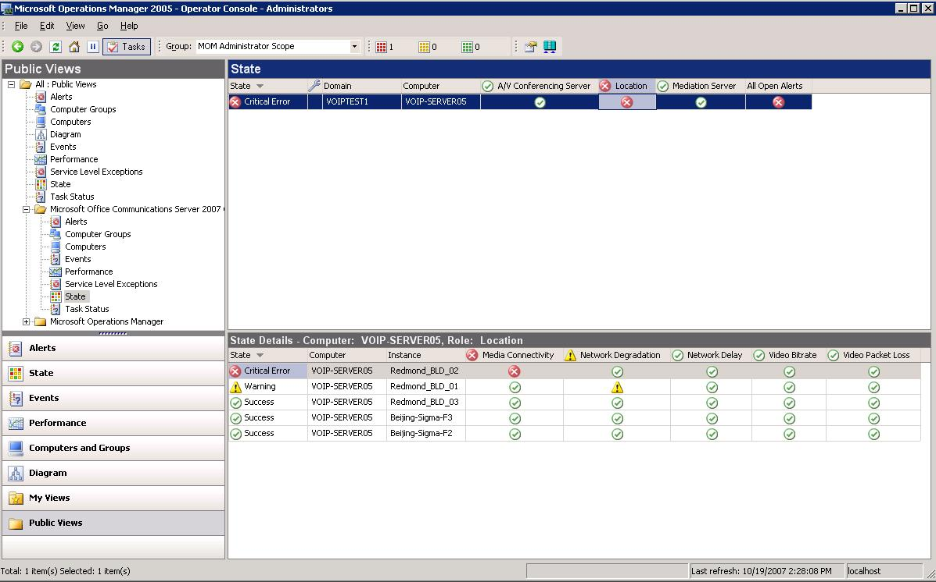
The state view comprises two panes. The State pane displays the computers and their roles, such as A/V Conferencing Server or Mediation Server. The State Details pane shows a detailed view of instances and the status of their components. The instances correspond to the Mediation Server, A/V Conferencing Server, and location instances. The following figure shows an example view of the location. This view would appear when the user clicks the Location cell in the State pane.
Note
You can choose to use agent or agentless monitoring; however, we recommend using agent monitoring.
To view overall audio and video using MOM’s alerts view
- On a computer that has the Microsoft Operations Manager 2005 Administrator Console installed, click Start, point to All Programs, point to Microsoft Operations Manager 2005, and then click Operator Console.
- Click Microsoft Office Communications Server 2007 QoE Monitoring Server.
- In the operator console, click Alerts.

The alerts view comprises two panes. The Alerts pane displays the computer, resolution state, and the name of the alert, as well as the severity of the alert as shown in the figure below. The Alert Details pane displays a detailed view of the alert that is selected in the Alerts pane. The Alert Details pane shows the alert instance, a description of the problem that caused the alert, the problem status, and the rule associated with this alert.

Part VI: Database Schema
This section provides an overview of the QoE Monitoring Server database schema. Any direct access to the database by using the active QoE Monitoring Server may cause severe performance degradation of the QoE Monitoring Server.
The following diagram shows the QoE Monitoring Server database relationships, as well as the primary and unique keys.
Figure 7. QoE Monitoring Server Database Relationships, Primary, and Foreign Keys
The following table explains each attribute and what data it stores.

Table 15. Audio and Video Metrics
Table Name | Table Contents
Audio Stream | Audio media quality metrics for each audio stream in the media line.
Conference | Conference URI and start time of conferences.
Endpoint | FQDN computer names of endpoints participating in audio and video sessions.
MediaLine | Information about each media line in a session. A media line is a collection of one or more audio and video streams. Typically, a single media line will have two streams, either audio or video.
Pool | FQDN pool name used in audio and video sessions.
Session | Overall information about an audio or video session. A session is defined as an audio or video SIP dialog between two UC endpoints.
User | User, conference, and phone URIs used in audio and video sessions.
User Agent | SIP User Agent (UA) strings and UA types used in audio and video Sessions.
Video Stream | Video media quality metrics for each audio stream in the media line.

Part VII: Troubleshooting

ISSUE: You receive a MOM warning alert that says “MOM failed to monitor memory usage of the MOM process”
You may receive this message after you remove the QoE Monitoring Server from your computer. When the QoE Monitoring Server is removed, Windows Management Instrumentation (WMI) is restarted.
This warning alert has no specific impact on MOM functionality and can safely be ignored.

ISSUE: There is a problem starting the service, and a custom error code appears in the event log.
One of the following custom error codes can appear in the event log if the QoE Monitoring Server service does not start correctly:
- 200 The QoE Monitoring server performance counters could not be initialized.
- 201 The configured certificate could not be found in the local machine certificate store. To correct this issue, configure a certificate.
- 202 There was an error during initialization of network connectivity. This could be caused by configuration problems with the certificate or the network port.
- 203 The message queue that is used by QoE Monitoring Server was not a transactional queue, as was expected. To correct this issue, reinstall the QoE Monitoring Server.
- 204 The message queue that is used by QoE Monitoring Server to send metrics reports could not be opened. To correct this issue, check the permissions of the service account. If the permissions are configured correctly, reinstall QoE Monitoring Server.
- 205 The message queue that is used by QoE Monitoring Server to receive administrative acknowledgements could not be opened. To correct this issue, re-install QoE Monitoring Server to get the queue properly configured and check the permissions of the service account.

ISSUE: Problems with deploying the report pack
If you experience problems when deploying the report pack, try the following:
- Ensure that you can connect to the Web site of the report server manually by using your Web browser. If you are unable to connect to the Web site, Report Services may not be configured correctly or the website may be unavailable due to network or DNS problems.
- If you are able to connect manually the report server and you are using an HTTPS Web site to deploy your reports, ensure that the Require client certificate check box is cleared for the Web site before you deploy the report pack. After you have finished deploying the report pack, return the Web site to its original settings. Additionally, ensure that the URL that you used to deploy the report pack contains the FQDN of the QoE Monitoring Server.
- Ensure that the SQL Reporting Services certificate has been configured properly. If the certificate is not configured properly, use SQL Server Reporting Services Configuration to properly configure the certificate.
- Ensure that you have permission for Content Manager for the SQL Reporting Services Server.

ISSUE: By default, Office Communications Server 2007, QoE Monitoring Server, listens on the default SIP port of 5061.
If you need to change the listening port, update the following two items with the desired port number:
- WMI Setting MSFT_SIPQMSConfigSetting::ListeningPort. To update this item, follow these steps:
- Click Start, and then click Run. In the Open box, type cmd, and then click OK.
- At the command prompt, type Wbemtest, and then press ENTER.
- Click Connect.
- In the Namespace box, type root\cimv2, then click Connect.
- Click Enum Instances.
- Enter MSFT_SIPQMSConfigSetting.
- Select ListeningPort property.
- Click Edit Property.
- Type in the new value (overtyping the value box).
- Click Save Property.
- Click Save Object.
- Click Close.
- Click Exit.
- Update the msRTCSIP-TrustedServicePort attribute of the QoE Monitoring Server’s Active Directory Domain Services object. To update this attribute, use the ADSIEdit tool to navigate to the msRTCSIP-TrustedService property of the QoE Monitoring Server object. ADSIedit can be found on the Windows Server 2003 Support Tools from the product CD.

Appendix A: WMI Settings
The following table lists the various configuration settings that can be set through Windows Management Instrumentation (WMI) for the MSFT_SIPQMSConfigSetting class.
Table 16. WMI Settings for Class MSFT_SIPQMSConfigSetting
Property Name | Description | Default | Range
ListeningAddress | Service listening IP Address | * | Valid IPv4 Address
ListeningPort | Service listening port | 5061 | 1-65535
QueueName | Name of MSMQ queue | LcsQoEQ | Max length 115
DBInstance | Full DB instance path | Supplied by the admin during setup | Max length 273
MaxQueueSize | Max size (in kb) of queue. 0 = unlimited | 1,000,000 | 0- 2147483647
ReportingServicesURL | URL where report pack were installed | Null | Valid URL
CallRecordRetentionDays | Records older than this number of days will get purged | 90 | 1-2147483647
PurgeChunkSize | Numbers of rows purged in a single transaction. This setting can be adjusted to help avoid database contention during purging. | 1000 | 1-2147483647
PurgeJobStartTime | When the daily purge job should run. | 1 (1 AM  local time of  QMS server) | 0-23 (hour of day of when purge will run)
AdminQueueName | Name of MSMQ Adminstration queue used by QMS | LcsQmsAdminQ | Max length 115
ReportLoggingMinFreeDisk | The minimum threshold of free disk space at which XML report logging will stop | 5 | 0-99
ReportLoggingAcceptedDir | File system path where accepted XMLreports are logged | Null | Max length 260
ReportLoggingRejectedDir | File system path where XML reports are logged | Null | Max length 260
ReportLoggingEnabled | Whether or not file system logging of XMLreports is enabled. If this is set to true, then the ReportLoggingAcceptedDir and ReportLoggingRejectedDir config settings must also be set. | False | Boolean

The following table lists the various configuration settings that can be set through WMI for the MSFT_SIPQMSDBConfigSetting class.
Table 17. WMI Settings for Class MSFT_SIPQMSDBConfigSetting
Property Name | Description | Default | Range
CurrentLocationMode | Contains the mode used for location monitoring | AutoEP | AutoEP, AutoSM,  Import
PoorJitterFactor | Jitter factor threshold for performance counter generation. No alerts are generated from this property. | Automatically obtained | 0.00-4.00
PoorPacketLossFactor | Packet loss threshold for performance counter threshold. No alerts are generated from this property. | 1.5 | 0.00-4.00
HighDelayThreshold | Default threshold for alerting on high delay | 500 | 1-2147483647
LowVideoBitRate | Default threshold for alerting on low video bit rate. | 100,000 | 0-2147483647
HighVideoPacketLossThreshold | Default percentage threshold that indicates poor level of packet loss. | 2% | 1-100
SlidingWindowSize | Time window, in minutes, in which media quality performance counters are generated | 5 minutes | 1-129600
StatsGenerationMinSamples | Minimum number of measures to include for Listening MOS, Sending MOS, or Conversational MOS | 30 | 1-2147483647
LastImportTime | Last time import was done through the QoE Monitoring Server snap-in | Null | N/A
MarginTime | Offset from current time, in seconds, for sliding window | 15 | 1-7776000
DegradationAvgThreshold | Default threshold for alerting on poor network degradation | 1.0 | 0.00-4.00
SingleSubnetMask | Single subnet mask that is used for automatic discovery | Null | int range

Appendix B: Deactivate the QoE Monitoring Server
If you want to remove the QoE Monitoring Server from your computer, we recommend that you first remove relationships between the QoE Monitoring Server and pools and Mediation Servers. After you have deactivated your QoE Monitoring Server, it will no longer appear in the QoE Monitoring Server snap-in.

Note
The database and report pack will not be removed when you remove the QoE Monitoring Server. For information about removing an instance of SQL Server, see http://support.microsoft.com/kb/909967. To remove the QMSReport folder, see http(s)://fqdn/Reports/Pages/Folder.aspx.
To deactivate your QoE Monitoring Server
- On the computer that is running QoE Monitoring Server, log on as a member of the RTCUniversalServerAdmins group.
- Click Start, point to All Programs, point to Administrative Tools, and then click Quality of Experience Monitoring Server.
- In the console tree, expand QoE Monitoring Servers.
- Right-click the monitoring server you want to configure, and then click Deactivate QoE Monitoring Server.
- On the Welcome to the QoE Monitoring Server Deactivation Wizard page, click Next.
- On the Deactivation Option page, if you want to force deactivation even if an association exists, select the Force Deactivation of QoE Monitoring Server check box. The default is not to force deactivation. Click Next to continue.
- On the Deactivation Information page, click Next.
- When the wizard has completed, select the View the log file when you click ‘Finish’ check box, and then click Finish.
- In the log file, verify that <Success> appears under the Execution Result column. Look for <Success> Execution Result at the end of each task to verify the server was deactivated. Close the log window when you finish.

Appendix C: Command-Line Reference
Like other Office Communications Server 2007 server roles, the QoE Monitoring Server supports command line setup, activation, and deactivation. For an overview of command line support in Office Communications Server, see the Microsoft Office Communications Server 2007 Command-Line Reference Guide.
Important
The version of LCSCMD.exe distributed with the QoE Monitoring Server should be used only for QoE Monitoring Server actions.

Installing QoE Monitoring Server with Qms.msi
The Windows Installer file Qms.msi installs or removes Office Communications Server, QoE Monitoring Server. Before you install Qms.msi, you will need to install UcmaRedist.msi. You can use the Msiexec command to install both files.
To start Qms.msi from the setup folder, use the following syntax:
Msiexec.exe /i qms.msi [Optional Msiexec.exe Parameters]

For example:
Msiexec.exe /i qms.msi /l*v C:\qms.log

To remove the QoE Monitoring Server, use the following syntax:
Msiexec.exe /x qms.msi /qr

Follow the instructions in the wizard to complete the installation or removal.
For details about optional MSIexec.exe parameters, see section “MSI Instructions, Parameters, and Switches” in the Microsoft Office Communications Server 2007 Command-Line Reference Guide.
Note
Installation of the QoE Experience Monitoring Server requires that Message Queuing be installed and started in advance. You can use the Add/Remove Windows Components wizard from Add or Remove Programs in Control Panel.

Activating QoE Monitoring Server
To activate the QoE Monitoring Server, use the following syntax :
lcscmd /QMS:<QoE Monitoring Server FQDN> /Action:Activate
/Password:<Account Password>
/backend:<SQL instance name (machine\instance name)>
/dbdatapath:<DB data file path>
/dblogpath:<DB log file path> [/RefDomain:<Domain FQDN> ]
[/PDCRequired:[TRUE|FALSE] ][/RootDC:<DC FQDN> ]
[/DC:<DC FQDN> ][/GC:<GC FQDN> ]
[/Global:<Configuration | System> ][/User:<Account Name> ]
[/clean:[TRUE|FALSE] ][/L:<log file path> ]
[/XML:[TRUE|FALSE] ][/?:[TRUE|FALSE] ]
Where:
/QMS | Executes the action for the specified QoE Monitoring Server computer. If no FQDN is specified, the current computer is used.
/Action | Takes a string specifying the action name. Valid action names include CheckLCServerState, Activate, and Deactivate.
/Password | Specifies the password of the service account that will run the QoE Monitoring Server.
/Backend | Specifies the full SQL instance name where the back-end database of the QoE Monitoring Server will be set up. The instance name can consist of a computer name and an instance name (For instance Computer01\QMS), or just the computer name if the default instance on the back-end database is used (such as Computer01).
/DBDataPath | Specifies the folder where the database data file will be located.
/DBLogPath | Specifies the folder where the database log file will be located.
/RefDomain | Specifies the FQDN of the reference domain.
/Global | Specifies the global setting location.
/User | Specifies the name of the service account that will run the QoE Monitoring Server The default name is RTCComponentService. If the specified user account does not exist, Office Communications Server 2007 automatically creates the account.
/Clean | Specifies whether to do a clean setup for back-end creation actions.
/L | Specifies the log file path. If not specified, %TEMP%\<ActionName>[<Date>][<Time>].html is used. To disable logging, use a hyphen character (-) as the log file name.
/XML | Specifies whether the log file to be generated should be in XML format instead of HTML.
/? | Shows Help on usage.

For example:
LCSCmd.exe /QMS /Action:Activate /Password:My$tr0ngPwd /backend:QMSServer\Live /DBDataPath:“e:\Microsoft\QMSData” /DBLogPath:“e:\Microsoft\QMSLog

When you run LCSCmd.exe, the command automatically discovers the global catalog server and primary domain controllers. If you experience problems because these servers are unavailable or because network connectivity is poor, you can use optional parameters to specify the global catalog server or domain controllers to use instead. For details, see “Optional LCSCmd.exe Parameters for Domain Controller and Global Catalog Server Discovery” in the Microsoft Office Communications Server 2007 Command-Line Reference Guide.

Note
For instructions on how to de-activate QoE Monitoring Server from the command line, see “Deactivating Servers” in the Microsoft Office Communications Server 2007 Command-Line Reference Guide.

