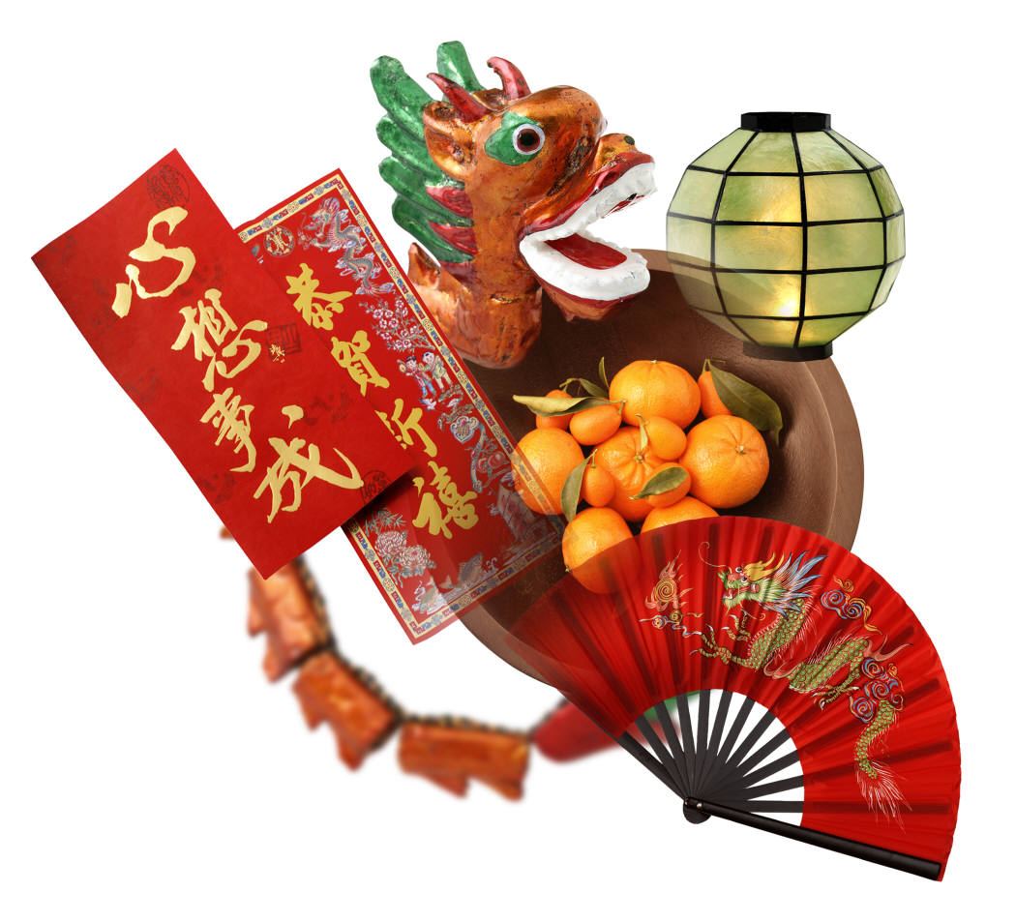
Sun | Mon | Tue | Wed | Thu | Fri | Sat
 |  |  |  | 1  元旦 | 2 | 3
4 | 5 | 6 | 7 | 8 | 9 | 10
11 | 12  成人の日 | 13 | 14 | 15 | 16 | 17
18 | 19 | 20 | 21 | 22 | 23 | 24
25 | 26 | 27 | 28 | 29 | 30 | 31

1
2004
Sun | Mon | Tue | Wed | Thu | Fri | Sat
1 | 2 | 3 | 4 | 5 | 6 | 7
8 | 9 | 10 | 11  建国記念日 | 12 | 13 | 14
15 | 16 | 17 | 18 | 19 | 20 | 21
22 | 23 | 24 | 25 | 26 | 27 | 28
29

2
2004

Sun | Mon | Tue | Wed | Thu | Fri | Sat
 | 1 | 2 | 3 | 4 | 5 | 6
7 | 8 | 9 | 10 | 11 | 12 | 13
14 | 15 | 16 | 17 | 18 | 19 | 20  秋分の日
21 | 22 | 23 | 24 | 25 | 26 | 27
28 | 29 | 30 | 31

3
2004
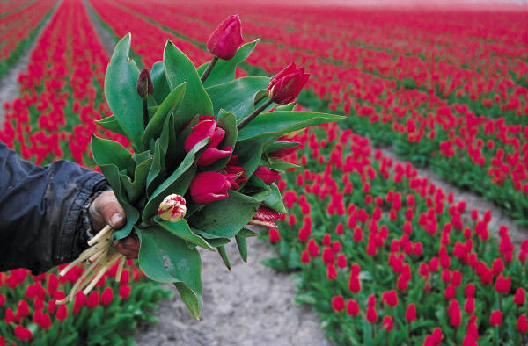

Sun | Mon | Tue | Wed | Thu | Fri | Sat
 |  |  |  | 1 | 2 | 3
4 | 5 | 6 | 7 | 8 | 9 | 10
11 | 12 | 13 | 14 | 15 | 16 | 17
18 | 19 | 20 | 21 | 22 | 23 | 24
25 | 26 | 27 | 28 | 29  みどりの日 | 30

4
2004
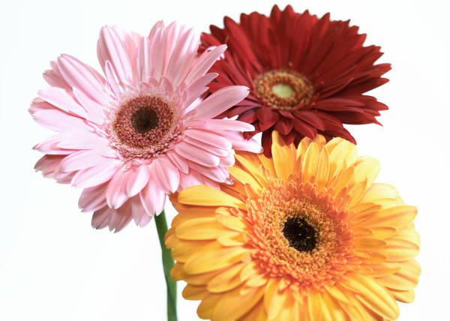

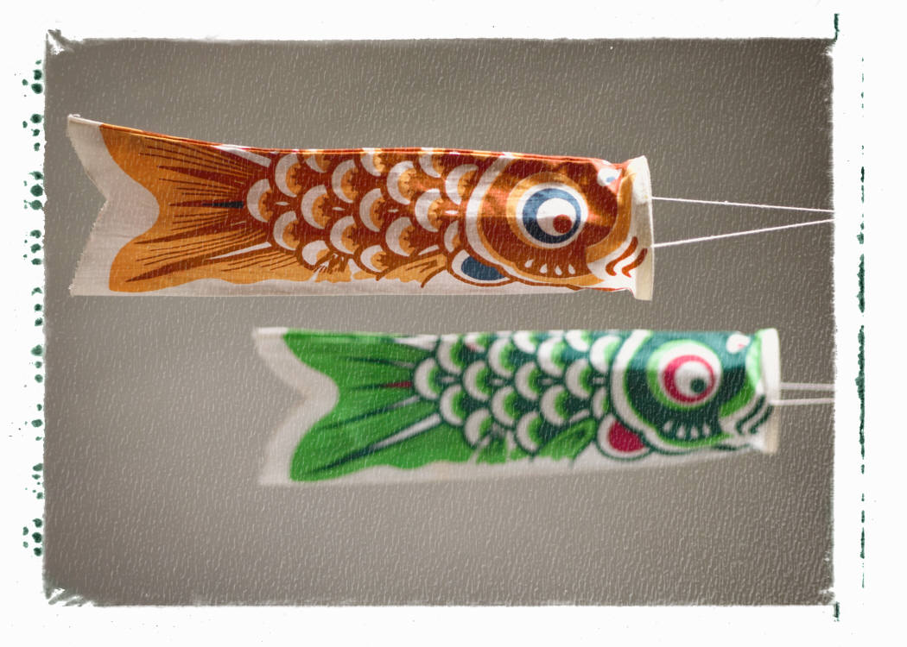
Sun | Mon | Tue | Wed | Thu | Fri | Sat
 |  |  |  |  |  | 1
2 | 3  憲法記念日 | 4  国民の休日 | 5  こどもの日 | 6 | 7 | 8
9 | 10 | 11 | 12 | 13 | 14 | 15
16 | 17 | 18 | 19 | 20 | 21 | 22
23 | 24 | 25 | 26 | 27 | 28 | 29
30 | 31

5
2004

Sun | Mon | Tue | Wed | Thu | Fri | Sat
 |  | 1 | 2 | 3 | 4 | 5
6 | 7 | 8 | 9 | 10 | 11 | 12
13 | 14 | 15 | 16 | 17 | 18 | 19
20 | 21 | 22 | 23 | 24 | 25 | 26
27 | 28 | 29 | 30

6
2004
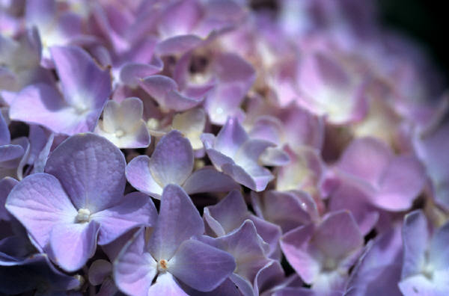

Sun | Mon | Tue | Wed | Thu | Fri | Sat
 |  |  |  | 1 | 2 | 3
4 | 5 | 6 | 7 | 8 | 9 | 10
11 | 12 | 13 | 14 | 15 | 16 | 17
18 | 19  海の日 | 20 | 21 | 22 | 23 | 24
25 | 26 | 27 | 28 | 29 | 30 | 31

7
2004
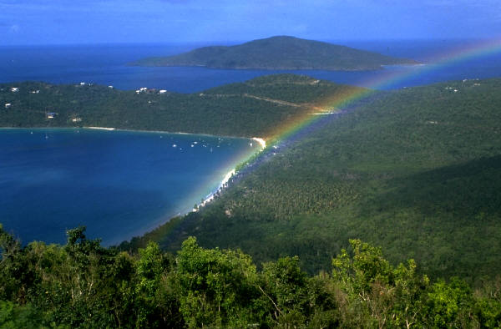

Sun | Mon | Tue | Wed | Thu | Fri | Sat
1 | 2 | 3 | 4 | 5 | 6 | 7
8 | 9 | 10 | 11 | 12 | 13 | 14
15 | 16 | 17 | 18 | 19 | 20 | 21
22 | 23 | 24 | 25 | 26 | 27 | 28
29 | 30 | 31

8
2004
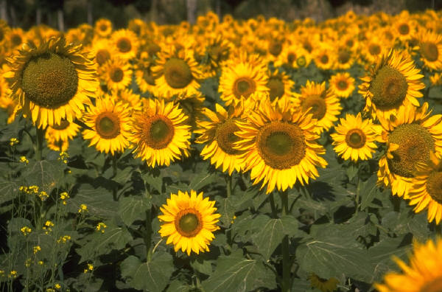

Sun | Mon | Tue | Wed | Thu | Fri | Sat
 |  |  | 1 | 2 | 3 | 4
5 | 6 | 7 | 8 | 9 | 10 | 11
12 | 13 | 14 | 15 | 16 | 17 | 18
19 | 20  敬老の日 | 21 | 22 | 23  秋分の日 | 24 | 25
26 | 27 | 28 | 29 | 30

9
2004


Sun | Mon | Tue | Wed | Thu | Fri | Sat
 |  |  |  |  | 1 | 2
3 | 4 | 5 | 6 | 7 | 8 | 9
10 | 11  体育の日 | 12 | 13 | 14 | 15 | 16
17 | 18 | 19 | 20 | 21 | 22 | 23
24 | 25 | 26 | 27 | 28 | 29 | 30
31

10
2004
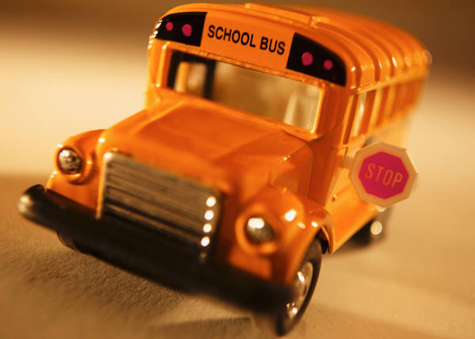

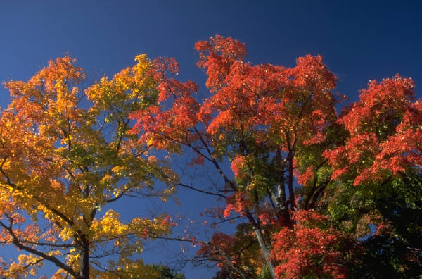
Sun | Mon | Tue | Wed | Thu | Fri | Sat
 | 1 | 2 | 3  文化の日 | 4 | 5 | 6
7 | 8 | 9 | 10 | 11 | 12 | 13
14 | 15 | 16 | 17 | 18 | 19 | 20
21 | 22 | 23  勤労感謝の日 | 24 | 25 | 26 | 27
28 | 29 | 30

11
2004

Sun | Mon | Tue | Wed | Thu | Fri | Sat
 |  |  | 1 | 2 | 3 | 4
5 | 6 | 7 | 8 | 9 | 10 | 11
12 | 13 | 14 | 15 | 16 | 17 | 18
19 | 20 | 21 | 22 | 23  天皇誕生日 | 24 | 25
26 | 27 | 28 | 29 | 30 | 31

12
2004
