

Step-by-Step Guide to Getting Started with Microsoft Windows Server Update Services on Windows Small Business Server 2003
Microsoft Corporation
Published: December 2005 (Version 2)
Author: Tim Elhajj

Abstract
Microsoft® Windows Server™ Update Services (WSUS) provides a comprehensive solution for managing updates within your network. This document tells you how to deploy WSUS on your network, including installing WSUS on computers running Windows® SBS 2003, configuring WSUS to obtain updates, configuring client computers to install updates, and approving and distributing updates.
For the most up-to-date product documentation for Windows SBS 2003, see the Microsoft Web site at http://go.microsoft.com/fwlink/?LinkId=33326.

The information contained in this document represents the current view of Microsoft Corporation on the issues discussed as of the date of publication. Because Microsoft must respond to changing market conditions, it should not be interpreted to be a commitment on the part of Microsoft, and Microsoft cannot guarantee the accuracy of any information presented after the date of publication.
This White Paper is for informational purposes only. MICROSOFT MAKES NO WARRANTIES, EXPRESS, IMPLIED OR STATUTORY, AS TO THE INFORMATION IN THIS DOCUMENT.
Complying with all applicable copyright laws is the responsibility of the user. Without limiting the rights under copyright, no part of this document may be reproduced, stored in or introduced into a retrieval system, or transmitted in any form or by any means (electronic, mechanical, photocopying, recording, or otherwise), or for any purpose, without the express written permission of Microsoft Corporation.
Microsoft may have patents, patent applications, trademarks, copyrights, or other intellectual property rights covering subject matter in this document. Except as expressly provided in any written license agreement from Microsoft, the furnishing of this document does not give you any license to these patents, trademarks, copyrights, or other intellectual property.
© 2005 Microsoft Corporation. All rights reserved.
Microsoft, Windows, and Windows Server are either registered trademarks or trademarks of Microsoft Corporation in the United States and/or other countries.
All other trademarks are property of their respective owners.

Contents
Step-by-Step Guide to Getting Started with Windows Server Update Services on Windows Small Business Server 2003 7
Step 1: Review WSUS Installation Requirements for Windows SBS 7
Hardware Requirements 8
Software Requirements 8
Disk Requirements and Recommendations 8
Automatic Updates Requirements 9
Step 2: Install WSUS 9
Step 3: Configure Your Network Connection 24
Step 4: Synchronize Your Server 27
Step 5: Update and Configure the Client Computers 20
Step 6: Create Computer Groups 34
Step 7: Approve Updates 35

Step-by-Step Guide to Getting Started with Windows Server Update Services on Windows Small Business Server 2003
To download the most recent version of this documentation, visit the Microsoft Web site (http://go.microsoft.com/fwlink/?LinkId=51211).
Microsoft® Windows Server™ Update Services (WSUS) provides a comprehensive solution for managing updates within your network. This document offers step-by-step instructions for basic tasks involved with deploying WSUS on your network. Use this guide to perform the following tasks:
• Install WSUS on a computer running the Windows® Small Business Server (SBS) 2003 server software with Service Pack 1 (SP1).
• Configure WSUS to obtain updates from Microsoft.
• Configure client computers to install updates from WSUS.
• Approve, test, and distribute updates.
Although WSUS includes several ways to accomplish each of these tasks, this guide offers only a single way to accomplish them. If alternatives are possible, a Note calls out these alternatives and points to more comprehensive instructions in either the "Deploying Microsoft Windows Server Update Services" white paper or the "Microsoft Windows Server Update Services Operations Guide" white paper. If you have already installed the predecessor to WSUS, Software Update Services (SUS), you should review this guide for any issues that are specific to Windows SBS, and you should also review the "Step-by-Step Guide to Migrating from Software Update Services to Windows Server Update Services" to understand how to migrate to WSUS. The latest version of these documents is available on the Tech Center site for WSUS at http://go.microsoft.com/fwlink/?linkid=41171.

Step 1: Review WSUS Installation Requirements for Windows SBS
This guide tells you how to install WSUS on Windows SBS.
The following requirements are the minimum you need to install WSUS with the default options. You can find hardware and software requirements for installations that do not use the default options in “Deploying Microsoft Windows Server Update Services” at the Microsoft Web site (http://go.microsoft.com/fwlink/?linkid=41171).

Hardware Requirements
WSUS has higher hardware requirements than Windows SBS. If your computer has the minimum system requirements for Windows SBS, you might notice decreased performance in WSUS. The minimum and recommended hardware requirement for WSUS are as follows:
• 750 megahertz (MHz) processor (1 gigahertz (GHz) recommended)
• 512 megabytes (MB) RAM (1 gigabyte (GB) recommended)

Software Requirements
To install WSUS with the default options, you must first install Windows SBS 2003 with SP1. Windows SBS 2003 with SP1 includes all of the software that you need to install WSUS. For more information about the software requirements for WSUS, see “Deploying Microsoft Windows Server Update Services” at the Microsoft Web site (http://go.microsoft.com/fwlink/?linkid=41171). For more information about installing Windows SBS 2003 with SP1, see "Getting Started" at the Microsoft Web site (http://go.microsoft.com/fwlink/?LinkId=51143).

Disk Requirements and Recommendations
To install WSUS, the file system of the server must meet the following requirements:
• Both the system partition and the partition on which you install WSUS must be formatted with the NTFS file system.
• The system partition must have a minimum of 1 GB free space.
• The volume where WSUS stores content must have a minimum of 6 GB free space; 30 GB is recommended.
Note
The 30 GB recommendation is only an estimate based on a number of variables, such as the number of updates released by Microsoft for any given product and how many products a WSUS administrator selects. Although 30 GB should work for most customers, a worst-case scenario might require more than 30 GB of disk space. If you require more than 30 GB of disk space, see "Windows Server Update Services Operations Guide" for guidance on how to point WSUS to a larger disk. "Windows Server Update Services Operations Guide" is available on the Tech Center site for Windows Server Update Services at http://go.microsoft.com/fwlink/?linkid=41171.
• The volume where WSUS Setup installs Windows SQL Server 2000 Desktop Engine (WMSDE) must have a minimum of 2 GB free space.

Automatic Updates Requirements
Automatic Updates is the client component of WSUS. Automatic Updates has no hardware requirements, other than the client computer must be connected to the network. You can use Automatic Updates with WSUS on computers that are running any of the following operating systems:
• Microsoft Windows 2000 Professional with Service Pack 3 (SP3), Service Pack 4 (SP4), or Service Pack 5 (SP5); Windows 2000 Server with SP3, SP4, or SP5; or Windows 2000 Advanced Server with SP3, SP4, or SP5.
• Microsoft Windows XP Professional, with or without Service Pack 1 or Service Pack 2.
• Microsoft Windows Server 2003, Standard Edition, Enterprise Edition, Datacenter Edition, or Web Edition, or any of these operating systems with SP1.
Note
For operating systems not listed above, you can try to download updates manually by going directly to the Download Center at http://go.microsoft.com/fwlink/?LinkId=51471.

Step 2: Install WSUS
After reviewing the installation requirements, you are ready to install WSUS. You must log on to the server you plan to install WSUS on by using an account that is a member of the local Administrators group. Only members of the local Administrators group can install WSUS.
The following procedure uses the default WSUS installation options for Windows SBS 2003 with SP1. These options include using Windows SQL Server 2000 Desktop Engine (WMSDE) as the WSUS database software, storing updates locally, and using the Internet Information Services (IIS) custom Web site on port 8530. You can find procedures for custom installation options, such as using different database software, in “Deploying Microsoft Windows Server Update Services” at the Microsoft Web site (http://go.microsoft.com/fwlink/?linkid=41171).
Important
If you plan to install WSUS on a server that has Windows Update Services Beta 1 or Beta 2 installed, you first need to uninstall the earlier version by using Add or Remove Programs in Control Panel.
To download the WSUS installer to your server
1. On the computer running Windows SBS, create a folder named WSUSFiles on the local hard disk.
2. Read how to register to download the latest version of WSUSSetup.exe at the Microsoft Web site (http://go.microsoft.com/fwlink/?LinkId=51144).
3. Answer all of the required questions on the Windows Server Update Services Registration Wizard Web page, and then click Continue.
4. When the file download security warning appears, click Save.
5. In the Save As dialog box, browse to the WSUSFiles folder, and then click Save.
To prepare the WSUS database
1. Extract the WSUS Setup files.
a. Click Start, click Run, and then type C:\WSUSFiles\WSUSSetup.exe /X, where C: is the letter of your local hard disk.
b. When prompted for a location to extract the files, select the WSUSFiles folder.
2. Type the following command, where C: is the letter of your local hard disk, and then press ENTER:
CD C:\WSUSFiles\wmsde

3. Type the following command with consideration to the points listed below, and then press ENTER:
Sqlrun03.msi InstanceName=WSUS BlankSAPwd=1 Reboot=ReallySuppress DisableNetworkProtocols=1 DisableAgentStartup=1 DisableThrottle=1

• If you want to specify the drive letter where the database instance will be located, you must add the DataDir="Path" argument to the command line, where Path is the path to the target directory in the file system.
• The command line implies that your WSUS database will have a blank password. However, during the actual installation of WSUS, a randomly generated password is set. You do not need to specify a password.
• The command line is not case sensitive.
4. Start the MSSQL$WSUS service. To do this, click Start, click Run, and then type Services.msc. Right-click MSSQL$WSUS, and then click Start. If the service is not listed, rerun the command in Step 3 of this procedure.
To install WSUS
1. Click Start, click Run, and then type C:\WSUSFiles\WSUSSetup.exe, where C: is the letter of your local hard disk.
2. On the Welcome page of the wizard, click Next.
3. Review the license agreement carefully. To continue, you must accept the agreement.
4. On the Select Update Source page, you can specify where the client computers get updates. If you select the Store updates locally check box, updates are stored on the server and you can select a location in the file system to store updates. If you do not store updates locally, the client computers connect to Microsoft Update to get approved updates.
Keep the default option to store updates locally, either choose a location to store updates or accept the default location, and then click Next.
Select Update Source Page
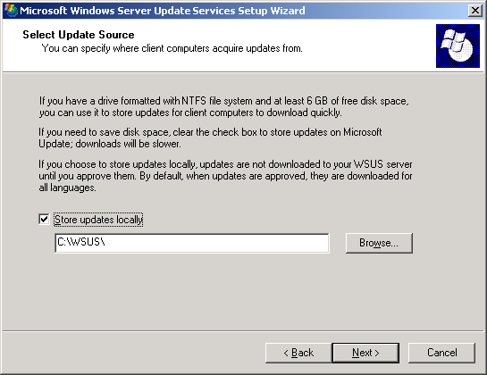

5. On the Database Options page, keep the default options, and then click Next. Because you installed WMSDE in the previous procedure, changing the options on this page of the wizard has no effect.
6. On the Web Site Selection page, specify a Web site for WSUS to use. This page also lists two important URLs based on this selection: the URL to which you will point WSUS client computers to get updates, and the URL for the WSUS console where you can configure WSUS.
Keep the default option and click Next.
Web Site Selection page
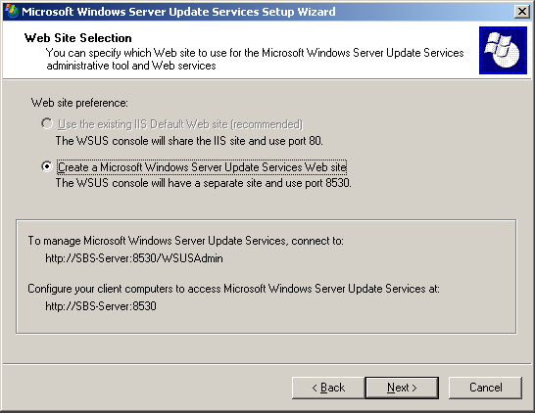

7. On the Mirror Update Settings page, keep the default option and click Next.
If you want to use multiple WSUS servers in a central management topology, see “Deploying Microsoft Windows Server Update Services” at the Microsoft Web site (http://go.microsoft.com/fwlink/?linkid=41171).
Mirror Update Settings Page
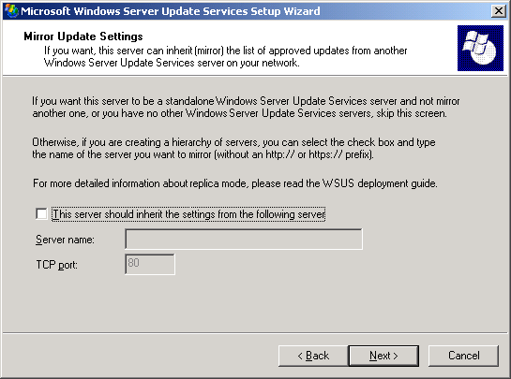

8. On the Ready to Install Windows Server Update Services page, review the selections, and then click Next.
Ready to Install Windows Server Update Services page
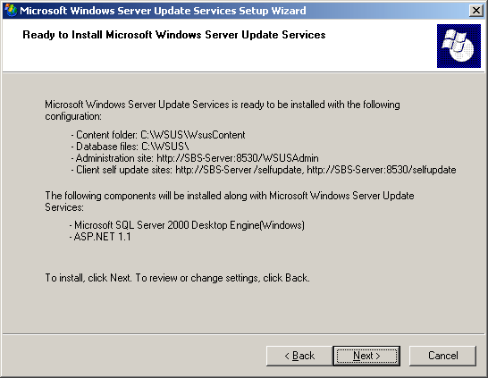

9. If the final page of the wizard confirms that WSUS installation was successfully completed, click Finish.
Note
After you install WSUS, you can delete the C:\WSUSFiles folder. However, do not delete the C:\WSUS folder, which is created when WSUS is installed.

Step 3: Configure Your Network Connection
After installing WSUS, you are ready to access the WSUS console in order to configure WSUS and get started. By default, WSUS is configured to use Microsoft Update as the location for obtaining updates. If you have a proxy server on your network, use the WSUS console to configure WSUS to use the proxy server.
If you have a firewall between WSUS and the Internet, you might need to configure the firewall to ensure that WSUS can obtain updates. If you are using Internet Security and Acceleration (ISA) Server and you have not created any additional rules beyond the default configuration, you do not have to configure your firewall.
Note
Although you must have Internet connectivity to download updates from Microsoft Update, WSUS offers you the ability to import updates on to networks that are not connected to the Internet. For more information, see “Deploying Microsoft Windows Server Update Services” at the Microsoft Web site (http://go.microsoft.com/fwlink/?linkid=41171).
Step 3 contains the following procedures:
• Configure your firewall so that WSUS can obtain updates.
• Open the WSUS console.
• Configure proxy-server settings so that WSUS can obtain updates.
To configure your firewall
• If you have a firewall between WSUS and the Internet—this could be a hardware firewall or ISA Server—you might need to configure the firewall to ensure that WSUS can obtain updates. To obtain updates from Microsoft Update, the WSUS server uses port 80 for the HTTP protocol and port 443 for the HTTPS protocol. The ports that WSUS uses to communicate with Microsoft Update are not configurable.
Note
If your organization does not allow ports 80 and 443 and protocols HTTP and HTTPS open to all addresses, then for more information about how to configure your firewall, see “Deploying Microsoft Windows Server Update Services” at the Microsoft Web site (http://go.microsoft.com/fwlink/?linkid=41171).
To open the WSUS console
• On your server, click Start, point to All Programs, point to Administrative Tools, and then click Microsoft Windows Server Update Services.
Note
You must be a member of either the WSUS Administrators or the local Administrators security groups on the server on which WSUS is installed in order to use the WSUS console.
If you do not add http://WSUSWebSiteName to the list of sites in the Local Intranet zone in Internet Explorer in Windows SBS 2003, you might be prompted for credentials each time you open the WSUS console.
If you change the port assignment in IIS after you install WSUS, you need to manually update the shortcut that is on the Start menu.
You can also open the WSUS console from Internet Explorer on any server or computer on your network by entering the following URL: http://WSUSServerName:8530/WSUSAdmin
To specify a proxy server
1. On the WSUS console toolbar, click Options, and then click Synchronization Options.
2. In the Proxy server box, select the Use a proxy server when synchronizing check box, and then type the proxy server name and port number in the corresponding boxes. If you are using ISA Server in its default configuration on your server, enter the name of the server and port 8080.
Proxy server box
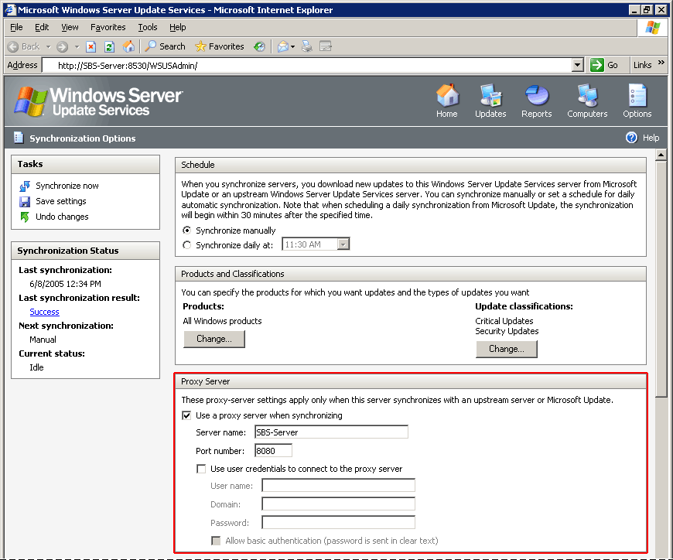

3. If you want to connect to the proxy server by using specific user credentials, select the Use user credentials to connect to the proxy server check box, and then type the user name, domain, and password of the user in the corresponding boxes. If you want to enable basic authentication for the user connecting to the proxy server, select the Allow basic authentication (password in clear text) check box.
4. Under Tasks, click Save settings, and then click OK in the confirmation dialog box.

Step 4: Synchronize Your Server
After you configure the network connection, you must synchronize the server. When you synchronize, the server contacts Microsoft Update and determines whether any new updates have been made available since the last time you synchronized. Because this is the first time you are synchronizing, all available updates appear for you to approve for installation.
Note
This paper describes synchronization using some bandwidth optimizations during synchronization. For more information about further optimizing bandwidth, see “Deploying Microsoft Server Windows Update Services” at the Microsoft Web site (http://go.microsoft.com/fwlink/?linkid=41171).
Consider changing the default language options for updates. By default, WSUS is configured to download all languages. You can change this to download updates only for the languages available on your network.
To change language options
1. On the WSUS console toolbar, click Options, and then click Synchronization Options.
2. Under Update Files and Languages, click Advanced.
3. Select Download updates only in the selected languages, and then select only the languages of the computers available on your network.
To synchronize your server with Microsoft Update
1. On the WSUS console toolbar, click Options, and then click Synchronization Options.
2. Under Tasks, click Synchronize now.
Note
The time required for synchronization depends on a number of things, including Internet connection speed and the number of products and update classifications selected.
To automate future synchronizations
1. On the WSUS console toolbar, click Options, and then click Synchronization Options.
2. Under Schedule, click Synchronize daily at, and then select a time for daily synchronizations from the drop down list.
By default, WSUS offers Critical and Security Updates for all Windows products to add products like SQL Server, Exchange, or Office, you must first synchronize WSUS and then perform the following procedure.
To modify the default list of products to update
1. On the WSUS console toolbar, click Options, and then click Synchronization Options.
2. Under Products, click Change.
3. Select Windows Small Business Server. Additionally, to update all components that are integrated with Windows SBS, you must select those specific products. For example, select Exchange Server 2003, SQL Server™, and Office 2003 (to update the Outlook component).
Note
If you add products like SQL Server, Exchange, or Office, you must synchronize the server at least one time.

Step 5: Update and Configure the Client Computers
WSUS client computers must be running a version of Automatic Updates that is compatible with WSUS. WSUS Setup automatically configures IIS to distribute the latest version of Automatic Updates to each client computer that contacts the server.
Also, the default Web site on Windows SBS 2003 must be modified to enable WSUS client computers to self-update. The WSUS server setup installs two vroots, SelfUpdate and ClientWebService, and some files under the home directory of the default Web site (on port 80). This enables client computers to self-update through the default Web site. By default, the default Web site is configured to deny access to any IP address other than localhost or specific subnets attached to the server. This means that client computers that are not on localhost or on those specific subnets cannot self-update. To grant access to these client computers, complete the following steps on the default Web site’s SelfUpdate and ClientWebService virtual directory.
To grant access to the client computers to self-update
1. In Server Management, expand Advanced Management, expand Internet Information Services, expand Web Sites, expand Default Web Site, right-click the Selfupdate virtual directory, and then select Properties.
2. Click Directory Security.
3. Under IP address and domain name restrictions, click Edit, and then click Granted Access.
4. Click OK, right-click the ClientWebService virtual directory, and then select Properties.
5. Click Directory Security.
6. Under IP address and domain name restrictions, click Edit, and then click Granted Access.
Note
Most versions of Automatic Updates automatically self-update to the WSUS-compatible version when you point them to the WSUS server. But the version of Automatic Updates that is included with Windows XP without any service packs cannot automatically self-update. If you have Windows XP without any service packs in your environment and you have never used Software Update Services (SUS), you should install Windows XP Service Pack 2, which includes the version of Automatic Updates that is compatible with WSUS. If you cannot do this, see “Deploying Microsoft Windows Server Update Services” at the Microsoft Web site (http://go.microsoft.com/fwlink/?linkid=41171) for other options.
Because that WSUS client computers update themselves automatically, you only need to configure and point client computers to the WSUS server. To configure Automatic Updates, create a new Group Policy object (GPO) for WSUS settings and then link that GPO on the domain level. Next, add all of your WSUS settings by editing the GPO you just created.
For more information about Group Policy, see the Microsoft Web site at http://go.microsoft.com/fwlink/?LinkID=47375.
Step 5 contains the following procedures:
• Create and link a GPO on the domain level.
• Configure Automatic Updates.
• Point client computers to your WSUS server.
• Disable auto-restarts for scheduled update installations (optional).
• Manually initiate detection on the client computer (optional).
To create and link a GPO on the domain level, and then open the new GPO in Group Policy Object Editor
1. In Server Management, expand Advanced Management, expand Group Policy Management, expand Forest, expand Domains, and then click your SBS domain.
Server Management
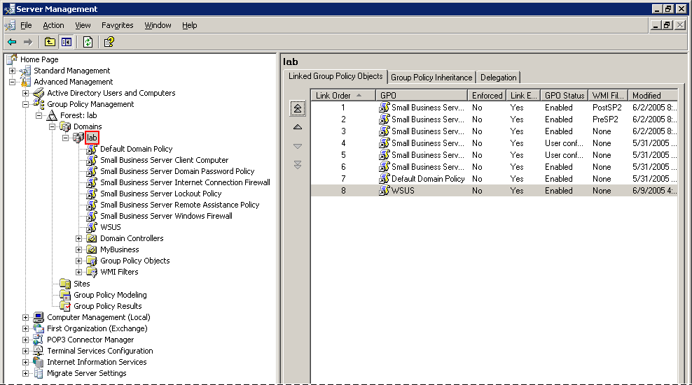

2. Right-click your SBS domain, and then select Create and Link a GPO Here.
3. In the Name box, type WSUS, and then click OK.
4. Right-click the new WSUS GPO, and then click Edit.
Group Policy Object Editor
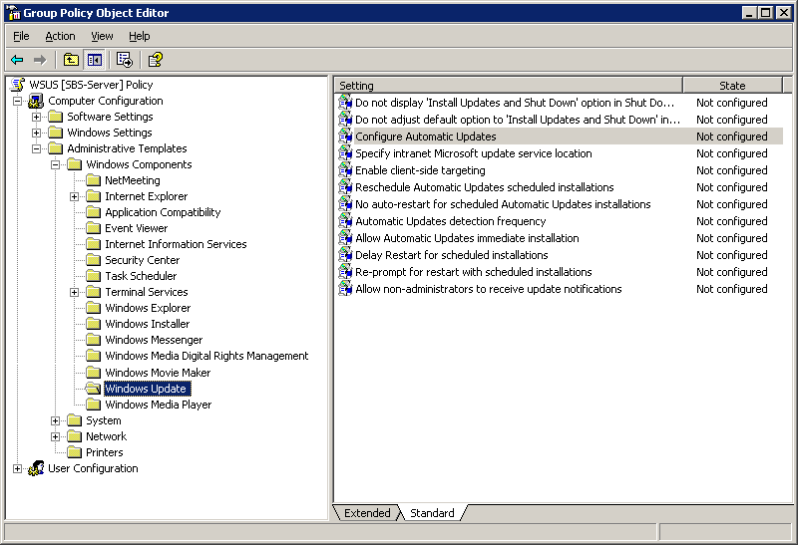

The following policy setting configures Automatic Updates to install updates on a schedule. You must enable this policy setting.
To configure the behavior of Automatic Updates
1. In Group Policy Object Editor, expand Computer Configuration, expand Administrative Templates, expand Windows Components, and then click Windows Update.
2. In the details pane, double-click Configure Automatic Updates.
3. Click Enabled, and then select Auto download and schedule the install.
4. Accept the default values for when installations should take place (every day at 3 AM), and then click OK.
The following policy setting configures Automatic Updates to use your WSUS server. You must enable this policy setting.
To point the client computer to your WSUS server
1. In Group Policy Object Editor, expand Computer Configuration, expand Administrative Templates, expand Windows Components, and then click Windows Update.
2. In the details pane, double-click Specify intranet Microsoft update service location.
3. Click Enabled, and then type the HTTP URL of the same WSUS server in the Set the intranet update service for detecting updates box and in the Set the intranet statistics server box. For example, type http://sbs-servername:8530 in both boxes.
4. Click OK.
The following policy setting prevents Automatic Updates from restarting the computer automatically if an update requires it. If you enable this policy setting, be aware that an update that requires a restart cannot take effect until you manually restart the computer. This policy setting is optional.
To disable automatic restart for scheduled update installations
1. In Group Policy Object Editor, expand Computer Configuration, expand Administrative Templates, expand Windows Components, and then click Windows Update.
2. In the details pane, double-click No auto-restart for scheduled Automatic Updates installations.
3. Click Enabled, and then click OK.
You have to wait for Group Policy to refresh for the settings to take effect. By default, Group Policy refreshes in the background every 90 minutes, with a random offset of 0 to 30 minutes. If you want to refresh Group Policy sooner, you can go to a command prompt on the client computer and type: gpupdate /force.
Note
On client computers running Windows 2000, you can type the following at a command prompt:
secedit /refreshpolicy machine_policy /enforce
After Group Policy refreshes, it can take up to 20 minutes before client computers appear on the Computers page in the WSUS console. If you initiate detection manually, you do not have to wait 20 minutes for the client computer to contact WSUS.
To manually initiate detection by the WSUS server
1. On the client computer click Start, and then click Run.
2. Type cmd, and then click OK.
3. At the command prompt, type wuauclt.exe /detectnow. This command-line option instructs Automatic Updates to contact the WSUS server immediately.
Note
Only the WSUS compatible client can use the /detectnow option. The WSUS compatible client comes with Windows 2000 Service Pack 4, Windows XP Service Pack 2, and Windows Server 2003 Service Pack 1. Otherwise, Automatic Updates self-updates to the WSUS compatible client.

Step 6: Create Computer Groups
Computer groups are an important part of a WSUS deployment, even a basic deployment. Computer groups enable you to target updates to specific computers. There are two default computer groups: All Computers and Unassigned Computers. By default, when each client computer initially contacts the WSUS server, the server adds it to both these groups.
You can create custom computer groups. Two benefits of creating computer groups are that they enable you to manage server computers differently from workstation computers and they enable you to test updates. There is no limit to the number of custom groups you can create.
Setting up computer groups is a three-step process. First, you specify how you are going to assign computers to the computer groups. There are two options: server-side targeting and client-side targeting. Server-side targeting involves manually adding each computer to its group by using WSUS. Client-side targeting involves automatically adding the client computers by using either Group Policy or the registry. Second, you create the computer group in WSUS. Third, you move the computers into groups by using whichever method you chose in the first step.
This paper explains how to use server-side targeting and manually move computers to their groups by using the WSUS console. If you had numerous client computers to assign to computer groups you could use client-side targeting, which would automate moving computers into computer groups.
You can use Step 6 to set up a server and a client-computer group. This step contains the following procedures:
• Specify server-side targeting.
• Create a Server and a Client group.
• Move computers to the appropriate group.
To specify the method for assigning computers to groups
1. On the WSUS console toolbar, click Options, and then click Computer Options.
2. In the Computer Options box, click Use the Move computers task in Windows Server Update Services.
3. Under Tasks, click Save settings, and then click OK when the confirmation dialog box appears.
To create a Server and a Client group
1. On the WSUS console toolbar, click Computers.
2. Under Tasks, click Create a computer group.
3. In the Group name box, type Server, and then click OK.
4. Under Tasks, click Create a computer group.
5. In the Group name box, type Client, and then click OK.
To manually add a computer to a group
1. On the WSUS console toolbar, click Computers.
2. In the Groups box, click the group of the computer you want to move.
3. In the list of computers, click the computer you want to move.
4. Under Tasks, click Move the selected computer.
5. In the Computer group list, select the group you want to move the computer to, and then click OK.

Step 7: Approve Updates
In this step you approve updates for any computers in the Server or the
Client computer groups. Computers in these groups will check in with the WSUS server over the next 24 hours. After this period, you can use the WSUS reporting feature to determine whether those updates have been installed.
Step 7 contains the following procedures:
• Approve and deploy an update.
• Check the Status of Updates report.
To approve and deploy an update
1. On the WSUS console toolbar, click Updates. By default, the list of updates is filtered to show only Critical and Security Updates that have been approved for detection by client computers. Use the default filter for this procedure.
2. On the list of updates, select the updates you want to approve for installation. Information about a selected update is available on the Details tab. To select multiple contiguous updates, press and hold down the SHIFT key while selecting; to select multiple non-contiguous updates, press and hold down the CTRL key while selecting.
3. Under Update Tasks, click Change approval. The Approve Updates dialog box appears.
4. In the Group approval settings for the selected updates list, click the default value in the Approval column for the group you intend to work with, and then click Install.
5. Click OK.
Note
There are many options associated with approving updates, such as setting deadlines and uninstalling updates. These are discussed in “Microsoft Windows Server Update Services Operations Guide,” which is available at the Microsoft Web site (http://go.microsoft.com/fwlink/?linkid=41171).
After 24 hours, you can use the WSUS reporting feature to determine whether those updates have been installed.
To check the Status of Updates report
1. On the WSUS console toolbar, click Reports.
2. On the Reports page, click Status of Updates.
3. If you want to filter the list of updates, under View, select the criteria you want to use, and then click Apply.
4. If you want to see the status of an update by computer group and then by computer, expand the view of the update as necessary.
5. If you want to print the Status of Updates report, under Tasks, click Print report.

