Step 1 - Acquiring a VeriSign ID
Acquiring a VeriSign ID is the first step in registering for the Microsoft Windows Catalog.
VeriSign's code signing digital ID's (or certificates) allow software developers to sign software and macros digitally for secure delivery over the Internet. It protects your company from impersonation and guarantees that all submissions come from your company. A VeriSign ID is required for obtaining a .NET Connected Logo even if your software is not being downloaded to a client system

To acquire a VeriSign ID
- Go to www.verisign.com/products/signing/code/
- Under Step 1, select Microsoft Authenticode Digital ID.
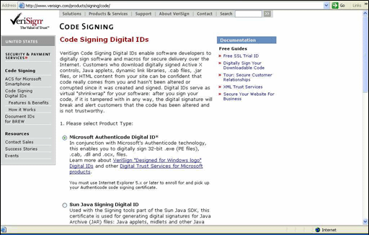

- Under Step 2, select the CodeSigner Standard ($400 version), and then click Buy Now.
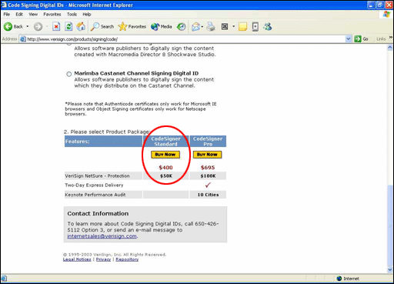

- Use the following guidelines to complete the enrollment form:
- Code Signing ID information – Enter your company's information.
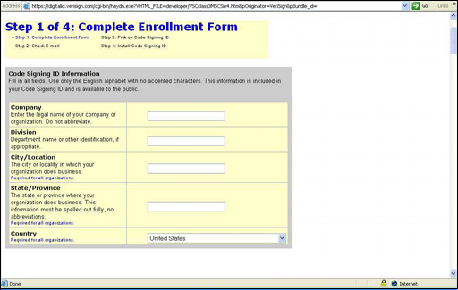

- Choose a Challenging Phrase – Enter a challenge phrase and a reminder question.
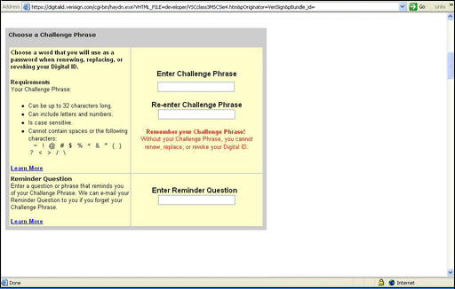

- Enter Your Technical Contact Information – Enter your name and company information.
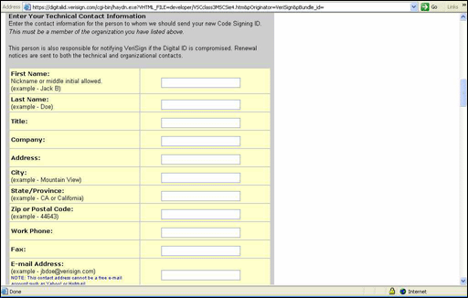

- Enter Your Organizational Contact Information – Enter your company information as appropriate.
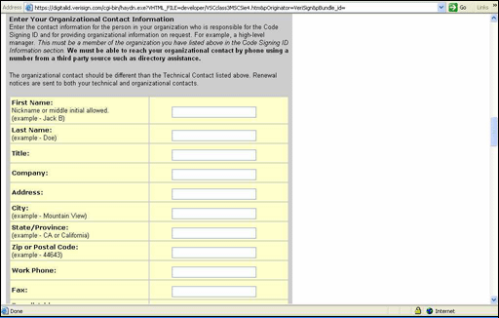

- Enter Your Billing Contact Information – Enter the following information:
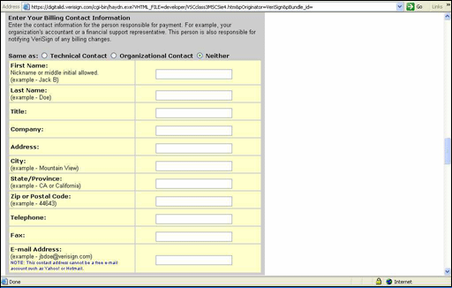

- Enter Payment Information – Select the option that best meets your needs.
- 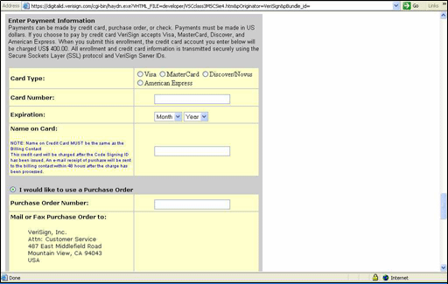

- Click Accept to accept the terms of the Subscriber Agreement.
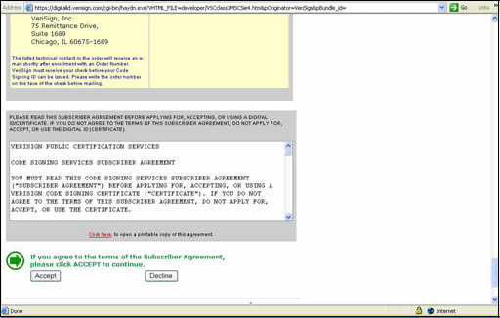

- Follow any additional on-screen instructions to complete this step of the registration process.

