

Security Compliance Manager

Getting Started Guide

Version 1.0

Published: June 2010

For the latest information, please see   
microsoft.com/technet/**SolutionAccelerators**

Copyright © 2010 Microsoft Corporation. All rights reserved. Complying with the applicable copyright laws is your responsibility. By using or providing feedback on this documentation, you agree to the license agreement below.

If you are using this documentation solely for non-commercial purposes internally within YOUR company or organization, then this documentation is licensed to you under the Creative Commons Attribution-NonCommercial License. To view a copy of this license, visit http://creativecommons.org/licenses/by-nc/2.5/ or send a letter to Creative Commons, 543 Howard Street, 5th Floor, San Francisco, California, 94105, USA.

This documentation is provided to you for informational purposes only, and is provided to you entirely "AS IS". Your use of the documentation cannot be understood as substituting for customized service and information that might be developed by Microsoft Corporation for a particular user based upon that user’s particular environment. To the extent permitted by law, MICROSOFT MAKES NO WARRANTY OF ANY KIND, DISCLAIMS ALL EXPRESS, IMPLIED AND STATUTORY WARRANTIES, AND ASSUMES NO LIABILITY TO YOU FOR ANY DAMAGES OF ANY TYPE IN CONNECTION WITH THESE MATERIALS OR ANY INTELLECTUAL PROPERTY IN THEM.

Microsoft may have patents, patent applications, trademarks, or other intellectual property rights covering subject matter within this documentation. Except as provided in a separate agreement from Microsoft, your use of this document does not give you any license to these patents, trademarks or other intellectual property.

Information in this document, including URL and other Internet Web site references, is subject to change without notice. Unless otherwise noted, the example companies, organizations, products, domain names, e-mail addresses, logos, people, places and events depicted herein are fictitious.

Microsoft, Active Directory, BitLocker, Excel, PowerPoint, Windows, and Windows Vista are either registered trademarks or trademarks of Microsoft Corporation in the United States and/or other countries.

The names of actual companies and products mentioned herein may be the trademarks of their respective owners.

You have no obligation to give Microsoft any suggestions, comments or other feedback ("Feedback") relating to the documentation. However, if you do provide any Feedback to Microsoft then you provide to Microsoft, without charge, the right to use, share and commercialize your Feedback in any way and for any purpose. You also give to third parties, without charge, any patent rights needed for their products, technologies and services to use or interface with any specific parts of a Microsoft software or service that includes the Feedback. You will not give Feedback that is subject to a license that requires Microsoft to license its software or documentation to third parties because we include your Feedback in them.

Contents

Overview 1

What the Security Compliance Manager Does 1

Key Features and Benefits 1

Security Environments 2

Section Descriptions 2

Setup 3

Requirements 3

Installing the Security Compliance Manager 3

Installation Steps 4

The Security Compliance Manager Console 5

Download and Import Security Baselines 6

Security Baseline Settings and Documentation 9

Customize 10

Customizing Your Security Baselines 10

Comparing Security Baselines 12

Merging Security Baselines 13

Deploy and Monitor 14

Preparing to Deploy Your Security Baseline 14

Preparing to Monitor Your Security Baseline 15

More Information 15

Feedback 15

# Overview

Welcome to the *Microsoft Security Compliance Manager Getting Started Guide*. The Microsoft Security Compliance Manager is the next evolution of the Microsoft Security Compliance Management Toolkit (SCMT) Series. We’ve taken our extensive guidance and documentation and incorporated it into this new tool, enabling you to access and automate all of your organization’s security baselines in one centralized location.

This guide provides you with brief instructions on how to set up the Security Compliance Manager, use this powerful tool to customize a security baseline, and then deploy it to monitor the security state of the computers in your environment.

## What the Security Compliance Manager Does

The Microsoft Security Compliance Manager provides centralized security baseline management features, a baseline portfolio, customization capabilities, and security baseline export flexibility to accelerate your organization’s ability to efficiently manage the security and compliance process for the most widely used Microsoft technologies.

Take advantage of the experience of Microsoft security professionals, and reduce the time and money required to harden your environment. This end-to-end Solution Accelerator will help you plan, deploy, operate, and manage your security baselines for Windows® client and server operating systems, and Microsoft applications. Access the complete database of Microsoft recommended security settings, customize your baselines, and then choose from multiple formats—including Excel® workbooks, Group Policy objects (GPOs), Desired Configuration Management (DCM) packs, or Security Content Automation Protocol (SCAP)—to export the baselines to your environment to automate the security baseline deployment and compliance verification process. Use the Security Compliance Manager to achieve a secure, reliable, and centralized IT environment that will help you better balance your organization’s needs for security and functionality.

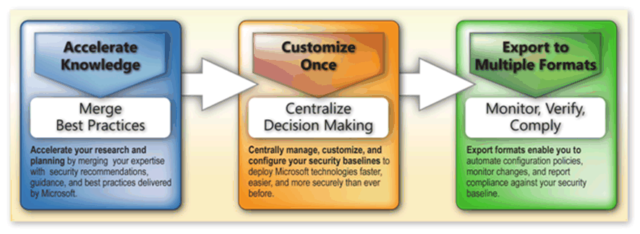

Figure 1. The Security Compliance Manager lets you choose, customize, export, and monitor your security baselines from a centralized location

## Key Features and Benefits

The Security Compliance Manager provides the following key features and benefits:

* **Centralized Management and Baseline Portfolio**: The centralized management console of the Security Compliance Manager provides you with a unified, end-to-end user experience to plan, customize, and export security baselines. The tool gives you full access to the complete portfolio of recommended baselines for Windows® client and server operating systems, and Microsoft applications. The Security Compliance Manager also enables you to quickly update the latest Microsoft baseline releases and take advantage of baseline version control.
* **Security Baseline Customization**: Customizing, comparing, merging, and reviewing your baselines just got easier. Use these capabilities of the Security Compliance Manager to duplicate any of the recommended baselines from Microsoft, and then quickly modify security settings to meet the standards of your organization’s environment.
* **Multiple Export Capabilities**: Export your security baselines in formats that include workbooks, GPOs, DCM packs, or SCAP to automate the deployment and security baseline monitoring processes.
* **Security Baseline Compliance Monitoring and Verification**: Keep current with the latest releases from Microsoft; automate your security baseline compliance process, and take advantage of baseline version control and automatic update features. The planning, customization, and export features that the Security Compliance Manager provide quickly enable you to leverage monitoring and verification technologies, automate policy deployment, and produce compliance reports.

## Security Environments

The Security Compliance Manager provides you with security baselines that align with two distinct security environments. Microsoft determined these security environments to meets the security requirements of enterprise and government organizations.

Microsoft security baselines are available for the following security environments:

* **Enterprise Client (EC)** security baselines that are intended for most organizations.
* **Specialized Security – Limited Functionality (SSLF)** security baselines that are intended for environments in which concern for security is more important than functionality, which can result in some loss of functionality.

**Caution**   The SSLF security baseline settings are not intended for the majority of enterprise organizations. To successfully implement the SSLF settings, organizations must first thoroughly test these settings in their environment to ensure that they do not limit required functionality.

## Section Descriptions

This guide includes the following sections:

* **Setup**. This section includes requirements for the Security Compliance Manager and instructions on how to install the tool. It includes an overview of the Security Compliance Manager Console, describes how to use the tool to import a security baseline, and where to access supporting information and documentation about the security baseline settings in the tool.
* **Customize**. This section provides instructions on how to use the Security Compliance Manager to customize a security baseline for Windows 7. It also demonstrates how to use the **Compare** feature in the tool to determine how close your existing environment is to recommended security baselines from Microsoft, and the **Merge** feature to combine security baselines.
* **Deploy and Monitor**. This section provides instructions on how to use the Security Compliance Manager to generate backup GPOs based on a security baseline, and how you can create and use DCM packs in System Center Configuration Manager to monitor the security state of the computers in your environment.

# Setup

This section lists the requirements for the Security Compliance Manager, and provides instructions on how to install the tool. It includes an overview of the Security Compliance Manager Console, describes how to use the tool to import a security baseline, and where to access supporting information and documentation about the security baseline settings in the tool.

## Requirements

The supported operating systems and requirements to use the Security Compliance Manager include:

* Windows® 7 and Windows Vista® Service Pack 2 (SP2).
* Microsoft® Excel® 2007 to export data in Excel workbooks.
* SQL Server® 2008 Express Edition to store security baselines.
* Microsoft .NET Framework 3.5.
* Windows Installer 4.5.
* An Internet connection to download Microsoft security baselines.

This Security Compliance Manager is intended to work with System Center Configuration Manager 2007 and the desired configuration management (DCM) feature of that product.

**Note**   You can use the Microsoft Office Compatibility Pack for Word, Excel, and PowerPoint File Formats (available as a free download) to open, edit, and save documents, workbooks, and presentations in Microsoft Office 2007 file formats. You also can use Microsoft Word or Microsoft Word Viewer (available as a free download) to view Word documents.

## Installing the Security Compliance Manager

This section provides instructions on how to install the tool. From the Microsoft download page for the tool, we recommend that you first download and read the Release Notes for the Security Compliance Manager, and then download the installation package for the tool.

While installing the tool, you can configure it to download all of the latest security baselines from Microsoft, or after completing the installation you can access the **Tools** menu to check for baselines.

**Note**   The download process for the Security Compliance Manager automatically installs SQL Server 2008 Express Edition on your computer if you do not already have this software.

### Installation Steps

Use the following steps to download and install the tool.

To download and install the Security Compliance Manager

1. On the [Microsoft Security Compliance Manager](http://go.microsoft.com/fwlink/?LinkId=14840) download page, scroll down to the **Files in This Download** section, and then click the **Download** button next to **Microsoft_Security_Compliance_Manager.Setup.exe** to start the download.
2. Do one of the following:

* On the **File Download – Security Warning** prompt, click **Run** to immediately start the download process.

– Or –

* On the **File Download – Security Warning** prompt, click **Save**, and then in the **Save** **as** dialog box, specify where on your computer to download the installation file for the tool, and then click **Save**.

1. If required, on the **User Account Control** prompt, provide your credentials if needed, and then click **OK** to allow the download to proceed.
2. On the **Welcome to the Microsoft Security Compliance Manager** **Wizard** page, consider the following options, and then click **Next**:

* **Automatically check for application and baseline updates from microsoft.com during application usage for current user**.
* The **Read the online privacy statement** link to this information on the tool.

1. On the **License Agreement** page of the wizard, review the terms of the license agreement, choose the option to accept the terms in order to proceed with the installation, and then click **Next**.

**Note**   There is an option on this page to print the license agreement for the tool if you want to make a copy for your reference.

1. On the **Installation Folder and Publisher Name** of the wizard, complete the following and then click **Next**:

* Confirm the default installation folder for the tool or click **Browse** to change it.
* In the **Publisher Name** field, type a distinct name to identify all baselines that you will create on your computer for your organization.

**Note**   The Publisher Name that you choose to use must start with a letter and may contain other letters and numbers, but no other special characters.

1. On the **SQL Server Express** page of the wizard, choose from the following options, and then click **Download**:

* **Download and install**.
* **Install from previously downloaded installation files**.

1. On the **SQL Server Express License Agreement** page of the wizard, review the terms of the license agreement to use SQL Server 2008 Express Edition, choose the option to accept the terms in order to proceed with this part of the installation process, and then click **Next**.

**Note**   There is also an option on this page to print the license agreement for this software if you want to make a copy for your reference.

1. On the **Ready to Install** page of the wizard, confirm the **Installation Summary** information that you specified previously, and then click **Install**.

**Important**   You cannot cancel the setup wizard after you start the installation process for the SQL Server Express and the Security Compliance Manager.

1. On the **Installing the Microsoft Security Compliance Manager** page of the wizard, monitor the installation progress for the software while waiting for the setup wizard to complete the installation.

**Note**   The installation process may take awhile to complete.

1. On the **Installation Successful** page of the wizard, click **Finish** to complete the installation process.

## The Security Compliance Manager Console

The Security Compliance Manager Console provides you with a single point of access to work with the recommended security baselines from Microsoft for your security environment. The console also provides access to supporting documentation to help you make informed decisions about how to customize the security baselines to meet your organization's security requirements.

To access the Security Compliance Manager Console

* On your computer, click **Start**, click **All Programs**, click **Microsoft Security Compliance Manager 1.0** to open this directory to access the tool, and then click **Security Compliance Manager** to open the welcome page of the tool console.

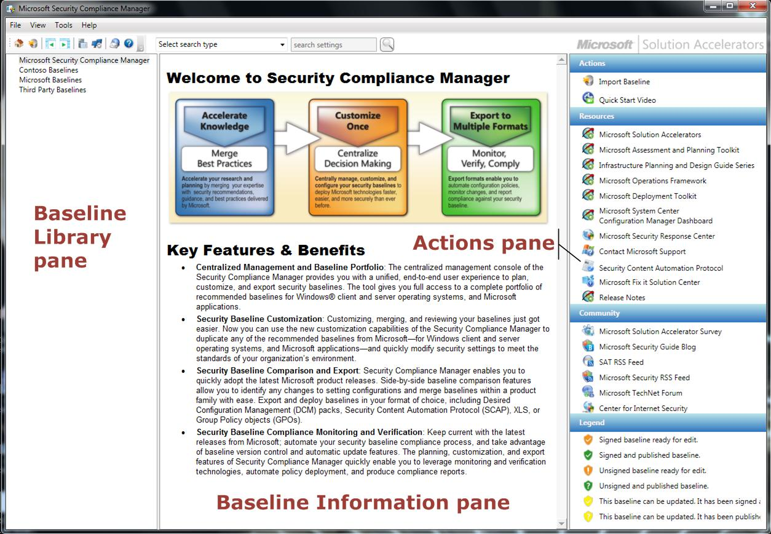

Figure 2. The Welcome page of the Security Compliance Manager Console

The Security Compliance Manager Console Welcome page displays the three panes that you use to import, customize, deploy, and monitor your security baselines. These are:

* **Baseline Library**: The left pane of the console lists all of the available baselines in a tree structure. When you right-click a baseline in this pane, a menu displays with commands that you can apply to the baseline.
* **Baseline** **Information**: The center pane of the console displays component information about the baseline that is currently selected in the left pane of the console.
* **Actions**: The right pane of the console lists commands to manage your baselines that change depending on what process you are using the tool to accomplish. The **Legend** area of this pane displays icons that the tool displays to inform you of the current status of the baseline that you are managing. For more information about the status icons, see the Help subtopic "Understanding Baseline Status."

For more information about the tool interface, and how you can customize your view of panes in the tool, see the Help topic "Using the Microsoft Security Compliance Management Tool."

### Download and Import Security Baselines

This section demonstrates how to download and import security baselines from Microsoft into the Security Compliance Manager. The tool displays imported baselines in the **Baseline Library** pane of the tool.

To download and import security baselines from Microsoft:

1. On the main menu of the Welcome page of the tool, click **Tools**, and then click **Check for** **Baselines**.
2. In the **Download Baselines** window, ensure that the **File details** check box is selected, and then click **Download**.

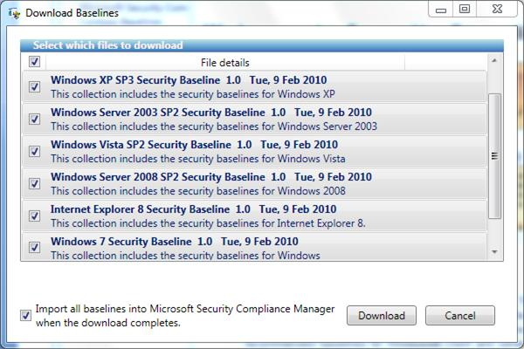

Figure 3. The Download Baselines window

**Note**If you want to select a particular set of baselines, clear the **File** **details** check box, select check boxes next to those baselines that you want, and then click **Download**.

1. In the **Browse For Folder** window, accept the default location to save the security baselines, or specify a location where you want to save them.
2. After the Import Baselines Wizard starts, on the **Security Warning** prompt that displays, click **Run**.
3. On the **Select package files** page of the Import Baselines Wizard, verify the package description, and then click **Next**.

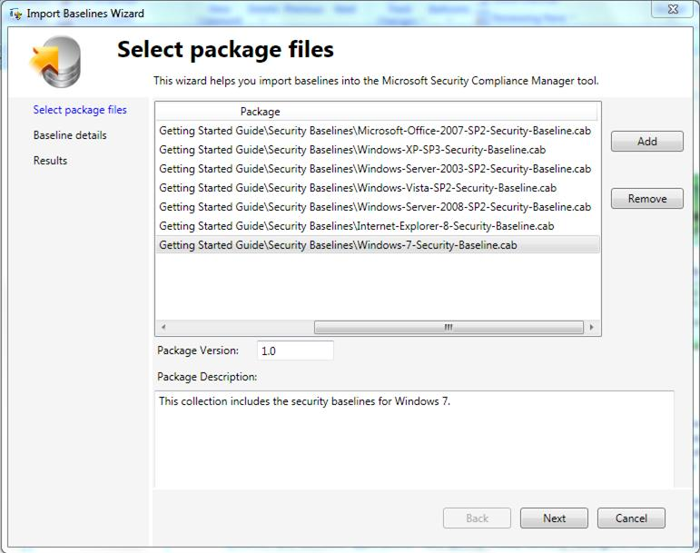

Figure 4. The Select package files page of the Import Baselines Wizard

1. On the **Baseline details** page of the Import Baselines Wizard, verify the Microsoft security baseline .cab files for both the EC and the SSLF environments, and then click **Import**.

**Note**If you want to change any of the baselines, select the check box on this page for the **Create modifiable copies of each baseline to be imported** option.

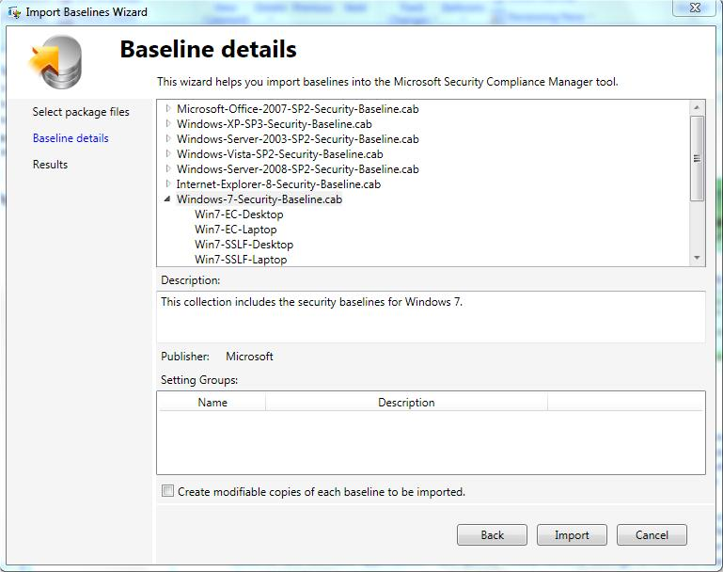

Figure 5. The Baseline details page of the Import Baselines Wizard

1. On the **Results** page of the dialog box, verify the results of the import process, and then click **Finish**.

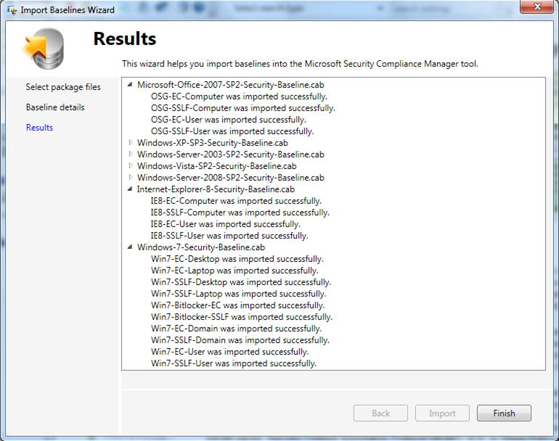

Figure 6. The Results page of the Import Baselines Wizard

### Security Baseline Settings and Documentation

After importing the Microsoft security baselines that you want to work with for your organization, you can access setting information and documentation to help you make informed decisions about how to manage them.

To access security baseline information about Windows 7:

1. In the **Baseline Library** pane of the console, expand **Microsoft** **Baselines** in the tree node, expand **Windows 7**, and then click the security environment for your organization (**EC** or **SSLF**).

**Note**The package of Windows 7 security baselines includes both EC and SSLF security baselines for BitLocker® Drive Encryption.

1. In the **Baseline Information** pane of the console, use the following tabs to access more information about the security baseline of interest to you:

* **Settings** tab: This tab displays the setting groups of the security baseline, and the settings that comprise each setting group. Use your arrow keys to select a setting group, and then click the group to display its settings.

For example, on this tab under **Win7-EC-User 1.0**, if you select the **Windows Components\Windows Explorer User Setting** group, and then click this group name, the console displays the group's two settings and their baseline configuration values. In the lower area of the **Baseline Information** pane, the **Description**, **Threats & Countermeasures**, and **Definition** tabs provide detailed information about how each setting is configured in the baseline.

**Note**   Click the **Option Help Text** button to obtain information about setting options.

* **Documents** tab: This tab provides access to security guide information about Microsoft operating systems and applications. In this example, you can access the *Windows 7 Security Guide* in Word format.
* **General** tab: This tab provides general information about each security baseline, and what each baseline is designed to accomplish for your organization.

For more information, see the following Help topics:

* "Managing Baselines"
* "Managing Baseline Documents"

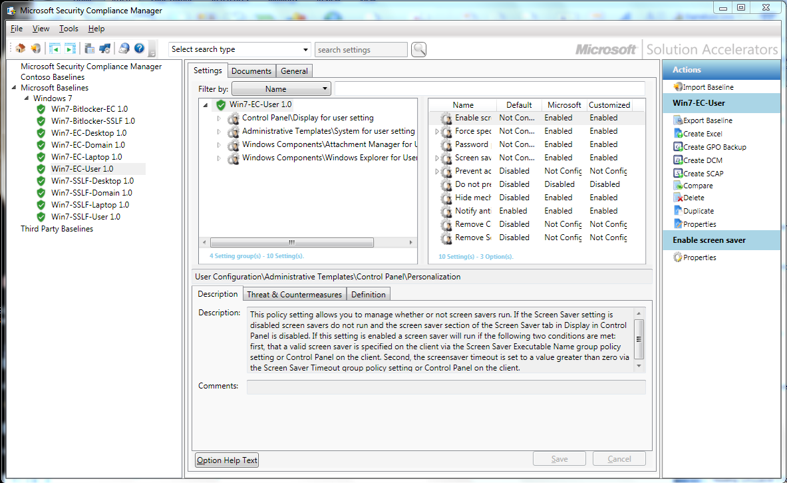

Figure 7. The Windows 7 EC User baseline settings

# Customize

This section provides instructions on how to use the Security Compliance Manager to copy or duplicate a security baseline for Windows 7 and then customize it. It also demonstrates how to use the **Compare** feature in the tool to determine how close your existing environment is to recommended security baselines from Microsoft, and how to use the **Merge** feature to combine security baselines.

You can use the security baselines from Microsoft without changing them. However, it is likely that you will need to customize one or more security baseline to address your organization’s security requirements. You cannot directly modify the security baselines that you download with the Security Compliance Manager. However, you can make copies of the baselines to then customize them.

## Customizing Your Security Baselines

Use the following steps to copy a security baseline from Microsoft and then customize it for your organization.

To copy and customize a security baseline from Microsoft

1. In the **Baseline Library** pane of the tool, right-click the baseline that you want to modify, select **Customize**, and then click **Duplicate**.
2. In the **Duplicate** dialog box, type a unique name in the **Baseline Name** box, add to the **Description** box as needed, and then click **Save**.

The result of this step provides you with a copy of the security baseline from Microsoft that you can now customize. The new baseline appears under your organization's name in the **Baseline Library** pane of the tool.

**Note**The orange icon next to the baseline copy signifies that you can now edit or change the settings in the baseline to customize it, and that the baseline is unsigned.

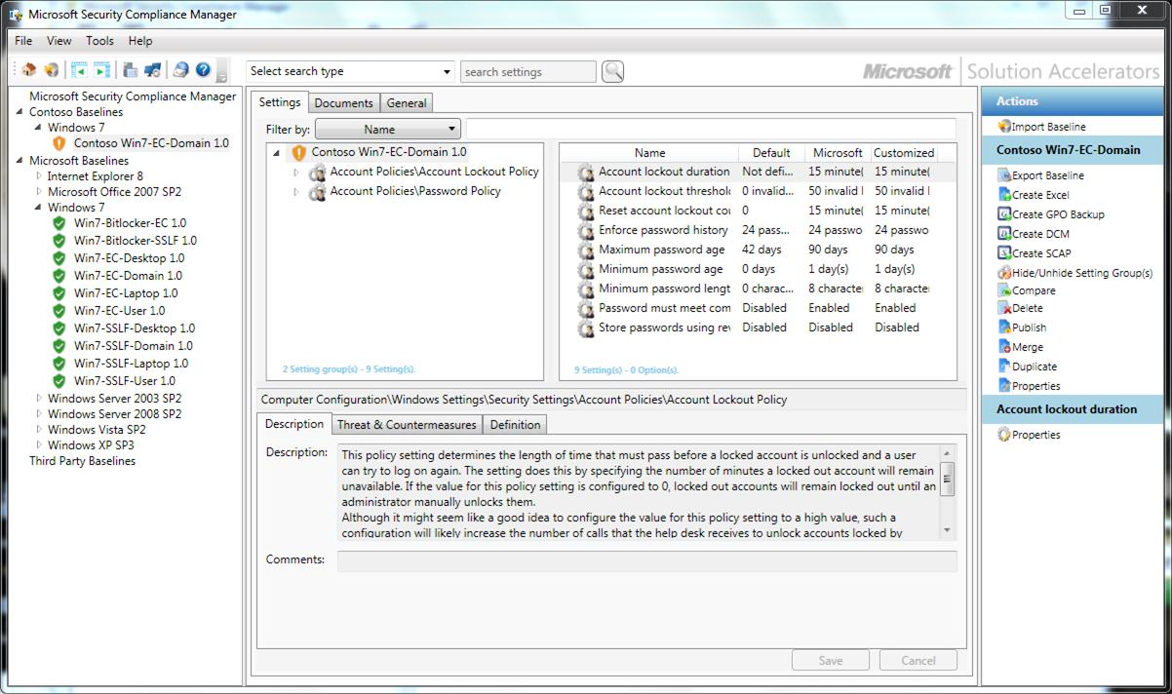

Figure 8. Contoso copy of the Win-7-EC-Domain baseline from Microsoft

1. To better view the baseline setting groups and settings that you want to customize in the **Baseline** **Information** pane, click the following **Show / Hide** buttons on the main toolbar of the Security Compliance Manager:

* **Show / Hide Baseline Tree** to hide the **Baseline Library** pane.
* **Show / Hide Actions Pane** to hide the **Actions** pane.

1. To view only a specific setting group, in the **Actions** pane, under the name of the baseline you want to customize, click the **Hide/Unhide Settings Group(s)** button, and then in **Hide/Unhide Setting Group(s)** window, use the arrow buttons to define the setting group you want to display in the **Baseline** **Information** pane.

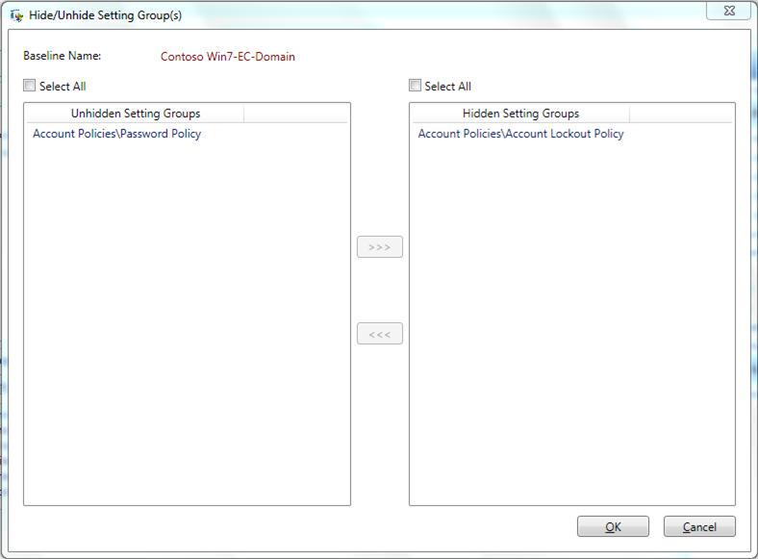

Figure 9. The Hide/Unhide Setting Group(s) window

1. To customize a setting, on the **Settings** tab of the **Baseline** **Information** pane, click the setting name, and then on the **Definition** tab for the setting, change the setting value by either enabling it or changing its value within the allowed range.

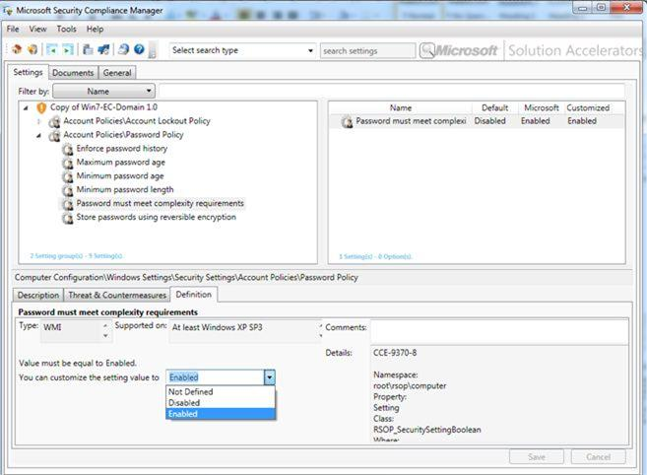

Figure 10. Customizing a Windows 7 EC Domain baseline setting for Contoso

**Important**You cannot customize setting rules, operations, or definitions. You can only customize recommended setting values from Microsoft.

## Comparing Security Baselines

Use the **Compare** feature to view the differences between two baselines.

To compare security baselines

1. In the **Baseline Library** pane, use one of the following options to start this process:

* Right-click the first baseline that you want to compare, select **Manage**, and then click **Compare**.

– Or –

* Click the first baseline that you want to compare to select it, and then in the **Actions** pane, click **Compare**.

1. In the **Compare Baselines** dialog box, navigate to the second baseline, click the second baseline to select it, and then click **OK**.

The **Show the results of comparing baselines** report appears.

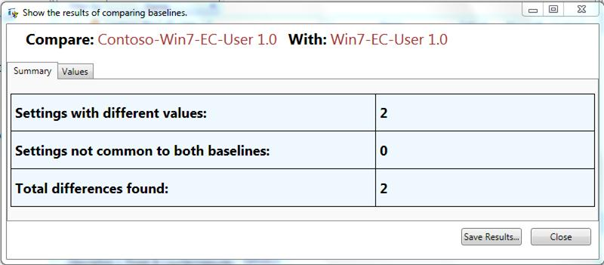

**Figure 11. The Show the results of comparing baselines report**

1. The **Summary** tab displays the number of security setting differences between the two baselines. Click the **Values** tab of the report to assess which settings and settings values are different between the two baselines.

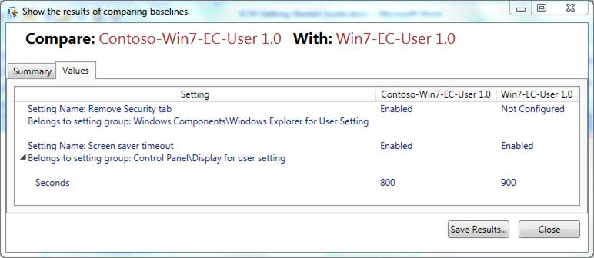

Figure 12. The Values tab information of the comparing baselines report

1. Click the **Save Results** button to save the report as an XML file.

## Merging Security Baselines

Use the **Merge** feature to combine two baselines into one.

To merge security baselines

1. In the **Baseline Library** pane, to select the source baseline, either:

* Right-click the source baseline that you want to use, select **Customize**, and then click **Merge**.

– Or –

* Click the source baseline that you want to use, and then in the **Actions** pane, click **Merge**.

**Note**   The contents of this baseline will be added to the target baseline. Information from the source baseline will overwrite the contents in the target baseline whenever the same setting or setting group is present in both baselines.

1. In the **Select source baseline** window, specify the source baseline. Navigate the **Baseline** **Library**, select the baseline that you want, and then click **OK** to display the Merge Wizard.
2. On the **Items with values** **that will change** page of the wizard, review any settings with values that will change: these are settings that are defined in both the source baseline and the target baseline. Select each setting that you want to overwrite in the target baseline, clear settings that you do not want to change, and then click **Next**.
3. On the **Items with changes other than setting values** page, the settings and setting groups that have differences other than their values display. Select each setting that you want to overwrite in the target baseline, clear settings that you do not want to change, and then click **Next**.
4. On the **Items only in the Source Baseline** page, select any settings that you want to add to the target baseline, and then click **Next**.
5. On the **Items only in the Target Baseline** page, review the settings and setting groups that are only present in the target baseline, and then click **Next**.
6. On the **Items in both the Target and Source baselines** page, review the settings and setting groups that are identical in both baselines, (no changes will be made to these settings), and then click **Next**.
7. On the **Additional** **Information** page, specify whether the description of the source baseline will overwrite the description of the target baseline, whether to copy the documents attached to the source to the target baseline, and then click **Next**.
8. On the **Summary** page of the wizard, confirm the setting changes to take place, and then click **Merge** to merge the source baseline into the target baseline.

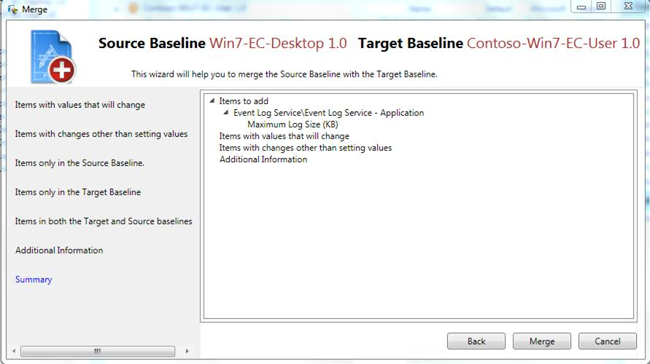

Figure 13. The Summary confirmation page of the Merge Wizard

# Deploy and Monitor

This section provides instructions on how to use the Security Compliance Manager to generate backup Group Policy objects (GPOs) to export or deploy a security baseline for Windows 7, and how you can use System Center Configuration Manager to monitor your security baselines with DCM packs.

## Preparing to Deploy Your Security Baseline

In preparation to deploy your security baseline, the Security Compliance Manager provides a feature to generate backup GPOs that you can then use to distribute your security baseline to the computers on your network.

**Note**   You can most efficiently deploy GPOs using Active Directory Directory® Services (AD DS). However, you can also use the Local Policy Tool (LPT) that accompanies the Security Compliance Manager to apply GPOs locally to individual computers in your organization.

For more information about the LPT, see the Help subtopic "Introducing the Local Policy Tool" under the main topic "Using the Microsoft Security Compliance Manager Tool."

Use the following procedure to create a backup GPO.

To create a backup GPO

1. In the **Baseline Library** pane, select the desired baseline, and then use one of the following ways to start this process:

* Right-click the baseline, select **Create**, and then click **GPO Backup**.

– Or –

* In the **Actions** pane, click **Create GPO Backup**.

1. In the **Browse For Folder** dialog box, either navigate to the folder in which you want to locate the backup GPO or create a new one for it, and then click **OK**.
2. On the confirmation prompt, consider the testing recommendations mentioned to ensure that the backup GPO works correctly in your environment, and then click **OK**.

**Important**   The backup GPOs that you can generate from Microsoft security baselines have been thoroughly tested. Remember to thoroughly test any backup GPOs that you create from customized baselines before deploying them in your environment.

## Preparing to Monitor Your Security Baseline

The Security Compliance Manager is designed to work with Microsoft System Center Configuration Manager 2007 to enable you to deploy backup GPOs, and then monitor the effectiveness of the security baselines based on those GPOs in your environment.

The desired configuration management (DCM) feature of System Center Configuration Manager 2007 monitors server or client computers against a single or multiple security baselines. To take advantage of this scanning feature, use the Security Compliance Manager to produce DCM configuration packs based on your security baselines.

DCM configuration packs provide the data format for the DCM feature to scan the computers you want to monitor.

To create a DCM configuration pack

1. In the **Baseline** **Library** pane, select the desired baseline, and then use one of the following ways to create a DCM pack:

* Right-click the baseline, select **Create**, and then click **DCM**.

– Or –

* In the **Actions** pane, click **Create** **DCM**.

1. In the **Save as** dialog box, navigate to the desired folder, specify a name for the file, and then click **Save**.
2. On the confirmation dialog box; click **OK**.

After creating the DCM packs you need, and importing them into Configuration Manager, you are ready to use Configuration Manager to monitor the computers in your environment based on the security baselines that you want to manage. The same process applies to customized security baselines that you want to use.

The Security Compliance Manager can also create baselines in SCAP format, a standard based on the Security Content Automation Protocol (SCAP) that is overseen by the National Institute of Standards and Technology (NIST).

SCAP consists of a handful of XML-based data formats that are used to describe software vulnerabilities and software configuration items. For more information about SCAP and the data formats it includes, see <http://scap.nist.gov/>.

For more information about using the Security Compliance Manager to create SCAP files, see the Help subtopic "Create SCAP Files" under the main topic "Using the Microsoft Security Compliance Manager Tool."

# More Information

Solution Accelerators are free, scenario-based guides and automations designed to help IT professionals who are proactively planning, deploying, and operating IT systems using Microsoft products and technologies. Solution Accelerator scenarios focus on security and compliance, management and infrastructure, and communication and collaboration.

For further information about the Security Compliance Manager, see the Help for this tool.

## Feedback

Please direct questions and comments about this guide to [satfdbk@microsoft.com](mailto:satfdbk@microsoft.com?subject=Security%20Compliance%20Manager:%20Getting%20Started%20Guide%20feedback).