

Microsoft Office Small Business Management Edition 2006
Product Guide
Table of Contents
Addressing the Challenges of a Small Business 3
What’s Included 3
Overview of Enhanced Features 3
Manage Your Business in One Place 3
Use Familiar Tools 3
Re-Use Information 3
Customer Scenario: Northwind Traders 3
Complete, Easy-to-Use Financial Software 3
Customer Scenario: Fabrikam, Inc. 3
Build Strong Customer Relationships 3
Consolidate Business Information in One View 3
Offer Informed Service and Sales Support 3
Create Professional, Accurate Customer Documents 3
Business Scenarios: Northwind Traders 3
Increase Employee Efficiency 3
A Clear View for Management 3
Scenario: Fabrikam, Inc. 3
Simplify Life by Simplifying Work 3
System Recommendations 3
Additional Items or Services 3
Product Highlights 3

The information contained in this document represents the current view of Microsoft Corporation on the issues discussed as of the date of publication. Because Microsoft must respond to changing market conditions, it should not be interpreted to be a commitment on the part of Microsoft, and Microsoft cannot guarantee the accuracy of any information presented after the date of publication.
This White Paper is for informational purposes only. MICROSOFT MAKES NO WARRANTIES, EXPRESS, IMPLIED OR STATUTORY, AS TO THE INFORMATION IN THIS DOCUMENT.
Complying with all applicable copyright laws is the responsibility of the user. Without limiting the rights under copyright, no part of this document may be reproduced, stored in or introduced into a retrieval system, or transmitted in any form or by any means (electronic, mechanical, photocopying, recording, or otherwise), or for any purpose, without the express written permission of Microsoft Corporation.
Microsoft may have patents, patent applications, trademarks, copyrights, or other intellectual property rights covering subject matter in this document. Except as expressly provided in any written license agreement from Microsoft, the furnishing of this document does not give you any license to these patents, trademarks, copyrights, or other intellectual property.
Unless otherwise noted, the example companies, organizations, products, domain names, e-mail addresses, logos, people, places, and events depicted herein are fictitious, and no association with any real company, organization, product, domain name, email address, logo, person, place, or event is intended or should be inferred.
© 2005 Microsoft Corporation. All rights reserved.
Microsoft, Excel, Outlook, PowerPoint, SharePoint, Windows, Windows Media and Windows Server are either registered trademarks or trademarks of Microsoft Corporation in the United States and/or other countries.
The names of actual companies and products mentioned herein may be the trademarks of their respective owners.

Addressing the Challenges of a Small Business
Just because a business is small doesn’t mean running it is easy. Like any business, small businesses face the daily challenges of managing sales, marketing, and finances while staying ahead of their competitors–some of whom could be much bigger companies. And they must do this with small-business resources–budgets, technology, administrative support, and so on–which oftentimes are limited. In short, small businesses must do more with less. And because of this, the owners and managers of a small business tend to lead a task-oriented life, running the business from top to bottom under the weight of ever-growing to-do lists.
Among these daily tasks is the selection and implementation of technology to help run the company and simplify its business processes. And because of their ongoing to-do lists, small business owners often don’t have the time to put aside customers and accounts in order to research the best software programs for their company. In addition, they rarely have the dedicated information technology (IT) staff to help set up new software and train employees to make the best use of it. As a result, many small businesses get by on an eclectic mix of computer- and paper-based solutions that, to the extent possible, help the small business owner stay on top of the company functions and processes.
The ideal small business technology would be a complete, integrated software package that helps small business owners manage customers, finances, and company processes. That package should be easy to use and help efficiently handle not only the core business focuses but also a myriad of day-to-day tasks. It should allow them to integrate all business processes and gain access to a rich body of company information, thereby increasing the efficiency of the company’s employees.
  - Manage your business in one place
- The solution would blend easily with software already in use, and adapt to the growing and changing needs of the business.
- Business information would be accessible in one complete financial and customer management solution.
- The company would reduce errors by sharing data across programs and across the company, rather than re-entering the data.
  - Access rich company information
- Owners could make more informed business decisions, with easy access to all needed information, including an up-to-the-minute picture of the company’s financial well-being.
- In-house staff could create dynamic and professional-quality sales and marketing materials, tailored to meet the specific needs of each client.
- The company could maintain and grow customer relationships by storing client information in a single location, so everyone in the company can view, edit, and track the latest business data and communications.
  - Increase employee efficiency
- Employees would be empowered with the information they need—anytime, anywhere.
- Business owners could create custom reports and multimedia presentations to strengthen customer bonds and expand the customer base.
Microsoft® Office Small Business Management Edition 2006, a comprehensive financial and customer management solution, was designed to address the unique needs of a small business. Office Small Business Management Edition 2006 combines familiar Microsoft Office 2003 programs with contact management and accounting programs to help business owners manage their customers, finances, and day-to-day tasks in one place. It puts powerful tools into the hands of the small business owner, smoothing out the day-to-day tasks to let them focus more on their “real job” of running the business.
What’s Included
Microsoft Office Small Business Management Edition 2006, available in Retail, Original Equipment Manufacturer (OEM), and Volume Licenses, includes the following Microsoft Office 2003 programs:
Program | Purpose
Microsoft Office Small Business Accounting 2006 | NEW: Comprehensive financial management program designed for companies with less than 25 employees.
Microsoft Office Outlook® 2003 with Business Contact Manager Update | NEW: Manage information, communicate with others, and organize work—all from one place.
Microsoft Office Publisher 2003 | Design, create, and publish professional marketing and communication materials, in-house.
Microsoft Office Word 2003 | Use innovative tools and features to more easily create, share, and read great-looking documents.
Microsoft Office Excel® 2003 | Turn data into information with powerful tools to analyze and communicate results.
Microsoft Office PowerPoint® 2003 | Use enhanced multimedia capabilities to create and deliver presentations with more impact.
Microsoft Office Access 2003 | Create and use powerful database solutions that enable organizing, accessing, and sharing information.
(See “System Recommendations” below for more details on all Microsoft Office Small Business Management Edition 2006 programs.)
Overview of Enhanced Features
Office Small Business Management Edition 2006 is different from other Office Editions–such as Office Small Business Edition 2003–because it includes Small Business Accounting 2006. These are specially designed to interoperate with each other and the rest of the programs in the Edition, together providing the tools small business owners and managers need to run their company:
- Small Business Accounting 2006 is a full-featured, easy-to-use financial management software solution, designed specifically to meet the needs of small businesses. It offers full-featured accounting functionality with the familiar ease of use of Microsoft Office programs, providing deep integration with Microsoft Office programs. It gives small business owners and managers the tools to effectively and easily manage company finances, share client information with employees, develop sales quotes, create invoices, stay on top of purchase orders and inventory, automate payroll, and more. And because it has the same familiar Microsoft Office interface and an easy start-up wizard, small business owners can get started quickly, giving them more time to spend on important business decisions.
- Outlook 2003 with Business Contact Manager Update gives business owners and managers more features to enhance their customer information sharing. New in the updated version are tools that enable synchronization with mobile devices, including Pocket PCs, permit multi-user access to customer accounts and information, and link customer financial history and communication records directly to the account, for easier tracking and better service. Companies can create quote sheets, orders, and invoices easily and get added insight into the entire sales pipeline.
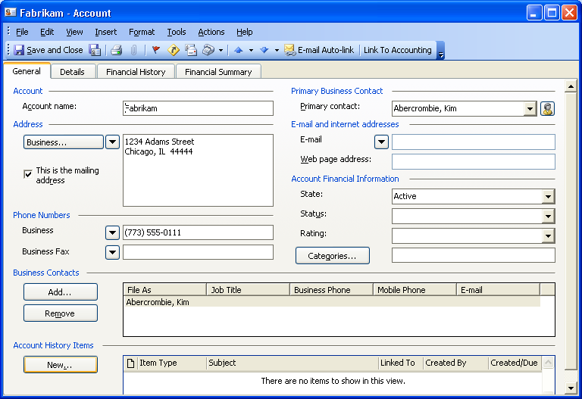

Manage Your Business in One Place
No matter how good a company’s record-keeping is, information doesn’t help the company if it’s not accessible. Many businesses use a number of different programs or systems in different parts of the company. Business functions such as quotes, statements, orders, or invoices, are often done on paper forms. Automating systems can be the answer, but it’s rarely done with a company-wide scope. Many small businesses have inventory management on one system, purchasing on another, sales orders on another, marketing on another, and so on. Even within a group, individuals often have their own ways of collecting and keeping information, from handwritten notes to individual favorite computer programs.
Office Small Business Management Edition 2006 gives small businesses a unified way to manage their most important business processes, in a single system. With Small Business Management Edition, small business owners and managers have the tools they need to get through their daily tasks quickly and efficiently, manage and grow customer relationships, and reduce the stress and busywork involved with managing the company finances. What’s more, these tools and functionalities integrate smoothly with the Microsoft Office programs used by the company’s employees.
Use Familiar Tools
Office Small Business Management Edition 2006 is built on the familiar Microsoft Office interface, so companies can capitalize on the Microsoft Office tools and features they already use to organize information. With Office Small Business Management Edition 2006, managers and employees can:
- Customize and automate key documents. Businesses can send out very professional-looking, personalized invoices and quotes to customers in only a few easy steps. For example, a manager can use the simple quote form in Small Business Accounting 2006 to create a quote, and easily view the lists of available inventory before sending the quote to the customer. For further customization, quotes can be converted to invoices without having to retype any information, and then exported to Word to add logos and personal messages to the invoice using familiar tools.
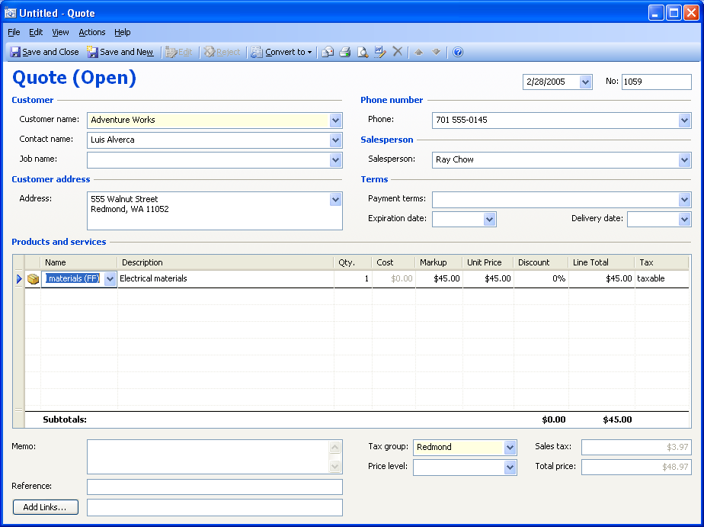
Easily create quotes using Small Business Accounting 2006.
- Utilize the latest customer data. It’s easy to create professional and accurate client-facing documents, from invoices to purchase orders, by combining the up-to-date data and information from the accounting software and the formatting features in familiar programs like Word. And with easy access to customer account information available in Small Business Accounting 2006, employees can more get help to accurately anticipate customer needs, making sure that they provide the right communications to the right accounts at the right time.

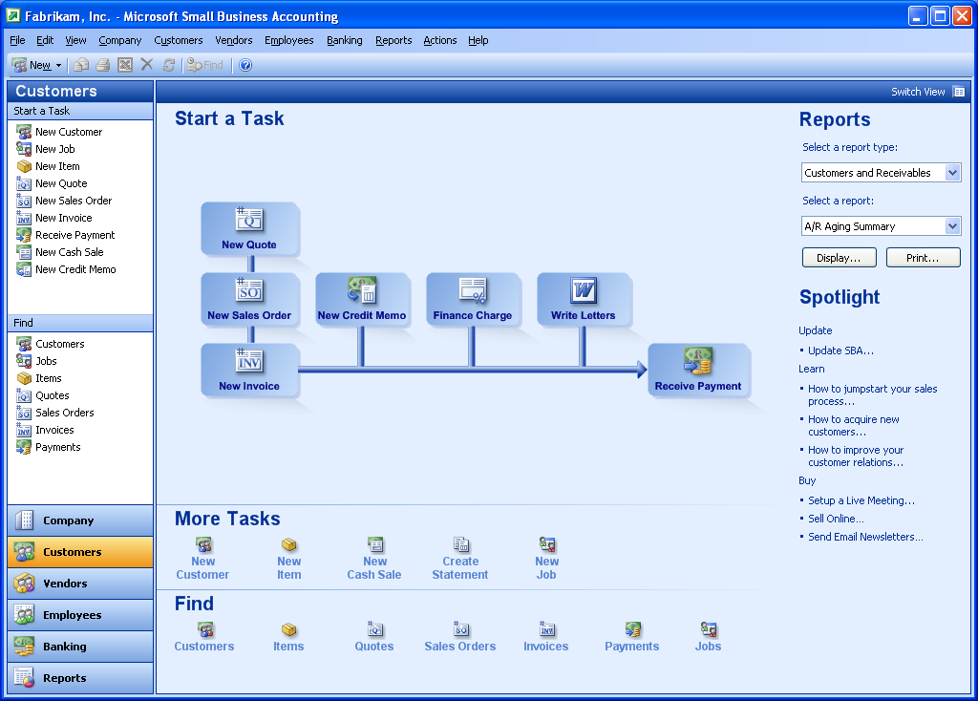
The Customer Home page walks business owners through their everyday tasks with an easy interface.
- Customize lists and reports. Small Business Accounting 2006 enables business owners and managers to develop financial reports and export them to Excel, along with their formatting; to view the information in a chart, table, or graph; or to perform more advanced calculations. Or Access databases can be linked to the accounting software to generate a variety of custom reports within Access.
- Manage e-mail more effectively. New desktop alerts in Outlook 2003 help a user see at a glance whether a new message is urgent. Improved Quick Flags help mark particular messages with specific follow-up instructions. And Search Folders help employees group related e-mails with specific search terms, so it’s possible to browse e-mail by name, task, or other criteria, without moving messages from one folder to another.
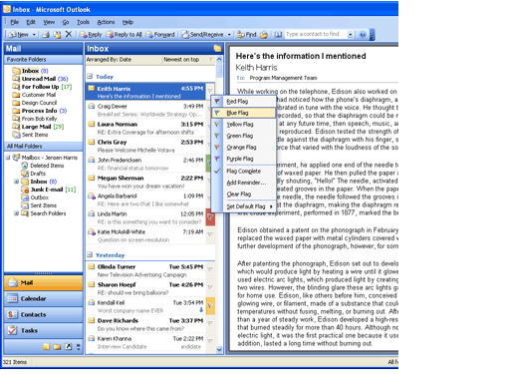
New Quick Flags help prioritize and organize e-mail messages.
Re-Use Information
The integration of Office Small Business Management Edition 2006 with Office 2003 Editions means that data can be exported from programs in the Microsoft Office System, saving time and eliminating errors introduced in data re-entry. This helps ensure that all documents with financial and customer data are current and consistent, and need to be entered only once. It also means information can be repurposed and more business intelligence gained from it. For example, data can be shared between programs to:
- Import data. Office Small Business Management Edition 2006 makes migration easy for users of existing accounting software, such as Intuit QuickBooks. Data such as contact information, master records, and beginning balances can be imported from QuickBooks to Small Business Accounting 2006 quickly and easily, to minimize any transition time. Data can be imported from Excel as well, using predefined templates. Either way, the switch to Small Business Accounting 2006 is almost effortless.
- Get full benefit from business information. Business managers can transfer the latest sales numbers directly from Small Business Accounting 2006 to a Word template where they can customize the information with company logos and a personalized message, and then send the information directly to the client. The numbers can also be exported to an Excel spreadsheet for further analysis, or to an Access database. The same numbers from Small Business Accounting 2006 can be reused in a variety of programs, allowing business owners and managers to see different views of business data, and then anticipate the company’s upcoming needs.
- Reduce data-entry error. Sharing data among programs not only uses information more efficiently and provides deeper insight into the business, but it also saves time and reduces error by eliminating the need to re-enter data in multiple programs.
Customer Scenario: Northwind Traders
PROBLEM: Jumbled islands of data
Northwind Traders is a six-employee company specializing in high-end sports equipment. When Brenda Diaz, the founder and owner, started Northwind Traders, she and just a few employees ran the operation. Just a few years later, her sales are growing rapidly and she now offers more than 50 different products, manages 25 different product vendors, and sells to a select group of sports stores outside her area. While Brenda is tempted to add more people, she must remain competitive with the larger chain sports stores in her area. Brenda realizes it would be risky to take that step. Ultimately, she knows it would be wiser to make her existing company more efficient and to cater to her specialized client base.
Brenda knows that one major area of inefficiency is in the way the company gathers, keeps, and uses business information. For years, Brenda ran the business off a single computer. As the business grew, it gradually acquired more computers so sales and inventory specialists could record prospects, order supplies, and bill customers. Brenda and her staff all used the Microsoft Office System, but as each person developed his or her own set of contacts and processes, they also developed their own way of recording information. Documents that one person created in Word were built by another in Excel. Sometimes documents were simply hand-written in a notebook on the sales manager’s desk. Customer and prospect lists could be in Excel or Access.
It takes painstaking data collection and entry by Brenda to keep track of the sales pipeline, or by the accountant to keep track of orders, vendors, and payments. As a result, numerous opportunities are missed for special promotions or reduced prices on supplies from vendors. Purchase orders often take too long to fill or even update, and the numbers just aren’t matching up, which means Brenda must devote part of her day to tracking down the error in the spreadsheet and fixing it. It often takes Brenda weeks to get a comprehensive picture of the state of the business for forecasting—typically, by the time she’s achieved it, the business has already changed.
SOLUTION: Seamless integration of software tools with Office Small Business Management Edition 2006
Brenda loaded Office Small Business Management Edition 2006 onto her computer and used the Startup Wizard in Small Business Accounting 2006 to move her financial data from existing Excel spreadsheets into the accounting software. Employees see nothing different about the tools or their jobs, apart from Brenda’s instructions to use specific programs for particular functions. The employees already like and regularly use Microsoft Office programs such as Word and Excel for such tasks as writing quotes, creating invoices, and even billing clients. But now, with Office Small Business Management Edition 2006, the data entered by Northwind Trader’s staff is integrated in a single location. For instance, Don Funk, Northwind Trader’s sales manager, now can create letters for prospective clients in Word that are linked to financial data from Small Business Accounting 2006. For frequent customers, he can send targeted marketing e-mail or other correspondence by using Word or Publisher along with Outlook 2003 with Business Contact Manager Update. If he wishes, those clients also can be linked with financial information in Small Business Accounting 2006 so he and Brenda can use the latest data to gain a better understanding of who their best customers are.
When it’s time to look at Northwind Trader’s books, all of the company’s financial data and lists can be exported from Small Business Accounting 2006 to Excel, with formatting and formulas intact, and then modified as needed. That saves time and reduces errors while letting Brenda use the power of Excel to create nearly any view of the data she wishes. She can create charts and tables to use for presentations, she can break down the numbers for forecasting purposes, she could test what-if scenarios on possible effects on the business if she extends certain discounts to customers.
Access also integrates with Small Business Accounting 2006. Sales data can be imported from Small Business Accounting 2006 to the existing Access database. There, the data can be analyzed and organized using the powerful features of Access 2003. Brenda can also make more thorough assessments of each sales team’s performance with a detailed look at the sales pipeline by exporting the same information to Excel to create a graphic image of her sales. This helps her be a better manager, addressing the needs of her employees and rewarding those who deserve it in a timely manner.

Complete, Easy-to-Use Financial Software
Microsoft Office Small Business Management Edition 2006 employs the familiar, easy-to-use Microsoft Office interface that most businesses already know and use every day. What makes it different and helpful for small business owners and managers are the tools that specifically address their needs, particularly the new Edition’s accounting and business-contact features. Each integrated program in Office Small Business Management Edition 2006 helps give small business owners and managers the comprehensive company information they need, information that helps them run the business effectively and make smart business decisions.
With the new Small Business Accounting 2006 program as a component of Office Small Business Management Edition 2006, business owners and managers have the tools necessary to handle company ledgers and monitor the pulse of the company’s financials, while still allowing enough time to spend on the business itself. Small Business Accounting 2006 is designed to perform for first-time business owners with no financial training or experience, but it has enough power to allow an accounting professional or experienced bookkeeper to look deeply into a company’s financial data and track changes made to that data.
Microsoft has built a range of tools into Small Business Accounting 2006 that make it easy to use, yet extremely helpful. These tools enable functions including:
  - Easy, quick start-up. A small company doesn’t need technology or accounting consultants to get going with Small Business Accounting 2006. Small business owners and office managers can get started right away, installing the program themselves and using the Startup Wizard to customize the accounting software to fit their company’s needs. The Startup Wizard helps users get started working in less than 45 minutes, walking them through simple screens to choose the areas in which they want to start working.
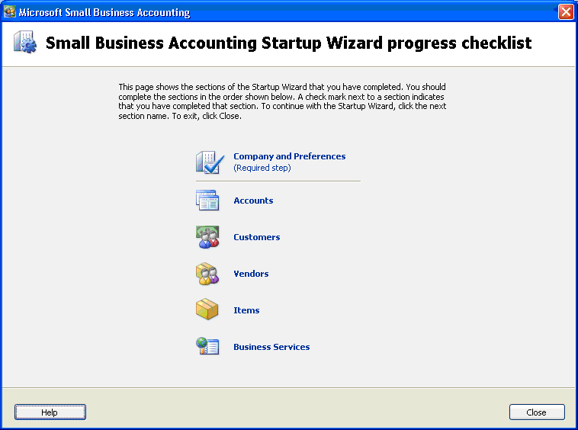
The Startup Wizard covers many important business functions automatically.
  - Easy migration from QuickBooks. The Startup Wizard makes it easy to import master records, such as chart of accounts, customers, vendors, items, employees, and supporting tables as well as beginning balances, from QuickBooks. Following the simple instructions in the Startup Wizard, small businesses can drastically reduce ramp-up time and start using more robust accounting software on their existing accounts and financial data. In addition, companies can import master records and beginning balances from any application using Microsoft Excel. Businesses don’t have to juggle data between two different programs, but can export everything from their existing QuickBooks, Excel, and Access databases into Small Business Accounting 2006 in a few easy steps.
  - Clean, streamlined business and financial processes. The clean, uncluttered interface of Small Business Accounting 2006 was designed with the unique needs of the small business owner in mind. Because of this, tasks can be accomplished in many different ways, and the various flowcharts, menus, and keyboard shortcuts allow users to work the way that makes sense for their business. Users can customize the way Small Business Accounting 2006 works for them during the set-up process, but can easily access the Startup Wizard to change these settings as their needs change.
  - Comprehensive, real-time view of the business. Small Business Accounting 2006 provides a Company Home page—a customizable, up-to-date view of business information that helps managers make more informed business decisions. The Company Home page gives business owners and managers a single, dynamic, real-time view of their company’s most critical information and is always just one click away from any screen in Small Business Accounting 2006. The Company Home page can be customized to feature information such as cash flow, reminders, bank balances, payments due, and more.
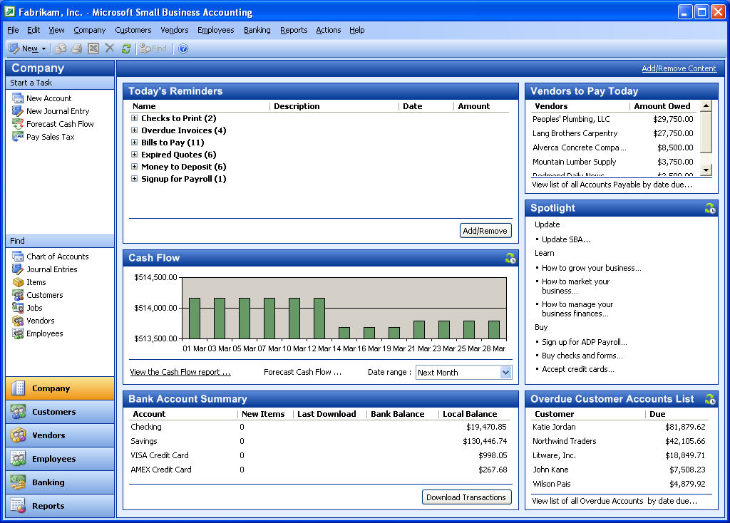
The Company Home page provides a centralized, customizable view of critical business information.
  - Tracking by job. Small Business Accounting 2006 is useful for companies that focus on specific customer jobs, such as a building contractor or public relations consultant. Owners and managers can record and track revenue and expenses for a single job, making it easier to monitor profitability and compare different jobs in terms of their costs and profits. Small Business Accounting 2006 also helps a business owner compare and track estimated job costs against actual costs, contributing to sharper accuracy of job quotes.
  - Real-time inventory management. Small Business Accounting 2006 uses FIFO (first-in, first-out) valuation to help companies manage and track inventory. Managers can write purchase orders for ordering new inventory, and the program records the arrival of those items. Small Business Accounting 2006 also automatically lowers inventory levels as invoices are created, which helps maintain a clear record of merchandise on hand. A manager also can track overall inventory in real time, and print out an inventory work sheet for a physical account.
  - Stay on top of vendor relationships. From the Vendor Home page in Small Business Accounting 2006, small business owners and managers can easily track purchase orders and inventory, enter bills, and create credit memos. The Vendor list helps companies stay on top of their outstanding balances and then view each vendor’s financial history, status, and any custom information, such as shipping preferences.
  - Automated payroll, checks, and forms. Small Business Accounting 2006 supports small business payroll capability from Automatic Data Processing, Inc. (ADP), a payroll-industry leader. ADP has several service options, available for an extra fee, that allow business owners to choose the service level that best fits company needs. ADP supports federal, state, and local taxes and calculates payroll in four easy steps, eliminating the need for paper-based timesheets. When managers click Run Payroll, ADP automatically uploads employees’ pay rates and hours, calculates the necessary taxes and deductions, and then allows checks to be printed. Other services offered include online banking, credit card processing, and the ability to order customized checks and forms from within Small Business Accounting 2006.
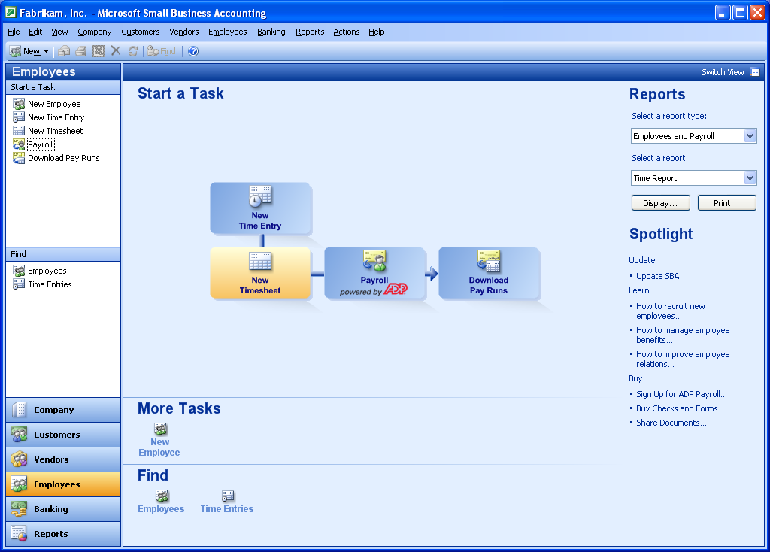
From the Employee home page, business owners can manage employee time sheets, run payroll, and download billable time easily and quickly.
  - Useful cash-flow information. Small Business Accounting 2006 tracks invoices, bills, and payments to help businesses handle and predict cash flow. Its cash-flow tool offers several views of company finances, from a high-level summary to a detailed look. And a business owner can develop “what-if” scenarios that examine the impact of different cash management strategies, helping make it possible to forecast future cash flow and make intelligent business decisions.

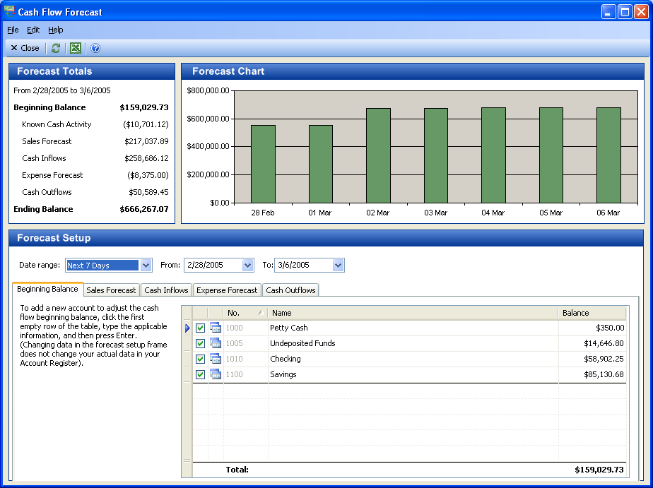
The Cash Flow Forecasting Tool helps small business owners manage and plan their business transactions, banking transactions, and cash flow.

  - Transaction tracking. While Small Business Accounting 2006 lets even accounting novices get right to work with the simple, easy-to-use interface, there is also advanced functionality to satisfy accounting professionals and bookkeepers. Advanced users can look at the underlying postings to accounts (debits and credits) resulting from transactions, track these activities using the Transaction Journal feature in Small Business Accounting 2006, and also turn on the Audit Trail feature to track who made each change and when.

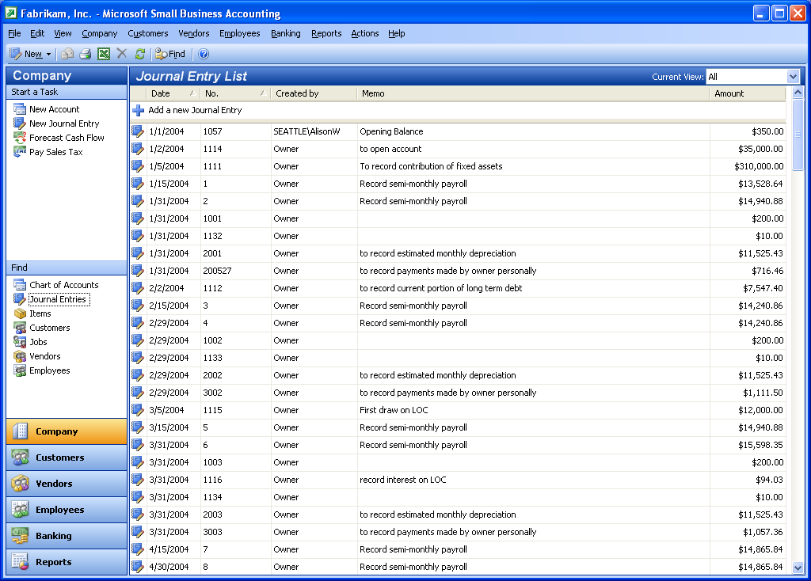
The Journal Entry list provides another view of business activity, along with insight into the details of each transaction.
  - Scalability to meet your companies’ needs. Small Business Accounting 2006 is designed to change or grow with a company, so a small business doesn’t leave its accounting software behind. The accounting back-end features of Small Business Accounting 2006 aren’t visible in the day-to-day tasks, so beginning users aren’t confused by complex accounting details. The program is scalable, so it can easily meet the more sophisticated needs of accountants as well. In addition, its Microsoft SQL Server™ Desktop Edition database system permits more storage as data volumes grow.
  - A solution that grows with your company. As the needs of the business grow more sophisticated, a company can transition smoothly over to enhancements offered to growing businesses through Microsoft Business Solutions.
Customer Scenario: Fabrikam, Inc.
PROBLEM: Growing pains
Fabrikam is a construction company that provides plumbing, roofing, and other construction services to a variety of small businesses in the area. When the company first started, owner Joe Fabrikam and sales manager Karen Archer handled company accounting on Excel in their home office. They then opted for QuickBooks when they began hiring and occupying commercial offices. Fabrikam’s performance in a recent high-profile renovation of a mixed commercial-residential neighborhood has started to earn the company new offers to bid on bigger projects, including a retail complex. Joe and Karen believe they will need to hire more construction specialists to handle the new business.
But they also worry that in doing so, that—along with the acceleration of the business itself—will mean they also need to hire more full-time sales managers to track and record bids, quotes, and invoices, and a full-time accountant to keep the books up-to-date. Already, it’s a challenge for Karen to monitor and gather all of the financial information required for government contracts–though QuickBooks does well with ordinary bookkeeping, almost all of the company’s communication with clients and contractors, including purchase orders and invoices, are written in Microsoft Office programs. Invoices are created in Word and then sent to clients, without an accurate record kept on the financial side of things. Checks sent to vendors, meanwhile, are tracked in a standalone personal-finance program that lacks a general ledger and doesn’t integrate with Microsoft Office applications. She must input all of this information manually and check for errors among all the information sources.
Joe and Karen have a part-time accountant who creates quarterly reports, and it takes her two or three days to properly balance the books. The accountant also manages the company’s payroll, using yet another program for tracking that. She works more hours during tax time, struggling with the stacks of data from the year and taking a few hours to track down the proper forms and tax information for all of the company’s employees. All of this makes it difficult to get a current view of the business financial status with which Karen and Joe can make strategic decisions about how the business should proceed.
SOLUTION: An accounting program integrated with Microsoft Office
Joe and Karen upgraded their own work computers, plus those of the office manager, business manager, and accountant, to Office Small Business Management Edition 2006. This brings Small Business Accounting 2006 to each, giving them a central, unified source of financial information about the company, plus accounting tools and powerful features specifically designed to help businesses with less then 25 employees.
Fast Start-up
Joe and Karen got Small Business Accounting 2006 loaded quickly into their machines, and with the Startup Wizard, had them fully operational in the company network and got all of their QuickBooks records and information imported by the end of the morning. With the Startup Wizard they promptly set up the program to suit the company’s needs, such as scheduling contractor payments, projecting cash flow against project schedules, and more. There was no learning curve for the Fabrikam team, since Small Business Accounting 2006, like all of the Office Small Business Management Edition 2006, uses the familiar Microsoft Office interface.
Integrated Information and Processes
Now that Fabrikam’s financial records have been moved into Small Business Accounting 2006, Joe and Karen, and their sales team have a central financial resource. They can track transactions with vendors and customers, record banking activity, and create and track quotes, purchase orders, statements, and other key financial documents. What’s more, it is integrated with Office Small Business Edition 2003, which is used by Fabrikam employees, so data from programs they use, such as Excel, Word, and Outlook, can be connected with Small Business Accounting 2006 to enable real-time recording of invoices, payments, billable time from meetings, bids, and more. Not only are financial details updated as changes occur, but authorized employees also can access critical information about each job so that they can respond more effectively when client calls come in.
Automated Payroll Support
Small Business Accounting 2006 integrates with a full-service, small-business payroll solution from payroll industry leader ADP for an additional fee. Small Business Accounting 2006 integrates with the ADP service that Joe and Karen have chosen to use, and transfers payroll and tax information to Fabrikam’s general ledger. The full-service ADP payroll option calculates employee withholdings, files direct deposit balances, and transfers funds to pay government employment taxes. This allows Joe and Karen to take payroll off their plate, and because they can have the sales associate easily oversee the process with little additional time demand, they don’t need to hire for this task. ADP Payroll for Small Business Accounting helps their accountant, by providing tax services to calculate local, state, and government taxes and pinpointing the necessary forms the company needs during tax time. This frees up their accountant to delve more deeply into any trouble spots, rather then spending her time tracking down paperwork.
Managing a Business More Intelligently
Joe and Karen now have comprehensive information about their business and its financial status, which they can use to make critical business decisions. They now have access to 60 customizable reports that provide detailed insight into the company finances. Every day, they also take advantage of the Company Home page feature in Small Business Accounting 2006, which provides at-a-glance views of cash flow, bank balances, critical customer tasks, and more. The Company Home page, which is one click away from any screen in Small Business Accounting 2006, can itself be customized to show the critical information needed for bids and other major decisions. Joe and Karen can also use a cash-flow tool to manage upcoming revenue and expenses, by running different scenarios to pick the best path for the business. This tool helps the Fabrikam team forecast when the cash flow would allow hiring more construction and sales associates, and exactly how many.
Room to Grow and Adapt
Fabrikam’s accountant can take advantage of the more sophisticated features in Small Business Accounting 2006 to monitor different company transactions, and to create an audit trail to track who made what edits to which transaction and when. As the company grows, the MSDE database on which Small Business Accounting 2006 is based is capable of greater storage. And as Fabrikam’s needs become more sophisticated, the company can migrate seamlessly to Microsoft Business Solutions.

Build Strong Customer Relationships
A company’s customers are its lifeblood. But for a small business, staying on top of customer commitments and making the most of new customer opportunities can be a struggle. That’s because customer information may be scattered throughout a company–in someone’s personal computer at the office, in another’s laptop, even jotted on pieces of paper. Some might make Excel spreadsheets from the data, others make tables in Word. But without a single clear view of a company’s customer base and customer history, following up on sales leads and business opportunities can swamp sales representatives and other customer-contact employees. It’s equally difficult to gain a clear view of what’s in the sales pipeline and how that will influence cash flow.
In addition, employees often spend valuable time tracking down the information or person who can fill them in on the latest customer transactions or sales-related data. Customers can get frustrated if an employee is not adequately informed, or provides information that conflicts with what they were told by another employee. This can result in missed opportunities, ill-informed business decisions, and ultimately, lost revenues.
Office Small Business Management Edition 2006 provides the small business the tools it requires to effectively manage customer relations. It helps put customer information into one view, so it is easily located when needed. Authorized employees can access this single view, which enables better and more informed service to customers. It also enables easier sales and status reporting, which helps the owner or manager spot and resolve any customer issues.
Consolidate Business Information in One View
Office Small Business Management Edition 2006 includes an updated version of Outlook 2003 with Business Contact Manager, which adds new features designed to make customer management easier and more efficient for small businesses. These include ability for multiple simultaneous users, easier aggregation of and access to communications history with a customer, and Pocket PC synchronization.
By combining Outlook 2003 with Business Contact Manager Update together with Small Business Accounting 2006, Office Small Business Management Edition 2006 helps companies unify customer profiles, account information, communication and financial history, contacts and more into one view. And it’s easy to use—employees don’t have to leave Outlook to incorporate customer financial data, instantly, into Small Business Accounting 2006. The integration offered by Office Small Business Management Edition 2006 provides business owners and managers with customer management capabilities and functions including:
- Unified customer data. With the combination of Outlook 2003 with Business Contact Manager Update and Small Business Accounting 2006, a small business owner or manager can see more of the important customer data in one place. Business managers and owners can quickly get a handle on customer contacts and activities, allowing them to track sales opportunities, develop reports of sales, and create targeted e-mail marketing messages without leaving the familiar Outlook interface. Employees can access customer profiles and account information easily, giving authorized employees a complete view of critical customer data.
- Customer contacts linked with financial data. One of the challenges when working with customers is keeping a clear view of who should be contacted for particular tasks, such as orders or accounts payable. Outlook 2003 with Business Contact Manager Update has an easy-to-use Accounts and Business Contacts tool that helps establish associations with customer companies and individual contacts who work there. That helps eliminate confusion when working with companies that have multiple contact points.
- Customer data updated in real time. Because customer information is centralized into one location and simply shared with other programs, any edits made in one program are immediately updated when viewed with any other program or any other user. For example, employees can create quotes, orders, or invoices in Outlook and link them directly to the accounting program. That automatically updates the customer account data available to all authorized users. Business owners get real-time customer account information that is always up-to-date.
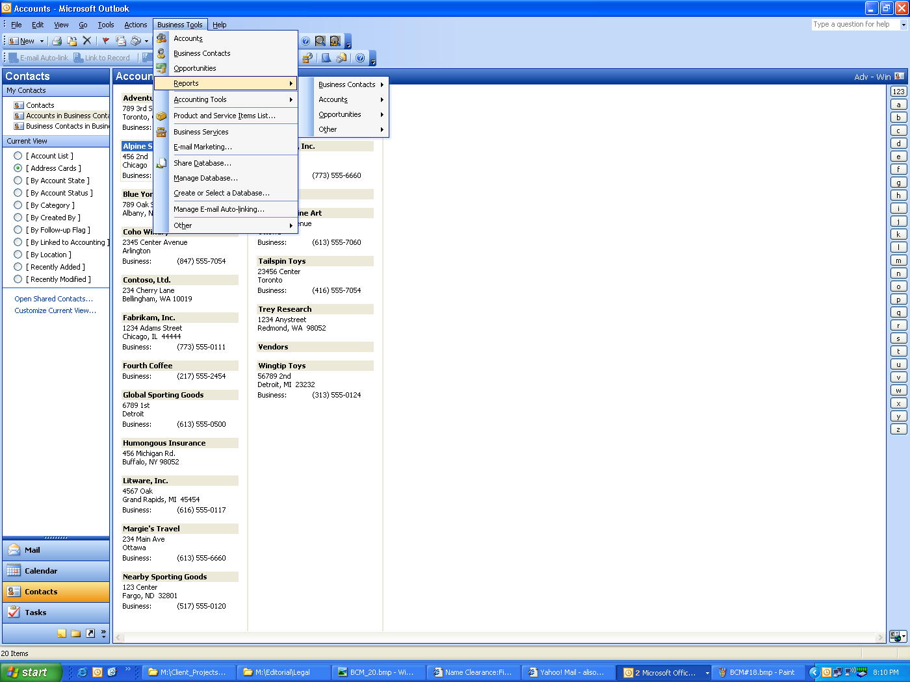
Business Contact Manager Update allows companies to create and manage accounts, business contacts, and sales opportunities, and establish associations between companies and individual contacts— all within Outlook.
Offer Informed Service and Sales Support
Outlook 2003 with Business Contact Manager Update also helps businesses maintain and grow customer relationships by ensuring that employees have the answers to customer questions at their fingertips. Business owners can provide authorized employees with access to complete records of sales, invoices, even notes from conversations with other employees, attached to the customer contact information.
Access to comprehensive account information means better service to customers, by enabling businesses to coordinate action on many work scenarios simultaneously:
- Get fast answers for customers. Outlook 2003 with Business Contact Manager Update has an Activity History tool that consolidates complete customer records. Now, when a customer calls with a question, authorized employees can quickly access needed information, including e-mail messages, calendar items, notes, and even faxed or scanned items. Employees can answer customer questions and make well-informed decisions and recommendations based on customer history and past interactions.

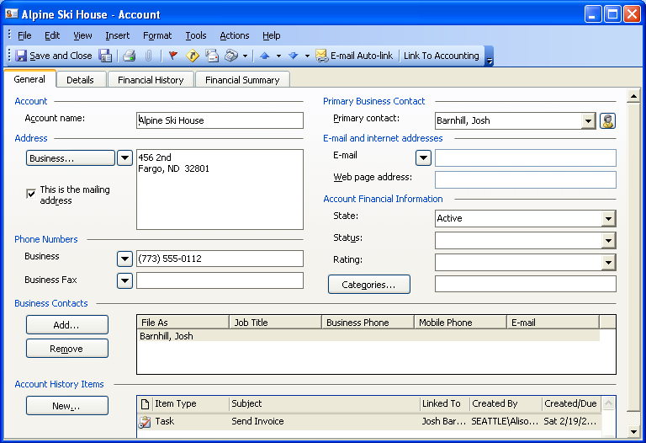

Sales staff can get a clear, detailed view into each customer’s sales cycles, including contacts, reminders, follow-up dates and more, helping to maximize the company’s ability to respond to each opportunity.
- Track financial history (NEW). Outlook 2003 with Business Contact Manager Update works with Small Business Accounting 2006 to give businesses a complete view of every customer’s financial history. Small business owners and managers now can easily access all important customer financial information—quotes, orders, invoices, credit history, and outstanding balances—directly from the account itself. This also helps the business owner track and forecast trends, enabling intelligent strategic decisions.

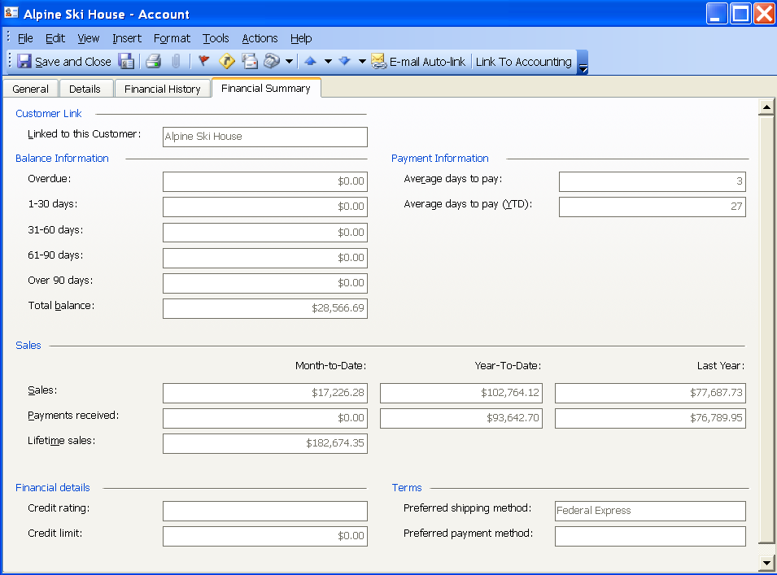

Business Contact Manager Update when integrated with Small Business Accounting 2006 provides a complete view of each customer’s financial history.
- Share sales information. Each time a salesperson develops a lead, he or she can create an opportunity item. Then, by just clicking on the form, the office manager can see details about the product or service being sold as well as information about the sales stage and the probability of closing the deal. Product pricing and other relevant information can be imported to the opportunity form, and each form is linked to an account or business contact. This helps build fast, accurate quotes and answer customer questions quickly.
- Share customer information with employees. Authorized employees can share customer information through Outlook 2003 with Business Contact Manager Update, such as who is working on which customer needs, what sales might be developing, and the contacts the customer has already had with company salespeople. All of a customer’s information is just a click away, whether it’s previous communications, recent orders, or financial information. Now there’s no wasted time or putting a customer on hold while a salesperson or other employee tries to find answers to a question. With advanced security features, Outlook 2003 with Business Contact Manager Update can be configured so that employees are granted access only to the sensitive company data that the business owner permits.

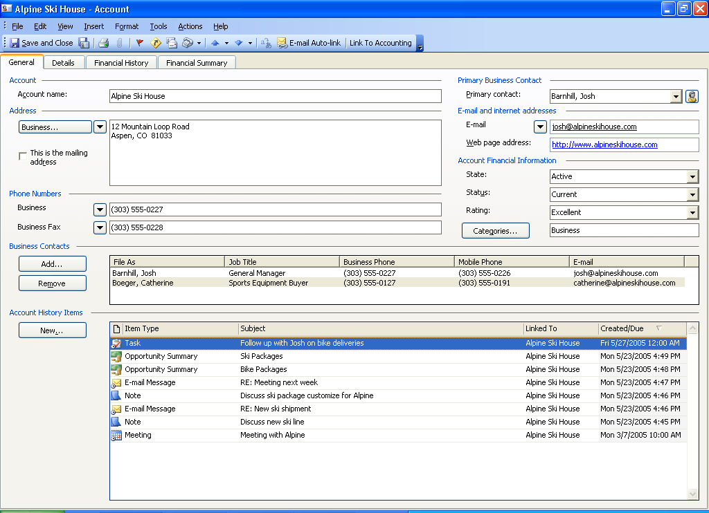

A centralized Activity History tool provides comprehensive information so every employee can effectively respond to customer inquiries.
- Track employee activity on customer accounts. Small business owners and managers can use Outlook 2003 with Business Contact Manager Update to keep track of which employees are talking to which customers. When quotes, invoices, and purchase orders are created in Outlook 2003 with Business Contact Manager Update, they instantly appear in Small Business Accounting 2006. Inventory and sales information is also shared by both programs, giving management a real-time view of customer account changes as they occur, and enabling strategic assessment of customer relations performance.
- Synchronize with Pocket PC synchronization (NEW). Employees on the move can more easily stay current with company information, because Outlook 2003 with Business Contact Manager Update can integrate with Pocket PC and other mobile devices. Even when on the road, business managers and employees can access customer and business information such as pending orders, customer contacts, and new product pricing that they’ve downloaded from their office computer. Plus, when the Pocket PC is returned to its cradle, all changes made to business contact data in the field automatically transfer to the office computer and thereby automatically update the account information for everyone sharing their business contact information.
Create Professional, Accurate Customer Documents
Because Outlook 2003 with Business Contact Manager Update integrates with Publisher 2003 and Word, it’s easy to create professional looking documents. It also allows businesses to create reports, presentations, and marketing materials in-house, but with a look that makes them seem as if a professional marketing agency had done the work. Publisher 2003 also includes new or enhanced tools for projects such as Web development and publishing, custom-design e-mail, developing publications for commercial printing, and more. There are even more enhancements to the familiar Microsoft Office interface, making it easier than ever to create professional, high-quality publications. This helps a small business compete with much larger companies, while staying within a small-business budget.
The powerful Office programs included in Office Small Business Management Edition 2006 enable small business owners and managers to take on a variety of projects:
- Build documents and reports. Employees can build customized quote sheets, orders, invoices, and more in Small Business Accounting 2006. These can be further given a professional feel in Word or Publisher, by adding corporate logos, graphic elements, and more. Employees can also access 20 preformatted reports in Outlook 2003 that can be customized to track sales, follow account history, highlight neglected accounts, and more. These all use the most updated information from customer accounts. Salespeople can set filters that show them information about specific accounts on which they’re working, or highlight customers that need to be contacted.
- Give customers the materials they need, when they need them. Small businesses can use the advanced features of Publisher 2003 to produce quality marketing materials such as brochures, product catalogs, and newsletters, all in-house. Using pre-formatted templates, companies can fill in the necessary information and customize the documents. The ability to provide a high-quality, personalized marketing piece may help retain and attract new and existing customers. Employees can then make a note of the sent information in Outlook 2003 with Business Contact Manager Update, so they never duplicate materials and always know when the last customer communication was sent.
- Create memorable presentations. Critical business presentations such as reports or proposals can be made memorable and impressive by exporting key data from Excel or other Microsoft Office programs into PowerPoint 2003. With enhanced support for custom graphics and full-screen video, presentations for the company or for the customer can have more and longer-lasting impact. The Package For CD function in PowerPoint provides everything needed to burn presentations onto CDs for distribution. There is no need to worry whether the recipient might not have the right version of PowerPoint—CDs created can include PowerPoint Viewer, which lets anyone see the presentation as it was created.
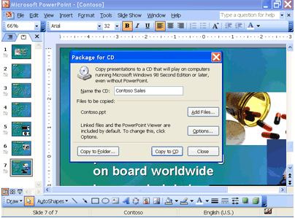
The Package For CD function in PowerPoint gives companies all the software they need to burn presentations directly onto CDs for customer distribution.
Business Scenarios: Northwind Traders
PROBLEM: Ineffective customer service and sales
Northwind Traders has always managed its customer and sales information the same way it handles financial data–primarily manually. It hasn’t automated the way it contacts potential customers or stays in touch with current ones. The company’s sales team members and managers all have different ways of taking notes and recording activities, some jotting down notes on slips of paper. Employees often respond to customer e-mail queries without keeping adequate records of what has been sent.
Brenda Diaz, the owner, is frustrated that the company has missed sales and provided less effective customer service than it must offer to stay competitive in the industry. Meanwhile, the growth of the business has resulted in more and more phone calls and e-mail inquiries about new products and overdue orders. And because Northwind Traders now is dealing with larger vendors and large orders from other specialized sports stores, Brenda has found that some vendors now have three our four contacts depending on the product model–for instance, with bikes, there are separate contacts for child models, adult models, and racing bikes. As the product line expands and orders grow larger, it’s more difficult for Brenda to accurately write quotes that reflect extra costs. So revenue is suffering, and she worries that she’s over-billing some vendors and under-billing others.
SOLUTION: Information yields stronger customer relationships
Northwind Traders employees have used Outlook for years to handle customer inquiries and to manage contacts. Now, they can use Outlook 2003 with Business Contact Manager Update and Small Business Accounting 2006 to track sales opportunities and client accounts, as well as contacts. Employees now find comprehensive and fully updated information about client accounts, from communication history to financial status, all in the familiar Outlook interface. This helps employees keep track of new clients and any changes to existing customer accounts. And with all client information right at hand, all employees can provide prompt and complete service to the client, a sure way to build stronger relationships.
Access Customer Financial Data Easily
The integration of account management functionality in Office Small Business Management Edition 2006 minimizes the possibility of any aspect of a customer account falling through or getting missed. For instance, Brenda or the sales manager can review accounts to resolve communication issues, look for unfulfilled orders or late payments, investigate discrepancies in an account, and more.
Employees now can use the Accounts and Business Contacts tool in Outlook 2003 with Business Contact Manager Update to link contacts at a particular company with that company’s account. Employees also can attach notes, e-mail messages, and Microsoft Office documents to business contacts and accounts in Outlook. Even faxed and scanned documents can be attached to those accounts. So it’s never hard to find information that relates to a particular customer.
This means that even if a sales assistant receives a call from a client who is not on her own “hot” list, she can quickly access account and contact history along with other relevant information—even notes from previous telephone calls the client has had with her colleagues. She can see the customer’s financial information, easily tracking previous quotes, invoices, and other material in one place. That helps her give fast, accurate answers to provide service that ultimately satisfies the customer.
Track Leads and Opportunities More Easily
Northwind Traders employees also can use the Business Opportunity tool in Outlook 2003 with Business Contact Manager Update to track leads and sales prospects through the sales cycle. Brenda and the sales manager, along with other authorized employees, can click the opportunity form to call up a complete history of that customer and the type of product being sold, including the progress of the sale and how close the client is to closing. Even pricing and other information is easily imported to the form. That helps determine potential revenue from the client, allowing Brenda to keep an eye on potential revenue opportunities, and assisting employees who need to write accurate quotes and quickly answer customer questions.
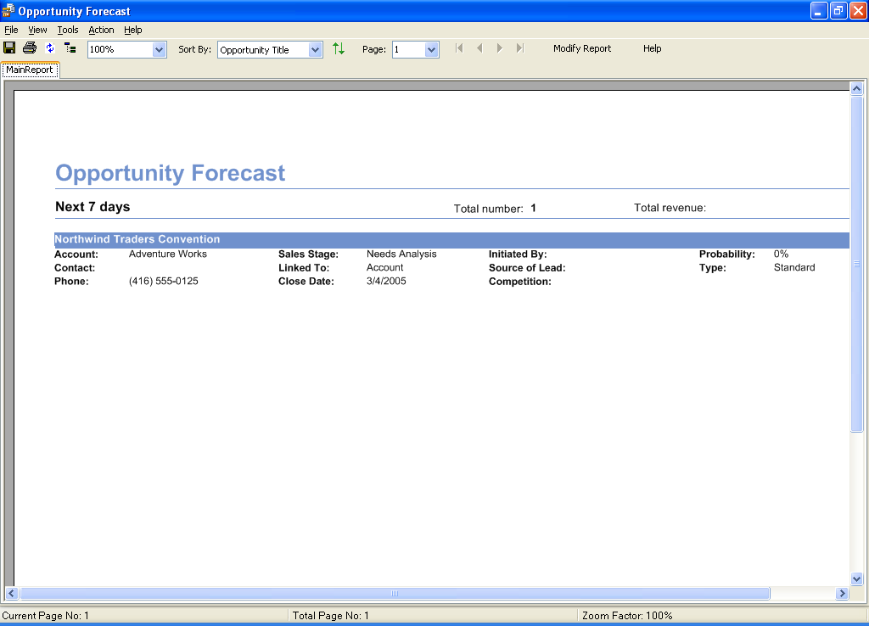
With 20 customizable, preformatted business reports available in Outlook 2003 with Business Contact Manager Update, small businesses can keep track of the sales pipeline, account history, neglected accounts, and more.
Gain Insight into Sales
The unification of comprehensive account information into a single view lets Brenda get a better handle on sales opportunities and potential customers, helping her make better business decisions based on the sales pipeline. She can create customizable reports that show sales status, previous quotes, and the probability of a client closing a deal, for all opportunities and accounts or for particular groups of them. She also can more effectively follow up with particular clients by using the reporting capabilities of Outlook 2003 with Business Contact Manager Update. She and her team of managers can choose from 20 customizable reports, filtering that data to see account status or to get updates on customers that need to be contacted. Now they can set better priorities for sales contacts, organize their days, and ensure that customer requests and sales opportunities aren’t ignored.

Increase Employee Efficiency
Business owners are typically dedicated to providing employees with what they need to be successful. Even in a small business, however, that can be a challenge. Many start off with the resources and technology they already have or can easily afford; building on those ad hoc resources is not always systematic and done with long-range plans in mind. Often this results in a patchwork of systems, programs, and databases, some with different access rights. Such an arrangement can make information hard to track down, and sometimes the format in which that information appears—paper, a computer program, word of mouth, or any number of possibilities—cannot be predicted. This kind of work environment makes it a challenge for employees to reach their potential efficiency.
The stated function of Office Small Business Management Edition 2006 is to help small business owners and managers work more efficiently. But its integration with Office Professional Edition 2003 and Office Small Business Edition 2003 —the Microsoft Office 2003 Editions designed for employees of small companies—enables a number of functions that boost work efficiency of other company employees as well. Management-level employees from different parts of the business can have password-protected access to view, edit, and update relevant financial and customer information. Having the information they need, along with the complete interoperability of Office Small Business Management Edition 2006 with Office Small Business Edition 2003, allows them to share data and tools with other employees and streamline their day-to-day customer and business tasks.
Office Small Business Management Edition 2006 helps raise efficiency of employees across the company by providing functions and tools including:
  - Integrated customer information. The interoperability of the programs within Office Small Business Management Edition, as well as their interoperability with those of other Office Editions, means employees can access critical customer and business information that helps them do their job well, such as financial status and communication history. Access to sensitive data can be restricted, but employees get information that provides greater insight into finances or customers to help them do their job more effectively.
  - Track and submit billable time. Service business owners know that the way to capture more billable time more accurately is to make it easy to track that time. Employees using Outlook 2003 with Business Contact Manager Update can easily mark appointments in their Outlook calendar, and then transfer that information to Small Business Accounting 2006 with the click of a button. A user can even create a time slip in Small Business Accounting 2006 from an appointment in Outlook. This eliminates the clutter of paper-based timesheets and gives managers an accurate snapshot of employee time.

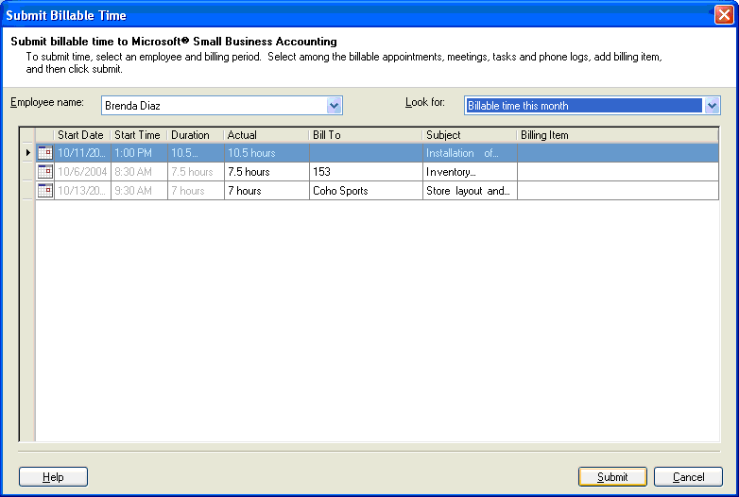
Employees can easily mark time as billable in their Outlook calendar and submit their billable time directly from Outlook to Small Business Accounting 2006.
  - Increased e-mail security. Unwanted e-mail is not just a nuisance; it can also cut into employee productivity and technology efficiency. Outlook 2003 has tools to manage e-mail, improve privacy and security, and reduce unwanted e-mail. It uses state-of-the-art technology to analyze incoming e-mail for factors such as the time it was sent and the content of the e-mail, examining the structure of the e-mail to determine the likelihood that it is junk. The sensitivity level of the junk-mail filter can be adjusted by the user, and specific e-mail senders can be added or removed from a junk mailer’s list.
A Clear View for Management
Not only are employees able to improve their productivity and flexibility with the tools of Office Small Business Management Edition, but their managers also have new ways to help ensure that their areas of responsibility are under control and thriving. As employees update and edit business data during the course of the day, managers see the results in real time and use new and enhanced tools to analyze that information. Consequently, they know how their direct reports are performing, where more attention should be focused, and where praise is due. They can make decisions based on the best and most current information available.
Office Small Business Management Edition 2006 gives managers new tools and abilities including:
- Multi-user access with Small Business Accounting 2006. Managers using Small Business Accounting 2006 can determine which employees have access to what data. Owners and managers decide who gets access to what programs, and employees get the information they need to work efficiently and grow their relationships with the customer.
- A complete view of account information. A manager working on a customer account can write a quote or invoice in Outlook 2003 with Business Contact Manager Update and link that information to Small Business Accounting 2006. That reduces errors caused when data is entered more than once, and makes real-time updates to critical data such as customer account information, inventory, commissions, and more.
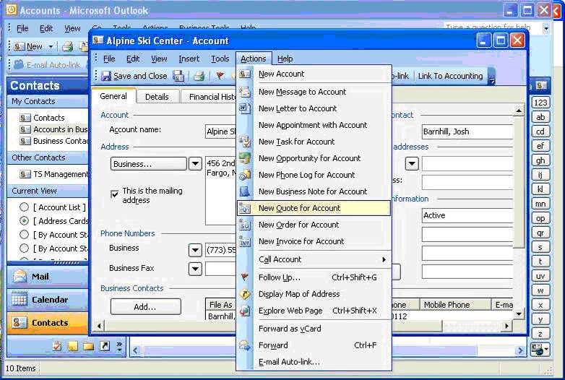
Employees can easily create quotes and invoices, which are automatically transferred to the accounting program.
- Sharing Outlook with Business Contact Manager Update (NEW). With new multi-user access for Outlook 2003 with Business Contact Manager Update, managers can see directly into the sales pipeline. Salespeople can track employee activity, conversations, and account activity, helping them to better forecast revenues and allocate resources. Managers can also ensure that employees have the information they need to respond immediately to customer queries, armed with comprehensive customer data.
Scenario: Fabrikam, Inc.
PROBLEM: Lack of information
While Fabrikam has always made sure it had the newest and best engineering software and computer hardware, it originally relied on a mélange of programs of various ages for its business processes. As a result, it was hard for owner Joe Fabrikam and sales manager Karen Archer to get a grasp on how the company was doing, and what exactly was being done for each client. Even team leaders sometimes struggled to bring together all the moving parts within their teams, from bids to client or contractor contacts to scheduling to billable time. Different employees had different ways of collecting and keeping information, though almost everyone used paper when in the field. This made it difficult not just to make sure everyone had the information they needed, but also to know what the most current and accurate information was.
SOLUTION: Connect employees with information
Office Small Business Management Edition 2006 provides full interoperability with the Microsoft Office programs used by every employee at Fabrikam. Business information can be shared in a controlled fashion: employees throughout the company have limited, password-protected access to different pools of information, depending on their role in the company. And it is the most current possible information, much of which was needed by many of the company employees but was not previously accessible.
Coordinate Business Functions
Client-facing employees at Fabrikam now have information they need at their desktops, about Fabrikam itself and also about clients, prospective clients, active jobs, bids, and more. Employees can continue to use Outlook as their primary time- and contact-management tool, and now can also link it to Small Business Accounting 2006 to update Joe and Karen with such information as prospects, pending contracts, and project budget status.
Now, it’s much easier to generate quotes and invoices with up-to-the-minute information. Plus, if a project reaches a point where one of the company’s set of preferred vendors is engaged—for example, an environmental engineer is needed to do an environmental impact survey of a site—the sales manager is notified that that particular vendor is not available at that time for other Fabrikam projects. When a vendor’s task is finished, the sales manager bills the client right away, so that the vendor is promptly paid and cash flow can easily be forecast. Everyone who needs a clear view of client and project status now has that view, so fewer project steps are dropped or double-booked.
Track Billable Time
Fabrikam absolutely relies on accurate and complete billing of employee time. The interoperability of Outlook 2003 with Business Contact Manager Update and Small Business Accounting 2006 makes it easy to simply link appointments in Outlook with projects in Small Business Accounting 2006, instantly and more accurately recording billable time. This helps ensure that clients are appropriately and fairly billed, without requiring the company office staff to put in extra work to double-check time sheets and other records.
Stay on Top of Projects
Managers have new tools to monitor and drive projects, thanks to the ability of Office Small Business Management Edition 2006 to integrate with other Microsoft Office 2003 Editions and share information between programs. They can easily track client communications to keep up with any new requests or changes from the client, and keep an eye on project spending against its budget. If a team member is traveling or on vacation, it’s easy for others to find key information if a call comes in from that person’s client. The Change Log in Small Business Accounting 2006 also lets the office manager keep track of new transactions on a project, and she can see who has entered information. If a mistake occurs, it may be caught early before it has a chance to multiply.

Simplify Life by Simplifying Work
A small business owner does not merely have an occupation—the business is that person’s life. While that makes success all the more gratifying, it does not mean work must necessarily be all-consuming.
Microsoft Office Small Business Management Edition 2006 is designed to make work less consuming, by simplifying it. Office Small Business Management Edition 2006 smoothes many of the elements of running a business that add to daily task lists, without requiring any special financial or technical expertise. It offers a depth and breadth of information about the company and its business that most small business owners don’t see, enabling informed, intelligent business decisions. It streamlines the collection and use of company and customer information, allowing greater employee efficiency and stronger customer relationships. It lets the small business set itself on an equal level with much larger competitors. Best of all, it looks and works just like the Microsoft Office programs that businesses of all sizes use all the time.
Office Small Business Management Edition 2006 is designed to help small businesses face the daily challenges faced by bigger companies with their greater resources. It helps small business owners do more with the resources available. It simplifies work, which for most small business owners would make success even more gratifying.

System Recommendations
Here are the system requirements for Microsoft Office Small Business Management Edition 2006:
  - Personal computer with an Intel Pentium 450-megahertz (MHz) or faster processor (Pentium III or equivalent recommended)
  - Microsoft Windows® 2000 with Service Pack 3 (SP3) or later, or Windows XP or later operating system
  - 256 megabytes (MB) of RAM or more recommended
  - 860 MB of available hard disk space; optional installation files cache (recommended) requires an additional 200 MB of available hard-disk space
  - Super VGA (800 × 600) or a higher-resolution monitor
Additional Items or Services
Additional items or services are required to use certain features:
- Microsoft Exchange Server is required for certain advanced functionality in Microsoft Office Outlook 2003; Microsoft Windows ServerTM 2003 operating system running Microsoft Windows SharePoint® Services is required for certain advanced collaboration functionality; certain inking features require Microsoft Office to run on the Microsoft Windows XP Tablet PC Edition; speech recognition functionality requires a close-talk microphone and audio output device; Information Rights Management (IRM) features require access to Windows Server 2003 running Windows Rights Management Services.
- Internet functionality requires dial-up or broadband Internet access provided separately; local or long-distance charges may apply.
- For certain sharing functionality, the host machine must be running Microsoft Windows 2000 with Service Pack 3 or Windows XP Professional Edition.
- Third party services, including ADP Payroll services require an additional fee.
Product Highlights
Small Business Accounting 2006
Microsoft Office Small Business Accounting 2006 puts the familiarity and ease of use of the Microsoft Office System into a full-featured accounting program designed for businesses of less than 25 employees. Now, a business owner or manager without an extensive accounting background can combine financial and customer information to get a complete view of the business, enhance customer relationships, and provide designated employees the information that makes them more productive. Key features include:
- Familiar Microsoft Office interface and ease of use
- Integration with other Microsoft Office programs
- Job tracking
- Vendor management
- Easy invoices, purchase orders, and quotes
- Inventory management
- Support for payroll, checks, and forms
- Cash flow forecasting
- Modifiable reports and lists
- Support for online banking
Outlook 2003 with Business Contact Manager Update
An add-in to Outlook, Outlook 2003 with Business Contact Manager Update provides a single desktop application for managing business contacts and sales opportunities. Small businesses can use Outlook 2003 with Business Contact Manager Update to connect with customers through integrated e-mail marketing services and link to critical business data through tight integration with other programs in the Microsoft Office System, now including Small Business Accounting 2006. Key features include:
- NEW – Multi-user access
- NEW – Pocket PC integration
- NEW – Customer financial history tracking
- Account and business contact tracking
- NEW – Integration with Small Business Accounting 2006
- Familiar Outlook user interface
- Activity history
- Sales and business opportunity management
- More than 20 preformatted and customizable reports
- Integration with Word and Publisher
- Integration with other Microsoft Office programs
Outlook 2003
Outlook 2003 is the Microsoft Office personal information manager and communication program. Outlook 2003 provides a unified place to manage e-mail, calendars, contacts, and other personal and team information. Key enhancements in Outlook 2003—such as the new cached mode, automatic grouping of messages, junk e-mail message handling, and improved reading views—dramatically improve the way users organize and manage information, and expand performance and user connectivity. Key enhancements include:
- Junk mail filtering
- Improved integration with third-party antivirus software and e-mail attachment blocking
User interface improvements include:
- Improved Reading pane
- Enhanced rules and alerts
- Improved Quick Flags
- New Search Folders
- New Navigation Pane
- New Cached Exchange Mode that features connection awareness and continuous synchronization for reduced data exchange between client and server
Integrated collaboration with Windows SharePoint Services enables small business employees to:
- Use Document Workspaces to manage collaborative projects.
- Prepare for an upcoming event or meeting at Meeting Workplace sites.
- Save e-mail attachments to shared workspaces.
- Share Contacts and Calendars to facilitate meeting coordination and scheduling.
- Internet faxing integrated with Outlook, making faxing as easy as e-mail.
Publisher 2003
With Publisher 2003, users can create and publish professional sales, marketing, and communication materials that are ready for desktop printing, commercial printing, e-mail distribution, or viewing on the Web. Publisher 2003 offers professional design template collections, built-in design expertise, and the familiar user interface, menus, tools, and features of other Microsoft Office programs within Microsoft Office Small Business Edition 2003. Key enhancements include:
- Familiar Microsoft Office tools including paragraph formatting consistency, indents and spacing, line and paragraph breaks, bullets and numbering dialog box, and Find and Replace.
- E-mail wizards for marketing and sales.
- Breadth of wizards and templates for creating impressive print publications and Web sites.
- New support for CMYK composite PostScript that makes it easier for small businesses to work with commercial printers.
- Catalog merge.
- Improved layout guides, baseline alignment and baseline guides, page sorter, and support for multiple master pages.
- 10 new Master Design Sets (45 total).
Word 2003
Word 2003 is the Microsoft Office word processor. In response to customer feedback, Word 2003 offers new features to make documents easier to create, share, and read. Review and markup features have been enhanced to address the many ways that users can track changes and manage comments. Word 2003 also supports XML as a file format and serves as a fully functional XML editor. In addition, with Word 2003 in Microsoft Office Professional Edition 2003, users can save and open XML files that integrate with key business data in the organization. Other enhancements include:
- Integration with Office Online for accessing clip art, templates, media, research, and online training.
- The ability to create a shared workspace for team review of a document with Windows SharePoint Services.
- New Reading Layout view.
- New Research task pane.
Excel 2003
Excel 2003, the Microsoft Office spreadsheet application, includes support for XML and new features that make it easier to analyze and share information. Customized XML formats are supported in Microsoft Office Professional Edition 2003 to integrate with business data within the organization. Users can define a portion of a spreadsheet as a list and export it to a Windows SharePoint Services site. In addition, Smart Tags in Excel 2003 are more flexible than in Office XP. Other enhancements include:
- Enhancements to collinearity detection, calculations of sum of squared deviations, normal distributions, and continuous probability distribution functions.
- Integration with Office Online for accessing clip art, templates, media, research, and online training.
- The ability to create a shared workspace for team review of a spreadsheet with Windows SharePoint Services.
- New Research task pane.
PowerPoint 2003
Users can create an impact in person or online. With improvements to the user interface and support for extensible smart tags, PowerPoint 2003 makes it simpler to view and create presentations. Users can easily save PowerPoint 2003 files to a CD, and the PowerPoint Viewer enables users without PowerPoint to view the CD presentations exactly as the author intended. Integration with Windows Media® Player enables users to view and play streaming audio and video within a slide show in full-screen presentation. Other enhancements include:
- Improvements to media playback including full-screen playback.
- Package for CD with automatic play option.
- Integration with Office Online for accessing clip art, templates, media, research, and online training.
- The ability to create a shared workspace for team review of a presentation with Windows SharePoint Services.
- New Research task pane.
Access 2003
Access 2003 provides a powerful set of tools that are sophisticated enough for professional developers, yet easy to learn for new users. Create or use powerful database solutions that make organizing, accessing, and sharing information easier than ever. Enhancements include:
- The ability to share and use information from multiple sources.
- Access data from multiple databases at one time.
- Easily share databases with Windows SharePoint Services.
- Error checking feature flags mark common errors in forms and reports, making testing and fixing errors faster.
- Publish forms and reports on the Web and bind your information to a record source to display, update, and work with data from your database.

