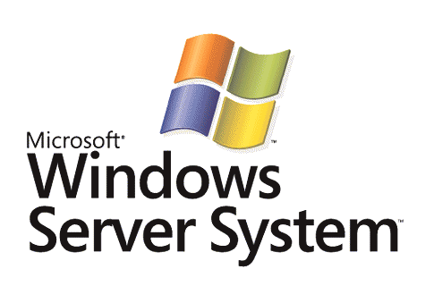

BizTalk Server 2006
PeopleSoft Adapter Sample Walkthrough – Using a PeopleSoft System

Microsoft Corporation
Published: November 2006

Abstract
This lab allows you to use the PeopleSoft system without needing Microsoft BizTalk® Server or any other Microsoft products. In this lab, you will connect to the PeopleSoft system to locate and modify a simple data record.



The information contained in this document represents the current view of Microsoft Corporation on the issues discussed as of the date of publication. Because Microsoft must respond to changing market conditions, it should not be interpreted to be a commitment on the part of Microsoft, and Microsoft cannot guarantee the accuracy of any information presented after the date of publication.
This White Paper is for informational purposes only. MICROSOFT MAKES NO WARRANTIES, EXPRESS, IMPLIED OR STATUTORY, AS TO THE INFORMATION IN THIS DOCUMENT.
Complying with all applicable copyright laws is the responsibility of the user. Without limiting the rights under copyright, no part of this document may be reproduced, stored in or introduced into a retrieval system, or transmitted in any form or by any means (electronic, mechanical, photocopying, recording, or otherwise), or for any purpose, without the express written permission of Microsoft Corporation.
Microsoft may have patents, patent applications, trademarks, copyrights, or other intellectual property rights covering subject matter in this document. Except as expressly provided in any written license agreement from Microsoft, the furnishing of this document does not give you any license to these patents, trademarks, copyrights, or other intellectual property.
Unless otherwise noted, the companies, organizations, products, domain names, e-mail addresses, logos, people, places, and events depicted in examples herein are fictitious. No association with any real company, organization, product, domain name, e-mail address, logo, person, place, or event is intended or should be inferred.
© 2006 Microsoft Corporation. All rights reserved.
Microsoft, MS-DOS, Windows, Windows Server, Windows Vista, BizTalk, Visual Studio, and Windows Server System are either registered trademarks or trademarks of Microsoft Corporation in the United States and/or other countries.
All other trademarks are property of their respective owners.

Contents
Using a PeopleSoft System 4
Prerequisites 4
Lab 1 - Using a PeopleSoft System 4
Procedures for Lab 1 - Using a PeopleSoft System 5
Summary 8

Using a PeopleSoft System
The PeopleSoft system is accessible from a BizTalk Server 2006 system by using the PeopleSoft adapter. This adapter is one of a group of eight line-of-business (LOB) adapters shipped by Microsoft for use with BizTalk Server 2006.
The PeopleSoft lab work is divided into two parts. This first lab (Lab 1) allows you to use the PeopleSoft system without needing BizTalk Server or any Microsoft products (except perhaps Internet Explorer, but you can use any browser). In this lab, you will connect to the PeopleSoft system to locate and modify a simple data record.
In the second lab (Lab 2), you will create a BizTalk project and orchestration. After you create the application, you will deploy it and use it to connect to a PeopleSoft system by using the PeopleSoft adapter. The goal is to access data through the BizTalk application by using the adapter.
Note
Microsoft is interested in your feedback about how useful this sample is to you. Please send feedback to docfb@microsoft.com and include the name of the sample in the correspondence.

Prerequisites
To perform the procedures for this lab, you need a browser and an Internet connection, along with a user account on a PeopleSoft system. You need to know the location to browse to for gaining Web access to your PeopleSoft system. You do not need BizTalk Server or any other Microsoft technologies.

Lab 1 - Using a PeopleSoft System
In this lab, you will use the PeopleSoft system without using any components of BizTalk Server 2006. The goal is to test your connectivity to PeopleSoft to ensure that the second lab will work correctly. Initially you connect to the PeopleSoft system through its Web interface that allows you to log on by using a browser such as Internet Explorer.

Procedures for Lab 1 - Using a PeopleSoft System
To log on to PeopleSoft by using a browser
1. Log on to the PeopleSoft system by browsing to a PeopleSoft logon page. Enter your User ID and Password and then click Sign In.
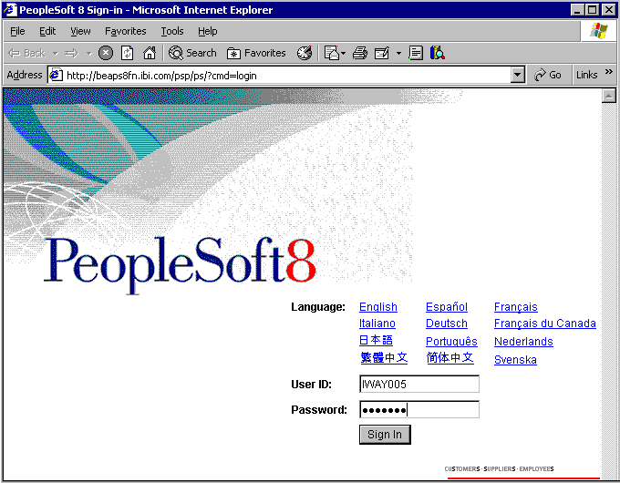

To locate and modify PeopleSoft data
1. A successful logon places you at the page to personalize the content you see by choosing its layout. Scroll down and expand Set Up Financials/Supply Chain, click Common Definitions, click Location, and then click Location again. This brings you to the Location search interface.
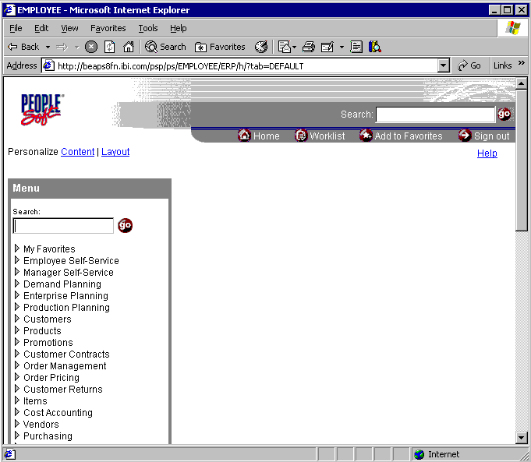

2. To begin the search, set SetID to =, set Location Code to begins with, enter A, and then click Search. This displays cities whose names start with A in the Search Results section of the interface.
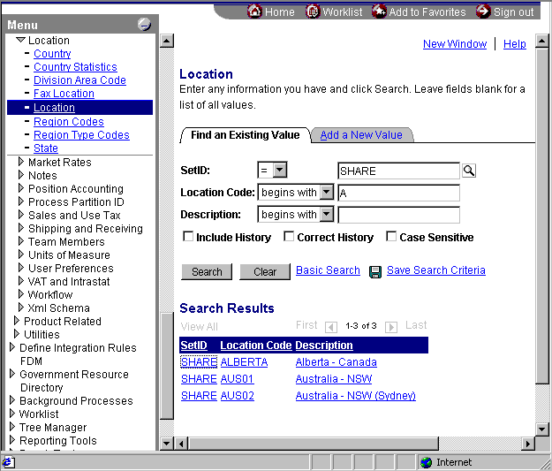

3. Click one of the locations to get its detail information. For example, in the figure below, the user clicked the AUS01 link in the Location Code column.
4. Enter some new data into one of the fields (such as the Address 2 field) and click Save in the lower-left corner. This saves the newly entered data into the record.
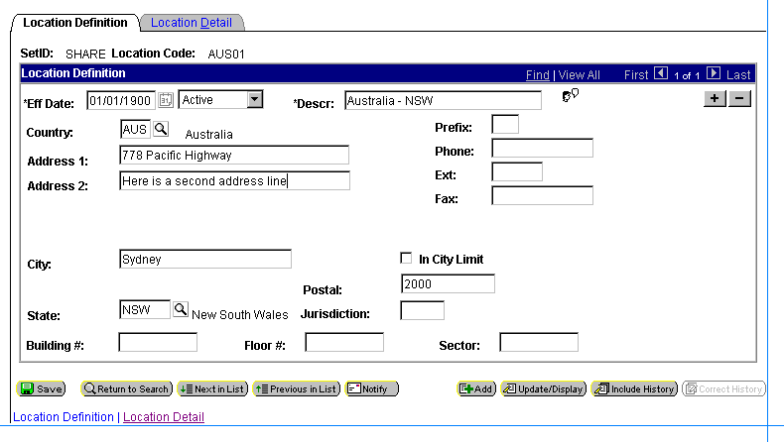

5. To verify the success of this change, repeat the process from step 2, find this same record again, and observe the changes made to the record.
6. In the upper-right portion of the window, click Sign out to end your PeopleSoft session.
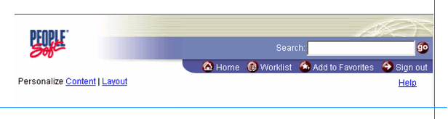

Note
In the next lab there are instructions for using the PeopleSoft adapter to retrieve the information for the location record (AUS01) that you modified.

Summary
In this lab you logged on to the PeopleSoft system through a browser. After you were connected, you searched for data, and then manipulated and updated a record's address field. After committing the change, you could view the modified data in the browser to verify that the change executed properly.

