Microsoft Business Solutions−Axapta Tools
Microsoft® Business Solutions−Axapta® Tools helps give developers the power to tailor almost every aspect of their solution, while remaining simple and easy to use.

Key Benefits
- Integrated development environment for fast and efficient customization and development

- One environment for development for all platforms, windows, Web, mobile, etc. You only need to learn one development environment.

- Changes made to any part of the system instantly replicate throughout the system, so there is no need to write code or set configurations more than once.
Microsoft Axapta Tools has been designed with easy customization in mind. The integrated development environment and powerful, easy-to-use tools help developers cost-effectively implement, customize and maintain their solution.
Microsoft Axapta is an all-in-one solution that gives you real-time connectivity across your business. Using Microsoft Axapta Tools, you can extend this connectivity to your customers, partners and employees in a flexible and stable environment as you grow your company.

The MorphX integrated development environment
The development environment used in Microsoft Axapta is called MorphX®. MorphX is an Integrated Development Environment, or IDE, because it integrates several different functions such as designing, editing, compiling and debugging within one common environment. MorphX includes editors for the Microsoft Axapta client of Microsoft Windows®, the Web and mobile devices, and it also uses IntelliMorph® technology and the X++® development language.
IntelliMorph technology makes it simple and easy to modify forms and menus in Microsoft Axapta. For example, IntelliMorph makes it possible for users that have the proper security privileges to hide and show fields on forms, move fields between tab pages and even add new fields to forms. Users can make all these changes themselves, without needing to call on developers for help.
IntelliMorph technology also helps developers ensure a consistent and well-arranged graphical display, so that all they need to specify is the structure of the user interface, and users can take care of their own detail changes. IntelliMorph also gives your custom applications the look and feel of the release of Microsoft Windows you are using. When you upgrade your operating system, IntelliMorph automatically changes the appearance of Microsoft Axapta and all your custom applications to that of the new operating system.
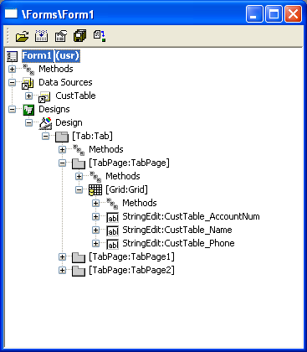
Designing a form with MorphX
The X++ Editor in Microsoft Axapta makes it possible for developers to incorporate modifications with little need for coding. Methods can be copied from one element to another simply by using the drag-and-drop function. If developers need to create custom code, Microsoft Axapta offers different functions to simplify their jobs and provide information about their options. For example, when writing method calls, the tool tip displays parameter information with the current parameter highlighted. When specifying a class instance, a selection box will appear that displays all available methods for the specific class. For quick and efficient coding, developers can check syntax in realtime while typing. Errors in the code will automatically be highlighted so developers can instantly see and correct mistakes. The X++ editor even comes with a debugger so developers can quickly see the results of their jobs without having to run a complete test.

Easy development with a single environment for all platforms
The MorphX environment was designed with ease of development in mind. Microsoft Axapta provides many tools and functions that work within that environment and that give developers great power to customize the solution using simple, logical methods. For example, a library called the Application Object Tree (AOT) stores all components of Microsoft Axapta, including the data dictionary, macros, classes, forms, reports and other objects. Using this central object repository, a developer can create new application objects easily, just by using drag-and-drop and then by setting properties. Most basic tasks will not require custom coding, which can greatly speed up the development process, save developer time and customization costs and reduce possible sources of errors. To make the job for developers even easier and faster, the solution provides auto settings for all application object properties.
Microsoft Axapta is Component Object Model (COM) enabled. This technology helps the solution interact easily with other COM-aware programs and Enterprise Resource Planning (ERP) solutions. From within Microsoft Axapta, you can use COM to interact with third party vendor objects. For example, you can access pivot table from Microsoft Excel® from within the solution. For the developer, this means that not every functionality needs to be developed from scratch.
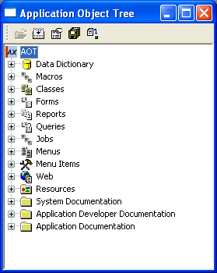
The Application Object Tree
Simple, developer-friendly support for ActiveX® components is another important tool built into Microsoft Axapta. When a developer uses an ActiveX component, (while adding a new control to a form, for example) the developer can open a list with all registered ActiveX components on the computer. After inserting the control, the developer will be able to access all the methods supplied by the component.

Built for Web development
Microsoft Axapta is built to use the Web as a natural extension of its functionality. The solution comes with out-of-the-box tools that help developers build Web applications or modify the existing Web-enabled functionality in the product. In Microsoft Axapta, Web applications run on realtime data and can use the full business logic of the solution.
Web development is integrated into the IDE, so any Web solution will use the same data and business logic as a regular Microsoft Windows client, but presented using a Web-based interface. Using the built-in tools, the entire business logic and virtually all areas of Microsoft Axapta can be accessed through a normal Web browser, the same way a user would do so from the normal Microsoft Windows client. This means that developers and users only need to learn one set of tools, and that modifications in the business logic or the underlying table definitions in the database will take immediate effect both in Microsoft Windows clients and on the Web.
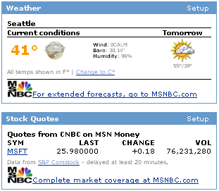
Weblets allow you to embed Web content in Microsoft Axapta user screens
Weblets are the Web components in Axapta that let you put active, ”live” content and data on the Web pages of an application. A weblet is a class that generates content for Web applications in HTML code. Microsoft Axapta gives you a number of standard weblets to simplify setting up your Web application with as little coding as possible. For example, the information viewer weblet for Microsoft Outlook® and Axapta will let you display items from an employee’s calendar in Microsoft Outlook. Other weblets, such as the News weblet and Discussion weblet, let you display news or discussion forums based on information already stored in Microsoft Axapta. With the Web Panel weblet, users are able to set up their own Web pages and choose which elements to display where. Customers can create their own weblets to include customized functionality and content

Inheritance cuts developers’ workload
The MorphX IDE also supports inheritance, a capability that can make development much quicker and easier. With inheritance, developers typically only need to modify a single parameter, and the entire system will inherit the change. For example, if you change the length of a database field from 10 characters to 20, this will instantly and automatically be reflected throughout the application, wherever that field is displayed.

For more information
To learn more about Microsoft Business Solutions–Axapta Tools, contact your local Microsoft Business Solutions office, a Microsoft Certified Business Solutions reselling partner, and/or visit www.microsoft.com/BusinessSolutions.

About Microsoft Business Solutions
Microsoft Business Solutions offers a wide range of integrated, end-to-end business applications and services designed to help small, mid-market segment and corporate businesses become more connected with customers, employees, partners and suppliers. Microsoft Business Solutions applications optimize strategic business processes across financial management, supply chain management, customer relationship management and analytics. The applications are designed to provide insight to help customers achieve business success. More information can be found at www.microsoft.com/BusinessSolutions.

Address
Microsoft
Frydenlunds Allé 6
2950 Vedbaek
Denmark
Tel +45 45 67 80 00
Fax +45 45 67 80 01
www.microsoft.com/BusinessSolutions
Microsoft
One Lone Tree Road
Fargo ND 58104-3911
USA
Tel +1 888 477 7989; +1 701 281 6500
Fax +1 425 936 7329
www.microsoft.com/BusinessSolutions

15 December 2003
The information contained in this document represents the current view of Microsoft Corporation on the issues discussed as of the date of publication. Because Microsoft must respond to changing market conditions, it should not be interpreted to be a commitment on the part of Microsoft, and Microsoft cannot guarantee the accuracy of any information presented after the date of publication. This document is for informational purposes only. MICROSOFT MAKES NO WARRANTIES, EXPRESS, IMPLIED OR STATUTORY, AS TO THE INFORMATION IN THIS DOCUMENT. Complying with all applicable copyright laws is the responsibility of the user. Without limiting the rights under copyright, no part of this document may be reproduced, stored in or introduced into a retrieval system, or transmitted in any form or by any means (electronic, mechanical, photocopying, recording, or otherwise), or for any purpose, without the express written permission of Microsoft Corporation. Microsoft may have patents, patent applications, trademarks, copyrights, or other intellectual property rights covering subject matter in this document. Except as expressly provided in any written license agreement from Microsoft, the furnishing of this document does not give you any license to these patents, trademarks, copyrights, or other intellectual property. © 2003 Microsoft Business Solutions ApS, Denmark. All rights reserved. Microsoft, Great Plains, Navision, FRx and Axapta are either registered trademarks or trademarks of Microsoft Corporation, Great Plains Software, Inc., FRx Software Corporation, or Microsoft Business Solutions ApS or their affiliates in the United States and/or other countries. Great Plains Software, Inc., FRx Software Corporation, and Microsoft Business Solutions ApS are subsidiaries of Microsoft Corporation. The names of actual companies and products mentioned herein may be the trademarks of their respective owners. The example companies, organizations, products, domain names, email addresses, logos, people and events depicted herein are fictitious. No association with any real company, organization, product, domain name, e-mail address, logo, person, or event is intended or should be inferred.

