

Step-by-Step Guide for Configuring a Two-Node Print Server Failover Cluster in Windows Server 2008
Microsoft Corporation
Published: September 2007
Author: Jan Keller
Editor: Ronald Loi
Abstract
A failover cluster is a group of independent computers that work together to increase the availability of applications and services. The clustered servers (called nodes) are connected by physical cables and by software. If one of the cluster nodes fails, another node begins to provide service (a process known as failover). This guide describes the steps for installing and configuring a print server failover cluster that has two nodes. By creating the configuration in this guide, you can learn about failover clusters and familiarize yourself with the Failover Cluster Management snap-in.

This is a preliminary document and may be changed substantially prior to final commercial release of the software described herein. The information contained in this document represents the current view of Microsoft Corporation on the issues discussed as of the date of publication. Because Microsoft must respond to changing market conditions, it should not be interpreted to be a commitment on the part of Microsoft, and Microsoft cannot guarantee the accuracy of any information presented after the date of publication.

This White Paper is for informational purposes only. MICROSOFT MAKES NO WARRANTIES, EXPRESS, IMPLIED OR STATUTORY, AS TO THE INFORMATION IN THIS DOCUMENT.

Complying with all applicable copyright laws is the responsibility of the user. Without limiting the rights under copyright, no part of this document may be reproduced, stored in or introduced into a retrieval system, or transmitted in any form or by any means (electronic, mechanical, photocopying, recording, or otherwise), or for any purpose, without the express written permission of Microsoft Corporation.

Microsoft may have patents, patent applications, trademarks, copyrights, or other intellectual property rights covering subject matter in this document. Except as expressly provided in any written license agreement from Microsoft, the furnishing of this document does not give you any license to these patents, trademarks, copyrights, or other intellectual property.

© 2007 Microsoft Corporation. All rights reserved.

Microsoft, MS-DOS, Windows, Windows Server, Windows Vista, and Active Directory are either registered trademarks or trademarks of Microsoft Corporation in the United States and/or other countries.

All other trademarks are property of their respective owners.

Contents
Step-by-Step Guide for Configuring a Two-Node Print Server Failover Cluster in Windows Server 2008 5
In this guide 5
Overview for a two-node print server cluster 5
Requirements for a two-node failover cluster 7
Hardware requirements for a two-node failover cluster 7
Deploying storage area networks with failover clusters 9
Software requirements for a two-node failover cluster 9
Network infrastructure and domain account requirements for a two-node failover cluster 10
Steps for installing a two-node print server cluster 11
Step 1: Connect the cluster servers to the networks and storage 11
Step 2: Install the failover cluster feature 12
Step 3: Validate the cluster configuration 14
Step 4: Create the cluster 16
Steps for configuring a two-node print server cluster 18
Additional references 21

Step-by-Step Guide for Configuring a Two-Node Print Server Failover Cluster in Windows Server 2008
A failover cluster is a group of independent computers that work together to increase the availability of applications and services. The clustered servers (called nodes) are connected by physical cables and by software. If one of the cluster nodes fails, another node begins to provide service (a process known as failover). Users experience a minimum of disruptions in service.
This guide describes the steps for installing and configuring a print server failover cluster that has two nodes. By creating the configuration in this guide, you can learn about failover clusters and familiarize yourself with the Failover Cluster Management snap-in interface in Windows Server® 2008 Enterprise or Windows Server® 2008 Datacenter.
Note
The failover cluster feature is not available in Windows Web Server 2008 or Windows Server 2008 Standard.
In Windows Server 2008, the improvements to failover clusters (formerly known as server clusters) are aimed at simplifying clusters, making them more secure, and enhancing cluster stability. Cluster setup and management are easier. Security and networking in clusters have been improved, as has the way a failover cluster communicates with storage. For more information about improvements to failover clusters, see http://go.microsoft.com/fwlink/?LinkId=62368.

In this guide
Overview for a two-node print server cluster
Requirements for a two-node failover cluster
Steps for installing a two-node print server cluster
Steps for configuring a two-node print server cluster
Additional resources

Overview for a two-node print server cluster
Servers in a failover cluster can function in a variety of roles, including the roles of file server, print server, mail server, or database server, and they can provide high availability for a variety of other services and applications. This guide describes how to configure a two-node print server cluster.
A failover cluster usually includes a storage unit that is physically connected to all the servers in the cluster, although any given volume in the storage is only accessed by one server at a time. The following diagram shows a two-node failover cluster connected to a storage unit.
Failover cluster with two nodes connected to a storage unit
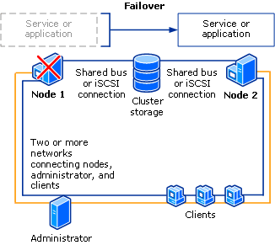

Storage volumes or logical unit numbers (LUNs) exposed to the nodes in a cluster must not be exposed to other servers, including servers in another cluster. The following diagram illustrates this.
Two failover clusters, each with its own LUNs
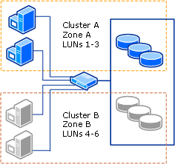

Note that for the maximum availability of any server, it is important to follow best practices for server management—for example, carefully managing the physical environment of the servers, testing software changes before fully implementing them, and carefully keeping track of software updates and configuration changes on all clustered servers.
The following scenario describes how a print server failover cluster can be configured.

Requirements for a two-node failover cluster
To create a failover cluster with two nodes (regardless of the service or application that the nodes provide), you need the hardware, software, accounts, and network infrastructure described in the sections that follow.
We recommend that you first use the information provided in this guide in a test lab environment. A Step-by-Step guide is not necessarily meant to be used to deploy Windows Server features without the accompanying documentation (as listed in the Additional references section), and it should be used with discretion as a stand-alone document.

Hardware requirements for a two-node failover cluster
You will need the following hardware for a two-node failover cluster:
• Servers: We recommend that you use a set of matching computers that contain the same or similar components.
Important
You should use only hardware components that are compatible with Windows Server 2008.
• Network adapters and cable (for network communication): The network hardware, like other components in the failover cluster solution, must be compatible with Windows Server 2008. If you use iSCSI, your network adapters must be dedicated to either network communication or iSCSI, not both.
In the network infrastructure that connects your cluster nodes, avoid having single points of failure. There are multiple ways of accomplishing this. You can connect your cluster nodes by multiple, distinct networks. Alternatively, you can connect your cluster nodes with one network that is constructed with teamed network adapters, redundant switches, redundant routers, or similar hardware that removes single points of failure.
Note
If you connect cluster nodes with a single network, the network will pass the redundancy requirement in the Validate a Configuration Wizard. However, the report from the wizard will include a warning that the network should not have single points of failure.
For more details about the network configuration required for a failover cluster, see Network infrastructure and domain account requirements for a two-node failover cluster, later in this topic.
• Device controllers or appropriate adapters for the storage:
• For Serial Attached SCSI or Fibre Channel: If you are using Serial Attached SCSI or Fibre Channel, in all clustered servers, the mass-storage device controllers that are dedicated to the cluster storage should be identical. They should also use the same firmware version.
Note
With Windows Server 2008, you cannot use parallel SCSI to connect the storage to the clustered servers.
• For iSCSI: If you are using iSCSI, each clustered server must have one or more network adapters or host bus adapters that are dedicated to the cluster storage. The network you use for iSCSI cannot be used for network communication. In all clustered servers, the network adapters you use to connect to the iSCSI storage target should be identical, and we recommend that you use Gigabit Ethernet or higher.
For iSCSI, you cannot use teamed network adapters, because they are not supported with iSCSI.
For more information about iSCSI, see the iSCSI FAQ on the Microsoft Web site (http://go.microsoft.com/fwlink/?LinkId=61375).
• Storage: You must use shared storage that is compatible with Windows Server 2008.
For a two-node failover cluster, the storage should contain at least two separate volumes (LUNs), configured at the hardware level. One volume will function as the witness disk (described in the next paragraph). One volume will contain the print drivers, print spooler directory, and print monitors. Storage requirements include the following:
• To use the native disk support included in failover clustering, use basic disks, not dynamic disks.
• We recommend that you format the partitions with NTFS (for the witness disk, the partition must be NTFS).
• For the partition style of the disk, you can use either master boot record (MBR) or GUID partition table (GPT).
The witness disk is a disk in the cluster storage that is designated to hold a copy of the cluster configuration database. (A witness disk is part of some, not all, quorum configurations.) For this two-node cluster, the quorum configuration will be Node and Disk Majority, the default for a cluster with an even number of nodes. Node and Disk Majority means that the nodes and the witness disk each contain copies of the cluster configuration, and the cluster has quorum as long as a majority (two out of three) of these copies are available.

Deploying storage area networks with failover clusters
When deploying a storage area network (SAN) with a failover cluster, follow these guidelines:
• Confirm compatibility of the storage: Confirm with manufacturers and vendors that the storage, including drivers, firmware, and software used for the storage, are compatible with failover clusters in Windows Server 2008.
Important
Storage that was compatible with server clusters in Windows Server 2003 might not be compatible with failover clusters in Windows Server 2008. Contact your vendor to ensure that your storage is compatible with failover clusters in Windows Server 2008.
Failover clusters include the following new requirements for storage:
• Because improvements in failover clusters require that the storage respond correctly to specific SCSI commands, the storage must follow the standard called SCSI Primary Commands-3 (SPC-3). In particular, the storage must support Persistent Reservations as specified in the SPC-3 standard.
• The miniport driver used for the storage must work with the Microsoft Storport storage driver.
• Isolate storage devices, one cluster per device: Servers from different clusters must not be able to access the same storage devices. In most cases, a LUN that is used for one set of cluster servers should be isolated from all other servers through LUN masking or zoning.
• Consider using multipath I/O software: In a highly available storage fabric, you can deploy failover clusters with multiple host bus adapters by using multipath I/O software. This provides the highest level of redundancy and availability. For Windows Server 2008, your multipath solution must be based on Microsoft Multipath I/O (MPIO). Your hardware vendor will usually supply an MPIO device-specific module (DSM) for your hardware, although Windows Server 2008 includes one or more DSMs as part of the operating system.
Important
Host bus adapters and multipath I/O software can be very version sensitive. If you are implementing a multipath solution for your cluster, you should work closely with your hardware vendor to choose the correct adapters, firmware, and software for Windows Server 2008.

Software requirements for a two-node failover cluster
The servers for a two-node failover cluster must run the same version of Windows Server 2008, including the same hardware version (32-bit, x64-based, or Itanium architecture-based). They should also have the same software updates (patches) and service packs.

Network infrastructure and domain account requirements for a two-node failover cluster
You will need the following network infrastructure for a two-node failover cluster and an administrative account with the following domain permissions:
• Network settings and IP addresses: When you use identical network adapters for a network, also use identical communication settings on those adapters (for example, Speed, Duplex Mode, Flow Control, and Media Type). Also, compare the settings between the network adapter and the switch it connects to and make sure that no settings are in conflict.
If you have private networks that are not routed to the rest of your network infrastructure, ensure that each of these private networks uses a unique subnet. This is necessary even if you give each network adapter a unique IP address. For example, if you have a cluster node in a central office that uses one physical network, and another node in a branch office that uses a separate physical network, do not specify 10.0.0.0/24 for both networks, even if you give each adapter a unique IP address.
For more information about the network adapters, see Hardware requirements for a two-node failover cluster, earlier in this guide.
• DNS: The servers in the cluster must be using Domain Name System (DNS) for name resolution. The DNS dynamic update protocol can be used.
• Domain role: All servers in the cluster must be in the same Active Directory domain. As a best practice, all clustered servers should have the same domain role (either member server or domain controller). The recommended role is member server.
• Domain controller: We recommend that your clustered servers be member servers. If they are, you need an additional server that acts as the domain controller in the domain that contains your failover cluster.
• Clients: As needed for testing, you can connect one or more networked clients to the failover cluster that you create, and observe the effect on a client when you move or fail over the clustered print server from one cluster node to the other.
• Account for administering the cluster: When you first create a cluster or add servers to it, you must be logged on to the domain with an account that has administrator rights and permissions on all servers in that cluster. The account does not need to be a Domain Admins account, but can be a Domain Users account that is in the Administrators group on each clustered server. In addition, if the account is not a Domain Admins account, the account (or the group that the account is a member of) must be given the Create Computer Objects permission in the domain.
Note
There is a change in the way the Cluster service runs in Windows Server 2008, as compared to Windows Server 2003. In Windows Server 2008, there is no Cluster service account. Instead, the Cluster service automatically runs in a special context that provides the specific permissions and privileges that are necessary for the service (similar to the local system context, but with reduced privileges).

Steps for installing a two-node print server cluster
You must complete the following steps to install a two-node print server failover cluster.
Step 1: Connect the cluster servers to the networks and storage
Step 2: Install the failover cluster feature
Step 3: Validate the cluster configuration
Step 4: Create the cluster
If you have already installed the cluster nodes and want to configure a file server failover cluster, see Steps for configuring a two-node file server cluster, later in this guide.

Step 1: Connect the cluster servers to the networks and storage
Use the following instructions to connect your selected cluster servers to networks and storage.
Note
Review Hardware Requirements for a Two-Node Failover Cluster earlier in this guide, for details about the kinds of network adapters and device controllers that you can use with Windows Server 2008.
For a failover cluster network, avoid having single points of failure. There are multiple ways of accomplishing this. You can connect your cluster nodes by multiple, distinct networks. Alternatively, you can connect your cluster nodes with one network that is constructed with teamed network adapters, redundant switches, redundant routers, or similar hardware that removes single points of failure (If you use a network for iSCSI, you must create this network in addition to the other networks).
For a two-node print server cluster, when you connect the servers to the cluster storage, you must expose at least two volumes (LUNs). You can expose additional volumes as needed for thorough testing of your configuration. Do not expose the clustered volumes to servers that are not in the cluster.
To connect the cluster servers to the networks and storage
1. Review the details about networks in Hardware Requirements for a Two-Node Failover Cluster and Network infrastructure and domain account requirements for a two-node failover cluster, earlier in this guide.
2. Connect and configure the networks that the servers in the cluster will use.
3. If your test configuration includes clients or a non-clustered domain controller, make sure that these computers can connect to the clustered servers through at least one network.
4. Follow the manufacturer's instructions for physically connecting the servers to the storage.
5. Ensure that the disks (LUNs) that you want to use in the cluster are exposed to the servers that you will cluster (and only those servers). You can use any of the following interfaces to expose disks or LUNs:
• The interface provided by the manufacturer of the storage.
• If you are using iSCSI, an appropriate iSCSI interface.
• Microsoft Storage Manager for SANs (part of the operating system in Windows Server 2008). To use this interface, you need to contact the manufacturer of your storage for a Virtual Disk Service (VDS) provider package that is designed for your storage.
6. If you have purchased software that controls the format or function of the disk, follow instructions from the vendor about how to use that software with Windows Server 2008.
7. On one of the servers that you want to cluster, click Start, click Administrative Tools, click Computer Management, and then click Disk Management. (If the User Account Control dialog box appears, confirm that the action it displays is what you want, and then click Continue.) In Disk Management, confirm that the cluster disks are visible.
8. If you want to have a storage volume larger than 2 terabytes, and you are using the Windows interface to control the format of the disk, convert that disk to the partition style called GUID partition table (GPT). To do this, back up any data on the disk, delete all volumes on the disk and then, in Disk Management, right-click the disk (not a partition) and click Convert to GPT Disk.
For volumes smaller than 2 terabytes, instead of using GPT, you can use the partition style called master boot record (MBR).
Important
You can use either MBR or GPT for a disk that is used by a failover cluster, but you cannot use a disk that you converted to dynamic by using Disk Management.
If you purchased software that controls the format or function of the disk, contact the vendor for instructions about how to use that software with Windows Server 2008.
9. Check the format of any exposed volume or LUN. We recommend NTFS for the format (for the witness disk, you must use NTFS).

Step 2: Install the failover cluster feature
In this step, you install the failover cluster feature. The servers must be running Windows Server 2008.
To install the failover cluster feature on the servers
1. If you recently installed Windows Server 2008, the Initial Configuration Tasks interface is displayed, as shown in the following illustration.
Initial Configuration Tasks
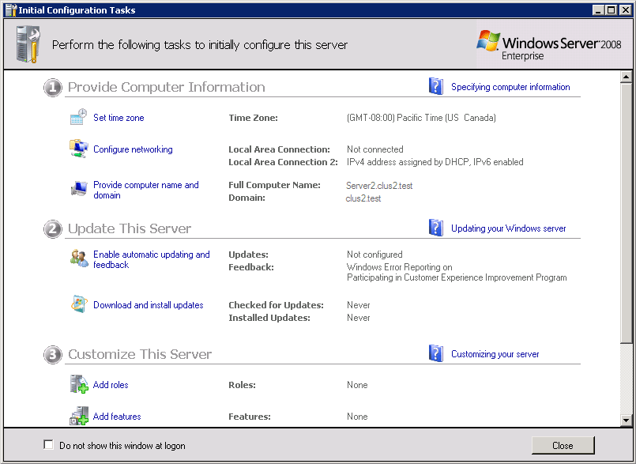

If this interface is displayed, under Customize This Server, click Add features. Then skip to step 3.
2. If the Initial Configuration Tasks interface is not displayed and Server Manager is not running, click Start, click Administrative Tools, and then click Server Manager. (If the User Account Control dialog box appears, confirm that the action it displays is what you want, and then click Continue.)
Server Manager
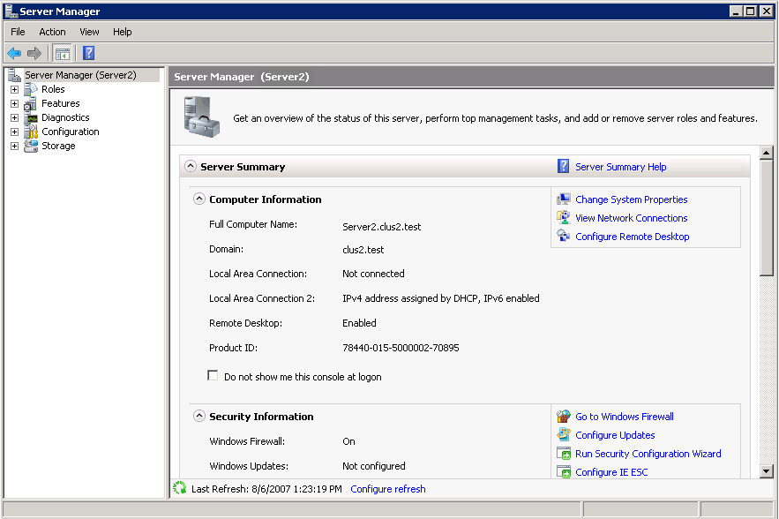

In Server Manager, under Features Summary, click Add Features.
3. In the Add Features Wizard, click Failover Clustering, and then click Install.
4. Follow the instructions in the wizard to complete the installation of the feature. When the wizard finishes, close it.
5. Repeat the process for each server that you want to include in the cluster.

Step 3: Validate the cluster configuration
Before creating a cluster, we strongly recommend that you validate your configuration. Validation helps you confirm that the configuration of your servers, network, and storage meets a set of specific requirements for failover clusters.
To validate the failover cluster configuration
1. To open the failover cluster snap-in, click Start, click Administrative Tools, and then click Failover Cluster Management. (If the User Account Control dialog box appears, confirm that the action it displays is what you want, and then click Continue.)
Failover Cluster Management snap-in
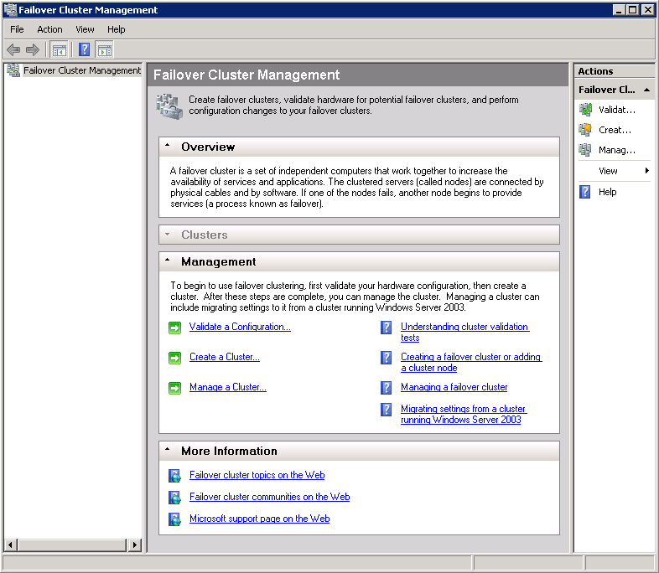

2. Confirm that Failover Cluster Management is selected and then, in the center pane under Management, click Validate a Configuration.
Validate a Configuration Wizard
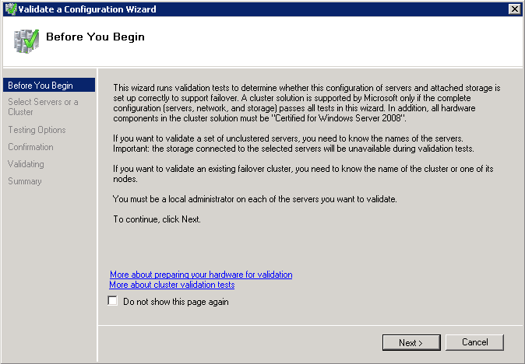

3. Follow the instructions in the wizard to specify the two servers and the tests, and then run the tests. To fully validate your configuration, run all tests before creating a cluster.
4. The Summary page appears after the tests run. To view Help topics that will help you interpret the results, click More about cluster validation tests.
5. While still on the Summary page, click View Report and read the test results.
To view the results of the tests after you close the wizard, see
SystemRoot\Cluster\Reports\Validation Report date and time.html
where SystemRoot is the folder in which the operating system is installed (for example, C:\Windows).
6. As necessary, make changes in the configuration and rerun the tests.
7. To view Help topics about cluster validation after you close the wizard, in Failover Cluster Management, click Help, click Help Topics, click the Contents tab, expand the contents for the failover cluster Help, and click Validating a Failover Cluster Configuration.

Step 4: Create the cluster
To create a cluster, you run the Create Cluster wizard.
To run the Create Cluster wizard
1. To open the failover cluster snap-in, click Start, click Administrative Tools, and then click Failover Cluster Management. (If the User Account Control dialog box appears, confirm that the action it displays is what you want, and then click Continue.)
2. Confirm that Failover Cluster Management is selected and then, in the center pane under Management, click Create a cluster.
Create Cluster Wizard
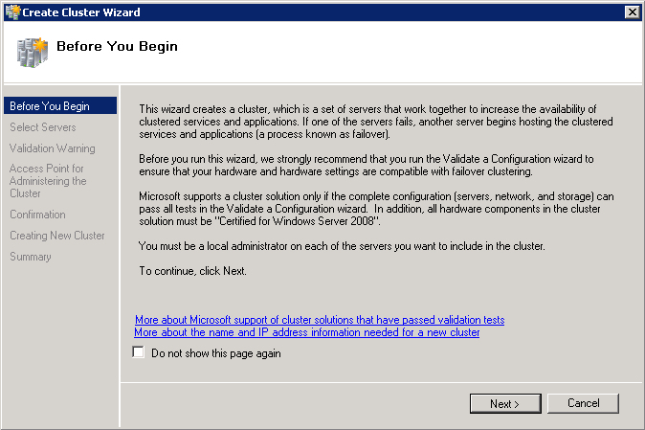

Follow the instructions in the wizard to specify:
• The servers to include in the cluster.
• The name of the cluster.
• Any IP address information that is not automatically supplied by your DHCP settings.
3. After the wizard runs and the Summary page appears, to view a report of the tasks the wizard performed, click View Report.

Steps for configuring a two-node print server cluster
To configure a two-node print server failover cluster, follow these steps:
To configure a two-node print server failover cluster
1. To open the failover cluster snap-in, click Start, click Administrative Tools, and then click Failover Cluster Management. (If the User Account Control dialog box appears, confirm that the action it displays is what you want, and then click Continue.)
2. In the console tree, if the cluster that you created is not displayed, right-click Failover Cluster Management, click Manage a Cluster, and then select the cluster you want to configure.
3. In the console tree, click the plus sign next to the cluster that you created to expand the items underneath it.
4. If the clustered servers are connected to a network that is not to be used for network communication in the cluster (for example, a network intended only for iSCSI), then under Networks, right-click that network, click Properties, and then click Do not allow the cluster to use this network. Click OK.
5. Click Services and Applications. Under Actions (on the right), click Configure a Service or Application.
High Availability Wizard
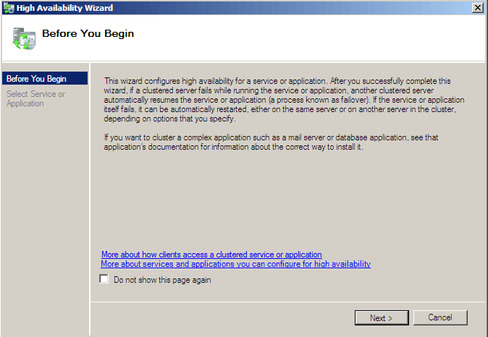

6. Review the text on the first page of the wizard, and then click Next.
List of Services and Applications in the High Availability Wizard
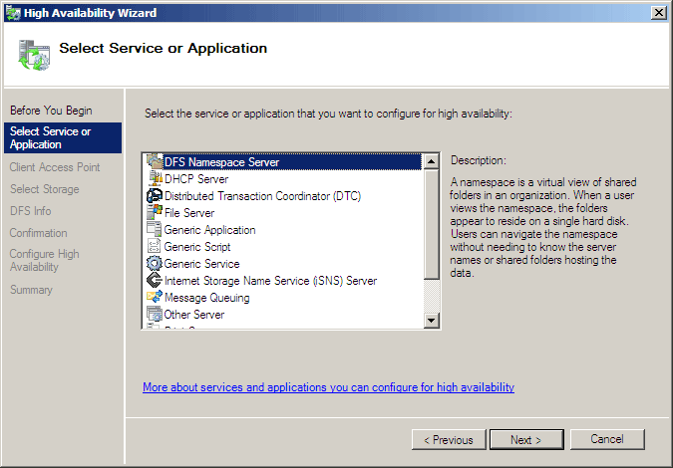

7. Click Print Server, and then click Next.
8. Follow the instructions in the wizard to specify the following details:
• A name for the clustered print server
• Any IP address information that is not automatically supplied by your DHCP settings—for example, a static IPv4 address for this clustered print server
• The storage volume or volumes that the clustered print server should use
9. After the wizard runs and the Summary page appears, to view a report of the tasks the wizard performed, click View Report.
10. To close the wizard, click Finish.
11. In the console tree, make sure Services and Applications is expanded, and then select the clustered print server that you just created.
12. Under Actions, click Manage Printers.
An instance of the Failover Cluster Management interface appears with Print Management in the console tree.
13. Under Print Management, click Print Servers and locate the clustered print server that you want to configure.
Always perform management tasks on the clustered print server. Do not manage the individual cluster nodes as print servers.
14. Right-click the clustered print server, and then click Add Printer. Follow the instructions in the wizard to add a printer.
This is the same wizard you would use to add a printer on a nonclustered server.
15. When you have finished configuring settings for the clustered print server, to close the instance of the Failover Cluster Management interface with Print Management in the console tree, click File and then click Exit.
16. To perform a basic test of failover, right-click the clustered print server instance, click Move this service or application to another node, and click the available choice of node. When prompted, confirm your choice.
You can observe the status changes in the center pane of the snap-in as the clustered print server instance is moved.

Additional references
The following resources provide additional information about failover clusters:
• For more information about iSCSI, see the iSCSI FAQ on the Microsoft Web site (http://go.microsoft.com/fwlink/?LinkId=61375).
• For information about the improvements in failover clusters as compared to server clusters in Windows Server 2003, see "What's New in Failover Clusters" on the Microsoft Web site (http://go.microsoft.com/fwlink/?LinkId=62368).

