

Configuring IP-DLC Link Service for IBM Enterprise Extender
White Paper
Published: September 2004
For the latest information, please see http://www.microsoft.com/hiserver
Copyright
The information contained in this document represents the current view of Microsoft Corporation on the issues discussed as of the date of publication. Because Microsoft must respond to changing market conditions, it should not be interpreted to be a commitment on the part of Microsoft, and Microsoft cannot guarantee the accuracy of any information presented after the date of publication.
This White Paper is for informational purposes only. MICROSOFT MAKES NO WARRANTIES, EXPRESS OR IMPLIED, AS TO THE INFORMATION IN THIS DOCUMENT.
Complying with all applicable copyright laws is the responsibility of the user. Without limiting the rights under copyright, no part of this document may be reproduced, stored in or introduced into a retrieval system, or transmitted in any form or by any means (electronic, mechanical, photocopying, recording, or otherwise), or for any purpose, without the express written permission of Microsoft Corporation.
Microsoft may have patents, patent applications, trademarks, copyrights, or other intellectual property rights covering subject matter in this document. Except as expressly provided in any written license agreement from Microsoft, the furnishing of this document does not give you any license to these patents, trademarks, copyrights, or other intellectual property.
© 2004 Microsoft Corporation. All rights reserved.
Unless otherwise noted, the example companies, organizations, products, domain names, e-mail addresses, logos, people, places and events depicted herein are fictitious, and no association with any real company, organization, product, domain name, e-mail address, logo, person, place or event is intended or should be inferred.
Microsoft, BizTalk, Visual Basic, Visual C++, Visual C#, Visual Studio, Windows, and Windows Server are either registered trademarks or trademarks of Microsoft Corporation in the United States and/or other countries.
The names of actual companies and products mentioned herein may be the trademarks of their respective owners.
Contents
Introduction 5
IP-DLC Configuration (Mainframe) 6
Host Requirements 6
Network Adapter Requirements 6
OS/390 VTAM and TCP/IP components Configuration 6
1. HPR and CP-CP Session Start Option (SYS1.VTAMLST(ATCSTR00)) 7
2. XCA Major Node (SYS1.VTAMLST(member)) 7
3. Configure VTAM to TCP/IP (TCPIP.PROFILE.TCPIP) 9
4. Switched Major Nodes for PUs SYS1.VTAMST(member) 17
How to Verify IP-DLC (Enterprise Extender) 19
1. D TCPIP,TCPIP,NETSTAT,DEV 19
2. D NET,ID=XCAEE,E 19
3. D NET,ID=PU3270,E 20
Host Integration Server Configuration 21
Link Service Configuration 21
IP-DLC Connection Configuration 23
HIS 2004 Supported Features over IP-DLC 28
Fault Tolerance and Load Balancing Features 29
Fault Tolerance Features 29
Load Balancing Features 29
Scalability 29
IP-DLC Link Service Limitations 30
Supported Network Configurations with Dependent LUs 31
Direct IP-DLC Connection to CS/390 (DLUS) and NNS 31
IP-DLC Connection to CS/390 (DLUS) through Separate NNS 32
Separate IP-DLC Connections to CS/390 (DLUS) and NNS 33
Simultaneous IP-DLC Connections to Multiple CS/390 Hosts 34
PU Concentration with Multiple IP-DLC Host Connections 35
Supported Network Configurations with Independent LUs 36
IP-DLC Connection to APPN “Peer-to-Peer” Network 36
IP-DLC Connection to APPN “Peer-to-Peer” Network 37
Secure Deployment 38
UDP Sockets for HPR/IP Protocol Traffic 38
Firewall Configuration 38
Securing HIS 2004 IP-DLC Connections 38
Problem Determination and Troubleshooting 39
Event Logs 39
Four types of IP-DLC Event logs 39
Typical IP-DLC Link Service Event Log Entry 39
UDP Trace 41
Internal Trace 41
Crash Dumps 41
Diagnostic Gathering Tool 41
Diagnosing Misconfiguration 41
Detailed Diagnostics Tool 41
Qryipdlc Command Line Syntax 41
Qryipdlc from Diagnostics Tool (Display.exe) 42
QRYIPDLC Sample Output 43
Performance Monitor Statistics 44
APPENDIX A - Concepts and Terminology 45
APPENDIX B - Glossary 48
APPENDIX C - Qryipdlc (Full Log) 49
APPENDIX D - Automated Configuration 61
LinkCFG 61
SNACFG 63
WMI 65
REFERENCES 66

Introduction
Host Integration Server (HIS) 2004 offers an efficient means to integrate Systems Network Architecture (SNA) within data centers, across wide area networks (WANs) and in branch offices through a new link service, IP-DLC (Internet Protocol – Date Link Control), also known as IBM Enterprise Extender. The IP-DLC link service provides SNA connectivity for applications using dependent and independent sessions over a native IP network.

SNA has evolved from the traditional subarea networks. Advanced Peer-to-Peer Networking® (APPN®) was an enhancement to SNA that brought the ability to move logical units and change routing without coordinated system definition. High Performance Routing (HPR) is an extension of the APPN architecture; it provides the following functions:
Rapid Transport Protocol (RTP) minimizes processing cycles and storage requirements for routing network layer packets through intermediate nodes on a session route.
Automatic network routing (ANR) enables APPN networks to automatically reroute sessions if a portion of the originally computed route fails.

Enterprise Extender (EE) is another evolution, providing a means for the efficient transport of SNA data across an IP network. Enterprise Extender is an industry-standard solution defined by IETF (RFC 2353). With Enterprise Extender, the RTP endpoint views its interface with the UDP layer of the stack as just another data link control, and treats the connection across the IP network the same as it would any SNA connection.

This purpose of this White Paper is to assist Mainframe Programmers and HIS 2004 administrators in configuring for IP-DLC. It also serves as a reference for HIS 2004, to be used in conjunction with online help in diagnosing and troubleshooting connectivity and configuration issues.

IP-DLC Configuration (Mainframe)
This section describes how to configure IP-DLC support on an IBM Mainframe running the OS/390 or z/OS operating system. IP-DLC is also known as IBM Enterprise Extender.

To support IP-DLC on OS/390, you need OS/390 (version 2.7 or later) or z/OS.

Host Requirements
- “IBM Enterprise Extender” solution
- OS/390 (V2R7 or higher) or z/OS
- Communication Server for OS/390 V6 or higher

Network Adapter Requirements
- OSA or OSA Express
- Modes
  - SNA and TCP/IP (non-QDIO)
  - TCP/IP only (QDIO)

The OS/390 VTAM and TCP/IP components must be configured as follows:

- Switch on the HPR support and CP-CP session support start options
- Define an XCA (External Communications Adapter) Major Node for HPR/IP
- Enable VTAM to be a TCP/IP application.
- Switched Major Nodes for PUs SYS1.VTAMST(member)
Each of the configuration steps above is described briefly in the following sections. For more detailed explanations on configuring Enterprise Extender as well as additional examples from the VTAM and TCP/IP configuration files (including a Switched Major Node Definition for some of the Physical Units), see the following IBM manuals and White Paper:

- OS/390 eNetwork Communications Server SNA Resource Definition Reference (SC31-8565-02)
- OS/390 eNetwork Communications Server IP Configuration (SC31-8513-02)
- http://www.1.ibm.com/servers/eserver/zseries/library/techpapers/enterprise_extender.html

1. HPR and CP-CP Session Start Option (SYS1.VTAMLST(ATCSTR00))
The HPR and CP-CP Session start options are set by adding the following line to the start options in SYS1.VTAMLST(ATCSTR00):
HPR=RTP,CPCP=YES
A typical ATCSTR00 file is displayed below:
CONFIG=00,SUPP=NOSUP,
SSCPID=06,NOPROMPT,
HOSTSA=1,SACONNS=YES,
SSCPNAME=P390,HOSTPU=P390$PU,
NETID=APPN,
NODETYPE=NN,CPCP=YES,
DYNLU=YES,CDSERVR=YES,HPR=RTP,CDRDYN=YES,CONNTYPE=APPN,DYNADJCP=YES,
CMPVTAM=4,BN=YES,
DIRTIME=90000S,
CRPLBUF=(208,,15,,1,16),
IOBUF=(400,508,19,,1,20),
LFBUF=(104,,0,,1,1),
LPBUF=(64,,0,,1,1),
SFBUF=(163,,0,,1,1)
*/*
*/* LIB: SYS1.VTAMLST(ATCSTR00)
*/* GDE: CBIPO COMMUNICATIONS
*/* DOC: THIS MEMBER CONTAINS THE ACF/VTAM DEFAULT
*/* START OPTIONS ON THE MODEL INSTALLATION SYSTEM.
*/*
2. XCA Major Node (SYS1.VTAMLST(member))
A new dataset member containing an IP-DLC XCA Major Node definition must be added to SYS1.VTAMLST. An example of SYS1.VTAMLST is displayed below:
*/* SYS1.VTAMLST(XCAE40EE)
*/* ------------------------------------------------------------------
*/*
*/* ENTERPRISE EXTENDER OVER TOKEN RING ADAPTER1 (E40)
*/*
*/* ------------------------------------------------------------------
*/*
XCAE40EE VBUILD TYPE=XCA
*/*
XPE40EE PORT MEDIUM=HPRIP, -
VNNAME=EEJEB, -
VNGROUP=EEGRPJ, -
LIVTIME=15, -
SRQTIME=15, -
SRQRETRY=9, -
SAPADDR=04
*/*
EEGRPJ GROUP ANSWER=ON, -
AUTOGEN=(64,L,P), -
CALL=INOUT, -
DIAL=YES, -
DYNPU=YES, -
DYNPUPFX=$E, -
ISTATUS=ACTIVE
*/*
It may be possible to add the new dataset member to the list of nodes that are activated during VTAM startup (SYS1.VTAMLST(ATCCON00). However, in order to do so, the TCP/IP stack first requires initialization. If adding the dataset member to the VTAM startup fails, try adding it to the VTAM application startup list (SYS1.PARMLIB(VTAMAPPL) by appending the following lines:

v net,act,id=xcae40ee (id= should be the XCA member name)
Pause 120

The Pause command is specified in seconds and should be coded long enough to let TCP/IP initialize on the target platform. An example of a VTAMAPPL file is displayed below:

CommandPrefix=None /* This is the default value */
/*--------------------------------------------------------------------*/
/* Automatically Start Several VTAM Applications */
/*--------------------------------------------------------------------*/
Pause 10 /* Wait for sys to get up first */
S vlf,sub=mstr
Pause 10 /* Wait for sys to get up first */
S lla,sub=mstr
S Tcas /* Time Sharing Option */
/*S rmf*/ /* RMF */
S tcpip
/*s irlmproc*/
Pause 10 /* Wait for sys to get up first */
/* s imwebsrv */
/* s nfss */
Pause 10 /* Wait extended for TCAS */
s sdsf
s cicsa
Pause 135 /* Wait extended for TCAS */
v net,act,id=xcae40ee
Pause 120
$S LOGON(1)
Pause 30
$s LINE(*)
Pause 30
$s RMT(*)
Pause 60
S BAZ1
Pause 60
F BAZ1,S,ALL
Pause 60
S NVDM
Pause 60
F NVDM,START
/*-START DB2*/
D T /* Display Ending time */
* Comment lines may also start with a single asterisk.
* Remember - blank lines are a BIG no-no.
*CommandPrefix=) /* Require all Vtamappl commands to start with ")" */
*@ *--------------------------*
*@ * IPL startup is complete! *
*@ * >>> Have a nice day! <<< *
*@ *--------------------------*

3. Configure VTAM to TCP/IP (TCPIP.PROFILE.TCPIP)
The TCP/IP profile file must be updated as follows.
- Add an IUTSAMEH device and link as shown below so that VTAM can access the TCP/IP stack:

DEVICE IUTSAMEH MPCPTP AUTORESTART
LINK samehlnk MPCPTP IUTSAMEH

- Add a VIPA device and link for IP-DLC as shown below:

DEVICE VIPADEV2 VIRT 0
LINK P390IP VIRT 0 VIPADEV2

- Add the VIPA link to the head of the HOME list as shown below:
HOME
172.1.1.1 P390IP

An example of a TCPIP.PROFILE.TCPIP file is as displayed below:
; TCPIP.PROFILE.TCPIP
; ===================
;
; COPYRIGHT = NONE.
;
; This is a sample configuration file
; for the TCPIP address space.
;
; NOTES:
;
; The device configuration statements MUST be changed to match your
; hardware and software configuration.
;
; The BEGINVTAM section must be changed to match your VTAM
; configuration.
;
;
; For more information about this file, see "Configuring the TCPIP
; Address Space" and "Configuring the Telnet Server" in the
; Configuration Guide.
;
; -----------------------------------------------------------------------
;
; The various pool sizes can be customized for your environment.
; Please see the Customization and Administration Guide for details on
; improving your system's overall performance by changing these
; values.
;
; NOTES:
;
; If you are running Offload, use a data buffer size of 28672. For
; example, the statement would be: DATABUFFERPOOLSIZE 160 28672.
;

;ACBPOOLSIZE 1000
;ADDRESSTRANSLATIONPOOLSIZE 1500
;CCBPOOLSIZE 150
;DATABUFFERPOOLSIZE 160 32768
;ENVELOPEPOOLSIZE 2500 ;750
;IPROUTEPOOLSIZE 300
;LARGEENVELOPEPOOLSIZE 50 32768
;RCBPOOLSIZE 50
;SCBPOOLSIZE 768 ; default 256
;SKCBPOOLSIZE 256
;SMALLDATABUFFERPOOLSIZE 1200
;TCBPOOLSIZE 256
;TINYDATABUFFERPOOLSIZE 500
;UCBPOOLSIZE 256
;
; -----------------------------------------------------------------------
;
; Inform the following users of serious errors.
;

;INFORM
; OPERATOR TCPMAINT
;ENDINFORM

; -----------------------------------------------------------------------
; SYSLOCATION is the physical location of this node. Used for MVS
; agent MIB variable "sysLocation".
;
;
;SYSLOCATION
; FIRST FLOOR COMPUTER ROOM
;ENDSYSLOCATION
;
; -----------------------------------------------------------------------
; -----------------------------------------------------------------------
;
; Flush the ARP tables every 20 minutes.
;

ARPAGE 20

; -----------------------------------------------------------------------
;
; You can specify DATASETPREFIX in the PROFILE.TCPIP and
; TCPIP.DATA data sets. If this statement is used in a profile or
; configuration data set that is allocated to a client or a server, then
; that client or server dynamically allocates additional required data
; sets using the value specified for DATASETPREFIX as the data set name
; prefix. The DATASETPREFIX parameter can be up to 26 characters long,
; and the parameter must NOT end with a period.
;
; For more information please see "Understanding TCP/IP Data Set
; Names" in the Customization and Administration Guide.
;

DATASETPREFIX TCPIP

;
; ----------------------------------------------------------------------
;
; Set Telnet time-out to 10 minutes.
;

TELNETPARMS
PORT 23
; INACTIVE 3600
INACTIVE 0
TIMEMARK 3600
SCANINTERVAL 120
SMFINIT STD
SMFTERM STD
WLMCLUSTERNAME TN3270E ENDWLMCLUSTERNAME
ENDTELNETPARMS

;
; -----------------------------------------------------------------------
;
; Reserve low ports for servers
;

TCPCONFIG RESTRICTLOWPORTS
UDPCONFIG RESTRICTLOWPORTS

; ----------------------------------------------------------------------
;
; AUTOLOG the following servers.
;

AUTOLOG 5
FTPD JOBNAME FTPD1 ; FTP Server
; LPSERVE ; LPD Server
; NAMESRV ; Domain Name Server
; NCPROUT ; NCPROUTE Server
PORTMAP ; Portmap Server
; OROUTED ; RouteD Server
; RXSERVE ; Remote Execution Server
; SMTP ; SMTP Server
; OSNMPD ; SNMP Agent Server
; SNMPQE ; SNMP Client
; TCPIPX25 ; X25 Server
ENDAUTOLOG

;
; ----------------------------------------------------------------------
;
; Reserve ports for the following servers.
;
; NOTES:
;
; A port that is not reserved in this list can be used by any user.
; If you have TCP/IP hosts in your network that reserve ports
; in the range 1-1023 for privileged applications, you should
; reserve them here to prevent users from using them.
;
; The port values below are from RFC 1060, "Assigned Numbers."
;

PORT
7 UDP MISCSERV ; Miscellaneous Server
7 TCP MISCSERV
9 UDP MISCSERV
9 TCP MISCSERV
19 UDP MISCSERV
19 TCP MISCSERV
20 TCP OMVS NOAUTOLOG ; FTP Server
21 TCP OMVS ; FTP Server
23 TCP INTCLIEN ; Telnet Server
25 TCP SMTP ; SMTP Server
53 TCP NAMESRV ; Domain Name Server
53 UDP NAMESRV ; Domain Name Server
69 UDP OMVS ; OE TFTP SERVER
80 TCP OMVS ; OE WEB SERVER
111 TCP PORTMAP ; Portmap Server
111 UDP PORTMAP ; Portmap Server
135 UDP LLBD ; NCS Location Broker
161 UDP OSNMPD ; SNMP Agent
162 UDP SNMPQE ; SNMP Query Engine
433 TCP OMVS ; OE WEB Server
443 TCP OMVS ; Secure Server
446 TCP OMVS ; DRDA SQL port for DB2
512 TCP RXSERVE ; Remote Execution Server
513 UDP OMVS ; OE RLOGIN SERVER
514 UDP OMVS ; OE syslog server
514 TCP RXSERVE ; Remote Execution Server
515 TCP LPSERVE ; LPD Server
520 UDP OROUTED ; RouteD Server
580 UDP NCPROUT ; NCPROUTE Server
750 TCP MVSKERB ; Kerberos
750 UDP MVSKERB ; Kerberos
751 TCP ADM@SRV ; Kerberos Admin Server
751 UDP ADM@SRV ; Kerberos Admin Server
; 1021 TCP OMVS ; OE FTP SERVER
1023 TCP OMVS ; OE TELNET SERVER
1023 UDP OMVS ; OE TELNET SERVER
1024 TCP OMVS ; OE SERVICES
3000 TCP CICSTCP ; CICS Socket
5020 TCP OMVS ; Resync port for DB2

;
; -----------------------------------------------------------------------
;
; Hardware definitions:
;
; NOTE: To use these device and link statements, update the statements
; to reflect your installation configuration and remove the semicolon
;

;
; LCS1 is a 3172 Model 1 with a Token-Ring and Ethernet adapter.
;

DEVICE LCS1 LCS E20
LINK P390 IBMTR 1 LCS1
LINK P390X IBMTR 3 LCS1
;LINK ETH1 ETHERNET 1 LCS1

;
; LCS2 is a 3172 Model 2 with a FDDI adapter.
;

;DEVICE LCS2 LCS BE0
;LINK FDDI1 FDDI 0 LCS2

;
; SNALU0 is an SNA Link.
;

;DEVICE SNALU0 SNAIUCV SNALINK LU000000 SNALINK
;LINK SNA1 IUCV 1 SNALU0
;
DEVICE IUTSAMEH MPCPTP AUTORESTART
LINK samehlnk MPCPTP IUTSAMEH
;
;DEVICE XCAMPCEE MPCPTP
;LINK EELINK2 MPCPTP XCAMPCEE
;
DEVICE VIPADEV3 VIRT 0
LINK P390XEE VIRT 0 VIPADEV3
DEVICE VIPADEV2 VIRT 0
LINK P390EE VIRT 0 VIPADEV2
;
; -----------------------------------------------------------------------
;
; HOME Internet (IP) addresses of each link in the host.
;
; NOTE: To use this home statement, update the ipaddress and linknames
; to reflect your installation configuration and remove the semicolon
;
HOME
;172.19.6.170 EELINK2
172.19.7.31 P390EE
172.19.4.100 P390
172.20.6.252 P390X
172.20.6.253 P390XEE
;9.117.56.221 ETH1
;9.117.142.91 TR1
; 14.0.0.0 LOOPBACK
; 130.50.75.1 TR1
; 193.5.2.1 ETH1
; 9.67.43.110 FDDI1
; 193.7.2.1 SNA1
;
; ---------------------------------------------------------------------
;
; The PRIMARYINTERFACE statement is used to specify which interface
; is the primary interface.
;
; If PRIMARYINTERFACE is not specified, then the first link in the HOME
; statement is the primary interface, as usual.
;
; NOTE: To use this primary statement, update the and linkname
; to reflect your installation configuration and remove the semicolon
;

PRIMARYINTERFACE P390X
;
; -----------------------------------------------------------------------
;
; IP routing information for the host. All static IP routes should
; be added here.
;
; NOTE: To use this GATEWAY statement, update the addresses and links
; to reflect your installation configuration and remove the semicolon
;

GATEWAY
;
; Direct Routes - Routes that are directly connected to my interfaces.
;
; Network First Hop Link Name Packet Size Subnet Mask Subnet Value

172.19 = P390 1500 0
172.20 = P390X 1500 0
; 9 = ETH1 1500 0.255.255.0 0.117.56.0
; 130.50 = TR1 2000 0.0.255.0 0.0.10.0
; 193.5.2 = ETH1 1500 0
; 9 = FDDI1 4000 0.255.255.0 0.67.43.0
; 193.7.2.2 = SNA1 2000 HOST

;
; Indirect Routes - Routes that are reachable through routers on my
; network.
;
; Network First Hop Link Name Packet Size Subnet Mask Subnet Value

defaultnet 172.19.2.55 P390 defaultsize 0
; defaultnet 9.117.56.251 ETH1 defaultsize 0
; 193.12.2 130.50.10.1 TR1 2000 0
; 10.5.6.4 193.5.2.10 ETH1 1500 HOST

;
; Default Route - All packets to an unknown destination are routed
; through this route.
;
; Network First Hop Link Name Packet Size Subnet Mask Subnet Value

; DEFAULTNET 9.67.43.1 FDDI1 DEFAULTSIZE 0

;
; -----------------------------------------------------------------------
;
; orouted Routing Information
;
; if you are using orouted, comment out the GATEWAY statement and
; update the BSDROUTINGPARMS statement to reflect your installation
; configuration and remove the semicolon
;
; Link Maxmtu Metric Subnet Mask Dest Addr
; BSDROUTINGPARMS false
; TR1 2000 0 255.255.255.0 0
; ETH1 1500 0 255.255.255.0 0
; FDDI1 DEFAULTSIZE 0 255.255.255.0 0
; ENDBSDROUTINGPARMS
;
; -----------------------------------------------------------------------
;
; Use TRANSLATE to specify the hardware address of a specific IP
; address. See the Customization and Administration Guide for more
; information.
;

;TRANSLATE
; A null translate statement issues the warning message EZZ0323I

;
; -----------------------------------------------------------------------
;
; Turn off all tracing. If tracing is to be used, change the following
; line. To trace the configuration component, for example, change
; the line to ITRACE ON CONFIG 1
;

ITRACE OFF

;
; -----------------------------------------------------------------------
; The ASSORTEDPARMS NOFWD will prevent the forwarding of IP packets
; between different networks. If NOFWD is not specified, IP packets
; will be forwarded between networks when this host is a gateway.
;
; Even though RESTRICTLOWPORTS was specified on TCPCONFIG and UDPCONFIG,
; ASSORTEDPARMS default would have been to reset RESTRICTLOWPORTS to off
; So it is respecified here.
; If the TCPCONFIG and UDPCONFIG followed ASSORTEDPARMS, RESTRICTLOWPORT
; would not have to be done twice.
;

ASSORTEDPARMS
NOFWD
RESTRICTLOWPORTS
ENDASSORTEDPARMS
; NOFWD issues the informational message EZZ0334I
; RESTRICTLOWPORTS issues the informational message EZZ0338I

;
; ----------------------------------------------------------------------
;
; Define the VTAM parameters required for the Telnet server.
;

BEGINVTAM
; Define logon mode tables to be the defaults shipped with the
; latest level of VTAM
TELNETDEVICE 3278-3-E NSX32703 ; 32 line screen - default of NSX32702 is 24
TELNETDEVICE 3279-3-E NSX32703 ; 32 line screen - default of NSX32702 is 24
TELNETDEVICE 3278-4-E NSX32704 ; 48 line screen - default of NSX32702 is 24
TELNETDEVICE 3279-4-E NSX32704 ; 48 line screen - default of NSX32702 is 24
TELNETDEVICE 3278-5-E NSX32705 ; 132 column screen - default of NSX32702 is 80
TELNETDEVICE 3279-5-E NSX32705 ; 132 column screen - default of NSX32702 is 80
; Define the LUs to be used for general users.
DEFAULTLUS
SC0TCP01 SC0TCP02 SC0TCP03 SC0TCP04 SC0TCP05
SC0TCP06 SC0TCP07 SC0TCP08 SC0TCP09 SC0TCP10
SC0TCP11 SC0TCP12 SC0TCP13 SC0TCP14 SC0TCP15
SC0TCP16 SC0TCP17 SC0TCP18 SC0TCP19 SC0TCP20
SC0TCP21 SC0TCP22 SC0TCP23 SC0TCP24 SC0TCP25
SC0TCP26 SC0TCP27 SC0TCP28 SC0TCP29 SC0TCP30
ENDDEFAULTLUS
LUSESSIONPEND ; On termination of a Telnet server connection,
; the user will revert to the DEFAULTAPPL
DEFAULTAPPL TSO ; Set the default application for all Telnet
; sessions to allow CLSDST Pass
LINEMODEAPPL TSO ; Send all line-mode terminals directly to TSO.
ALLOWAPPL SAMON QSESSION ; SAMON appl does CLSDST Pass to next appl
ALLOWAPPL TSO* DISCONNECTABLE ; Allow all users access to TSO
; applications.
; TSO is multiple applications all beginning with TSO,
; so use the * to get them all. If a session is closed,
; disconnect the user rather than log off the user.
RESTRICTAPPL IMS ; Only 3 users can use IMS.
USER USER1 ; Allow user1 access.
LU TCPIMS01 ; Assign USER1 LU TCPIMS01.
USER USER2 ; Allow user2 access from the default LU pool.
USER USER3 ; Allow user3 access from 3 Telnet sessions,
; each with a different reserved LU.
LU TCPIMS31 LU TCPIMS32 LU TCPIMS33
ALLOWAPPL * ; Allow all applications that have not been
; previously specified to be accessed.

; Map Telnet sessions from this node to display USSAPC screen.
; USSTAB USSAPC 130.50.10.1
;
; Map Telnet sessions from this link to display USSCBA screen.
; USSTAB USSCBA SNA1
ENDVTAM
;
; -----------------------------------------------------------------------
;
; Start all the defined devices.
;
; NOTE: To use these START statements, update the device name
; to reflect your installation configuration and remove the semicolon
;

; SNMP Configuration - added by NHW
SACONFIG COMMUNITY public
DISABLED
AGENT 161
OSASF 760
ATMENABLED
SETSENABLED

START LCS1
START IUTSAMEH
; START XCAMPCEE
; START LCS2
; START OFF1
; START SNALU0
4. Switched Major Nodes for PUs SYS1.VTAMST(member)
It is possible to define each PU to VTAM in a Switched Major Node. However, the recommended method is to configure the VTAM user exit ISTEXCCS to dynamically define PUs as connections are made over IP-DLC. These PU definitions are not specific to IP-DLC and can be used by PUs to connect over any External Communications Adapter (XCA).

An example of a Switched Major Node is displayed below:
*/* SYS1.DYNXID.VTAMLST(WSICSW01)
*/* ------------------------------------------------------------------
*/*
*/* SWITCHED NETWORK DEFINITIONS FOR WSIC DEMONSTRATIONS
*/*
*/* IDBLK=07D/IDNUM=00001:00005
*/*
WSICSW01 VBUILD TYPE=SWNET
*/*
*/* - -- ---------------------------------------------- WSICPU01
*/*
WSICPU01 PU PUTYPE=2,MAXDATA=1456,ADDR=01, -
IDBLK=07D,IDNUM=00001, -
DLOGMOD=DYNAMIC,USSTAB=USSTAB1
*/*
*/* 3278/9 DISPLAY TERMINALS
WSIC0101 LU LOCADDR=1,DLOGMOD=SNX32702
WSIC0102 LU LOCADDR=2,DLOGMOD=SNX32702
WSIC0103 LU LOCADDR=3,DLOGMOD=SNX32702
WSIC0104 LU LOCADDR=4,DLOGMOD=SNX32702
WSIC0105 LU LOCADDR=5,DLOGMOD=SNX32702
WSIC0106 LU LOCADDR=6,DLOGMOD=SNX32702
WSIC0107 LU LOCADDR=7,DLOGMOD=SNX32702
*/* LU TYPE 1 PRINTER
WSIC0108 LU LOCADDR=8,DLOGMOD=SCS,USSTAB=ISTINCDT
*/* RJE TERMINALS
WSIC0109 LU LOCADDR=9,DLOGMOD=BATCHS1,USSTAB=ISTINCDT
WSIC0110 LU LOCADDR=10,DLOGMOD=BATCHS1,USSTAB=ISTINCDT
WSIC0111 LU LOCADDR=11,DLOGMOD=BATCHS1,USSTAB=ISTINCDT
*/* DEPENDENT LU6.2 LUS
WSIC0112 LU LOCADDR=12,DLOGMOD=LU62A,USSTAB=ISTINCDT
WSIC0113 LU LOCADDR=13,DLOGMOD=#INTER,USSTAB=ISTINCDT,LOGAPPL=CICSA
*/* LU TYPE 3 PRINTER TERMINAL
WSIC0114 LU LOCADDR=14,DLOGMOD=DSC4K,USSTAB=ISTINCDT
*/* - -- ---------------------------------------------- WSICPU02
WSICPU02 PU PUTYPE=2,MAXDATA=1456,ADDR=01, -
IDBLK=07D,IDNUM=00002, -
DLOGMOD=DYNAMIC,USSTAB=USSTAB1
*/* 3278/9 DISPLAY TERMINALS
WSIC0201 LU LOCADDR=1,DLOGMOD=SNX32702
WSIC0202 LU LOCADDR=2,DLOGMOD=SNX32702
WSIC0203 LU LOCADDR=3,DLOGMOD=SNX32702
WSIC0204 LU LOCADDR=4,DLOGMOD=SNX32702
WSIC0205 LU LOCADDR=5,DLOGMOD=SNX32702
WSIC0206 LU LOCADDR=6,DLOGMOD=SNX32702
WSIC0207 LU LOCADDR=7,DLOGMOD=SNX32702
*/* LU TYPE 1 PRINTER
WSIC0208 LU LOCADDR=8,DLOGMOD=SCS,USSTAB=ISTINCDT
*/* RJE TERMINALS
WSIC0209 LU LOCADDR=9,DLOGMOD=BATCHS1,USSTAB=ISTINCDT
WSIC0210 LU LOCADDR=10,DLOGMOD=BATCHS1,USSTAB=ISTINCDT
WSIC0211 LU LOCADDR=11,DLOGMOD=BATCHS1,USSTAB=ISTINCDT
*/* DEPENDENT LU6.2 LUS
WSIC0212 LU LOCADDR=12,DLOGMOD=LU62A,USSTAB=ISTINCDT
WSIC0213 LU LOCADDR=13,DLOGMOD=LU62A,USSTAB=ISTINCDT
*/* LU TYPE 3 PRINTER TERMINAL
WSIC0214 LU LOCADDR=14,DLOGMOD=DSC4K,USSTAB=ISTINCDT
*/* - -- ---------------------------------------------- WSICPU03
*/*

How to Verify IP-DLC (Enterprise Extender)
After IP-DLC activation, issue the following three commands to verify Enterprise Extender is running:

1. D TCPIP,TCPIP,NETSTAT,DEV
2. D NET,ID=XCAEE
3. D NET,ID=PUTO65,E

1. D TCPIP,TCPIP,NETSTAT,DEV
D TCPIP, TCPIP, NETSTAT, DEV shows the status of Virtual IP Adapter (VIPA) and IUTSAMEH (VTAM) DEVICEs used for Enterprise Extender.

D TCPIP,TCPIP,NETSTAT,DEV
DEVNAME: VIPA DEVTYPE: VIPA
DEVSTATUS: READY
LNKNAME: VLINK LNKTYPE: VIPA LNKSTATUS: READY
NETNUM: 0 QUESIZE: 0
DEVNAME: IUTSAMEH DEVTYPE: MPC
DEVSTATUS: READY
LNKNAME: EELINK LNKTYPE: MPC LNKSTATUS: READY
NETNUM: 0 QUESIZE: 0

Things to look for:
Ensure Virtual IP Adapter and IUTSAMEH (VTAM) have a link status of “READY”.

2. D NET,ID=XCAEE,E
D NET,ID=XCAEE,E shows a display of XCAEE (XCA majnode) used for Enterprise Extender.

D NET,ID=XCAEE,E
IST097I DISPLAY ACCEPTED
IST075I NAME = XCAEE, TYPE = XCA MAJOR NODE 222
IST486I STATUS= ACTIV, DESIRED STATE= ACTIV
IST1679I MEDIUM = HPRIP
IST1685I TCP/IP JOB NAME = TCPIPD
IST1680I LOCAL IP ADDRESS 172.168.1.2 (VIPA1)
IST1656I VTAMTOPO = REPORT, NODE REPORTED - YES
IST170I LINES:
IST232I L0000000 ACTIV
IST232I L0000001 ACTIV
IST232I L0000002 ACTIV
IST232I L0000003 ACTIV
IST314I END
Things to look for:
Ensure the status of the XCA Major Node is set to ACTIV and that the following has been configured:
HPRIP Medium=HPRIP (as opposed to CSMACD, ATM, or RING).
TCPIPD This is the TCP/IP job name.
172.168.1.2 This is the local VIPA.

3. D NET,ID=PU3270,E
D NET,ID=PU3270,E shows a display of the Physical Unit used for Enterprise Extender.

D NET,ID=PU3270,E
IST097I DISPLAY ACCEPTED
IST075I NAME = PU33270, TYPE = PU_T2.1 643
IST486I STATUS= ACTIV, DESIRED STATE= ACTIV
IST1043I CP NAME = HISERVER, CP NETID = APPN, DYNAMIC LU = YES
IST1589I XNETALS = YES
IST1105I RESOURCE STATUS TGN CP-CP TG CHARACTERISTICS
IST1106I PU3270 AC/R 22 YES 98750000000000000000017100808080
IST1482I HPR = RTP - OVERRIDE = N/A - CONNECTION = YES
IST1510I LLERP = NOTPREF - RECEIVED = NOTALLOW
IST1680I LOCAL IP ADDRESS 172.168.1.2
IST1680I REMOTE IP ADDRESS 172.168.1.3
IST136I SWITCHED SNA MAJOR NODE = TOKEN01
IST081I LINE NAME = L0000000, LINE GROUP = EEGROUP, MAJNOD = XCA

Things to look for:
PU_T2.1 The link station is a PU type 2.1, APPN connection between the
NNs.
TGN CP-CP The link station is in the APPN topology database CP-CP
HPR=RTP. The level of HPR supported is RTP and the status of
the connection.
LOCAL IP ADDRESS 172.168.1.2 is the VIPA address of the TCP/IP stack being used
by this VTAM.
REMOTE IP ADDRESS 172.168.1.3 is the VIPA address of the remote NN.

Host Integration Server Configuration
Configuration of Host Integration Server 2004 is typically configured through SNA Server Manager. However, there are automated methods in configuring IP-DLC link service and Connections (see APPENDIX – D for more details).

Follow the instructions below to create an IP-DLC Link Service:
- Click on Start | Programs| Microsoft Host Integration Server | SNA Manager.
- SNA Manager should appear (see below):

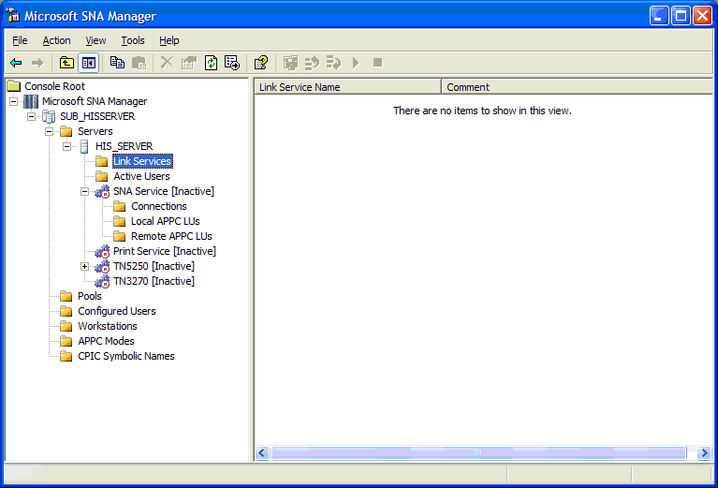

- Right click on Link Services | click on New | then Link Service.
- Select IP-DLC Link Service | then click on Add.
- Use the following the Link Service Configuration below quick reference as a guidelines to configure the IP-DLC Link Service.
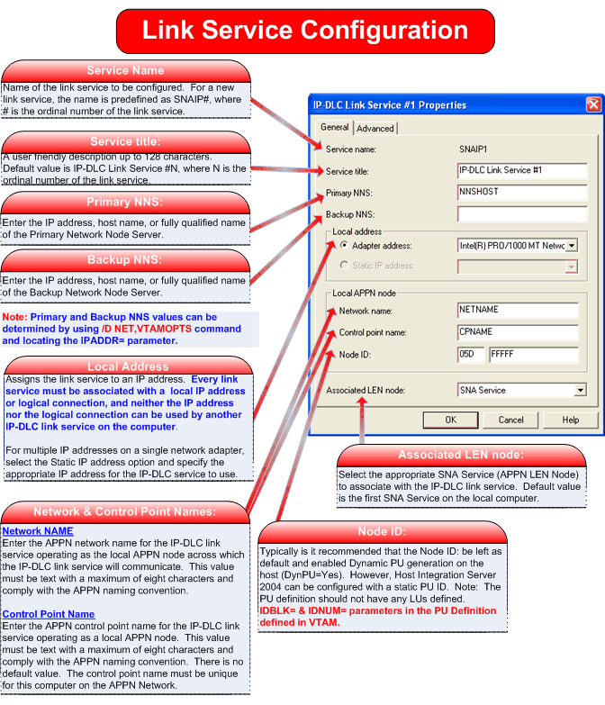
__

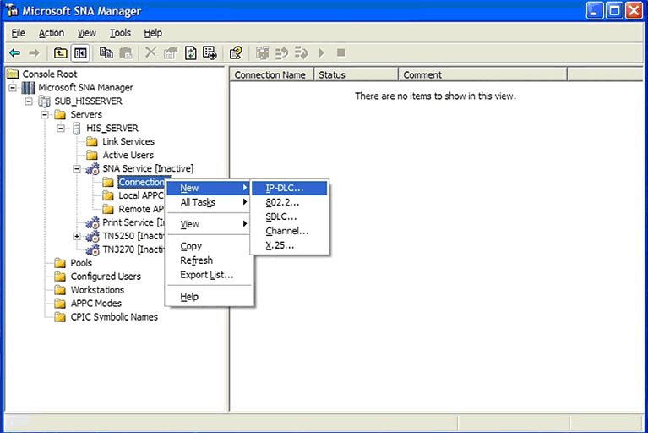

- From SNA Manager, Right click on Connections | New | IP-DLC.
- Use the following Connection Configuration quick reference as guidelines to configure the IP-DLC connection.
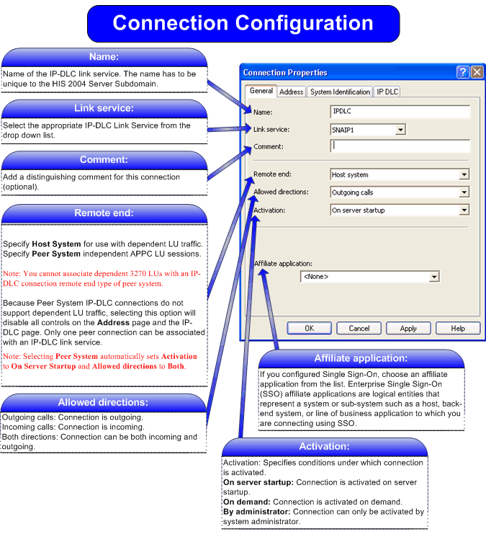

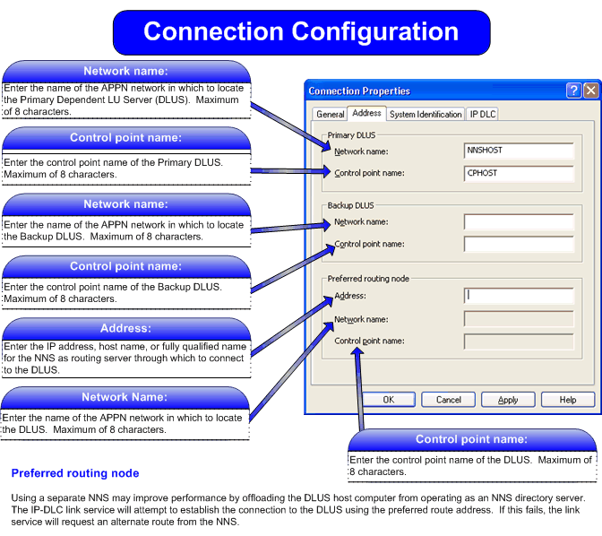

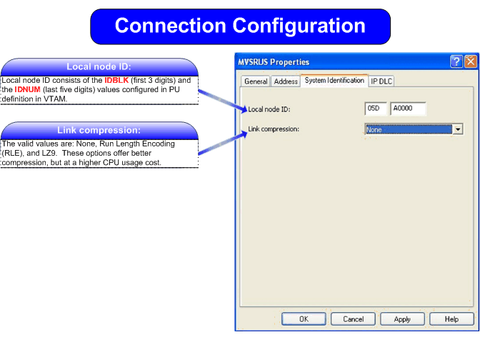

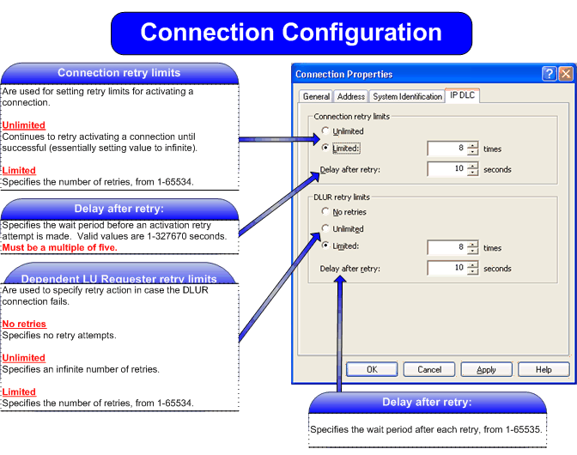

HIS 2004 Supported Features over IP-DLC

Base SNA Features
The following existing HIS 2004 SNA features are supported over the IP-DLC link service.
- LU types 0, 1, 2, 3 and 6.2 (dependent and independent)
- LUA, FMI, APPC and CPI-C APIs
- Dynamically Defined Dependent LUs (DDDLUs)
- Dynamic local LU, remote LU and connection configuration
- Incoming and outgoing calls
- Connection Activation at Server startup, on demand or by administrator
- SNA data compression
- PU concentration with the upstream link over IP-DLC
- NetView RUNCMD/Alerts (note that the IP-DLC link service does not generate alerts)

- HIS-compatible 3270 emulators
- HIS-compatible 5250 emulators
- APPC - 3270 Session Viewer (including the LU-LU Test feature)
- Host Print Service
- Data Integration Services
- Local and remote administration
- TN3270 server
- TN5250 server
- MSMQ_MQSeries Bridge
- Transaction Integrator (Formerly known as COMTI)

Fault Tolerance and Load Balancing Features

Fault Tolerance Features
Note that since the IP-DLC link service uses the APPN and HPR/IP protocols, it is automatically able to take advantage of the following fault tolerance features.
- A function of HPR is the ability to reroute sessions around a failure in the network, provided that an alternative route exists.
- IBM’s Parallel Sysplex technology and Multi-Node Persistent Sessions (MNPS) features together allow mainframe applications to be moved to a different processor with little or no impact to users when system or application failures occur on the mainframe. Parallel Sysplex is a clustering technology that provides high availability, load balancing and scalable growth to the large mainframe environment. MNPS allows sessions to be restarted on another system in a Parallel Sysplex after hardware or software failure. (See Networking Implications of S/390 Parallel Sysplex, http://www.networking.ibm.com/375/impsys.html, for further information.)
The IP-DLC link service cannot provide any fault tolerance capabilities to seamlessly handle local adapter failures. However, it may be possible to achieve some fault tolerance for adapter failure on the HIS system by using NIC teaming at the MAC layer.

Load Balancing Features
Load balancing for a single IP-DLC link service, with a single local IP address, over multiple adapter cards can be achieved using NIC Teaming at the MAC layer. The IP-DLC link service handles frames arriving out of sequence.

Scalability
The IP-DLC link service contains no hard limits of its own on the number of sessions or users. The scalability limits are the same as the existing 802.2 link service. The IP-DLC link service supports the HIS capacity of 30,000 simultaneous host sessions per server. (Note that four nodes are required to achieve 30,000 simultaneous host sessions and a single node supports a maximum of 15,000 simultaneous host sessions.)

IP-DLC Link Service Limitations
The key limitations with the IP-DLC link service implementation are as follows.
- Some network configurations are not supported. These are documented explicitly in the next section (Supported Network Configurations with Dependent Lus).
- The IP-DLC link service cannot be run as a distributed link service (DLS). However, given that there is an IP connection between the node’s server and the APPN network, it is unclear that there is any requirement to implement IP-DLC distributed link service.
- The PU Passthrough and Downstream connections are not supported over IP-DLC connections. It is not possible to have a one-to-one correspondence between upstream and downstream messages where the upstream connection is an IP-DLC connection.
- Each IP-DLC link service must use a different CP name from the SNA node service. This limitation is a consequence of the fact that each IP-DLC link service appears in the APPN network as a separate node and therefore must have a unique node name. This restriction must be enforced by the SNA Manager configuration panels.
- Each IP-DLC link service requires a unique local IP address. If multiple IP-DLC link services are required, each must have its own unique local IP address.
- A single IP-DLC link service cannot be shared by multiple SNA node services. Each SNA node service must use a different IP-DLC link service for IP-DLC connectivity.

Supported Network Configurations with Dependent LUs
This section shows how HIS with IP-DLC can be used to activate dependent LU sessions between HIS applications and host applications.

Direct IP-DLC Connection to Mainframe (DLUS) and NNS
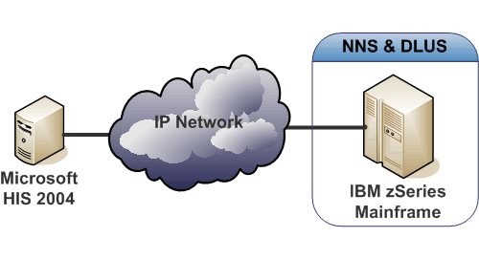

This configuration shows a single HIS node with a direct IP-DLC connection to a host running CS/390. In this scenario, the Mainframe is providing Network Node Services to the HIS node as well as providing the DLUS support required to support dependent LUs over the IP-DLC link service. HIS applications such as 3270 emulators can establish sessions with applications such as TSO/E on the Mainframe system.

It is possible to define multiple HIS internal PUs, each having its own IP-DLC connection. All of these PUs are multiplexed over the single HPR/IP link to the same DLUS on the same CS/390.

IP-DLC Connection to Mainframe (DLUS) through Separate NNS
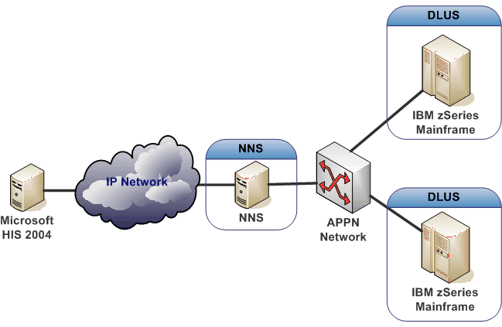

This scenario is similar to the previous one, except that Network Node Services are provided by another APPN NNS (for example, Data Connection Limited (DCL) SNAP-IX) rather than the Mainframe running the DLUS. Dependent LU support is provided through the NNS. The key requirement here is that the NNS and Mainframe must be part of the same reachable APPN network so that SNA sessions can be activated between them.

Separate IP-DLC Connections to Mainframe (DLUS) and NNS
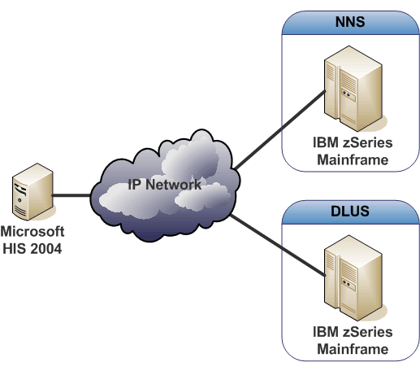

This scenario is similar to the previous one, except that the HIS node also has a direct APPN link to the Mainframe that is running the DLUS and on which the host applications reside. This allows the dependent LU traffic to flow directly between HIS and the Mainframe where the host applications are running, which avoids making the APPN Network Node Server a “bottleneck”.

Simultaneous IP-DLC Connections to Multiple Mainframe Hosts
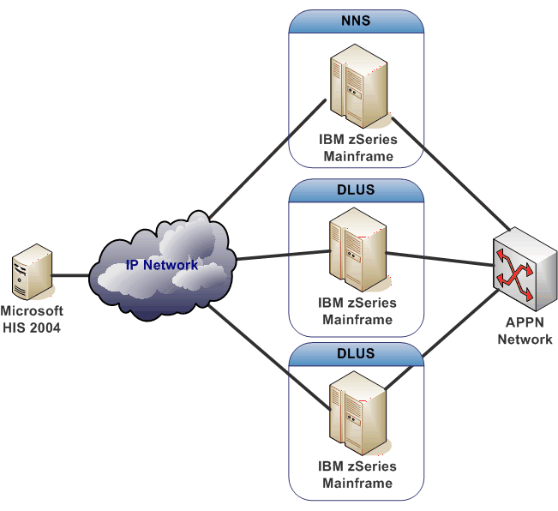

In this configuration, the HIS IP-DLC link service is supporting multiple internal HIS PUs but to different DLUS on different CS/390s. One Mainframe is providing Network Node Services and there are separate IP paths to each CS/390. Again, there is a requirement that all of the CS/390s must be part of the same APPN network.

PU Concentration with Multiple IP-DLC Host Connections

Again, this setup is similar to the last one except that the HIS 2004 box is providing PU concentration support for several downstream PUs (DSPUs). 3270 applications on the downstream PUs can communicate, through HIS 2004, with applications on all of the Mainframe machines.

No specific provision is required in the IP-DLC link service for this and it can be configured in the usual way. However, note that the link service used by the DSPUs cannot be IP-DLC.

Supported Network Configurations with Independent LUs
This section shows how HIS with IP-DLC can be used to activate independent LU sessions between HIS applications and applications on peer systems.

IP-DLC Connection to APPN “Peer-to-Peer” Network
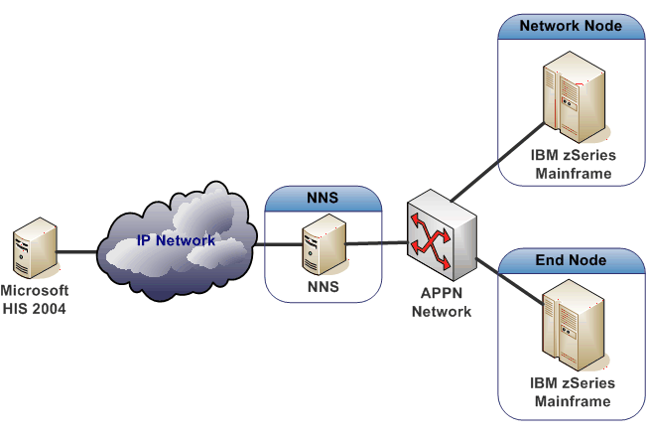

In this configuration, the Network Node Server provides access to the entire APPN network. Therefore, HIS is able to activate independent LU6.2 sessions with any reachable node in that network.

APPC and CPI-C transaction programs on HIS can communicate with partner transaction programs on any other node in the APPN network.

IP-DLC Connection to APPN “Peer-to-Peer” Network
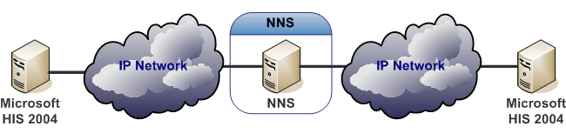

This configuration is similar to the last but also shows that two HIS nodes can communicate via the same (or possibly different) NNS.

Secure Deployment

UDP Sockets for HPR/IP Protocol Traffic
There are two specific concerns at the UDP sockets level:
- Attempts to activate connections that are not defined to HIS.
- Denial of Service Attacks by flooding the IP-DLC link service with datagrams or by sending large datagrams.
Any incoming frames from IP addresses that are not defined in HIS 2004 configuration are rejected at the earliest point in the IP-DLC link service code (this prevents the main SNA node service from being attacked).

When receiving datagrams, the IP-DLC link service checks the length before copying the data into internal data areas and discards any that are too long.

Firewall Configuration
The IP-DLC protocol is based on 5 hard coded UDP ports 12000-12004. The traffic should be enabled in both directions.
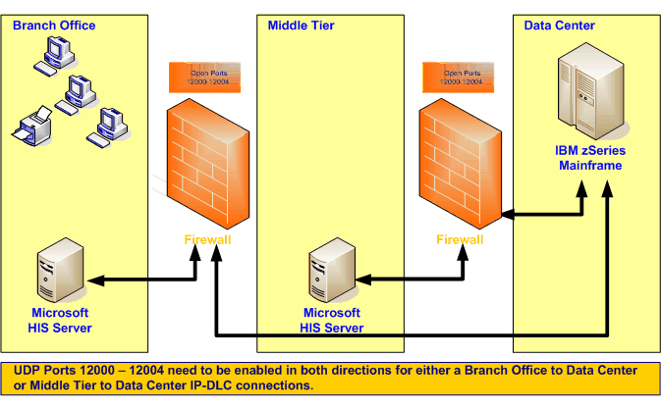

Securing HIS 2004 IP-DLC Connections
Since the IP-DLC link service uses UDP/IP, the Windows IPSec feature can be used to provide end to end data security over the IP-DLC link service. Configuration of IPSec is handled independently by Windows. No specific configuration is required for the IP-DLC link service.

Problem Determination and Troubleshooting
The IP-DLC link service uses several methods of logging and tracing which are fully integrated with the existing HIS diagnostic functions. They are controlled by the SNA Trace Utility and can be viewed with the HIS Trace Viewer.

The problem determination facilities range from high-level event logging to detailed tracing for administrators and developers. Also included are off-line debugging aids that can be used in the event of a crash. Moreover, HIS 2004 includes performance counters which can be used for troubleshooting purposes.

Event Logs
The IP-DLC link service uses the Windows event log to record events which may be of interest to administrators in troubleshooting problems.

Four types of IP-DLC Event logs
Each is uniquely identified by Event Category (Base, Tools, APPN, LDLC) and Event ID.
- Fatal (unrecoverable error) - severity event message.
- Problem (degrades link service operation) – ‘error’ event log.
- Exception (may degrade link service operation) – ‘warning’ event log.
- Audit (normal event, for admin use) – ‘informational’ event log.

Typical IP-DLC Link Service Event Log Entry

Event Type: Warning
Event Source: SNA IP-DLC Link Service
Event Category: APPN
Event ID: 585
Date: 8/12/2004
Time: 6:06:15 PM
User: HISERVER\HISADMIN
Computer: HISERVER
Description:
CPSVRMGR pipe session failure
DLUS partner = MVSRUS.P390SSCP
Sense Code = 0x08a00008

Cause:
CPSVRMGR pipe failed to specified DLUS. This error may occur during normal deactivation of the CPSVRMGR pipe when the DLUS no longer requires it. Note that this message could be logged during normal node shutdown.

Effect:
Any PUs using the specified DLUS are deactivated (that is, DACTPU(cold)) is sent. DLUR may attempt to contact one or more backup DLUSs, if configured.

Action:
If a pipe with backup DLUS is not initiated automatically manually restart any required PUs

For more information, see Help and Support Center at http://go.microsoft.com/fwlink/events.asp.
Data:
0000: 53 4e 41 49 50 31 2c 20 SNAIP1,
0008: 31 1

Note: Administrators can either allow or suppress event logs based on severity by changing the Default Audit Log Level on the ‘Subdomain Properties: Error / Audit Logging’ property sheet in SNA Manager. No changes are required to the configuration interface (see Figure below).
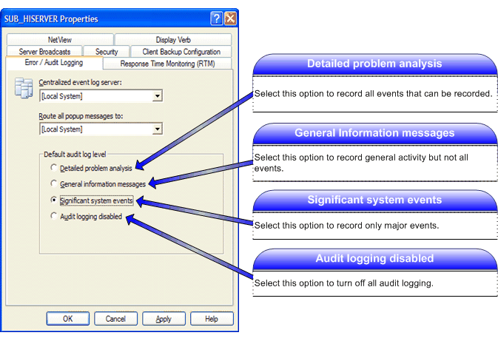

UDP Trace
The IP-DLC link service traces the contents of all UDP packets that it sends and receives over the IP network. This trace appears in the HIS Message Trace files, LINKMSGX.ATF.
UDP tracing is configured by the HIS Trace Initiator on a per link service basis (Message Trace, Level 2 Messages).

Internal Trace
The internal tracing from the IP-DLC link service uses the standard HIS internal tracing mechanism and appears in the HIS Internal Trace files, LINKINTX.ATF. It is configured by the HIS Trace Initiator on a per link service basis.

Crash Dumps
In the event of a crash, Dr Watson can generate a dump of the IP-DLC link service process data. Crash Dumps can be very useful to diagnose problems which cannot be determined by through other diagnostic forms and sent to Product Support Services (PSS) upon request.

Diagnostic Gathering Tool
Diagnosing Configuration Issues
Configuration errors are typically diagnosed by examining the application event log. PSS may also request IP-DLC Link Service traces to help diagnose the issue.

Detailed Diagnostics Tool
The Detailed Diagnostics Tool is a separate executable that queries the current state of an IP-DLC link service and then outputs the information to a text file. There are two methods of running the detailed diagnostics tool. First via a command line as shown below:
Qryipdlc Command Line Syntax
C:\Program Files\Microsoft Host Integration Server\system>qryipdlc
Microsoft (R) Microsoft Host Integration Server IP-DLC Detailed Diagnostics Tool Version 6.0.1701.0 Copyright (C) 1993-2004 Microsoft Corporation

The syntax of this command is:

QRYIPDLC [/S server-name] [/L link-service-names] [/A] /O output-file-name

/? Prints this usage message.

/S server-name
The name of the server on which the IP-DLC link services
are running. If omitted, the local machine is assumed.

/L link-service-names
The names of the IP-DLC link services to query, separated
by semicolons (e.g. snaip1;snaip2). If omitted, all IP-DLC
link services will be queried.
/A Append to the output file.

/O output-file-name
The name of the file to write the diagnostics to.

An example of a typical command line syntax (if running on the HIS 2004 machine) is shown below:

Qryipdlc /L SNAIP1 /O IPDLCLOG.txt

Qryipdlc from Diagnostics Tool (Display.exe)
Secondly, you can execute Qryipdlc via the Diagnostics Utility from the Tools menu in SNA Server manager. Configure the Server name or IP Address in the appropriate field and click on Status button. The Diagnostics tool will automatically query all link services configured on the server. A copy of the log file is automatically saved to the traces directory with the name of QueryIPDLC.txt.

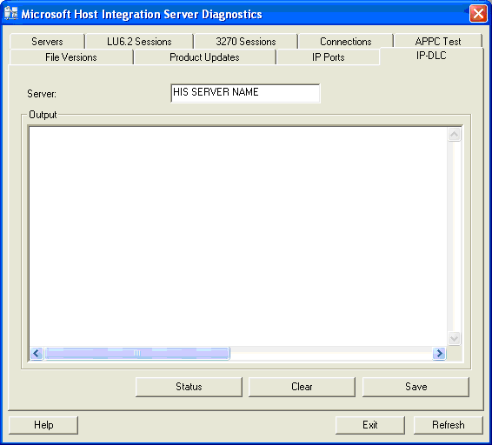

QRYIPDLC Sample Output
The Qryipdlc utility interrogates the selected link service(s) and prints detailed state information (either to a file specified via command line or QueryIPDLC.txt via Diagnostics tool). Note however, that this information is intended for use by Product Support Services (PSS) to aid in problem diagnosis. The file is retained on disk so that it can be sent to PSS if necessary.

The following is an excerpt from a Qryipdlc log (see Appendix C for a complete Qryipdlc log).

Detailed Diagnostics for IP-DLC Link Service SNAIP1 on HISERVER Created at Tue Aug 03 2004 16:46:52 Pacific Time.

Link Service Status
Create parameters:
Node type Branch Network Node
FQCP name MYNET.HISERVER
CP alias HISERVER
Node ID (IDBLK/IDNUM) X'05D.FFFFF'

Network Node Server Status
LS name | State | Adjacent CP name | Default NNS | Remote address
---------+------------------+-------------------+-------------+--------------------
@N000001 | Active | MVSRUS.P390SSCP | Yes | MVSRUS

Peer Connection Status

Host Connection Status
Connection name | Internal LS state | External LS state | External LS name | Preferred route
----------------+-------------------+-------------------+------------------+-------
MVSRUS | Active | N/A | None | None

Internal Link Station Status
Link station name MVSRUS
Determined data:
Link station state Active
Link station sub-state Active
Adjacent CP name IPDLCNET.@C000001
Adjacent CP type End Node

External Link Station Status

RTP Connection Status
RTP connection name | First hop LS name | Destination node name | COS name | # active sessions
--------------------+-------------------+-----------------------+----------+-------
@R000001 | @N000001 | MVSRUS.P390SSCP | CPSVCMG | 2
@R000002 | @N000001 | MVSRUS.P390SSCP | SNASVCMG | 2
@R000003 | @N000001 | MVSRUS.P390SSCP | RSETUP | 0
@R000007 | @N000001 | MVSRUS.P390SSCP | #CONNECT | 1
Performance Monitor Statistics
The IP-DLC link service supports performance monitor counters. The following HIS performance monitor counters are included when installing an IP-DLC link service:
- TotalBytesThroughput
- TotalFramesThroughput
- TotalBytesReceived
- TotalBytesTransmitted
- TotalFramesReceived
- TotalFramesTransmitted
- SuccessfulConnects
- ConnectionFailures
- AdapterFailures.
Note: all of the counters above are visible in the Windows Performance Monitor while the IP-DLC link service is running.

APPENDIX A - Concepts and Terminology
This section is a brief introduction to the terminology and concepts that are referred to in this document, including APPN and HPR. For a more complete description of APPN and HPR, a good book is “Inside APPN and HPR: The Essential Guide to New SNA” by Brian Dorling, Peter Lenhard, Peter Lennon, Velibor Uskokovic, Prentice Hall, 1997.

Session
A session is a logical connection between two network accessible units (NAUs). The most common example of an NAU is a Logical Unit (see below).

Physical Unit (PU)
The component that manages and monitors the resources (such as attached links and adjacent link stations) associated with a node. This term applies to non-APPN nodes only.

Logical Unit (LU)
A Logical Unit (LU) is a port through which an application or end user accesses the SNA network in order to communicate with another application or end user. An LU may be capable of supporting many sessions with other LUs.

Dependent LU
A Dependent LU is an LU that requires assistance from a mainframe to establish a session with another LU. These are also sometimes referred to as “old LUs”.

Independent LU
An Independent LU is an LU that can establish a session with another LU without the assistance of a mainframe.

APPN
Advanced Peer-to-Peer Networking (APPN) is a network architecture that supports distributed network control. It makes networks easier to configure and use, provides centralized network management, and supports flexible connectivity.

APPN Nodes

Introduction
APPN nodes include systems of various sizes, such as mainframes using CS/390, Solaris servers running DCL’s SNAP-IX, PCs running CS/NT and the Application System/400 (AS/400).
In an APPN network, nodes can be one of the following types.
- Network Nodes (NN)
- End Nodes (EN)
- Branch Network Nodes (BrNN)
- Low-entry networking nodes (LEN nodes)
Each node in an APPN network is connected to at least one other node in the APPN network. Where supported, CP-CP (Control Point to Control Point) sessions are established over these connections to adjacent nodes (nodes in the same network that can establish direct connections without going through a third node). CP-CP sessions are used to exchange network topology information, request the location of network resources and manage sessions. All of the nodes in an APPN network share a common network name.

Network Node
A Network Node provides distributed directory and routing services for all LUs in its “domain”, where its domain is all directly attached End Nodes and LEN nodes that are using the services of the Network Node. The Network Node is referred to as the Network Node Server (NNS) for those directly attached End Nodes and LEN nodes.
A Network Node provides the following services:
- LU-LU session services for its local LUs
- directory searches and route selection for all LUs in its domain
- intermediate session routing for sessions between LUs on different nodes
- routing for Management Services (MS) data, such as alerts, between a served End Node or LEN node and an MS focal point.

End Node
An End Node is an end point in an APPN network. It maintains directory information only for local resources. An APPN End Node can independently establish sessions between local LUs and LUs on adjacent nodes. For sessions with LUs on nodes not directly connected to the End Node, an End Node requests routing and directory information from its Network Node Server using CP-CP sessions.
End Nodes can register their local LUs with their Network Node Server. This capability means the network operator at the Network Node Server does not have to predefine the names of all LUs on the attached End Nodes to which the Network Node provides services.
An End Node can be attached to multiple network nodes, but it can have CP-CP sessions active with only one Network Node at a time: its Network Node Server. The other Network Nodes can be used only to provide intermediate routing for the end node or as substitute Network Node servers if the main Network Node Server becomes unavailable.
An End Node can also have a direct connection to another End Node or LEN node, but CP-CP sessions are never established between the two nodes.

LEN Node
A LEN Node is a type 2.1 node that uses independent LU 6.2 protocols, but does not support CP-CP sessions. It can be connected to a Network Node or End Node but does not support APPN functions. Host Integration Server’s existing SNA node is a LEN node.
A Network Node can provide routing services for an attached LEN node, enabling the LEN node to participate in an APPN network without requiring links to be defined between the LEN node and all of the nodes in the APPN network.
LUs in the APPN network with which the LEN node may want to establish sessions must be defined to the LEN node as if they reside on the LEN node's Network Node server. The LEN node establishes sessions with LUs defined to be contacted through its Network Node Server. The Network Node routes the session through the APPN network to the node in the network where the LU actually resides.
LUs on the LEN node must be predefined to the Network Node that serves the LEN node. LU resources on LEN nodes (unlike those on End Nodes) cannot be registered on the Network Node Server by the LEN node.
When a LEN node's only link is to an End Node, the LEN node can communicate only with LUs on the End Node through the direct link between the two nodes. This is because an End Node cannot provide intermediate routing.

Branch Network Node
The Branch Network Node (BrNN) combines the functions of a Network Node and an End Node. As the name implies, a BrNN can be used to subdivide a network into a backbone network and attached branch networks.
- To the backbone network, the BrNN appears as an End Node, connected to its Network Node Server (NNS) in the backbone network.
- The nodes in the backbone network are not aware of the nodes within the branch, reducing the amount of topology information that must be stored.
- Because the BrNN appears as an End Node, it does not receive topology information from the backbone network (topology information is transmitted only between Network Nodes) reducing the amount of network overhead traffic flowing into the branch network.
- The BrNN registers all resources in the branch with its NNS as though they were located on the BrNN itself. This means that the nodes in the backbone network can locate resources in the branch without having to be aware of the separate nodes in the branch.
- To the branch network, the BrNN appears as a Network Node, acting as the NNS for End Nodes and LEN Nodes in the branch.

High Performance Routing
High Performance Routing (HPR) is an extension of the APPN architecture. HPR provides the following functions.
- Rapid Transport Protocol (RTP) minimizes processing cycles and storage requirements for routing network layer packets through intermediate nodes on a session route.
- Automatic network routing (ANR) enables APPN networks to automatically reroute sessions if a portion of the originally computed route fails.

IP-DLC
IP-DLC is the HIS feature that provides SNA connectivity for applications using dependent and independent sessions over a native IP network. It implements the “HPR/IP” protocol, which is also known as “HPR over IP” or “Enterprise Extender”. Each SNA packet is transmitted natively across the IP network as a UDP datagram.

Dependent LU Requester/Server
Dependent LU Requester (DLUR) function enables sessions for dependent LUs to reside on remote nodes across an APPN network, instead of requiring a direct connection to the host.
DLUR works in conjunction with Dependent LU Server (DLUS) at the host. Together, they route sessions across the network from dependent LUs in the APPN network to the DLUS host. The route to the host can span multiple nodes and can take advantage of APPN's network management, dynamic resource location, and route calculation facilities.
If the local node is a Network Node, dependent LUs on downstream computers can also use passthrough DLUR, in the same way that LUs internal to the node do, to access the host across the network.

APPENDIX B - Glossary
802.2 | IEEE Logical Link Control 802.2
AFTP | APPC File Transfer Protocol
ANR | HPR Automatic Network Routing
APPN | Advanced Peer-to-Peer Networking
BrNN | APPN Branch Network Node
CP | APPN node Control Point
CP-CP | Control Point to Control Point
CS/390 | IBM eNetwork Communications Server for OS/390 product, previously known as VTAM (Virtual Telecommunications Access Method)
CS/NT | IBM eNetwork Communications Server for Windows NT
DDDLU | Dynamically Defined Dependent LU
DLC | Data Link Control
DLS | Distributed Link Service
DLUR | APPN Dependent LU Requester
DLUS | APPN Dependent LU Server
DSPU | Downstream PU
EN | APPN End Node
FEP | IBM Front-End Processor
HPR | High-Performance Routing
IP | IETF Internet Protocol
IP-DLC | A mechanism to allow SNA communications over Internet Protocol (IP) networks, providing the benefits of High-Performance Routing (HPR) functionality for the SNA traffic. Also known as HPR/IP (HPR over IP) and Enterprise Extender
IPSec | IETF IP Security Protocol
LDLC | Enterprise Extender Logical Data Link Control (sometimes referred to as Lightweight Data Link Control)
LEN | SNA Low-entry Networking Node
LU | SNA Logical Unit
LU6.2 | SNA Logical Unit type 6.2
MNPS | Multi-Node Persistent Sessions
MS | SNA Management Services
NN | APPN Network Node
NNS | APPN Network Node Server
RTP | HPR Rapid Transport Protocol
OSA Express | IBM’s family of high-speed adapters for zSeries and S/390 mainframes
PU | SNA Physical Unit
SNA Switch | Cisco SNA switching product
UDP | IETF User Datagram Protocol

APPENDIX C - Qryipdlc (Full Log)
Detailed Diagnostics for IP-DLC Link Service SNAIP1 on HISERVER
Created at Tue Aug 03 2004 16:46:52 Paci

Link Service Status
===================
Create parameters:
Node type Branch Network Node
FQCP name MYNET.HISERVER
CP alias HISERVER
Node ID (IDBLK/IDNUM) X'05D.FFFFF'
Mode to COS mapping supported No
MDS and MS capabilities supported No
Maximum locates 1000
Directory cache size 1000
Maximum directory entries Unlimited
Locate timeout 540 seconds
Register resources with NN All
Size of MDS send alert queue 16
Size of COS database weights cache 8
Size of topology database routing tree cache 8
Maximum number of uses of a cache tree 1
Maximum number of nodes in topology database Unlimited
Maximum number of TGs in topology database Unlimited
Maximum ISR sessions 30000
Upper threshold for ISR sessions 29000
Lower threshold for ISR sessions 28000
Maximum ISR RU size 61440 bytes
ISR receive pacing window size 63
NN route additional resistance 0
HPR support Control flows
Program Temporary Fix (PTF) array X'060000000000001E8000'
Disable branch awareness No
Uptime 4931.85 seconds
Memory available 226993 KB
Memory used 353 KB
NN status Uncongested
NN resource sequence number 2
Good XIDs for defined link stations 2
Bad XIDs for defined link stations 0
Good XIDs for dynamic link stations 0
Bad XIDs for dynamic link stations 0
NNS support for registration of DLUS-served LUs Yes
NNS support for receipt of different owning CP name No
Network node server name MVSRUS.P390SSCP
Current ISR sessions 0

Network Node Server Status
==========================
LS name | State | Adjacent CP name | Default NNS | Remote address
---------+------------------+-------------------+-------------+------------------------
@N000001 | Active | MVSRUS.P390SSCP | Yes | MVSRUS

Link station name @N000001
Determined data:
Link station state Active
Link station sub-state Active
Adjacent CP name MVSRUS.P390SSCP
Adjacent CP type Network Node
TG number 21
Link station statistics:
XID bytes received 825
Message bytes received 92898
XID frames received 5
Message frames received 964
XID bytes sent 565
Message bytes sent 70868
XID frames sent 6
Message frames sent 1040
Invalid frames received 0
Control frames received 0
Control frames sent 0
Echo responses received 0
Current delay 0 ms
Maximum delay 0 ms
Minimum delay 0 ms
Time since maximum delay 0.00 seconds
Successful XID exchanges 1
Unsuccessful XID exchanges 0
Start time 0.30 seconds
Stop time 0.00 seconds
Uptime 4931.55 seconds
Time in current state 4931.55 seconds
Deactivation cause None
Auto activation support By remote node
Link station role Secondary
Adjacent node ID (IDBLK/IDNUM) X'FFF.186DF'
Maximum send BTU size 1493 bytes
Local address 157.59.127.143 (LSAP 4)
Adjacent CP is a BrNN No
HPR support Control flows
ANR label X'90FF'
Reverse ANR label X'80A7006001000000'
Defined data:
Adjacent CP type Network Node
Destination address IPv4: MVSRUS (172.30.252.27) (LSAP 4)
Limited resource No
Default NNS Yes
CP-CP sessions supported Yes
Auto activation support No
Link station attributes X'00000000'
Target pacing count 7
Maximum send BTU size 1493 bytes
Maximum receive BTU size 1493 bytes
Link station role Negotiable
Maximum I-frames that can be received 7
Maximum activation attempts Unlimited
Activation delay timer 25 seconds

Peer Connection Status
======================

Host Connection Status
======================
Connection name | Internal LS state | External LS state | External LS name | Preferred route
----------------+-------------------+-------------------+------------------+-------
MVSRUS | Active | N/A | None | None

Connection name MVSRUS
Internal LS state Active
External LS state N/A
External LS name None
Defined data:
Address:
Primary DLUS name MVSRUS.P390SSCP
Backup DLUS name
Preferred route None
System Identification:
Local node ID X'05D.A003A'
IP-DLC:
DLUR retry limit 8
Delay after retry 10 seconds

Internal Link Station Status
============================
Link station name MVSRUS
Determined data:
Link station state Active
Link station sub-state Active
Adjacent CP name IPDLCNET.@C000001
Adjacent CP type End Node
Link station statistics:
XID bytes received 300
Message bytes received 3560
XID frames received 3
Message frames received 278
XID bytes sent 178
Message bytes sent 41111
XID frames sent 3
Message frames sent 227
Invalid frames received 0
Control frames received 30
Control frames sent 22
Echo responses received 0
Current delay 0 ms
Maximum delay 0 ms
Minimum delay 0 ms
Time since maximum delay 0.00 seconds
Successful XID exchanges 1
Unsuccessful XID exchanges 0
Start time 4.71 seconds
Stop time 0.00 seconds
Uptime 4927.14 seconds
Time in current state 4927.14 seconds
Deactivation cause None
Auto activation support By local node, By remote node
Link station role Primary
Adjacent node ID (IDBLK/IDNUM) X'05D.A003A'
Maximum send BTU size 1493 bytes
Currently active sessions 7
Currently active ISR sessions 0
Currently active LU-LU sessions 1
Currently active SSCP sessions 6
Defined data:
Adjacent CP name IPDLCNET.@C000001
Adjacent node ID (IDBLK/IDNUM) X'05D.A003A'
Local node ID (IDBLK/IDNUM) X'000.00000'
Adjacent CP type Back Level LEN Node
DSPU name @C000001
DLUS name MVSRUS.P390SSCP
Backup DLUS name
DLUS retry timeout 10 seconds
DLUS retry limit 8
Auto activation support Yes
Link station attributes X'00000000'
Target pacing count 7
Maximum send BTU size 1493 bytes
Maximum receive BTU size 1493 bytes
Link station role Primary
Maximum I-frames that can be received 7
Maximum activation attempts 10
Activation delay timer 25 seconds

External Link Station Status
============================

Directory Status
================
Maximum number of cache entries 1000
Current cache entry count 0
Current home entry count 8
Current registered entry count 0
Current directory entry count 8
Cache hits 0
Cache misses 0
Locates in 0
Broadcast locates in 1
Locates out 1
Broadcast locates out 0
Unsuccessful locates 0
Unsuccessful broadcast locates 0
Total outstanding locates 0

Resource name | Resource type | Resource location
------------------+----------------------+------------------
MYNET.HISERVER | NNCP resource | Local
MYNET.HISERVER | LU resource | Local
APPN.L3163A02 | DLUR LU resource | Local
APPN.L3163A03 | DLUR LU resource | Local
APPN.L3163A04 | DLUR LU resource | Local
APPN.L3163A05 | DLUR LU resource | Local
APPN.L3163A06 | DLUR LU resource | Local

Resource name MYNET.HISERVER
Resource type NNCP resource
Parent name
Parent resource type None
Directory entry type Local resource
Resource location Local
Real owning CP type None
Real owning CP name
Supplier CP type None
Supplier CP name

Resource name MYNET.HISERVER
Resource type LU resource
Parent name MYNET.HISERVER
Parent resource type NNCP resource
Directory entry type Local resource
Resource location Local
Real owning CP type None
Real owning CP name
Supplier CP type None
Supplier CP name

Resource name APPN.L3163A02
Resource type DLUR LU resource
Parent name MYNET.HISERVER
Parent resource type NNCP resource
Directory entry type Local resource
Resource location Local
Real owning CP type None
Real owning CP name
Supplier CP type None
Supplier CP name

Resource name APPN.L3163A03
Resource type DLUR LU resource
Parent name MYNET.HISERVER
Parent resource type NNCP resource
Directory entry type Local resource
Resource location Local
Real owning CP type None
Real owning CP name
Supplier CP type None
Supplier CP name

Resource name APPN.L3163A04
Resource type DLUR LU resource
Parent name MYNET.HISERVER
Parent resource type NNCP resource
Directory entry type Local resource
Resource location Local
Real owning CP type None
Real owning CP name
Supplier CP type None
Supplier CP name

Resource name APPN.L3163A05
Resource type DLUR LU resource
Parent name MYNET.HISERVER
Parent resource type NNCP resource
Directory entry type Local resource
Resource location Local
Real owning CP type None
Real owning CP name
Supplier CP type None
Supplier CP name

Resource name APPN.L3163A06
Resource type DLUR LU resource
Parent name MYNET.HISERVER
Parent resource type NNCP resource
Directory entry type Local resource
Resource location Local
Real owning CP type None
Real owning CP name
Supplier CP type None
Supplier CP name

DLUS Status
===========
DLUS name | Pipe state | # active PUs
------------------+------------------+-------------
MVSRUS.P390SSCP | Active | 1

DLUS name MVSRUS.P390SSCP
Pipe state Active
Number of active PUs 1
DLUS pipe statistics:
REQACTPUs sent 1
REQACTPU responses received 1
ACTPUs received 1
ACTPU responses sent 1
REQDACTPUs sent 0
REQDACTPU responses received 0
DACTPUs received 0
DACTPU responses sent 0
ACTLUs received 6
ACTLU responses sent 5
DACTLUs received 0
DACTLU responses sent 0
SSCP-PU MUs received 0
SSCP-PU MUs sent 0
SSCP-LU MUs received 55
SSCP-LU MUs sent 71
Persistent pipe support Not supported
Persistent pipe No

DLUR Status
===========
PU name | PU identifier | Active DLUS name | PU status | DLUS

session status
---------+---------------+-------------------+-------------------------+-----------
@C000001 | X'05D.A003A' | MVSRUS.P390SSCP | Active | Active

LU name | PU name | NAU address | Primary LU name
---------+----------+-------------+----------------
L3163A02 | @C000001 | 2 |
L3163A03 | @C000001 | 3 |
L3163A04 | @C000001 | 4 |
L3163A05 | @C000001 | 5 | MVSRUS.A06TSO01
L3163A06 | @C000001 | 6 |

PU name @C000001
Defined DLUS name MVSRUS.P390SSCP
Backup DLUS name
PU identifier (IDBLK/IDNUM) X'05D.A003A'
Active DLUS name MVSRUS.P390SSCP
ANS support Stop
PU status Active
DLUS session status Active
FQPCID used on pipe X'E32F2405AD4D24C2' (MYNET.HISERVER )
DLUS retry timeout 10 seconds
DLUS retry limit 8

Session Status
==============
FQPCID | COS name | ISR session state | Primary LS name | Secondary LS name
--------------------+----------+-------------------+-----------------+-------------
FQPCID | COS name | ISR session state | Primary LS name | Secondary LS name
--------------------+----------+-------------------+-----------------+-------------
X'DD238E7F72E3A732' | #CONNECT | Active | @R000007 | MVSRUS

FQPCID X'DD238E7F72E3A732' (MVSRUS.P390SSCP )
Transmission priority Medium
Class of Service name #CONNECT
Limited resource No
Primary hop session statistics:
Session receive RU size 1024 bytes
Session send RU size 3840 bytes
Maximum send BTU size 1359 bytes
Minimum send BTU size 1464 bytes
Maximum send pacing window size 1
Current send pacing window size 1
Send residual pacing count 0
Maximum receive pacing window size 63
Current receive pacing window size 63
Receive residual pacing count 62
Number of data frames sent 0
Number of FMD data frames sent 0
Number of data bytes sent 0
Number of FMD data bytes sent 0
Number of data frames received 2
Number of FMD data frames received 2
Number of data bytes received 1121
Number of FMD data bytes received 1121
Session ID high byte 2
Session ID low byte 0
ODAI bit set 1
Link station name @R000007
Type of pacing in use Adaptive
Secondary hop session statistics:
Session receive RU size 3840 bytes
Session send RU size 1024 bytes
Maximum send BTU size 1493 bytes
Minimum send BTU size 1493 bytes
Maximum send pacing window size 1
Current send pacing window size 1
Send residual pacing count 0
Maximum receive pacing window size 0
Current receive pacing window size 0
Receive residual pacing count 0
Number of data frames sent 2
Number of FMD data frames sent 2
Number of data bytes sent 1121
Number of FMD data bytes sent 1121
Number of data frames received 0
Number of FMD data frames received 0
Number of data bytes received 0
Number of FMD data bytes received 0
Session ID high byte 1
Session ID low byte 5
ODAI bit set 0
Link station name MVSRUS
Type of pacing in use None
ISR session state Active

RTP Connection Status
=====================
RTP connection name | First hop LS name | Destination node name | COS name | # active sessions
--------------------+-------------------+-----------------------+----------+-------@R000001 | @N000001 | MVSRUS.P390SSCP | CPSVCMG | 2
@R000002 | @N000001 | MVSRUS.P390SSCP | SNASVCMG | 2
@R000003 | @N000001 | MVSRUS.P390SSCP | RSETUP | 0
@R000007 | @N000001 | MVSRUS.P390SSCP | #CONNECT | 1

RTP connection name @R000001
LS name of first hop @N000001
Destination node name MVSRUS.P390SSCP
ISR boundary function No
Class of Service name CPSVCMG
Maximum BTU size 1464 bytes
Liveness timer 0 seconds
Local TCID X'0000000001000000'
Remote TCID X'1A05404C0000013B'
RTP statistics:
Bytes sent 1332
Bytes received 1021
Bytes resent 0
Bytes discarded 0
Packets sent 446
Packets received 444
Packets resent 0
Packets discarded 0
Gaps detected 0
Current send rate 2663 Kbits/s
Maximum send rate 4915 Kbits/s
Minimum send rate 9 Kbits/s
Current receive rate 0 Kbits/s
Maximum receive rate 33 Kbits/s
Minimum receive rate 0 Kbits/s
Burst size 16646 bytes
Total uptime 4931 seconds
Smoothed round-trip time 164 ms
Last round-trip time 20 ms
SHORT_REQ timer duration 880 ms
Number of SHORT_REQ timeouts 1
Number of liveness timeouts 0
Invalid SNA frames received 0
SC frames received 2
SC frames sent 2
Number of active sessions 2
ARB mode Responsive mode

RTP connection name @R000002
LS name of first hop @N000001
Destination node name MVSRUS.P390SSCP
ISR boundary function No
Class of Service name SNASVCMG
Maximum BTU size 1464 bytes
Liveness timer 0 seconds
Local TCID X'0000000002000000'
Remote TCID X'1A05404E00000141'
RTP statistics:
Bytes sent 10444
Bytes received 17817
Bytes resent 0
Bytes discarded 0
Packets sent 179
Packets received 160
Packets resent 0
Packets discarded 0
Gaps detected 0
Current send rate 200 Kbits/s
Maximum send rate 200 Kbits/s
Minimum send rate 102 Kbits/s
Current receive rate 0 Kbits/s
Maximum receive rate 13 Kbits/s
Minimum receive rate 0 Kbits/s
Burst size 5000 bytes
Total uptime 4926 seconds
Smoothed round-trip time 313 ms
Last round-trip time 30 ms
SHORT_REQ timer duration 7752 ms
Number of SHORT_REQ timeouts 6
Number of liveness timeouts 0
Invalid SNA frames received 0
SC frames received 2
SC frames sent 2
Number of active sessions 2
ARB mode Responsive mode

RTP connection name @R000003
LS name of first hop @N000001
Destination node name MVSRUS.P390SSCP
ISR boundary function No
Class of Service name RSETUP
Maximum BTU size 1464 bytes
Liveness timer 0 seconds
Local TCID X'0000000003000000'
Remote TCID X'1A05404D0000012E'
RTP statistics:
Bytes sent 1415
Bytes received 1225
Bytes resent 0
Bytes discarded 0
Packets sent 18
Packets received 19
Packets resent 0
Packets discarded 0
Gaps detected 0
Current send rate 4915 Kbits/s
Maximum send rate 4915 Kbits/s
Minimum send rate 4915 Kbits/s
Current receive rate 0 Kbits/s
Maximum receive rate 0 Kbits/s
Minimum receive rate 0 Kbits/s
Burst size 30720 bytes
Total uptime 4927 seconds
Smoothed round-trip time 109 ms
Last round-trip time 90 ms
SHORT_REQ timer duration 626 ms
Number of SHORT_REQ timeouts 0
Number of liveness timeouts 0
Invalid SNA frames received 0
SC frames received 0
SC frames sent 0
Number of active sessions 0
ARB mode Responsive mode

RTP connection name @R000007
LS name of first hop @N000001
Destination node name MVSRUS.P390SSCP
ISR boundary function No
Class of Service name #CONNECT
Maximum BTU size 1464 bytes
Liveness timer 0 seconds
Local TCID X'0000000007000000'
Remote TCID X'1A05405200000140'
RTP statistics:
Bytes sent 210
Bytes received 1330
Bytes resent 0
Bytes discarded 0
Packets sent 13
Packets received 10
Packets resent 0
Packets discarded 0
Gaps detected 0
Current send rate 200 Kbits/s
Maximum send rate 200 Kbits/s
Minimum send rate 200 Kbits/s
Current receive rate 36 Kbits/s
Maximum receive rate 36 Kbits/s
Minimum receive rate 0 Kbits/s
Burst size 5000 bytes
Total uptime 480 seconds
Smoothed round-trip time 391 ms
Last round-trip time 50 ms
SHORT_REQ timer duration 8392 ms
Number of SHORT_REQ timeouts 1
Number of liveness timeouts 0
Invalid SNA frames received 0
SC frames received 2
SC frames sent 1
Number of active sessions 1
ARB mode Responsive mode

Topology Information
====================
TG destination node | TG number | Branch link type | Operative | CP-CP sessions active
--------------------+-----------+--------------------+-----------+-----------------
MVSRUS.P390SSCP | 21 | Uplink | Yes | Yes
IPDLCNET.@C000001 | 1 | Downlink | Yes | No

TG destination node MVSRUS.P390SSCP
TG destination node type Network Node
TG number 21
Resource Sequence Number 0
TG status HPR, RTP, CP-CP sessions, Operative
TG characteristics:
Effective capacity 94 Mbits/s
Connection cost 0
Byte cost 0
Security No security
Propagation delay 384 microseconds
Modem class 0
User-defined parameter 1 128
User-defined parameter 2 128
User-defined parameter 3 128
CP-CP sessions active Yes
Branch link type Uplink
Branch TG No

TG destination node IPDLCNET.@C000001
TG destination node type End Node
TG number 1
Resource Sequence Number 0
TG status Operative
TG characteristics:
Effective capacity 94 Mbits/s
Connection cost 0
Byte cost 0
Security No security
Propagation delay 384 microseconds
Modem class 0
User-defined parameter 1 128
User-defined parameter 2 128
User-defined parameter 3 128
CP-CP sessions active No
Branch link type Downlink
Branch TG No

APPENDIX D - Automated Configuration
There are two methods of automating the configuration of Host Integration Server 2004’s IP-DLC feature: (LinkCFG & SNACFG) and Windows Management Interface (WMI).

LinkCFG
LinkCfg is a useful command line utility for deploying and managing link services. The format of the command line for configuring the link service is specified below.

Available options are:
LINKCFG LINKSVC "title"
/SERVER:servername
/LSTYPE:"IP-DLC Link Service"
/PRIMARYNNS:NNSServer
[/BACKUPNNS:NNSServer]
/LOCALADDRESS:ipaddress OR /ADAPTER:adaptername
/NETWORKNAME:networkname
/CPNAME:name
[/NODEID:xxx.xxxxx]
/LENNODE:lennode
/DOMAIN:domain
/USERID:user
/PASSWORD:password
[/RECEIVEACK:number]
[/LIVETIME:number]
[/CMDMAXRETRY:number]
[/MAXACTIVATION:number]
[/ACTIVATIONDELAY:number]
[/MAXBTUSEND:number]
[/MAXBTURCV:number]

The description of the command line parameters is specified in the table below:
Property | Description | Content
“Title” | The title of the link service | 1-128 symbols
/SERVER:servername | The name of the server | Valid server name
/PRIMARYNNS:NNSServer | The primary network node server | DNS name or IP Address
/BACKUPNNS:NNSServer | Backup network node server | DNS name or IP Address
/ADAPTER:adaptername | Name of the local adapter | Name of the physical or logical adapter on the machine
/LOCALADDRES:ipaddress | Local address | Valid IP address or server name
/NETWORKNAME:name | Network name of the Branch Network Node implemented by the link service | 1-8 characters & must comply with the APPN naming convention.

/CPNAME:name | Control point name of the Branch Network Node implemented by the link service | 1-8 characters, must be unique in APPN Network & must comply with the APPN naming convention.
/NODEID:”xxx.xxxxx” | The identity of the Branch Network Node implemented by the link service | String in format HHH.HHHHH where H is a hexadecimal digit
/LENNODE:lennode | The name of the Associated LEN node | Name of a LEN node deployed on the local machine
/DOMAIN:domain | The Domain Name which to authenticate in order to add a link service. | Valid Domain Name
/USERID:user | The Userid which to authenticate in order to add a link service. | Valid User ID
/PASSWORD:password | The Password which to authenticate in order to add a link service. | Valid Password

SNACFG
SnaCfg utility is a command line tool for managing SNA Server configuration. The format of the command line for configuring the link service is specified below.
SNACFG CONNECTION /LIST
SNACFG CONNECTION connectionname
SNACFG CONNECTION connectionname /PRINT
SNACFG CONNECTION connectionname /ADD [options]
SNACFG CONNECTION connectionname [options]
SNACFG CONNECTION connectionname /DELETE

Available options are:
/SERVER:Text
/COMMENT:""
/COMPRESSION:None
/ACTIVATION:{ OnServerStartup | OnDemand | ByAdministrator }
/CALLDIRECTION:{ Incoming | Outgoing | Both }
/CPNAME: Text
/NETNAME: Text
/REMOTEBLOCKNO:hex string
/REMOTENODENO: hex string
/LOCALBLOCKNO:hex string
/LOCALNODENO:hex string
/LINKSERVICE:text
/REMOTEEND:{ Host | Peer }
/CONNTYPE:IP-DLC
/DLUSPRIMNETWORKNAME: Text
/DLUSPRIMCPNAME: Text
/DLUSBACKUPNETWORKNAME: Text
/DLUSBACKUPCPNAME: Text
/PREFERREDROUTE: Text
/DLURRETRYTYPE:{ NONE | INFINITE | LIMITED }
/DLURRETRYLIMIT: Value, default is 8
/DLURRETRYDELAY: Value, default is 10
/XIDTYPE:Must be Format3
/ACTIVATEDELAY:Default is 10s, must be multiple of 5s i.e. 5, 10, 15, 20 & etc.
/ACTIVATERETRYLIMIT:Default is 8
/AFFILIATEAPP:text

The description of the command line parameters is specified in the table below:
Note: properties highlighted in red denote the property is not supported for Peer IP-DLC connections.
Property | Description | Validation
/conntype:type | The connection type | IPDLC connection type will be added to the list of types
/RemoteAddress:adr | The address of the remote DLUS service. | Valid IP address or DNS name
/PrimNetworkName:name | The network name of the primary DLUS server. | 1-8 characters & must comply with the APPN naming convention.
/PrimCPName:name | The control point name of the primary DLUS server | 1-8 characters & must comply with the APPN naming convention.
/BackupNetworkName:name | The network name of the backup DLUS server | 1-8 characters & must comply with the APPN naming convention.
/BackupCPName:name | The control point name of the backup DLUS server | 1-8 characters & must comply with the APPN naming convention.
/DLURRetryType:N | DLUR retry type | 0 – “none”  1 – “infinite”  2 – “limited”
/DLURRetryLimit:N | DLUR retry limit. Ignored unless the DLUR retry type is set to limited | 1-65535
/DLURRetryDelay:N | Delay after a DLUR retry. Ignored unless the DLUR retry type is set to limited | 1-65534
/RetryLimit:N | Number of the connection retries. | 0 – unlimited  1-65534 number of retries
/RetryDelay:N | Delay after a connection retry | 0-327670  Must be a factor of 5
/XIDFormat:N | XID Type. | Should be 1 – “Format 3”
/RemoteNetName:name | Remote net name is hard coded to the network name of the link service | For a new connection, must be left blank
/RemoteCPName:name | Remote control point name is hard coded to the CP name of the link service | For a new connection, must be left blank

WMI
The MsSna_LinkService_IPDLC class has been added to the WMI provider. The class will have the following properties:
Property | Type | Description | Content
Name | String | This read only property contains the name of the link service. The name will be assigned automatically for a new link service. | 1-8 characters US_ASCII String
Title | String | The title of the link service | 1-128 symbols
PrimaryNNS | String | The primary network node server | DNS name or IP Address
BackupNNS | String | Backup network node server. | DNS name or IP Address
AddressType | Uint32 | Local address type | 1 – Adapter address  2 – Static IP Address
LocalAddress | String | Local network adapter or address | Depending on the value of the AddressType property, this field contain ether a valid network adapter name or static IP address
NetworkName | String | Network name of the Branch Network Node implemented by the link service | 1-8 characters & must comply with the APPN naming convention.
CPName | String | Control point name of the Branch Network Node implemented by the link service | 1-8 characters & must comply with the APPN naming convention.
NodeId | String | The identity of the Branch Network Node implemented by the link service | String in format HHH.HHHHH where H is a hexadecimal digit
LENNode | String | The name of the Associated LEN node | Name of a LEN node deployed on the local machine

REFERENCES
HIS Online Books, Developer’s Guide, Device Interface Specification Drivers SNADIS Guide
Data Connection Product Overviews

Data Connection SNAP APPN
[Online]. Available: http://www.dataconnection.com/sna/snapappn.htm

Data Connection SNAP-LINK
[Online]. Available: http://www.dataconnection.com/sna/snaplink.htm

Data Connection SNAP-LLC2
[Online]. Available: http://www.dataconnection.com/sna/snapllc2.htm

Data Connection SNAP-DLSw
[Online]. Available: http://www.dataconnection.com/sna/snapdlsw.htm

Data Connection SNAP-IPDLC
[Online]. Available: http://www.dataconnection.com/sna/snapipd.htm

IBM (1999, September). SNA/APPN HPR Architecture Reference
[Online]. Available: http://www.elink.ibmlink.ibm.com/public/applications/publications/cgibin/pbi.cgi?CTY=US&FNC=SRX&PBL=SV40-1018-04

IBM (2000, December 29) SNA/APPN DLUR Architecture Reference
[Online]. Available: http://www.elink.ibmlink.ibm.com/public/applications/publications/cgibin/pbi.cgi?CTY=US&FNC=SRX&PBL=SV40-1010-04

IBM (1999, September 25) SNA/APPN Branch Extender Architecture Reference
[Online]. Available: http://www.elink.ibmlink.ibm.com/public/applications/publications/cgibin/pbi.cgi?CTY=US&FNC=SRX&PBL=SV40-0129-01

IBM (2000, September 20) Systems Network Architecture Formats
[Online]. Available:
http://www.elink.ibmlink.ibm.com/public/applications/publications/cgibin/pbi.cgi?CTY=US&FNC=SRX&PBL=GA27-3136-19

IBM (1997, June) Inside APPN and HPR: The Essential Guide to New SNA
[Online]. Available: http://www.redbooks.ibm.com/redbooks/pdfs/sg243669.pdf


