Best Practices for WOW64
May 17, 2006
Abstract
The PC industry is gradually transitioning from an installed base of primarily 32-bit systems to one of primarily 64-bit systems. In the interim, many application developers will continue to build 32-bit versions of their applications or will provide both 32-bit and 64-bit versions. To ease the effort involved in porting applications and to help encourage adoption of 64-bit computing, Microsoft® Windows® provides Windows 32-bit On Windows 64-bit (WOW64), an emulation layer that enables 32-bit Windows-based applications to run seamlessly on 64-bit Windows. This paper defines best practices for building applications that run on WOW64.
The current version of this paper is maintained on the Web at:
http://www.microsoft.com/whdc/system/platform/64bit/WoW64_bestprac.mspx
Contents
Introduction 3
Limitations 4
Common Porting Issues 4
Registry Redirection 4
Registry Reflection 4
File System Redirection 5
Application Installation and Removal 5
Starting Applications 6
Kernel-Mode Drivers 6
Best Practices 6
Further Reading 6

Disclaimer

This is a preliminary document and may be changed substantially prior to final commercial release of the software described herein.

The information contained in this document represents the current view of Microsoft Corporation on the issues discussed as of the date of publication. Because Microsoft must respond to changing market conditions, it should not be interpreted to be a commitment on the part of Microsoft, and Microsoft cannot guarantee the accuracy of any information presented after the date of publication.

This White Paper is for informational purposes only. MICROSOFT MAKES NO WARRANTIES, EXPRESS, IMPLIED OR STATUTORY, AS TO THE INFORMATION IN THIS DOCUMENT.

Complying with all applicable copyright laws is the responsibility of the user. Without limiting the rights under copyright, no part of this document may be reproduced, stored in or introduced into a retrieval system, or transmitted in any form or by any means (electronic, mechanical, photocopying, recording, or otherwise), or for any purpose, without the express written permission of Microsoft Corporation.

Microsoft may have patents, patent applications, trademarks, copyrights, or other intellectual property rights covering subject matter in this document. Except as expressly provided in any written license agreement from Microsoft, the furnishing of this document does not give you any license to these patents, trademarks, copyrights, or other intellectual property.

Unless otherwise noted, the example companies, organizations, products, domain names, e-mail addresses, logos, people, places and events depicted herein are fictitious, and no association with any real company, organization, product, domain name, email address, logo, person, place or event is intended or should be inferred.

© 2006 Microsoft Corporation. All rights reserved.

Microsoft, Windows, Windows Server, and Windows Vista are either registered trademarks or trademarks of Microsoft Corporation in the United States and/or other countries.

The names of actual companies and products mentioned herein may be the trademarks of their respective owners.

Introduction
The PC industry is gradually transitioning from an installed base of primarily 32-bit systems to one of primarily 64-bit systems. In the interim, many application developers will continue to build 32-bit versions of their applications or will provide both 32-bit and 64-bit versions. To ease the effort involved in porting applications and to help encourage adoption of 64-bit computing, Microsoft® Windows® provides Windows 32-bit On Windows 64-bit (WOW64), an emulation layer that enables 32-bit Windows-based applications to run seamlessly on 64-bit Windows. This paper defines best practices for building applications that run on WOW64.
At a high level, WOW64 is a collection of user-mode dynamic-link libraries (DLLs) that intercepts calls to and from 32-bit processes and translates them. The following diagram illustrates how a 32-bit process is run on 64-bit Windows.
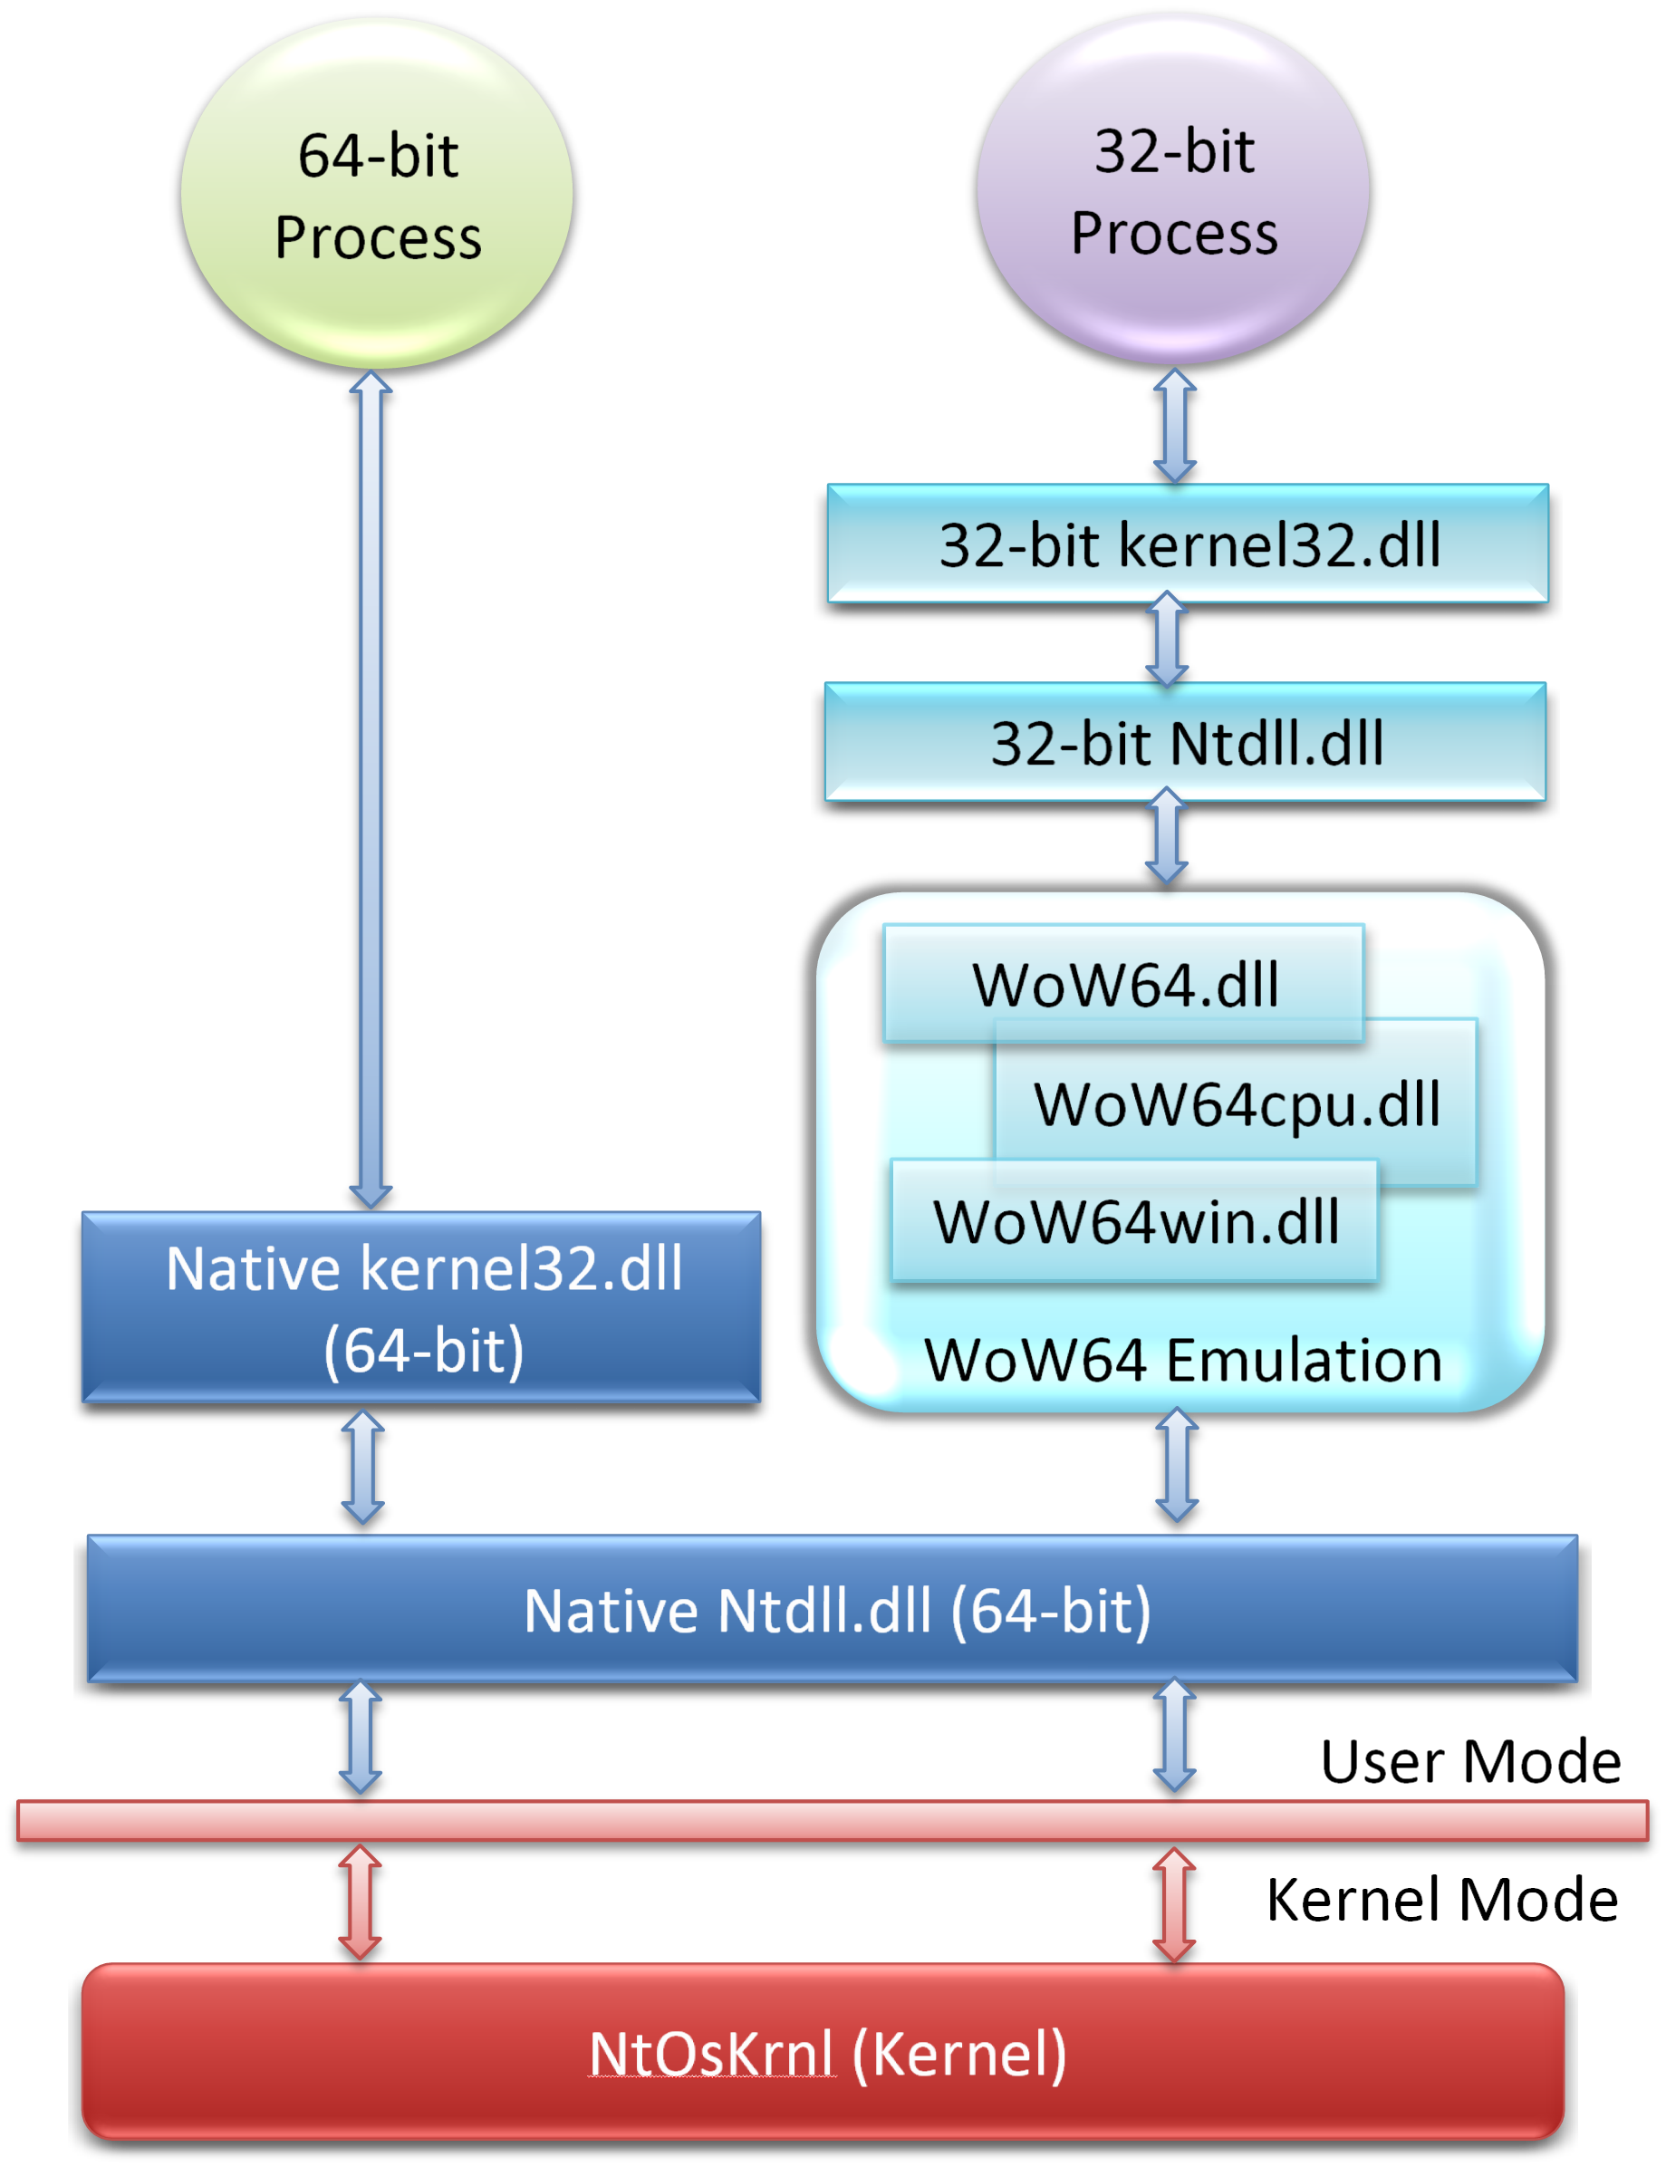
Figure 1. How a 32-Bit Process Runs on 64-Bit Windows
When a 32-bit application is run, the native library loader is invoked first. It recognizes the executable image to be a 32-bit process and handles it in a special manner. The native loader sets up a WOW64 emulation environment for 32-bit processes and transfers control to the 32-bit loader (in 32-bit Ntdll.dll).
The WOW64 emulation layer runs between the 32-bit application and the native (64-bit) Ntdll.dll and translates the application’s calls to the 32-bit Ntdll.dll to calls to the 64-bit Ntdll.dll. Any return calls are similarly translated and passed to the 32-bit application.

Limitations
WOW64 has the following limitations:
- The address space is limited to 2 GB by default, and 4 GB if /LARGEADDRESSAWARE is used. For more information, see Memory Limits for Windows Releases.
- A 32-bit process cannot load a 64-bit DLL (except for certain system DLLs).
- Running 16-bit processes is not supported. For information on 16-bit installer programs, see Application Installation.
- The Virtual DOS Machine (VDM) API is disabled.
- Page-size dependent APIs such as Address Windowing Extension (AWE), scatter/gather I/O, and write tracking are not available on IPF. For more information, see Memory Management.
- The Physical Address Extension (PAE) API is not available on IPF.
- Microsoft DirectX® hardware acceleration APIs are not supported on IPF.

Common Porting Issues
The following areas are often a source of common porting issues.

Registry Redirection
Many applications store binary 32- or 64-bit specific configuration information in the registry. To allow separate configuration of native and WOW64 applications, the registry is split at important nodes into a 32-bit part and a 64-bit part. Redirection is a mechanism to transparently allow a 64-bit process to see the native registry view and a 32-bit process to see the 32-bit registry view. This creates a separation of state between 32-bit and 64-bit applications, thus allowing conflict-free and safe interoperation. For more information, see Registry Redirector.

Registry Reflection
To prevent registry key collisions, WOW64 presents 32-bit applications with an alternative view of the registry by splitting key portions of the registry into a 32-bit version and a 64-bit version. In spite of this separation of the registry, applications require a certain level of awareness of the different views of the registry. Registry reflection is a mechanism to keep specific registry keys and values synchronized by copying them intelligently between the two registry views. For more information, see Registry Reflection.
Some applications may require both 32 and 64-bit versions to access the same registry data. To emulate the automatic bidirectional reflection of keys that are not reflected, an application can create a symbolic link between two registry keys. A symbolic link in the registry provides a shortcut to another key. All symbolic links address a single physical key and a change to any one reflects instantaneously in all the linked keys.
An application can use this behavior to emulate only full reflection of a key. Imagine that an application ‘HelloWorld’ uses a key K under HKEY_LOCAL_MACHINE\Software\HelloWorld. Because HKLM\Software is split into a 32-bit and 64-bit view, let us denote the key in the 32-bit view to be K₃₂ and that in the 64-bit hive to be K₆₄. If the key K contains the same value irrespective of the application type (native or WOW64), then a symbolic link from K₃₂ to K₆₄ allows a single copy of the key to be accessed. This allows better interoperability and management of the application.

File System Redirection
A 32-bit process cannot load a 64-bit DLL and, likewise, a 64-bit process cannot load a 32-bit DLL. As the Windows system folder contains both the installed applications and their DLLs, it must be separated into a native system folder for the 64-bit applications (%windir%\system32) and a WOW64 folder for the 32-bit applications (%windir%\syswow64).
Developers often hard code the system folder pathname in their application. Therefore, to preserve application compatibility, the 64-bit system folder is still called system32. To enable 32-bit applications with hard-coded paths to transparently access the WOW64 system directory, the WOW64 layer provides a File System Redirector.
All accesses made by a WOW64 process to the %windir%\system32 directory are redirected to the %windir%\syswow64 directory. As a result, with file system redirection enabled, a 32-bit application accesses the same contents for both the system32 and syswow64 directories. File system redirection is enabled for all WOW64 applications by default.
To disable the file system redirection on a per-thread basis, use the Wow64DisableWow64FsRedirection function. To revert to the default behavior, use the Wow64RevertWow64FsRedirection function.
Applications typically disable file system redirection to access the contents of the native system directory (for example, virus scanners). Developers are urged to exercise caution because if redirection is not reenabled in time, subsequent calls that depend on redirected paths fail. For example, with file system redirection disabled, an API that attempts to load a syswow64 (32-bit) DLL loads the 64-bit version from the system32 directory and fails.

Application Installation and Removal
Applications that have both 32-bit and 64-bit components side by side are difficult to install and uninstall cleanly. As far as possible, it is recommended that both types of components be installed at the same time.
If a 32-bit application is being installed and a 64-bit application is already installed on the system, it is likely that it will over-write certain configuration data. To avoid problems, the 64-bit installer (and un-installer) must be intelligent; it should be able to detect the presence of an older version and store the data in separate locations for compatibility.

Starting Applications
The following table summarizes the behavior when applications start a 32-bit application, a 64-bit application, or an interpreted file.
 | 32-bit application | 64-bit application | Interpreted file
32-bit application | Both processes run on WOW64. No application changes are required. | File system redirection is enabled by default. The 32-bit application must disable redirection, start the 64-bit application, and reenable redirection. | The 32-bit version of the interpreter is started. The interpreter and any processes the script starts are run on WOW64.
64-bit application | File system redirection does not apply. The application must be aware of the SysWow64 directory. | Both processes are native. No application changes are required. | The 64-bit version of the interpreter is started.

Kernel-Mode Drivers
A 32-bit driver cannot run on the 64-bit Windows kernel so it must be ported. A guide for porting 32-bit kernel drivers to 64-bit Windows can be found here. Developers are urged to apply Microsoft’s Porting Issues Checklist to their code.
Special care must be given when porting the I/O drivers because 64-bit device drivers must support I/O requests from 32-bit applications. WOW64 does not translate the IOCTL path due to lack of knowledge about interpreting the data buffer. The driver must be able to handle both 32-bit and 64-bit data structures in its IOCTL path.
A kernel I/O driver can determine whether it is being invoked in the context of WOW64 or a native process by using IoIs32bitProcess. In addition to this API, two APIs were added to Kernel32.dll to detect WOW64 processes: IsWow64Process and GetNativeSystemInfo.

Best Practices
The following are best practices:
- File system redirection is on a per-thread basis. Therefore, isolate operations that require disabling redirection in a separate thread.
- Reenable redirection as soon as possible after performing the task.
- Be aware of interoperability when installing a 64-bit process alongside its 32-bit version.
- When using interprocess communication methods such as sockets, pipes, RPC, and COM, test for bit-awareness in the way that you handle data.
- Avoid accessing 64-bit processes from 32-bit processes.

Further Reading
64-bit Platform
http://www.microsoft.com/whdc/system/platform/64bit/default.mspx
Running 32-bit Applications
http://msdn.microsoft.com/library/en-us/win64/win64/running_32_bit_applications.asp

