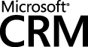

Experience Business Success
Invest in Microsoft CRM Today

Published: August 2005

The information contained in this document represents the current view of Microsoft Corporation on the issues discussed as of the date of publication. Because Microsoft must respond to changing market conditions, it should not be interpreted to be a commitment on the part of Microsoft, and Microsoft cannot guarantee the accuracy of any information presented after the date of publication.

This White Paper is for informational purposes only. MICROSOFT MAKES NO WARRANTIES, EXPRESS OR IMPLIED, AS TO THE INFORMATION IN THIS DOCUMENT.

Complying with all applicable copyright laws is the responsibility of the user. Without limiting the rights under copyright, no part of this document may be reproduced, stored in or introduced into a retrieval system, or transmitted in any form or by any means (electronic, mechanical, photocopying, recording, or otherwise), or for any purpose, without the express written permission of Microsoft Corporation.

Microsoft may have patents, patent applications, trademarks, copyrights, or other intellectual property rights covering subject matter in this document. Except as expressly provided in any written license agreement from Microsoft, the furnishing of this document does not give you any license to these patents, trademarks, copyrights, or other intellectual property.

© 2005 Microsoft Corporation. All rights reserved.

Microsoft, Windows, and Windows Server are either registered trademarks or trademarks of Microsoft Corporation in the United States and/or other countries.

The names of actual companies and products mentioned herein may be the trademarks of their respective owners.

Overview
Most modern organizations today understand the value of an integrated view of a company’s customers at all touch points throughout the lifecycle of the relationship. Most organizations also recognize the value of taking advantage of new technologies designed to help organizations meet new levels of profitability through more efficient processes to market to, sell to, and support its customers. Customer Relationship Management (CRM) presents companies of all sizes and in every industry with several compelling business drivers, among them being operational excellence, cost savings, and revenue growth.

On the flip side, the hard reality is that the results of many CRM implementations have fallen below expectations. Companies today know that selecting the right CRM vendor is one of the most critical pieces of achieving CRM success. Microsoft CRM ensures its customers the viability of its investments today – and tomorrow. This white paper highlights the value of purchasing Microsoft CRM today. It will also describe key business and economic benefits of buying now and upgrading later to Microsoft CRM 3.0. Learn how you can leverage that investment in the most cost-effective way to prepare for the future growth and success of your business.

Are You Evaluating Microsoft CRM?
Microsoft CRM 3.0 will provide a complete suite of powerful marketing, sales and service capabilities, all with a familiar and consistent user experience based on Microsoft Office and Microsoft Outlook®. Extensive new configuration, customization and integration capabilities will make it easier for customers and partners to deploy highly tailored solutions that help drive measurable business results and offer a lower total cost of ownership (TCO).

Microsoft CRM 3.0 is designed to address three key challenges that determine the success or failure of most CRM initiatives: user adoption, business fit and total cost of ownership. The new release focuses on three main themes:

- Works the way you do: Microsoft CRM 3.0 offers a user experience familiar and comfortable to anyone who uses Microsoft Office or Microsoft Outlook. The Outlook client and Web client interfaces are completely redesigned to provide a look and feel consistent with other Microsoft products, allowing work to be completed more easily. Customers get instant visibility into trends and issues through pre-built reports and views and can also take live CRM data directly into Microsoft Excel® for online or offline analysis. Microsoft CRM 3.0 provides a complete mobility solution, with a new high-performance engine for role-based synchronization of laptop data as well as an improved client for Microsoft Windows Mobile™.
- Works the way your business does: Microsoft CRM 3.0 completes the CRM suite by offering a rich marketing automation module for list management, campaign management, marketing resource management and closed-loop response management. The new release also will introduce a sophisticated new service scheduling module, which automatically manages complex scheduling requests that today require specific people, skills and resources. These new modules, along with enhancements to the sales and customer service capabilities previously available in Microsoft CRM 1.2, are highly configurable and workflow-driven, enabling consistent execution of CRM business processes, automated handling of exceptions and alerts, and closed-loop reporting and analysis across the organization.
- Works the way IT wants it to: The new release extends the configurability, customizability and integration options for Microsoft CRM’s service-oriented architecture. New data objects can be easily added to the system and linked to other predefined objects, with all underlying data storage and Web services automatically generated by the system. A new environmental diagnostics wizard automatically checks more than 100 system and network settings to help ensure a fast and reliable installation, and a new upgrade advisor streamlines the upgrade process for existing Microsoft CRM 1.0 and 1.2 customers. Integration with Microsoft Operations Manager simplifies the management of the overall system.

Microsoft CRM 1.2 offers many of these design points today and offers a seamless upgrade path to version 3.0. In addition, any customer that purchases any module of Microsoft CRM 1.2 Professional today will have full-suite rights to this next product release, including Sales, Service and Marketing Automation. This offer also applies to any existing Microsoft CRM customer who has an active Software Assurance license.

Key Benefits
If you need a CRM solution that is easy to learn, integrates with Microsoft Outlook, and stores customer and contact data in one central database --- Microsoft CRM is for you. Your company can be up and running with Microsoft CRM immediately out of the box; or you can also choose to customize the solution to your individual business process requirements. Other key benefits are discussed below.

First Time CRM User
Microsoft CRM provides first time CRM users the ability to be installed and running in a matter of hours. You will have full functionality to manage:

- Activities
- Leads
- Opportunities
- Accounts
- Contacts
- Quotes
  - Orders
  - Invoices
  - Cases/Incidents
  - Contracts
  - Sales Literature
  - Competitors

Leverage Existing CRM Platforms
Microsoft CRM provides you the ability to migrate your existing CRM data to Microsoft CRM. Utilizing the Microsoft CRM Data Migration Framework you can import your existing CRM data to Microsoft CRM. The Data Migration Framework ships with Microsoft CRM.
Integration to Line of Business Applications
Microsoft CRM has a fully enabled Software Development Kit (SDK) and utilizes web services that together allow you to integrate Microsoft CRM to your line of business applications. Whether you need real-time integration or batch updates Microsoft CRM can support your integration needs.

Anywhere/Anytime CRM Access
Microsoft CRM has your needs covered. Use the Microsoft CRM Sales for Outlook client to utilize CRM in a disconnected or remote user mode. If you don’t have access to your company PC but you have access to the Internet, you can utilize the web client of Microsoft CRM to gain access to your important CRM data, tools and more.

Fast User Adoption
While every CRM implementation is unique, all CRM success stories rely on fast and proficient user adoption. Because Microsoft CRM is integrated directly into your Microsoft Office System it provides a familiar environment for users. Microsoft Outlook users can easily navigate between email, calendaring, contacts, and tasks. Additionally, for offline functionality, users can simply click “go offline” within Microsoft Outlook to take Microsoft CRM data with them as they head out of the office and wherever they go.

Key Components of Microsoft CRM
In a market filled with a multitude of CRM solutions, each with varying key benefits, it is not always an easy task to identify the right vendor with the best mix of products and services.

Ask yourself: “What are the key components that will make my CRM implementation successful? Will this solution deliver optimally user support? Does this solution align with my business and technology investments?”

Utilize Table 1 on the following page to help guide your decision process and to steer your organization to accurately mapping your organization’s key business objectives to Microsoft CRM business applications.

Table 1: Microsoft CRM Key Components
Feature | Highlights
Email | - Send emails to customers and have Microsoft CRM automatically track the email as a closed activity against the email recipient  - Automatically track email threads of original CRM email messages without any intervention (inbound and outbound email messages)  - Create email templates and use them to send mass emails and track the messages as closed activities against the recipients
Calendar | - Schedule CRM meetings and have them synchronize to your Outlook calendar  - Add attendees to your meetings and automatically create activities for those CRM contacts  - Manage your meetings from Outlook or Microsoft CRM and keep your data synchronized
Tasks | - Create CRM tasks and have them synchronize to your Outlook calendar  - Manage your tasks from Outlook or Microsoft CRM and keep your data synchronized
Lead Tracking | - Import your marketing lists in a matter of minutes  - Schedule activities, take notes and qualify leads separately from customer accounts and contacts  - Convert leads as won or lost  - Automatically map data from lead screens to a new account, contact and opportunity
Opportunity Management | - Track opportunities against specific lead sources  - Create automated sales processes with specific activities to occur before advancing to the next sales stage  - View sales pipeline data  - Track opportunities by sales reps, products or services
Case Management | - Track cases (trouble tickets) against specific accounts and contacts  - Assign cases to individuals, teams and queues  - Escalate cases based on priority and workflow  - Assign support contracts to accounts  - Solve cases using Microsoft CRM’s knowledge base articles
Customization | - Modify Microsoft CRM forms without having to be a developer  - Create powerful views to help segment your data  - Utilize the workflow manager to create powerful workflow routines  - Use the deployment manager to maintain schema fields

Extending Your Microsoft CRM Solution
While a lot of companies are looking for core CRM functionality there are those who require more sophisticated integration and customization needs. Microsoft CRM 1.2 ships with a powerful software development kit (SDK) that enables your organization to extend the application to fit your specific needs. Below is just one example of how customers can work with Microsoft certified partners to extend and customize their solution to meet specific business requirements.

Bailiwick: Integrated Innovation Example
Bailiwick (www.bwick.com), a Minnesota (United States of America) based company that specializes in the deployment of Information Technology solutions, has been using Microsoft CRM for three years. They utilized the powerful functionality of Microsoft CRM to integrate to Microsoft MapPoint and created an application, MapIT, which allows their project managers to assign vendors to specific job sites by plotting them on MapPoint. Bailiwick vendors exist as accounts in Microsoft CRM. MapIT allows them to import vendors from CRM into MapPoint, assign vendors to job sites, and then create CRM tasks that associate a vendor to a specific site location.

MapIT is a .NET custom developed application that integrates MapPoint and Microsoft CRM using the Microsoft CRM SDK. This is just one of many examples of how companies are using the power of Microsoft CRM to build state-of-the-art business applications.

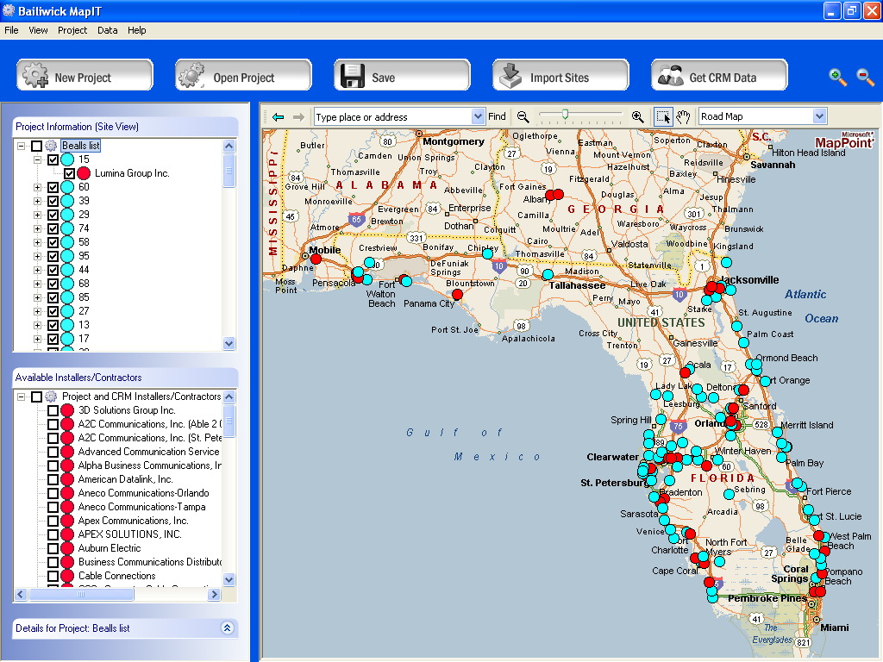

Upgrading Microsoft CRM 1.2 to 3.0 is Easy
One concern companies have is: “If I implement a CRM solution now and a new version comes out, do we have to start all over with unique configuration that we invested time and money in?” The simple answer to this question is, “no.” The configuration changes you make to Microsoft CRM 1.2 will be mapped to the next release of Microsoft CRM. This will provide for a straightforward upgrade to the next version of Microsoft CRM. There will be wizards that walk you through the upgrade process and will map your current configurations to the new version of the product.

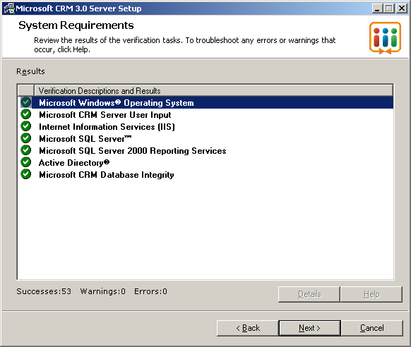

Microsoft CRM 3.0 will extend the capabilities of the existing platform. This means that what your users learn today will still exist in the next release of the application. Installing Microsoft CRM today will allow your users to be trained and knowledgeable on the core components of the application and will be prepared for the significant enhancements of Microsoft CRM 3.0. Best of all, if you buy Microsoft CRM 1.2 today, you will receive the upgrade to Microsoft 3.0 at no additional charge.

Opportunity Cost of Waiting
How much is it costing your business in lost revenue by not making a buying decision today? What are your criteria for making a buying decision? Are you betting your future on features? Or are you betting on technology that be used now to deliver high strategic impact and to help your organization streamline and standardize business processes?

Buying Questions
As you look to acquire and implement CRM, start asking yourself some important questions (see below for some examples). The Microsoft CRM application is truly a platform decision. If you have committed to Microsoft Exchange and Microsoft Office then Microsoft CRM 1.2 is a powerful compliment to these investments. By configuring the application to support your business processes you can begin recognizing returns from the moment you install the Microsoft CRM applications.

- How much does closing an opportunity mean to your business?
- How much potential revenue does it cost your business for every lost lead?
- How long does it take to resolve customer issues?
- Do you have the ability to track an accurate sales pipeline?
- Do you have a centralized database of customer information?

Minimize lost leads and capture important business opportunities by purchasing Microsoft CRM 1.2 today. Prepare your business for the future by leveraging the strengths of Microsoft CRM today. Take advantage of the powerful sales and services functionality that exists and enable your users to work smarter and be more successful.

Microsoft CRM enables you to effectively record information about your customers and prospects. Without this information your company could lose leads that are being generated by your marketing efforts. Lost leads equal lost revenue. The information you capture in CRM also helps you deliver higher customer care. When customer information is in many disparate applications, gaps in information occur and clients generally are the ones that must suffer. Microsoft CRM brings information together in a common repository, giving you one place to go to find and access a complete view of all your customer interactions.

Get Started Today
There are more than 4,000 companies that are using Microsoft CRM today. These companies are utilizing the strengths of Microsoft CRM to help build a better business. Microsoft CRM 1.2 is available for purchase through Microsoft Volume Licensing (http://www.microsoft.com/licensing/default.mspx). We recommend finding a business partner who has a competency in Microsoft Business Solutions and focuses on the Microsoft CRM platform. Get to know your partner and work them to identify and document your business processes and create a roadmap for a successful CRM implementation. To learn more about Microsoft CRM visit http://www.microsoft.com/crm. To see how organizations benefit from Microsoft CRM, visit http://www.microsoft.com/resources/casestudies/FindCaseStudyResults.aspx?SearchTypeId=0&ProTaxID=1851

The information contained in this document represents the current view of Microsoft Corporation on the issues discussed as of the date of publication. Because Microsoft must respond to changing market conditions, it should not be interpreted to be a commitment on the part of Microsoft, and Microsoft cannot guarantee the accuracy of any information presented after the date of publication.

This White Paper is for informational purposes only. MICROSOFT MAKES NO WARRANTIES, EXPRESS OR IMPLIED, AS TO THE INFORMATION IN THIS DOCUMENT.

Complying with all applicable copyright laws is the responsibility of the user. Without limiting the rights under copyright, no part of this document may be reproduced, stored in or introduced into a retrieval system, or transmitted in any form or by any means (electronic, mechanical, photocopying, recording, or otherwise), or for any purpose, without the express written permission of Microsoft Corporation.

Microsoft may have patents, patent applications, trademarks, copyrights, or other intellectual property rights covering subject matter in this document. Except as expressly provided in any written license agreement from Microsoft, the furnishing of this document does not give you any license to these patents, trademarks, copyrights, or other intellectual property.

© 2005 Microsoft Corporation. All rights reserved.

Microsoft, Windows, and Windows Server are either registered trademarks or trademarks of Microsoft Corporation in the United States and/or other countries.

The names of actual companies and products mentioned herein may be the trademarks of their respective owners.

